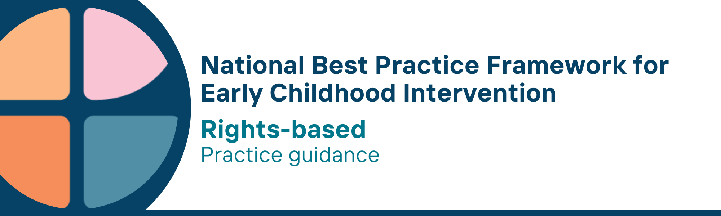

What is the rights-based universal principle?
A rights-based approach involves recognising human rights principles and actively promoting and protecting those rights. Common principles underpinning a human rights approach include:
- participation (everyone has the right to participate in decisions which affect their human rights)
- accountability (effective monitoring of compliance with human rights standards and goals)
- non-discrimination and equality (all forms of discrimination in the realisation of rights must be eliminated)
- empowerment (everyone is entitled to claim and exercise their rights and freedoms); and
- legality (the law is consistent with human rights principles and recognises human rights and freedoms as legally enforceable entitlements

Why is this principle important?
- Australia has signed a number of key international rights conventions including the UN Convention on the Rights of the Child, the UN Convention on the Rights of Persons with Disabilities and the UN Declaration on the Rights of Indigenous Peoples
- Human rights are essential because they offer protections and support access to basic needs such as healthcare and education. They also positively promote opportunities such as the opportunity to participate in the economic, religious and political life of the country
- This principle relates to all other universal and key Framework principles and they should be applied together in practice

What are rights-based practices?
Practitioners
- understand and promote the rights of children, people with disability and Aboriginal and Torres Strait Islander peoples
- respect and understand children’s right to privacy
- understand a child’s right to be safe from discrimination, harm or neglect is paramount
- understand that children have the right to learn and use the language and customs of their families
- share information about rights with parents, carers, families and professionals to support children’s learning, development, participation and wellbeing
- build parents, carers and family capacity to advocate for their child and themselves
- support children to be decision-makers and have a say about matters that are important to them
- share information in ways that enable parent, carers and families to make informed decisions about matters that affect them and their children
- are participating fully in the social, cultural and economic life of the community
- use rights-based approaches to planning, implementing and measuring programs and supports

We know it’s working well when…
Children, parents, carers and families
- have access to support and opportunities, free from abuse, neglect and discrimination
- have agency and a voice and provide informed consent in matters that affect them
- have strong connections to their culture and community
- can advocate for themselves

Essential resources
You can find more information about the National Best Practice Framework for Early Childhood Intervention online.
- Resources for practitioners including the
- Looks like/doesn’t look like guide for the principle
- Outcome measures resources
- Resources for families and others
- The podcast where families and professionals discuss practices related to this principle
- Unpacking the Framework video/s for this principle
- The Framework including
- Decision making guide
- The Framework
- The development of the Framework
- Background papers
- Bibliography for the principles and practice guidance

© UoM 2025. National Best Practice Framework for Early Childhood Intervention (a joint collaboration between Healthy Trajectories, the Melbourne Disability Institute, STRONG Kids STRONG Future at the University of Melbourne, and the Murdoch Children’s Research Institute (MCRI), Professionals and Researchers in Early Childhood Intervention (PRECI), SNAICC – National Voice for our Children, Children and Young People with Disability Australia, and ACD – Advocating for Children with Disability). Commissioned by the Department of Social Services.
This work is copyrighted to The University of Melbourne under a creative commons license, CC-BY-NC-ND. This material contains and draws upon Indigenous Cultural and Intellectual Property (ICIP) contributed by SNAICC and its members and staff and is used with their consent. Dealing with any part of the materials containing ICIP for any purpose that has not been authorised by the custodians is a serious breach of customary laws. You must handle ICIP accordingly when exercising the Creative Commons Licence described above.
For more information about copyright please visit https://healthy-trajectories.com.au/eci-framework/

