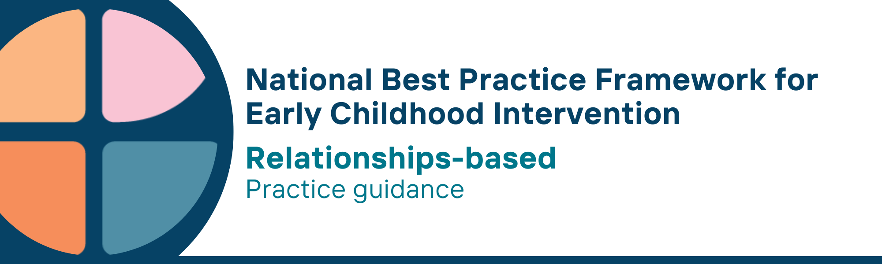

What is the relationships-based universal principle?
- A relationship-based approach is a way of working where establishing and maintaining trusted relationships between practitioners, children, parents, carers, families and others is essential
- Early Childhood Intervention (ECI) services are fundamentally relational services: they involve relationships that practitioners have with parents, carers, family, colleagues, and other services in the community
- The relationships that children have with their parents, carers, families and practitioners are central to positive child outcomes
- The relationship-based principle recognises that positive relationships are necessary for creating change or for being an effective practitioner. The relationship between the practitioner, the child, and parent, carer, and family is the medium through which collaboration, learning and change can occur
- Practitioners use core relationship skills – authenticity, empathy, active listening and responding, respect, reciprocity in all interactions with children, parents/carers, and families. To do this effectively, practitioners are aware of their own values, judgements, cultural backgrounds, and biases
- Practitioners build trust and relationships by advocating for the child and family and have a role in supporting families to build the capability to advocate for themselves where required
- Building trust with children and parents, carers and families takes time. Practitioners commit time to developing these relationships, supported by good leadership, system design, and funding models

Why is this principle important?
- How services are provided is as important as what is provided: the effectiveness of the support provided by practitioners depends as much upon the quality of the relationships they establish with children, parents, carers and families as it does upon the practical guidance they provide
- Promoting positive parent/child attachments and responsive caregiving is critical for all later development. Positive relationships with parents, carers and families are the building blocks for healthy relationships and good child outcomes in the future. Positive relationships can also buffer children from the negative effects of growing up in difficult circumstances such as socioeconomic disadvantage
- Relationships are important for supporting initial parent, carer and family engagement with a service or practitioner as well as maintaining engagement over time
- Building trusted relationships is important for ensuring effective collaboration between universal systems of support, specialist service providers and ECI practitioners, as well as between ECI practitioners and their colleagues
- A relationship-based approach is based on evidence from multiple sources (including medicine, psychology, psychiatry, social work and early childhood intervention) that building trusting relationships is central to effective engagement and service delivery

What are relationship-based practices?
Practitioners
- recognise that effective support depends on building positive, trusted relationships among parents, carers and families, community members, universal systems of support and specialist service providers
- recognise and strengthen positive interactions between parents, carers and their children
- prioritise investing the time required for establishing trusted relationships between parents, carers, families, and service providers
- are proficient in the key relational skills of active listening, responding, empathy, authenticity, respect, and reciprocity
- continually reflect on their own values and reactions to ensure these do not compromise the development of positive, trusted relationships with children, parents, carers, families, and others
- seek feedback from parents, carers, families, and others to ensure that the support and services being provided are consistent with best practice
- recognise that Aboriginal and Torres Strait Islander families require culturally safe places and opportunities for family-led activities and connecting with community and culture; where families are in control and make informed decisions that suit them; where they can safely raise concerns without fear of child removal; and where there are opportunities for multigenerational support from other family members
- recognise that building relationships and collaboration is everybody’s business and promote relationship building with children, parents, carers, families, communities and across services
- are transparent and involve parents, carers

We know it’s working well when….
- parents, carers and families say they feel listened to, respected, and understood in interactions with practitioners
- all services involved with the child are talking to each other and working collaboratively
- children have secure, stable and safe relationships with parents, carers, families and significant others
- parents, carers, families and practitioners recognise when relationships are effective and conducive to desired child and family outcomes
- parents, carers and families are connected to a social support network (including peers) that provides emotional, cultural, and practical support
- parents, carers and families make informed choices and decisions about ECI services
- Aboriginal and Torres Strait Islander families report that services are culturally safe
- parents, carers and families indicate that practitioners are collaborating effectively with colleagues and other service providers to provide the support they and their children need
- parents, carers and families say they feel listened to, respected, and understood in interactions with practitioners
- all services involved with the child are talking to each other and working collaboratively
- children have secure, stable and safe relationships with parents, carers, families and significant others
- parents, carers, families and practitioners recognise when relationships are effective and conducive to desired child and family outcomes
- parents, carers and families are connected to a social support network (including peers) that provides emotional, cultural, and practical support
- parents, carers and families make informed choices and decisions about ECI services
- Aboriginal and Torres Strait Islander families report that services are culturally safe
- parents, carers and families indicate that practitioners are collaborating effectively with colleagues and other service providers to provide the support they and their children need

Essential resources
You can find more information about the National Best Practice Framework for Early Childhood Intervention online.
- Resources for practitioners including the
- Looks like/doesn’t look like guide for the principle
- Outcome measures resources
- Resources for families and others
- The podcast where families and professionals discuss practices related to this principle
- Unpacking the Framework video/s for this principle
- The Framework including
- Decision making guide
- The Framework
- The development of the Framework
- Background papers
- Bibliography for the principles and practice guidance

© UoM 2025. National Best Practice Framework for Early Childhood Intervention (a joint collaboration between Healthy Trajectories, the Melbourne Disability Institute, STRONG Kids STRONG Future at the University of Melbourne, and the Murdoch Children’s Research Institute (MCRI), Professionals and Researchers in Early Childhood Intervention (PRECI), SNAICC – National Voice for our Children, Children and Young People with Disability Australia, and ACD – Advocating for Children with Disability). Commissioned by the Department of Social Services.
This work is copyrighted to The University of Melbourne under a creative commons license, CC-BY-NC-ND. This material contains and draws upon Indigenous Cultural and Intellectual Property (ICIP) contributed by SNAICC and its members and staff and is used with their consent. Dealing with any part of the materials containing ICIP for any purpose that has not been authorised by the custodians is a serious breach of customary laws. You must handle ICIP accordingly when exercising the Creative Commons Licence described above.
For more information about copyright please visit https://healthy-trajectories.com.au/eci-framework/

