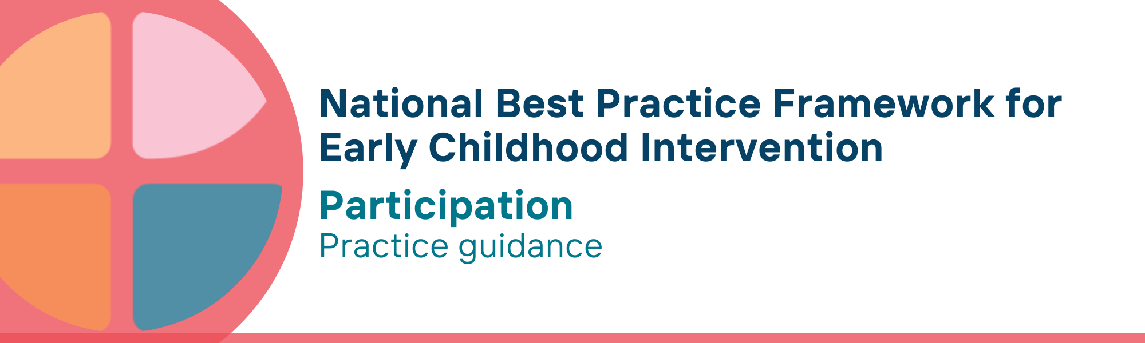

What is the participation key principle?
Participation and inclusion are closely related ideas – but they are not exactly the same. Inclusion means having access to the same opportunities and resources as others. Participation means attending and being fully, meaningfully and actively involved in all activities and situations where children live, learn, play, and relax.
- Attending means being present at an activity or place - as children grow and develop, they attend a wider range of activities and settings. However, attending on its own is not enough - being involved is what leads to children’s learning, experiencing, and understanding their world
Involvement is the experience of meaningful participation when attending - for young children this means being involved in play, and with the activities and people around them. Learning and a sense of belonging are only possible with full involvement
- To ensure involvement, adaptations, equipment and supports may be needed to strengthen the participation of children, parents, carers and families. Key issues to be addressed include: can they get there? can they play? and can they stay?
To achieve the benefits of participation for children, genuine inclusion and meaningful participation extend to the whole family, including parents, carers and siblings.
In Aboriginal and Torres Strait Islander communities, culture is inclusion – children growing up immersed in culture brings acceptance of each child.
How much a child can participate depends on the people, place, activities, equipment and time involved – as well as attributes, development, safety, and well-being of the child.
What drives participation experiences and outcomes is how well we adapt the environment to support and match the needs of the child. To attend an activity, it must be available, and accessible in terms of time, effort, energy and cost. To be involved, the setting must accommodate the child’s and family’s needs.
Promoting participation and inclusion is everyone’s responsibility.

Why is this principle important?
The principle of participation is based on the following rights, values and evidence:
- Every child has a right to equal access to environments, opportunities and resources to thrive, participate in and benefit from all aspects of life, including education, healthcare, and community activities
- Being truly included and able to participate fully are key for the wellbeing and development of children with developmental concerns, delay or disability, their parents, carers and the whole family
- Participation-attendance and involvement- in home, early childhood education and care (ECEC), school settings, and the wider community provide essential opportunities for children to learn, belong, develop autonomy, and explore their interests
- Participation of all children is also vital to developing understanding, skills, knowledge and positive attitudes in peers, families and community
This principle relates to all other universal and key Framework principles, and they should be applied together in practice.

What are participation practices?
Practitioners
- ensure children have access to equitable opportunities and resources as others
- work with parents, carers, families, and children to identify and understand the activities and settings where child and family want to participate
- co-design solutions to participation, considering changes to activity, place, objects/equipment, and time frames
- understand the importance of children attending and being actively involved in all home, ECEC, school and wider community settings
- develop competency in trauma-informed practice to understand and respond to the impact of trauma on children’s meaningful participation
- work with parents, carers, families and other service providers to provide children with opportunities to practice functional skills in the course of everyday environments and activities
- use routines-based approaches that embed teaching and learning opportunities for children at home, ECEC, school and in wider community settings
- use interest- and strengths-based approaches to support the child’s wellbeing, engagement, learning and playing alongside their peers
- provide specialist equipment the child needs to access, interact and be involved in activities and environments where they live, learn and play
- promote universal design for learning and tiered systems of support to help ECEC, school, services and wider community settings meet the diverse needs of all children more effectively
- ensure meaningful participation through the use of culturally affirming practices
- build trusted relationships and work in partnership with local Aboriginal and Torres Strait Islander community-controlled organisations as providers of culturally safe and inclusive services for Aboriginal and Torres Strait Islander children and families

We know it’s working well when…
Children
- enjoy access to experiences, interactions, opportunities and resources to participate effectively
- attend and are meaningfully involved in all activities and situations where they live, learn and play
- have opportunities to learn, use and practice new knowledge and skills
- follow their interests and enjoy play opportunities with peers
- participate and maintain engagement in everyday home, community, ECEC and school environments
Families
- are enjoy access to experiences, interactions, opportunities and resources to participate effectively
- experience welcoming environments where young children and their families usually spend time
Early childhood settings
- are welcoming and accommodating of children with developmental concerns, delay or disability

Essential resources
You can find more information about the National Best Practice Framework for Early Childhood Intervention online.
- Resources for practitioners including the
- Looks like/doesn’t look like guide for the principle
- Outcome measures resources
- Resources for families and others
- The podcast where families and professionals discuss practices related to this principle
- Unpacking the Framework video/s for this principle
- The Framework including
- Decision making guide
- The Framework
- The development of the Framework
- Background papers
- Bibliography for the principles and practice guidance

© UoM 2025. National Best Practice Framework for Early Childhood Intervention (a joint collaboration between Healthy Trajectories, the Melbourne Disability Institute, STRONG Kids STRONG Future at the University of Melbourne, and the Murdoch Children’s Research Institute (MCRI), Professionals and Researchers in Early Childhood Intervention (PRECI), SNAICC – National Voice for our Children, Children and Young People with Disability Australia, and ACD – Advocating for Children with Disability). Commissioned by the Department of Social Services.
This work is copyrighted to The University of Melbourne under a creative commons license, CC-BY-NC-ND. This material contains and draws upon Indigenous Cultural and Intellectual Property (ICIP) contributed by SNAICC and its members and staff and is used with their consent. Dealing with any part of the materials containing ICIP for any purpose that has not been authorised by the custodians is a serious breach of customary laws. You must handle ICIP accordingly when exercising the Creative Commons Licence described above.
For more information about copyright please visit https://healthy-trajectories.com.au/eci-framework/

