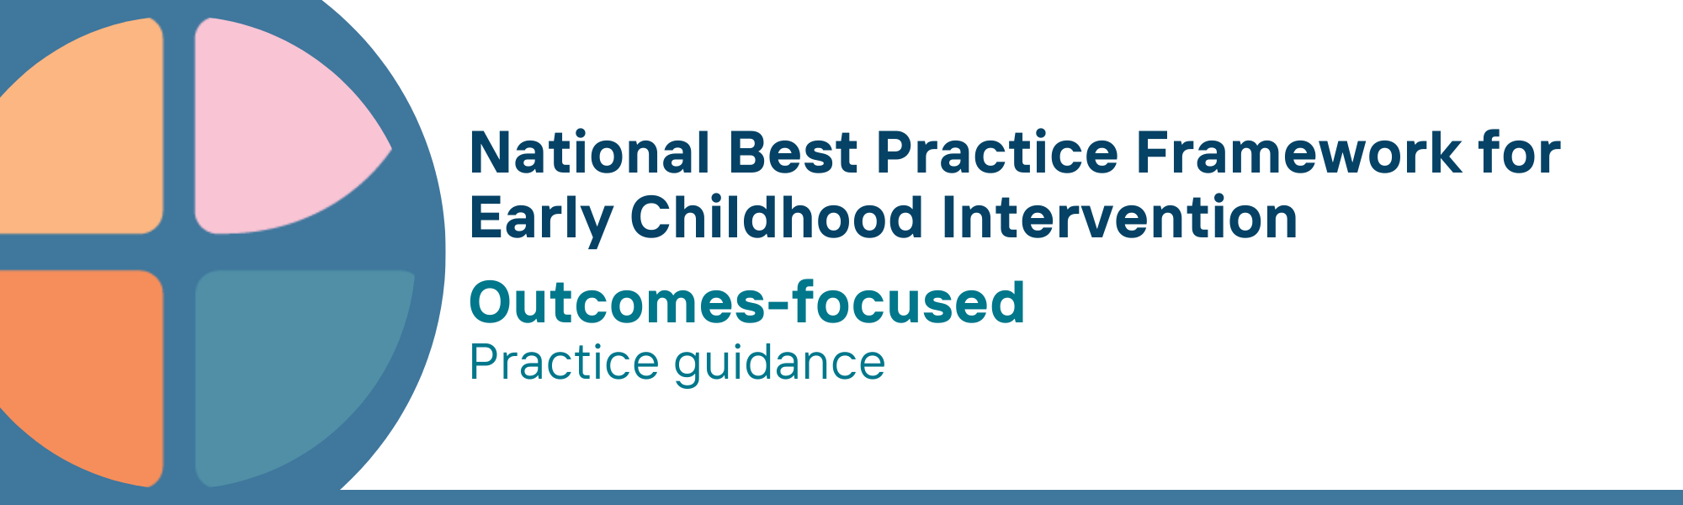

What is the outcomes-focused key principle?
Being outcomes-focused means making decisions about services and strategies based on the outcomes that children, parents, carers and families want for themselves.
Outcomes are the benefits and changes experienced by children and families after agreed services, supports and strategies are implemented.
The outcomes-focused principle recognises the involvement of children, parents, carers and families in decision-making and goal setting, and makes sure that services and supports are designed to achieve desired outcomes.
The outcomes-focused principle means that children and families are actively involved in monitoring progress, and that services deliberately collect data, which is observed and reported by children and families.
Outcomes integrate a series of meaningful behaviours, skills or indicators aligned with goals that mirror the concerns, priorities and aspirations of children and families.
The outcomes-focused principle requires that we assess the extent to which services have been effective in achieving timely child and family outcomes. Assessment can involve outcome measures, observation and other means of documenting outcomes.
A central element of the outcome-focused principle is authentic assessment which is designed to evaluate functional outcomes on children’s learning, development, participation and wellbeing.
Outcomes must be differentiated from goals: Goals are what one aims to achieve, while outcomes are the actual results or changes that happen after efforts are made toward a goal.

Why is this principle important?
- The outcomes-focused principle highlights what matters to children, parents, carers and families
- Starting with the outcome in mind ensures that the decisions that are made about the services to be offered are guided by what the child, parents, carers, and families want, not what the practitioners and others think will be best for them
- The outcomes-focused principle is fundamental in tailoring timely assessments, supports, interventions and strategies designed to meet the specific priorities and goals of children and families in the context of their daily lives
- Using an outcomes-focused approach makes it easier to measure whether the strategies used are being effective
- This principle supports the shared decision-making process involved in goal setting, planning, choosing and evaluating interventions, strategies and monitoring of services, programs, and plans
This principle relates to all other universal and key Framework principles, and they should be applied together in practice.

What are outcomes-focused practices?
Practitioners
- help professionals working in universal settings (e.g., maternal and child health, school, early childhood education and care (ECEC), community programs) and specialist services (e.g., child and family services) to be able to recognise, identify and respond to developmental concerns and delays on a timely manner
- work with children, parents, carers and families to identify and agree on meaningful child and family outcomes. These are based on the goals, priorities and aspirations, strengths and circumstances of children and families
- ensure that goals for children, parents, carers, and families are identified and drive the planning of supports and services
- are aware of their own values and biases and provide complete and unbiased information, and help select strategies that directly address the outcomes agreed with the children, parents, carers and family
- use authentic assessment procedures (e.g., play-based, naturalistic, performance-based) focusing on children’s functional outcomes that meet children’s learning, development, wellbeing and participation goals
- work with parents, carers, families and children to monitor outcomes for children and families using culturally appropriate and validated assessment tools
- recognise that children and families will ‘progress’ at their own pace and ensure measures and assessments are conducted with appropriate flexibility
- use agreed and validated tools and measures to assess community outcomes, including partnerships/collaborations with other service providers

We know it’s working well when…
- the goals, priorities, aspirations and circumstances of children, parents, carers, and families lead the planning, selection of strategies, evaluation, and monitoring of services, programs, and plans
- children, parents, carers, and families have access to validated assessment tools to identify and monitor meaningful and functional outcomes
- practitioners are skilled and confident in the use of authentic assessment
- validated and culturally safe tools are used to measure outcomes for children, parents, carers, families, communities, and practitioners/service organisations.
- intervention approaches are revised based on regular review of outcomes

Essential resources
You can find more information about the National Best Practice Framework for Early Childhood Intervention online.
- Resources for practitioners including the
- Looks like/doesn’t look like guide for the principle
- Outcome measures resources
- Resources for families and others
- The podcast where families and professionals discuss practices related to this principle
- Unpacking the Framework video/s for this principle
- The Framework including
- Decision making guide
- The Framework
- The development of the Framework
- Background papers
- Bibliography for the principles and practice guidance

© UoM 2025. National Best Practice Framework for Early Childhood Intervention (a joint collaboration between Healthy Trajectories, the Melbourne Disability Institute, STRONG Kids STRONG Future at the University of Melbourne, and the Murdoch Children’s Research Institute (MCRI), Professionals and Researchers in Early Childhood Intervention (PRECI), SNAICC – National Voice for our Children, Children and Young People with Disability Australia, and ACD – Advocating for Children with Disability). Commissioned by the Department of Social Services.
This work is copyrighted to The University of Melbourne under a creative commons license, CC-BY-NC-ND. This material contains and draws upon Indigenous Cultural and Intellectual Property (ICIP) contributed by SNAICC and its members and staff and is used with their consent. Dealing with any part of the materials containing ICIP for any purpose that has not been authorised by the custodians is a serious breach of customary laws. You must handle ICIP accordingly when exercising the Creative Commons Licence described above.
For more information about copyright please visit https://healthy-trajectories.com.au/eci-framework/

