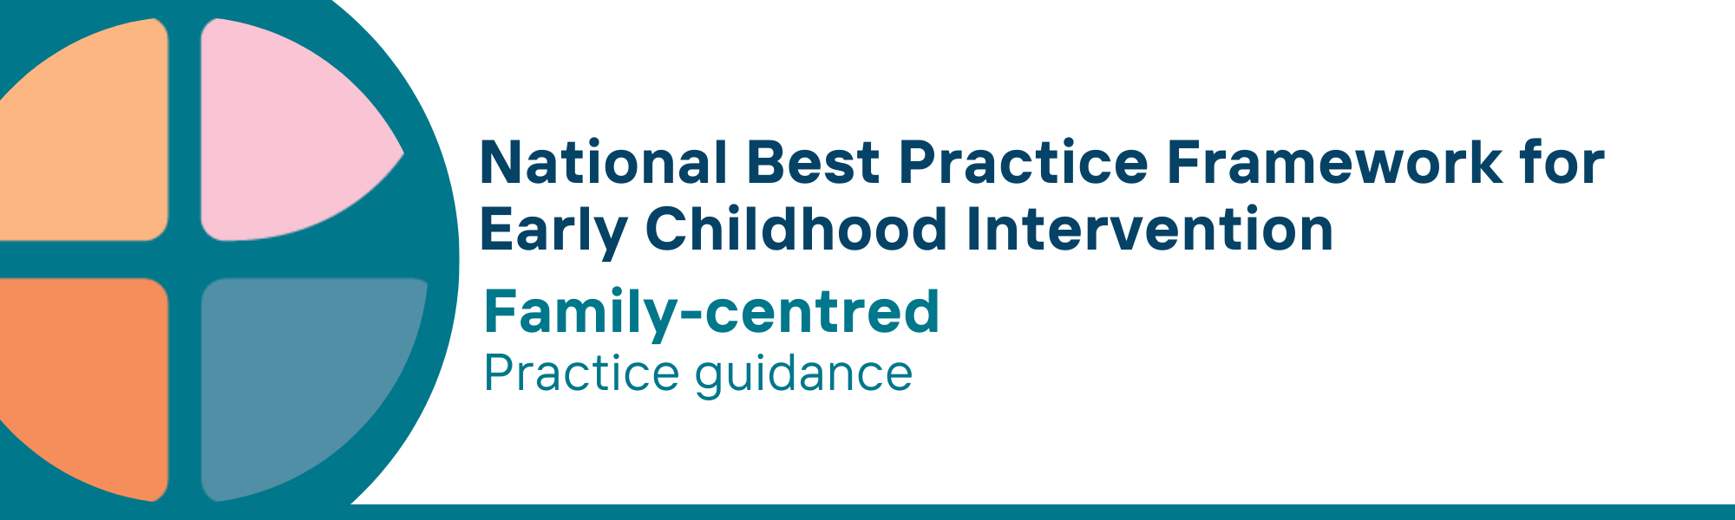

# What is the family-centred key principle?

The family-centred principle recognises the central role of families in a child’s development. It respects families as the experts on their child and understand their child’s needs and strengths as well as those of parents, carers, siblings and the family as a whole.

Valuing family strengths and forming strong, trusted partnerships among parents, carers, families, practitioners, and other support services, ensures support is tailored to families’ needs and circumstances. Sharing decision making, planning and problem solving empowers families and strengthens their ability to support their child’s development and wellbeing. This process brings in the knowledge and skills of all involved.

Being family-centred requires recognising family priorities, needs and circumstances, and providing support that is individualised, flexible, and culturally relevant. It strengthens the ability of parents, carers and family to support and advocate for their child’s growth and well-being.

Only families can deem if the services received are family-centred.

# Why is this principle important?

* Families play a central role in a child's development. When families are actively involved in planning, delivering and monitoring services and supports, children feel secure, connected and experience better developmental, social, and emotional outcomes
* By prioritising family strengths, preferences, and cultural values, this principle promotes the capability and confidence of parents, carers and families, which in turn, leads to more consistent and meaningful support for the child and other family members
* By building on families’ resources and supporting them to use both informal and formal supports and services, the core needs of parents, carers and families are more likely to be met, enabling them to support their children’s learning and development
* Building strong partnerships between parents, carers, families and practitioners ensures that strategies are practical, sustainable, and tailored to the family’s and child's everyday environment
* A collaborative relationship between parents, carers, families and service providers empowers them as decision-makers. It supports understanding of raising children with developmental concerns, delay or disability, leading to improved outcomes for the child and family

The family-centred principle is included in other key national frameworks and policy documents including the [Early Years Learning Framework V2.0, 2022](https://www.acecqa.gov.au/sites/default/files/2023-01/EYLF-2022-V2.0.pdf) and the [Early Years Strategy 2024-2034](https://www.dss.gov.au/early-years-strategy/resource/early-years-strategy-2024-2034). It is also a key feature of other international frameworks.

This principle relates to all other universal and key Framework principles, and they should all be applied together in practice.

# What are family-centred practices?

Practitioners

* understand that parents, carers and families are the child's first and most important influence
* listen to and respect the knowledge, values and decisions that parents, carers and families bring about their child, family and daily life
* respect the personal and cultural beliefs, priorities, preferences and circumstances of parents, carers, family members and children
* build trust and rapport with families through open and respectful communication and actions
* recognise and value the strengths and contributions of each family member
* collaborate with families to set goals, both individual and whole-of-family and make decisions that reflect the family’s priorities, concerns, preferences and needs
* ensure distinct and/or combined goals for children, parents, carers, and families are considered and formulated
* are non-judgmental and respectful in response to family views and decisions
* actively involve parents, carers and families as equal partners in planning and implementing strategies that they can use at home, in play and during daily routines
* share information (e.g., about service options and evidence) with parents, carers and families in a complete and unbiased manner
* work with parents, carers and families to develop capabilities to advocate for their child and family
* provide parents, carers and families with access to independent and evidence-based/ appropriate information about additional supports and resources that might help them achieve their aims and support family wellbeing
* provide information in a way that is accessible to parents, carers and families
* recognise that Aboriginal and Torres Strait Islander families require culturally safe places and opportunities for family-led activities and connecting with community and culture; where families are in control and make decisions that suit them; where they are supported to fully understand what is being said and can safely raise concerns; and where there are opportunities for multigenerational support from other family members; awareness that Aboriginal and Torres Strait Islander families may be concerned that seeking information and support for their children risks bringing them to the attention of child protection agencies and possible child removal
* build trusted relationships and engage with Aboriginal and Torres Strait Islander community-controlled organisations who are already involved with and trusted by families

# We know it’s working well when…

Parents, carers and families

* have positive views about their child’s strengths, developmental progress and functioning
* are confident in their ability to provide their children with the experiences and opportunities they need
* can make informed choices about quality evidence-informed ECI services and other supports that will best meet their child, parent, carer and family needs
* are confident in advocating for their child and family
* Identify, communicate, and have a positive social support network providing emotional, cultural and practical support
* are participating in the social, cultural and economic life of the community
* are continuing to develop their individual interests and life pursuits

# Essential resources

You can find more information about the [National Best Practice Framework for Early Childhood Intervention](https://healthy-trajectories.com.au/eci-framework) online.

* [Resources for practitioners](https://healthy-trajectories.com.au/eci-framework/resources-for-practitioners/) including the
* Looks like/doesn’t look like guide for the principle
* Outcome measures resources
* [Resources for families and others](https://healthy-trajectories.com.au/eci-framework/resources-for-families-and-others/)
* The podcast where families and professionals discuss practices related to this principle
* [Unpacking the Framework video/s](https://healthy-trajectories.com.au/eci-framework/unpacking-the-framework/) for this principle
* [The Framework](https://healthy-trajectories.com.au/eci-framework/) including
* Decision making guide
* The Framework
* [The development of the Framework](https://healthy-trajectories.com.au/eci-framework/development-of-the-framework/)
* Background papers
* Bibliography for the principles and practice guidance

© UoM 2025. National Best Practice Framework for Early Childhood Intervention (a joint collaboration between Healthy Trajectories, the Melbourne Disability Institute, STRONG Kids STRONG Future at the University of Melbourne, and the Murdoch Children’s Research Institute (MCRI), Professionals and Researchers in Early Childhood Intervention (PRECI), SNAICC – National Voice for our Children, Children and Young People with Disability Australia, and ACD – Advocating for Children with Disability). Commissioned by the Department of Social Services.

This work is copyrighted to The University of Melbourne under a creative commons license, CC-BY-NC-ND. This material contains and draws upon Indigenous Cultural and Intellectual Property (ICIP) contributed by SNAICC and its members and staff and is used with their consent. Dealing with any part of the materials containing ICIP for any purpose that has not been authorised by the custodians is a serious breach of customary laws. You must handle ICIP accordingly when exercising the [Creative Commons Licence](https://creativecommons.org/licenses/by-nc-nd/4.0/) described above.

For more information about copyright please visit <https://healthy-trajectories.com.au/eci-framework/>