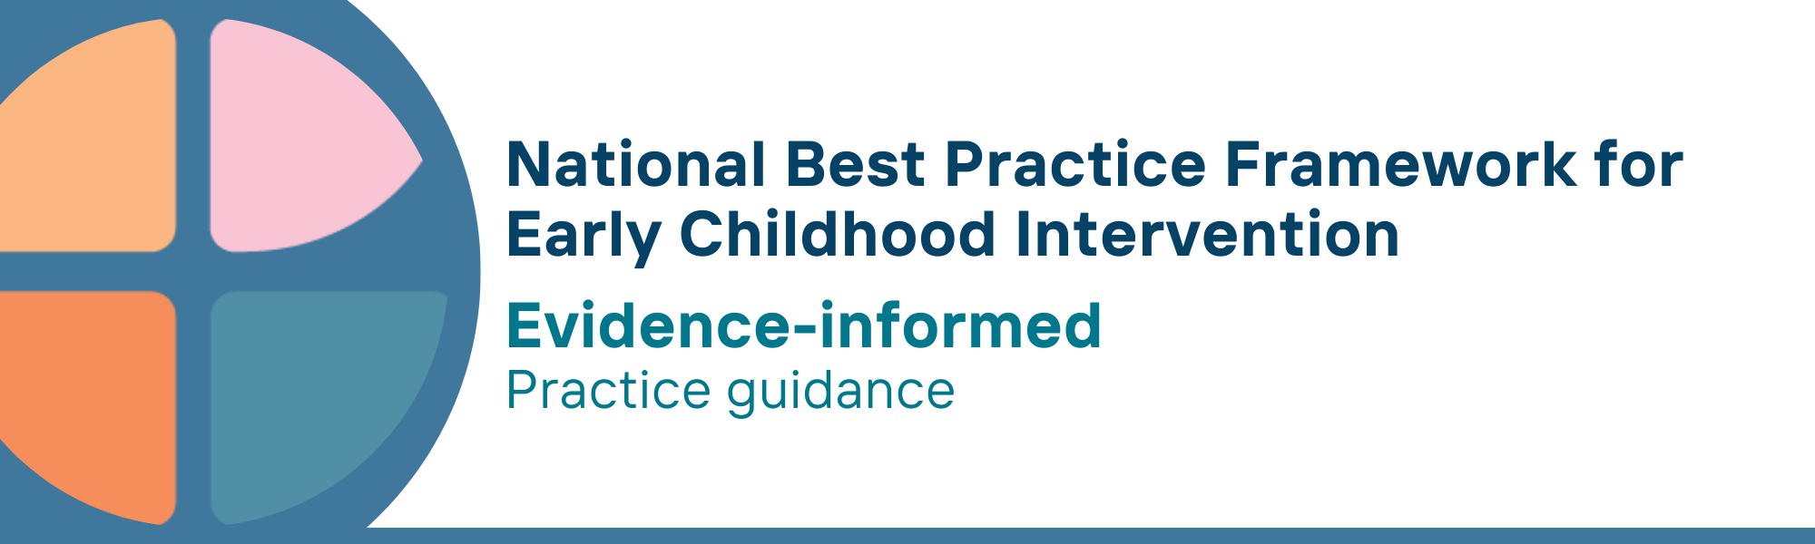

What is the evidence-informed key principle?
The evidence-informed principle draws from:
- research on evidence-based early childhood intervention strategies and/or programs, including those that are discipline- or diagnostic-specific
- practitioner expertise and knowledge of what works well in real life settings; and
- family values, knowledge, and priorities
The evidence-informed principle requires the integration of these three sources of evidence as the base for organising and delivering services.
It involves using a decision-making process that brings together the knowledge and expertise of parents, carers, families, and practitioners.
The evidence-informed principle involves ongoing quality evaluation using data and indicators to create a continuous feedback loop between research and practice.
The availability of a competent and confident workforce is pivotal to ensuring that the evidence-informed principle is effectively in place.
Effective leaders are key to the application of the practices related to this principle to ensure high-quality service provision, continuous improvement and accountability.

Why is this principle important?
- When practitioners are familiar with and able to implement the most effective strategies, parents, carers, and families can be confident that this will give their child the best chance of achieving positive outcomes
- When parents, carers, families, and practitioners use an evidence-informed decision-making process, they are more likely to choose strategies and adaptations that are acceptable to families, able to be implemented by them, and have positive outcomes
- The evidence-informed principle is crucial in determining what goals are important for children and families, and what strategies and programs are acceptable and effective
- This principle underpins all aspects of early childhood intervention (ECI) service provision, and is central to ensuring quality improvement, accountability, and transparency
- The evidence-informed principle allows for the identification and implementation of innovative practices to address specific needs and circumstances of children and families
- The combination of the three sources of evidence and knowledge reduces the potential for bias, ensuring the delivery of quality practices
Evidence-informed practice is a central feature of both international ECI frameworks and national policies and frameworks for young children and children with developmental concerns, delay or disability.
This principle relates to all other universal and key Framework principles, and they should be applied together in practice

What are evidence-informed practices?
Practitioners
- facilitate bringing together the rights and perspectives of children, parents, carers, and their families and communities with the best available research evidence and professional expertise
- work with children, parents, carers, and families to use an evidence- and trauma-informed decision-making framework for determining supports and strategies to use and how to adapt them
- stay up to date and are informed by the best available evidence on child development, engagement, learning, participation, and wellbeing
- are familiar with evidence-based early childhood intervention strategies and/or programs, including those that are discipline- or diagnostic-specific
- use culturally safe and effective tools for monitoring program and process fidelity
- regularly seek feedback from children, parents, carers, families, and others using validated assessment tools and approaches that provide both qualitative and quantitative outcomes information
- apply the principles and practices of Indigenous Data Sovereignty and Governance when working with Aboriginal and Torres Strait Islander children, families, communities and organisations consistent with the National Agreement on Closing the Gap. Indigenous Data Sovereignty is the right of Aboriginal and Torres Strait Islander peoples to own, control, access and possess data that pertains to them.

We know it’s working well when…
- parents, carers, families, and practitioners use evidence- and trauma-informed decision-making processes to select strategies and adaptations that are acceptable, implementable and that lead to positive outcomes
- families report that they are in control of what, how and where information is shared about them
- practitioners report that they understand and apply culturally validated measurement tools
- Practitioners have the capacity (e.g., skills, readiness, time) and resources to keep up to date with current research on evidence-based practices
- Practitioners are confident in their use of shared decision-making processes to guide evidence-and trauma-informed practice

Essential resources
You can find more information about the National Best Practice Framework for Early Childhood Intervention online.
- Resources for practitioners including the
- Looks like/doesn’t look like guide for the principle
- Outcome measures resources
- Resources for families and others
- The podcast where families and professionals discuss practices related to this principle
- Unpacking the Framework video/s for this principle
- The Framework including
- Decision making guide
- The Framework
- The development of the Framework
- Background papers
- Bibliography for the principles and practice guidance

© UoM 2025. National Best Practice Framework for Early Childhood Intervention (a joint collaboration between Healthy Trajectories, the Melbourne Disability Institute, STRONG Kids STRONG Future at the University of Melbourne, and the Murdoch Children’s Research Institute (MCRI), Professionals and Researchers in Early Childhood Intervention (PRECI), SNAICC – National Voice for our Children, Children and Young People with Disability Australia, and ACD – Advocating for Children with Disability). Commissioned by the Department of Social Services.
This work is copyrighted to The University of Melbourne under a creative commons license, CC-BY-NC-ND. This material contains and draws upon Indigenous Cultural and Intellectual Property (ICIP) contributed by SNAICC and its members and staff and is used with their consent. Dealing with any part of the materials containing ICIP for any purpose that has not been authorised by the custodians is a serious breach of customary laws. You must handle ICIP accordingly when exercising the Creative Commons Licence described above.
For more information about copyright please visit https://healthy-trajectories.com.au/eci-framework/

