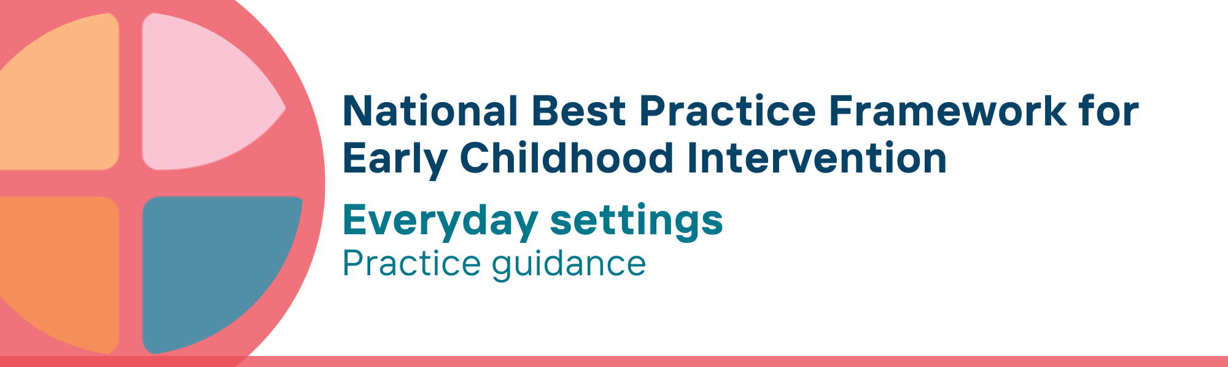

What is the everyday settings key principle?
Everyday settings (also known as ‘natural learning environments’) are the places and spaces where it is usual for children and their families to spend time. They are the places where children live, learn, play, and relax. These include children’s homes, early childhood education and care (ECEC) settings, schools, neighbourhoods and community settings - places where children and families take part in spiritual, educational, cultural, recreational, play, social activities, or undertake activities of daily life.
The everyday settings principle highlights that, to the maximum extent possible, children are supported to learn and participate in those settings. This means using everyday routines, experiences, events and places as sources of learning opportunities for children, families and communities.

Why is this principle important?
The principle of everyday settings is based on the following rights, values and evidence:
- Every child has a right to be in the same settings as other children and families
- Children learn best in the everyday settings in which they spend time, so support should be provided in those settings
- Using opportunities provided by everyday activities and routines as sources of learning is more beneficial than practitioners introducing strategies and practices that do not blend into and support engagement in those activities
- A capability-building approach, which enhances the skills and confidence of parents, carers and families to provide development-enhancing opportunities for children in their everyday settings, can improve children’s learning and development
This principle relates to all other universal and key Framework principles, and they should be applied together in practice.

What are everyday settings practices?
Practitioners
- support capability building of parents, carers, families and other service providers to strengthen children’s engagement, participation, learning, development, wellbeing, and safety in everyday settings
- scaffold learning within everyday settings in the least intrusive and intensive manner
- support children in play and interest-based activities when participating in a range of different settings
- work with parents, carers, families and others (e.g., ECEC staff, school teachers, sport coaches) and make necessary adjustments that address barriers impacting the child’s access to and involvement in everyday settings
- provide timely support within the everyday settings and activities where children, parents, carers, and families participate as part of a range of formal and informal services
- develop competency in trauma-informed practice to understand and respond to the impact of trauma on children’s participation, learning and well-being within everyday settings
- build trusted relationships with cultural leaders and community-controlled organisations in order to build community understanding and knowledge of child development journeys and the importance of learning and participating meaningfully in everyday settings
- understand that Aboriginal and Torres Strait Islander families require safe places and opportunities for family-led activities
  - where families are in control and make decisions that suit them;
  - where they are supported to fully understand what is being said and can raise concerns without feelings of shame and fear of child removal; and
  - where there are opportunities for multigenerational support from other family members

We know it’s working well when…
Children
- participate in everyday home, community, ECEC and school environments
- have opportunities to enjoy, learn, use, and practice emerging knowledge and skills in everyday life
- follow their interests and enjoy play opportunities with peers
Families
- are building confidence about taking part in activities with their child and family in everyday settings
- feel welcomed and meaningfully included in everyday community settings
Other providers
- are building confidence and competence in including children with developmental concerns, delay or disability in the settings young children spend time

Essential resources
You can find more information about the National Best Practice Framework for Early Childhood Intervention online.
- Resources for practitioners including the
- Looks like/doesn’t look like guide for the principle
- Outcome measures resources
- Resources for families and others
- The podcast where families and professionals discuss practices related to this principle
- Unpacking the Framework video/s for this principle
- The Framework including
- Decision making guide
- The Framework
- The development of the Framework
- Background papers
- Bibliography for the principles and practice guidance

© UoM 2025. National Best Practice Framework for Early Childhood Intervention (a joint collaboration between Healthy Trajectories, the Melbourne Disability Institute, STRONG Kids STRONG Future at the University of Melbourne, and the Murdoch Children’s Research Institute (MCRI), Professionals and Researchers in Early Childhood Intervention (PRECI), SNAICC – National Voice for our Children, Children and Young People with Disability Australia, and ACD – Advocating for Children with Disability). Commissioned by the Department of Social Services.
This work is copyrighted to The University of Melbourne under a creative commons license, CC-BY-NC-ND. This material contains and draws upon Indigenous Cultural and Intellectual Property (ICIP) contributed by SNAICC and its members and staff and is used with their consent. Dealing with any part of the materials containing ICIP for any purpose that has not been authorised by the custodians is a serious breach of customary laws. You must handle ICIP accordingly when exercising the Creative Commons Licence described above.
For more information about copyright please visit https://healthy-trajectories.com.au/eci-framework/

