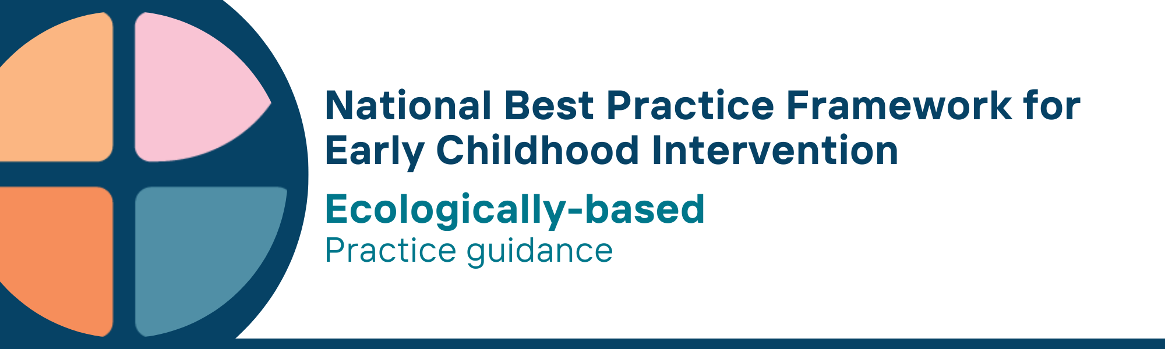

What is the ecologically-based universal principle?
- We know the environment in which children and families live has a big impact on outcomes. Everything from socioeconomic status to the physical environment in which children and families live can have an impact
- The ecologically-based principle takes environmental factors into account and makes sure services and support are tailored to fit individual circumstances
- This principle also ensures that children and their families are connected to broader formal services – such as health, parenting or peer support –as well as informal supports associated with positive family functioning

Why is this principle important?
- The consideration of a range of environments (home, early childhood education and care (ECEC), school or community) is essential in the planning and delivery of early childhood intervention (ECI) services and supports
- The immediate environments in which children are living shape how they develop and function. These environments may require modification, to promote children’s skill development and meaningful participation
- The complex and interactive nature of environmental influences on child, parent, carer and family outcomes recognises that in addition to ECI services, others may be needed to optimise child and maternal health, children’s development and school readiness.
- Focusing on the various conditions under which children and families thrive, ensures that support is holistic, inclusive, and sustainable over time
- The overall living conditions of families have a major impact on their ability to create an environment where their children can thrive
- Accumulated exposure to adverse experiences and environments can have a negative impact on a child’s development and potentially have lifelong consequences - there is a strong argument for acting early to address these environmental factors (i.e. political, social, cultural, socioeconomic, and physical) and reduce the risk of poorer developmental outcomes
- This approach is rooted in Bronfenbrenner’s Ecological Systems Theory which highlights the importance of contextual influences on a child’s growth and learning. The importance of an ecologically-based approach is also highlighted in other national ECI frameworks such as New Zealand’s He Pikorua Practice Framework

What are ecologically-based practices?
Practitioners
- understand how cultural, social, political, and socio-economic factors impact children’s, parents’, carers’ and families’ experiences directly or indirectly
- build relationships and seek to integrate services with other providers to address adverse environmental factors and promote good outcomes for children and families
- tailor support to recognise and meet each family’s situation, priorities and aspirations and local service context, and understand and respond flexibly to any changes over time
- work with other services and the family to provide wraparound support for the whole family to enable the family to meet its wider needs and therefore be able to provide an environment for children to thrive
- understand and use referral pathways for parents, carers and families who may require specialist services to support family functioning and children’s wellbeing and safety - these services may include child and family services, services for family violence, mental health, addiction or housing stress
- work with parents, carers, families, community members, and other service providers to identify, create and maintain environments that provide all children with opportunities to learn and participate
- use strengths-based, culturally relevant, and safe tools or frameworks to work with families to identify adverse environmental factors that may affect parenting or family functioning
- encourage system flexibility to enable service pathways and outcomes that are locally appropriate, locally determined, well understood and integrated, and which adapt systems to meet family and community needs rather than requiring families to fit a standardised service system

We know it’s working well when
- practitioners and other universal systems of support and specialist service providers are collaborating with each other and the family to provide holistic support that is adapted for local circumstances and meets the family’s needs and priorities
- children participate and feel they belong in their everyday home, community, ECEC and school environments
- children build strong identities and connections to their culture and community
- parents, carers and families have timely access to a range of formal support services to address family needs
- parents, carers and families know how to recognise and strengthen their informal supports
- families live in communities that are strong and inclusive places for children and their families to live, grow, play and connect

Essential resources
You can find more information about the National Best Practice Framework for Early Childhood Intervention online.
- Resources for practitioners including the
- Looks like/doesn’t look like guide for the principle
- Outcome measures resources
- Resources for families and others
- The podcast where families and professionals discuss practices related to this principle
- Unpacking the Framework video/s for this principle
- The Framework including
- Decision making guide
- The Framework
- The development of the Framework
- Background papers
- Bibliography for the principles and practice guidance

© UoM 2025. National Best Practice Framework for Early Childhood Intervention (a joint collaboration between Healthy Trajectories, the Melbourne Disability Institute, STRONG Kids STRONG Future at the University of Melbourne, and the Murdoch Children’s Research Institute (MCRI), Professionals and Researchers in Early Childhood Intervention (PRECI), SNAICC – National Voice for our Children, Children and Young People with Disability Australia, and ACD – Advocating for Children with Disability). Commissioned by the Department of Social Services.
This work is copyrighted to The University of Melbourne under a creative commons license, CC-BY-NC-ND. This material contains and draws upon Indigenous Cultural and Intellectual Property (ICIP) contributed by SNAICC and its members and staff and is used with their consent. Dealing with any part of the materials containing ICIP for any purpose that has not been authorised by the custodians is a serious breach of customary laws. You must handle ICIP accordingly when exercising the Creative Commons Licence described above.
For more information about copyright please visit https://healthy-trajectories.com.au/eci-framework/

