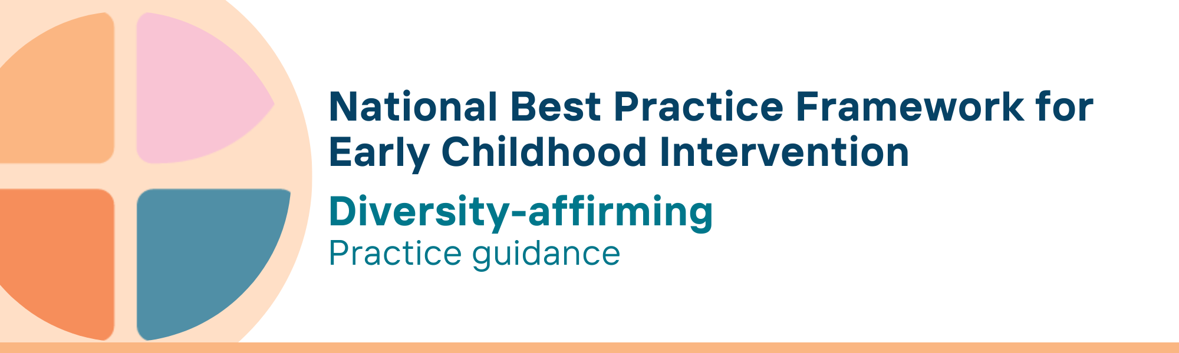

What is the diversity affirming key principle?
Diversity affirming practice recognises, values and respects the identities and strengths of children, parents, carers, families and communities. This includes their abilities, race, ethnicity, religion, gender, sexual orientation and socio-economic status. Diversity affirming practice also respects and centres the culture of families, including their attitudes and beliefs, child-raising style and family and community traditions.
Diversity affirming practice understands the ways in which power and privilege generate inequities. It challenges racism and other conscious and unconscious biases and recognises the compounding discrimination or stigma for those who live with intersecting identities. It embraces everyone’s unique understanding of other people and the world around them and is always affirming of all disabilities including neurodiversity.

Why is this principle important?
Responsive interactions and respectful relationships that affirm the culture, language, identity and strengths of children and their parents, carers and families are essential to building a sense of safety, belonging and wellbeing.
Parents, carers and families are more likely to engage with services when their individual circumstances, cultural background and abilities are respected and understood.
Diversity-affirming practices are embedded in rights conventions and are also a key feature of Safe and Supported: The National Framework for Protecting Australia’s Children 2021-2031, the Early Years Learning Framework, V2.0 (2022) and the Early Years Strategy 2024-2034 (2024).
This principle relates to all other universal and key Framework principles, and they should all be applied together in practice.

What are diversity affirming practices?
Practitioners
- develop cultural knowledge, responsiveness, and competency in providing diversity affirming support
- acknowledge and respect the values, knowledge, preferences, and cultural perspectives of children, families, and their communities
- work with families respectfully to understand their culture while ensuring practices uphold the dignity, rights, and full participation of children
- provide families with accessible information on disability and evidence-based practices to support their child's development and meaningful participation in their community
- understand the barriers to children from diverse backgrounds can experience in accessing universal child and family services (e.g., Early childhood education care (ECEC), school, Maternal Child Health) and support access where needed
- support parents, carers and families in navigating any stigma from within their family and/or community
- work with parents, carers and families to understand and value children’s individual circumstances, background and abilities, including race, ethnicity, culture, gender, sexual orientation, socio-economic status and abilities, and neurodiversity
- engage with children and families in ways that recognise commonalities, embrace differences, create connections with others, and cultivate mutual respect
- provide intentional learning and support for children who are multilingual to continue to develop skills using their home language and assist them in developing other language and communication skills
- actively seek to involve trusted community organisations/members in conversations with families to ensure mutual understanding
- access translation services with the consent of the parents, carers and family

We know it’s working well when…
Children
- build strong identities and connections to their culture and community
- have a positive sense of belonging to their family and community
Parents, carers and families
- are provided with information in ways that respect their language and culture
- have a positive social support network providing emotional, cultural, and practical support
- are participating in the social, cultural, and economic life of the community
- feel respected, heard, and valued as active partners in their child’s development
- engage with services, and decision-making processes
- deem services to be diversity affirming and safe

Essential resources
You can find more information about the National Best Practice Framework for Early Childhood Intervention online.
- Resources for practitioners including the
- Looks like/doesn’t look like guide for the principle
- Outcome measures resources
- Resources for families and others
- The podcast where families and professionals discuss practices related to this principle
- Unpacking the Framework video/s for this principle
- The Framework including
- Decision making guide
- The Framework
- The development of the Framework
- Background papers
- Bibliography for the principles and practice guidance

© UoM 2025. National Best Practice Framework for Early Childhood Intervention (a joint collaboration between Healthy Trajectories, the Melbourne Disability Institute, STRONG Kids STRONG Future at the University of Melbourne, and the Murdoch Children’s Research Institute (MCRI), Professionals and Researchers in Early Childhood Intervention (PRECI), SNAICC – National Voice for our Children, Children and Young People with Disability Australia, and ACD – Advocating for Children with Disability). Commissioned by the Department of Social Services.
This work is copyrighted to The University of Melbourne under a creative commons license, CC-BY-NC-ND. This material contains and draws upon Indigenous Cultural and Intellectual Property (ICIP) contributed by SNAICC and its members and staff and is used with their consent. Dealing with any part of the materials containing ICIP for any purpose that has not been authorised by the custodians is a serious breach of customary laws. You must handle ICIP accordingly when exercising the Creative Commons Licence described above.
For more information about copyright please visit https://healthy-trajectories.com.au/eci-framework/

