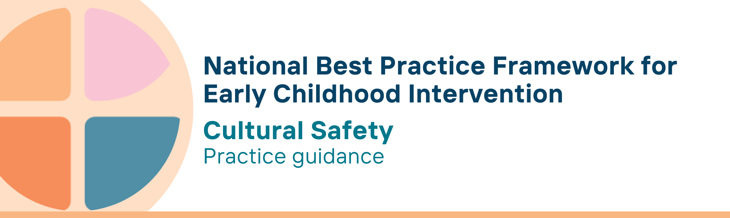

What is the cultural safety key principle?
A culturally-safe environment is one that Aboriginal and Torres Strait Islander peoples experience as safe for them - where they feel safe, valued and respected and free from racism and discrimination, and where there is no attack on, challenge or denial of their identity and experience.
Cultural safety is about individuals, organisations, and systems being aware of the impact of their own culture, values and beliefs on Aboriginal and Torres Strait Islander peoples and acting to intentionally create and maintain environments where all people are treated in a culturally respectful manner. Cultural safety requires a non-judgemental and curious attitude, critical reflection of one's own beliefs and actions, and a commitment to lifelong learning.

Why is this principle important?
Cultural safety
- ensures Aboriginal and Torres Strait Islander children experience safe, nurturing, and positive environments, where their voices are heard and valued, and they are free to explore and express themselves and their culture, views and needs
- is vital for achieving justice and equity for Aboriginal and Torres Strait Islander peoples; addressing the historical and ongoing impacts of racism and colonisation; reducing health and social inequities; and improving access, quality, and safety in health, education and other services
- builds trust, addresses alienation and disengagement from services and supports required by families, and reduces disparities in socioeconomic outcomes
- reduces fear of child removal arising from interactions with allied health and other health and disability practitioners and services, addressing a significant barrier to families seeking advice and support for children
- emerged initially from Māori in Aotearoa New Zealand and has been advocated and developed consultatively in Australia by Aboriginal and Torres Strait Islander peoples. It addresses the intergenerational impacts of colonisation and the systemic racism that pervades Australian service systems
The cultural safety principle is enshrined in key national frameworks and policy documents including the National Agreement on Closing the Gap, The Early Years Strategy 2024-2034, the National Aboriginal and Torres Strait Islander Early Childhood Strategy, the NDIS First Nations Strategy 2025-30 and Safe and Supported: The National Framework for Protecting Australia’s Children (2021-31).
This principle relates to all other universal and key Framework principles and should be applied together in practice.

What are culturally safe practices?
Practitioners
- take the time to build trusted relationships through deep and open-minded listening before commencing any service delivery
- learn about and respect Aboriginal and Torres Strait Islander cultural perspectives on child-rearing, learning and behaviour
- engage with children and families in their everyday settings, including through outreach in the community and/or through Aboriginal and Torres Strait Islander community-controlled organisations
- recognise that Aboriginal and Torres Strait Islander cultures are not all the same and be guided by families about how they want to share their culture and what is important to them
- promote self-determination and family-determined/led decision-making
- recognise that Aboriginal and Torres Strait Islander worldviews on disability are inclusive, with children accepted and included at their own pace and at their own level; being mindful of any shame or stigma around disability, stemming in part from institutional and systemic racism and past or ongoing interactions with services and governments
- use trauma-aware and healing informed skills to work positively with families
- support children and families to connect to their culture, Country and language
- celebrate the strengths and identities of children, families and communities, and base assessments and practices on those identified strengths and cultural identities
- assume that families want the best outcomes for their children and don’t rush to judgement based on their own values

- actively seek to be good allies with Aboriginal and Torres Strait Islander families, communities and organisations
  - engage in ongoing learning, taking action, critically reflecting and improving practice, including through confronting previously held understanding and beliefs, and prioritising Aboriginal and Torres Strait Islander perspectives and ways of knowing, being and doing
  - be open and non-judgemental in listening, receiving feedback and learning from Aboriginal and Torres Strait Islander families, communities and practitioners
  - reflect on and address discriminatory or harmful individual and organisational attitudes, assumptions, and behaviours
  - authentically engage with Aboriginal and Torres Strait Islander communities and community-controlled organisations in order to connect with local culture and to build trust with community members and families

We know it’s working well when…
We know it’s working well when Aboriginal and Torres Strait Islander peoples report that
- they feel welcomed, listened to and respected
- they see positive changes in their child
- their experiences are believed and validated
- their cultures are centred and valued in service design and delivery
- they feel welcomed and respected in service environments
- they see other Aboriginal and Torres Strait Islander people working in positions of power and authority
- they do not experience any form of racism

Essential resources
You can find more information about the National Best Practice Framework for Early Childhood Intervention online.
- Resources for practitioners including the
- Looks like/doesn’t look like guide for the principle
- Outcome measures resources
- Resources for families and others
- The podcast where families and professionals discuss practices related to this principle
- Unpacking the Framework video/s for this principle
- The Framework including
- Decision making guide
- The Framework
- The development of the Framework
- Background papers
- Bibliography for the principles and practice guidance

© UoM 2025. National Best Practice Framework for Early Childhood Intervention (a joint collaboration between Healthy Trajectories, the Melbourne Disability Institute, STRONG Kids STRONG Future at the University of Melbourne, and the Murdoch Children’s Research Institute (MCRI), Professionals and Researchers in Early Childhood Intervention (PRECI), SNAICC – National Voice for our Children, Children and Young People with Disability Australia, and ACD – Advocating for Children with Disability). Commissioned by the Department of Social Services.
This work is copyrighted to The University of Melbourne under a creative commons license, CC-BY-NC-ND. This material contains and draws upon Indigenous Cultural and Intellectual Property (ICIP) contributed by SNAICC and its members and staff and is used with their consent. Dealing with any part of the materials containing ICIP for any purpose that has not been authorised by the custodians is a serious breach of customary laws. You must handle ICIP accordingly when exercising the Creative Commons Licence described above.
For more information about copyright please visit https://healthy-trajectories.com.au/eci-framework/

