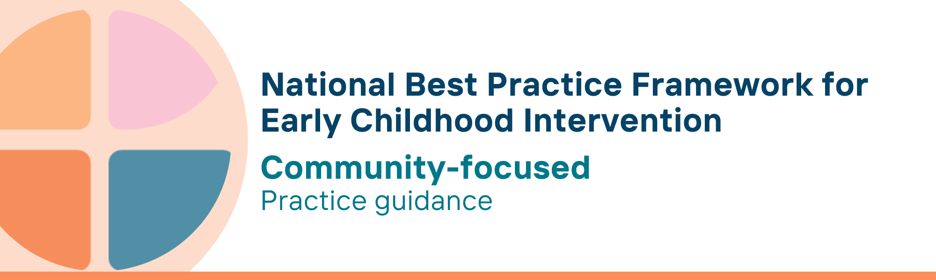

What is the community-focused key principle?
This principle recognises the importance of creating welcoming and inclusive communities where children and their families feel valued and accepted. Supporting children with developmental concerns, delay or disability and their parents, carers and families requires a community-wide approach. Individuals, families, community organisations, local government and service agencies all need to work together to meet the needs of children and their families.
Community-focused practice recognises that everyone shares responsibility for ensuring that all children and their families can meaningfully participate in cultural, recreational, educational and social activities as well as engage with their peers and other families, for example at local parks, playgrounds and libraries.
Connected communities bring resources, knowledge and expertise, which lead to integrated systems of support to strengthen children’s development, family well-being, and meaningful participation in the community.

Why is this principle important?
Collaboration between the community and early childhood intervention (ECI) services is an essential element of supporting children with developmental concerns, delay or disability and their families because of the interconnected nature of their needs.
- When families, service providers and communities work together, they can eliminate service silos; identify and reduce service gaps and duplication; and ensure support is collaborative, holistic, effective and tailored to each family’s needs
- Building strong and trusted partnerships between families, services, organisations and the wider community creates a unified system of support and helps to build more inclusive, responsive and equitable communities where every child and their family can thrive
- By combining family, practitioner and community expertise, resources, and strategies, the community can be more responsive in the services and supports available to children and families
- Community connection is built on shared decision-making, mutual respect, and a capacity-building approach that empowers and enables communities to address their unique challenges
- Families and practitioners can work together with the community to identify strengths, mobilise local resources, and co-create solutions that reflect cultural and social diversity
- Promoting meaningful community participation and fostering trust among key stakeholders ensures that community activities and services become more responsive and equitable, ensuring all children and families receive the support they need
This principle relates to all other universal and key Framework principles, and they should be applied together in practice.

What are community-focused practices?
Practitioners
- know the resources and settings in the local community and service ecosystem, actively foster service integration, and tailor responses to recognise and fit the diversity and circumstances of communities
- support families in advocating for their needs within their community
- work with the local community to identify, understand and break down the barriers that prevent the meaningful participation of children, parents, carers, and families
- work together with community to build understanding and knowledge of child development and of the needs of children with developmental concerns, delay or disability
- work together with community to build knowledge about what best practice early childhood intervention means
- provide information to parents, carers and families on accessible community resources, such as playgroups or parent workshops
- promote and advocate for inclusive community spaces where all children can participate
- advocate for community policies that support children with developmental concerns, delay or disability and their families
- work in partnership with cultural leaders and organisations to support diverse families
- understand that parents and carers from diverse cultural backgrounds can rely on their family members (including extended family) to support their children
- ensure community materials and resources are available in multiple languages including Auslan
- encourage peer-to-peer support among families with similar experiences
- connect with or facilitate parent/family mentoring programs, and support groups
- understand that in Aboriginal and Torres Strait Islander cultures, extended family, community members and Elders contribute to child raising and seek to build relationships with local Aboriginal and Torres Strait Islander community-controlled organisations and community leaders to support shared knowledge of early childhood developmental journeys as well as supporting families and children

We know it’s working well when…
Children, parents, carers, and families
- have ready access to family-friendly, inclusive, and culturally safe community facilities
- feel a sense of belonging in their community
Parents, carers and families
- are informed and have access to relevant parenting support, mentoring or peer-support groups that meet their needs
Communities
- have services that communicate and collaborate to meet the needs of children with developmental concerns, delay or disability and their families
- are connected and integrated
- are knowledgeable about best practice in early childhood intervention

Essential resources
You can find more information about the National Best Practice Framework for Early Childhood Intervention online.
- Resources for practitioners including the
- Looks like/doesn’t look like guide for the principle
- Outcome measures resources
- Resources for families and others
- The podcast where families and professionals discuss practices related to this principle
- Unpacking the Framework video/s for this principle
- The Framework including
- Decision making guide
- The Framework
- The development of the Framework
- Background papers
- Bibliography for the principles and practice guidance

© UoM 2025. National Best Practice Framework for Early Childhood Intervention (a joint collaboration between Healthy Trajectories, the Melbourne Disability Institute, STRONG Kids STRONG Future at the University of Melbourne, and the Murdoch Children’s Research Institute (MCRI), Professionals and Researchers in Early Childhood Intervention (PRECI), SNAICC – National Voice for our Children, Children and Young People with Disability Australia, and ACD – Advocating for Children with Disability). Commissioned by the Department of Social Services.
This work is copyrighted to The University of Melbourne under a creative commons license, CC-BY-NC-ND. This material contains and draws upon Indigenous Cultural and Intellectual Property (ICIP) contributed by SNAICC and its members and staff and is used with their consent. Dealing with any part of the materials containing ICIP for any purpose that has not been authorised by the custodians is a serious breach of customary laws. You must handle ICIP accordingly when exercising the Creative Commons Licence described above.
For more information about copyright please visit https://healthy-trajectories.com.au/eci-framework/

