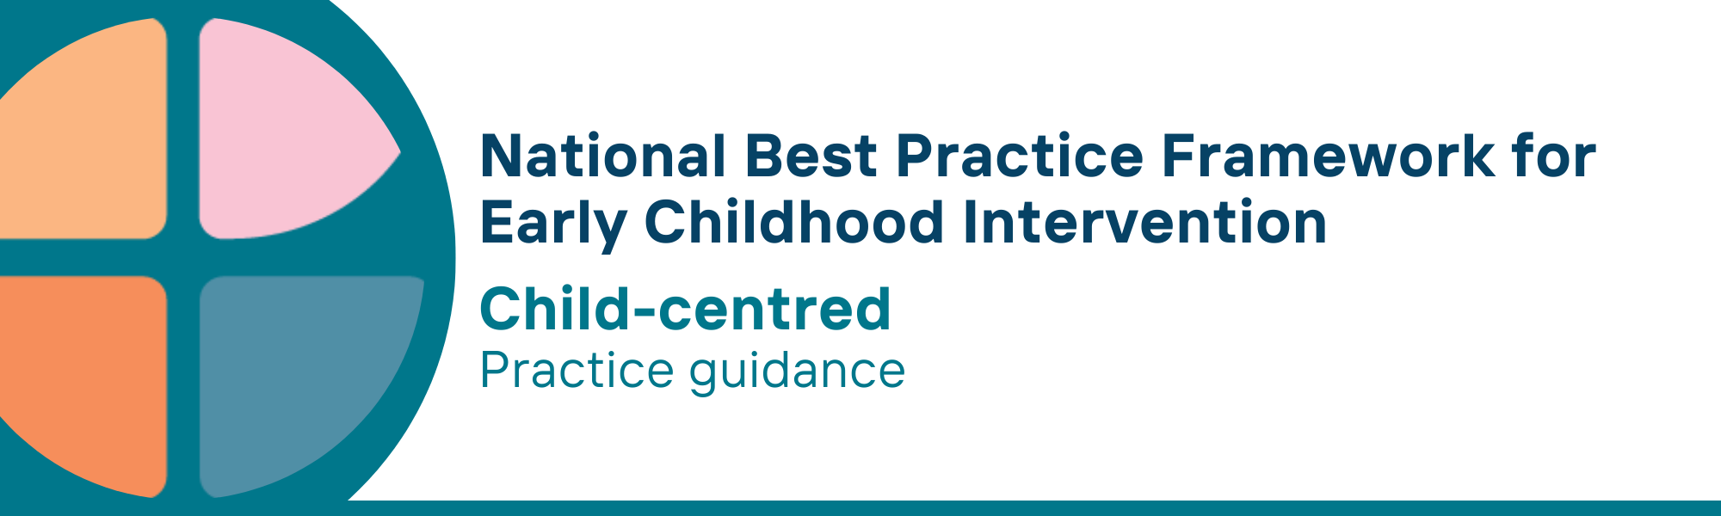

What is the child-centred key principle?
The child-centred principle involves supporting children’s engagement, learning, development, participation, and wellbeing.
The principle recognises children’s:
- voice, agency, and decision-making to the maximum extent possible
- strengths, interests and preferences
- right to:
  - learn, contribute, participate and be safe across everyday life settings, activities and routines
  - be affirmed as who they are
  - a good life
  - engage in fun, play-based, and relaxing activities with peers, siblings, and adults

Why is this principle important?
Responsive interactions, nurturing and stable relationships, secure attachment, and rich learning experiences in the early years of a child’s life lay the foundation for developmental outcomes such as self-confidence, good mental health, motivation to learn, academic achievement, conflict resolution, emotional regulation, and friendships with peers.
Children learn best through interactions and experiences:
- with familiar people (e.g., family members including siblings, extended family members, peers, and educators/teachers)
- in everyday settings (e.g., home, early childhood education and care (ECEC), school, community settings)
- that are fun, motivating and based on strengths and preferences; and,
- that provide opportunities to practice previously mastered skills and to encounter, engage with and build on new knowledge and skills

This principle relates to all other universal and key Framework principles, and they should be applied together in practice.

What are child-centred practices?
Practitioners
- In working with children
  - promote children’s agency, voice, identity and emotional and behavioural wellbeing
  - recognise that children develop at their own pace
  - listen to and involve children in making choices and having input into goals to ensure they are meaningful and relevant
  - follow their lead to encourage engagement, exploration, learning and creativity
  - engage and involve peers and siblings in ways that are fun, enjoyable, and protective of their identity.
  - identify, respect and ensure timely access to the child's preferred method of communication (e.g., Auslan, spoken language, augmentative and alternative communication (AAC)) and assistive technology to support child interactions, play, mobility, independence and participation
  - use the least intrusive adaptations to enable children’s participation in daily routines and activities
  - develop competency in trauma-informed practice to respond to the impact of trauma on children's social, emotional, behavioural, and communication development and family functioning
- Partner
  - with parents, carers, families, and children to identify and build on child strengths, evolving interests and preferences to support learning, development, and meaningful participation
  - with parents, carers and families to facilitate secure attachment and positive adult-child interactions and experiences with siblings, peers and adults during daily routines and activities
  - with parents, carers and families to ensure that the strategies chosen do not prevent the child from participating in regular activities with family and peers or to have an adverse effect upon child and family wellbeing
  - with parents, carers, families and other service providers to embed and reinforce learning within and across daily routines, activities, and everyday settings (e.g., home, ECEC, school) to provide contextually relevant, consistent and meaningful learning opportunities across the different areas of a child’s life
  - with parents, carers, families, and other service providers to determine how individualised strategies will be developed, measured, adapted, and shared
  - with parents, carers, families, and other service providers, agree to and decide how and what information about the child and family is shared
- work with parents, carers, families, and communities to ensure children are safe
- learn about and value individual and family circumstances, cultural background and abilities of children and their families to tailor responses and supports
- develop, maintain, and apply their own skills and knowledge about child development, learning, participation, and wellbeing
- understand and apply professional obligations related to reporting abuse, harm and neglect
- recognise that their judgement of what constitutes ‘neglect’ can be influenced by their own values and assumptions and approach each situation with openness and cultural sensitivity to best support the child and family

We know it’s working well when…
Children
- have secure, stable and trusting relationships with parents, carers, families, and significant others
- are building social and self-regulation skills, and strong identities through interactions with other children, families, and community
- have connections to their culture and community
- are listened to and have a voice in matters that affect them
- learn and use new knowledge, functional and self-care skills in everyday life

Essential resources
You can find more information about the National Best Practice Framework for Early Childhood Intervention online.
- Resources for practitioners including the
- Looks like/doesn’t look like guide for the principle
- Outcome measures resources
- Resources for families and others
- The podcast where families and professionals discuss practices related to this principle
- Unpacking the Framework video/s for this principle
- The Framework including
- Decision making guide
- The Framework
- The development of the Framework
- Background papers
- Bibliography for the principles and practice guidance

© UoM 2025. National Best Practice Framework for Early Childhood Intervention (a joint collaboration between Healthy Trajectories, the Melbourne Disability Institute, STRONG Kids STRONG Future at the University of Melbourne, and the Murdoch Children’s Research Institute (MCRI), Professionals and Researchers in Early Childhood Intervention (PRECI), SNAICC – National Voice for our Children, Children and Young People with Disability Australia, and ACD – Advocating for Children with Disability). Commissioned by the Department of Social Services.
This work is copyrighted to The University of Melbourne under a creative commons license, CC-BY-NC-ND. This material contains and draws upon Indigenous Cultural and Intellectual Property (ICIP) contributed by SNAICC and its members and staff and is used with their consent. Dealing with any part of the materials containing ICIP for any purpose that has not been authorised by the custodians is a serious breach of customary laws. You must handle ICIP accordingly when exercising the Creative Commons Licence described above.
For more information about copyright please visit https://healthy-trajectories.com.au/eci-framework/

