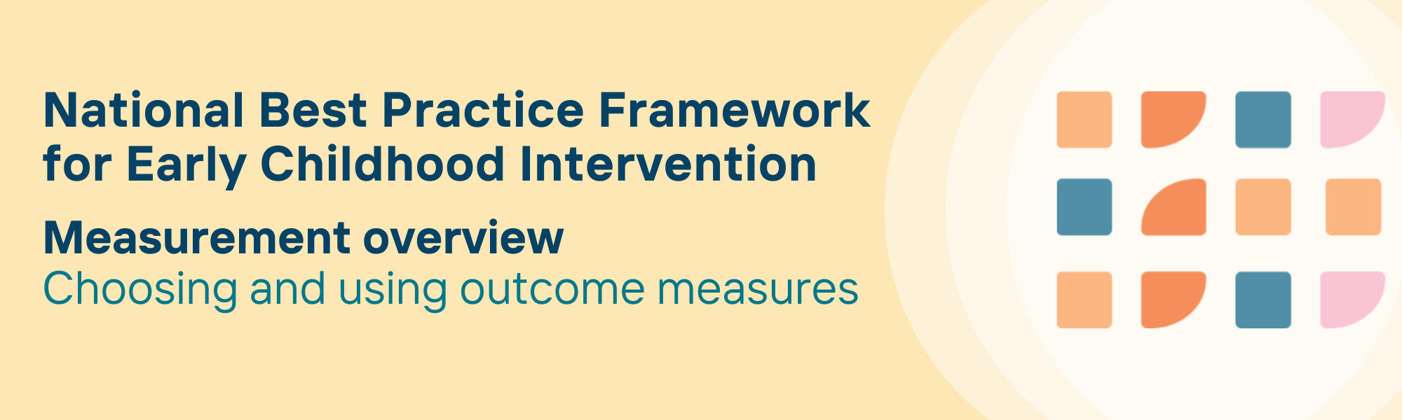
Introduction
This document provides an overview to support choice and use of outcome measures for the National Best Practice Framework for Early Childhood Intervention (ECI) (the Framework). The Framework describes important outcomes of ECI for four groups: children; parents, carers and families; communities; and services and practitioners. A comprehensive review of relevant outcome measures has been completed, which is explained in the document titled Developing a suite of resources to support outcome measurement: Methods Explainer. To date, the measures review has focused on outcomes for children; parents, carers and families; and services and practitioners.
This overview document provides guidance on how to use the accompanying tables that include information and evidence summaries of specific outcome measures that can be used to evaluate Framework outcome statements in relation to:
1. Children; those aged <9 years with developmental concerns, delay or disability
2. Parents, carers and families of children <9 years
3. Early childhood intervention (ECI) services and practitioners
The suite of measures provided to support implementation of the Framework is not exhaustive. In some cases, there are outcome areas where quality measures may not be available. This resource is also not an endorsement of the use of any included outcome measures in a particular circumstance. The information provided is intended to inform decision making. It is expected that practitioners and families will make decisions regarding outcome measures based on their professional judgement and the specific circumstances of the families. This measurement overview can be used to inform this decision-making process.

Who is this outcome measures resource for?
The suite of measures included are intended to serve as an easily accessible, living resource for practitioners and their organisational managers working in the ECI sector who are looking for information on how to measure outcomes according to the Framework. By ‘living resource’ we mean that this resource needs to be continually updated, to provide more comprehensive coverage of the desired outcome of ECI and as new evidence becomes available. Outcome measures may be used at the service level for program planning, funding decisions, and more rigorous monitoring of quality of care across systems. They can also be used by practitioners and families to assess outcomes that are important to individual children and families and guide their decision-making.
The suite of measures should be considered when using the Framework’s Decision-Making Guide as shown in the figure below.
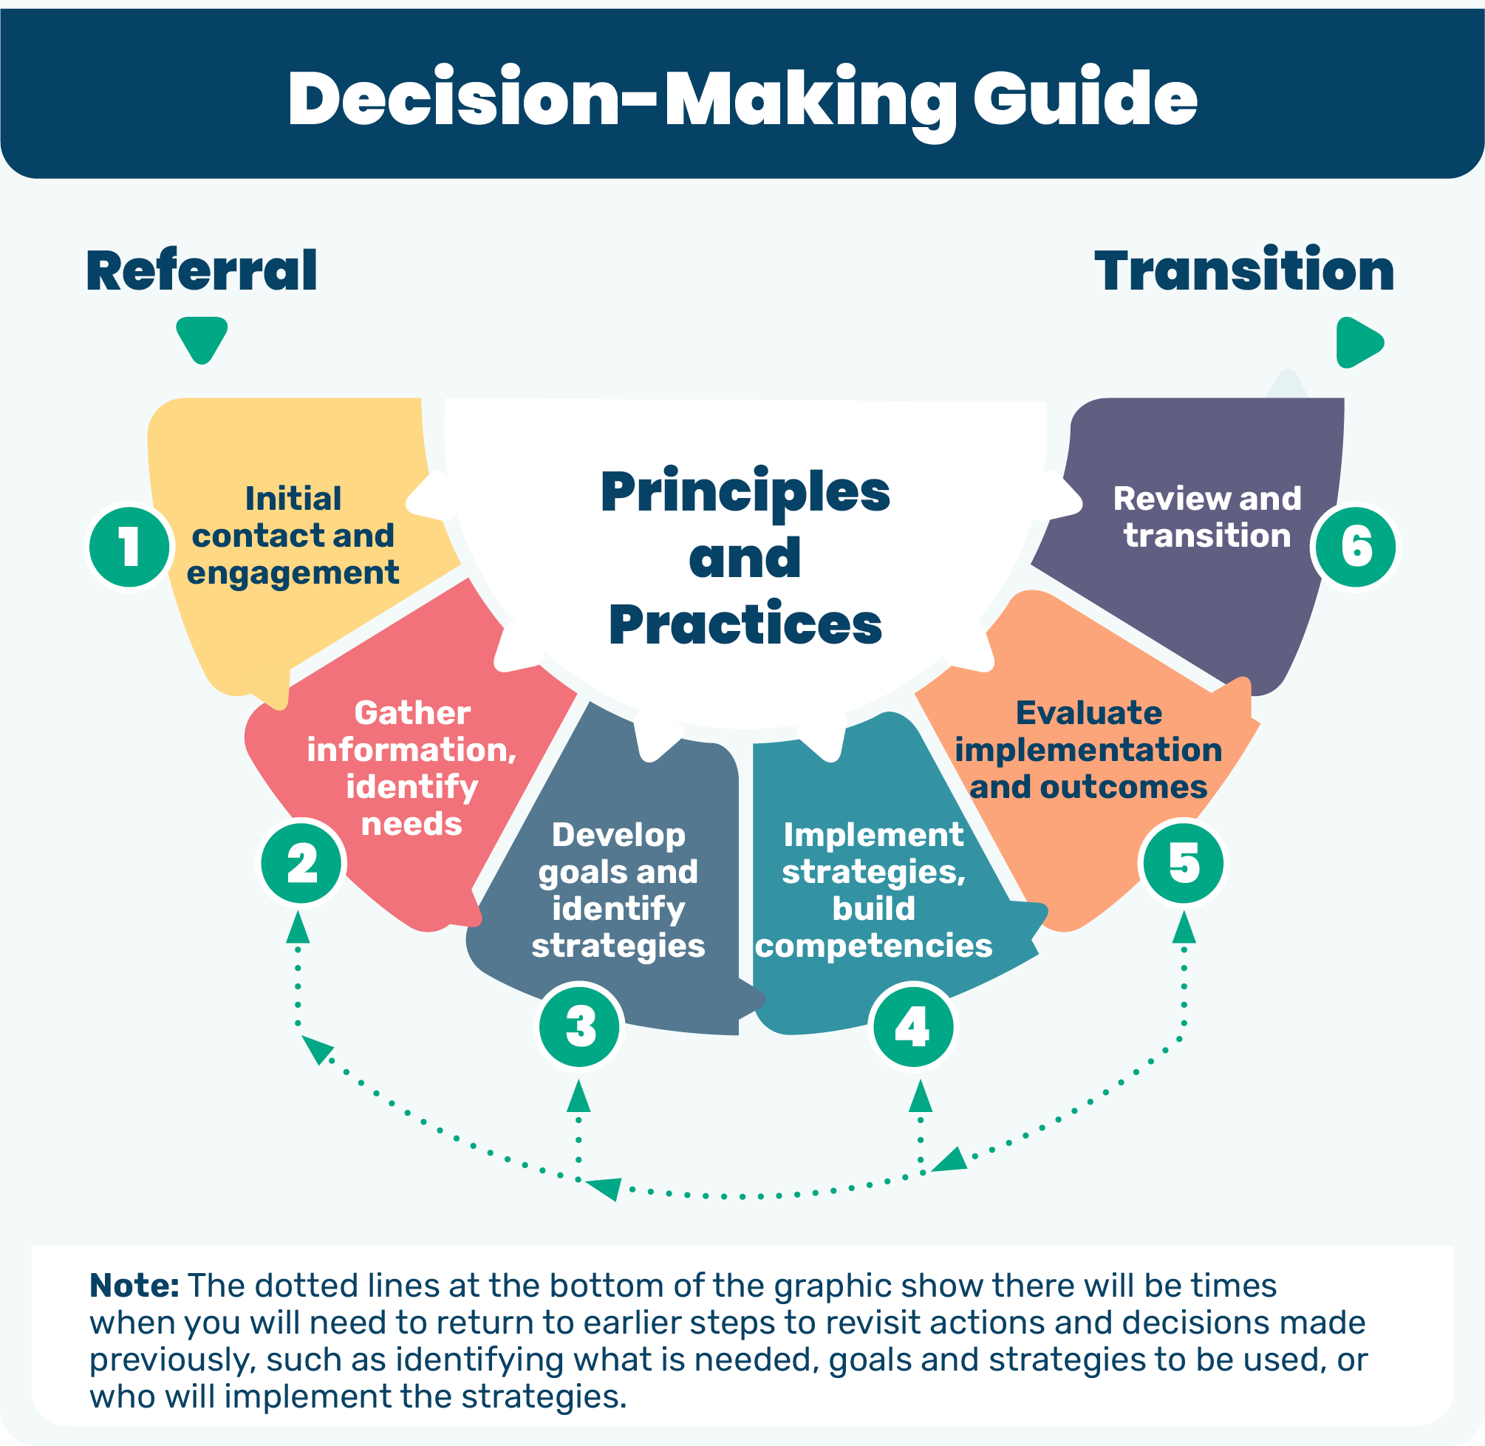
Figure 1. The six steps of the decision-making guide.

What is an outcome measure?
An outcome measure is a standardised assessment or tool used to evaluate the results of interventions, programs, or services. The measure helps to determine whether a particular approach has produced the intended change or outcome. You can read more about the Framework’s Outcomes-focused principle in the Practice Guidance tools. The Framework describes important outcomes of ECI for children; parents, carers and families; services and practitioners. Outcome measures can be used to measure outcomes for any of these groups. While many tools focus on measuring changes in people (e.g., children, families), it is also important to consider outcome measures that evaluate aspects of the environment around the child and family, to capture whether interventions that aim to change or adapt aspects of the environment or setting achieve their outcomes.
Outcome measures can be completed using various methods:
- self-report
- parent, carer or family report, for example, about their child or their experiences of services
- teacher or educator report
- health professional report, for example, administered by a health professional to rate symptoms or functioning based on clinical observations, interviews or expertise
- performance-based, for example, methods involve direct testing or observation of an individual performing specific tasks

Some measures have multiple versions
Outcome measures are sometimes available in multiple versions to accommodate diverse assessment needs, populations, and contexts. The different versions available for each outcome measure have been noted in the outcome measure summaries. Versions may be:
- Age-specific – tailored for different developmental stages
- Rater-specific – parallel forms for different respondents, e.g., child, parent, caregiver, teacher, clinician
- Length variations – short versus long forms
- Population-specific – adaptations for particular groups, settings or contexts
- Cultural/linguistic variations – cultural adaptations and translations
- Format options – paper forms, digital versions, questionnaire versus interview
- Time frame variations – reporting on the past week, month, current state

How to use this outcome measures resource
Selecting appropriate outcome measures is critical for evaluating outcomes following implementation of the Framework’s principles and practices, aligning with its outcomes-focused and evidence-informed principles. The universal principle of strengths-based should also apply – that is, choose and apply measures in ways that affirm child and family strengths.
What is measured needs to be primarily based on the priorities and goals of the child and family.
Other important factors to consider include:
- measurement properties of the outcome measure – that is, reliability, validity, and responsiveness to change
- acceptability and utility – that is, whether the outcome measure is user-friendly and relevant
- feasibility in the practice setting and family circumstances
- developmental appropriateness
- cultural appropriateness – including availability of cultural adaptations
A range of outcome measures for use with the Framework are included here in alphabetical order, categorised by outcome measures that measure: child; parent, carer or family; or, service and practitioner outcomes. The following steps will guide you through how to use this resource to decide on an appropriate outcome measure.

Step 1.
Determine whether you want to measure an outcome for a child; parent, carer or family; or service and practitioner. Deciding what outcomes are the focus of ECI occurs at the second step described within the Framework’s Decision-Making Guide (see figure). When you have decided which group, and the outcome focus you are seeking to measure, go to the Outcome Measure resource document for that group:
- Outcome measures for children
- Outcome measures for parents, carers and families
- Outcome measures for services and practitioners
The first part of each Outcome Measure resource document provides information about potential measures for the outcome statements for that group, and identifies which of the Framework’s outcome statement/s the measure is aligned with.

Step 2.
Review the summary information for the particular measure(s) you would like to consider. The summary table provides information to assist you to understand whether the measure is suitable and feasible for use in your particular setting and the circumstances of the child and family.
The summary information for each measure includes:
- a general description of the measure
- the measure’s domains and subscales
- age range
- any special considerations
- availability of cultural adaptations
- how it is administered
- training requirements
- how it can be accessed

Step 3.
Following the general description of the measure, is an evidence summary. The evidence summaries provide information on the psychometric properties of the outcome measures. The table includes an overview of the available evidence: review papers (if available), measurement properties, papers reporting on cultural adaptations (if available), and any outcome studies that have used this measure in the ECI practice setting.
Please note that this is summary information only. A list of references is provided for further information about each measure.
You can use the evidence summary and reference list to evaluate:
- Reliability of the measure – that is, the measure consistently produces the same results under the same condition
- Validity of the measure – that is, it measures what it is intending to measure
- Responsiveness to change – that is, ability to pick up meaningful differences overtime
- Developmental appropriateness

Important considerations when choosing an outcome measure
Evaluating progress to determine if the intervention is effective (i.e., measuring outcomes) ideally utilises a measure that has demonstrated validity (i.e., assessing what it is supposed to) and reliability (i.e., showing a minimum of error) for this purpose.
All outcome measures have limitations on their intended purpose, scope and application. It is important to ensure that selected outcome measures are being used as intended by the developers of the measure.
Deciding when and how to evaluate the outcomes of ECI is a collaborative process among practitioners and children and families. The Frameworks’ Decision-Making Guide can support this process.

Can I use a screening tool as an outcome measure?
Screening is a brief evaluation intended to identify those children with potential difficulties who require a more in-depth assessment. By definition, developmental screening tools are brief while still being accurate.
Screening tools are not designed to be used as outcome measures. Challenges can arise when an instrument that is primarily designed for screening, needs assessment or service planning is used for measuring outcomes. For example, many items on developmental screening tools are included because they accurately discriminate between children of different chronological ages, not because they are targets of intervention for young children. Therefore, items included on screening measures may or may not be appropriate developmental targets or be suitable for informing intervention content. Furthermore, it is important to remember that screening tools need to be brief. Thus, the few items available may not enable comprehensive measurement of progress. The scores may not reflect the growth that could have occurred.
Screening tools are rarely developed to also be used as outcome measures. However, in the absence of an appropriate outcome measure, using a screening tool to measure outcomes may be better than using nothing at all. It is imperative that if this less-than-ideal approach is adopted, the outcomes/results are qualified. The practitioner or service who has chosen to use the screening tool as an outcome measure must be aware that this is not recommended practice and that the limitations should be considered when interpreting results.

Can I make changes to an outcome measure to better suit my context?
It is possible that existing tools may not fully meet the needs of a specific context. While it can be tempting to make changes to an existing measure, it is important to know that if you do, this affects what the tool actually measures and has implications for its validity and reliability. If significant changes are needed, explore alternative outcome measures or seek expert guidance. While creating your own outcome measure is an option, designing instruments that accurately measure specific outcomes requires specialised expertise. Developing valid and reliable outcome measures is resource-intensive and may not be practical in your organisation. The recommended approach is to first thoroughly explore existing validated measures before considering making adaptations or custom development.

Important considerations when using an outcome measure
Wherever possible, measures that have been designed to be strengths-based and culturally appropriate should be selected. No matter which measure is chosen, however, the manner in which it is undertaken can have a deep impact on the experience of those involved. This means that practitioners need to ensure there is sufficient time to plan for and prepare children and families for the assessment process – considering time before, during and after administration.
In the outcome measures resources, information is provided (where available) about the time required to administer or complete a measure. It is important to note that this time usually relates to the time taken to ‘fill in a questionnaire’ or administer an assessment. It does not include the additional time that is always required to effectively:
- Review, score, consider and interpret the findings
- Share and discuss the findings with the respondent/s to gain a shared understanding of what they mean
- Decide together what to do in relation to the findings
These three activities are crucial.

Summary
This document provides an overview of how to use the Outcome Measures resource for the Framework. The related resources are:
- Developing a suite of resources to support outcome measurement: Methods Explainer
- Outcome measures for children
- Outcome measures for parents, carers and families
- Outcome measures for services and practitioners
- The Decision-Making Guide

Recommended citation
Knight, S., D’Aprano, A., Long, S., Lami, F., Wilson, M., Yates, M. & Imms, C. Measurement overview: choosing and using outcome measures for the National Best Practice Framework for Early Childhood Intervention. The University of Melbourne. Commissioned by the Commonwealth of Australia’s Department of Social Services.
Along with the named authors of the report, the partners would like to acknowledge the full Leadership team including Bruce Bonyhady, Kirsten Deane, Tim Moore, Denise Luscombe, SNAICC authors, Karen Dimmock and Skye Kakoschke-Moore.
The partners would also like to thank the national and international expert advisors who generously gave their time and advice over the course of the project.

© UoM 2025. National Best Practice Framework for Early Childhood Intervention (a joint collaboration between Healthy Trajectories, the Melbourne Disability Institute, STRONG Kids STRONG Future at the University of Melbourne, and the Murdoch Children’s Research Institute (MCRI), Professionals and Researchers in Early Childhood Intervention (PRECI), SNAICC – National Voice for our Children, Children and Young People with Disability Australia, and ACD – Advocating for Children with Disability). Commissioned by the Department of Social Services.
This work is copyrighted to The University of Melbourne under a creative commons license, CC-BY-NC-ND. This material contains and draws upon Indigenous Cultural and Intellectual Property (ICIP) contributed by SNAICC and its members and staff and is used with their consent. Dealing with any part of the materials containing ICIP for any purpose that has not been authorised by the custodians is a serious breach of customary laws. You must handle ICIP accordingly when exercising the Creative Commons Licence described above.
For more information about copyright please visit https://healthy-trajectories.com.au/eci-framework/
The outcome measures resources were produced by STRONG kids; STRONG future and Healthy Trajectories at the University of Melbourne.

