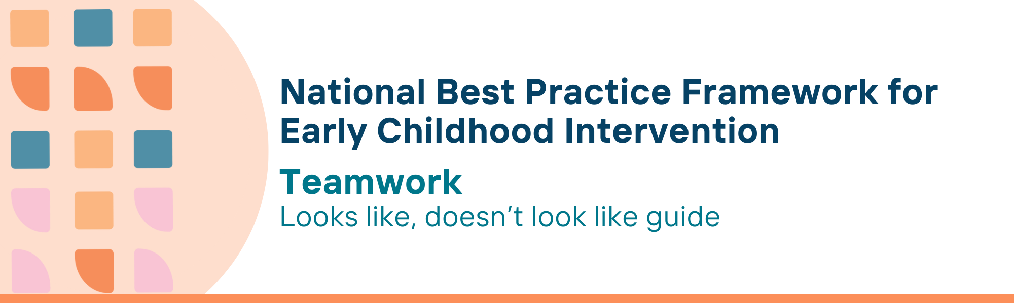

This resource has been specifically developed for Early Childhood Intervention (ECI) practitioners. While each set of Looks Like, Doesn’t Look Like examples align with a specific principle, they are grounded in all the universal principles of the Framework. Some of these Looks Like, Doesn’t Look Like examples may overlap with other principles. It is essential to consider the Framework as a whole when using these resources.
The Looks Like, Doesn’t Look Like examples below have been carefully curated based on feedback from consultations and contributions from consortium teams. However, this is not an exhaustive list. Please use these resources as a guide and incorporate other relevant factors as needed to best support your practice.

Teamwork

Looks like:
- Acknowledging parents, carers and families as experts on their child and family and partnering with them to build a team to work together
- Respecting the family’s traditions, beliefs, and cultural values, and recognising them as final decision-makers when planning with the team and when implementing strategies
- Working with families and other practitioners and service providers to foster integrated and collaborative service delivery regardless of programmatic and service boundaries
- Encouraging open and respectful communication among parents, carers and families and all other team members
- Working collaboratively with other team members and other local agencies to ensure that there is a clear understanding of roles, shared pathways and resources for supporting children and families
- Enabling families to determine who they want as part of the team, and then making it happen - this should include people important to and trusted by the family and people from community services and supports, as well as practitioners from relevant disciplines to meet child and family goals
- Understanding that a team can consist of just two adults, such as a parent and a professional, and can apply a team approach
- Respecting each team member’s expertise and contributions
- Meeting regularly to plan, review, and adjust ideas and strategies at a time and place convenient for family
- Prioritising and proactively coordinating meetings with other team members, including family members and other service providers
- Supporting families to identify a practitioner from the team who will be the primary contact between the family and other team members
- Coaching or supporting the family and others to incorporate strategies using relevant expertise in the team
- Convening regular meetings across services to understand what each is able to do and for whom
- Sharing resources for providers and families across organisations (e.g., a communication device or library holding resources about effective communication that are made available to students and families)
- Building strong relationships with people in other services, so that they can be called on to collaboratively support families and children as circumstances change
- Make time for regular interagency catch-ups to identify and apply local workarounds to barriers to implementing best practice
- Working with families and other agencies to provide timely and flexible support through transition phases (such as school transition) when families may be at risk of losing or changing familiar supports

Doesn’t look like:
- Not including families as team partners in a shared process in matters relating to their child
- Disregarding or ignoring cultural values, beliefs, and traditions, and not recognising families as the final decision makers; making decisions on behalf of the child and/or family
- Working in silos and attributing service delivery challenges to systemic issues without seeking collaborative solutions
- Providing limited or one-way communication that excludes parents, carers and families from discussions
- Working in isolation from other team members with focus on discipline-specific goals only
- Defining the team based only on the professional disciplines involved with a focus on only the child’s deficits or child’s goals only, disregarding needs of parents, carers and other family members
- Utilising a team approach only when three or more adults are involved
- Disregarding or undervaluing other disciplines or family or community insights and providing services outside one’s scope of expertise
- Meeting sporadically or not at all causing misalignment in goals and review processes
- Expecting the parent to coordinate between team members and other service providers
- Having separate providers seeing the family at separate times and addressing narrowly defined, separate outcomes or issues; expecting families to manage integration across services/supports
- Providing services outside one’s scope of expertise without input from relevant team members
- Providing inflexible services that add pressure on parents, carers and families to alter their everyday routines to suit various practitioners
- Prioritising the importance of one's own practice area with little respect or regard for team members or family strengths
- Creating dependency on a single practitioner by working in isolation and disempowering other team members and the family around the child
- Avoiding regular interagency meetings by attributing the challenges to service systems and policies, thereby not supporting child and family outcomes effectively
- Overlooking one's own role in the transition processes and failing to support the future needs of children (e.g., transition to school); waiting for families to ask for support when transitioning into new systems

© UoM 2025. National Best Practice Framework for Early Childhood Intervention (a joint collaboration between Healthy Trajectories, the Melbourne Disability Institute, STRONG Kids STRONG Future at the University of Melbourne, and the Murdoch Children’s Research Institute (MCRI), Professionals and Researchers in Early Childhood Intervention (PRECI), SNAICC – National Voice for our Children, Children and Young People with Disability Australia, and ACD – Advocating for Children with Disability). Commissioned by the Department of Social Services.
This work is copyrighted to The University of Melbourne under a creative commons license, CC-BY-NC-ND. This material contains and draws upon Indigenous Cultural and Intellectual Property (ICIP) contributed by SNAICC and its members and staff and is used with their consent. Dealing with any part of the materials containing ICIP for any purpose that has not been authorised by the custodians is a serious breach of customary laws. You must handle ICIP accordingly when exercising the Creative Commons Licence described above.
For more information about copyright please visit https://healthy-trajectories.com.au/eci-framework/

