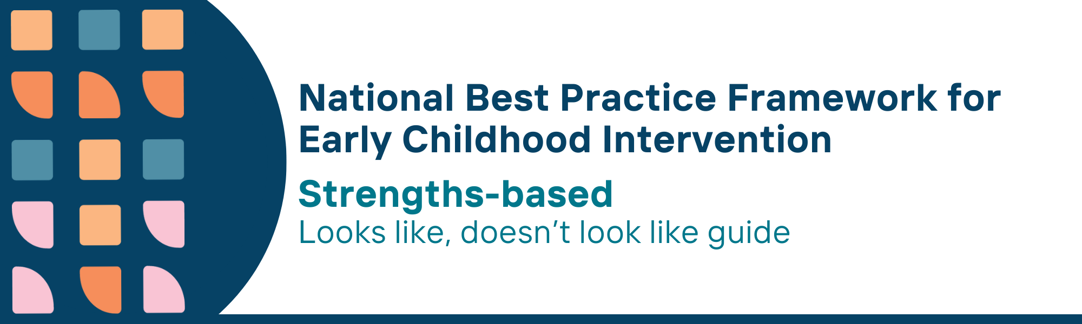

This resource has been specifically developed for Early Childhood Intervention (ECI) practitioners. While each set of Looks Like, Doesn’t Look Like examples align with a specific principle, they are grounded in all the universal principles of the Framework. Some of these Looks Like, Doesn’t Look Like examples may overlap with other principles. It is essential to consider the Framework as a whole when using these resources.
The Looks Like, Doesn’t Look Like examples below have been carefully curated based on feedback from consultations and contributions from consortium teams. However, this is not an exhaustive list. Please use these resources as a guide and incorporate other relevant factors as needed to best support your practice.

Strengths-based universal principle

Looks like:
- Working with families to identify and build on what their child can do, is good at and enjoys
- Recognising the unique relationships, strengths, interests and capabilities of children and families in written reports
- Adopting a positive approach regarding the child and parent, carer and family’s future and mentioning what strengths each member brings in achieving goals
- Building on the skills that children already have or are developing
- Acknowledging and promoting positive and responsive interactions among family members by encouraging open conversations and supporting strong family connections
- Promoting and using guided discovery (supported exploration) and strengths-based interventions with parents, carers and family members that promote a child’s autonomy, confidence and competence
- Reflecting strengths-based language in written documentation and communication by using words that foster a positive and empowering perspective on the child's abilities and progress such as motivated, resilient, persistent
- Reflecting and challenging own values and assumptions about families and children prior to suggesting strategies

Doesn’t look like:
- Focusing on skills that children do not have when describing their development and learning
- Focusing on deficits of the child, and what children and their parents, carers and families cannot do, emphasising family limitations
- Ignoring child and parent, carer and family hopes and long-term goals for their child in the planning of supports
- Using interventions that focus on deficits rather than building on what a child can already do
- Ignoring positive interactions and focusing on changing interactions between the child and their parent, carer and other members of the family
- Designing interventions to create dependency and reliance on service providers and discourage parent, carers and family members from using their own ideas and strategies
- Using deficit-focussed language in written documentation and communication by being overly clinical, impersonal, or focused only on diagnostic labels and limitations
- Assuming that all children, parents, carers and families share practitioner values and aspirations about what is ‘good’ for them

© UoM 2025. National Best Practice Framework for Early Childhood Intervention (a joint collaboration between Healthy Trajectories, the Melbourne Disability Institute, STRONG Kids STRONG Future at the University of Melbourne, and the Murdoch Children’s Research Institute (MCRI), Professionals and Researchers in Early Childhood Intervention (PRECI), SNAICC – National Voice for our Children, Children and Young People with Disability Australia, and ACD – Advocating for Children with Disability). Commissioned by the Department of Social Services.
This work is copyrighted to The University of Melbourne under a creative commons license, CC-BY-NC-ND. This material contains and draws upon Indigenous Cultural and Intellectual Property (ICIP) contributed by SNAICC and its members and staff and is used with their consent. Dealing with any part of the materials containing ICIP for any purpose that has not been authorised by the custodians is a serious breach of customary laws. You must handle ICIP accordingly when exercising the Creative Commons Licence described above.
For more information about copyright please visit https://healthy-trajectories.com.au/eci-framework/

