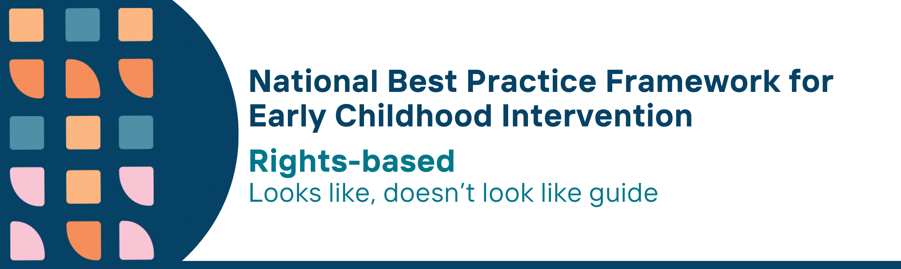

This resource has been specifically developed for Early Childhood Intervention (ECI) practitioners. While each set of Looks Like, Doesn’t Look Like examples align with a specific principle, they are grounded in all the universal principles of the Framework. Some of these Looks Like, Doesn’t Look Like examples may overlap with other principles. It is essential to consider the Framework as a whole when using these resources.
The Looks Like, Doesn’t Look Like examples below have been carefully curated based on feedback from consultations and contributions from consortium teams. However, this is not an exhaustive list. Please use these resources as a guide and incorporate other relevant factors as needed to best support your practice.

Rights-based universal principles

Looks like:
- Learning about rights-based practices by reading, understanding, valuing and discussing the purpose and key principles of appropriate Conventions, Declaration and Standards
- Sharing accessible information about rights such as displaying easy- read rights information
- Informing parents, carers and families of their right to privacy of information when asked to share information with new team members
- Providing accessible information including translated resources so families can make informed decisions
- Adopting human rights principles (participation, accountability, non-discrimination, equality, empowerment, legality) to support children's right to education
- Understanding individual and systemic racism, other forms of discrimination and inequity by taking active steps in their practice and organisations to challenge discrimination and reduce inequity
- Ensuring all children, including Aboriginal and Torres Strait Islander children have equitable access to services
- Prioritising training and development to learn about systemic racism

Doesn’t look like:
- Lacking knowledge about rights-based practices, and assuming it is not part of their service with disregard or no knowledge of the Conventions and Declaration
- Not offering information under the assumption that families will not understand it
- Sharing information about a child or family with team members without consent
- Providing complex or inaccessible communication that limits parent, carers and families’ understanding of their rights
- Not discussing child rights or principles of inclusion and participation with parents, carers and families
- Assuming that it is not their responsibility to understand systemic racism and discrimination and passively accepting that ‘the system’ is to blame for discrimination, inequities and poor outcomes
- Overlooking specific needs and barriers faced by all children from diverse cultures and backgrounds in accessing services
- Failing to recognise the importance of training to learn about systemic racism, and its impact on service delivery

© UoM 2025. National Best Practice Framework for Early Childhood Intervention (a joint collaboration between Healthy Trajectories, the Melbourne Disability Institute, STRONG Kids STRONG Future at the University of Melbourne, and the Murdoch Children’s Research Institute (MCRI), Professionals and Researchers in Early Childhood Intervention (PRECI), SNAICC – National Voice for our Children, Children and Young People with Disability Australia, and ACD – Advocating for Children with Disability). Commissioned by the Department of Social Services.
This work is copyrighted to The University of Melbourne under a creative commons license, CC-BY-NC-ND. This material contains and draws upon Indigenous Cultural and Intellectual Property (ICIP) contributed by SNAICC and its members and staff and is used with their consent. Dealing with any part of the materials containing ICIP for any purpose that has not been authorised by the custodians is a serious breach of customary laws. You must handle ICIP accordingly when exercising the Creative Commons Licence described above.
For more information about copyright please visit https://healthy-trajectories.com.au/eci-framework/

