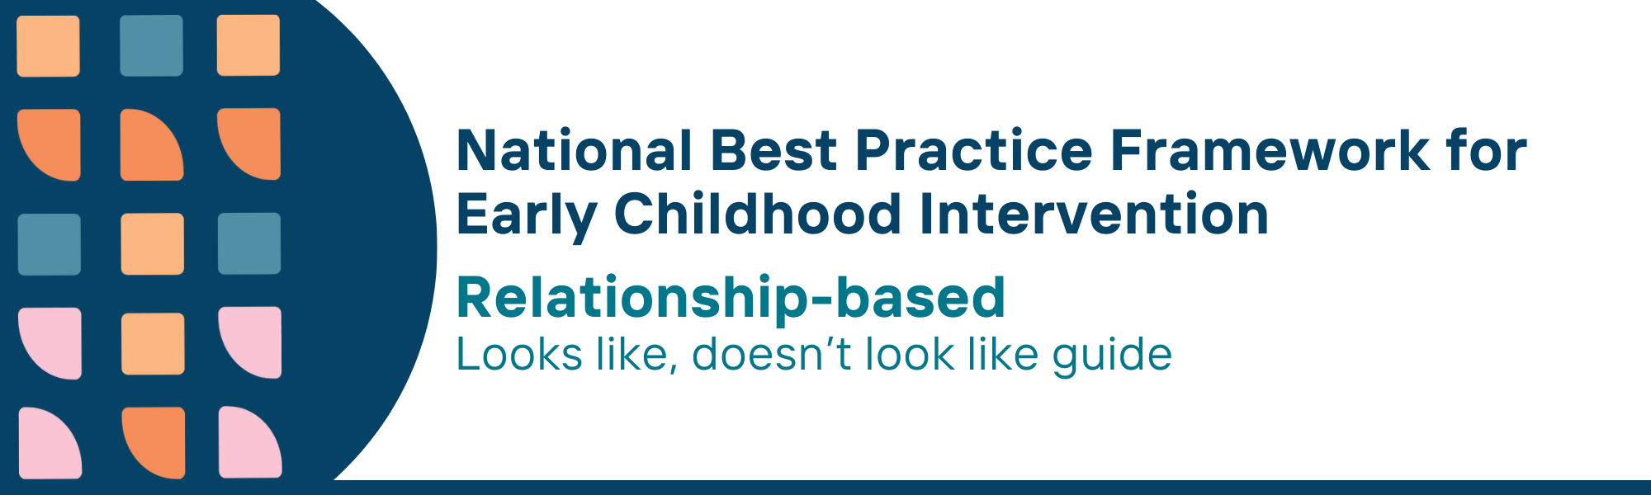

This resource has been specifically developed for Early Childhood Intervention (ECI) practitioners. While each set of Looks Like, Doesn’t Look Like examples align with a specific principle, they are grounded in all the universal principles of the Framework. Some of these Looks Like, Doesn’t Look Like examples may overlap with other principles. It is essential to consider the Framework as a whole when using these resources.
The Looks Like, Doesn’t Look Like examples below have been carefully curated based on feedback from consultations and contributions from consortium teams. However, this is not an exhaustive list. Please use these resources as a guide and incorporate other relevant factors as needed to best support your practice.

Relationship-based universal principle

Looks like:
- Investing time to build relationships with parents, carers and families, for example reading referrals and reports, meeting with and learning about background and needs
- Actively listening by asking clarifying questions such as asking for more details about a concern, to show engagement and understanding
- Following through on commitments that have been agreed upon and maintaining transparent communication
- Strengthening positive interactions between parents, carers and child and between other family members including siblings
- Regularly asking parents, carers and families if services are being delivered according to child and family goals
- Using strategies to build trust and emotional security, attachment and bonding between a child and their parents, carers and family
- Investing time in building connections between parents, carers and families and supportive network of peers and community groups
- Supporting parents, carers and families to advocate for themselves
- Building strong relationships with Aboriginal and Torres Strait Islander families by collaborating with community leaders, providing culturally safe services, upholding data sovereignty, and maintaining transparency in data collection and sharing

Doesn’t look like:
- Keeping interactions with parents, carers and families short and rushed
- Not individualising conversations or interactions as per the family needs; not acknowledging what the parents, carers or family member are saying
- Forgetting or not noting what was previously discussed and repeating similar questions
- Not relating to anyone other than child and parent or carer even when other family members are present
- Continuing to provide services without seeking feedback or reviews of goals
- Ignoring signs or cues when a child appears anxious, withdrawn, and not tuning in to attachment, bonding or emotional needs
- Assuming it is not their role to connect parents, carers and families to peer and other support networks
- Speaking for parents, carers and families without involving them in decision-making and proceeding in meetings without their presence
- Using rigid processes that ignore cultural context, collecting data without consent, and neglecting partnerships with Aboriginal and Torres Strait Islander communities and organisations, leading to mistrust and disengagement

© UoM 2025. National Best Practice Framework for Early Childhood Intervention (a joint collaboration between Healthy Trajectories, the Melbourne Disability Institute, STRONG Kids STRONG Future at the University of Melbourne, and the Murdoch Children’s Research Institute (MCRI), Professionals and Researchers in Early Childhood Intervention (PRECI), SNAICC – National Voice for our Children, Children and Young People with Disability Australia, and ACD – Advocating for Children with Disability). Commissioned by the Department of Social Services.
This work is copyrighted to The University of Melbourne under a creative commons license, CC-BY-NC-ND. This material contains and draws upon Indigenous Cultural and Intellectual Property (ICIP) contributed by SNAICC and its members and staff and is used with their consent. Dealing with any part of the materials containing ICIP for any purpose that has not been authorised by the custodians is a serious breach of customary laws. You must handle ICIP accordingly when exercising the Creative Commons Licence described above.
For more information about copyright please visit https://healthy-trajectories.com.au/eci-framework/

