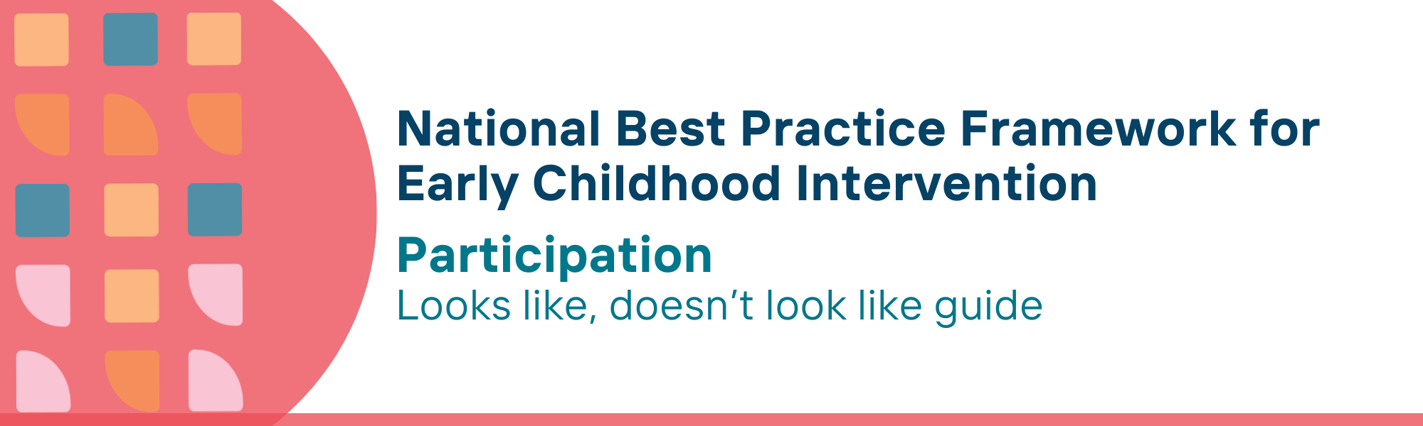

This resource has been specifically developed for Early Childhood Intervention (ECI) practitioners. While each set of Looks Like, Doesn’t Look Like examples align with a specific principle, they are grounded in all the universal principles of the Framework. Some of these Looks Like, Doesn’t Look Like examples may overlap with other principles. It is essential to consider the Framework as a whole when using these resources.
The Looks Like, Doesn’t Look Like examples below have been carefully curated based on feedback from consultations and contributions from consortium teams. However, this is not an exhaustive list. Please use these resources as a guide and incorporate other relevant factors as needed to best support your practice.

Participation

Looks like:
- Knowing how to engage with children and families to set explicit participation-focused goals (attendance and involvement in key life situations) for children and their families
- Ensuring that children, parents, carers, and families feel welcome and comfortable to participate in all their usual everyday settings
- Ensuring children have access to equitable opportunities and resources
- Providing specialist equipment that the child needs to access, interact and be involved in activities and environments where they live, learn and play
- Partnering with parents, carers, families and others (e.g., early childhood education and care (ECEC) or school staff) to address attitudinal, social and environmental barriers to participation to create safe and welcoming learning opportunities for all children
- Scaffolding skill building where children spend time to ensure participation
- Using routines-based approaches that embed teaching and learning opportunities to increase participation
- Understanding and using strategies to support children’s social, emotional and behavioural development
- Co-designing practical strategies (such as adapting activities, environments, equipment, time frames) with parents, carers and families to support children’s meaningful participation
- Promoting universal design to support ECEC, schools and wider community settings to meet the diverse needs of all children
- Building trusted relationships and working in partnership with local Aboriginal and Torres Strait Islander community-controlled organisations as providers of culturally safe and inclusive services for Aboriginal and Torres Strait Islander children and families

Doesn’t look like:
- Disregarding interactions with children and families and instead focusing on the skill deficits of children
- Overlooking or neglecting to explore the full range of settings in which children and families participate, thereby limiting awareness to only one or two environments
- Not addressing discrimination based on children’s developmental concerns, delay or disability
- Avoiding or delaying the provision of equipment that enables participation
- Using one professional’s understanding of barriers to participation as the basis for the introduction of strategies without consulting parents, carers, families and other professionals
- Providing individual skill building activities that exclude children’s interaction with peers and others
- Using one-off support strategies in activities unrelated to children’s everyday experience in different environments
- Ignoring the function of child behaviours of concern as a form of communication; seeking to eliminate behaviours of concern using exclusion and restraint strategies
- Making individualised changes in the setting that act to discriminate against children, such as providing specific strategies in a classroom that highlight the child’s difference or separate them from peers
- Failing to address diverse needs by making appropriate adaptations to support all children in ECEC, schools and community settings
- Devaluing the role of local Aboriginal and Torres Strait Islander community-controlled organisations, leading to limited participation of children, parents, carers and families in environments that meet their needs

© UoM 2025. National Best Practice Framework for Early Childhood Intervention (a joint collaboration between Healthy Trajectories, the Melbourne Disability Institute, STRONG Kids STRONG Future at the University of Melbourne, and the Murdoch Children’s Research Institute (MCRI), Professionals and Researchers in Early Childhood Intervention (PRECI), SNAICC – National Voice for our Children, Children and Young People with Disability Australia, and ACD – Advocating for Children with Disability). Commissioned by the Department of Social Services.
This work is copyrighted to The University of Melbourne under a creative commons license, CC-BY-NC-ND. This material contains and draws upon Indigenous Cultural and Intellectual Property (ICIP) contributed by SNAICC and its members and staff and is used with their consent. Dealing with any part of the materials containing ICIP for any purpose that has not been authorised by the custodians is a serious breach of customary laws. You must handle ICIP accordingly when exercising the Creative Commons Licence described above.
For more information about copyright please visit https://healthy-trajectories.com.au/eci-framework/

