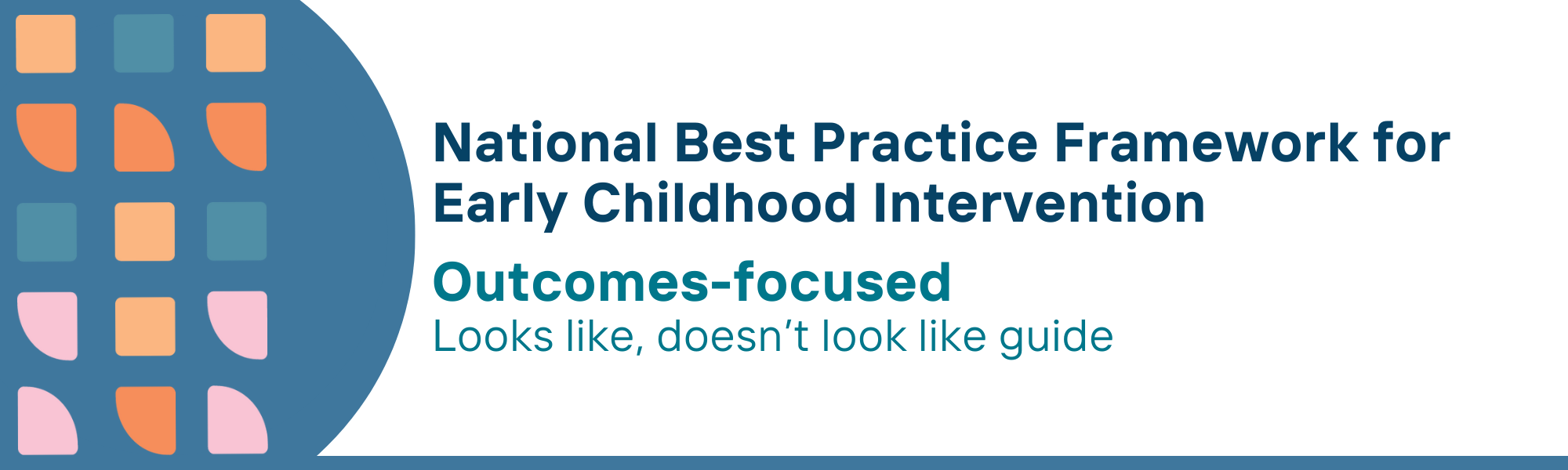

This resource has been specifically developed for Early Childhood Intervention (ECI) practitioners. While each set of Looks Like, Doesn’t Look Like examples align with a specific principle, they are grounded in all the universal principles of the Framework. Some of these Looks Like, Doesn’t Look Like examples may overlap with other principles. It is essential to consider the Framework as a whole when using these resources.
The Looks Like, Doesn’t Look Like examples below have been carefully curated based on feedback from consultations and contributions from consortium teams. However, this is not an exhaustive list. Please use these resources as a guide and incorporate other relevant factors as needed to best support your practice.

Outcomes-focused

Looks like:
- Assisting universal settings (e.g., maternal and child health, early childhood education and care) and families in the identification and monitoring of developmental concerns and delays in a timely manner
- Taking an authentic, strengths-based, safe, and sensitive approach in the use of assessment practices and tools
- Using validated and relevant outcome measures appropriately when measuring outcomes
- Using culturally appropriate and valid assessment tools in association with local cultural groups
- Identifying how a child participates in everyday activities and what types of abilities the child uses in interactions with toys, materials, and people
- Working collaboratively towards meaningful, functional and participation-focused outcomes with children and families based on their goals, priorities and aspirations
- Collaborating and agreeing with the family about specific child, family and community outcomes
- Using relevant services, supports, contexts and strategies to address the agreed/identified outcomes
- Fostering service pathways and outcomes that are locally appropriate and locally determined and which adapt systems to meet family and community needs and outcomes

Doesn’t look like:
- Being unprepared and unaware of when, how, and what data needs to be gathered to identify child and family concerns at the right time
- Only identifying and focusing on what children and families cannot do in documentation and reporting
- Choosing descriptive assessments and information gathering tools for measuring change over time
- Employing mainstream developmental assessment instruments which are not culturally and linguistically adapted
- Assessing child learning and development in unfamiliar situations with materials that are unfamiliar to the child
- Using a one-size-fits-all approach, such as the same tools for all children and families without considering their unique needs, goals, outcomes and circumstances
- Including only child focused outcomes in the planning of supports
- Ignoring children’s learning and development contexts as outcomes, focusing on addressing the child’s deficits only
- Insisting families fit a standardised service system that does not readily meet their needs or achieve the outcomes they are seeking

© UoM 2025. National Best Practice Framework for Early Childhood Intervention (a joint collaboration between Healthy Trajectories, the Melbourne Disability Institute, STRONG Kids STRONG Future at the University of Melbourne, and the Murdoch Children’s Research Institute (MCRI), Professionals and Researchers in Early Childhood Intervention (PRECI), SNAICC – National Voice for our Children, Children and Young People with Disability Australia, and ACD – Advocating for Children with Disability). Commissioned by the Department of Social Services.
This work is copyrighted to The University of Melbourne under a creative commons license, CC-BY-NC-ND. This material contains and draws upon Indigenous Cultural and Intellectual Property (ICIP) contributed by SNAICC and its members and staff and is used with their consent. Dealing with any part of the materials containing ICIP for any purpose that has not been authorised by the custodians is a serious breach of customary laws. You must handle ICIP accordingly when exercising the Creative Commons Licence described above.
For more information about copyright please visit https://healthy-trajectories.com.au/eci-framework/

