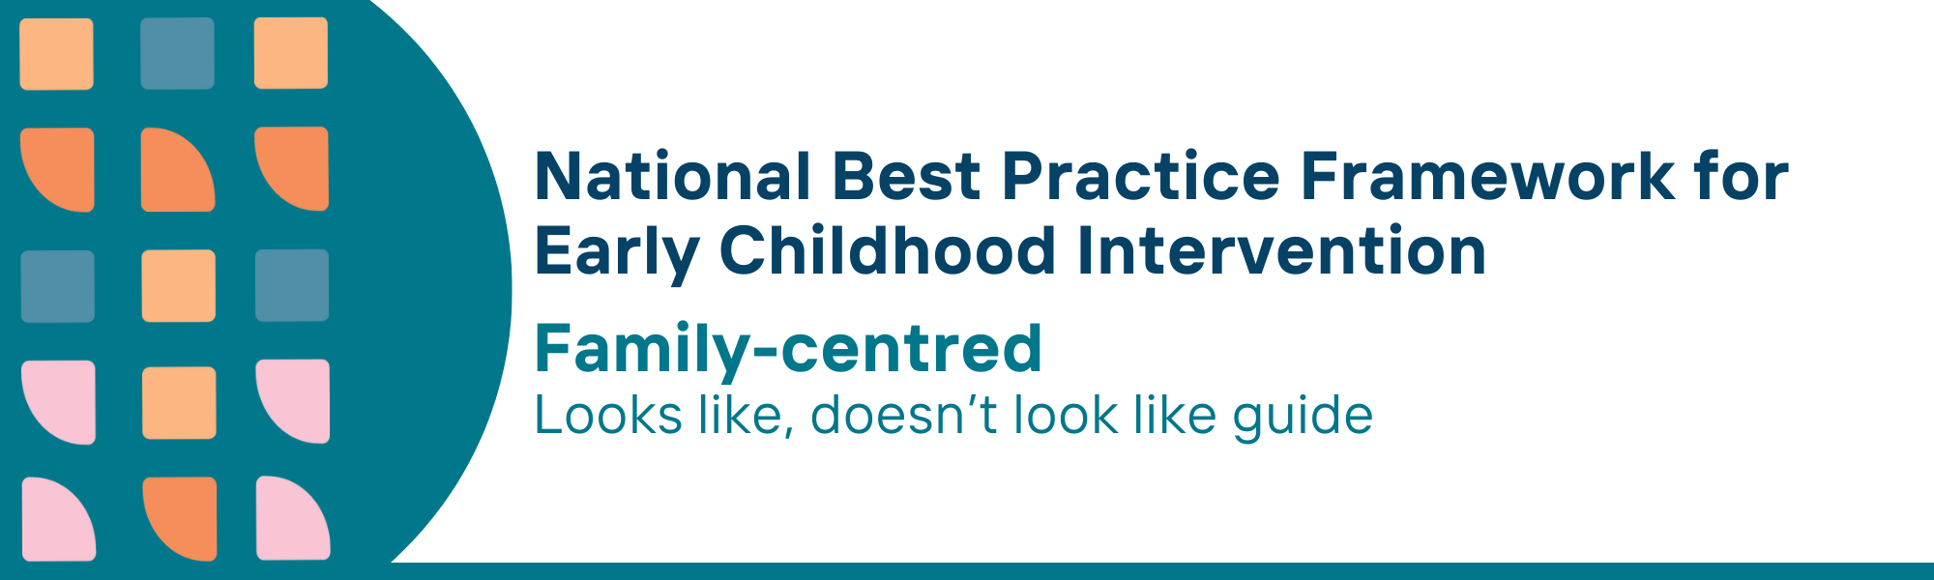

This resource has been specifically developed for Early Childhood Intervention (ECI) practitioners. While each set of Looks Like, Doesn’t Look Like examples align with a specific principle, they are grounded in all the universal principles of the Framework. Some of these Looks Like, Doesn’t Look Like examples may overlap with other principles. It is essential to consider the Framework as a whole when using these resources.
The Looks Like, Doesn’t Look Like examples below have been carefully curated based on feedback from consultations and contributions from consortium teams. However, this is not an exhaustive list. Please use these resources as a guide and incorporate other relevant factors as needed to best support your practice.

Family-centred

Looks like:
- Presenting information and knowledge about the family-centred practice model of service provision to all parents, carers and families
- Recognising and valuing parents, carers and families as the child's first and most important influence by actively involving them in decision-making and daily activities
- Listening to and respecting the culture, knowledge, and values that parents, carers and families bring about their child, family and daily life
- Communicating openly and respectfully and valuing the strengths and contributions of parents, carers and families
- Inviting parents, carers and families to have trusted people or other involved professionals and practitioners participating in conversations
- Providing parents, carers and families with comprehensive and unbiased information about service options and evidence, ensuring they are well-informed to make decisions
- Making sure parents, carers and families are provided with regular feedback; ensuring that progress is documented in ways and formats that meet their needs, to help them to understand and implement what will help their child
- Building relationships with parents, carers and families so they can confidently determine where, when and how conversations and discussions occur
- Formulating goals that include the child, parent, carer and family to ensure skill development, enhanced interactions, and increased family functioning and quality of life
- Working with parents, carers and families in the development of capabilities to advocate for their child and family
- Respecting the personal and cultural beliefs, priorities, preferences, and circumstances of parents, carers, family members, and children
- Building strong relationships and family-centred care with Aboriginal and Torres Strait Islander families by respecting culture, Elders, Country and working together to set goals and identify appropriate services
- Recognising that extended family and community are part of the wraparound support; recognising extended family members and the importance of grandparents and aunties in caring for Aboriginal and Torres Strait Islander children
- Linking families with peers via peer support and parent support programs to build support networks and collaborative care
- Ensuring parents, carers and families are included in all decisions and discussions affecting them, so that families are part of all decision-making about their children, with supports determined by family decisions
- Supporting families and children while they are waiting for specialist services required for formal support pathways
- Establishing a variety of neutral and safe spaces for Aboriginal and Torres Strait Islander families to ask questions (for example pop-up playgroups, community centre events, online telehealth chats), with local Aboriginal and Torres Islander people employed as allied health assistants to be a conduit between families and service providers
- Inviting families to bring all/any of their children to meetings and discussions

Doesn’t look like:
- Assuming that parents, carers and families want an expert model and providing services based on a medical- or child-centric model of service delivery, assuming that family-centred care only ‘works’ with some families
- Not creating opportunities for parents, carers and families to be actively engaged in making decisions and setting goals and supporting their child to learn and develop across all areas
- Disregarding or undervaluing the insights, preferences, and decisions of parents, carers and families, and failing to tailor services
- Not taking time to listen and use information shared by parents, carers and families; not helping parents, carers and families to feel comfortable in sharing what they think
- Working in isolation from other professionals, practitioners and services involved with the child or family, with no consideration of their holistic needs; not encouraging having people they trust as part of communications
- Filtering information based on assumptions about what the family can handle or cope with; withholding potentially beneficial information from parents, carers and families without consulting them
- Not recording accurately or without sufficient detail, using professional jargon and complex language, making it difficult for parents, carers and families to understand documentation or progress
- Being inflexible about the times and venues for interactions and how, why and with whom conversations are held
- Not considering parent, carer and family goals or well-being, resulting in unmet family needs, reduced family engagement, and suboptimal child development outcomes
- Assuming parents, carers and families already know, or are not ready for, how to advocate for their child and not providing information that would support or build their advocacy skills
- Applying a one-size-fits-all approach without considering each family’s dynamics and cultural contexts
- Not acknowledging the relevance and importance of cultural context, collecting information without consent, and neglecting partnerships with Aboriginal and Torres Strait Islander families and organisations, leading to mistrust and disengagement
- Focusing only on parents and carers and overlooking the role of the wider family and community in raising Aboriginal and Torres Strait Islander children
- Not providing opportunities or information for parents, carers, and families to connect with peers or access support programs, leading to dependency on professionals
- Being party to discussions and decisions about the child and family without the parent, carer and family participating
- Leaving families unsupported while they are waiting for services to be formalised
- Not upskilling to learn about Aboriginal and Torres Strait Islander peoples, and cultural safety
- Assuming all families have ready access to child care and transport

© UoM 2025. National Best Practice Framework for Early Childhood Intervention (a joint collaboration between Healthy Trajectories, the Melbourne Disability Institute, STRONG Kids STRONG Future at the University of Melbourne, and the Murdoch Children’s Research Institute (MCRI), Professionals and Researchers in Early Childhood Intervention (PRECI), SNAICC – National Voice for our Children, Children and Young People with Disability Australia, and ACD – Advocating for Children with Disability). Commissioned by the Department of Social Services.
This work is copyrighted to The University of Melbourne under a creative commons license, CC-BY-NC-ND. This material contains and draws upon Indigenous Cultural and Intellectual Property (ICIP) contributed by SNAICC and its members and staff and is used with their consent. Dealing with any part of the materials containing ICIP for any purpose that has not been authorised by the custodians is a serious breach of customary laws. You must handle ICIP accordingly when exercising the Creative Commons Licence described above.
For more information about copyright please visit https://healthy-trajectories.com.au/eci-framework/

