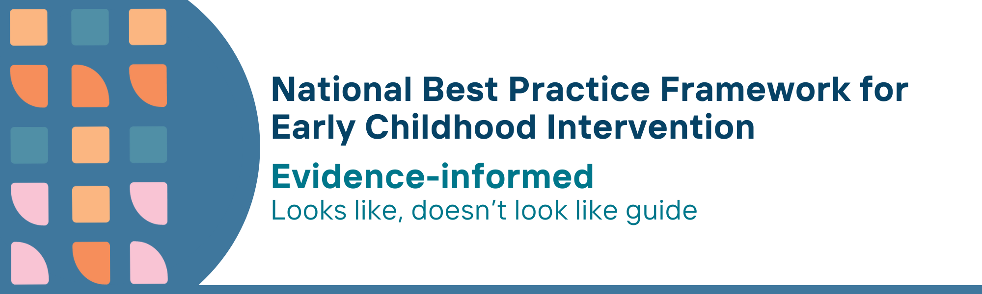

This resource has been specifically developed for Early Childhood Intervention (ECI) practitioners. While each set of Looks Like, Doesn’t Look Like examples align with a specific principle, they are grounded in all the universal principles of the Framework. Some of these Looks Like, Doesn’t Look Like examples may overlap with other principles. It is essential to consider the Framework as a whole when using these resources.
The Looks Like, Doesn’t Look Like examples below have been carefully curated based on feedback from consultations and contributions from consortium teams. However, this is not an exhaustive list. Please use these resources as a guide and incorporate other relevant factors as needed to best support your practice.

Evidence-informed

Looks like:
- Integrating the rights and perspectives of children with developmental concerns, delay or disability, their families and communities with best available research evidence and professional expertise
- Keeping abreast of, and informed by, the best available evidence on child development, learning, participation, and wellbeing
- Engaging in a shared decision-making process with parents, carers, families and any other relevant service providers to determine and apply evidence-based practices
- Knowing how to promote and deliver evidence-informed practices which are selected and developed in partnership with families
- Evaluating and monitoring practice through seeking ongoing, regular and intentional feedback from parents, carers and families
- Monitoring own practice through seeking evidence from peer reviewed literature, mentors or joining evidence-based communities of practice
- Using tools for monitoring fidelity of implementation (practice and process)
- Using reflective practice for continuous improvement
- Preferencing local Aboriginal and Torres Strait Islander cultures and practice to adapt and validate assessment and other tools, taking soft approaches even for culturally modified tools, resources and assessments, while recognising need for ‘fidelity’
- Work with local Aboriginal and Torres Strait Islander community-controlled organisations providing services for children and families to learn about and apply the principles and practices of Indigenous Data Sovereignty
- Being transparent about data sharing about families and children between services and gaining clear consent from the family about what data could be shared, with who and why, going back for new or additional consent if there are any changes

Doesn’t look like:
- Offering families intervention strategies inconsistent with contemporary evidence, family values and priorities
- Implementing programs and strategies that have not been tested to effectively achieve child developmental, learning and participation outcomes
- Disregarding evidence and family values and designing support plans and strategies solely based on own experiences, and/or discussions with other service providers
- Implementing manualised programs or strategies in isolation from families’ values, beliefs and priorities
- Recording parent satisfaction with the service yearly or not at all and without considering individualised child and family outcomes
- Trusting own practice without prioritising time to review new evidence or enhance skills in contemporary and emerging practice areas, such as intersectionality, trauma-informed care, and neurodiversity-affirming practice
- Relying solely on anecdotal reports of progress towards child and family outcomes, without consideration and use of other performance indicators
- Failing to engage in self-assessment and feedback from peers and supervisors about their own practice, or doing so in a limited or cursory manner
- Using tools with Aboriginal and Torres Strait Islander children and families that have not been culturally validated or adapted for local cultural settings, or which worry or shame participants
- Assuming that learning about and applying Indigenous Data Sovereignty and Governance principles and practices is someone else’s responsibility
- Assuming it is not their responsibility, feeling uncomfortable or too afraid to ask for help, or neglecting to ask about consent about data sharing before every review or meeting

© UoM 2025. National Best Practice Framework for Early Childhood Intervention (a joint collaboration between Healthy Trajectories, the Melbourne Disability Institute, STRONG Kids STRONG Future at the University of Melbourne, and the Murdoch Children’s Research Institute (MCRI), Professionals and Researchers in Early Childhood Intervention (PRECI), SNAICC – National Voice for our Children, Children and Young People with Disability Australia, and ACD – Advocating for Children with Disability). Commissioned by the Department of Social Services.
This work is copyrighted to The University of Melbourne under a creative commons license, CC-BY-NC-ND. This material contains and draws upon Indigenous Cultural and Intellectual Property (ICIP) contributed by SNAICC and its members and staff and is used with their consent. Dealing with any part of the materials containing ICIP for any purpose that has not been authorised by the custodians is a serious breach of customary laws. You must handle ICIP accordingly when exercising the Creative Commons Licence described above.
For more information about copyright please visit https://healthy-trajectories.com.au/eci-framework/

