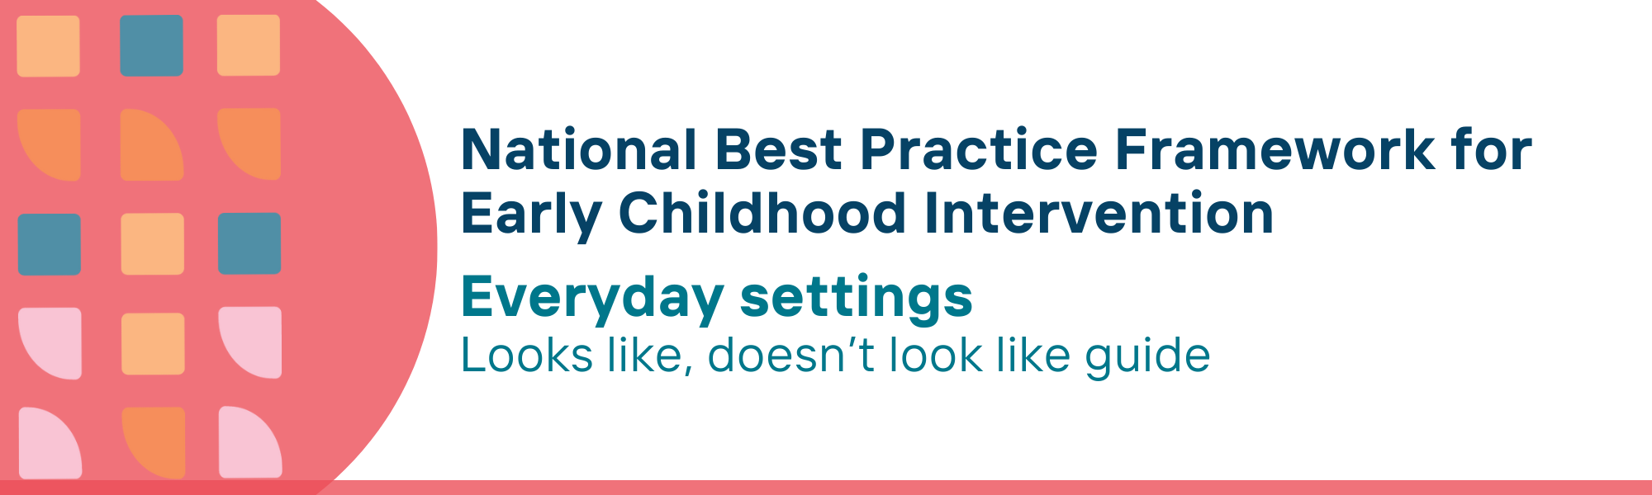

This resource has been specifically developed for Early Childhood Intervention (ECI) practitioners. While each set of Looks Like, Doesn’t Look Like examples align with a specific principle, they are grounded in all the universal principles of the Framework. Some of these Looks Like, Doesn’t Look Like examples may overlap with other principles. It is essential to consider the Framework as a whole when using these resources.
The Looks Like, Doesn’t Look Like examples below have been carefully curated based on feedback from consultations and contributions from consortium teams. However, this is not an exhaustive list. Please use these resources as a guide and incorporate other relevant factors as needed to best support your practice.

Everyday settings

Looks like:
- Building the capabilities of the people in everyday settings such as homes, early childhood settings, schools, gyms, libraries, sports venues to support children with developmental concerns, delay or disability and their families
- Providing services in settings like parks, shops, family gatherings, playgroups or sporting events that align with family goals and child interests
- Working with families, early childhood education and care, schools and other everyday settings to identify children’s strengths, interests, preferences and adapt activities accordingly
- Collaborating with parents, carers, families and community members to identify and address participation barriers, to enable children to attend and be meaningfully involved in everyday settings
- Scaffolding skill learning within everyday settings in the least intrusive manner
- Collaborating and planning with parents, carers, families and other community members to create accessible spaces
- Ensuring Aboriginal and Torres Strait Islander children and families have access to culturally safe spaces where they lead decisions, feel empowered to raise concerns, and are supported by multigenerational family networks
- Recognising and valuing neurodiversity and the unique experiences of LGBTQI+ families in everyday settings like early childhood centres, schools, shops, parks, and libraries, adapting practices to support their individual needs and preferences, and creating an inclusive environment where everyone feels welcome, respected and valued
- Holding pop-up events such as playgroups and providing other supports within walking distance of where people live and/or with free transport provided

Doesn’t look like:
- Working with the child exclusively (i.e. withdrawing or working alone) while visiting everyday settings and failing, or not knowing how, to discuss practices and strategies with others working in those settings e.g. educators, teachers, coaches
- Conducting learning activities, practitioner-led sessions in settings that isolate the child from their peers, family members or naturally occurring activities with no transfer to everyday settings
- Using toys, materials and other equipment in practitioner-led sessions that are not available, and cannot be made available, in the child’s everyday life outside of sessions
- Ignoring the perspectives of parents, carers and families and adopting one-size-fits-all solutions which limit child participation in everyday settings
- Conducting one-to-one skill building sessions using strategies that are inconsistent with the settings, routines and activities of the child and family
- Providing spaces that are not designed or modified to suit the specific needs of children, parents, carers and families
- Not providing culturally safe environments and services for Aboriginal and Torres Strait Islander children and families, leaving them feeling disempowered, fearful or shamed; discouraging or excluding wider family from participating
- Ignoring or too afraid to ask about neurodiversity and the unique experiences of LGBTQI+ families; assuming all children and families will respond to interventions and environments in the same way, or assuming that understanding and engaging with diversity is outside the scope of practice
- Assuming that families have ready access to transport and/or that they can easily walk to local events

© UoM 2025. National Best Practice Framework for Early Childhood Intervention (a joint collaboration between Healthy Trajectories, the Melbourne Disability Institute, STRONG Kids STRONG Future at the University of Melbourne, and the Murdoch Children’s Research Institute (MCRI), Professionals and Researchers in Early Childhood Intervention (PRECI), SNAICC – National Voice for our Children, Children and Young People with Disability Australia, and ACD – Advocating for Children with Disability). Commissioned by the Department of Social Services.
This work is copyrighted to The University of Melbourne under a creative commons license, CC-BY-NC-ND. This material contains and draws upon Indigenous Cultural and Intellectual Property (ICIP) contributed by SNAICC and its members and staff and is used with their consent. Dealing with any part of the materials containing ICIP for any purpose that has not been authorised by the custodians is a serious breach of customary laws. You must handle ICIP accordingly when exercising the Creative Commons Licence described above.
For more information about copyright please visit https://healthy-trajectories.com.au/eci-framework/

