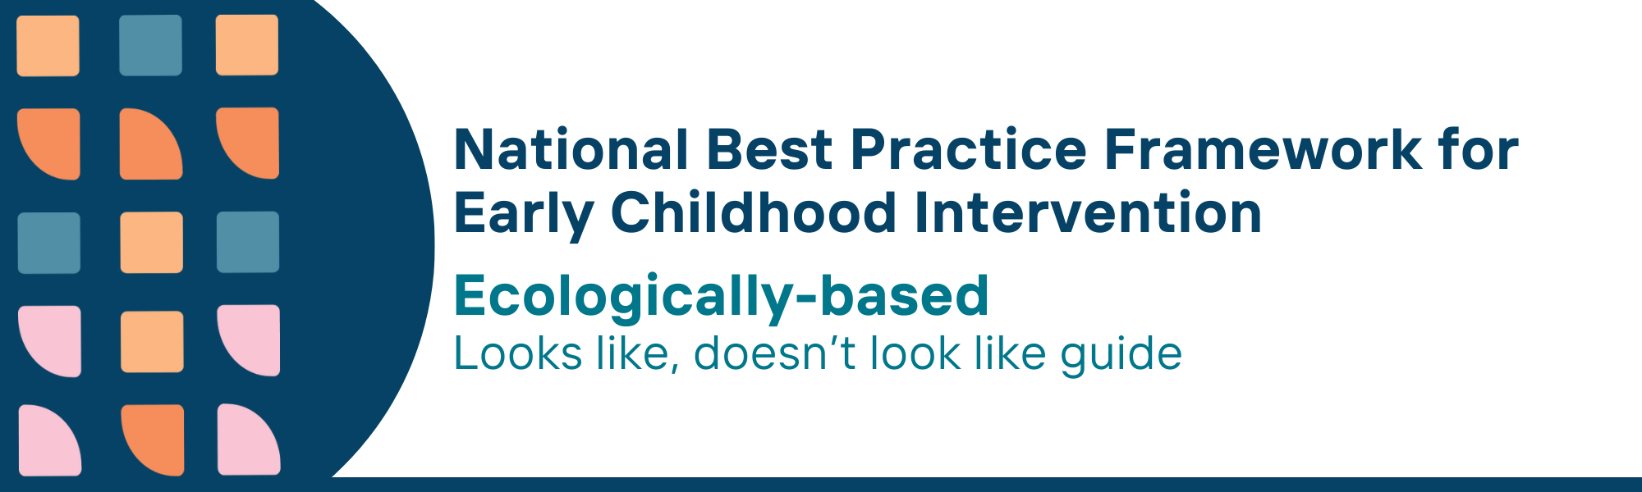

This resource has been specifically developed for Early Childhood Intervention (ECI) practitioners. While each set of Looks Like, Doesn’t Look Like examples align with a specific principle, they are grounded in all the universal principles of the Framework. Some of these Looks Like, Doesn’t Look Like examples may overlap with other principles. It is essential to consider the Framework as a whole when using these resources.
The Looks Like, Doesn’t Look Like examples below have been carefully curated based on feedback from consultations and contributions from consortium teams. However, this is not an exhaustive list. Please use these resources as a guide and incorporate other relevant factors as needed to best support your practice.

Ecologically-based universal principle

Looks like:
- Attending to and respecting the environments in which the child and family are living – their social, physical and socioeconomic circumstances
- Partnering with parents, carers, families and other services to contribute to and provide wrap around support within homes, Early Childhood Education and Care (ECEC) settings, schools and community wherever possible
- Understanding the multiple relationships around the child and parent, carer and family through utilising ecomaps and family resource checklists
- Facilitating children, parents, carers and families to access welcoming, culturally safe community spaces (such as local libraries, playgrounds) where they feel respected and included
- Measuring child outcomes that show strong identity, cultural connections, and active participation in home, community, ECEC, and school settings
- Engaging and building relationships with Aboriginal and Torres Strait Islander organisations and leaders in culturally relevant settings to ensure referrals align with the family's cultural and social contexts
- Advocating for flexible service delivery models that can be tailored to meet the unique needs of children, parents, carers family and community

Doesn’t look like:
- Paying no attention to the circumstances in which the family is living and focusing mainly on improving child and family functioning directly
- Working exclusively with the child, with little or not attention to the child and family’s settings, contexts or circumstances
- Ignoring the broader context of the child's life, without considering the various relationships surrounding the child, parent, carer and family
- Neglecting or not supporting the importance of community participation for children, parents, carers and families
- Using child outcomes and checklists, that focus only on developmental milestones, with little attention to cultural identity, sense of belonging, or community participation
- Relying solely on standardised service systems, without considering community-preferred spaces or engaging with Aboriginal and Torres Strait Islander leaders to support culturally safe referrals
- Assuming that all families and children need to fit within a standardised service system without considering multiple individual social, cultural, family factor or relationships

© UoM 2025. National Best Practice Framework for Early Childhood Intervention (a joint collaboration between Healthy Trajectories, the Melbourne Disability Institute, STRONG Kids STRONG Future at the University of Melbourne, and the Murdoch Children’s Research Institute (MCRI), Professionals and Researchers in Early Childhood Intervention (PRECI), SNAICC – National Voice for our Children, Children and Young People with Disability Australia, and ACD – Advocating for Children with Disability). Commissioned by the Department of Social Services.
This work is copyrighted to The University of Melbourne under a creative commons license, CC-BY-NC-ND. This material contains and draws upon Indigenous Cultural and Intellectual Property (ICIP) contributed by SNAICC and its members and staff and is used with their consent. Dealing with any part of the materials containing ICIP for any purpose that has not been authorised by the custodians is a serious breach of customary laws. You must handle ICIP accordingly when exercising the Creative Commons Licence described above.
For more information about copyright please visit https://healthy-trajectories.com.au/eci-framework/

