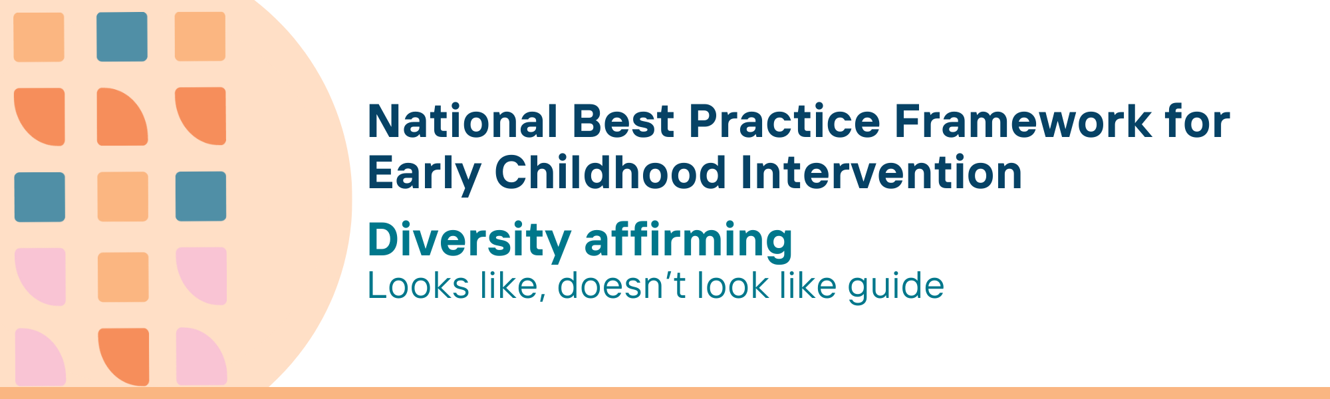

This resource has been specifically developed for Early Childhood Intervention (ECI) practitioners. While each set of Looks Like, Doesn’t Look Like examples align with a specific principle, they are grounded in all the universal principles of the Framework. Some of these Looks Like, Doesn’t Look Like examples may overlap with other principles. It is essential to consider the Framework as a whole when using these resources.
The Looks Like, Doesn’t Look Like examples below have been carefully curated based on feedback from consultations and contributions from consortium teams. However, this is not an exhaustive list. Please use these resources as a guide and incorporate other relevant factors as needed to best support your practice.

Diversity affirming

Looks like:
- Identifying activities the child, parent, carer and family like to do together which builds on their individual strengths, interests, culture and identity
- Making decisions that uphold children’s rights to have their individual circumstances, culture, background and abilities acknowledged and valued
- Recognising and valuing neurodiversity by understanding the unique ways children, parents, carers and families experience and interact with the world and adapting practices to support their individual needs and preferences
- Exploring and celebrating family’s culture, including their language, customs, religion and practices, including child-raising practices
- Offering bilingual support, Auslan, interpreters, and communication tools for children, parents, carers and families where appropriate and needed
- Using plain language in all communications and providing readily accessible easy-to-read versions of all resources so that families with varying English literacy are not excluded
- Learning about each individual’s language preferences such as person-first or identity-first, his/her/they and declaring own preferences if comfortable
- Creating a welcoming space where everyone feels safe to express their various identities (e.g., gender, culture, neuro-divergence) or differences without fear of judgment or discrimination
- Listening and learning from the lived experience of neurodivergent people and participating in relevant professional development activities
- Learning about intersectionality - the overlapping systems of inequality and discrimination for individuals (e.g. a parent with a disability who identifies as LGBTIQA+)
- Recognising the impact of stressors caused by socio-economic status and providing referral to local resources and services where appropriate
- Ensuring that everyone welcomes LGBTIQA+ parents, carers, and children
- Exploring, celebrating and learning about and respecting Deaf culture, including their language (such as Auslan), customs, and practices and incorporating them into interactions and activities

Doesn’t look like:
- Designing activities that focus on, either implicitly or explicitly, practitioners’ interests, culture and identity
- Feeling uncomfortable or too afraid to ask for information, or training, or neglecting to understand the diversity of families and children
- Prioritising neuro-normativity by assuming all children, parents, carers and families will respond to interventions in the same way, without considering their unique perspectives and need
- Assuming that families from a specific culture will all share the same language, customs and parenting practices
- Relying on the family’s extended family members to interpret and translate information
- Using jargon and medical language that is not easy to understand or too technical, leaving the parents, carers and families unclear about communications
- Using generic terms for everyone or making assumptions about language and terminology preferences. Failing to use person’s name and calling people by role like mum, grandpa
- Making assumptions about gender, race, or culture, based on appearance or name and using language or behaviour that invalidates or disrespects their diversity
- Assuming own experience with a few neurodivergent children and families can be generalised to all others
- Not learning about intersectionality and potential impacts on children, parents, carers and families
- Making assumptions about family involvement or capabilities based on socio-economic status
- Using heteronormative language and making assumptions about gender identity
- Assuming that all Deaf individuals will share the same experiences, language preferences, or cultural practices with no understanding and respect for the diversity within the Deaf community

© UoM 2025. National Best Practice Framework for Early Childhood Intervention (a joint collaboration between Healthy Trajectories, the Melbourne Disability Institute, STRONG Kids STRONG Future at the University of Melbourne, and the Murdoch Children’s Research Institute (MCRI), Professionals and Researchers in Early Childhood Intervention (PRECI), SNAICC – National Voice for our Children, Children and Young People with Disability Australia, and ACD – Advocating for Children with Disability). Commissioned by the Department of Social Services.
This work is copyrighted to The University of Melbourne under a creative commons license, CC-BY-NC-ND. This material contains and draws upon Indigenous Cultural and Intellectual Property (ICIP) contributed by SNAICC and its members and staff and is used with their consent. Dealing with any part of the materials containing ICIP for any purpose that has not been authorised by the custodians is a serious breach of customary laws. You must handle ICIP accordingly when exercising the Creative Commons Licence described above.
For more information about copyright please visit https://healthy-trajectories.com.au/eci-framework/

