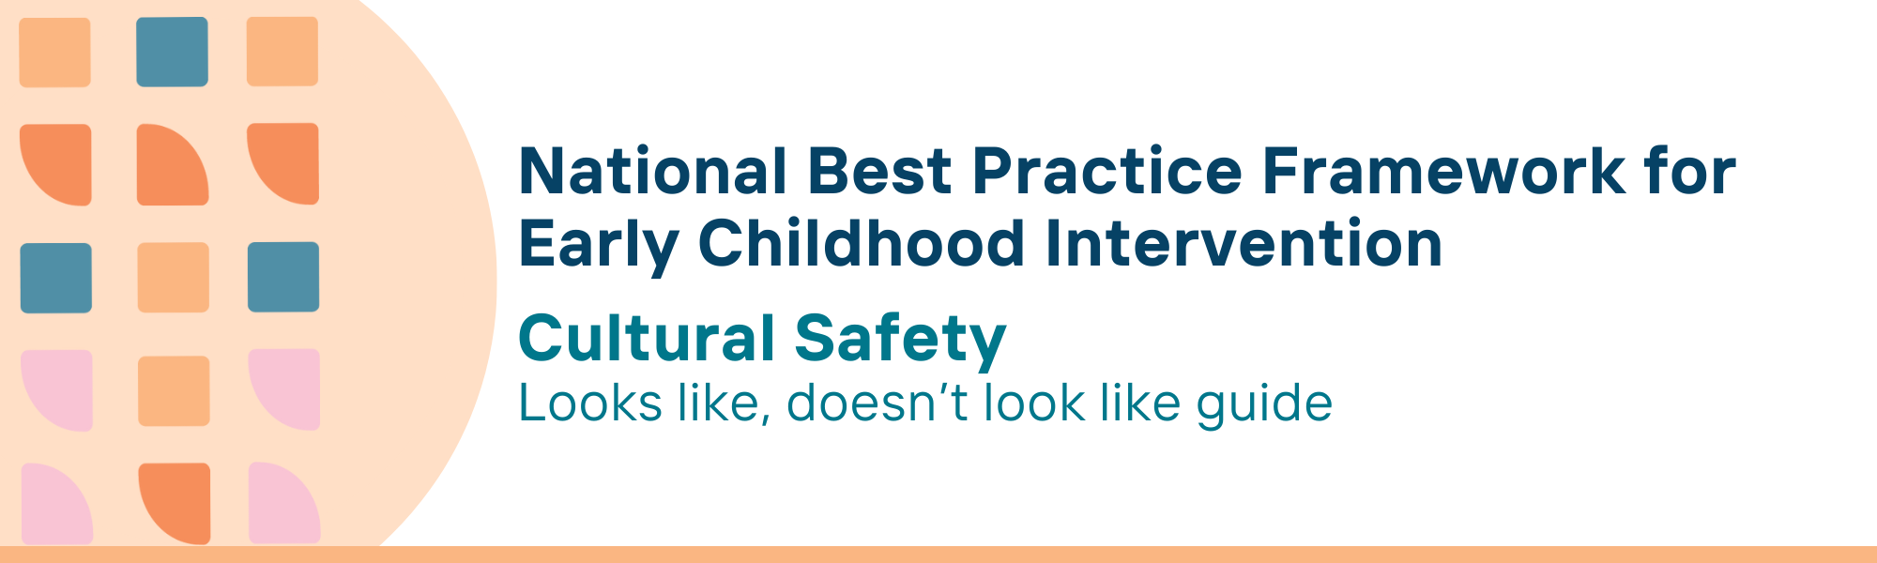

This resource has been specifically developed for Early Childhood Intervention (ECI) practitioners. While each set of Looks Like, Doesn’t Look Like examples align with a specific principle, they are grounded in all the universal principles of the Framework. Some of these Looks Like, Doesn’t Look Like examples may overlap with other principles. It is essential to consider the Framework as a whole when using these resources.
The Looks Like, Doesn’t Look Like examples below have been carefully curated based on feedback from consultations and contributions from consortium teams. However, this is not an exhaustive list. Please use these resources as a guide and incorporate other relevant factors as needed to best support your practice.

Cultural Safety

Looks like:
- Using terms that focus on children’s learning and development and well-being of families (e.g., early childhood supports) when talking about ECI services and supports
- Taking personal responsibility to learn about local Aboriginal and Torres Strait Islander people(s) and cultures from public, reliable sources and participating in community events
- Being open-minded and ready to listen and learn more from Aboriginal and Torres Strait Islander peoples, even though (practitioners) might be nervous about being wrong or offensive
- Critically reflecting on own actions and resulting feelings of cultural safety/unsafety for Aboriginal and Torres Strait Islander families and accepting advice and criticism as part of learning
- Analysing own personal and cultural beliefs and values, being aware of the impact of these on Aboriginal and Torres Strait Islander children and families and adjusting behaviour and practice accordingly
- Spending time and working with Aboriginal and Torres Strait Islander community members and community-controlled services to build trusted relationships with community members and staff who can support children and families
- Inviting Aboriginal and Torres Strait Islander community-controlled services, board members, management and staff to learn more about own service and discuss adapting or how to better work with children and families
- Becoming familiar with the national strategies, frameworks and guidance for supporting Aboriginal and Torres Strait Islander children, parents, carers and families and communities and the priority reform areas and targets for the National Agreement on Closing the Gap; thinking about and acting on how your practice can support these aims and outcomes
- Working with organisational colleagues at all levels to ensure service entry points are soft, safe and non-judgemental for children and families; consider there are many reasons such as lack of transport, other logistical barriers or emergencies for families’ engagement with services
- Learning about and practising trauma-aware and healing-informed approaches to address trauma-induced behaviours which may overlap with, or present as developmental concerns
- Seeking local Aboriginal and Torres Strait Islander peoples input to using culturally appropriate and validated tools and measures

Doesn’t look like:
- Using terms such as ‘intervention’ or ‘intervening’ which may be considered deficit-based and suggest a relationship with child protection and child removal
- Making assumptions about behaviour and circumstances without fully understanding the family’s situation
- Using racial stereotyping or deficit-base language and behaviour to, or about, the family or child in any form of communication
- Ignoring feedback from Aboriginal and Torres Strait Islander children and families or dismissing their perspectives, with no engagement in self-reflection; disregarding opportunities for learning
- Jumping straight to identifying and addressing ‘problems’ rather than taking time to build trust, empowering children and families and understanding their strengths
- Only being available through time-constrained appointments in an office setting
- Superficially engaging with Aboriginal and Torres Strait Islander culture (e.g., displaying Aboriginal and Torres Strait Islander flags or artworks) but not seeking to understand how to best work with and support Aboriginal and Torres Strait Islander peoples
- Focusing solely on immediate tasks without considering broader strategies or frameworks, and neglecting to integrate relevant reforms, national priorities and targets for supporting Aboriginal and Torres Strait Islander peoples into practice
- Using service entry points which make the family feel unsafe, unwelcome or judged when seeking support; for example, making assumptions that a child is being neglected based on appearance or behaviour in unfamiliar environments and with unfamiliar people, when a family is seeking help for that child; making assumptions that families missing an appointment indicates lack of interest
- Applying a one-size-fits-all approach to behaviour management without considering the potential impact of trauma; overlooking the importance of creating a supportive and healing environment for children and families who have experienced trauma
- Applying assessments or measures that are standardised for use, however that are not culturally validated

© UoM 2025. National Best Practice Framework for Early Childhood Intervention (a joint collaboration between Healthy Trajectories, the Melbourne Disability Institute, STRONG Kids STRONG Future at the University of Melbourne, and the Murdoch Children’s Research Institute (MCRI), Professionals and Researchers in Early Childhood Intervention (PRECI), SNAICC – National Voice for our Children, Children and Young People with Disability Australia, and ACD – Advocating for Children with Disability). Commissioned by the Department of Social Services.
This work is copyrighted to The University of Melbourne under a creative commons license, CC-BY-NC-ND. This material contains and draws upon Indigenous Cultural and Intellectual Property (ICIP) contributed by SNAICC and its members and staff and is used with their consent. Dealing with any part of the materials containing ICIP for any purpose that has not been authorised by the custodians is a serious breach of customary laws. You must handle ICIP accordingly when exercising the Creative Commons Licence described above.
For more information about copyright please visit https://healthy-trajectories.com.au/eci-framework/

