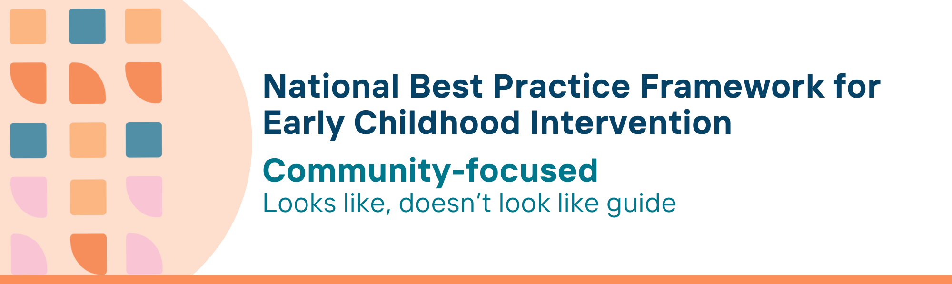

This resource has been specifically developed for Early Childhood Intervention (ECI) practitioners. While each set of Looks Like, Doesn’t Look Like examples align with a specific principle, they are grounded in all the universal principles of the Framework. Some of these Looks Like, Doesn’t Look Like examples may overlap with other principles. It is essential to consider the Framework as a whole when using these resources.
The Looks Like, Doesn’t Look Like examples below have been carefully curated based on feedback from consultations and contributions from consortium teams. However, this is not an exhaustive list. Please use these resources as a guide and incorporate other relevant factors as needed to best support your practice.

Community-focused

Looks like:
- Creating welcoming and inclusive community spaces where all children and families feel valued and accepted
- Ensuring all children can participate in community activities like recreation, education, and social and cultural events
- Providing information on accessible community resources, such as playgroups and libraries to all families
- Developing high-quality, inclusive, and sustainable programs that reflect community knowledge and support children and families
- Using a variety of services like telepractice and fly-in-fly-out programs to bridge geographical gaps
- Supporting families in advocating for their needs within the community
- Combining the resources of, and using settings in, the local community and service ecosystem to actively foster service integration and community responsiveness
- Engaging in shared decision-making, mutual respect, and capacity-building approaches to empower communities
- Respecting family culture and practices and co-creating solutions that reflect cultural and social diversity
- Connecting parents, carers and family members to existing peer groups and parent support programs in the local community
- Embedding Aboriginal and Torres Strait Islander cultural knowledge, traditions, and practices in community programs and decision-making
- Partnering with Aboriginal and Torres Strait Islander Elders, leaders, and community-controlled organisations to co-design and deliver services
- Providing tailored resources in the community such as access to Auslan and interpreters to ensure full participation
- Sharing knowledge and understanding of early childhood developmental journeys (especially the first 2000 days), providing information to community members about where to ask for help (including parents, partners, families, extended family, Elders and others) to build everyone’s capacity to support children and families to thrive
- Providing flexible, place-based support that is adapted to recognise and fit the diversity of cultures and circumstances of local communities

Doesn’t look like:
- Working in segregated settings and assuming it is not their role to make children and families feel included
- Failing to focus on child and family participation in community activities, thus, limiting access and involvement due to lack of accommodations or awareness
- Not informing families about available community resources, leading to missed opportunities for engagement and inclusion
- Ignoring community strengths, resources, expertise and knowledge in designing programs and services
- Not utilising or advocating for alternative forms of services, leaving families without necessary support
- Advocating at individual level or not at all, assuming it is not part of their work
- Using funded time to design resources that already exist in the community leaving families segregated and depleted of funding
- Making top-down decisions that exclude community voices
- Ignoring cultural and social diversity in program planning and implementation
- Assuming existing community programs will not be useful, or that the family is not ready, and withholding them from such community supports
- Ignoring or failing to acknowledge Aboriginal and Torres Strait Islander perspectives and ways of knowing, being and doing
- Implementing services without consulting or collaborating with Aboriginal and Torres Strait Islander communities
- Expecting children and families to navigate community spaces without appropriate communication support or accommodation
- Assuming it is not their responsibility to share this knowledge, feeling uncomfortable or too afraid to ask for help, or neglecting to engage with community members, thereby missing opportunities to build collective capacity to support children
- Believing that adapting support to fit diverse cultures and circumstances is too challenging or failing to acknowledge the importance of cultural and situational differences, resulting in rigid, one-size-fits-all support

© UoM 2025. National Best Practice Framework for Early Childhood Intervention (a joint collaboration between Healthy Trajectories, the Melbourne Disability Institute, STRONG Kids STRONG Future at the University of Melbourne, and the Murdoch Children’s Research Institute (MCRI), Professionals and Researchers in Early Childhood Intervention (PRECI), SNAICC – National Voice for our Children, Children and Young People with Disability Australia, and ACD – Advocating for Children with Disability). Commissioned by the Department of Social Services.
This work is copyrighted to The University of Melbourne under a creative commons license, CC-BY-NC-ND. This material contains and draws upon Indigenous Cultural and Intellectual Property (ICIP) contributed by SNAICC and its members and staff and is used with their consent. Dealing with any part of the materials containing ICIP for any purpose that has not been authorised by the custodians is a serious breach of customary laws. You must handle ICIP accordingly when exercising the Creative Commons Licence described above.
For more information about copyright please visit https://healthy-trajectories.com.au/eci-framework/

