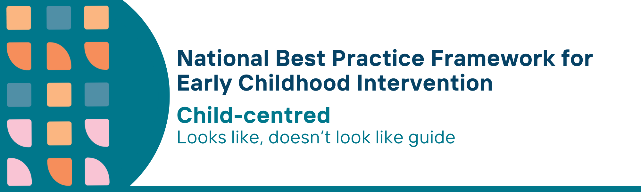

This resource has been specifically developed for Early Childhood Intervention (ECI) practitioners. While each set of Looks Like, Doesn’t Look Like examples align with a specific principle, they are grounded in all the universal principles of the Framework. Some of these Looks Like, Doesn’t Look Like examples may overlap with other principles. It is essential to consider the Framework as a whole when using these resources.
The Looks Like, Doesn’t Look Like examples below have been carefully curated based on feedback from consultations and contributions from consortium teams. However, this is not an exhaustive list. Please use these resources as a guide and incorporate other relevant factors as needed to best support your practice.

Child-centred

Looks like:
- Identifying activities that children like to do by themselves or with others to build on their strengths and interests
- Observing, listening and involving children in making decisions about things that matter to them
- Maintaining knowledge of current research about child learning, development, participation and wellbeing
- Understanding, the individual impact of delay or disability on the child’s learning, development, participation and wellbeing
- Ensuring and advocating for children to have fun and friendships, irrespective of developmental concerns, delay or disability
- Understanding that there is no single "right" way to think, learn, or behave
- Partnering with parents, carers, families, peers and others in the community to create enjoyable, play-based and incidental learning opportunities within daily routines that allow for practice
- Developing goals with the child, parents, and carers that build on their strengths, their interactions and learning opportunities
- Sharing information about how children learn and develop through play and practice in all their daily activities and interactions with peers, siblings and adults
- Responding promptly and positively to children’s attempts to engage in interactions with siblings and peers during everyday activities and routines
- Providing children with explicit, timely, clear feedback and consequences to increase participation, play, learning and skill development
- Talking with the child, parents, carers, and families about children’s safety first, while considering mandated obligations regarding child safety and wellbeing
- Understanding, identifying, and responding to the differential impact of trauma

Doesn’t look like:
- Designing activities that exclusively focus on skill deficits or are not functional, fun, or satisfying for the child
- Overlooking opportunities for children to choose their goals, strategies, and settings, while disregarding their interests and failing to ensure goals are meaningful and relevant
- Using specialised strategies based on professional experience alone, without considering child, parent, carer and family values, wisdom and the best available research
- Using a “one-size-fits-all" approach and strategies without considering children’s individual development, interests, strengths and preferences
- Focusing on children’s deficits in all interactions, forgetting that they are children first
- Expecting all children to respond to interventions in the same way or trying to "fix" behaviours that are different from the norm while trying to make the child conform to typical behaviours or ignoring their unique ways of interacting with their environment
- Teaching specific skills through massed repetition in a contrived setting with no clear functional or participation and wellbeing outcomes
- Developing goals that only focus on deficits or problems to be fixed
- Suggesting or using the “more is better” approach for service provision
- Prioritising adult interactions without providing balanced opportunities for peer interactions
- Providing vague or generalised feedback not involving the child
- Not considering children’s safety and wellbeing as part of their role
- Not considering children's socio-emotional-behavioural development and family functioning in relation to trauma

© UoM 2025. National Best Practice Framework for Early Childhood Intervention (a joint collaboration between Healthy Trajectories, the Melbourne Disability Institute, STRONG Kids STRONG Future at the University of Melbourne, and the Murdoch Children’s Research Institute (MCRI), Professionals and Researchers in Early Childhood Intervention (PRECI), SNAICC – National Voice for our Children, Children and Young People with Disability Australia, and ACD – Advocating for Children with Disability). Commissioned by the Department of Social Services.
This work is copyrighted to The University of Melbourne under a creative commons license, CC-BY-NC-ND. This material contains and draws upon Indigenous Cultural and Intellectual Property (ICIP) contributed by SNAICC and its members and staff and is used with their consent. Dealing with any part of the materials containing ICIP for any purpose that has not been authorised by the custodians is a serious breach of customary laws. You must handle ICIP accordingly when exercising the Creative Commons Licence described above.
For more information about copyright please visit https://healthy-trajectories.com.au/eci-framework/

