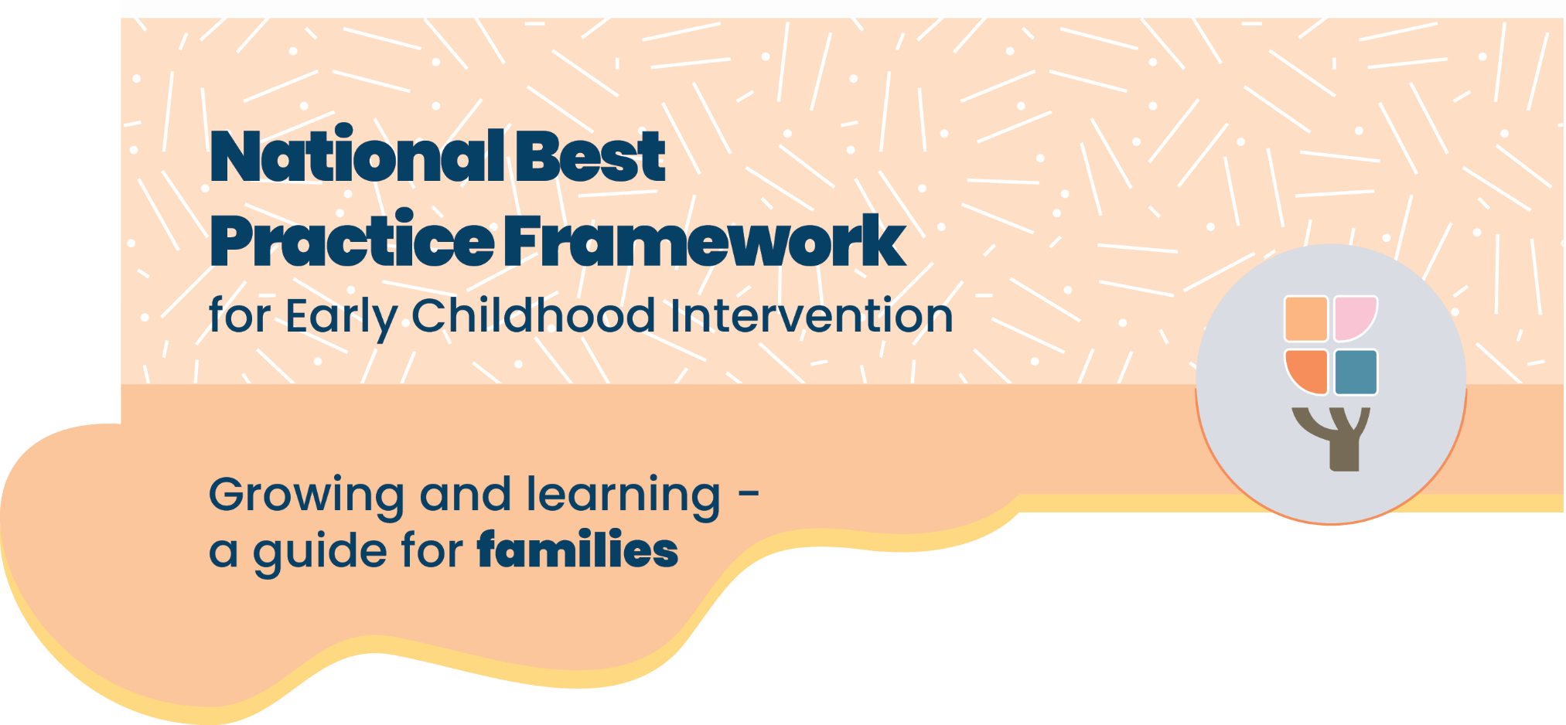

# Helping your child grow and learn

### All children, including those with developmental concerns, delays or disabilities, need love, support and the chance to learn new things. Here are some simple ways you can help every day:

#### **Play, laugh, connect**

Spending time playing, cuddling and talking with your child helps their brain and body grow. The more you connect, the more they thrive.

#### Focus on strengths

Start with what your child can already do and build from there. This boosts their confidence and helps them learn new skills.

#### Talk and listen

Talk to your child about everyday things and listen when they communicate in any way—words, pictures, gestures or sounds. It shows them they’re understood.

#### Use daily routines

Daily routines help children feel safe and give them chances to practice new skills.

#### Use helpful tools

Specialist equipment or changing the space at home or in their classroom can help your child move, sit, or communicate.

#### Work with your team

You know your child best. Share what’s working and what matters to your family. Together with professionals and teachers, you can create the best support for your child.

#### Find balance

Make time for fun, rest and being together as a family. These moments are just an important as early childhood intervention.

#### Take care of you

Hearing your child has a delay or disability can feel overwhelming. It’s OK to feel unsure. Looking after your own wellbeing helps your whole family.

#### Connect with others

Talking with other families in similar situations can be a big help. There are many ways to connect—online or in person, with all kinds of groups.

Practitioners are only a small part of the week. The big changes happen in everyday moments.

# **The National Best Practice Framework**

* This guide is based on the National Best Practice Framework for Early Childhood Intervention.
* The framework helps you know what to expect from early childhood intervention.
* The framework will help you feel confident that you’re doing the best for your child

## **What is early childhood intervention?**

#### Who is it for?

Early childhood intervention supports families raising children with developmental concerns, delay or disability (from birth up to 9).

#### What does it include?

Early childhood intervention services are provided by a range of professionals, for example speech pathologists, occupational therapists, physiotherapists or psychologists. In this guide we call them practitioners.

#### Who is involved?

Practitioners work closely with families, your child, and other important people in your child’s life.

#### What is the aim of early childhood intervention?

To help your child grow, learn, and enjoy life and help you as a family best support your child’s development

# Where can I find more information?

You can find more information about the National Best Practice Framework for Early Childhood Intervention online here: <https://healthy-trajectories.com.au/eci-framework/>

© UoM 2025. National Best Practice Framework for Early Childhood Intervention (a joint collaboration between Healthy Trajectories, the Melbourne Disability Institute, STRONG Kids STRONG Future at the University of Melbourne, and the Murdoch Children’s Research Institute (MCRI), Professionals and Researchers in Early Childhood Intervention (PRECI), SNAICC – National Voice for our Children, Children and Young People with Disability Australia, and ACD – Advocating for Children with Disability). Commissioned by the Department of Social Services.

This work is copyrighted to The University of Melbourne under a creative commons license, CC-BY-NC-ND. This material contains and draws upon Indigenous Cultural and Intellectual Property (ICIP) contributed by SNAICC and its members and staff and is used with their consent. Dealing with any part of the materials containing ICIP for any purpose that has not been authorised by the custodians is a serious breach of customary laws. You must handle ICIP accordingly when exercising the [Creative Commons Licence](https://creativecommons.org/licenses/by-nc-nd/4.0/) described above.

For more information about copyright please visit <https://healthy-trajectories.com.au/eci-framework/>