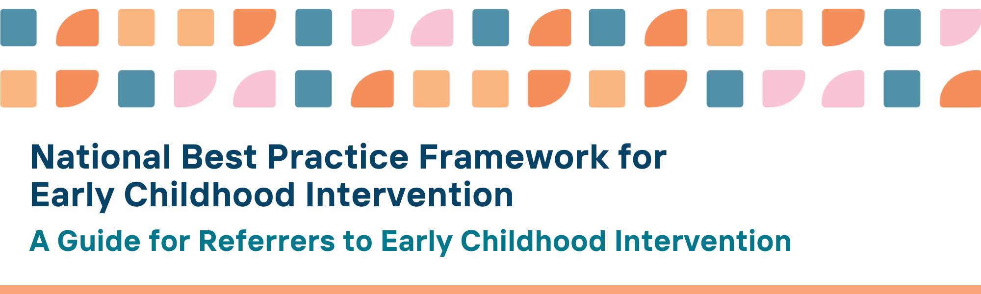

Our vision: All children with developmental concerns, delay or disability and their families thrive in the early years
The National Framework for Best Practice in Early Childhood Intervention (the Framework) describes what high-quality, evidence-informed practice looks like to support children with developmental concerns, delay or disability, their parents, carers, and families.
The aim of this guide is to engage with and support professionals referring children and families to early childhood intervention to understand best practice, and to know what to expect from, and how to work with, early childhood intervention practitioners.

The Framework describes
- the vision and aims for children with developmental concerns, delay or disability and their families
- desired outcomes for children, parents, carers, families, communities, and services
- principles for guiding best practice
- practices, tools and resources for practitioners in the early years across early childhood intervention, education and health, and community services
- and provides guidance for parents, carers and families on what to expect from early childhood intervention

The Framework is designed to be used by
- parents, carers and families of children with developmental concerns, delay or disability
- universal services (such as education and health services) supporting children, parents, carers and families
- specialist and community-based support services (such as child and family services, mental health services, social services)

Implications of the Framework for professionals referring to early childhood intervention services
Professionals in health, education, and community services are usually the first point of contact with children with developmental concerns, delay or disability and their families.
As such, they need to keep abreast of current, changing policy and service landscape, to ensure they refer children and families to the most appropriate supports on a coordinated and timely basis.
Professionals in health, education, and community services are in an optimal position to share information with parents, carers, families and other service providers to support their understanding of best practice in early childhood intervention, as well as model what best practice looks like in their interactions with parents, carers and families.
To assist in their role as referrers to early childhood intervention services, this resource provides guidance on the Framework, which seeks to improve outcomes for children and families.
Applying best practice requires referrers to
- understand and use the principles of the Framework themselves, focusing on building family capability
- focus on strong and collaborative approaches with other professionals and services to foster a positive and smooth service pathway for children and families
- understand and protect the rights of children, ensuring they are safe and free from discrimination, neglect and harm
- recognise that positive and nurturing relationships are critical for children to thrive
- build on child, family and community knowledge, capabilities, and resources recognise families’ fundamental role in their children’s, learning, development, well-being
- understand the impact of socioeconomic, political, social, cultural and physical circumstances and influences on children’s and families’ core needs
- promote children’s voice, identity and emotional and behavioural wellbeing
- provide support and services that are culturally safe for Aboriginal and Torres Strait Islander children, families, and communities.
- value and respect the abilities, race, culture, ethnicity, religion, gender, and sexual orientation status of children and families
- ensure children participate and are meaningfully involved in everyday places and spaces where they learn, develop and spend time
- value the importance of teamwork with practitioners from other disciplines to meet the goals of children, parents, carers and families
- create welcoming and inclusive community environments where children and their families feel valued and accepted, fostering a sense of belonging
- develop, measure, and monitor outcomes for children, parents/carers and families
- ensure children and families have access to evidence-informed early childhood intervention practices

We know this is working well when…

Children, parents, carers and families
- have timely and effective access to services and supports that meet their core and additional needs
- are able to smoothly navigate the service system in order to meet their goals
- have access to professionals and services working together, based on strong, collaborative and coordinated approaches
- are positively engaged with relevant services that are using evidence-informed practice
- have access to information and support if there is a need to wait for specialist services
- have increased capabilities, meaningfully participate in their community and can access and advocate for services

Professionals
- have and maintain positive and trusting relationships with children, parents, carers and families
- build on the strengths (rather than deficits), interests, and priorities of children, parents, carers and families from the first point of contact
- use evidence- and trauma-informed observations and resources to identify children’s developmental concerns, delay or disability early
- assist parents, carers and families to understand information and resources relevant to their child’s developmental concern, delay or disability
- understand and identify the impact of socioeconomic, cultural, social and physical factors on children’s learning, development and families’ agency and wellbeing
- know and facilitate access to relevant resources and settings in the local community and service ecosystem, including peer support services for parents, carers and families
- actively foster connection, collaboration and coordination with universal and specialised services, and communities
- provide information to children and families on accessible community resources

Access Tools and Resources for the National Best Practice Framework for Early Childhood Intervention
You can find more information about the National Best Practice Framework for Early Childhood Intervention online here: https://healthy-trajectories.com.au/eci-framework/
- Practice guidance
- Looks like/doesn’t look like practice tools
- Podcasts
- Videos
- Family resources
- Read about how the Framework was developed

© UoM 2025. National Best Practice Framework for Early Childhood Intervention (a joint collaboration between Healthy Trajectories, the Melbourne Disability Institute, STRONG Kids STRONG Future at the University of Melbourne, and the Murdoch Children’s Research Institute (MCRI), Professionals and Researchers in Early Childhood Intervention (PRECI), SNAICC – National Voice for our Children, Children and Young People with Disability Australia, and ACD – Advocating for Children with Disability). Commissioned by the Department of Social Services.
This work is copyrighted to The University of Melbourne under a creative commons license, CC-BY-NC-ND. This material contains and draws upon Indigenous Cultural and Intellectual Property (ICIP) contributed by SNAICC and its members and staff and is used with their consent. Dealing with any part of the materials containing ICIP for any purpose that has not been authorised by the custodians is a serious breach of customary laws. You must handle ICIP accordingly when exercising the Creative Commons Licence described above.
For more information about copyright please visit https://healthy-trajectories.com.au/eci-framework/

