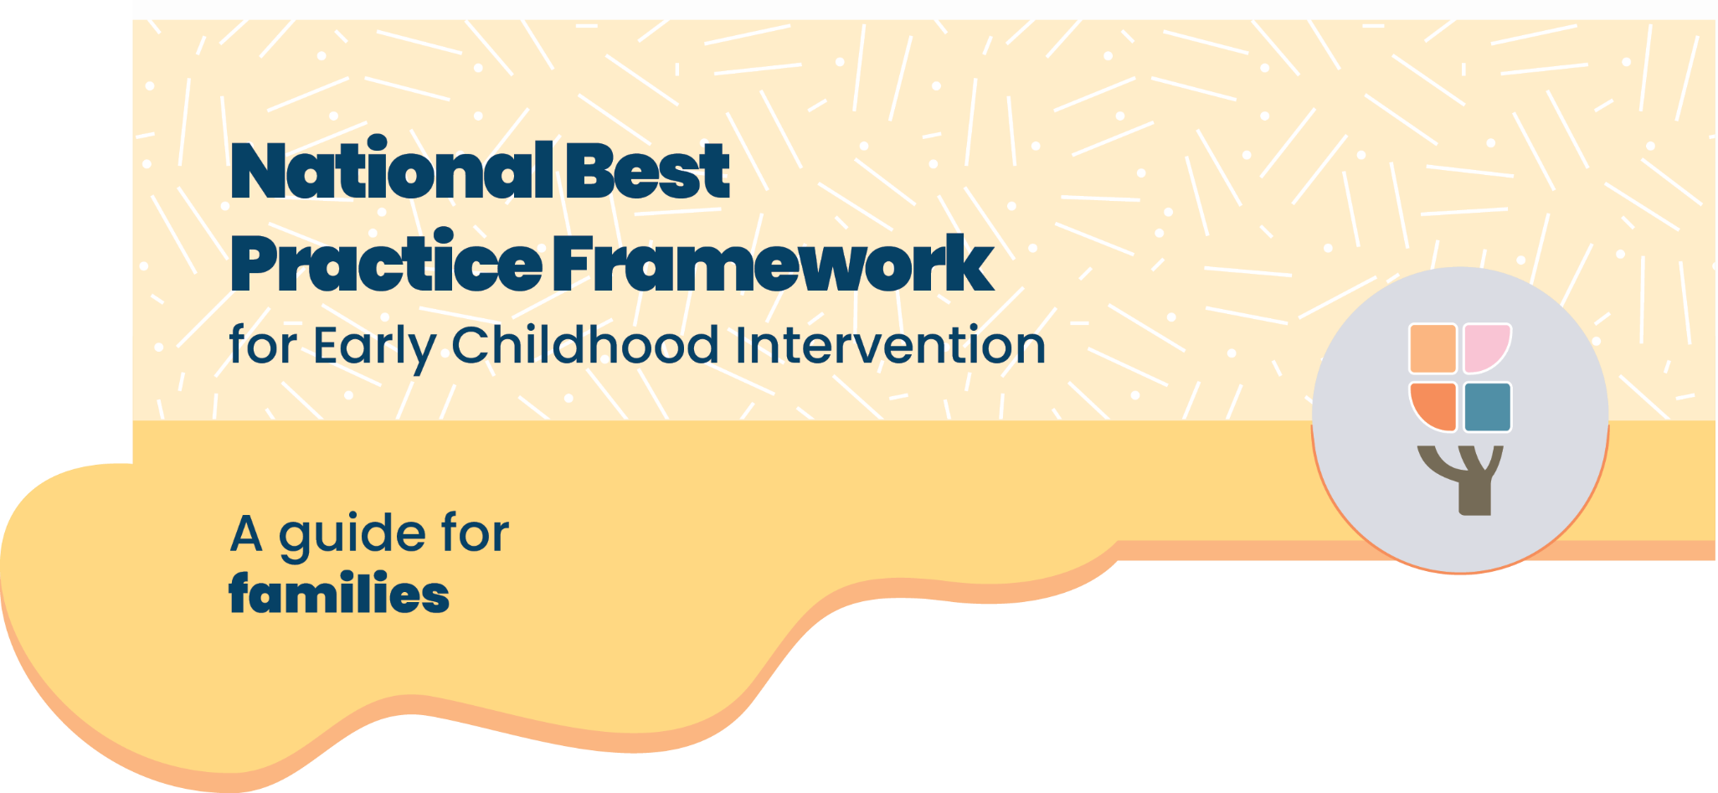

The National Best Practice Framework
- This guide is based on the National Best Practice Framework for Early Childhood Intervention.
- The framework helps you know what to expect from early childhood intervention.
- The framework will help you feel confident that you’re doing the best for your child
What is early childhood intervention?

Who is it for?
Early childhood intervention supports families raising children with developmental concerns, delay or disability (from birth up to 9).

What does it include?
Early childhood intervention services are provided by a range of professionals, for example speech pathologists, occupational therapists, physiotherapists or psychologists. In this guide we call them practitioners.

Who is involved?
Practitioners work closely with families, your child, and other important people in your child’s life.

What is the aim of early childhood intervention?
To help your child grow, learn, and enjoy life and help you as a family best support your child’s development

Where can I find more information?
You can find more information about the National Best Practice Framework for Early Childhood Intervention online here: https://healthy-trajectories.com.au/eci-review/

What does best practice early childhood intervention look like?

For your family
- You are respected as the expert on your child
- You’re involved in all decisions
- Helps you use daily play and routines to build your child’s skills
- Siblings and other family members are welcomed and included
- You feel more confident to support your child

For your child
- Practitioners focus on your child’s strengths and interests
- Support happens at your child’s pace, through fun play-based activities
- Your child’s way of communicating is respected, and they are listened to
- Practitioners help your child feel good about themselves
- It’s not about “fixing”, it’s about helping your child thrive

From your practitioner
- Services are based on evidence
- They respect your family’s culture and values
- You get information that is easy to understand
- You get help to connect with other families and help to access other useful services
- They work with your child’s educators and teachers, so your child gets the support they need to join in learning

What is the most effective early childhood intervention?
- Children learn best through daily routines like mealtime, playtime, or getting dressed
- It’s most effective to see your practitioner at home, at your child’s preschool, or even in the playground
- Practitioners help you use daily routines and play to support learning and development
- They may suggest equipment or changes at home or in the classroom to help your child move, communicate and join in
- It can be helpful to have family-only sessions (without your child)
- If you see your practitioner at their office or through telehealth, they still support your daily routines at home and can work with your child’s educators and teachers

How much early childhood intervention is best?
Families often ask how often they should see their practitioner. There’s no one-size-fits-all answer. What matters most is how you use everyday moments to support your child.
- It can be good to start with one practitioner and only add others if needed
- The frequency of appointments can change over time, it’s okay to take breaks
- It’s just as important to have family time, rest and do fun things together

How do we know if early childhood intervention is working?
You and your practitioner will set short-term and long-term goals that matter to your family.
You’ll regularly check in on progress through observation, play or assessments, your practitioner will update you and celebrate every step forward, big or small.

What do we do if something doesn’t feel right?
If you’re unsure about your practitioner’s approach:
- Compare what they do with the guide above
- Talk to them about your concerns
- Speak to their manager or another trusted professional
- You can change practitioner
Make sure there is enough time for just being a family and doing ordinary things. That’s what’s really important.

Where can I find more information?
You can find more information about the National Best Practice Framework for Early Childhood Intervention online here: https://healthy-trajectories.com.au/eci-framework/
© UoM 2025. National Best Practice Framework for Early Childhood Intervention (a joint collaboration between Healthy Trajectories, the Melbourne Disability Institute, STRONG Kids STRONG Future at the University of Melbourne, and the Murdoch Children’s Research Institute (MCRI), Professionals and Researchers in Early Childhood Intervention (PRECI), SNAICC – National Voice for our Children, Children and Young People with Disability Australia, and ACD – Advocating for Children with Disability). Commissioned by the Department of Social Services.
This work is copyrighted to The University of Melbourne under a creative commons license, CC-BY-NC-ND. This material contains and draws upon Indigenous Cultural and Intellectual Property (ICIP) contributed by SNAICC and its members and staff and is used with their consent. Dealing with any part of the materials containing ICIP for any purpose that has not been authorised by the custodians is a serious breach of customary laws. You must handle ICIP accordingly when exercising the Creative Commons Licence described above.
For more information about copyright please visit https://healthy-trajectories.com.au/eci-framework/

