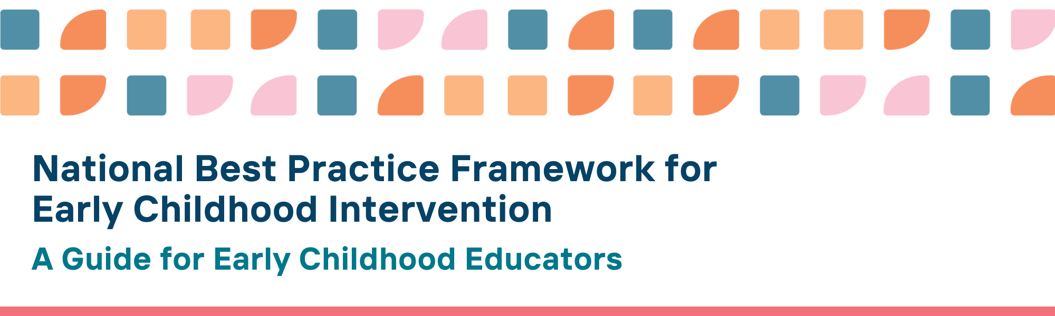

Our vision: All children with developmental concerns, delay or disability and their families thrive in the early years
The National Best Practice Framework for Early Childhood Intervention (the Framework) describes what high-quality evidence-informed early childhood intervention looks like to support children with developmental concerns, delay or disability, their parents, carers, and families.
The Early Years Learning Framework for Australia and the Framework align in their vision, principles, and practices. The aim of this guide is to engage with and support early childhood educators and early childhood intervention practitioners to work together to ensure our aligned vision and outcomes are achieved.
The Framework has been developed to support children with developmental concerns, delay or disability, their parents, carers and families, as well as universal, specialist and community services.

The Framework describes
- what high-quality evidence-informed practice looks like to support children with developmental concerns, delay or disability, their parents, carers, and families
- desired outcomes for children; parents, carers and families; communities; and services
- principles for guiding best practice
- practices, tools and resources for practitioners in the early years across education, health, community and specialist services
- what parents, carers and families can expect from early childhood intervention

Implications of the Framework for early childhood educators
Early childhood educators play a pivotal role in the development, learning, wellbeing and safety of all children, including children with developmental concerns, delay, or disability.
Early childhood educators are essential to creating quality, inclusive environments that support the meaningful participation of children of all abilities and their families, and to forming trusted relationships with parents, carers, and families.
The Framework seeks to improve outcomes for children with developmental concerns, delay or disability and their families by early childhood educators and early childhood intervention practitioners working together to
- identify and respond to emerging developmental concerns, delay or disability in a timely way
- understand and protect the rights of children, ensuring they are safe and free from discrimination, neglect and harm
- identify and build on the strengths of children and families
- build strong nurturing relationships with children and support peer to peer friendships among children and with informal supports in the community
- recognise families’ fundamental role in their children’s development, learning and well-being
- establish partnerships with parents, carers, families and other professionals
- build trusted relationships and engage with Aboriginal and Torres Strait Islander community-controlled organisations and leaders who are already trusted by families
- use observations, and strengths-based, culturally relevant and safe assessment tools to monitor progress
- communicate with and enable children, parents, carers and families to set their own meaningful and functional goals
- develop children’s learning outcomes as a team
- make reasonable adjustments to optimise access, participation and engagement in learning.
- implement evidence- and trauma-informed practices and strategies
- stay informed about policy developments in early childhood and early childhood intervention
- support each other in building knowledge, skills, and confidence
- understand and recognise the Early Years Learning Framework for Australia and the National Best Practice Framework for Early Childhood Intervention
- work with other local services, organisations and agencies to ensure that there is a clear understanding of roles, and flexibility to establish clear and shared pathways and resources for supporting children and families

We know this is working well when...

Children with developmental concerns, delay or disability
- enjoy access to experiences, interactions, opportunities and resources to participate meaningfully in early childhood education and care settings
- attend early childhood education and care regularly and are meaningfully involved in activities and routines
- have opportunities to learn, use and practice new knowledge and skills
- follow their interests and enjoy play opportunities with peers, and have the equipment and supports they need

Parents, carers and families raising children with developmental concerns, delay or disability
- feel they and their child are welcome and included in the early childhood settings in their community
- have positive views about their child’s strengths, developmental progress and functioning in the early childhood education and care setting
- make informed choices and decisions about evidence-informed and high-quality early childhood intervention and early childhood education and care services that best meet their needs
- are confident in advocating for their child and family
- report that services respect and prioritise the perspectives of Aboriginal and Torres Strait Islander peoples, families and children and are culturally safe

Early childhood educators and early childhood intervention practitioners
- work collaboratively with parents, carers, families and other services to focus on children’s strengths, interests and preferences
- embed learning in the early childhood education and care environment, routines and activities rather than withdrawing children from the learning environment for therapy
- provide the least intrusive adaptations to support learning
- promote generalisation of strategies across the early childhood education and care environment, home and other settings
- provide learning opportunities that support positive interactions with peers

Access Tools and Resources for the National Best Practice Framework for Early Childhood Intervention
You can find more information about the National Best Practice Framework for Early Childhood Intervention online here: https://healthy-trajectories.com.au/eci-framework/
- Practice guidance
- Looks like/doesn’t look like practice tools
- Podcasts
- Videos
- Family resources
- Read about how the Framework was developed

© UoM 2025. National Best Practice Framework for Early Childhood Intervention (a joint collaboration between Healthy Trajectories, the Melbourne Disability Institute, STRONG Kids STRONG Future at the University of Melbourne, and the Murdoch Children’s Research Institute (MCRI), Professionals and Researchers in Early Childhood Intervention (PRECI), SNAICC – National Voice for our Children, Children and Young People with Disability Australia, and ACD – Advocating for Children with Disability). Commissioned by the Department of Social Services.
This work is copyrighted to The University of Melbourne under a creative commons license, CC-BY-NC-ND. This material contains and draws upon Indigenous Cultural and Intellectual Property (ICIP) contributed by SNAICC and its members and staff and is used with their consent. Dealing with any part of the materials containing ICIP for any purpose that has not been authorised by the custodians is a serious breach of customary laws. You must handle ICIP accordingly when exercising the Creative Commons Licence described above.
For more information about copyright please visit https://healthy-trajectories.com.au/eci-framework/

