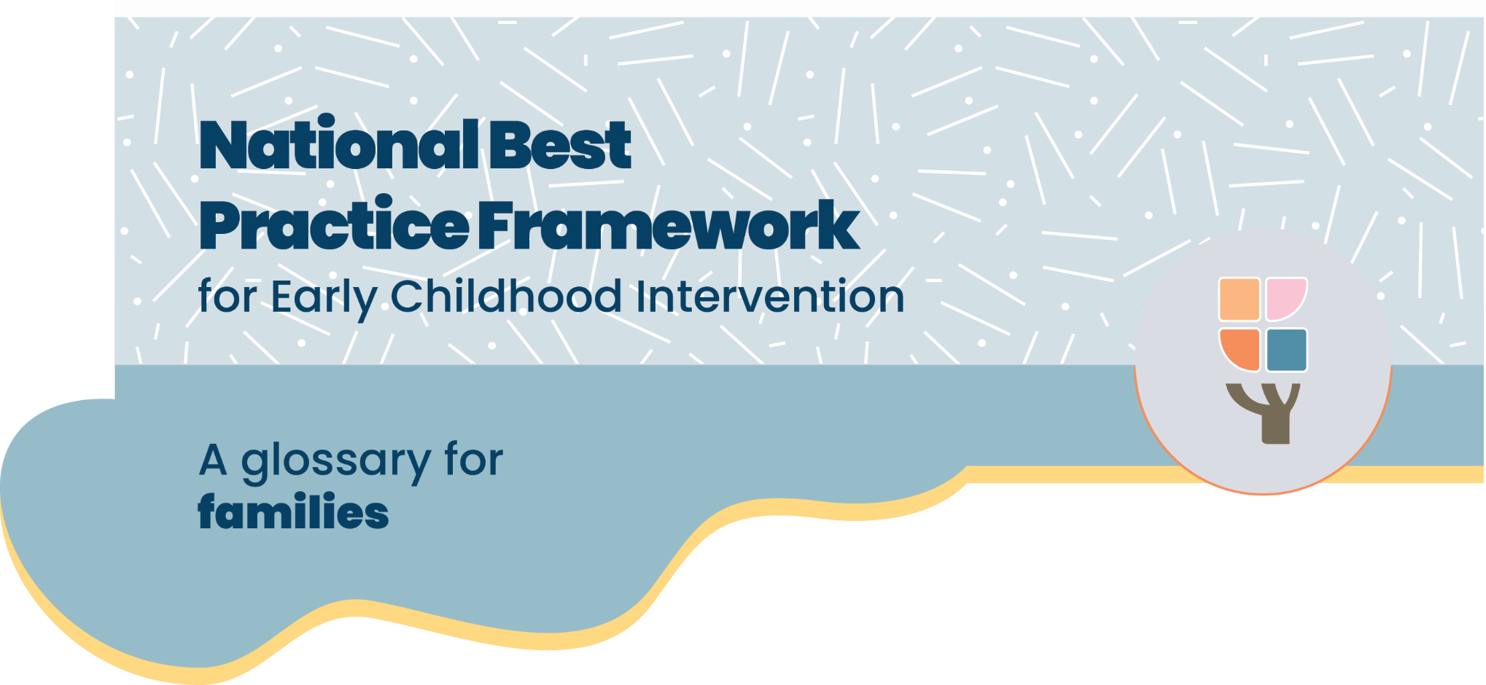

### Starting early childhood intervention can be a confusing time. This glossary explains some of the words that are used when talking about early childhood intervention.

#### AAC

AAC stands for Augmentative and Alternative Communication. Communication is more than talking. ACC can help children communicate through can be pointing, pictures or apps. Speech pathologists help children use AAC

#### Allied health practitioner

Trained health professionals who work with families to support their child’s development. Allied health includes speech pathologists, occupational therapists and physiotherapists

#### Child with disability

A child who has a life-long condition that affects how they move, see, hear, think, learn or feel.

#### Development

Development means changes in your child’s physical, social, emotional, behaviour, thinking and communication skills. All of these areas of development are linked, and each depends on and influences the others. It is more than walking, talking and toileting, it is also about children developing a sense of who they are and of belonging.

#### Developmental concern

Developmental concern is when families or professionals are worried about some aspect of a child’s development and are seeking more information and support.

#### Developmental delay

Developmental delay is when a child is taking longer to reach milestones than other children their age. This can include in areas like moving, talking, playing and doing things by themselves.

#### Early childhood intervention

Early childhood intervention supports families raising children with developmental concerns, delay or disability (from birth up to 9). Early childhood intervention services include speech pathologists, occupational therapists, physiotherapists and psychologists. Practitioners work closely with families to help your child grow, learn, and enjoy life and help you as a family best support your child’s development.

#### Early childhood approach

The way the NDIA helps children with disability and developmental concerns from birth to when they turn 9.

#### Evidenced-informed

Services are based on up-to-date knowledge, evidence and research as well as the knowledge of the family about their child

#### Every-day settings

Every-day settings are places like your home, a local park or your child’s preschool. It is most effective if you see your practitioner in an every-day setting.

#### Lead practitioner

An allied health, developmental or early childhood educator who is the main professional working with the family. This is sometimes called a Key worker. They help coordinate the team around the child, provide information and advice, emotional support, identify and address needs and support the family to develop self-advocacy skills.

#### NDIA

NDIA stands for National Disability Insurance Agency. The NDIA is the Australian government agency responsible for implementing and managing the NDIS.

#### NDIS

NDIS stands for National Disability Insurance Scheme. It is an Australian Government program that provides funding to eligible people for NDIS supports. This includes early childhood intervention and other support for children with disability and children younger than 6 years with developmental delay who meet the criteria for access to the scheme.

An early childhood partner is an organisation in your local area where you can go to find out more information about support for your child and apply for access to the NDIS. Or, you can contact the National Disability Insurance Agency (NDIA) directly.

#### Occupational Therapists (OT)

OTs work with families to support your child to do everyday activities, such and sleeping, playing, eating, getting dressed, and toileting. They also support you to improve your child’s fine motor skills like drawing and writing. OTs can help families manage sensory issues like sensitivity to noise or light.

#### Paediatricians

A paediatrician is a doctor who specialises in caring for children. Paediatricians check how children are developing and can diagnose health conditions and disabilities. Paediatricians work closely with families and other professionals like allied health practitioners.

#### Physiotherapists (Physio)

Physio’s work to improve physical movement and mobility, supporting families to help their children sit, stand and move. Physiotherapists prescribe wheelchairs and other Assistive Technology, like walkers or supportive seating.

#### Practitioner

Allied health professionals and others who provide early childhood intervention. It’s important to celebrate the wins and ask for help when needed.

#### Psychologists

Psychologists work with children and families to address emotional and behavioural concerns. They build your skills as a family to support your child to identify and cope with emotions and support positive behaviour.

#### Routines

Routines are the way you do things in your family, like mealtime or bedtime. Routines at home and in the classroom are the most effective way to give your child opportunities to learn and practice new skills.

#### **Speech** **pathologists**

Speech pathologists focus on building your skills as a family to help your child’s communication, including understanding what others are saying, and communicating, either by talking or using AAC. Speech pathologies also help children who have difficulty swallowing or eating.

#### Therapy assistants

A therapy assistant helps children and families use routines and strategies that an Allied health practitioner has helped the family develop. The Therapy Assistant is supervised by an Allied Health practitioner.

# **The National Best Practice Framework**

* This guide is based on the National Best Practice Framework for Early Childhood Intervention.
* The framework helps you know what to expect from early childhood intervention.
* The framework will help you feel confident that you’re doing the best for your child

## **What is early childhood intervention?**

#### Who is it for?

Early childhood intervention supports families raising children with developmental concerns, delay or disability (from birth up to 9).

#### What does it include?

Early childhood intervention services are provided by a range of professionals, for example speech pathologists, occupational therapists, physiotherapists or psychologists. In this guide we call them practitioners.

#### Who is involved?

Practitioners work closely with families, your child, and other important people in your child’s life.

#### What is the aim of early childhood intervention?

To help your child grow, learn, and enjoy life and help you as a family best support your child’s development

# Where can I find more information?

You can find more information about the National Best Practice Framework for Early Childhood Intervention online here: <https://healthy-trajectories.com.au/eci-framework/>

© UoM 2025. National Best Practice Framework for Early Childhood Intervention (a joint collaboration between Healthy Trajectories, the Melbourne Disability Institute, STRONG Kids STRONG Future at the University of Melbourne, and the Murdoch Children’s Research Institute (MCRI), Professionals and Researchers in Early Childhood Intervention (PRECI), SNAICC – National Voice for our Children, Children and Young People with Disability Australia, and ACD – Advocating for Children with Disability). Commissioned by the Department of Social Services.

This work is copyrighted to The University of Melbourne under a creative commons license, CC-BY-NC-ND. This material contains and draws upon Indigenous Cultural and Intellectual Property (ICIP) contributed by SNAICC and its members and staff, and is used with their consent. Dealing with any part of the materials containing ICIP for any purpose that has not been authorised by the custodians is a serious breach of customary laws. You must handle ICIP accordingly when exercising the [Creative Commons Licence](https://creativecommons.org/licenses/by-nc-nd/4.0/) described above.

For more information about copyright please visit <https://healthy-trajectories.com.au/eci-framework/>