Support at Home program – pooled care management funding and service delivery branches

Fact sheet for providers
This fact sheet gives guidance to providers on the allocation of pooled care management funds within a service delivery branch.
The pooled funding model for care management allows you to flexibly adjust support for participants based on their changing needs, rather than assigning a fixed number of care hours monthly for each participant. This will help you respond to urgent or evolving care needs.

Pooled care management funding
Support at Home participants receiving ongoing services will have 10% of their quarterly budget deducted for care management. This funding will be allocated to providers and pooled with the care management funding from all other participants within a service delivery branch.
Care management funding will be allocated to your care management account on 1 November 2025, so you can deliver care management services from the start of Support at Home.

Service delivery branches
On 1 November 2025, all notified home care services will automatically become service delivery branches. Services Australia will create and manage a care management account for each service delivery branch and will allocate care management funding to the care management account.
This change does not represent any intended operational changes for you.
Pooling of care management funds is at the service delivery branch level. To claim care management funds, you must have a service delivery branch and your Support at Home participants must be connected to your service delivery branch.

Registered provider structure from 1 November 2025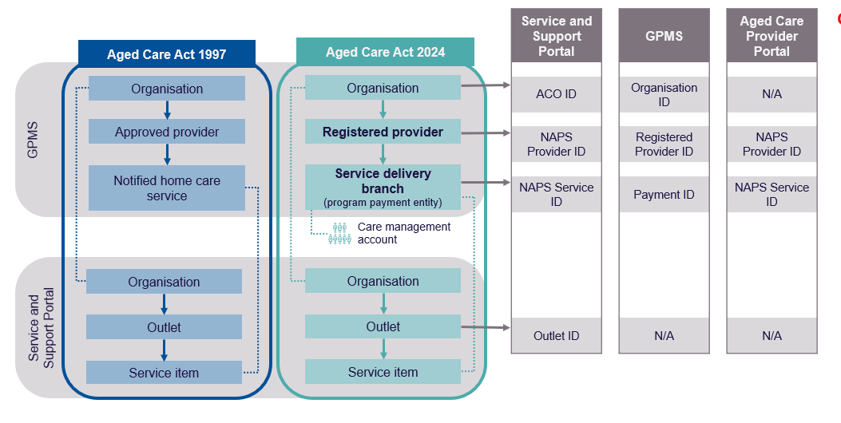What is a service delivery branch?
Under the new Aged Care Act, a service delivery branch is the place of business of the registered provider through which funded aged care services are delivered to an individual.
A service delivery branch is a type of program payment entity (PPE). It will have the same National Approved Provider System (NAPS) Service ID as before and claims will be made against the PPE.
You can configure your outlets in the My Aged Care Service and Support Portal to receive referrals for the services claimed under the service delivery branch. These services can be configured in different regions across one or more outlets.

Allocation of care management funding for transitioning HCP care recipients on 1 November 2025
From 1 November to 31 December 2025, care management funding will be credited to your care management account at a pro-rata rate by Services Australia. The amount credited on 1 November will be your daily provider base amount plus your care management supplement amount (as per 204-5 and 205-15 of the Aged Care Rules), multiplied by the number of days between 1 November to 31 December 2025.

Allocation of care management funding from 1 November 2025
A care management account is considered ‘new’ in the first and second quarter of its operation under Support at Home. The first quarter of operation for an account is determined by the date a start notification is received for the first participant connected to the care management account, after it is established.
Care management funding is allocated to new care management accounts on a pro-rata basis for participants joining mid-quarter. The amount is based on the start notification date and the remaining days in the quarter.
Care management accounts are considered ‘existing’ from the third quarter of operation. These accounts do not have care management funding allocated for the quarter in which the participant joins. Care management activities for the quarter should be funded from your established pooled care management funds.
You retain the full care management allocation for participants who exit care part way through a quarter.

Ongoing quarterly allocation of care management funding
From 1 January 2026, Services Australia will credit funding to care management accounts on the first day of each quarter. The first day of each quarter is 1 January, 1 April, 1 July and 1 October.
On the last day of each quarter, Services Australia will calculate the amount of funding to be allocated to each care management account for the next quarter. The last day of each quarter is the last day of December, March, June and September.
You must submit a valid start notification by 10 pm (by legal time in the Australian Capital Territory) on the last day of the quarter a participant joins, to ensure crediting for the participant on the first day of each quarter.
More information on the calculation and allocation of care management funding is in section 8.8 of the Support at Home program manual.

Management of pooled care management funding
You must be able to flexibly use care management funding to support the needs of new or moving participants.
If a participant exits during a quarter, you retain their allocation of care management funding. The exiting participant will not be included in the calculation of care management funding from the next quarter.
Unused care management funding from one quarter will rollover to the next quarter within the same financial year, with no cap on the rollover amount. However, the rollover amount between financial years is limited. Each service delivery branch can only rollover an amount equal to their 4th quarter (April) allocation, excluding any previous rollover funds.
If you are a new provider who starts operation in quarter 3 or quarter 4 of the financial year, there is no limit on the funds you can rollover to the next financial year.

