Stakeholder resource kit

Contents
About this toolkit 2
What’s in this toolkit 2
Key messages 2
Resources 3
Social media posts 5
More information 5

About this toolkit
This toolkit has information and resources to help communicate about aged care reforms with older Aboriginal and Torres Strait Islander people. It is for stakeholders of the Department of Health, Disability and Ageing.
Yarn with your community about aged care with our:
- Brochures and factsheets on what your community needs to know
- Videos about the reforms
- Social media tiles about the reforms you can post to your page

What’s in this toolkit
- Key messages
- Brochures and factsheets
- Videos
- Social media tiles

Key messages
- Aged care is changing so that eligible Aboriginal and Torres Strait Islander people aged 50 years or older have faster and simpler access to more culturally safe and appropriate aged care services.
- The Aged Care Act is the main law regulating the aged care system. It includes an important Statement of Rights.
- This means that older Aboriginal and Torres Strait Islander people have the right to:
  - get the information they need and choose what their care looks like
  - access top quality care that is culturally safe
  - have their privacy respected
  - raise issues when something isn’t right
  - speak in language and take part in cultural activities
  - stay connected to community and Country
- For more information visit MyAgedCare.gov.au or call 1800 200 422.

Resources
Resource | Preview | Link | Suggested use
Brochure 1 – What is aged care? | 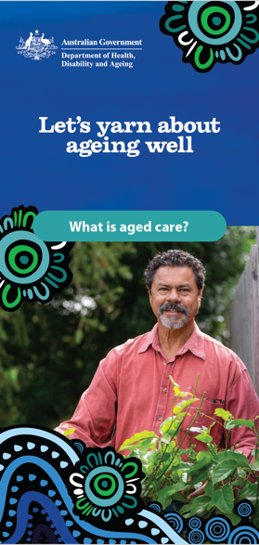 | Download here | Print for distribution in reception or waiting areas.  Add a download link to your website.
Brochure 2 – Getting ready for aged care | 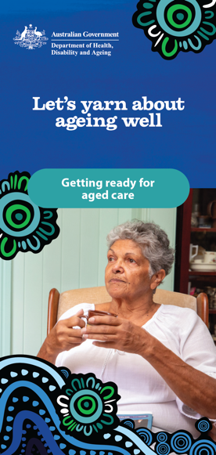 | Download here | Print for distribution in reception or waiting areas.  Add a download link to your website.
Brochure 3 – Aged care assessments and kinship care | 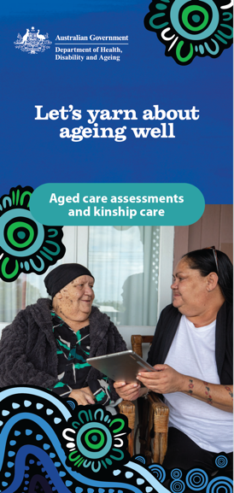 | Download here | Print for distribution in reception or waiting areas.  Add a download link to your website.
Brochure 4 – What is palliative care? |  | Download here | Print for distribution in reception or waiting areas.  Add a download link to your website.
Factsheet – Your rights and aged care | 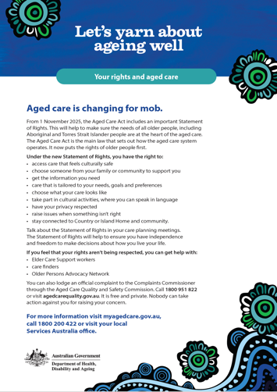 | Download here | Print for distribution in reception or waiting areas.  Add a download link to your website.
Video 1 – Strengthened Quality Standards  (3:11 mins duration) | 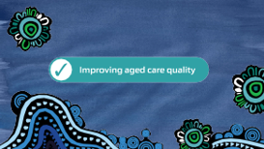 | Access here | Share on your website or social media channels.
Video 2 – Trusted Workforce (1:44 mins duration) |  | Access here | Share on your website or social media channels.
Video 3 – Statement of Rights (2:04 mins) | 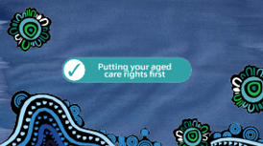 | Access here | Share on your website or social media channels.
Video 4 – Supporting your rights (3:08 mins) | 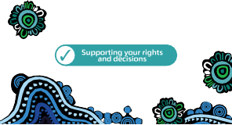 | Access here | Share on your website or social media channels.
Social media tile |  | Access here | Share on your social media channels.

Social media post
Below is a social media post to share about changes to the new Aged Care Act.
Channel | Copy | Social media tile
Facebook Instagram | Aged care is changing so that Aboriginal and Torres Strait Islander people aged 50 years or older have faster and simpler access to more culturally safe and appropriate aged care services.  The new Aged Care Act, including the Support at Home Program, will start on 1 November 2025.  Start the conversation about aged care today!  For more information visit MyAgedCare.gov.au or call 1800 200 422. | 

More information
For more information about aged care for Aboriginal and Torres Strait Islander people, visit health.gov.au/aged-care-for-mob

