



Evaluation of the care finder program

Second evaluation report

Australian Government Department of Health, Disability and Ageing

24 April 2025

© Commonwealth of Australia as represented by the Australian Government Department of Health, Disability and Ageing, 2025

Apart from uses permitted by the Copyright Act 1968 and this copyright notice, all other rights (including all commercial rights) are expressly reserved.

Permitted uses

You may download, display, print, and reproduce the whole or part of this publication in unaltered form for:

* your own personal use;
* use within your organisation; or
* distribution and sharing with third parties,

but only if:

* you or your organisation do not use or reproduce the publication for any commercial purpose; and
* if reproduced, this copyright notice and all disclaimer notices are included as part of any reproduction.

This licence does not cover, and there is no permission given for, use of the Commonwealth Coat of Arms or any logos and trademarks (including the logo of the Australian Government Department of Health, Disability and Ageing).

Disclaimer

This publication has been produced independently by Australian Healthcare Associates at the request of the Australian Government Department of Health, Disability and Ageing.

The Australian Government accepts no responsibility for material contained in the publication. Thes or recommendations expressed in this publication may include the views or recommendations of third parties and do not necessarily reflect those of the Australian Government or indicate a commitment to a particular course of action.

Providing access to the publication does not constitute an endorsement, approval or recommendation by the Australian Government of any organisation, association, entity, service, program, products or research offered by virtue of any information, material or content within the publication.

The information in this publication is provided on the basis that all persons accessing it undertake responsibility for assessing the relevance and accuracy of its content.

Suggested citation

AHA (Australian Healthcare Associates) (2025) Evaluation of the care finder program – Second evaluation report, report to the Australian Government Department of Health, Disability and Ageing, AHA.

Australian Healthcare Associates: Australia's largest health and human services consulting firm

Level 6, 140 Bourke St, Melbourne VIC 3000

Locked Bag 32005, Collins Street East, VIC 8006

1300 242 111

aha@ahaconsulting.com.au

www.ahaconsulting.com.au

Acknowledgement of Country

In the spirit of respect and reconciliation, Australian Healthcare Associates acknowledges the traditional custodians of Country, the Aboriginal and Torres Strait Islander peoples, and their continuing connection to land, waters, sea, and community.

Australian Healthcare Associates is located on the lands of the Kulin Nation. We pay respect to Elders past and present.

Acknowledgements

We are grateful for the support provided to us by staff in care finder organisations and Primary Health Networks for reporting their activities, facilitating and submitting surveys and sharing their experiences of the care finder program with us. Our thanks also go to referrers and intermediaries who shared their experiences and representatives of related initiatives who discussed the intersection of their program with the care finder program. Lastly, we gratefully acknowledge those clients who completed a feedback survey and spoke with us about their experiences with the program.

Contents

1 Summary 6

1.1 Key findings 6

1.2 Lessons learned and future opportunities 9

2 Context 14

2.1 About the program 14

2.2 About this evaluation 16

3 Program establishment 19

3.1 About the program 19

3.2 Training for care finders 23

4 Program support and oversight 26

4.1 Support for care finder organisations 26

4.2 Communities of practice 27

4.3 Support for care finders 28

4.4 Resources to deliver the program 29

4.5 Continuous program improvement 31

5 Program connections 35

5.1 Promotion of the program 35

5.2 Referral pathways into the program 37

5.3 Awareness of the program among intermediaries and referrers 39

5.4 Integration between the health, aged care and other systems 41

6 Services delivered 45

6.1 Connecting with clients 45

6.2 Supporting clients 50

7 Client characteristics and experiences 58

7.1 Client characteristics 58

7.2 Client experiences 63

7.3 Performance indicators related to client experience 66

8 Summary of program outcomes, successes and challenges 69

8.1 Short-term program outcomes 69

8.2 Program success by region 70

8.3 Medium – and long-term program outcomes 71

8.4 Program enablers 72

8.5 Program challenges and barriers 74

8.6 Unintended outcomes 76

9 Conclusion 77

9.1 Limitations 77

9.2 Final reflections 79

Abbreviations 103

Glossary 104

References 105

Tables

Table 1: Proportion of care finder activities delivered, by quarter 51

Table 2: Total number and proportion of external referrals made, by service type 54

Table 3: Proportion of surveyed clients who indicated that they are in the program’s target populations, by target population group 59

Table 4: Proportion of surveyed clients who identified with at least one special needs group, by special needs group 60

Table 5: Overall progress against PHN performance indicators, by quarter 66

Table 6: Progress towards short-term system outcomes 70

Table 7: Progress towards short-term client outcomes 70

Table 8: Evaluation questions and sub-questions 81

Table 9: PHN performance indicators used in this evaluation 85

Table 10: Activity reports submitted by CF organisations 89

Table 11: Intake reports submitted by CF organisations 90

Table 12: Data for Figure 2 94

Table 13: Data for Figure 3 94

Table 14: Data for Figure 4 95

Table 15: Data for Figure 5 95

Table 16: Data for Figure 7 96

Table 17: Data for Figure 8 96

Table 18: Data for Figure 9 96

Table 19: Data for Figure 10 97

Figures

Figure 1: Timeline of reporting, deliverables, and project activities 17

Figure 2: Care finder program staff FTE, by quarter 22

Figure 3: Total hours of assertive outreach, by quarter 46

Figure 4: New client cases, by quarter 47

Figure 5: Proportion of closed client case bands, by quarter 49

Figure 6: Care finder activities to support clients 50

Figure 7: Average number of outbounds referrals per new client case, by quarter 53

Figure 8: Age groups of My Aged Care clients, by support role 61

Figure 9: Indigenous status of My Aged Care clients, by support role 62

Figure 10: Who My Aged Care clients live with, by support role 62

Figure 11: Client agreement that they are satisfied with the outcome of the care finder process, by key demographics 64

Figure 12: Program logic for the care finder program 80

Figure 13: Timeline of reporting, deliverables, and project activities 84

# Summary

The Australian Government Department of Health, Disability and Ageing (the department) has engaged Australian Healthcare Associates (AHA) to evaluate the care finder program (the program). The program began on 1 January 2023 and forms part of the Australian Government’s response to the Royal Commission into Aged Care Quality and Safety (2021). The program is funded to establish a care finder network to provide specialist help to older Australians who need extra support to access aged care and other community supports. Primary Health Networks (PHNs) commission and manage care finder organisations (CF organisations) and are charged with integrating them into their local aged care and community support systems.

## Key findings

Below we summarise the key findings of the evaluation of the program. These findings relate to its implementation, appropriateness and effectiveness and are based on a range of quantitative and qualitative data collected over the first 2 years of the program. This data included documentation from the department, PHN reports, activity data submitted by CF organisations and consultations with clients, intermediaries, care finders and PHN representatives.

Broadly speaking, the program has met its short-term outcomes and is on track to meet its medium – and long‑term outcomes. It has strong support from care finders, PHNs, intermediaries and clients.

### Program establishment

A national care finder network was established in 2023 as planned, and there are currently 164 CF organisations providing specialist assistance to help clients understand and access aged care services and other relevant supports in the community.

All PHNs completed a supplementary needs assessment report in late 2022 to direct their planning for the program and commissioning of CF organisations. PHNs said needs assessment activities were a helpful mechanism to establish local connections and learn more about local services. Over the first 2 years of the program, PHNs have gained a greater understanding of local needs in relation to care finder support and built networks with aged care providers, intermediaries, and community organisations.

The Assistance with Care and Housing (ACH) program transitioned from the Commonwealth Home Support Programme (CHSP) to the care finder program on 1 January 2023 with support from the department (through webinars, emails, letters and individual assistance) and PHNs. Currently, former ACH program providers account for 54% (n = 89) of CF organisations. Services delivered under the care finder program are similar to former ACH program services, and their existing staff, networks and housing expertise meant these organisations could start delivering services more quickly than many other commissioned CF organisations.

Other (non-ACH) organisations were largely commissioned as planned and almost all organisations had commenced by 30 April 2023. Some PHNs struggled with what they perceived to be a short timeframe to complete their commissioning activities. PHNs greatly valued the deep connections that their commissioned CF organisations have with other relevant services in the community, their understanding of local community’s needs, and their knowledge of appropriate ways to connect with the program’s target population.

Most CF organisations were able to recruit staff as planned and there currently 550 full-time equivalent (FTE) CF organisation staff working on the program, with around three‑quarters in the care finder role. Recruiting and retaining staff in regional and remote areas has been more challenging for a range of reasons, including the more limited pool of potential candidates.

The department created mandatory online program induction training for care finders and PHNs which is delivered on the MAClearning portal and takes approximately 2.5 hours. While this induction training was helpful, care finders also complete a range of other supplementary training to help them better meet the complex needs of the client cohort. However, they often struggle to find the time for additional training due to the demands of their client-facing work.

### Program support and oversight

The department has provided regular program, training and broader sector updates to PHNs throughout the program’s first 2 years of operation. Care finders have received direct support from their commissioning PHN, their CF organisation and other commissioned CF organisations in the region. Early guidance from PHNs, through communities of practice (CoP) and early consultation, set CF organisations up for success and greatly helped program implementation.

CoP have uniformly been seen by care finders as a valuable platform for strategic collaboration and to share lessons learned, build capacity, and drive continuous improvement. In some regions, however, PHN or CF organisation workforce issues have disrupted the continuity of meetings or attendees’ ability to participate or engage meaningfully in discussions.

PHNs that actively engaged with intermediaries such as GPs and other local health services were better able to integrate the program into the broader healthcare system and increase its visibility. Where there was less collaboration between PHNs and CF organisations, care finders were unclear on how the program had been promoted by PHNs, if at all, and what gaps they needed to address.

While a few PHNs reported underspends, financial and workforce limitations pose significant hurdles in other regions. Travel costs associated with delivering intensive, face-to-face support to clients in rural and remote areas were also higher than some organisations had budgeted.

### Program connections

While the program has deliberately not been promoted nationally to potential clients, the department has engaged with other government agencies (e.g. Services Australia) and My Aged Care to introduce the program to referrers and intermediaries and define appropriate referral pathways into the program. Intermediaries reported that while the program is becoming better known, ongoing awareness raising of the program is needed so that more people understand its scope, target population and referral pathways.

PHNs and CF organisations have developed referral pathways into the program and in late 2024 care finders reported receiving a higher number of appropriate referrals compared to earlier in the program. The department has also developed referral pathway resources to reduce the number of inappropriate referrals into the program and explain pathways for certain cohorts, including First Nations peoples and people below 65 years.

Awareness of the program among My Aged Care contact centre staff and call wait times have improved; however, care finders are still reporting challenges completing some tasks for clients that require input from contact centre staff, which suggests that further refinement of contact centre processes is needed.

### Services delivered

Since the start of the program, more than 40,000 new client cases have been reported by CF organisations, and the number of new client cases in 2024 is now stable at an average of approximately 5,700 new client cases per quarter.[1] As of 31 December 2024 there are almost 12,000 active care finder client cases.

Care finders are delivering a range of activities to support their clients, centring around engaging and building rapport with their clients and assisting them to find their required supports. About half of services are being delivered in person, which aligns with the program’s policy guidance.

Over the first 2 years of the program, the number of support hours clients are receiving has increased, which reflects care finders’ ability to better identify clients in the target population who typically have high support needs. In the last quarter of 2024 (1 October 2024 to 31 December 2024), 70% of client cases involved 5 or more support hours.

Combined, care finders are also undertaking between 18,500 and 20,000 hours of assertive outreach activities in each quarter to complement their promotion work. There is substantial variation in the hours of assertive outreach reported by CF organisations, which could reflect how organisations are reporting this activity or variation in the existing networks organisations can tap into.

Since the beginning of the program, CF organisations have reported a total of 130,295 outbound referrals, commonly to aged care services, homelessness supports and health services.

A valued feature of the program is high level check-ins, whereby care finders reconnect with the client within the first 2 months of services starting to check whether these services are appropriate for their needs. These check-ins are highly regarded by clients and intermediaries but may restrict the capacity of care finders to support new client cases as issues can be identified during the check-ins that necessitate a new case being opened.

A recurring challenge for care finders has been the lack of aged care services and housing services in most regions to refer clients to. This lack of services, coupled with the complexity of clients’ needs (requiring services from multiple providers), has meant care finders report that they are assuming more of a care management role and working outside the scope of the program.

### Client characteristics and experiences

The program is targeted at older Australians who are eligible for government-funded aged care but need intensive support to access services. CF organisations report that almost all clients receiving program services are in the target population and 82% of clients agree that they belong to at least one of the target population groups. Clients most commonly indicated that they live alone and need more support to access aged care services. Almost three-quarters of clients also identified as a member of at least one special needs group defined in the Aged Care Act 1997.[2] Half of surveyed clients said they were financially or socially disadvantaged, and one‑third said they came from a culturally and/or linguistically diverse background.

Pleasingly, most clients reported positive experiences with the program:

* 92% found the care finder program easy to access
* 96% found the care finder service appropriate for their needs
* 92% were satisfied with the referrals they received
* 97% found the CF organisation to be trustworthy
* 95% were satisfied with the outcome of the care finder process.

## Lessons learned and future opportunities

We identified 9 lessons learned from the program’s first 2 years of implementation:

1 Initial and ongoing training on handling complex cases, such as clients who are experiencing homelessness or mental health issues, would help set care finders up for success.

Future opportunities:

The department’s Navigation and Access Branch could consider:

* reviewing MAClearning training to ensure it accounts for the complexity of care finder clients and their circumstances and including content on trauma informed care and homelessness
* strengthening the contractual requirements for PHNs to ensure that PHN staff and care finders possess a baseline knowledge of how to manage complex cases and support people experiencing homelessness
* updating the policy guidance to specify in greater detail the core competencies that care finders should possess.

PHNs could consider:

* ensuring their commissioned CF organisations have access to training resources linked to the core competencies specified in the updated policy guidance
* leveraging care finders’ expertise and experience to help support and train their other commissioned CF organisations.

2 CF organisations and PHNs in rural and remote areas have access to a smaller pool of qualified staff, services and IT resources, which presents a risk to continuous program delivery.

Future opportunities:

The department’s Navigation and Access Branch could consider:

* working with PHNs and regionally based department staff to better understand the unique challenges faced in rural and remote areas and together develop strategies to mitigate recruitment and training challenges
* re-examining funding for rural and remote PHNs to ensure it adequately covers required travel and infrastructure such as IT systems
* considering joint funding models in remote areas with thin markets to allow qualified personnel to work across multiple similar programs (e.g. Elder Care Support program, National Aged Care Advocacy Program and the National Disability Insurance Scheme).

PHNs could consider:

* encouraging CF organisations in their regions to collaborate and share resources to support staff in rural and remote areas (particularly in those with fewer than 1 FTE staffing).

3 Communities of practice have been critical to the program’s success.

Future opportunities:

The department’s Navigation and Access Branch could consider:

* strengthening PHNs’ contractual obligations around coordinating and maintaining CoP, for instance, stipulating PHNs’ responsibilities and a minimum frequency of meetings and ensure this is captured in PHN reporting.

PHNs could consider:

* ensuring that at least one CoP meeting each year is in person, where resources allow, in recognition of the benefits of face-to-face interactions and exchange
* regularly inviting representatives from other relevant programs and roles (e.g. aged care assessors, ACSOs, Elder Care Support program officers) to meetings to build mutual understanding of each program, strengthen referral pathways and improve the appropriateness of referrals.

4 Mechanisms to support care finders succeed in their role are critical considering the complexity of clients and systemic barriers they face when delivering services.

Future opportunities:

The department’s Navigation and Access Branch could consider:

* ensuring PHNs are providing support and training to care finders on vicarious trauma and self-care.

PHNs could consider:

* ensuring CF organisations have comprehensive systems in place to support staff such as peer support, mentoring and debriefing opportunities.

5 Relying on PHNs to disseminate department communications to CF organisations by email has resulted in some CF organisations missing out on the information they need.

Future opportunities:

The department’s Navigation and Access Branch could develop a multi-pronged communication strategy to improve information sharing between the department, PHNs and CF organisations, reducing the reliance on email. Options may include:

* ensuring PHN staff are aware of, and are accessing, the existing program SharePoint page to receive information about program updates and other resources
* providing CF organisations with access to the program SharePoint page to encourage sharing of resources (e.g. translated promotional materials and data capture templates) and to ensure all care finders can access program and training updates and evaluation findings
* establishing an online national forum for care finders to share important program and aged care sector updates
* continuing to provide tailored information on related initiatives (e.g. Support at Home) summarising how upcoming key changes in the sector will impact care finders’ ways of working
* leading an online national forum for PHN representatives to provide program updates, share promotion and integration strategies, answer questions and keep PHN staff engaged with the program.

PHNs could consider:

* prioritising the circulation of communiques and other information from the department to both CF organisations management and front-line care finders to ensure that they receive the information they need
* ensuring department updates, including evaluation developments and information about training, are standing agenda items at CoP meetings.

6 Additional and ongoing promotion to intermediaries is crucial to remind them of the program scope, its target population and appropriate referral pathways.

Future opportunities:

The department’s Navigation and Access Branch could consider:

* creating a standardised referral form for use across the program
* updating the policy guidance to specify that PHNs are responsible for promoting the program to GPs and other local healthcare professionals
* ensuring PHNs are aware of their responsibilities to raise awareness of the program in their region, including to foster links across the aged care and health systems
* undertaking ongoing awareness raising efforts to promote the care finder program to My Aged Care contact centre and Services Australia staff
* updating the My Aged Care website so that information about the program can be more easily accessed and exploring if the list of CF organisations could be searched by postcode rather than by PHN.

PHNs could consider:

* strengthening efforts to ensure relevant health professionals, such as GPs and state-funded agencies, receive consistent information about the program, including its target population, appropriate referral pathways, and local CF organisations
* ensuring they work collaboratively with CF organisations to streamline awareness raising efforts and reduce duplication
* exploring novel approaches to improving integration, such as embedding care finders in hospital discharge planning teams.

7 Client data and the functionalities of the My Aged Care Service and Support portal could be better utilised to allow care finders to work more effectively.

Future opportunities:

The department’s Navigation and Access Branch could consider:

* disseminating information about the capabilities of the Service and Support portal, including how client relationships can be established and by whom
* expanding the agent role to allow care finders to access more client information (once consent has been obtained)
* providing additional guidance and training on the My Aged Care agent access functionality, such as by promoting the MAClearning module and/or more explicit troubleshooting mechanisms
* working with aged care service providers to improve the accuracy of service availability data.

PHNs could consider:

* ensuring care finders receive communiques from the department about the functionalities of the agent role and the appropriate My Aged Care contact phone number
* encouraging CF organisations to report all confusing or misleading interactions with contact centre staff to the department to incorporate the feedback into staff training
* prompting a discussion of issues related to My Aged Care in each CoP so that CF organisations can work together to share knowledge and collectively find solutions to common issues.

8 Care finders are often working outside program scope to support the target cohort.

Future opportunities:

The department’s Navigation and Access Branch could consider:

* providing resources to help PHNs lead conversations with care finders about managing clients within the scope of the program
* providing information to PHNs on how the new Support at Home program will take on care management and intersect with support provided through the care finder program
* ensuring promotion to intermediaries clearly outlines the scope of the care finder role and the referral pathways for clients who have needs that cannot be met by care finders.

PHNs could consider:

* using CoP meetings as a forum to discuss how to assist clients while remaining within program scope
* ensuring local intermediaries are informed about the scope of the care finder role and referral pathways for clients who have needs that cannot be met by care finders.

9 The program is reaching its target population and making a significant difference in their lives. The extension of the program has been welcomed and supported by all stakeholders.

Future opportunities:

The department’s Navigation and Access Branch could consider:

* maintaining the highly valued flexibility of the program
* continuing to share positive client feedback when communicating the program to referrers, intermediaries and other services.

PHNs could consider:

* using client success stories to demonstrate the scope and supports available to vulnerable older people when building relationships with referrers and intermediaries.

# Context

The Australian aged care system is complex and has long presented challenges for older people trying to understand their options and access care. Navigating the aged care system is even more challenging for people from diverse backgrounds, including those who experience language and literacy barriers or social disadvantage or who live in regional, rural and remote areas.

The Australian Government introduced several initiatives that aim to address system complexity and reduce barriers to access, including:

* My Aged Care (2013), which provides a single and centralised entry point to the aged care system
* the Aged Care System Navigator (ACSN) trial measure (2018) and extension (2021) (AHA 2022), which tested several models for helping people to find and access the care they need
* the Single Assessment System for aged care, which was introduced in December 2024 to simplify the assessment process and integrates Regional Assessment Service (RAS) and Aged Care Assessment Team (ACAT) processes
* the Support at Home program, which will commence on 1 July 2025 and combines in‑home aged care programs to help older people remain in their own home for longer.

The ACSN trial measures informed the design and rollout of the care finder program.

## About the program

A total of $93.7 million was initially committed to the program under the 2021–22 budget measure “Connecting senior Australians to aged care services”. The program started on 1 January 2023 and CF organisations were initially contracted to deliver services until 30 June 2025. In 2024 the department announced the program had been extended until 30 June 2029.

The [Care finder policy guidance](https://www.health.gov.au/resources/publications/care-finder-policy-guidance-for-phns?language=en) (Department of Health, Disability and Ageing n.d.) provides PHNs with guidance and expectations on the implementation and delivery of the program. It identifies the program’s target population, services to be delivered, referral pathways and commissioning processes. Further details on the policy guidance are given in section C.1.1.

### Target population

The program is targeted towards senior Australians who are eligible for government-funded aged care but need intensive support to access services. People may need intensive support for a range of reasons, including isolation, communication barriers, difficulty processing information and resistance to engaging with the aged care system (Department of Health, Disability and Ageing n.d.).

It is expected that many care finder clients will also belong to one or more of the 9 special needs groups defined in the Aged Care Act[3]. The new Aged Care Act (commencing on 1 July 2025) calls out these 9 special needs groups plus 2 additional groups – people with disability, cognitive impairment or dementia and people living with trauma or mental health conditions.

### CF organisations

In 2022 the Australian Government tasked the 31 PHNs across Australia with implementing the program, in line with their broader mandate to understand and address local needs through regional planning and service integration.

Each PHN was required to commission at least one organisation to deliver care finder services. These organisations needed to have relevant community connections as well as specialist skills and experience in supporting people in the program’s target population in order to be commissioned as CF organisations. PHNs were also required to support the transition of the Assistance with Care and Housing (ACH) program (apart from hoarding and squalor services)[4] from the Commonwealth Home Support Programme (CHSP) to the care finder program by offering ACH providers a contract as a CF organisation and quarantining funding to contract ACH providers as care finders.

### Program services

The program is designed to help vulnerable older Australians understand, navigate and access aged care and other services in the community. Care finders provide intensive specialist assistance, where possible face to face, to help their clients:

* interact with My Aged Care to confirm their eligibility for aged care services, register with My Aged Care and be referred for an assessment
* understand and navigate the assessment process
* find and connect with aged care supports and other services in the community.

They also check in with their clients once services are up and running to see if additional or ongoing support is needed.

Care finders undertake assertive outreach to proactively identify and engage with people in the care finder target population as well as intermediaries, which are people or organisations who identify and connect potential clients with a care finder, such as health professionals, aged care and community sector professionals and people in community and voluntary organisations.

### Program outcomes

The program logic for the care finder program (Appendix A) depicts the theoretical relationship between different aspects of the program. It outlines the program’s expected activities, outputs and short-, medium – and long-term system and client outcomes.

## About this evaluation

The department engaged AHA to evaluate the implementation, appropriateness and effectiveness of the program. The evaluation commenced in December 2021 and will finish in June 2025. This evaluation seeks to answer the following 14 primary evaluation questions. These primary questions are supplemented by detailed sub-questions. All the evaluation questions and sub-questions are listed in Appendix B.

Implementation

1. Was the care finder program implemented as planned?
2. What lessons can be learned from implementation to improve ongoing delivery of the care finder program?
3. Do PHNs and CF organisations have adequate resources to deliver their functions?

Appropriateness

1. To what extent are PHNs commissioning CF organisations in a way that addresses local needs for care finder support?
2. To what extent is the care finder program meeting the needs of clients?
3. Is the care finder program reaching its intended target population?
4. What opportunities exist for improving the appropriateness of the care finder program?

Effectiveness

1. To what extent has the care finder program achieved its intended short – to medium-term system outcomes?
2. To what extent has the care finder program achieved its intended short – to medium-term client outcomes?
3. Did effectiveness vary across PHN regions? If so, how and why?
4. What were the enablers and barriers to success?
5. Were there any unintended outcomes? If so, what and why?
6. Is the care finder program tracking in such a way that it will be able to achieve its intended long-term outcomes?
7. What are the opportunities for improving ongoing delivery of the care finder program?

### Approach

The evaluation is being conducted using a 3-phase approach. A timeline of evaluation activities and deliverables is shown in Figure 1.

Figure 1: Timeline of reporting, deliverables, and project activities

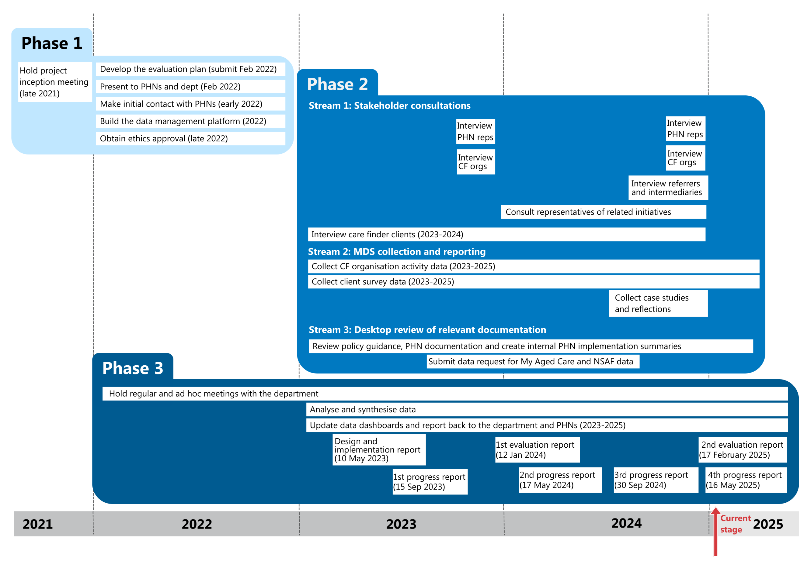

Read Figure 1 long description.

The evaluation is informed by 6 main data sources:

* **Consultations**

We completed 154 individual and group interviews in total. In 2023 and 2024 we spoke with PHNs, CF organisations and clients. In 2024 we also consulted with referrers, intermediaries and representatives of related initiatives.

* **CF organisation reporting**

CF organisations have reported program activity data each month from January 2023. Organisations also submitted case studies and responses to reflection questions in October 2024.

* **Client surveys**

Over the program’s first 2 years we received 5,300 responses to the client feedback survey. This equates to a completion rate of 22% of eligible clients.

* **Department documentation**

The department provided us with the policy guidance, aged care schedule and other program documentation distributed to PHNs and other stakeholders.

* **PHN reporting**

PHNs also shared the 2022 Once-off Report on Supplementary Needs Assessment Activities (needs assessment) and 12-month performance report (completed in September 2024) with us.

* **My Aged Care data**

Demographic data from My Aged Care was provided by the department in August and November 2024.

Further details of the data sources and evaluation activities are provided in Appendix C.

### About this report

This second evaluation report focuses on progress of the program in its first 2 years of operation and summarises:

* program establishment (section 3)
* program support and oversight (section 4)
* program connections (section 5)
* services delivered (section 6)
* client characteristics and experiences (section 7)
* program outcomes, successes and challenges (section 8)
* concluding remarks (section 9).

# Program establishment

The launch of the program was described in detail in earlier deliverables, including the first evaluation report submitted to the department in January 2024. This section summarises our recent findings based on additional data and builds on our earlier findings.

## About the program

A national care finder network was established in 2023, and in 2024 the program has continued to provide specialist assistance to help clients understand and access aged care services and other relevant supports in the community. Almost all commissioned CF organisations and intake‑only organisations[5] (n = 164, 95%) commenced service by 30 April 2023 as planned. A further 10 CF organisations began operating between May 2023 and December 2023 and 2 more on 1 July 2024.

Just 8 commissioned CF organisations ceased service delivery over the first 2 years of the program with 7 of these organisations being former ACH program providers. A list of CF organisations commissioned by each PHN is available on the My Aged Care website.

There are currently 164 CF organisations delivering services across Australia and 4 intake‑only organisations.

### Needs assessments revealed local needs

All PHNs completed a supplementary needs assessment report (using a department template) in late 2022 and also conducted forums, interviews and desktop analysis to direct their planning for the program and commissioning of CF organisations. When asked in October 2024 if the needs assessments accurately identified their communities’ needs, PHN representatives reported that they were largely accurate and are a useful tool to learn about some of the vulnerabilities and service needs of older people in their region, especially for PHNs that lacked aged care experience. They also felt that the data gathering process, which included interviews and workshops with local community members and other PHNs, was helpful to establish local connections and learn more about local services.

[The program has] really supported identifying a wider range of services in the community that we weren’t necessarily aware of as well and that supports our knowledge of the community and the services that it needs, the gaps that it has. – PHN representative

Since the program commenced, PHNs have developed an increased understanding of local needs for care finder support over time. This growth in knowledge is also attributed to their engagement with stakeholders, attendance at CoP meetings and community outreach activities. Some PHNs have undertaken supplementary activities beyond their existing needs assessments to identify regional requirements for care finder services. For instance, some have built networks with aged care providers, intermediaries, and community organisations to better understand the challenges faced by vulnerable populations.

Unsurprisingly, some PHNs reported difficulties in capturing the perspectives of harder-to-reach populations, such as those experiencing homelessness or with cultural and linguistic barriers, which further complicates efforts to understand local needs comprehensively. A small number of PHNs reflected that they had underestimated the number and complexity of isolated and vulnerable older people in their communities. There were also challenges accessing comprehensive, up-to-date local data.

### Care finder organisations were commissioned appropriately

CF organisations were largely commissioned as planned although some PHNs struggled with what they perceived as a short timeframe to complete their commissioning activities. Commissioning took place in December 2022 and service delivery had to commence on 1 January 2023 for all ACH transitioning organisations and by 30 April 2023 for all other organisations.

Upon reflection in October 2024, almost all PHN representatives who were involved with commissioning activities felt that the CF organisations they had contracted in 2022 were appropriate and broadly met the requirements identified in their needs assessment reports. However, in areas with a skilled workforce shortage or insufficient service providers, PHNs have faced significant challenges in aligning commissioning decisions with identified local needs.

PHN and CF organisation representatives also suggested that commissioning decisions often reflect regional priorities, with PHNs tailoring services to address specific challenges such as isolation, language barriers, and cognitive impairments. For example, in some regions, PHNs have prioritised commissioning care finders with expertise in working with CALD communities or individuals at risk of homelessness.

Many PHNs greatly valued the deep connections their commissioned CF organisations had with other relevant services in the community, their understanding of the local community’s needs, and their knowledge of appropriate ways to connect with the program’s target population.

One of the most important things is that the providers have those established local networks and have a strong understanding of the specific needs of the community [and] across the whole region because we are so diverse. And one LGA will look so different to the other. And so you really need providers who have that existing understanding. – PHN representative

PHNs would have benefited from more information about the Elder Care Support program at the commissioning stage.[6] PHNs were unsure how the Elder Care Support program intersected with the care finder program, if it would run in their region and meet the needs of local First Nations people, or if they needed to commission a CF organisation to meet local needs. This challenge was more pronounced in regional and remote areas where there is a limited skilled workforce.

PHN commissioning of CF organisations is largely addressing local needs for care finder support but commissioning alone is not able to meet all demands comprehensively due to workforce constraints and broader contextual issues.

Case study data and referrer interview data provide examples of successful outcomes where PHN-commissioned care finder services have filled critical gaps, such as supporting isolated older adults or those with low literacy to navigate the aged care system. These successes highlight the potential of the program to address local needs when commissioning is informed by a thorough understanding of community challenges.

### The ACH program has now been absorbed by the care finder program

In 2021 and 2022 the department introduced the care finder program to ACH providers through webinars, emails, letters and individual assistance. The guidance focused on changes expected under the care finder program, the target population, funding, and timeframes for service commencement. PHNs were required to offer contracts to existing ACH providers in their region CF organisation.

ACH providers transitioned to the care finder program as planned, with former ACH program providers accounting for 54% (n = 89) of CF organisations. On reflection in October 2024, most former ACH organisations said that their transition was smooth thanks to the information and assistance provided by PHNs and the department. They also noted that the services delivered under the care finder program were similar to those that they had been delivering under the ACH program. Former ACH organisations could also draw on existing staff and networks, which meant they could start delivering services more quickly than other organisations without suitable staff or existing community connections.

Former ACH providers also brought significant experience and expertise in assisting clients who are experiencing homelessness, which is frequently an issue in the target population. However, some former ACH providers needed to quickly upskill in other areas of program delivery, such as comprehensive aged care navigation and basic client advocacy.

I think there was maybe a difficulty in transitioning [from the ACH program] to the expectation that it was a brand‑new program that was different and not necessarily focused on housing support. – Care finder

PHNs and CF organisations reported that some former ACH providers are still struggling with the expanded scope of the program. While some PHNs provided significant support and training opportunities for providers transitioning from the ACH program, others did not.

… the ACH programs were pretty well firmly entrenched in organisations, so it was a big shift to get that happening culturally and also from a contractual point of view. – Care finder

Furthermore, some PHNs felt that the level of funding provided to absorbing ACH service providers made the transition and ongoing staffing challenging, both for PHNs and the providers themselves.[7] From the perspective of PHNs, some ACH providers transitioned with low funding, which has in some cases limited the ability of organisations to:

* invest the time required to assist people who are geographically or socially isolated
* meet AHA and PHN data reporting requirements
* maintain service delivery in the event of staff absences or recruitment challenges.

### Care finder numbers are now stable

Care finders have been recruited over the program’s first 2 years of operation largely as planned, and CF organisations reported that they now have relatively stable staffing. Previous ACH providers and organisations transitioning from the ACSN trial did not need to recruit a care finder in many instances as existing staff were kept on, which was viewed positively.

During the last quarter of 2024, CF organisations reported a total of 550 full-time equivalent (FTE) staff for the quarter. This FTE was distributed across the 4 designated roles in the program: care finder, manager, intake officer and administration assistant. Care finders made up three quarters of the total FTE for the last quarter of 2024 (Figure 2).

The distribution of FTE by staff role has remained largely consistent throughout the program. In the early stages of program delivery, a greater proportion of FTE was allocated to care finder managers and intake officers. This was most likely to ensure that the program was implemented accordingly and clients were appropriately onboarded into the program. Once the program began to mature, there has been a shift in staffing to care finders to deliver services.

Figure 2: Care finder program staff FTE, by quarter

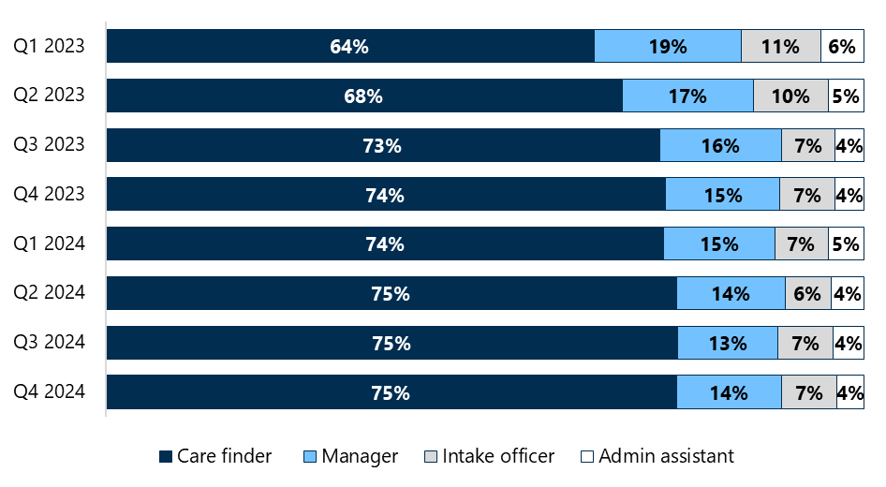

Figure 2 data is provided in Table 12.

Recruiting staff from within the region, particularly those with cultural or strong connections with local community organisations, has helped build trust and engagement with the target client population. However, recruiting care finders in regional and remote areas has been more challenging due to the more limited pool of potential candidates with the requisite skill sets. The role is more complex than a “traditional” aged care job and requires expertise in navigating multiple sectors, including housing and mental health. Staff turnover and broader aged care sector workforce shortages have also impacted the ability of organisations to maintain the delivery of program services in some regional areas, particularly when there are only one or 2 care finders. Some CF organisations worked together by pooling resources for recruitment activities (e.g. preparing a joint care finder position description) to attract and retain care finders.

Another recruitment issue voiced by PHN and CF organisations was the expectation for care finder remuneration to align with Social, Community, Home Care and Disability Services Industry (SHADS) award package level 5 or 6. While we note that not all CF organisations pay care finders at these levels, a small number of CF organisations said that this reduced the number of care finders that organisations could employ. In some instances, care finder remuneration exceeded team leader salaries, which caused some friction within organisations.

## Training for care finders

Program training for care finders comprises mandatory induction training and ongoing supplementary training to complement their existing knowledge and skills and respond to the needs of the local target population. CF organisations are expected to deliver initial orientation and onboarding activities with new staff and help care finders identify and complete relevant training. PHNs are responsible for ensuring care finders participate in the required training to ensure they can respond to local needs.

### Most care finders have completed their mandatory program induction training

Care finders complete their mandatory program induction training online in the MAClearning portal over approximately 2.5 hours. The training comprises 3 modules and covers the aged care system, expected program outcomes, the care finder’s role and the client journey. It seeks to support national consistency in program understanding and service delivery. PHNs are responsible for registering care finder staff for the training.

Feedback about the usefulness of this training was mixed. While some care finders reported it to be helpful and provide a solid introduction to the program and care finder role, others felt the training did not adequately cover the complexity of the cohort, broader sector challenges, such as the lack of timely and appropriate services, or the daily challenges faced by care finders, especially how to address complex and diverse client needs.

As of 12 February 2025:

* 1,050 staff (86% of those registered) had completed the induction training
* in 47 CF organisations (40%), all registered staff had completed the training and in a further 21 CF organisations, 90% or more registered staff had completed the training
* in all but one CF organisation[8] (99%), one or more registered staff member was trained.

It is important to highlight that the training completion data does not paint an accurate picture of the proportion of active staff who are trained. Staff registered by PHNs for induction training in 2022 may have left the organisation or been deployed to another program and their MAClearning course registration may not have been removed.[9]

### Targeted supplementary training is needed to meet the needs of the target cohort

Some PHNs arranged supplementary training for care finders and offered training to all its commissioned CF organisations in the region. In other instances, CF organisations set up the training and invited other organisations to participate. Care finders reported supplementary training related to trauma‑informed practice, diversity, and health and wellbeing of staff.

Some CF organisations noted that this supplementary training, while beneficial, took time away from client-facing work, and they felt that care finders would benefit from more targeted, scenario‑based training, particularly relating to complex cases.

It’s a constant juggling act. The demands of the role, the client need, which is pretty high and complex, and the need for the training and its relevance to the actual care finder role were the main barriers that we faced. – Care finder

At the program’s outset, some care finders who were not transitioning from the ACH program had limited experience in assisting clients experiencing homelessness, which led to a steep learning curve. Care finders expressed a need for training specifically in how best to navigate local housing and homelessness services. In October 2024, the department provided PHNs with details of a useful online module created by Country SA PHN on the housing and homelessness sectors to help address this important training gap.

Key lessons learned

1. Initial and ongoing training on handling complex cases, such as clients who are experiencing homelessness or mental health issues, would help set care finders up for success.

Future opportunities:

The department’s Navigation and Access Branch could consider:

* reviewing MAClearning training to ensure it accounts for the complexity of care finder clients and their circumstances and including content on trauma‑informed care and homelessness
* strengthening the contractual requirements for PHNs to ensure that PHN staff and care finders possess a baseline knowledge of how to manage complex cases and support people experiencing homelessness
* updating the policy guidance to specify in greater detail the core competencies that care finders should possess.

PHNs could consider:

* ensuring their commissioned CF organisations have access to training resources linked to the core competencies specified in the updated policy guidance
* leveraging care finders’ expertise and experience to help support and train their other commissioned CF organisations.

# Program support and oversight

Care finders are receiving support from their commissioning PHN, their CF organisation and other commissioned CF organisations in the region. CoP meetings, which PHNs are responsible for establishing, coordinating and maintaining, are a key channel for care finders to receive support and share learnings. PHNs also support care finders by coordinating training and helping to integrate the program into local systems.

CF organisations are charged with managing their staff day-to-day, overseeing the services delivered by care finders and ensuring staff are trained appropriately.

## Support for care finder organisations

CF organisations appreciated the initial support and proactive efforts of PHNs, particularly mechanisms such as CoP and the early consultation processes. These efforts provided a solid foundation for care finder activities and ensured smoother implementation in many regions. Early consultation and clear communication from PHNs were particularly appreciated, as these efforts helped align expectations and define care finder roles and responsibilities. Ongoing communication and regular touchpoints were highlighted as areas needing improvement, however.

Implementation-wise, we felt really fortunate because the PHN consulted with lots of stakeholders early, and what we had to add to how the program needs were represented in our areas was considered. It felt relatively seamless for us to transition into care finder. – Care finder

### Actively engaged PHNs have aided integration

Reflections data and case studies illustrated how early guidance smoothed the program’s implementation in several regions. For instance, PHNs that actively engaged with intermediaries, such as GPs and other local health services, were able to better integrate the program into the broader healthcare system and increase its visibility. Where there has been less collaboration between PHNs and CF organisations, care finders were unclear on how the program had been promoted by PHNs, if at all, and what gaps they needed to address.

However, we found a more nuanced picture for ongoing support and guidance provided by PHNs with proactive efforts, successes, and gaps. While some PHNs actively raised the profile of the program and addressed local barriers (e.g. by connecting care finders with local intermediaries), which led to improved visibility and impact, others were less consistent in their engagement. CF organisations also noted a lack of tailored resources and structured communication channels, which has limited the ability of some organisations to address evolving or complex challenges. For example, CF organisations in regions with high demand and limited resources struggled to access the necessary support to address systemic challenges such as long wait times for services or unclear role definitions.

## Communities of practice

CoP were highlighted in the policy guidance as a key mechanism for PHNs to connect with CF organisations, share expertise, learn about the program, offer support and troubleshoot issues. Involving other groups such as assessors and representatives from the Elder Care Support program was also highly valued. Following the initial CoP meeting at the start of the program in early 2023, PHNs have established ongoing and regular CoP meetings to varying degrees.

### Communities of practice are a valued platform that could be used more fully

Interview participants and reflections data confirm that CoP have proven to be valuable platforms for strategic collaboration, sharing lessons learned, capacity building, and driving continuous improvement, as intended. Ongoing CoP meetings have allowed organisations to exchange evaluation findings, which has enabled CF organisations to develop collaborative solutions to challenges such as clarifying referral pathways and implementing the program. This has anecdotally improved client outcomes. Referrer interviews showed that accessible and well‑promoted CoP were viewed positively. PHN and care finder interview data showed that CoP were particularly effective in fostering collaboration between organisations, enabling them to address systemic issues together.

CoP vary significantly in their structure, purpose, frequency, and focus, reflecting the unique needs and challenges of different regions and providers. Some CoP operate at the PHN level, others function at the state or multijurisdictional level, and still others operate as a combination of both. For example, one PHN reported quarterly CoP meetings are held virtually for one hour, with standing agenda items like local experience sharing and capacity building, whereas another PHN hosts quarterly face-to-face CoP meetings, allowing for richer in-person collaboration and discussions. In contrast, another PHN operates virtual CoP meetings every 2 to 3 months, complemented by an annual in-person gathering for broader networking and education.

Discussions at CoP meetings, which often align with local priorities and cover topics such as cultural awareness, mental health services, and homelessness, have also supported continuous improvement, collaboration across PHN boundaries and more streamlined service delivery. Educational components are driven by participant needs, covering topics such as the Elder Care Support program, housing services, elder abuse and mental health services. One PHN representative said the meetings also promoted workforce wellbeing and consistency in care finder practices.

However, while some CF organisations actively participate in CoP, others are unaware of the meetings, with gaps in awareness, inconsistent implementation, and workforce challenges limiting their reach and impact in some areas.

Despite their benefits, CoP face challenges that can impact their effectiveness. For example, some PHNs noted that staff turnover in CoP coordinator roles disrupted continuity, requiring temporary informal meetings. Some PHNs noted that limited funding was another common constraint that led to these PHNs opting for annual in-person CoP meetings. Both reflections data and referrer interviews highlighted workforce shortages and heavy workloads as significant obstacles to participating or engaging meaningfully in CoP.

These findings strongly suggest that CoP are a critical mechanism for driving learning and improvement when implemented effectively.

## Support for care finders

The perspectives of care finders on the support and guidance provided by their organisations reveal a generally positive view of internal support mechanisms but also highlight areas where improvements are needed to ensure they can deliver program activities effectively. Care finders generally feel well supported in terms of team collaboration, supervision, and initial training. This sense of support was particularly evident during the onboarding phase, where organisations provided a solid foundation for staff to begin their roles. Reflections data consistently highlighted how initial training and orientation programs helped care finders understand the program’s scope and objectives.

### CF organisations could provide more targeted training and advocate for their care finders

However, inconsistencies in ongoing guidance, the informal nature of peer collaboration, and external stakeholder challenges (e.g. difficulties connecting with local healthcare professionals) present opportunities for improvement. While some organisations provided regular supervision and professional development opportunities, others fell short when adapting support to meet the evolving challenges of care finder activities. Peer collaboration has also emerged as a valuable, albeit informal, support mechanism for many care finders. Care finders described how discussions with colleagues often helped them navigate difficult cases and share solutions. Care finders indicated that while their organisations were responsive to internal needs, they sometimes failed to advocate for or support care finders when dealing with external systems, such as My Aged Care and local service providers.

Workload pressures were another recurring theme in care finders’ feedback. Care finders in regions with high client demand and limited resources reported feeling overburdened, which impacted their ability to provide consistent and effective support to clients. Addressing these pressures through increased staffing or workload management strategies was a key recommendation from care finder staff.

Interview participants also emphasised the need for ongoing, adaptive training. While initial training provided a strong foundation, care finders expressed a desire for continuous learning opportunities that reflect the evolving nature of their work. For example, care finders indicated that training on how to handle complex cases and mental health challenges or navigate the aged care system could better equip them to meet the diverse needs of their clients.

Care finders and PHNs recognised that the complexity of clients and challenges with assisting them mean care finders are at risk of burning out and experiencing vicarious trauma, which in turn threatens staff retention. While care finders were repeatedly described as passionate, highly skilled and empathetic people, it is vital that CF organisations provide support mechanisms and debriefing opportunities.

When you’re just constantly hitting that barrier and that brick wall, you lose that job fulfilment. – CF organisation representative

## Resources to deliver the program

The program faces several resource and capacity challenges that make it difficult for CF organisations and PHNs to perform their roles. Both PHNs and CF organisations are making commendable efforts to meet the program’s objectives, and while a few PHNs have reported underspends, financial and workforce limitations pose significant hurdles in other regions. These challenges highlight gaps between the policy framework and the practical realities of implementation.

### Client complexity and insufficient resources are impacting the ability to deliver services

The policy guidance assumes that operational costs, such as IT systems, travel, and communication, will be adequately covered by program funding. However, interview data from PHNs and CF organisations reveal financial strain in meeting these costs. PHN representatives indicated that IT and communication tools are critical for supporting remote client engagement, but current funding levels may be insufficient to fully accommodate these costs. Travel expenses, particularly in rural and remote regions, are also a significant financial burden for organisations and limit the number of clients who can be assisted in these areas. Some organisations appear to have underestimated travel expenses in their original 2022 proposal to PHNs or they transitioned from the ACH program with insufficient funds for travel.

These financial constraints are compounded by the program’s underestimation of the complexities involved in addressing the needs of the target population and do not seem to account for the higher-than-anticipated resources needed to engage with highly vulnerable clients, including those requiring assertive outreach and intensive, face-to-face support. The policy guidance provides a comprehensive framework for identifying and assisting the target population, but interview data indicates that the reality of working with highly vulnerable clients often exceeds the policy’s assumptions. For example, referrer interview data highlighted instances where CF organisations were required to perform functions beyond their intended scope, such as driving clients to appointments or assisting with basic needs due to a lack of available services.

### **Some local needs are not being met**

While PHNs have commissioned CF organisations that have addressed many identified local needs, there remains a need to support isolated individuals, engage CALD and LGBTI communities, address homelessness, and meet specific cultural requirements for First Nations clients. These challenges underscore the need for CF organisations to be contracted with adequate funding, tailored outreach strategies, and capacity-building initiatives to ensure that the program can meet the diverse needs of older Australians. They also highlight many contextual and sector challenges that are impacting the program.

One significant challenge is the inability to identify and assist highly isolated individuals in some regions. Care finders are often overwhelmed by the demands of assisting clients who cannot access services due to system delays or shortages and lack capacity to conduct face-to-face consultations in remote areas, which is leaving some of the most vulnerable individuals without urgently needed support.

While 33% of surveyed clients identified as being from a CALD background, care finders suggested that the needs of some people from CALD backgrounds are not being fully addressed. In their view, a lack of translated promotional materials and care finders who speak an additional language limits the program’s ability to reach CALD communities effectively. Additionally, care finders perceive that other special needs groups, including veterans and LGBTI clients, are under-represented and suggest that more targeted outreach and inclusive practices are needed to ensure equitable access to care finder services.

Homelessness and housing instability present additional challenges for the program as individuals in temporary housing or experiencing homelessness often cannot have their aged care needs met. Hoarding and squalor are additional barriers to addressing local needs as they prevent aged care services from commencing yet fall outside the scope of the program, leaving clients without adequate support. Hoarding and squalor services fall under the Commonwealth Home Support Programme (CHSP) (Department of Health, Disability and Ageing 2024); however, in many regions the availability of this service is very limited. Similarly, community transport is being provided by care finders in some regions to fill gaps left by CHSP delays or the absence of local providers. While this demonstrates the flexibility and dedication of care finders, it diverts resources from their core functions and highlights systemic gaps in service availability.

The specific needs of First Nations clients are also not being fully addressed in some regions. One PHN noted that while they support providers with ongoing training and quality improvement to deliver culturally appropriate services, best practice would involve offering First Nations clients the option to engage with an Elder Care Support program provider. However, some care finders are unaware of, or don’t have, a local Elder Care Support program provider, limiting their capacity to provide this level of culturally specific support.

We’ve been working quite closely with all our providers to ensure that they are capable of delivering culturally appropriate services. So, we support them with ongoing training and quality improvement. But obviously noting that the best practice would be to offer First Nations clients an opportunity to either engage with a NACCHO provider. – PHN representative

In contrast, in some regions Elder Care Support program representatives have been invited to CoP meetings to promote a shared understanding of the programs and linkages between them.

In May 2024 the department sent PHNs a resource that outlined the aims of the Elder Care Support program and a link to further information on the NACCHO website. In August 2024 the department’s communique to PHNs included a list of Elder Care Support organisations.

Efforts are under way in some regions to map areas of unmet need, which could help address these gaps in the future. For example, some PHNs are actively identifying regions where services are lacking or under-resourced to create a foundation for targeted interventions, such as encouraging aged care service providers operating in nearby regions to expand their service boundary.

## Continuous program improvement

PHNs and CF organisations are increasingly drawing on local experiences, lessons learned and innovations to continuously improve the care finder program. However, resource constraints, workforce turnover, and inconsistent knowledge-sharing mechanisms continue to limit the ability of both PHNs and CF organisations to fully leverage these insights.

The department has also worked to continually improve the program by sharing program reminders, evaluation findings, training opportunities and other resources (e.g. guidance on referral pathways) with PHNs.

### Improving awareness and application of knowledge

PHNs and CF organisations have demonstrated growing awareness of local experiences, lessons learned, and innovations, though application of this knowledge varies across regions. PHN and CF organisation interviews highlighted several examples of how local insights have been leveraged to enhance program delivery. For instance, some PHNs will adjust their commissioning strategies for the next stage of the program based on feedback from stakeholders, focusing on areas with the highest unmet needs, such as remote regions or CALD populations. Similarly, CF organisations have adapted their approaches to service delivery by incorporating lessons from client interactions, such as simplifying intake processes or providing more personalised support to build trust with vulnerable clients.

Reflection questions data also showed that local innovations, such as embedding care finders in community hubs or co-locating them with other services, have been effective in improving access for hard-to-reach populations. These practices have been shared through CoP, enabling other regions to replicate successful models.

However, barriers to obtaining and applying this knowledge persist. Referrer interview data revealed that limited resources and high workloads often prevent CF organisations from fully documenting and sharing local lessons. Additionally, we heard in PHN and CF organisation interviews that smaller organisations, particularly those in rural and remote areas, may lack the capacity to participate in CoP or other knowledge-sharing forums, limiting their access to insights from other regions. Also, in some areas CoP meetings are not being well supported by PHNs or are not taking place regularly which limits opportunities for collaboration and knowledge sharing.

We’ve delivered the “Connecting Care Finder to the Aged Care Network” forums. And in those forums we’ve learned from the people that are referring [into the program] what their needs are. And then we’ve also been able to pick up what some of the issues are from the care finder … I think that’s been really important, we’ve got everyone in the same room … [to] allow those open tough questions. And I think that’s really helped with that continuous improvement. – PHN representative

### Awareness and application of key evaluation findings to support continuous improvement is broadly lacking

The department emailed the first evaluation report to PHNs and included a link to the report in the May 2024 communique. PHN and CF organisations’ awareness of the key evaluation findings was patchy when discussed in October 2024, which is not unexpected given the evaluation report was released many months earlier. However, it was unclear whether PHNs had forwarded either the report (or a summary of findings) or the department communique, which included a link to the report, to CF organisations.

Some PHNs and CF organisations are aware of key evaluation findings, but when we asked representatives about the findings in October 2024, we found their recall and ability to apply this knowledge to support continuous improvement was lacking. A small number of PHNs are using evaluation data to refine their forthcoming commissioning strategies and address identified gaps.

Some CoP were a significant opportunity for PHNs to disseminate evaluation findings and support continuous improvement. Data from reflection questions and PHN and CF organisation interviews highlighted that these meetings allow stakeholders to share best practices, discuss challenges, and collaborate on solutions. For instance, one PHN used evaluation insights shared during a CoP meeting to implement a targeted outreach strategy for older men, who they believed were under-represented in their client base. PHNs have provided training on trauma‑informed care or cultural safety in response to evaluation findings about the needs of specific client groups. Case study data showed that these training sessions improved service delivery and client outcomes in some regions.

Despite these efforts, some PHNs and most CF organisations had no or limited knowledge of the evaluation findings and only very few CF organisations benefited from these PHN-led activities. PHN and CF organisation interviews revealed that resource constraints and competing priorities often limit the capacity of PHNs and CF organisations to act on evaluation insights.

Key lessons learned

1. CF organisations and PHNs in rural and remote areas have access to a smaller pool of qualified staff, services and IT resources, which presents a risk to continuous program delivery.

Future opportunities:

The department’s Navigation and Access Branch could consider:

* working with PHNs and regionally based department staff to better understand the unique challenges faced in rural and remote areas and together develop strategies to mitigate recruitment and training challenges
* re-examining funding for rural and remote PHNs to ensure it adequately covers required travel and infrastructure such as IT systems
* considering joint funding models in remote areas with thin markets to allow qualified personnel to work across multiple similar programs (e.g. Elder Care Support program, National Aged Care Advocacy Program and the National Disability Insurance Scheme).

PHNs could consider:

* encouraging CF organisations in their regions to collaborate and share resources to support staff in rural and remote areas (particularly in those with fewer than 1 FTE staffing).

1. Communities of practice have been critical to the program’s success.

Future opportunities:

The department’s Navigation and Access Branch could consider:

* strengthening PHNs’ contractual obligations around coordinating and maintaining CoP, for instance, stipulating PHNs’ responsibilities and a minimum frequency of meetings and ensure this is captured in PHN reporting.

PHNs could consider:

* ensuring that at least one CoP meeting each year is in person, where resources allow, in recognition of the benefits of face-to-face interactions and exchange
* regularly inviting representatives from other relevant programs and roles (e.g. aged care assessors, ACSOs, Elder Care Support program officers) to meetings to build mutual understanding of each program, strengthen referral pathways and improve the appropriateness of referrals.

1. Mechanisms to support care finders succeed in their role are critical considering the complexity of clients and systemic barriers they face when delivering services.

Future opportunities:

The department’s Navigation and Access Branch could consider:

* ensuring PHNs are providing support and training to care finders on vicarious trauma and self-care.

PHNs could consider:

* ensuring CF organisations have comprehensive systems in place to support staff such as peer support, mentoring and debriefing opportunities.

1. Relying on PHNs to disseminate department communications to CF organisations by email has resulted in some CF organisations missing out on the information they need.

Future opportunities:

The department’s Navigation and Access Branch could develop a multi-pronged communication strategy to improve information sharing between the department, PHNs and CF organisations, reducing the reliance on email. Options may include:

* ensuring PHN staff are aware of, and are accessing, the existing program SharePoint page to receive information about program updates and other resources
* providing CF organisations with access to the program SharePoint page to encourage sharing of resources (e.g. translated promotional materials and data capture templates) and to ensure all care finders can access program and training updates and evaluation findings
* establishing an online national forum for care finders to share important program and aged care sector updates
* continuing to provide tailored information on related initiatives (e.g. Support at Home) summarising how upcoming key changes in the sector will impact care finders’ ways of working
* leading an online national forum for PHN representatives to provide program updates, share promotion and integration strategies, answer questions and keep PHN staff engaged with the program.

PHNs could consider:

* prioritising the circulation of communiques and other information from the department to both CF organisations management and front-line care finders to ensure that they receive the information they need
* ensuring department updates, including evaluation developments and information about training, are standing agenda items at CoP meetings.

# Program connections

PHNs and CF organisations are helping to integrate the care finder network with other elements of the aged care system by raising awareness of the program with referrers and intermediaries as well as connecting clients to services through referral pathways. Growing awareness of the program is also helping to embed and refine referral pathways. PHNs are more aware of opportunities for integrating the program with health, aged care and other supports and are leveraging their existing networks, although resource limitations are resulting in inconsistent application of this knowledge.

## Promotion of the program

The department has intentionally not driven national promotion of the program to prospective clients to limit the number of people who are outside the target population seeking assistance from the program. The department has, however, engaged with other government agencies (e.g. Services Australia) and My Aged Care to introduce the program to referrers and intermediaries and define appropriate referral pathways into the program.

Both PHNs and CF organisations are required to develop and carry out appropriate activities to raise regional awareness of the program with potential referrers and intermediaries and to a lesser degree the target population. PHNs are also charged with establishing and maintaining connections with local and jurisdiction-based services, for example, homelessness services and hospitals.

In some regions PHNs have promoted the program at many different aged care network meetings and health practitioner forums. This was greatly appreciated and supported by CF organisations as it built awareness of the program and its target population among some referrers, allowing care finders to focus their promotional efforts elsewhere. GPs and nurse navigators are also being reached by some PHNs through HealthPathways, an online decision‑making tool for health practitioners.

Elsewhere, individual care finders have been left to promote the program to GPs and local hospital staff, which was viewed by many as inefficient due to the high turnover of health practitioners. The lack of coordinated PHN or jurisdiction-level promotion to hospitals has meant awareness of the program is patchy across hospitals according to care finders.

Intermediaries reported that the program could be better supported at the regional level through more comprehensive awareness campaigns and clearer communication to about its scope and limitations. There is also a need to improve awareness and collaboration between care finders and aged care assessment teams.

… care finders remain unaware when initial contact is made with the client by the My Aged Care or RAS or aged care assessment teams. Consequently, assessments can proceed without the involvement of the care finder who’s an integral part of the support. I guess this means lost advocacy opportunities. – PHN representative

Some care finders reported that referrers in some regions lack understanding of the care finder role and fail to recognise their professional standing, leaving them feeling undervalued.

Care finders are not treated as professionals by organisations like My Aged Care or government departments. We are essentially advocates for vulnerable people but lack a professional space and recognition. – Care finder

### Promotion of the program in local communities is uneven

While the program is not promoted nationally, PHNs and CF organisations are required to reach out to the local community to actively identify and engage with potential clients, including through direct contact and supported contact through intermediaries (such as health professionals, aged care and disability sector professionals and people from community and voluntary organisations). Resources to support engagement activities varied in format, type, and content, with most organisations focusing on physical promotional materials such as magnets, flyers, and information sheets. These were considered useful for distributing to potential referrers or intermediaries at community events and at local businesses. Fewer organisations opted for online promotional resources.

In 2022 the department sent PHNs a flyer template, fact sheet, and referral templates to use as a starting point for activities to promote the program. In 2024 consultations some care finders were unaware of these resources, possibly because they had started after the program’s rollout and resources were not shared by outgoing staff or their PHN did not pass the templates on to CF organisations.

Care finders said that they needed to invest significant resources to create and adapt the department’s promotional materials for their local context, particularly when catering to CALD populations. Some CF organisations translated materials, but these weren’t consistency shared with other organisations.

### Ongoing national promotion to referrers and intermediaries may be needed

Around 3% (n = 165) of clients reported seeing a promotion or advertisement about the program. This is expected given there is no broadscale national promotion of the program to prospective clients. However, several CF organisations and surveyed clients advocated for coordinated national promotion and did not understand why this had not occurred.

Care finder is still widely unknown in the community and aged care sector, and we do feel targeted national messaging will complement our assertive outreach work. – Care finder

Intermediaries and referrers suggested that the program is not well known enough and that it should be more broadly and repeatedly promoted, as staff may miss a one-off email. It was also clear that many referrers and intermediaries thought care finders only help clients to navigate the aged care system and were surprised to hear learn about the program’s broader scope. This may be a result of a pre-existing relationship between referrers and intermediaries and the CF organisation in which the CF organisation had acted as a specialist provider of aged care services.

## Referral pathways into the program

Referral pathways are a cornerstone of the program and are intended to connect clients with appropriate services through collaboration between care finders, My Aged Care staff, hospitals, and other intermediaries. The policy guidance explicitly outlines the importance of referral pathways, stating that PHNs must work with CF organisations to establish and promote them. PHNs are required to engage intermediaries, such as hospitals and community organisations, to ensure care finders are effectively integrated into the aged care ecosystem. Despite these clear directives, the data reveals inconsistencies in implementation and paints a picture of progress, challenges, and opportunities.

The department has reminded PHNs how CF organisations should determine whether people aged under 65 years can be assisted by the program and provided a clear referral pathway. Despite this, some care finders are not yet fully aware of the appropriate pathways of support for people aged under 65 years. They also reported that there is confusion among referrers and service providers, which means they receive inappropriate referrals or other providers are reluctant to accept client referrals.

### Referral pathways are improving but still need strengthening

Care finders, referrers, and intermediaries have improved their understanding of referral pathways into the program to some extent, but challenges remain. In May 2024 the department distributed a detailed resource to help care finders, assessors and other referrers to identify appropriate referral pathways and included a checklist for intermediaries to use when referring to the program. Data from multiple sources provides a nuanced perspective on the successes and ongoing gaps in referral processes.

PHN representatives and CF organisations highlighted that many organisations are actively working to clarify referral processes by strengthening relationships with local intermediaries and health professionals. As GPs, social workers, and neighbourhood house staff have become more familiar with the program and its services, their understanding of the program’s target population has deepened, leading to more accurate referrals. However, referrer interviews highlighted persistent gaps in their understanding of the program’s scope and target population. For example, some referrers were unaware that care finders could assist with housing-related support, leading to missed opportunities to connect clients with relevant services. Others misunderstood the boundaries of the care finder role, occasionally referring clients who fell outside the target population.

Some CF organisations indicated that they have introduced clear intake processes and referral forms, which have standardised the way referrers provide client information. These tools have improved communication and reduced confusion for some referrers, enabling them to better identify prospective clients who are in the program’s target population. Referrer and intermediary perspectives nevertheless indicate significant variability in the robustness and appropriateness of referral pathways to the program. Referrers consistently noted that the lack of a standardised referral system across regions is creating inconsistencies and some suggested a central referral pathway into the program. While some referrers praised the simple and flexible referral methods used by some CF organisations, such as emailing or texting client information directly to the organisations, others expressed frustration with the time-consuming and duplicative nature of external forms required by other organisations. These inconsistencies can delay support and negatively impact client outcomes.

### Inbound referrals are increasingly appropriate

Referrers noted that as care finders have built stronger relationships with intermediaries and referrers, the proportion of appropriate inbound referrals has increased, with care finders reporting that they received more referrals in 2024 for clients in the program’s target population compared to earlier in the program. Correspondingly, the proportion of inappropriate referrals has decreased. However, this improvement is uneven across regions, with organisations in rural and remote areas continuing to report higher rates of inappropriate referrals.

… professionals sometimes use care finder services as a “dumping ground” for complex cases, overwhelming staff and blurring the lines of their roles. – Care finder

The department made efforts to improve the appropriateness of referrals into the program by creating a referral pathway resource (in April 2024) for care finders, intermediaries and referrers. This comprehensive resource outlined referral pathways for clients who sit outside the care finder and Elder Care Support programs. In May 2024 the department also provided guidance to PHNs detailing in-person services available at Services Australia to help care finders refer clients who sit outside the target population.

Limited availability of alternative in-person navigation services may be forcing referrers to rely on care finders even for clients who fall outside the target population. However, inappropriately referring such clients to care finders risks stretching their resources and detracting from their ability to focus on the most vulnerable clients. Some CF organisations are also receiving referrals from “at capacity” specialist housing organisations which they feel ill‑equipped to manage, particularly where a CF organisation has significantly less experience assisting clients who are experiencing housing instability or homelessness.

From the beginning of 2024 a stand-alone intake reporting portal was implemented to better capture the interactions undertaken by the program’s intake‑only organisations. Almost two‑thirds of enquiries to these intake-only organisations in 2024 came from potential care finder clients or their representatives. Three-quarters of these enquiries were referred to a CF organisation in their relevant PHN catchment with the remaining one-quarter being referred to more appropriate services. However, this model has only been implemented in 4 PHNs and we are not able to discern how many inappropriate referrals are made to CF organisations in PHNs without intake‑only organisations.

## Awareness of the program among intermediaries and referrers

Referrers reported that CF organisations have participated in community events and professional development days to raise awareness and improve support for the program among potential referrers.

In the past year, the program has gained considerable traction, with many stakeholders now aware of its services and reaching out directly for assistance. This increased awareness has been driven by our advertising efforts across various mediums and the promotion of Triple I services[10], which has led to greater visibility within the community. – Care finder

Significant gaps remain, however. While targeted relationship-building efforts have been effective in some regions, a lack of consistent promotion and integration with related initiatives continues to limit the program’s reach and impact. For example, in some regions, joint appointments between Aged Care System Officers (ACSOs) and care finders have been highly effective. Elsewhere, ACSOs were aware of the program but had not directly worked with care finders. Improving awareness of the program, building relationships and integration will be critical for ensuring that the program is widely understood and supported, ultimately enhancing its capacity to serve vulnerable populations.

### Awareness of the program’s scope and target population is improving

Intermediaries and referrers have shown increasing awareness of and support for the care finder program, the services it provides and its target population, largely due to sustained efforts by PHNs and CF organisations to engage stakeholders, but this understanding appears to be uneven. Referrers indicated that some stakeholders became aware of the program through targeted promotion efforts, such as presentations at community meetings, emails, and professional development sessions. These efforts have built foundational knowledge of the program and its target population.

However, referrers continue to express confusion about the program’s scope and eligibility criteria. It seems that stakeholders have misunderstood the boundaries of the care finder role, particularly for clients with less intensive needs or those already receiving informal support. Representatives from the National Aged Care Advocacy Program (NACAP) highlighted similar challenges, noting that confusion over eligibility and advocacy boundaries sometimes undermines program effectiveness, except where an organisation is delivering both the NACAP and care finder program. PHNs and CF organisations highlighted that while awareness-raising activities have been somewhat effective, they have not been universally applied, and many intermediaries, such as housing services, remain unaware of the program. This gap was particularly noted in rural and remote areas, where promotion efforts require additional travel resources. We also heard calls for better integration of the care finder program into the My Aged Care system to improve its visibility. Collaboration between the NACAP and the care finder program has shown promise, with cross‑referrals ensuring that clients are supported through the most appropriate services.

There is strong support for the program among intermediaries and referrers who have worked closely with it. Referrers consistently highlighted the value of the program in addressing gaps in aged care navigation for vulnerable clients. Many stakeholders appreciate the program’s person-centred approach and its capacity to meet clients face to face, especially as the program’s target population has complex needs.

### Awareness of the program amongst My Aged Care contact centre staff has improved

In 2022 and 2023 the department provided My Aged Care contact centre staff with program training, scripts and referral resources to use when assisting care finders. A boost in the contact centre workforce was helpful for care finders – they widely acknowledged that wait times when phoning the My Aged Care contact centre had improved since early 2023.

The progress is definitely evident in the phone communication with My Aged Care. Every phone call I have experienced recently, once identifying as a care finder has been smooth, the operator has a clear understanding and is always prompt and helpful. I feel as time goes on these relationships will only strengthen and this will aid in the effectiveness of the system. – Care finder

Nevertheless, there was variability in the support provided by contact centre staff. While some staff were receptive and knew about the program, others were less helpful and less aware of the program and the value that care finders bring. This has at times meant care finders have faced roadblocks when registering clients with My Aged Care or accessing client information, such as details of previous assessments and their outcomes. Care finders also reported they were unable to action tasks without the client present, even when consent was given and a My Aged Care agent relationship had been established.

In March 2024 a department communique to PHNs reminded staff that care finders should use the service provider and assessor helpline rather than the general My Aged Care contact centre number. Care finders who reported difficulties with My Aged Care may have been using the incorrect phone number, meaning their agent status was not immediately recognised and they were prohibited from accessing client information.

Currently, care finders with My Aged Care agent access can view only limited client information in the Service and Support Portal once they have obtained client consent. They reported that while this is useful, it would be beneficial to have access to more client information, as was previously the case in the ACH program. This would avoid the client having to retell their story and enable care finders to learn more about earlier assessments and services that clients may not recall.

## Integration between the health, aged care and other systems

PHNs have made notable progress in identifying opportunities to enhance integration between the health, aged care, and other systems. Their growing knowledge has enabled a small number of PHNs to implement successful initiatives, such as partnerships with hospitals and community organisations or inter-sector meetings.

Over time, our relationships with local health and aged care services have significantly improved, enhancing coordination and service delivery. However, there is still a need for continued capacity building within our area to strengthen these partnerships and ensure the program’s full potential is realised. – Care finder

However, application of this knowledge remains inconsistent due to systemic barriers, including resource constraints and service fragmentation.

### PHNs have increased knowledge of opportunities to enhance integration

PHNs have developed a clearer understanding of local service gaps and service fragmentation through their engagement with aged care providers, health professionals, and community organisations. For example, some PHNs have recognised the potential to leverage existing relationships with hospitals and community health services to better connect clients with aged care supports.

Moreover, reflection questions data revealed that participating in regional networking events and CoP meetings has provided PHNs with insights into successful integration models and best practices, such as co-locating care finders in health services or collaborating with housing organisations. This enhanced understanding has positioned PHNs to identify integration opportunities that align with the unique needs of their regions.

Referrers indicated that some PHNs nevertheless struggle to capture the perspectives of other stakeholders, such as housing providers or mental health services, which are critical for addressing the broader needs of vulnerable populations. Additionally, rural and remote PHNs face challenges in engaging with smaller service providers that lack the resources to participate in collaborative initiatives.

### PHNs are maximising opportunities to enhance integration

PHNs seem to have applied their knowledge of integration opportunities although with varying levels of success. PHN and CF organisation interviews documented several examples where PHNs have actively sought to enhance collaboration across systems. In one example, a care finder was embedded in a hospital discharge planning team to provide immediate navigation support, reducing the risk of clients falling through the cracks after leaving hospital care.

PHNs have also encouraged care finders to build networks with local community groups, neighbourhood houses, and social services to provide holistic support. This approach has helped address social isolation and connect clients with non-health-related services that improve their overall wellbeing.

While these examples demonstrate the potential of integrated approaches, we saw significant variability in how effectively PHNs apply their knowledge of integration opportunities. In some cases, integration efforts were hindered by limited resources and workforce shortages, which made it difficult to sustain collaborative initiatives. For example, one PHN reported difficulties maintaining partnerships with mental health services due to high staff turnover in both sectors.

Case study data highlighted instances where CF organisations were overwhelmed by their core responsibilities, leaving little capacity to engage in broader integration efforts.

Key lessons learned

1. Additional and ongoing promotion to intermediaries is crucial to remind them of the program scope, its target population and appropriate referral pathways.

Future opportunities:

The department’s Navigation and Access Branch could consider:

* creating a standardised referral form for use across the program
* updating the policy guidance to specify that PHNs are responsible for promoting the program to GPs and other local healthcare professionals
* ensuring PHNs are aware of their responsibilities to raise awareness of the program in their region, including to foster links across the aged care and health systems
* undertaking ongoing awareness raising efforts to promote the care finder program to My Aged Care contact centre and Services Australia staff
* updating the My Aged Care website so that information about the program can be more easily accessed and exploring if the list of CF organisations could be searched by postcode rather than by PHN.

PHNs could consider:

* strengthening efforts to ensure relevant health professionals, such as GPs and state-funded agencies, receive consistent information about the program, including its target population, appropriate referral pathways, and local CF organisations
* ensuring they work collaboratively with CF organisations to streamline awareness raising efforts and reduce duplication
* exploring novel approaches to improving integration, such as embedding care finders in hospital discharge planning teams.

1. Client data and the functionalities of the My Aged Care Service and Support portal could be better utilised to allow care finders to work more effectively.

Future opportunities:

The department’s Navigation and Access Branch could consider:

* disseminating information about the capabilities of the Service and Support portal, including how client relationships can be established and by whom
* expanding the agent role to allow care finders to access more client information (once consent has been obtained)
* providing additional guidance and training on the My Aged Care agent access functionality, such as by promoting the MAClearning module and/or more explicit troubleshooting mechanisms
* working with aged care service providers to improve the accuracy of service availability data.

PHNs could consider:

* ensuring care finders receive communiques from the department about the functionalities of the agent role and the appropriate My Aged Care contact phone number
* encouraging CF organisations to report all confusing or misleading interactions with contact centre staff to the department to incorporate the feedback into staff training
* prompting a discussion of issues related to My Aged Care in each CoP so that CF organisations can work together to share knowledge and collectively find solutions to common issues.

# Services delivered

In this section we discuss the volume and characteristics of the services delivered by CF organisations to date. While the value of assertive outreach is recognised, the time spent on identifying and connecting with potential clients and intermediaries varies considerably across PHNs. Care finders are also largely engaging with clients face to face, although they are adapting their mode of service delivery in response to available resources.

Building rapport with potential clients and intermediaries remains a priority activity for care finders. Care finders are making more outbound referrals, about half of which are to external aged care supports, compared to the start of the program. Clients and care finders alike appreciate the high level check-ins and most clients are still connected to services that they consider appropriate at check-in.

## Connecting with clients

CF organisations are identifying and engaging vulnerable older people in the program’s target population using assertive outreach and enhanced referral networks, enabling them to connect with clients and deliver the supports they need.

### Care finders are using assertive outreach to connect with clients

Care finders undertake assertive outreach activities to proactively identify and engage with people in the care finder target population and intermediaries who may interact with and refer potential clients to the program. Activities include establishing different ways to engage and build rapport with clients and building networks of intermediaries to identify and refer clients to the program.

CF organisations are highly supportive of the program’s emphasis on engaging vulnerable people through assertive outreach. Some organisations are constrained in their capacity to deliver assertive outreach activities due to limited resources, however. Organisations are working hard to build awareness of the program among aged care and community care sector stakeholders (including staff delivering other programs and services) and intermediaries who routinely come into contact with hard-to-reach clients and can refer them to a care finder. CF organisations are also engaging with intermediaries to determine where and how care finders can most effectively target their outreach activities to connect directly with people who may benefit from, and are eligible for, the program.

Assertive outreach has proven to be a critical enabler of the care finder program. Proactive engagement with the community helps identify and connect with individuals who may otherwise be difficult to reach. This approach is instrumental in ensuring that the program effectively reaches and supports its target population. – CF organisation representative

CF organisations undertake assertive outreach activities across metropolitan, regional and remote areas to ensure nearly all older Australians who are in the target population can access the program. Since the beginning of the program, all CF organisations have reported assertive outreach activities totalling approximately 150,000 hours. Care finders are engaging with health services (hospitals, GP clinics, community nursing services, pharmacists and paramedics), police and local services such as post offices to identify intermediaries who may refer potential clients.

The time spent on assertive outreach steadily increased throughout the rollout period as the program was established and CF organisations were onboarded. From the last quarter of 2023 until the end of 2024, the amount of assertive outreach has stabilised to between approximately 18,500 and 20,000 hours per quarter (Figure 3).

Figure 3: Total hours of assertive outreach, by quarter

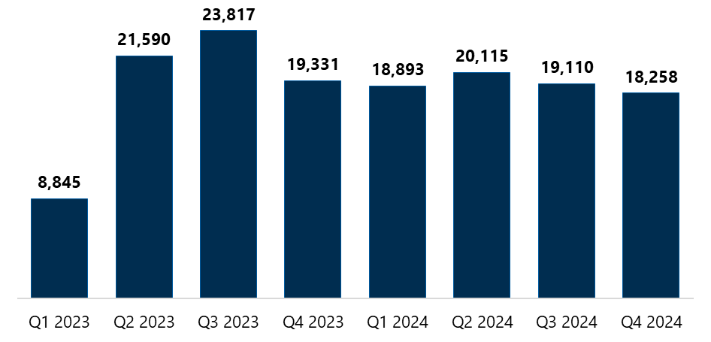

Figure 3 data is provided in Table 13.

There has been substantial variation in the number of hours spent in assertive outreach across CF organisations and PHNs. This may reflect the ability of some CF organisations to tap into existing referral networks or draw on more comprehensive experience to engage with clients. Other CF organisations may have had to develop new networks and would therefore have needed to spend more time on assertive outreach to connect with the target population. The variation in hours may also be a result of the staff resources available in the CF organisations. The substantial variation may also be rooted in different understandings of the definition or scope of assertive outreach, with organisations including promotional activities in assertive outreach or including travel time in their reporting.

Interestingly, there does not appear to be a relationship between the time spent on assertive outreach and rurality, as PHNs with a large geographic footprint reported comparatively different hours on this activity.

While PHNs and CF organisations see assertive outreach as a critical part of the program, care finder capacity constraints and existing waitlists mean outreach activities are not being delivered in some regions. Some care finders raised concerns that the high demand for their services meant isolated people are not being assisted.

[W]e actually haven’t had too much opportunity to be doing assertive outreach into really vulnerable pockets of the population. So I guess this is an opportunity to say if there’s any opportunity for growth funding or more support to say there’s lots of demand out there and just trying to cover that off. It feels like sometimes we’re probably not reaching the most vulnerable people. – Care finder

### Care finders are reaching more clients

Through increased assertive outreach and refined referral networks, CF organisations have identified and engaged with vulnerable older people, helping to connect them to the services they may require. CF organisations are also communicating effectively both within their PHN catchment and with other PHNs to facilitate client connections to the program. Where a CF organisation is unable to provide the care finder service (e.g. due to the client’s needs or location or the CF organisation’s capacity), CF organisations are using warm handovers to ensure the client receives timely support and continuity of care.

Care finders, referrers and clients greatly appreciated that care finders were not constrained by program KPIs that are focused on case numbers or the length of service delivery for individual clients. This freedom has meant that clients are more likely to receive the support they need.

#### New client cases

CF organisations have collectively supported thousands of older people, most of whom fall in the program’s target population. Since the start of the program, more than 40,000 new client cases have been reported by CF organisations, and the number of new client cases in 2024 is now stable at an average of approximately 5,700 new client cases per quarter (Figure 4).

Figure 4: New client cases, by quarter

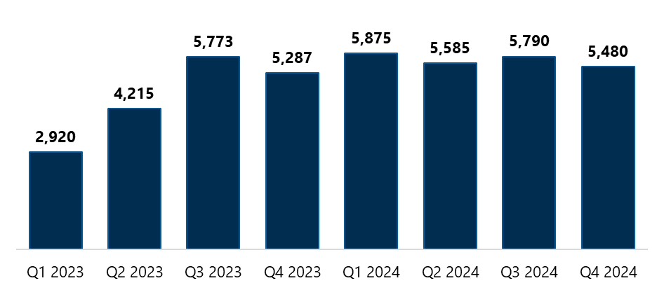

Read the Figure 4 long description. Figure 4 data is provided in Table 14.

We note that the care finder program MDS, developed in collaboration with the department, captures the number of client cases rather than the number of clients. This decision was made to allow us to capture data, such as time and resources needed, that is specific to the issues clients present with. As a result, client case numbers may overestimate the number of unique clients engaging with the program, as clients are counted each time they present with a new issue. There is currently no mechanism to follow a single client through their care finder journey in the data collection process; however, this may be possible in the future following the continued use of the My Aged Care Agent functionality.

#### Interactions that did not result in a client case are being captured

From 1 May 2024, CF organisations were asked to estimate the total time spent on all interactions that did not result in a care finder case to capture evidence of efforts not previously captured in the MDS.[11] These interactions can include attending to phone or email enquiries about the care finder program from intermediaries and referrers, potential clients, or the public. Typically, in these interactions care finders handle enquiries from outside the care finder target population but they may also assist a prospective client who then decides not to proceed with the service. They may also refer a prospective client to a different CF organisation because of the client’s location or because their own organisation has limited capacity.

For the CF organisations that reported on interactions over the last 7 months that did not result in a care finder client case, each CF organisation spent an average of 12 hours per month completing activities and interactions that did not result in a client case, which corresponds to 6 hours per FTE per month (4% of the total FTE per month). We note that this estimation is based on the number of CF organisations who opted to report this optional data item.

#### Closed client cases

Care finders are expected to close a client’s case when they believe that they understand and have addressed the client’s needs (including making referrals as needed), supports have commenced (at least in part, where needed), or neither the care finder nor the client see a need for continued care finder support. Cases may also be closed at the client’s request regardless of the case’s resolution state. Cases are assigned to a band based on the total hours of support provided:

* band 0: 0 to 2 hours
* band 1: 2 to 5 hours
* band 2: 5 to 10 hours
* band 3: 10 to 15 hours
* band 4: 15+ hours.

Since the start of the program, 30,394 client cases have been closed. Figure 5 shows that over time the proportion of closed client case bands has shifted towards cases that require more hours of support.[12]

Figure 5: Proportion of closed client case bands, by quarter

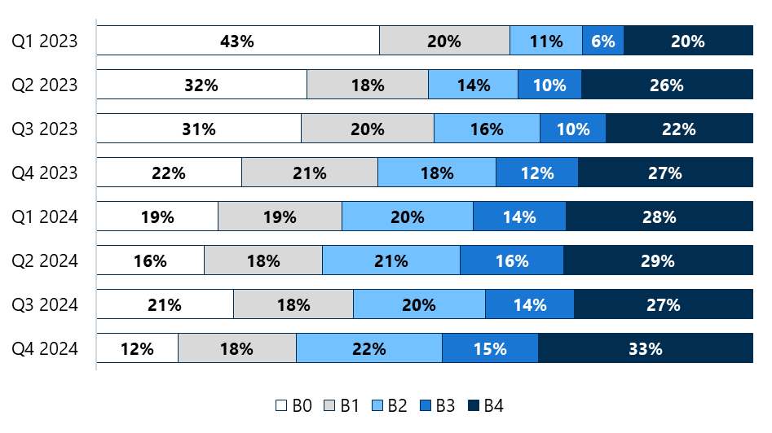

Read the Figure 5 long description. Figure 5 data is provided in Table 15.

This shift is gradually aligning with the performance indicator requiring that across PHNs at least 70% of closed client cases should receive more than 5 hours of support (bands 2 to 4): this was the case in the last quarter of 2024. To date, however, 60% of all closed client cases were assigned to bands 2 to 4, which falls short of PHNs’ performance indicator target, with only 9 out of 31 (29%) PHNs having at least 70% of closed cases in bands 2 to 4. Over the course of evaluation, PHNs raised 2 key concerns about this performance indicator. First, complex clients often have multiple issues that are not apparent at the outset, meaning that several shorter cases are opened and closed for the same client. Individual clients may therefore receive more than 5 hours of support, but this is not reflected in the data. Second, CF organisations are often not closing cases due to a lack of available services, leaving clients “on the books” while care finders establish stand‑in supports.

#### Active client cases

As of 31 December 2024, there are almost 12,000 active care finder client cases. There is no mechanism to track how long a case has been active or how many hours of support have been spent on it until the case is closed and assigned a band.

## Supporting clients

Care finders are expected to support clients through one or more of the following activities, shown in Figure 6, depending on their clients’ individual needs and preferences:

* engagement and rapport building
* support to interact with My Aged Care
* guidance through the assessment process
* support to find required aged care and other community supports
* high level check-ins and follow-up support after services and supports have commenced.

Figure 6: Care finder activities to support clients

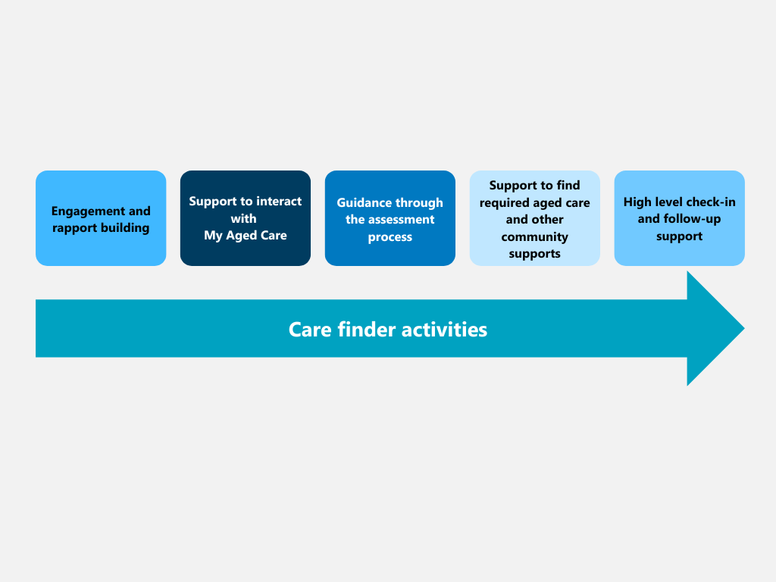

### Care finders are engaging with and assisting clients

Engagement and building rapport are foundational to the subsequent assistance that care finders provide to their clients. Care finders believe that the strong relationships they form mean that clients are staying engaged when they may otherwise not, for example, after repeatedly encountering roadblocks to service access.

As the program has progressed, there has been a slight shift in the focus of care finder activities to assisting clients to find appropriate services and supports (Table 1). This shift may be due to new cases now being more complex than when the program launched or more complex cases staying open for longer. It may also reflect difficulties with connecting clients to the right supports.

Table 1: Proportion of care finder activities delivered, by quarter

| Reporting quarter | Engagement and rapport building | Assistance to find required supports | Support to interact with My Aged Care | Guidance through assessment | High level check-in |
| --- | --- | --- | --- | --- | --- |
| Q1 2023 | 36% | 27% | 13% | 12% | 12% |
| Q2 2023 | 37% | 29% | 14% | 12% | 9% |
| Q3 2023 | 36% | 31% | 13% | 12% | 9% |
| Q4 2023 | 34% | 31% | 14% | 11% | 10% |
| Q1 2024 | 34% | 31% | 13% | 10% | 11% |
| Q2 2024 | 33% | 32% | 13% | 10% | 12% |
| Q3 2024 | 32% | 35% | 12% | 9% | 12% |
| Q4 2024 | 33% | 33% | 12% | 9% | 13% |
| Total | 34% | 32% | 13% | 10% | 11% |

Stakeholders repeatedly said that the lack of other supports means care finders are often operating outside the scope of the program and delivering care management type activities to ensure clients are safe at home and have their basic needs met while they wait for services to commence.[13]

While care finders view this work as critical, it can also lead to clients becoming over-reliant on care finders and finding it difficult to disengage from the program when services commence. It has meant some care finders had high caseloads and had to “close their books”, thereby limiting the number of vulnerable people they can assist.

The cohort of people that we’re looking after, they have much higher needs than just linking them with a service provider. So we can be doing things like making sure they have smoke alarms, contacting [service provider] to get gutters cleaned, helping people if they’ve got cognitive impairment to do their shopping … it could be an 8‑month wait until they get that and CHSP services, yes, they might provide some simple services like domestic assistance or some lawn mowing, but they’re not covering all the details that someone needs when they’re actually living their life at home. – Care finder

Possibly, some organisations that transitioned from the ACH program are also still adjusting to the care finder program’s focus on navigation support.

John’s story

John lived alone and was extremely socially isolated. During an extended stay in hospital, the medical team had concerns about whether he could be safely discharged home, because of his frailty, complex health needs and lack of support.

However, John was determined to go back home, rather than enter an aged care home, and once he was medically stable, he was discharged with initial support from the GEM@Home program along with approval for a level 4 high-priority Home Care Package (HCP). The Transition Care Program manager also referred him to the care finder program.

The care finder spoke with the Transition Care Program manager and hospital physiotherapist, who suggested that John might be resistant to care finder support and formal assistance in general. The care finder’s primary goal for the first visit was therefore to build rapport. Although John was gruff, during the initial home visit the care finder spent 3 hours listening to his concerns about receiving support. The care finder learned he was apprehensive about losing his independence and worried about the costs of home care.

To address John’s fears, the care finder reassured him that they would find out if he needed to pay an income‑tested care fee before he decided whether to accept the HCP. John asked the care finder to leave the paperwork for him to review at his own pace. The care finder respected his request and scheduled a follow-up appointment in 10 days. At the next visit, John agreed to receive ongoing care finder support.

The care finder assisted John by helping him select an HCP provider, facilitating introductions with the care manager and supporting him at his initial meetings. The care finder then worked with John to clarify his priorities for his HCP, resulting in accompanied shopping and gardening services being introduced.

Once John felt comfortable, domestic assistance, transport, podiatry, and a personal alarm were added, along with care management to ensure he was keeping on top of his bills and administration.

John appreciated the amount of time that the care finder took to listen to his needs and understand his concerns and felt that the program had helped him avoid moving into residential care.

*Names changed to protect anonymity

### Care finders are delivering services in person as appropriate

The care finder policy guidance states that support should predominately be provided face to face, with other modes provided if required. This expectation has been taken on board by CF organisations with almost half (45%) of care finder services to date being delivered in person, either in an individual (42%) or group (3%) setting.

Over the lifespan of the program, there has been a subtle shift in the mode of care finder service delivery with a 6% decrease in the proportion of face‑to‑face service delivery mirrored by a 6% increase in the proportion of services delivered over the phone. CF organisations indicated that engaging in person with clients is a valuable aspect of the program, particularly during initial contacts to build rapport. However, once rapport has been established with clients, care finders often switch to communicating with them by phone to make best use of limited resources including funding, services, time and staffing.

It’s not just about population; it’s got to be about the distance as well. We know we get better outcomes when we see people face to face. We can get a sense of what’s happening for them. They trust us more quickly, more deeply. That experience is very different, so we need to find a way that we can have complete coverage over entire region, and we can have that localised response when there is very, very thin talent pools for staffing, but also the services. – Care finder

At the PHN level, the amount of face‑to‑face care finder services delivered ranges from 23% to 64%. There does not appear to be any systematic similarities or differences between PHNs that have very similar or different patterns of service delivery. For example, there was no clear impact of rurality on the proportion of services delivered in person. The diverse range of service delivery methods across the program confirms that there is no one‑size‑fits‑all approach to service delivery.

### Outbound referrals are increasing

Since the beginning of the program, CF organisations have reported a total of 130,295 outbound referrals. The number of outbound referrals made has increased over the life of the program from 49,620 in 2023 to 80,675 in 2024. During 2024, the average number of outbound referrals made each quarter was 20,169, peaking in the third quarter with 21,140. The growing number of outbound referrals does not simply reflect the growing number of cases, as the average number of referrals for each new client case has also increased over time (Figure 7).

Figure 7: Average number of outbounds referrals per new client case, by quarter

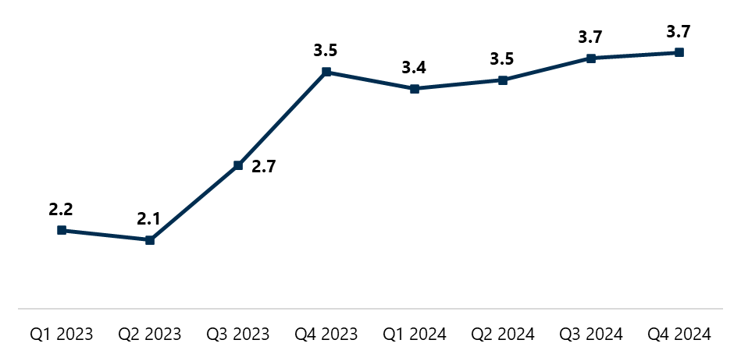

Figure 7 data is provided in Table 16.

Of the total number of outbound referrals made by care finders to date, 12,276 (9%) were internal, that is, referrals made to services delivered by other sections of their CF organisation. All CF organisations that reported internal referrals confirmed that clients’ choices were respected and facilitated and that conflict-of-interest requirements were met.

The remaining 118,019 (91%) referrals were made to external services and supports, that is, those not delivered by CF organisations. To date, aged care services account for about half (51%) of external referrals for individual service types (Table 2). The remaining external referrals (49%) were made to a wide range of non‑aged‑care services and supports, most commonly those related to housing and homelessness. This supports reflections from both CF organisations and PHNs that a greater than expected proportion of clients require housing and homelessness services.

Table 2: Total number and proportion of external referrals made, by service type

| Service types | External referrals | Proportion |
| --- | --- | --- |
| Aged care services | 60,639 | 51% |
| Housing and homelessness services and supports | 17,349 | 15% |
| Health services | 11,510 | 10% |
| Social services and supports | 9,260 | 8% |
| Community groups | 5,713 | 5% |
| Mental health services and supports | 3,324 | 3% |
| Drug and alcohol service and supports | 630 | 1% |
| Other | 9,594 | 8% |
| Total | 118,019 | 100% |

We recognise that the data shows there are more referrals to aged care services (n = 60,639) than new client cases reported (n = 40,925). This may be a result of a single client case receiving multiple referrals to aged care services, as each referral is counted separately.

Robert’s story

Robert (77) was unable to navigate the aged care system due to cognitive impairment and was also reluctant to engage with some government services. He was referred to the CF organisation by an occupational therapist provided through the Department of Veteran Affairs (DVA), with whom Robert had already established a good relationship. The occupational therapist was aware of the program through the CF organisation’s outreach work and had previously had positive outcomes with other clients with complex needs.

The care finder carried out a comprehensive range of tasks to engage with and assist Robert, taking a tailored approach to meeting his complex needs. This included investing significant time in building rapport, initially meeting casually at a local coffee shop along with the occupational therapist. This gradual approach helped Robert feel more comfortable and eventually he allowed the care finder to visit his home.

The care finder assisted with a range of referrals, including for DVA nursing, domestic and home maintenance, continence support (through his local hospital), a personal alarm, Meals on Wheels, social support and welfare checks.

While the case is not yet closed, the care finder referral process created a positive experience for Robert and helped set him up for the future.

*Names changed to protect anonymity

### Clients are still connected with services at high level check-ins

Care finders believe high level check-ins are a proactive and useful way to make sure that the client is not only connected to a service but engaging with that service. Care finder clients also greatly value these check-ins.

I was shocked when [my care finder] called to check in and see if I was happy or if I needed help with my services. I have tried many other services where they say they will call you back, but they never do. [My care finder] didn’t forget me or my circumstances and called me when she said she would. – Care finder client

Over the life of the program, the proportion of referred clients who, on high level check-in, are still connected with the services they need has risen from 68% in the first quarter of 2023 to 88% in the last quarter of 2024. For clients who are no longer connected with services on check‑in, care finders reported several reasons for this loss of connection:

* there are no suitable services available
* clients are still waiting for services to commence
* clients did not want to accept the available services offered
* clients could not afford the services offered
* clients do not have a stable address for the services to be delivered at
* clients were dissatisfied with the services received
* clients had difficulty accessing the service on an ongoing basis
* the client is deceased.

While high level check-ins have been vital to the program, some care finders have expressed it can be difficult to “let clients go” when their clients are not receiving ongoing or stable services. As a result, this can restrict the capacity of care finders to support new client cases, especially given that check-ins do not necessarily result in the client leaving the program but rather a new case being opened (if, for example, the care finder finds that a client’s services have commenced but are inappropriate).

Daisy’s story

Daisy presented at the CF organisation with a My Aged Care letter advising that she had been approved for an HCP but was confused and hesitant to follow up this paperwork. The care finder helped Daisy understand the letter and offered to help connect her with an HCP provider, with a focus on support with cleaning. After some initial difficulties, Daisy chose a provider who accepted her package.

The care finder attended Daisy’s home to support her during her first meeting with the HCP care manager. The care manager presented the care plan to Daisy and explained the budget, which Daisy was happy with. Subsequently, a specialist cleaner attended and was shown around the home by the care manager so that they could prepare a quote. The care finder then told Daisy that they would now step back and allow the care manager to provide ongoing support but would check in with her from time to time to ensure everything is meeting her needs.

A month later, the care finder called Daisy to check in. Daisy told the care finder that she had not heard from the care manager and felt abandoned by them. The care finder emailed the care manager to check on progress with the cleaning service. The care manager responded that the cleaning had not yet been done because they needed to wait until enough funds had accumulated to cover the cost. The care manager also told the care finder that they would be going on leave for several weeks.

Over the next month, the care finder frequently called the cleaning service, stressing the importance of having it done soon because of Daisy’s mobility issues. The care finder also checked in with Daisy every week to provide reassurance and updates. The care finder suggested to Daisy that she consider using a different cleaning service, but Daisy preferred to wait until her care manager was back from leave.

The care finder eventually received a call from the care manager letting them know that the funds were now available for the specialist cleaning and it would be booked in soon. The care finder requested that they be notified of the date for the cleaning to ensure the client was prepared. However, the cleaning company only called Daisy for the day before the clean, which she found distressing. The care finder arranged to be present with Daisy during the cleaning to make sure she was comfortable.

Following the clean, the care manager advised the care finder that regular ongoing cleaning had been arranged. The care finder called Daisy to let her know that they would again step back to let the care manager support her but stressed that Daisy could contact the care finder if she has any further trouble communicating with the care manager.

*Names changed to protect anonymity

Key lessons learned

1. Care finders are often working outside program scope to support the target cohort.

Future opportunities:

The department’s Navigation and Access Branch could consider:

* providing resources to help PHNs lead conversations with care finders about managing clients within the scope of the program
* providing information to PHNs on how the new Support at Home program will take on care management and intersect with support provided through the care finder program
* ensuring promotion to intermediaries clearly outlines the scope of the care finder role and the referral pathways for clients who have needs that cannot be met by care finders.

PHNs could consider:

* using CoP meetings as a forum to discuss how to assist clients while remaining within program scope
* ensuring local intermediaries are informed about the scope of the care finder role and referral pathways for clients who have needs that cannot be met by care finders.

# Client characteristics and experiences

In this section we explore the characteristics of care finder clients and their experiences with the program. Most care finder clients are in the target population of the program as outlined in the policy guidance. Furthermore, almost two-thirds of surveyed clients identified as being a member of both the program’s target population and a special needs group. This continues to align with the policy guidance which states that there is likely to be significant cross-over between people who are in both the target population and the special needs groups.

Overall, care finder clients have had positive experiences and outcomes when engaging with both the program and the care finders.

## Client characteristics

To understand the characteristics of care finder clients, we examined whether clients are in the program’s target population and whether they identify with any special needs groups. We also explored the similarities and differences between My Aged Care clients who have a care finder agent registered in a support role and those clients with a regular representative acting in a support role.

### Clients are in the target population

As mentioned in section 2.1.1, the program is targeted at older Australians who are eligible for government-funded aged care but need intensive support to access services.

During the evaluation we captured target population data using 2 mechanisms:

* CF organisations report the proportion of new client cases that are in the target population in their monthly activity reports
* clients can indicate which of the target population groups they identify with when completing the client survey.

While data collected from both sources indicates that most care finder clients are in the target population, there are differences between the 2 data sources.

Overall, CF organisations have reported that 98% of new client cases are in the target population.[14] Across PHNs the proportion of new client cases that are in the target population has varied between 95% to 100%. Even with this variation, all PHNs have surpassed the target population performance indicator target of 90%.

In contrast, only 82% (n = 4,360) of clients who completed the client survey[15] reported that they belong to at least one of the target population groups, with clients most commonly indicating that they live alone and need more support (Table 3). The remaining clients indicated that they are not a member of any of the target population groups (13%) or preferred not to disclose this information (5%).

Table 3: Proportion of surveyed clients who indicated that they are in the program’s target populations, by target population group

|  |  |
| --- | --- |
| Target population groups | Proportion  n = 4,360 |
| Lives by themselves and requires more support | 57% |
| Is worried or unsure about getting aged care services | 42% |
| Has difficulty communicating | 33% |
| Finds it hard to make decisions | 31% |
| Has trouble trusting government or large organisations | 24% |
| Has had negative experiences when receiving aged care services in the past | 17% |

Note: The number of clients who belong to at least one of the target population groups is 4,360. Response options were not mutually exclusive; therefore, percentages sum to more than 100%.

There are several possible reasons for the disparity between representation of target population groups as reported by CF organisations and clients:

* Only 22% of eligible clients completed the survey. This group may be less likely than non‑completers to belong to the program’s target population (for example, clients with communication barriers may be less likely to have completed the survey).
* Clients in the target population may find the survey difficult to understand, may not recognise or may not wish to disclose a vulnerability or identify with one of the target populations.
* A single client may be counted as multiple cases by the CF organisation, but they are likely to complete the survey only once.

### Many clients belong to special needs groups

Clients were also asked to indicate if they belong to any of the special needs groups defined in the Aged Care Act 1997. Of the 5,300 clients who completed a client survey, almost three‑quarters (n = 3,736; 70%) of clients identified as a member of at least one special needs group, with 21% saying they did not see themselves as a member of any of the listed special needs groups and 8% not disclosing this information.

Table 4 shows the breakdown of which special needs groups clients identified with.

Table 4: Proportion of surveyed clients who identified with at least one special needs group, by special needs group

|  |  |
| --- | --- |
| Special needs group | Proportion  n = 3,736 |
| Financially or socially disadvantaged | 45% |
| Culturally and/or linguistically diverse background | 33% |
| Lives in rural or remote area | 32% |
| Homeless or at risk of homelessness | 17% |
| Aboriginal or Torres Strait Islander | 9% |
| Care leaver | 4% |
| Veteran | 3% |
| Lesbian, gay, bisexual, transgender and intersex (LGBTI) | 2% |
| Affected by forced adoption or removal | 1% |

Note: The number of clients who identify as a member of at least one of the listed special needs groups is 3,736. Response options were not mutually exclusive; therefore, percentages sum to more than 100%.

### Comparing clients with care finder agents and those with regular representatives

In general, individuals can appoint a family member, friend, person they trust or an organisation as a representative or agent to support them in their interactions with My Aged Care. A representative can:

* communicate with My Aged Care, assessors, and service providers on behalf of or with an individual
* help the individual to make decisions or make decisions on their behalf about aged care assessments and referrals for aged care services
* seek and update personal information held by My Aged Care.

While an agent supports an individual in a professional capacity by being involved in discussions and accessing and updating information in My Aged Care, they cannot make or convey decisions on the individual’s behalf.

When a care finder establishes an ongoing relationship with a client, they can seek the client’s permission to become their agent in the My Aged Care system. We compared the following demographics for individuals with a care finder agent and those with a regular representative using My Aged Care data provided by the department:[16]

* age
* who the client lives with
* Indigenous status
* gender
* their need for help with communication
* DVA entitlement
* preferred language.

Consideration

My Aged Care data provided by the department includes 10,284 clients with a care finder agent established between 1 January 2023 and 30 April 2024. In the same period, there were 25,930 new client cases reported by CF organisations. Noting that a single client may have multiple cases, My Aged Care data represents approximately 40% of care finder cases. Furthermore, not all care finder clients are registered in My Aged Care and as such this subset of care finder clients may not truly reflect all care finder clients.

Below we discuss only the demographic characteristics that show differences. Comparing the remaining demographic characteristics revealed few to no differences between the 2 client groups.

Looking at the distribution of clients by age (Figure 8), clients aged 75 to 79 years are the most common in both client groups. However, the data shows that clients with a care finder agent are younger than clients with a regular representative.

Figure 8: Age groups of My Aged Care clients, by support role

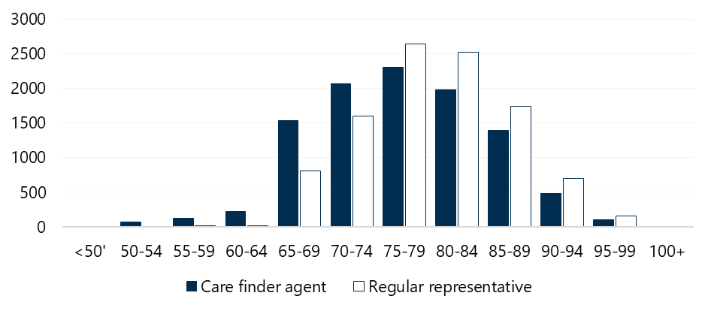

Figure 8 data is provided in Table 17.

Care finder clients may also face additional barriers to accessing aged care services, as is the case for First Nations people or people who are prematurely aged or are experiencing homelessness who are eligible for aged care before the age of 65. This reasoning is strengthened by the fact that there are a greater number (almost sixfold) of First Nations clients with a care finder agent than those with a regular representative (Figure 9).

Figure 9: Indigenous status of My Aged Care clients, by support role

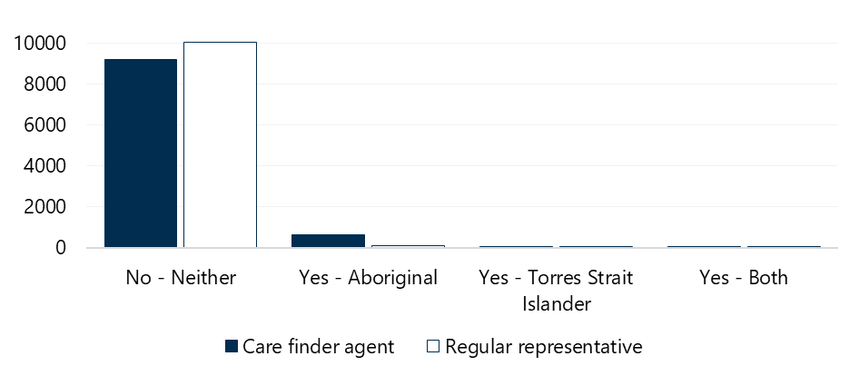

Note: Clients who did not indicate their status or provided inadequate information have been excluded.

Figure 9 data is provided in Table 18.

As previously mentioned, clients who live by themselves are part of the care finder target population. Figure 10 shows that care finders are engaging with clients who live alone. My Aged Care data shows that the number of clients who live alone who have a care finder agent is almost double that of those who have a regular representative.

Figure 10: Who My Aged Care clients live with, by support role

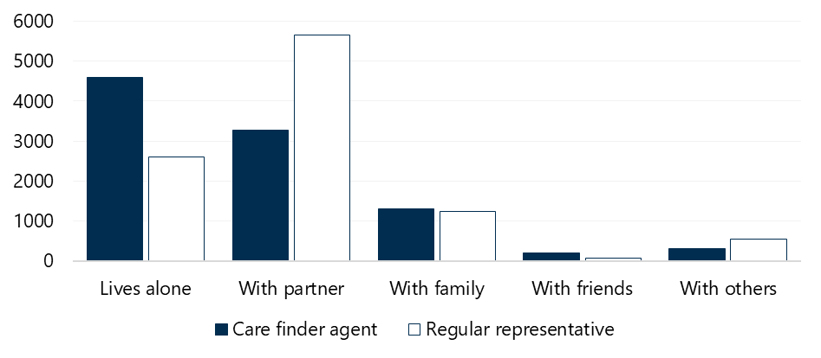

Note: Clients who did not indicate their status or provided inadequate information have been excluded.

Figure 10 data is provided in Table 19.

## Client experiences

Throughout the program, most clients have reported positive experiences.[17] Overall, clients have felt that:

* the care finder service is easy to access
* the care finder services and referrals they received are appropriate
* the CF organisation is trustworthy
* the outcome of the care finder process is satisfactory.

### Accessing the service is easy

On average, 92% of clients reported that the care finder service is easy to access. Across PHNs, this view was shared between 85% and 100% of clients.[18]

I attend a Parkinson’s disease support group where a care finder did a presentation. She spoke for an hour about the care finder service and what was available. She stood at the front and had everyone’s attention. [It was like she was] like one of us – it impressed me. I got a card and a form from her. I sent an email on the Thursday and got a call Monday morning from [the care finder]. – Care finder client

### Care finder services and referrals are appropriate

Overall, almost all clients (96%) felt that the care finder service is appropriate for their needs and most (92%) clients were satisfied with the aged care services or community supports they were referred to.

Across PHNs, the proportion of clients agreeing that care finder services were appropriate for their needs ranged from 89% to 100%, while the proportion agreeing that referrals were appropriate varied slightly more, ranging from 79% to 99%.

### The care finder organisation is trustworthy

Almost all clients (n = 5,094; 97%) found their CF organisation to be trustworthy. Trust in CF organisations was high across all PHNs, ranging from 93% to 100%.

A key activity for care finders is to build trust and rapport with their clients and we heard that trust is enhanced when clients can see their care finder working hard for them, trying to locate appropriate services, explaining hard‑to‑digest information and promptly answering questions.

Absolutely, I found the care finder very trustworthy. I was seeing the care finder once per week. I would process the information, then raise things with her. I could email her questions and she would get back to me. It was a good connection and a good relationship. I had a lot of respect for her, and she had that for me. – Care finder client

### The outcome of the care finder process is satisfactory

Almost all clients (95%) felt satisfied with the outcome of the care finder process. In each PHN, at least 8 out of 10 clients reported that they are satisfied with the outcome of the care finder process. We also analysed responses by client’s gender, age, preferred language, and whether they had had help completing the survey and found that none of these factors had a noticeable impact on clients’ satisfaction with the outcome of the care finder process (Figure 11).

Figure 11: Client agreement that they are satisfied with the outcome of the care finder process, by key demographics

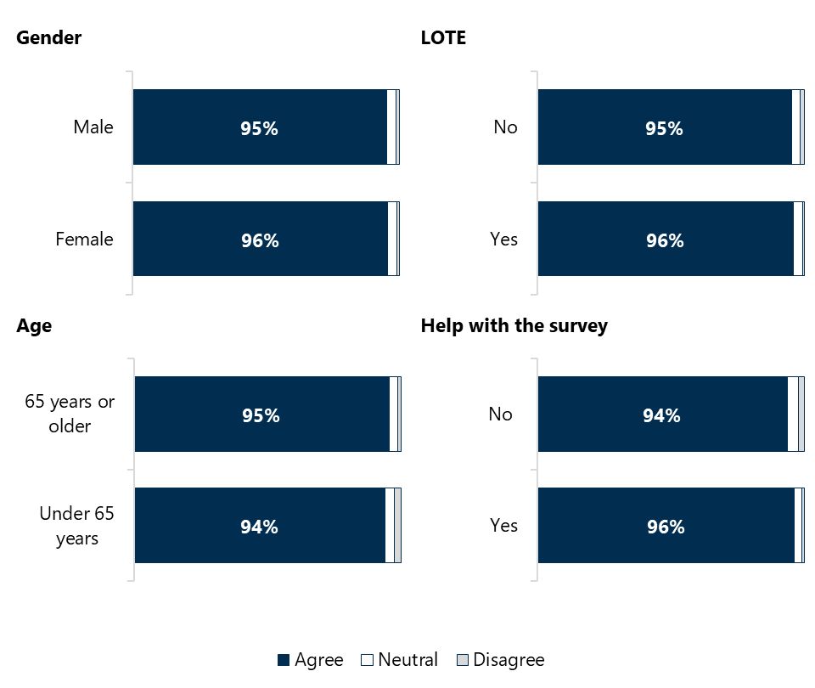

It is possible that systemic issues that prevent care finders from finding appropriate care negatively impact satisfaction with the program for some clients. A very small proportion of the clients was dissatisfied with their care finder outcome (n = 69; 1%). Of these, more than one‑third (n = 26; 38%) raised concerns and frustrations about the lack of services that are available rather than about the program itself.

I found the care finder to be most helpful and tried to help me connect to the appropriate service provider. Unfortunately, the service providers were most unhelpful and when the process was finished, I was no better off … I think the care finder service is a great innovation, but it can only be as good as the rest of the system allows it. – Care finder client

Tony’s story

Tony (70) is an Aboriginal client. He was referred to the care finder program by an ACAT assessor for support to connect with an aged care provider. Tony had been admitted to hospital for a heart attack and following assessment in the hospital, he was approved for a priority level 3 HCP. Prior to this, Tony had not been receiving any care or support.

After several meetings with the care finder, Tony shared that he was currently a caregiver to 3 of his grandchildren and that he was a member of the Stolen Generations, having been forcibly removed from his family at the age of 3. The children in Tony’s care were placed with him under a family arrangement with the Department of Child Protection and Family Services (CPFS). CPFS had identified several concerns about the safety of the children living in Tony’s home, due to the house being poorly maintained, and had notified Tony that the children’s living conditions would need to improve for them to remain in his care.

Being part of the Stolen Generations made Tony reluctant to engage with the aged care system. It was critical that the care finder establish trust and rapport with Tony and help him seek aged care from a provider that could support him in a way that is safe, culturally appropriate and informed by Tony’s trauma. Tony’s main goal was to continue to care for his grandchildren, and he acknowledged that his own health needed to improve to achieve this. The care finder helped Tony build his confidence and capacity to engage with medical support by helping him book and attend medical appointments. The care finder also helped medical staff to understand Aboriginal cultural ways of understanding time and how this may impact Tony’s attendance at appointments. Tony needed to bring his 18-month-old grandchild with him. Removing these barriers helped Tony receive sufficiently consistent care to improve his heart health following his heart attack.

Tony knew that he would benefit from receiving HCP services but was reluctant to do so due to stigma about accepting help through mainstream services. The care finder talked through these concerns with Tony and helped him feel confident to pursue aged care services. The care finder found a suitable provider for Tony and negotiated a flexible approach to delivering services. The care finder arranged for specialist cleaning of Tony’s house, and following this, organised regular domestic assistance through his HCP to maintain the condition of the home.

Tony had faced considerable obstacles in the aged care, health, housing and child protection systems that were addressed through care finder support. The care finder helped Tony to feel confident to speak up about his needs so that providers understood what he needed so that they could appropriately support him. Tony reports now feeling positively engaged with the aged care, health, child protection and housing systems. The care finder helped Tony to improve his health, receive support for his trauma, significantly reduce interpersonal and environmental risks, and improve his confidence when engaging with systems and services. Overall, this case study highlights how removing barriers can lead to improved access to aged care.

*Names changed to protect anonymity

## Performance indicators related to client experience

The aged care schedules contain 3 PHN performance indicators that relate to the client experience:

* Indicator A – clients should feel that the care finder service has improved their understanding of aged care services and how to access them
* Indicator B – clients should, after contact with the care finder, feel more open to engage with the aged care system
* Indicator C – clients should feel that the care finder provided them with the help needed to access aged care and/or connect with other supports in the community.

These performance indicators are also the expected short-term client outcomes for the program. Further discussion of program outcomes is found in section 8.1.

As part of the client survey, care finder clients were asked to report on their experience of the program in line with the 3 performance indicators above. At the program level, performance indicators related to the client experience have been met each quarter since the start of the program (Table 5). This suggests the program has achieved the short-term client outcomes related to these indicators.

Table 5: Overall progress against PHN performance indicators, by quarter

|  |  |  |  |  |  |  |  |  |  |  |
| --- | --- | --- | --- | --- | --- | --- | --- | --- | --- | --- |
| Performance indicator | Target | Q1 2023 | Q2 2023 | Q3 2023 | Q4 2023 | Q1 2024 | Q2 2024 | Q3 2024 | Q4 2024 | Overall |
| Indicator A | ≥85% | 91% | 92% | 88% | 91% | 94% | 96% | 97% | 96% | 94% |
| Indicator B | ≥85% | 91% | 92% | 85% | 90% | 91% | 96% | 97% | 96% | 94% |
| Indicator C | ≥85% | 95% | 95% | 93% | 92% | 95% | 96% | 94% | 95% | 95% |

Anna’s story

Anna (73) was referred to the program by WA Police after they had received several requests for welfare checks from neighbours. Anna’s daughter, Nina, explained that her mum used to work in the education system but retired 10 years ago due to fatigue, insomnia and a sudden inability to get out of bed on time. Nina was concerned that Anna had not seen her GP for 4 years and possibly had cataracts.

This information gave the care finder a way to approach Anna that would encourage her to engage, knowing that trust and rapport would be paramount. The care finder made an initial home visit and saw signs of hoarding and squalor in the home. At her next visit, the care finder had built enough trust with Anna to assist her with registering with My Aged Care, with Nina as her representative.

After several weeks, Anna shared with the care finder that she had recently fallen in her home and was unable to get off the floor for 4 days. It was critical at this point that Anna receive priority aged care support. The care finder assisted Anna to book an appointment with her GP and accompanied her. The GP provided Anna with a referral to receive an MRI, but Anna lost this paperwork when she returned home, so the care finder followed up with the GP to reinstate the referral.

Although the care finder faced challenges in getting Anna an expedited aged care assessment, Anna was eventually approved for a priority level 4 HCP and the care finder successfully advocated for high-level CHSP services in the interim. The care finder helped Anna connect to CHSP providers immediately upon approval.

In the meantime, Anna’s MRI results revealed that she had a benign brain tumour that was consistent with symptoms of malaise, an inability to solve problems, and impaired vision. The care finder was with Anna when she received these results and was instructed by the doctor to calmly take Anna to hospital as soon as possible, as there were concerns she may have a stroke. Nina and a neurosurgeon were waiting for her on arrival at the hospital, and Anna was operated on to remove the tumour. Following surgery, Anna said she felt “better than she had felt in 10 years”. Anna’s vision improved immediately after surgery, and she described feeling as if a fog had lifted. Anna spent 3 weeks in hospital before returning to her newly cleaned home, supported by Rehab in the Home services as well as the CHSP services the care finder had previously put in place.

Anna recovered remarkably well and no longer required intensive support from the program. Anna was maintaining her home well thanks to both her improved condition and support from CHSP services. Anna was also now reconnected with her family and support network. When Anna’s level 4 HCP became available, she no longer required such a high level of support and opted to remain on the CHSP.

Anna’s case illustrates the impact the program has on improving intersections between the aged care and healthcare systems. The client progressed from being withdrawn, not seeking support and not engaging with health services to being informed and actively involved in choosing her preferred aged care supports. The care finder’s person-centred approach helped Anna to re-engage, regain control of her life and ultimately save her life thanks to timely medical diagnoses.

*Names changed to protect anonymity

Key lessons learned

1. The program is reaching its target population and making a significant difference in their lives. The extension of the program has been welcomed and supported by all stakeholders.

Future opportunities:

The department’s Navigation and Access Branch could consider:

* maintaining the highly valued flexibility of the program
* continuing to share positive client feedback when communicating the program to referrers, intermediaries and other services.

PHNs could consider:

* using client success stories to demonstrate the scope and supports available to vulnerable older people when building relationships with referrers and intermediaries.

# Summary of program outcomes, successes and challenges

The program is evolving into a strong and impactful initiative. Its successes – rooted in localised staff placement, flexibility, collaboration, data-driven decision-making, and the dedication of its workforce – highlight the program’s potential to continue making a meaningful difference in the lives of vulnerable older Australians.

Overall, the program has significantly helped to fill the large gap of supporting people to work through aged care, as well as housing and health services. – Care finder

While the program has achieved almost all expected short-term outcomes and is on track to meet medium and long-term system outcomes, there have been several implementation challenges such as program staffing, communication pathways and the policy guidance. A number of systemic barriers to efficient and effective service delivery persist, including the complexity of the aged care system and the current housing crisis.

## Short-term program outcomes

The program has expected short-, medium – and long-term system and client outcomes which are to be achieved at 1 to 2 years, 3 to 6 years and 7 years or more respectively (see the care finder program logic in Appendix A).

At the end of the program’s second year, all short-term system and client outcomes had been achieved except for the outcome related to stakeholders’ awareness of key evaluation findings (Table 6 and Table 7). As stated in section 4.5.2, in October 2024 many PHN and CF organisations representatives were unaware of the evaluation findings and were not applying the findings to inform continuous improvement activities.

Table 6: Progress towards short-term system outcomes

| Expected system outcomes | Status |
| --- | --- |
| Establishment of a national care finder network providing specialist and intensive support to understand and access aged care services and connect with other relevant supports in the community | Achieved |
| PHNs have increased knowledge of local needs in relation to care finder support and opportunities to enhance integration between the health, aged care and other systems | Achieved |
| PHNs apply knowledge of local needs when commissioning care finder services | Achieved |
| Care finders, referrers and intermediaries have improved understanding of referral pathways and appropriate services to meet people’s needs | Achieved |
| Referrers and intermediaries have increased awareness of the care finder service | Achieved |
| PHNs and care finder orgs have improved awareness of local experiences, lessons learned and innovations | Achieved |
| Department, PHNs and care finder orgs have awareness of key evaluation findings | Partially achieved |
| Care finders have increased skills and knowledge | Achieved |

Table 7: Progress towards short-term client outcomes

|  |  |
| --- | --- |
| Expected client outcomes | Status |
| Clients experience improved coordination of support when seeking to access aged care | Achieved |
| Clients have improved understanding of aged care services and how to access them | Achieved |
| Clients are more open to engage with the aged care system | Achieved |

## Program success by region

As stated in section 3.1, the program was implemented largely as planned although it was more successful in some PHN regions than others. Initial program implementation was more successful in PHNs with dedicated and well-resourced staff to oversee the program. This included staff to manage contracting elements and staff to help with routine program queries and provide program updates to CF organisations. These PHNs informed care finders of training opportunities and helped to identify local training needs. They also consistently coordinated CoP meetings beyond the initial rollout, including some in-person sessions that care finders found particularly beneficial.

Successful PHNs were proactive and quickly engaged with commissioned CF organisations in January 2023 to establish connections, ways of working and promote knowledge sharing. Care finders told us that while it was helpful if the PHN staff understood aged care, it was more important that they responded promptly to issues and questions, especially in the early days.

While effectiveness of the program across PHN regions has varied, clients nationwide are receiving much-needed support through the program. We did not find a clear relationship between the number of CF organisations commissioned by a PHN and the success of the program in that region. While we did find that CF organisations with low staffing levels may have struggled to meet the requirements of the program (including service delivery, data reporting and promotional work), effective support systems and processes at the PHN level appear to have mitigated any regional performance issues.

PHNs’ success in enhancing integration varied due to the maturity of local integration before the program began and existing connections with health, housing and other systems. Proactive PHNs that have consistently promoted the program to local intermediaries such as GPs and referral pathways have also had more success with integrating local systems.

Unsurprisingly, PHNs with higher levels of staff turnover or with staff stretched across multiple programs were less engaged and responsive, which hindered program implementation and effectiveness. Also, PHN rurality appeared to be a more significant factor impacting the effectiveness of a PHN region. The program was less effective in rural and remote regions due to travel distances, lower levels of funding and staffing challenges (including recruitment and retention of qualified staff).

## Medium – and long-term program outcomes

While the program’s long-term outcomes are targeted to be achieved in 2030, pleasingly, in late 2024 many PHN and CF organisation representatives felt the program had already achieved them.

I think we’ve already achieved those longer-term outcomes because it has become an effective, sustainable, integrated part of the aged care system in [PHN region]. We are all in. [However,] it’s contingent on other parts of the system continuing to play their part. – PHN representative

Importantly, almost all clients have reported positive outcomes from the program. Referrers also expressed the program is reducing isolation and filling an important gap in aged and community care support systems.

While almost all stakeholders felt the program will achieve its expected medium – and long-term system outcomes, they were less sure about the medium – and long-term client outcomes due to constraints on the services available. Specifically, they reported the program is not on track to achieve the following medium – and long-term outcomes:

* population groups identified as needing care finder support have increased rates of access to aged care and connections with other relevant supports in the community
* clients have improved outcomes (improved access to the right care, at the right place, at the right time).

Accessing the right care at the right place and time is not yet possible for many clients due to service availability constraints. Wait times for assessments and service commencement are other constraints frequently mentioned by care finders.

Clients can be waiting up to 12 months for a basic service to be implemented to keep them safe in their homes. – Care finder

The high demand for housing, including social housing which has wait times of up to 10 years in some areas, also restricts clients’ ability to receive the right care. At-home services cannot start while a client is in temporary housing, which significantly compromises the effectiveness of the program to achieve client outcomes.

George’s story

George (75) lives with his wife in a retirement village. He was diagnosed with temporal glioblastoma and needed to undergo a craniotomy. He needed help from the care finder to find the right aged care support once he was discharged.

George had been assessed before being admitted to the hospital. However, his family faced challenges in finding a provider and felt overwhelmed by the system, especially with the various CHSP referral codes and as a result, services had not commenced.

Following his discharge, George received transition care for 3 months. This included personal care, help with transport, and allied health care. The care finder arranged for George to be reassessed for aged care given that his needs had changed. He was assessed as eligible for a level 3 HCP with medium priority. However, his HCP is not yet in place and his transition care will soon end.

The care finder will continue to work with George to ensure he and his wife have the supports they need to live at home. George is typical of many care finder clients who experience challenges in locating a provider and lengthy waits for their HCP to commence.

*Name changed to protect anonymity

## Program enablers

The program’s implementation success and achievement of short-term system and client outcomes has been aided by several enablers.

PHNs have a deep understanding of their regions, established relationships, and a flexibility that have enabled PHNs to address local needs, respond quickly to emerging challenges and integrate care finders into existing networks.

Local placement of individual care finders across different regions has allowed care finders to establish and build on strong local networks and cement trust within their communities. It has also reduced travel costs, making the program more efficient.

The program’s flexibility and lack of rigid time constraints around service delivery have allowed care finders to tailor their support to the unique needs of each client, providing a level of support that is often unavailable in more prescriptive programs. This has been especially valuable for the target population which commonly have complex and extensive support needs.

In-person service delivery, where possible, has provided the care finder with a more accurate picture of the client’s circumstances and meant that less mobile or socially isolated people could receive program services.

Collaboration among CF organisations whereby some organisations are working together seamlessly, sharing referrals, expertise, and resources as if they were a single entity. This has led to more efficient and effective program delivery.

In-person CoP meetings have been particularly beneficial in fostering collaboration and knowledge-sharing among care finders. These gatherings facilitate connections and allow for the exchange of experiences and expertise, enhancing the overall cohesion of the program.

Activity reporting and other PHN-required data have been instrumental in identifying issues and gaps in service delivery. PHNs can adopt a data-driven approach and respond proactively to issues as they arise, refining the program’s focus and ensuring that resources are directed where they are most needed.

Care finders’ empathy, enthusiasm, responsiveness, and passion for the work are a cornerstone of the program’s success. Their broad range of skills and experience across range of areas including council and community services, mental health, homelessness services, social work and nursing has helped clients receive more specialised and tailored solutions to meet their individual needs.

Lina’s story

Lina (86) sought assistance after experiencing a fall, which led to a hospital stay. Hospital staff referred Lina to a care finder, to address her urgent support needs. Lina had previously been assessed for home care services, but services never commenced due to her unsafe home environment, which included a beehive in her garden.

The care finder provided a range of assistance, including:

* arranging a high-priority aged care reassessment to expedite support for Lina’s complex needs
* reaching out to various bee removal services: she eventually found a volunteer beekeeper who removed the hive
* engaging local health officers and coordinating with Lina’s local council to conduct a health and safety reassessment
* researching and organising professional decluttering and cleaning services from a company that specialises in hoarding to restore Lina’s home to a liveable state.

The home was then deemed liveable by the authorities. A level 4 HCP was approved, and a suitable service provider was secured for Lina.

This case study highlights some of the key enablers of the program, including its flexibility and lack of strict time constraints around service delivery. The absence of rigid time constraints meant that the care finder could tailor support to meet Lina’s complex needs. It further highlights the care finder’s responsiveness, compassion and unique skills in coordinating various stakeholders and services, such as the local council, aged care services and other local resources.

*Names changed to protect anonymity

## Program challenges and barriers

The program’s success has nevertheless been tempered by several implementation challenges and barriers to service delivery. These include **systemic challenges** that sit outside the program.

The current housing crisis has increased the complexity of client needs and reduced the number of clients that can be assisted through the program with clients remaining “on the books” while waiting for suitable housing.

Older people still have difficulties understanding and navigating the aged care system despite a range of efforts to simplify the aged care system. Older people with lower-level needs (and therefore outside the target population), including those “in the system”, are contacting CF organisations for navigation assistance. Care finders are unclear where to refer this cohort and managing these enquiries takes time.

Limited service availability and long wait times for assessments in many regions is an ongoing major challenge as care finders are left “holding” the client and looking for interim services (e.g. volunteer services), which are often not available.

Care finders are limited in the client information they can view in the Service and Support portal and cannot action client requests without the client present, even when the client has provided consent and an agent relationship has been established. This was viewed as very inefficient and made helping clients who live in regional or remote areas more difficult.

The inaccuracy of service availability data on My Aged Care meant care finders need to phone potential service providers individually, adding to their workload.

**Program-level challenges** include:

**CF organisations with low FTE**, including many that transitioned from the ACH program, are limited in their ability to deliver all aspects of the program and meet local need for support. Staff lack capacity to deliver assertive outreach and promotional activities, and they are restricted in their ability to travel, which means some truly isolated people are not being reached.

**Staff turnover in some regions** (both in PHNs and CF organisations) has limited program momentum, community connections and the sharing of corporate knowledge. Robust recruitment practices and strong staff support are crucial to the continued success of the program, particularly for CF organisations with low staff numbers.

For CF organisations and intermediaries working across multiple regions, PHNs’ differing interpretations of the policy guidance (including the target population), unique reporting requirements, referral pathways and contracting processes have been challenging to manage.

The capacity and priorities of individual PHNs have created a fragmented experience and variation in the program’s effectiveness across regions. While CF organisations in some regions benefit from strong PHN involvement others lack the same level of guidance and resources.

The department requires that PHNs share program and My Aged Care updates and information on related aged care programs with CF organisations in communiques. It appears that this important information is not reaching some care finders, possibly because it was not forwarded by PHNs or care finders were too busy to read the email update and it was not circulated in another context, such as a CoP.

Susan’s story

Susan (82) was a returning client to the program. She was diagnosed with stage 4 breast cancer and referred herself to the program in February 2024 for additional help to find a new level 4 HCP provider that could better meet her needs and service expectations. Susan had received over 50 hours of care finder support in 2023 because she was not satisfied with her existing level 3 HCP provider and needed help to find a new one. The care finder helped Susan to connect to a new provider under a level 4 package.

During this time, Susan received tragic news that her son had passed away. In the subsequent period of significant distress and grief, she ceased attending all health appointments for 6 months. Susan also disclosed to the care finder deeply personal and traumatic experiences of family and domestic violence. Susan subsequently refused to engage with aged care, health or mental health services and formed a strong attachment to the care finder, insisting on almost daily phone calls or home visits. Susan also refused to speak with her service provider or accept a home visit by the provider’s registered nurses so they could review her needs.

Despite efforts to establish clear boundaries with Susan on the role of a care finder, and her responsibilities to engage with the provider, the care finder was unsuccessful in meeting Susan’s increasing expectations and escalating behaviour. The care finder discussed the case with management, who provided advice and support to manage the impacts of vicarious trauma. Management also recommended that all home visits with Susan be conducted by 2 team members, to mitigate health and safety risks. This has created additional workforce pressure because the CF organisation is funded 0.8 FTE and needs to draw on staff from other programs.

This case study highlights in-program barriers, including the limited capacity of CF organisations with low FTE It also shows how clients may become over-reliant on care finders.

*Names changed to protect anonymity

## Unintended outcomes

In previous sections we identified 2 main unintended outcomes of the program.

First, care finders are delivering services outside the program scope to help at-risk clients who cannot attend medical appointments, buy groceries or arrange services for vital house maintenance, for example. Many care finders are taking on care management roles due to the complexity of clients, the work required to support them, and the lack of other support services available to help the client while waiting for an assessment and services to commence.

If you know that someone needs to have their front door fixed because they can’t lock it, it’s not secure, and then you make the referral to the home modifications people or the maintenance and then they can’t get hold of the client, what [does the care finder] do? We say, it’s not our responsibility to follow that through. It’s the provider's responsibility to go out and see that person. It’s not really, we need to make sure that that person can lock their door. So we’re in that situation where people can be at risk if we don’t step outside the usual guidelines. – Care finder

High level check-ins, while viewed positively by clients, care finders and intermediaries alike, can exacerbate this challenge as clients remain connected with the program and may disrupt clients’ connection with service providers.

Some referrers want to know, where are the boundaries of the care finder? – Referrer to the program

Extending the scope of services provided risks increasing staff burnout and reduces the number of new clients who can be assisted. It also creates inequities across CF organisations whereby some clients receive extra services outside the scope of the program and others do not.

Second, increasing awareness of the program among referrers and the wider community has enabled care finders to assist more people. However, this increase in demand has also added pressure to the program, increased demand for aged care services and possibly increased the wait time for all older people seeking support. Care finders have repeatedly raised the issue of “navigating to nowhere”, whereby a client cannot be linked to a service, causing them to distrust the aged care system and be reluctant to re-engage.

# Conclusion

This evaluation has assessed the implementation, appropriateness and effectiveness of the program. Below we outline some of the limitations of the evaluation and its underlying data and reflect on its findings and the future direction of the program.

## Limitations

A key strength of this evaluation is the volume of quantitative activity reporting and client feedback data we gathered from the program’s first 2 years of operation and qualitative data from interviews with 5 stakeholder groups. It would, however, be prudent to consider our reporting limitations when reflecting on our findings and future opportunities.

### Data, reporting and documentation

Activity data reported by each CF organisation each month provides an excellent overview of the services delivered by care finders; however, the accuracy of this data relies on CF organisations interpreting the MDS guidelines accurately and consistently. For example, early in the program CF organisations were unsure about how closed case bands are classified. As a result of this confusion, some CF organisations were recording interactions that did not result in a care finder case as band 0 cases.

The MDS has been updated several times since the start of the program to ensure that we collect relevant and useful data. Some of these updates have made it difficult to align data collected before and after the changes. For instance, the reporting of supplementary training was significantly updated in May 2024, which meant that we needed to archive previously collected training data. As result, this report may not paint an accurate picture of all training undertaken.

At the time of this report’s submission, some discrepancies in activity reporting data are still being reviewed by the relevant CF organisations and PHNs.

### Client feedback survey

We relied on care finders to invite clients to complete a client feedback survey. While care finders were asked to offer the survey to all eligible clients who have the capacity to provide informed consent (and received the requisite number of support hours), we cannot validate the appropriateness of clients who were deemed unsuitable to receive the survey.

At the CF organisation level, 4 organisations have a completion rate that exceeds 100%, meaning they have more completed surveys than eligible clients. We believe this may be due to these organisations inviting clients who were ineligible for the survey to complete it or to incorrect survey links being used. We are working with PHNs to address this issue.

The client survey data reflects only the experiences of clients with closed cases who have chosen to complete the survey. In instances where clients have closed cases because they have commenced or received services, they are potentially more likely to report positive experiences with the care finder process than people whose case has not yet been closed or those who left the program. It is also possible that clients who can and are willing to complete the survey do not represent the most vulnerable participants in this cohort. Finally, the survey data may be subject to recall bias.

### Consultations

PHNs

Allowing PHN staff in management roles to attend these consultations may have discouraged individuals in less senior roles from discussing issues or providing feedback that could be seen as critical or negative.

CF organisations

While we offered all CF organisations the opportunity to participate in the group consultations, in both October 2023 and October 2024, not all CF organisations accepted:

* October 2023 – representatives from 99 of 166 CF organisations participated
* October 2024 – representatives from 91 of 165 CF organisations participated.

It is possible that the views and experiences of CF organisation representatives that participated may differ from those that did not. In addition, like the PHN consultations, we conducted CF organisation consultations in a group format. It is possible that care finders may have felt uncomfortable discussing issues or providing feedback that could be seen as critical or negative with their managers present. To address this limitation, we invited participants to contact us by email or phone if they had additional information to share after the consultation.[19]

Care finder clients

We interviewed one care finder client from each PHN region. While it is possible that data from this relatively small sample may not represent the broader client cohort, we found that this data was largely consistent with data collected through other sources, including the client survey. We did, however, find that many interviewees had difficulty recalling their experience with the program or were unable to differentiate the care finder program from other programs and services. To minimise this issue, we phoned clients shortly after receiving their completed survey, however recall remained a problem for some interviewees.

## Final reflections

Over the program’s first 2 years of operation, the effectiveness of service delivery has improved, and the program is establishing itself as an integral and more integrated part of the local health, aged care and other systems. Care finders and PHNs alike have welcomed the program’s extension to 2029 which will further cement its place in the local community.

I think [the care finder program] will become a permanent feature within the community aged care sector. – PHN representative

The program is well supported by care finders, intermediaries and clients alike and the findings of this evaluation show clients are in the program’s target population and highly satisfied with the services they have received.

While tens of thousands of vulnerable and isolated older Australians across the country have received much‑needed support, the program’s ability to reach its long-term client outcomes is significantly hampered by aged care and housing service constraints. The lack of these and other support services means care finders are often also working outside the program’s scope to ensure clients are safe in their homes and have their basic needs met.

The evaluation has shown that a PHN-led aged care program can be agile and responsive to local needs. It can also leverage PHNs’ existing networks to promote the program and begin integrating it into the broader regional healthcare system. However, successful implementation of any program relies on proactive and supportive PHNs, and we found variation in the level of support provided across regions.

Despite these limitations, care finders are making a meaningful difference to clients’ lives – many of whom experience multiple and intersecting forms of vulnerability.

Program logic for the care finder program

Figure 12: Program logic for the care finder program

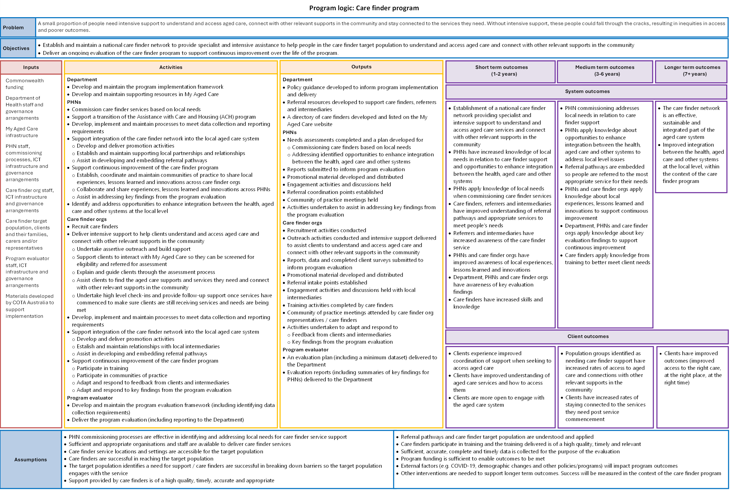

Read the Figure 12 long description.

Evaluation questions

Table 8: Evaluation questions and sub-questions

| Evaluation question | |
| --- | --- |
| 1. Was the care finder program implemented as planned? | |
| 1a. To what extent has a national care finder network been established to provide specialist assistance to help clients understand and access aged care services and other relevant supports in the community? | |
| 1b. Were referral pathways to and from the care finder program developed, promoted and utilised to support care finders, My Aged Care staff and other referrers and intermediaries? | |
| 1c. Did PHNs complete a needs assessment and develop a plan in their region for the following elements:   * Commissioning care finders based on local needs. * Addressing opportunities to enhance integration between the health, aged care and other systems. | |
| 1d. Did PHNs commission CF organisations as planned? | |
| 1e. Did transition of the Assistance with Care and Housing (ACH) program to the care finder program occur as planned? | |
| 1f. Did PHNs establish communities of practice for CF organisations to share local experiences, lessons learned, innovations and key evaluation findings? | |
| 1g. Was promotional material developed and distributed as planned? | |
| 1h. Did CF organisation recruitment and training of care finders occur as planned? | |
| 1i. Were processes to meet data collection and reporting requirements established as planned? | |
| 1j. Was the care finder program implemented within the planned timeframes? | |
| 2. What lessons can be learned from implementation to improve ongoing delivery of the care finder program? | |
| 2a. What worked well? Why did these elements work well and what impacts did they have? | |
| 2b. What were the implementation challenges? What impacts did these challenges have and how were these addressed? | |
| 2c. Do CF organisations feel they have the necessary supports and guidance from PHNs to deliver care finder activities effectively? | |
| 2d. Do care finder staff feel they have the necessary supports and guidance from their organisation to deliver care finder activities effectively? | |
| 2e. Is there good awareness of, and support for, the care finder program and its target population among intermediaries and referrers (and has this increased over time)? | |
| 2f. Was implementation more successful in some PHNs than others? If so, how and why? | |
| 3. Do PHNs and CF organisations have adequate resources to deliver their functions? | |
| 4. To what extent are PHNs commissioning CF organisations in a way that addresses local needs in relation to care finder support? | |
| 4a. To what extent do PHN needs assessments identify local needs in relation to care finder support? | |
| 4b. To what extent is PHN commissioning of care finder service delivery organisations addressing local needs in relation to care finder support? | |
| 4c. What needs (if any) are not being met through PHN commissioning? |  |
| 5. To what extent is the care finder program meeting the needs of clients? | |
| 5a. What activities are being delivered by care finders? To what extent and why does this differ from what was expected? | |
| 5b. How are care finder activities being delivered and by whom? To what extent and why does this differ from what was expected? | |
| 5c. Are CF organisations considered to be trusted and accessible by clients? | |
| 5d. Were clients satisfied with the services they received and did client satisfaction differ across and within PHN regions? | |
| 6. Is the care finder program reaching its intended target population? | |
| 6a. What are the characteristics of care finder clients? To what extent and why does this differ from what was expected? | |
| 6b. Are care finder services focusing on their intended target population? Are all diverse groups being adequately supported within this (noting that not all people from diverse backgrounds are in the target population and not everyone in the target population is from a diverse group)? | |
| 7. What opportunities exist for improving the appropriateness of the care finder program? | |
| 8. To what extent has the care finder program achieved its intended short – to medium-term system outcomes? | |
| 8a. To what extent:   * Do PHNs have increased knowledge about local needs in relation to care finder support? * Have PHNs applied knowledge of local needs when commissioning care finder services?   Has PHN commissioning addressed local needs in relation to care finder support? | |
| 8b. To what extent:   * Do PHNs have increased knowledge of opportunities to enhance integration between the health, aged care and other systems?   Have PHNs applied knowledge of opportunities to enhance integration between the health, aged care and other systems? | |
| 8c. To what extent are PHNs and CF organisations aware of and/or applying knowledge about:   * Local experiences, lessons learned and innovations?   Key evaluation findings to support continuous improvement? | |
| 8d. To what extent is there improved understanding of referral pathways among care finders, referrers and intermediaries so that people are referred to the most appropriate service(s) for their needs? | |
| 8e. To what extent are care finders applying skills and knowledge gained from training to better meet client needs? | |
| 9. To what extent has the care finder program achieved its intended short-to medium-term client outcomes? | |
| 9a. To what extent do clients have improved:   * Understanding of aged care services and how to access them? * Openness to engage with the aged care system?   Help when seeking to access aged care or other supports in the community? | |
| 9b. To what extent is there increased access to aged care and other relevant supports in the community for population groups identified as needing care finder support? |  |
| 9c. To what extent do care finders assist clients to stay connected to the services they need? |  |
| 10. Did effectiveness vary across PHN regions? If so, how and why? | |
| 10a. What differences were there in terms of effectiveness in PHNs that commissioned a larger or smaller number of CF organisations, and why? | |
| 11. What were the enablers and barriers to success? | |
| 12. Were there any unintended outcomes? If so, what and why? | |
| 13. Is the care finder program tracking in such a way that it will be able to achieve its intended long-term outcomes? | |
| 14. What are the opportunities for improving ongoing delivery of the care finder program? | |

Evaluation activities

The overall timeline of the evaluation is shown in Figure 13. All planned activities for this reporting period have been completed on schedule, except for a request for National Screening and Assessment Form (NSAF) data, as we decided the NSAF data lacked the required specificity to assist the evaluation, as described below.

Figure 13: Timeline of reporting, deliverables, and project activities



Read the Figure 13 long description.

Data collection

As stated in section 2.2.1, this report is informed by data collected from 6 main sources:

* department documentation
* consultations
* PHN reports
* CF organisation reporting
* client surveys
* My Aged Care data.

Department documentation

The department has provided AHA with 3 types of program-related documents to inform the evaluation.

Aged care schedules

Aged care schedules outline the activities PHNs are expected to undertake for the program and the intended outcomes of these. Table 9 shows 5 performance indicators for PHNs that are relevant to the evaluation.

Table 9: PHN performance indicators used in this evaluation

|  |  |
| --- | --- |
| Performance indicator | Target |
| 1. Closed cases in complexity bands 2 to 4 | ≥70% |
| 2. Clients in the target population | ≥90% |
| 3a. Clients who have an improved understanding of aged care services and how to access them | ≥85% |
| 3b. Clients who feel more open to engage with the aged care system | ≥85% |
| 3c. Clients who feel the care finder helped them access aged care and/or other supports | ≥85% |

We used this information to understand the department’s expectations of PHNs and to inform our regular reporting back to PHNs and the department.

Care finder policy guidance

The policy guidance outlines the planned implementation of the program and defines:

* the target population
* the care finder role and its functions, including services to be delivered
* referral pathways into the program
* commissioning processes, including the transition of ACH providers to the program.

This important document provides a useful basis to compare what was planned with what has happened and to explore any differences to see what they tell us about the appropriateness of the program design and the implementation process.

Supporting documentation

Early in the evaluation the department’s project team shared additional supporting documentation with us that was used to help establish the program and support its implementation. This included the emails, factsheets, training materials and letters that were distributed to PHNs, My Aged Care staff, RAS and ACAT assessors, advocates and ACH program providers.

More recently the department has shared program communiques with us. These emails are sent to PHNs and contain program and training updates, reminders and information about related programs and upcoming reforms. This has been a useful data source as it clarifies the program information and guidance that has been provided and therefore should be familiar to PHN representatives and in turn care finders.

Consultations

In 2023, we conducted a total of 74 interviews with PHN, CF organisations and clients. In 2024 we interviewed 80 representatives from 5 different stakeholder groups.

PHNs

In October 2024 we conducted 28 interviews with PHN representatives. We conducted one interview with each PHN, except in Western Australia where the WA Primary Health Alliance represents all 3 PHNs. We also were not able to speak with the Eastern Melbourne PHN as representatives could not meet at the scheduled time and then staff resigned before a new meeting time could be established.

During the interview we asked PHN representatives about lessons learned from program implementation, whether their PHN now has better knowledge of local needs and opportunities to enhance integration, and their views on whether the program had achieved its short‑term outcomes.

CF organisations

We completed 30 interviews with representatives from 91 CF organisations. We conducted one interview with each PHN and invited all CF organisations commissioned by that PHN (between one and 12 organisations per interview) to participate. CF organisations from Perth North and Perth South PHNs were interviewed together as 6 CF organisations were commissioned by both PHNs. Interviews were conducted in MS Teams in October 2024.

We asked CF organisation representatives if the program had been implemented as planned, about the support provided by their PHN, characteristics of program clients and whether the program is on track to achieve its long-term outcomes.

Referrers and intermediaries

In December 2024 we conducted 4 group interviews (in MS Teams) with referrers and intermediaries which involved 20 participants. Participants were employed across many different roles including aged care service providers, hospitals, assessment teams and local councils. They came from 6 different jurisdictions and their input was requested in an email, composed by AHA, sent by their local CF organisation.

The group interviews explored what has worked well with program implementation, whether the program meets local needs, referral pathways, and enablers and barriers to success of the program.

Representatives from related initiatives

In 2024 we spoke to representatives from 4 relevant initiatives:

* Aged Care Specialist Officer program
* Support at Home program
* National Aged Care Advocacy Program
* COTA Australia.

We sought to understand how each initiative intersects with the program and if there is duplication to minimise or synergies to harness. We also gauged awareness of the program among the interviewee’s team and asked for suggestions of ways to improve the program.

We have also requested an interview with representatives from the My Aged Care contact centre and the Elder Care Support program team and expect these interviews to occur in early 2025.

Clients

Over 2023 and 2024 we interviewed a total of 31 care finder clients who had completed the client survey (see section C.1.5) and agreed to a telephone interview. Each client interviewed resided in a different PHN region.

We asked clients about their experience with the program, whether the support they received met their needs, whether they were satisfied with the support they received, and if they had any suggestions for improvement.

PHN reports

The department has provided us with 3 program-specific reports from each PHN:

* Supplementary needs assessment reports that were submitted by PHNs to the department in August 2022. These reports detailed local needs and priority populations for the program.
* Initial reports, submitted in November 2022, that outlined commissioning activities for the program. They identified the CF organisations commissioned, target population groups targeted, geographic reach of each CF organisation and a commencement date for program service delivery.
* Twelve-month performance reports that were completed by PHNs in September 2023 and 2024. These reports contain PHNs’ perspectives on program successes, challenges and issues encountered. PHNs also provided information on CoP meetings, integration work and efforts to support continuous improvement of the program.

CF organisation reporting

We established data collection and reporting requirements in collaboration with the department and PHNs, before the program commenced, as planned. As the evaluation and the program progressed, the data collection portal was refined to better capture relevant data. This entailed creating 2 reporting portals: one for CF organisations delivery care finder services and the other for intake‑only organisations. Both portals involve organisations submitting monthly data through Qualtrics.

Activity reporting

Since activity reporting commenced in January 2023, 93% of reports have been submitted on or before the monthly deadline (Table 10). Of the 254 late reports received, 74 (29%) were known to us prior to the due date and extensions were given (though these are still recorded as late submissions). The main reason for late activity reporting was workforce issues (including vacancies and planned and unplanned leave). Where possible, we have tried to mitigate this challenge by sending monthly activity reporting reminders to multiple contacts within each CF organisation.

As of 20 January 2025, there are 24 outstanding activity reports (Table 10). Relevant PHNs were notified by email of these outstanding reports shortly after the data dashboard was refreshed in the given month.

Data from all activity reports submitted by 7 CF organisations that are no longer part of the program has been included in our analysis for this report. However, we have excluded all data submitted by an eighth CF organisation, also no longer in the program, after being advised by their PHN that all their submitted data is incorrect.

Table 10: Activity reports submitted by CF organisations

| Reporting period | Early | Timely | Total on time | Late | Total received | Total expected | No report |
| --- | --- | --- | --- | --- | --- | --- | --- |
| Jan 2023 | 24 | 66 | **90** | 22 | **112** | 113 | 1 |
| Feb 2023 | 38 | 76 | **114** | 13 | **127** | 128 | 1 |
| Mar 2023 | 100 | 31 | **131** | 5 | **136** | 138 | 2 |
| Apr 2023 | 47 | 90 | **137** | 14 | **151** | 151 | 0 |
| May 2023 | 45 | 110 | **155** | 8 | **163** | 165 | 2 |
| Jun 2023 | 72 | 72 | **144** | 21 | **165** | 165 | 0 |
| Jul 2023 | 35 | 119 | **154** | 9 | **163** | 165 | 2 |
| Aug 2023 | 51 | 107 | **158** | 6 | **164** | 165 | 1 |
| Sep 2023 | 76 | 82 | **158** | 7 | **165** | 165 | 0 |
| Oct 2023 | 44 | 111 | **155** | 11 | **166** | 166 | 0 |
| Nov 2023 | 48 | 100 | **148** | 18 | **166** | 166 | 0 |
| Dec 2023 | 59 | 95 | **154** | 13 | **167** | 167 | 0 |
| Jan 2024 | 44 | 107 | **151** | 15 | **166** | 167 | 1 |
| Feb 2024 | 45 | 116 | **161** | 5 | **166** | 167 | 1 |
| Mar 2024 | 36 | 126 | **162** | 5 | **167** | 167 | 0 |
| Apr 2024 | 34 | 128 | **162** | 5 | **167** | 167 | 0 |
| May 2024 | 92 | 64 | **156** | 11 | **167** | 167 | 0 |
| Jun 2024 | 50 | 105 | **155** | 12 | **167** | 167 | 0 |
| Jul 2024 | 60 | 95 | **155** | 9 | **164** | 165 | 1 |
| Aug 2024 | 46 | 116 | **162** | 3 | **165** | 165 | 0 |
| Sep 2024 | 62 | 90 | **152** | 13 | **165** | 165 | 0 |
| Oct 2024 | 74 | 79 | **153** | 9 | **162** | 165 | 3 |
| Nov 2024 | 56 | 94 | **150** | 14 | **164** | 165 | 1 |
| Dec 2024 | 41 | 109 | **150** | 6 | **156** | 164 | 8 |
| Total | 1,279 | 2,288 | 3,567 | 254 | 3,821 | 3,845 | 24 |

Early = submitted prior to reminder (7th of the month or next business day)

Timely = submitted after reminder but prior to close of business on the due date (10th of the month or next business day)

Late = submitted after the due date

No report = activity report remains outstanding as of 20 January 2025

Intake‑only reporting

On 7 February 2024, the intake reporting tool was released to the 4 intake‑only CF organisations to capture their data from January 2024 onwards. To date, all expected intake reports have been submitted (Table 11).

Table 11: Intake reports submitted by CF organisations

| Reporting period | Early | Timely | Total on time | Late | Total received | Total expected | No report |
| --- | --- | --- | --- | --- | --- | --- | --- |
| Jan 2024 | 0 | 3 | **3** | 1 | **4** | 4 | 0 |
| Feb 2024 | 0 | 1 | **1** | 3 | **4** | 4 | 0 |
| Mar 2024 | 1 | 3 | **4** | 0 | **4** | 4 | 0 |
| Apr 2024 | 1 | 2 | **3** | 1 | **4** | 4 | 0 |
| May 2024 | 1 | 3 | **4** | 0 | **4** | 4 | 0 |
| Jun 2024 | 1 | 3 | **4** | 0 | **4** | 4 | 0 |
| Jul 2024 | 1 | 3 | **4** | 0 | **4** | 4 | 0 |
| Aug 2024 | 1 | 3 | **4** | 0 | **4** | 4 | 0 |
| Sep 2024 | 1 | 3 | **4** | 0 | **4** | 4 | 0 |
| Oct 2024 | 1 | 3 | **4** | 0 | **4** | 4 | 0 |
| Nov 2024 | 1 | 3 | **4** | 0 | **4** | 4 | 0 |
| Dec 2024 | 1 | 3 | **4** | 0 | **4** | 4 | 0 |
| Total | 10 | 33 | 43 | 5 | 48 | 48 | 0 |

Early = submitted prior to reminder (7th of the month or next business day)

Timely = submitted after reminder but prior to close of business on the due date (10th of the month or next business day)

Late = submitted after the due date

No report = activity report remains outstanding as of 20 January 2025

Client surveys

We developed a survey comprising a mix of multiple choice and open-ended questions asking clients about their experience of the program, satisfaction with the service, and demographic characteristics.

It was reviewed by Bellberry Human Research Ethics Committee in 2022 and subsequently approved for use with clients residing in the Northern Territory in 2023.

Clients who receive 2 or more hours of care finder support (bands 1 to 4) are invited to complete a brief feedback survey when their case is closed and if they can provide informed consent. All clients can choose to not complete the survey.

To date, we have received 5,300 client surveys – a completion rate of 22% of eligible clients.

My Aged Care data

In August and November 2024, the department supplied us with 2 My Aged Care datasets, focusing on client demographic data. These 2 datasets contained deidentified information for:

* 10,284 My Aged Care registered clients with a care finder agent established between 1 January 2023 and 30 April 2024
* 10,199 My Aged Care registered clients with a regular representative role established in 2023.[20]

The datasets included, but were not limited to, information on client age, gender, preferred language, Indigenous status, communication challenges, DVA entitlement and whether the client lives alone.

Analysis and reporting

Each month we perform high‑level quantitative analysis of the activity reports and client surveys submitted by CF organisations to identify any anomalies or program trends. In November 2023, we undertook qualitative analysis of the consultations completed with clients, PHNs and CF organisations.

PHN reporting was also used to inform and supplement findings from our interviews with PHN, CF organisation representatives and clients.

Quantitative data

We analysed the quantitative data collected from activity and intake reporting, client surveys and My Aged Care data using standard descriptive statistics (counts and percentages for categorical data; and means, medians, and/or ranges for continuous data). Highlights are presented in sections 3 to 7.

Our overall quantitative analysis includes all data collected to date (except the excluded data discussed in Appendix C.1.4). We also analysed data by PHN, drawing on:

* all (included) activity reporting data
* client survey data from PHNs with 10 or more completed client surveys.

Data dashboard reporting to the department and PHNs

AHA has developed a Power BI dashboard summarising the activity reporting and client survey data, which can be viewed by PHNs and the department. The dashboard is refreshed each month to show data from the previous month. All PHNs had accessed and viewed the dashboard regularly throughout the program; however, it appears not all PHNs are identifying and following up reporting errors with their commissioned organisations.

Qualitative **data**

We coded the qualitative data collected through consultations and client surveys against the evaluation questions. Emerging and relevant themes were deduced from the coded notes and are presented in sections 3 to 7.

Figure long descriptions and data tables

Figure 1 long description

The project runs from late 2021 to mid 2025 and comprises 3 overlapping phases. The project is currently close to completion.

Phase 1 ran from 2021 to 2022. The activities and deliverables included:

* holding a project inception meeting in late 2021
* developing the evaluation plan, submitted in February 2022
* presenting to PHNs and the department in February 2022
* making initial contact with PHNs in early 2022
* building the data management platform in 2022
* obtaining ethics approval in late 2022

Phase 2 began in 2023 and continues into 2025. This phase involves 3 streams of work:

* Stream 1: Stakeholder consultations involves:
  + interviewing PHN representatives in late 2023 and late 2024
  + interviewing care finder organisations in late 2023 and late 2024
  + interviewing care finder clients throughout 2023 and 2024
  + interviewing referrers and intermediaries in late 2024
  + consulting representatives of related initiatives throughout 2024
* Stream 2: MDS collection and reporting involves:
  + collecting CF organisation activity data from 2023 to 2025
  + collecting client survey data from 2023 to 2025
  + collecting case studies and reflections in late 2024
* Stream 3: Desktop review of relevant documentation involves:
  + reviewing policy guidance and PHN documentation and create internal PHN implementation summaries from 2023 to 2025
  + submitting data request for My Aged Care and NSAF data from mid 2023 to mid 2024

Phase 3 overlaps with the other phases, running from the start of 2022 to the end of the project in mid-2025. The activities and deliverables are:

* holding regular and ad hoc meetings with the department, from 2022 to 2025
* analysing and synthesising data, from 2023 to 2025
* updating data dashboards and reporting back to the department and PHNs, from 2023 to 2025
* delivering the design and implementation report (10 May 2023)
* delivering the first evaluation report (12 January 2024)
* delivering the first progress report (15 September 2023)
* delivering the second progress report (17 May 2024)
* delivering the third progress report (30 September 2024)
* delivering the second evaluation report (17 February 2025)
* delivering the fourth progress report (16 May 2025)

Go back to Figure 1.

Figure 2 data table

Table 12: Data for Figure 2

| Quarter | Care finder | Manager | Intake officer | Administration assistant |
| --- | --- | --- | --- | --- |
| Q1 2023 | 64% | 19% | 11% | 6% |
| Q2 2023 | 68% | 17% | 10% | 5% |
| Q3 2023 | 73% | 16% | 7% | 4% |
| Q4 2023 | 74% | 15% | 7% | 4% |
| Q1 2024 | 74% | 15% | 7% | 5% |
| Q2 2024 | 75% | 14% | 6% | 4% |
| Q3 2024 | 75% | 13% | 7% | 4% |
| Q4 2024 | 75% | 14% | 7% | 4% |

Go back to Figure 2.

Figure 3 data table

Table 13: Data for Figure 3

| Quarter | Sum of assertive outreach hours |
| --- | --- |
| Q1 2023 | 8,845 |
| Q2 2023 | 21,590 |
| Q3 2023 | 23,817 |
| Q4 2023 | 19,331 |
| Q1 2024 | 18,893 |
| Q2 2024 | 20,115 |
| Q3 2024 | 19,110 |
| Q4 2024 | 18,258 |

Go back to Figure 3.

Figure 4 long description and data table

Quarter 1 2023: 2,920, quarter 2 2023: 4,215, quarter 3 2023: 5,773, quarter 4 2023: 5,287, quarter 1 2024: 5, 875, quarter 2 2024: 5,585, quarter 3 2024: 5,790, quarter 4 2024: 5,480.

Table 14: Data for Figure 4

| Quarter | New client cases |
| --- | --- |
| Q1 2023 | 2,920 |
| Q2 2023 | 4,215 |
| Q3 2023 | 5,773 |
| Q4 2023 | 5,287 |
| Q1 2024 | 5,875 |
| Q2 2024 | 5,585 |
| Q3 2024 | 5,790 |
| Q4 2024 | 5,480 |

Go back to Figure 4.

Figure 5 long description and data table

Quarter 1 2023 – band 0: 43%, band 1: 20%, band 2: 11%, band 3: 6%, band 4:20%, quarter 2 2023 – band 0: 32%, band 1: 18%, band 2: 14%, band 3: 10%, band 4: 26%, quarter 3 2023 – band 0: 31%, band 1: 20%, band 2: 16%, band 3: 10%, band 4: 22% , quarter 4 2023 – band 0: 22%, band 1: 21%, band 2: 18%, band 3: 12%, band 4: 27%, quarter 1 2024 – band 0: 19%, band 1: 19%, band 2: 20%, band 3: 14%, band 4: 28% , quarter 2 2024 – band 0: 16%, band 1: 18%, band 2: 21%, band 3: 16%, band 4: 29%, quarter 3 2024 – band 0: 21%, band 1: 18%, band 2: 20%, band 3: 14%, band 4: 27% , quarter 4 2024 – band 0: 12%, band 1: 18%, band 2: 22%, band 3: 15%, band 4: 33%.

Table 15: Data for Figure 5

| Quarter | B0 | B1 | B2 | B3 | B4 |
| --- | --- | --- | --- | --- | --- |
| Q1 2023 | 43% | 20% | 11% | 6% | 20% |
| Q2 2023 | 32% | 18% | 14% | 10% | 26% |
| Q3 2023 | 31% | 20% | 16% | 10% | 22% |
| Q4 2023 | 22% | 21% | 18% | 12% | 27% |
| Q1 2024 | 19% | 19% | 20% | 14% | 28% |
| Q2 2024 | 16% | 18% | 21% | 16% | 29% |
| Q3 2024 | 21% | 18% | 20% | 14% | 27% |
| Q4 2024 | 12% | 18% | 22% | 15% | 33% |

Go back toFigure 5.

Figure 7 data table

Table 16: Data for Figure 7

| Quarter | Total outbound referrals | New client case | Outbound referrals per new client case |
| --- | --- | --- | --- |
| Q1 2023 | 6,349 | 2,920 | 2.2 |
| Q2 2023 | 8,811 | 4,215 | 2.1 |
| Q3 2023 | 15,772 | 5,773 | 2.7 |
| Q4 2023 | 18,688 | 5,287 | 3.5 |
| Q1 2024 | 19,921 | 5,875 | 3.4 |
| Q2 2024 | 19,334 | 5,585 | 3.5 |
| Q3 2024 | 21,140 | 5,790 | 3.7 |
| Q4 2024 | 20,280 | 5,480 | 3.7 |

Go back to Figure 7.

Figure 8 data table

Table 17: Data for Figure 8

| Age Category | Care finder agent | Regular representative |
| --- | --- | --- |
| <50 | 7 | 2 |
| 50-54 | 73 | 5 |
| 55-59 | 122 | 16 |
| 60-64 | 222 | 14 |
| 65-69 | 1,536 | 804 |
| 70-74 | 2,064 | 1,601 |
| 75-79 | 2,303 | 2,633 |
| 80-84 | 1,975 | 2,514 |
| 85-89 | 1,388 | 1,737 |
| 90-94 | 487 | 701 |
| 95-99 | 99 | 161 |
| 100+ | 8 | 11 |

Go back to Figure 8.

Figure 9 data table

Table 18: Data for Figure 9

| Indigenous status | Care finder agent | Regular representative |
| --- | --- | --- |
| No - Neither | 9,216 | 10,056 |
| Yes - Aboriginal | 614 | 101 |
| Yes - Torres Strait Islander | 16 | 4 |
| Yes - Both | 23 | 6 |

Go back to Figure 9.

Figure 10 data table

Table 19: Data for Figure 10

| Lives with | Care finder agent | Regular representative |
| --- | --- | --- |
| Lives alone | 4,598 | 2,602 |
| With partner | 3,265 | 5,650 |
| With family | 1,293 | 1,231 |
| With friends | 197 | 63 |
| With others | 315 | 541 |

Go back to Figure 10.

Figure 12 long description

Problem:

A small proportion of people need intensive support to understand and access aged care, connect with other relevant supports in the community and stay connected to the services they need. Without intensive support, these people could fall through the cracks, resulting in inequities in access and poorer outcomes.

Objectives:

Establish and maintain a national care finder network to provide specialist and intensive assistance to help people in the care finder target population to understand and access aged care and connect with other relevant supports in the community

Deliver an ongoing evaluation of the care finder program to support continuous improvement over the life of the program.

Inputs:

* Commonwealth funding
* Department of Health staff and governance arrangements
* My Aged Care infrastructure
* PHN staff, commissioning processes, ICT infrastructure and governance arrangements
* Care finder org staff, ICT infrastructure and governance arrangements
* Care finder target population, clients and their families, carers and/or representatives
* Program evaluator staff, ICT infrastructure and governance arrangements
* Materials developed by COTA Australia to support implementation

Activities:

Department:

* Develop and maintain the program implementation framework
* Develop and maintain supporting resources in My Aged Care

PHNs:

* Commission care finder services based on local needs
* Support a transition of the Assistance with Care and Housing (ACH) program
* Develop, implement and maintain processes to meet data collection and reporting requirements
* Support integration of the care finder network into the local aged care system
  + Develop and deliver promotion activities
  + Establish and maintain supporting local partnerships and relationships
  + Assist in developing and embedding referral pathways
* Support continuous improvement of the care finder program
  + Establish, coordinate and maintain communities of practice to share local experiences, lessons learned and innovations across care finder orgs
  + Collaborate and share experiences, lessons learned and innovations across PHNs
  + Assist in addressing key findings from the program evaluation
* Identify and address opportunities to enhance integration between the health, aged care and other systems at the local level

Care finder organisations

* Recruit care finders
* Deliver intensive support to help clients understand and access aged care and connect with other relevant supports in the community:
  + Undertake assertive outreach and build rapport
  + Support clients to interact with My Aged Care so they can be screened for eligibility and referred for assessment
  + Explain and guide clients through the assessment process
  + Assist clients to find the aged care supports and services they need and connect with other relevant supports in the community
  + Undertake high level check-ins and provide follow-up support once services have commenced to make sure clients are still receiving services and needs are being met
* Develop, implement and maintain processes to meet data collection and reporting requirements
* Support integration of the care finder network into the local aged care system
  + Develop and deliver promotion activities
  + Establish and maintain relationships with local intermediaries
  + Assist in developing and embedding referral pathways
* Support continuous improvement of the care finder program
  + Participate in training
  + Participate in communities of practice
  + Adapt and respond to feedback from clients and intermediaries
  + Adapt and respond to key findings from the program evaluation

Program evaluator

* Develop and maintain the program evaluation framework (including identifying data collection requirements)
* Deliver the program evaluation (including reporting to the Department)

Outputs

Department

* Policy guidance developed to inform program implementation and delivery
* Referral resources developed to support care finders, referrers and intermediaries
* A directory of care finders developed and listed on the My Aged Care website

PHNS

* Needs assessments completed and a plan developed for:
  + Commissioning care finders based on local needs
  + Addressing identified opportunities to enhance integration between the health, aged care and other systems
* Reports submitted to inform program evaluation
* Promotional material developed and distributed
* Engagement activities and discussions held
* Referral coordination points established
* Community of practice meetings held
* Activities undertaken to assist in addressing key findings from the program evaluation

Care finder organisations

* Recruitment activities conducted
* Outreach activities conducted and intensive support delivered to assist clients to understand and access aged care and connect with other relevant supports in the community
* Reports, data and completed client surveys submitted to inform program evaluation
* Promotional material developed and distributed
* Referral intake points established
* Engagement activities and discussions held with local intermediaries
* Training activities completed by care finders
* Community of practice meetings attended by care finder org representatives/care finders
* Activities undertaken to adapt and respond to:
* Feedback from clients and intermediaries
* Key findings from the program evaluation

Program evaluator

* An evaluation plan (including a minimum dataset) delivered to the Department
* Evaluation reports (including summaries of key findings for PHNS) delivered to the Department

Short term outcomes (1–2 years) (System outcomes)

* Establishment of a national care finder network providing specialist and intensive support to understand and access aged care services and connect with other relevant supports in the community
* PHNs have increased knowledge of local needs in relation to care finder support and opportunities to enhance integration between the health, aged care and other systems
* PHNs apply knowledge of local needs when commissioning care finder services
* Care finders, referrers and intermediaries have improved understanding of referral pathways and appropriate services to meet people's needs
* Referrers and intermediaries have increased awareness of the care finder service
* PHNs and care finder orgs have improved awareness of local experiences, lessons learned and innovations
* Department, PHNs and care finder orgs have awareness of key evaluation findings
* Care finders have increased skills and knowledge

Short term outcomes (1–2 years) (Client outcomes)

* Clients experience improved coordination of support when seeking to access aged care
* Clients have improved understanding of aged care services and how to access them
* Clients are more open to engage with the aged care system

Medium term outcomes (3–6 years) (System outcomes)

* PHN commissioning addresses local needs in relation to care finder support
* PHNs apply knowledge about opportunities to enhance integration between the health, aged care and other systems to address local level issues
* Referral pathways are embedded so people are referred to the most appropriate service for their needs
* PHNs and care finder orgs apply knowledge about local experiences, lessons learned and innovations to support continuous improvement
* Department, PHNs and care finder orgs apply knowledge about key evaluation findings to support continuous improvement
* Care finders apply knowledge from training to better meet client needs

Medium term outcomes (3–6 years) (Client outcomes)

* Population groups identified as needing care finder support have increased rates of access to aged care and connections with other relevant supports in the community
* Clients have increased rates of staying connected to the services they need post service commencement

Longer term outcomes (7+ years) (System outcomes)

* The care finder network is an effective, sustainable and integrated part of the aged care system
* Improved integration between the health, aged care and other systems at the local level, within the context of the care finder program

Longer term outcomes (7+ years) (Client outcomes)

* Clients have improved outcomes (improved access to the right care, at the right place, at the right time)

Assumptions:

* PHN commissioning processes are effective in identifying and addressing local needs for care finder service support
* Sufficient and appropriate organisations and staff are available to deliver care finder services
* Care finder service locations and settings are accessible for the target population
* Care finders are successful in reaching the target population
* The target population identifies a need for support / care finders are successful in breaking down barriers so the target population engages with the service
* Support provided by care finders is of a high quality, timely, accurate and appropriate
* Referral pathways and care finder target population are understood and applied
* Care finders participate in training and the training delivered is of a high quality, timely and relevant
* Sufficient, accurate, complete and timely data is collected for the purpose of the evaluation
* Program funding is sufficient to enable outcomes to be met
* External factors (e.g. COVID-19, demographic changes and other policies/programs) will impact program outcomes
* Other interventions are needed to support longer term outcomes. Success will be measured in the context of the care finder program

Go back to Figure 12.

Figure 13 long description

The project runs from late 2021 to mid 2025 and comprises 3 overlapping phases. The project is currently close to completion.

Phase 1 ran from 2021 to 2022. The activities and deliverables included:

* holding a project inception meeting in late 2021
* developing the evaluation plan, submitted in February 2022
* presenting to PHNs and the department in February 2022
* making initial contact with PHNs in early 2022
* building the data management platform in 2022
* obtaining ethics approval in late 2022

Phase 2 began in 2023 and continues into 2025. This phase involves 3 streams of work:

* Stream 1: Stakeholder consultations involves:
  + interviewing PHN representatives in late 2023 and late 2024
  + interviewing care finder organisations in late 2023 and late 2024
  + interviewing care finder clients throughout 2023 and 2024
  + interviewing referrers and intermediaries in late 2024
  + consulting representatives of related initiatives throughout 2024
* Stream 2: MDS collection and reporting involves:
  + collecting CF organisation activity data from 2023 to 2025
  + collecting client survey data from 2023 to 2025
  + collecting case studies and reflections in late 2024
* Stream 3: Desktop review of relevant documentation involves:
  + reviewing policy guidance and PHN documentation and create internal PHN implementation summaries from 2023 to 2025
  + submitting data request for My Aged Care and NSAF data from mid 2023 to mid 2024

Phase 3 overlaps with the other phases, running from the start of 2022 to the end of the project in mid-2025. The activities and deliverables are:

* holding regular and ad hoc meetings with the department, from 2022 to 2025
* analysing and synthesising data, from 2023 to 2025
* updating data dashboards and reporting back to the department and PHNs, from 2023 to 2025
* delivering the design and implementation report (10 May 2023)
* delivering the first evaluation report (12 January 2024)
* delivering the first progress report (15 September 2023)
* delivering the second progress report (17 May 2024)
* delivering the third progress report (30 September 2024)
* delivering the second evaluation report (17 February 2025)
* delivering the fourth progress report (16 May 2025)

Go back to Figure 13.

Abbreviations

|  |  |
| --- | --- |
| Term | Definition |
| ACAT | aged care assessment team |
| ACH | Assistance with Care and Housing |
| ACSO | Aged Care Specialist Officer |
| AHA | Australian Healthcare Associates |
| CALD | culturally and linguistically diverse |
| CF organisation | care finder organisation |
| CHSP | Commonwealth Health Support Programme |
| CoP | communities of practice |
| DVA | Department of Veterans’ Affairs |
| FTE | full-time equivalent |
| HCP | Home Care Package |
| KPIs | key performance indicators |
| LGBTI | lesbian, gay, bisexual, transgender and intersex |
| NACAP | National Aged Care Advocacy Program |
| NACCHO | National Aboriginal Community Controlled Health Organisation |
| NSAF | National Screening and Assessment Form |
| PHN | Primary Health Network |
| RAS | Regional Assessment Service |
| the department | Department of Health, Disability and Ageing |
| the program | the care finder program |

Glossary

| Term | Definition |
| --- | --- |
| assertive outreach | Activities to proactively identify and engage with people in the care finder target population as well as intermediaries who may interact with the target population and refer potential clients to the program. |
| band | An indicator of the complexity of a client’s case, defined as the number of support hours provided to the client from when the case was opened:   * band 0 – up to 2 hours of support in total * band 1 – 2 to up to 5 hours of support in total * band 2 – 5 to up to 10 hours of support in total * band 3 – 10 to up to 15 hours of support in total * band 4 – 15+ hours of support in total. |
| closed client case | A closed client case is one where the client:   * has had a high level check-in and it is determined that the client’s needs have been addressed effectively and referred services and supports have commenced (at least in part) and/or * does not require or want any further support from the care finder or * no services are available and there are no further opportunities to support the client.   A client whose case has been closed can receive care finder services again in the future, including immediately after the closure where the client has a newly identified need; however, for reporting purposes, these cases are to be reported as a new client case. |
| high level check-in | A high level check-in is a phone call or visit to the client to ask:   * how they are * whether their services are in place and still meeting their needs * whether they have any need for support from the care finder. |
| intake-only organisations | Organisations that are responsible for triaging all queries and referrals to the program and connecting prospective clients with the most appropriate CF organisation in the PHN region. There are currently 4 intake-only organisations. |
| intermediary | People or organisations, such as health professionals, aged care and disability sector professionals and people from community and voluntary organisations, who identify and connect potential clients with their local care finder. |
| new client case | A new client case is case where:   * a care finder has identified, or been referred, a: * new client who they have not helped before, or * a client who has previously been an active client has had their case closed for reporting purposes (see below for the definition of a closed case), and * the care finder has determined the client is within the care finder target population, and * the client has provided their consent to receive support from that care finder. |

References

AHA (2022) [Evaluation of the Aged Care System Navigator trial extension measure: Final Report](https://www.health.gov.au/sites/default/files/2023-02/evaluation-of-the-aged-care-system-navigator-trial-extension-measure-final-report.pdf), report to the Australian Government Department of Health, Disability and Ageing, Australian Healthcare Associates, accessed 11 January 2024.

Commonwealth, Royal Commission into Aged Care Quality and Safety (2021) [Final Report: Care, Dignity and Respect](https://www.royalcommission.gov.au/aged-care/final-report), accessed 11 January 2024

Department of Health, Disability and Ageing (n.d.) [Care finder policy guidance](https://www.health.gov.au/resources/publications/care-finder-policy-guidance-for-phns?language=en), Department of Health, Disability and Ageing.

Department of Health, Disability and Ageing (2024) [Commonwealth Home Support Programme (CHSP) Manual 2024–2025](https://www.health.gov.au/sites/default/files/2023-08/commonwealth-home-support-programme-chsp-manual.pdf), accessed 10 January 2025

1. It is worth noting that client case numbers may overestimate the number of unique clients engaging with the program as clients are counted each time they present with a new issue.
2. The special needs groups defined in the act include people from Aboriginal and Torres Strait Islander communities, people from culturally and linguistically diverse (CALD) backgrounds, people who live in rural or remote areas, lesbian, gay, bisexual, transgender and intersex (LGBTI) people, people who are financially or socially disadvantaged, veterans, people who are homeless or at risk of becoming homeless, care leavers, and parents separated from their children by forced adoption or removal.
3. The special needs groups defined in the Act include people from Aboriginal and Torres Strait Islander communities, people from culturally and linguistically diverse (CALD) backgrounds, people who live in rural or remote areas, lesbian, gay, bisexual, transgender and intersex (LGBTI) people, people who are financially or socially disadvantaged, veterans, people who are homeless or at risk of becoming homeless, care leavers, and parents separated from their children by forced adoption or removal.
4. The ACH program was established in 1993 to help financially disadvantaged older people who are homeless or in a vulnerable housing situation to find secure accommodation. The ACH program (except hoarding and squalor services) has now been fully absorbed into the care finder program with ACH providers operating as care finders.
5. Intake-only organisations were commissioned by 4 PHNs and are responsible for triaging all queries and referrals to the program and connecting prospective clients with the most appropriate CF organisation in the PHN region.
6. The Elder Care Support program is managed by the National Aboriginal Community Controlled Health Organisation (NACCHO) and seeks to support older First Nations people to understand, navigate and access culturally appropriate aged care services. It commenced in 2023 and will end on 30 June 2025.
7. All ACH providers could apply for additional funding (to expand their reach) before transitioning to the care finder program.
8. This organisation has just one staff member registered for the mandatory training.
9. In its October 2024 communique, the department reminded organisations to review their lists of registered users and remove users who are inappropriate or no longer employed in the program.
10. Triple I services are intake, information and intervention services, acting as a point of contact for patients, carers, and health professionals.
11. This new data item was made optional to not create additional reporting burden for the CF organisations.
12. This shift is most likely a result of the clarification issued in late 2023. PHNs and CF organisations were informed that they should not record interactions that did not result in a care finder case as band 0 cases. An additional MDS data item to capture these interactions was also included in May 2024. These 2 changes led to a noticeable drop in the number of band 0 cases reported.
13. From 1 July 2025 care management activities, including care planning, service coordination and system navigation, (which are currently provided by some care finders while clients are waiting for services to commence) will be delivered by care partners under the new Support at Home program. It is unclear whether care partners will support clients while they are waiting for services to commence.
14. This proportion has remained consistently high since the start of the program, with an overall monthly value ranging between 97% and 99%.
15. Since the start of the program, we have received 5,300 client surveys.
16. The department provided demographic data for approximately 20,500 My Aged Care clients.
17. For the purposes of reporting, we have combined response options as follows: Agree = strongly agree and agree, Neutral = neither agree nor disagree and Disagree = strongly disagree and disagree.
18. To protect client anonymity, PHNs with fewer than 10 completed surveys have been excluded.
19. Two participants sent us written comments following their group interview
20. Clients with a regular representative role established between 1 January 2023 and 30 April 2024 numbered in the hundreds of thousands. As such, the department provided the requested information for 10,199 randomly selected clients from 2023.