Referral pathway for allied health treatment of complex neurodevelopmental conditions

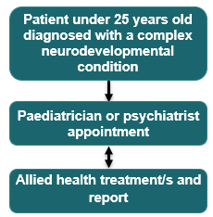

## Restrictions or requirements

### Referrals

* A GP must refer you to a paediatrician or psychiatrist for an MBS benefit to be paid.
* A paediatrician or psychiatrist must prepare a treatment and management plan and refer you to an allied health professional for an MBS benefit to be paid.

### Treatment services

* A course of treatment covers up to 10 allied health treatment services. One course of treatment can be requested per referral.
* A maximum of 20 treatment services from [eligible allied health professionals](https://www9.health.gov.au/mbs/fullDisplay.cfm?type=note&q=MN.10.3&qt=noteID) can be claimed per patient per lifetime.
* A report must be prepared for the referring paediatrician or psychiatrist after each course of treatment.

### Further information

* Further information on relevant items can be found on [MBSOnline](https://www.mbsonline.gov.au/internet/mbsonline/publishing.nsf/Content/Home) under [M10 items](https://www9.health.gov.au/mbs/search.cfm?cat1=251&cat2=478&cat3=&adv=) and explanatory note [MN.10.2](https://www9.health.gov.au/mbs/fullDisplay.cfm?type=note&qt=NoteID&q=MN.10.2).
* A neurodevelopmental condition is referred to as a ‘neurodevelopmental disorder’ in the Diagnostic and Statistical Manual of Mental Disorders (DSM-5). Complexity is determined by the treating paediatrician or psychiatrist.

Please note that the information provided is a general guide only. It is ultimately the responsibility of treating practitioners to use their professional judgment to determine the most clinically appropriate services to provide, and then to ensure that any services billed to Medicare fully meet the eligibility requirements outlined in the legislation.

This sheet is current as of the last updated date shown and does not account for MBS changes since that date.