Referral pathway for allied health assessment of complex neurodevelopmental conditions

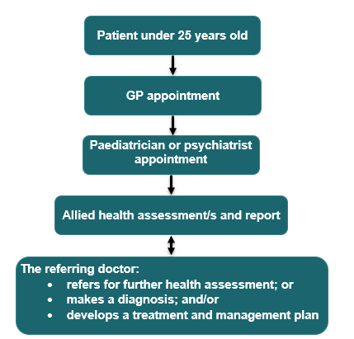

## Restrictions or requirements

### Referrals

* A GP must refer you to a paediatrician or psychiatrist for an MBS benefit to be paid.
* A paediatrician or psychiatrist must refer you to an allied health professional for an MBS benefit to be paid.
* Allied health providers can refer to another allied health professional for an assessment however, the referring paediatrician or psychiatrist must agree.

### Assessment services

* Up to 8 allied health assessment services are available per lifetime. Up to four of these services can be provided to the patient on the same day.
* A report must be prepared for the referring paediatrician or psychiatrist after the final allied health assessment.
* The assessment services are to assist the referring paediatrician or psychiatrist with their diagnosis.
* Assessment services where the psychologist makes the diagnosis, or the diagnosis is not confirmed by the referring paediatrician or psychiatrist, are not claimable through Medicare.

### Patients 25 and over

* GPs can use general time-based appointments to initially assess and refer patients to psychiatrists to undertake a comprehensive assessment and diagnosis.
* Psychiatrists can undertake assessment or diagnosis during an appointment. There are several initial or time-based Medicare items available for this.

## Further information

* Further information on relevant items can be found on [MBSOnline](https://www.mbsonline.gov.au/internet/mbsonline/publishing.nsf/Content/Home) under [M10 items](https://www9.health.gov.au/mbs/search.cfm?cat1=251&cat2=478&cat3=&adv=) and explanatory note [MN.10.1](http://MN.10.1).
* A neurodevelopmental condition is referred to as a ‘neurodevelopmental disorder’ in the Diagnostic and Statistical Manual of Mental Disorders (DSM-5). Complexity is determined by the treating paediatrician or psychiatrist.

Please note that the information provided is a general guide only. It is ultimately the responsibility of treating practitioners to use their professional judgment to determine the most clinically appropriate services to provide, and then to ensure that any services billed to Medicare fully meet the eligibility requirements outlined in the legislation.

This sheet is current as of the last updated date shown and does not account for MBS changes since that date.