Referral pathway for allied health assessment for eligible disabilities

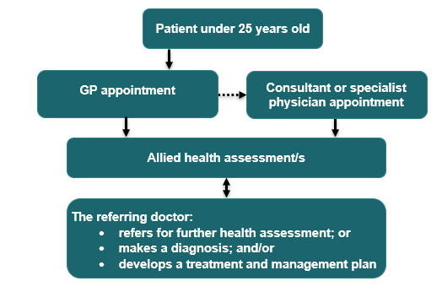

## Restrictions or requirements

* An eligible disability is defined on [MBSOnline](https://www.mbsonline.gov.au/internet/mbsonline/publishing.nsf/Content/Home) at explanatory note [MN.10.3](https://www9.health.gov.au/mbs/fullDisplay.cfm?type=note&q=MN.10.3&qt=noteID&criteria=Eligibility%20for%20allied%20health%20assessment%20and%20treatment%20services%20for%20complex%20neurodevelopmental%20disorder%20and%20eligible%20disability%20services).

### Referrals

* If the GP makes a diagnosis of the eligible disability, a referral to a specialist or consultant physician is not needed.
* If needed, the GP may refer the patient to a specialist or consultant physician for diagnosis.
* A GP, specialist or consultant physician must refer you to an allied health professional for an MBS benefit to be paid.
* The allied health professional can refer to another allied health professionals for an assessment however, the referring GP, specialist or consultant physician must agree.

### Assessment services

* Up to 8 allied health assessment services are available per lifetime. Up to four of these services can be provided to the patient on the same day.
* A report must be prepared for the referring GP, specialist or consultant physician after the final assessment service.
* The assessment services are to assist the referring GP, specialist or consultant physician with their diagnosis.

### Patients 25 and over

* A GP, specialist or consultant physician can use general time-based appointments to initially assess and refer for an assessment or diagnosis for a condition on the eligible disability list.

## Further information

* Further information on relevant items can be found on [MBSOnline](https://www.mbsonline.gov.au/internet/mbsonline/publishing.nsf/Content/Home) under [M10 items](https://www9.health.gov.au/mbs/search.cfm?cat1=251&cat2=478&cat3=&adv=) and explanatory note [MN.10.1](https://www9.health.gov.au/mbs/fullDisplay.cfm?type=note&q=MN.10.1&qt=noteID&criteria=mn%2E10%2E1).

Please note that the information provided is a general guide only. It is ultimately the responsibility of treating practitioners to use their professional judgment to determine the most clinically appropriate services to provide, and then to ensure that any services billed to Medicare fully meet the eligibility requirements outlined in the legislation.

This sheet is current as of the last updated date shown and does not account for MBS changes since that date.