National vaccine storage guidelines

Strive for 5

4th edition

NATIONAL VACCINE STORAGE GUIDELINES

STRIVE FOR 5

4th edition

Australian Government Department of Health, Disability and Ageing

**Title:** National Vaccine Storage Guidelines – Strive for 5, 4th edition  
**Online ISBN:** 978-1-76007-583-5

**Copyright**  
© 2025 Commonwealth of Australia as represented by the Department of Health, Disability and Ageing

This work is copyright. You may copy, print, download, display, and reproduce the whole or part of this work in unaltered form for your own personal use or, if you are part of an organisation, for internal use within your organisation, but only if you or your organisation:

* Do not use the copy or reproduction for any commercial purpose; and
* Retain this copyright notice and all disclaimer notices as part of that copy or reproduction.

Apart from rights permitted by the Copyright Act 1968 (Cth) or allowed by this copyright notice, all other rights are reserved, including (but not limited to) all commercial rights.

Requests and inquiries concerning reproduction and other rights to use are to be sent to:  
**Communication Branch**  
Department of Health, Disability and Ageing  
GPO Box 9848  
Canberra ACT 2601  
Email: [copyright@health.gov.au](mailto:copyright@health.gov.au)

Although these guidelines are copyright, they may be freely reproduced for non-profit purposes, provided the source is acknowledged.

Contents

Acknowledgments 5

Glossary 6

1 Introduction 9

1.1 Using these Guidelines 9

1.2 Scope 9

2 Safe vaccine storage 10

Why is vaccine storage management important? 10

1.3 What is the cold chain? 10

1.4 What is a cold chain breach? 10

1.5 How sensitive are vaccines to heat and cold? 10

1.6 Principles of safe vaccine storage management 11

1.7 Vaccine storage 11

3 Purpose-built vaccine refrigerators (PBVR) 12

1.8 3.1 Minimum requirements 13

1.9 3.2 Optimal features of PBVRs 13

1.10 3.3 When choosing a PBVR 13

1.11 3.4 Positioning the PBVR 14

1.12 3.5 Alarm systems 14

1.13 3.6 Power source reliability 14

1.14 3.7 Stabilising the PBVR temperature 15

1.15 3.8 Monitoring and recording PBVR temperatures 15

1.16 3.9 Maintaining the PBVR 15

4 Vaccine temperature-monitoring devices 16

1.17 Minimum Requirements 16

1.18 4.2 Data loggers 16

1.19 4.3 When purchasing a data logger 17

1.20 4.4 Automated temperature monitoring systems 17

1.21 4.5 Battery powered or digital minimum/maximum thermometers 18

1.22 4.6 How to check the accuracy of a thermometer (‘slush test’) 18

1.23 4.7 Disposable cold chain monitors received with deliveries 19

5 5. Vaccine management protocol and audit 19

6 6. Caring for vaccines during immunisation clinics 20

1.24 6.1 Mobile or outreach immunisation clinics 20

1.25 6.2 Community pharmacies 21

1.26 6.3 Transporting vaccines to another PBVR 21

7 7. Managing a power failure 21

1.27 7.1 Back-up plans 21

1.28 7.2 PBVRs during a power failure. 22

1.29 7.3 When power is restored 23

8 8. Coolers 23

1.30 8.1 Tips for using coolers 23

1.31 8.2 Freezing and conditioning ice packs and gel packs 24

1.32 8.3 How to pack a cooler 25

1.33 8.4 Specialised vaccine coolers 29

APPENDIX 1 - Vaccine management protocol 30

1.34 Vaccine ordering 30

1.35 Vaccine delivery 30

1.36 Temperature monitoring and recording 30

1.37 Documentation 31

1.38 Equipment maintenance 31

1.39 Transporting vaccines off-site 31

1.40 Staff education — vaccine management 31

APPENDIX 2 - Vaccine storage self-audit 32

APPENDIX 3 - Cold chain breach protocol 34

1.41 Cold chain breach steps 34

1.42 Information needed when reporting a cold chain breach 34

APPENDIX 4 - Frequently asked questions 35

1.43 A: Yes. You must contact your state or territory health department to inform them of your move and change in contact details. Also see Section 6.3 ‘Transporting vaccines to another PBVR’. 37

APPENDIX 5 - Preparation for mobile or outreach immunisation clinics 38

APPENDIX 6 - Checklist and temperature chart for mobile or outreach immunisation clinics, or emergency storage of vaccines 39

1.44 When the vaccines are returned to the PBVR 40

Temperature chart for mobile or outreach immunisation clinics, or emergency storage of vaccines 41

APPENDIX 7 - Checklist for emergency storage in the event of power or PBVR failure 43

1.45 When the power is returned 44

Appendix 8 - Resource collection 45

Additional reading 46

Useful contacts 47

Acknowledgments

The Australian Government Department of Health, Disability and Ageing gratefully acknowledges the work of the National Vaccine Storage Guidelines Jurisdictional Immunisation Coordinators Advisory Group, the Working Group and peak bodies who provided valuable input to updating this fourth edition of the guidelines.

Glossary

The list below gives the meanings of words as used in this document. Some of these words have different meanings elsewhere.

**Accuracy check** A method used to ascertain the accuracy of a thermometer. See Section 4.6.

**Ambient temperature** Temperature of the surrounding environment in which the purpose-built vaccine refrigerator (PBVR) is operating.

**Automated temperature-monitoring systems** Wireless temperature-monitoring systems that provide real-time temperature readings, and email or text message alerts when a temperature excursion outside the recommended +2°C to +8°C range occurs.

**Back-to-base system** A computer-based control system that alerts staff when a temperature excursion outside the recommended +2°C to +8°C range occurs.

**Building management system (BMS)** A system that can be integrated with PBVRs to enable real-time, continuous monitoring of vaccine storage conditions, especially temperature.

**Cold chain** The system of transporting and storing vaccines within the safe temperature range of +2°C to +8°C.

**Cold chain breach** Exposure of vaccines to temperatures outside the recommended range of +2°C to +8°C excluding temperature excursions reaching up to +12°C for 15 minutes or less.

**Cold life** The maximum length of time that a specialised cooler or cooler can maintain temperatures and store vaccines between +2°C and +8°C.

**Cold mass** A non-technical term for materials (e.g. cooled bottles of water) stored in a PBVR to help maintain cold temperatures if, for example, the power fails, or the door has been left opened. **Frozen products must not be used for this purpose.**

**Cold spot** Usually occurs in thebottom and back sections of the PBVR where cold air sinks.

**Conditioning of ice packs/gel packs** Leaving ice packs/gel packs at room temperature to allow the ice or gel at the surface of the pack to defrost and the ice core to move freely within the pack, surrounded by a melted layer. This minimises the risk of freezing the vaccines. See Section 8.2.

**Cooler** A generic term to describe portable solid-walled or vaccine-specific soft-walled insulated containers, also known by names such as Esky™, Willow™ or Coleman™.

**Cooling plate** Also known as the plate evaporator, load heat exchanger or cold plate. It is located inside the PBVR, usually on the back wall.

**Data logger** A small electronic device that continuously measures temperatures at preset time intervals and keeps a record of the results over a period of time.

**Dual time–temperature indicator** A device that shows the accumulated time –temperature history of vaccine stock and signals when the vaccines have been exposed to temperatures outside the recommended range of +2°C to +8°C.

**Freezing** A situation in which vaccines experience temperatures at or below 0°C. Vaccines may not appear frozen but may have been compromised at these temperatures.

**Gel packs** Commercial coolant products, commercial gel packs and other non-ice coolants.

**Immunisation service providers** Health services that provide immunisation services. Includes medical practices, pharmacies, outreach providers, nurse practitioners, maternal and child health services, Aboriginal Community Controlled Health Services, aged care facilities and hospitals.

**Lagging** The process of using specific materials to reduce short-term fluctuations in a PBVR temperature. Lagging provides a better indication of the actual temperature of vaccines and prevents the alarm going off unnecessarily.

**Mobile immunisation clinic** A clinic that spans several days and involves travelling long distances and providing immunisation sessions in several different sites. A mobile clinic should not be confused with an ‘outreach clinic.’

**Outreach immunisation clinic** An immunisation session that is conducted away from the main or ‘home’ immunisation venue. This service normally lasts several hours, and staff then return to the ‘home’ venue before the end of the day. An outreach clinic should not be confused with a ‘mobile clinic.’

**Purpose-built vaccine refrigerator (PBVR)** A refrigerator that is designed and constructed specifically for vaccine storage at temperatures between +2°C and +8°C.

**Refrigeration** Withdrawal of heat from a chamber to achieve a temperature below ambient temperature.

**Temperature excursion** Any temperature reading outside the recommended +2°C to +8°C temperature range.

**Thermometer** Measures temperatures accurately, but the readings must still be collected, recorded and interpreted manually by human operators.

**Thermostat** A device that adjusts the amount of heating and cooling produced and/or distributed by automatically responding to the temperature in the environment.

**UV light exposure**  Exposure to ultraviolet (UV) light, whether from direct sunlight or artificial sources.

1. Introduction

Australia maintains a comprehensive vaccine cold chain system designed to ensure the potency, safety, and reliability of all vaccines, both government-funded and privately sourced. This system is underpinned by the National Vaccine Storage Guidelines - Strive for 5, which provide a nationally consistent framework for vaccine storage and handling across Australia’s decentralised health system.

The Strive for 5 guidelines are a Commonwealth resource that provides authoritative guidance to jurisdictions and immunisation providers to support compliance with cold chain management protocols.

The cold chain operates through a shared responsibility model:

* The Commonwealth Government
* Sets national standards, develops and maintains the Strive for 5 guidelines, and collects some degree of data on cold chain breaches.
* The State and Territory Governments
* Oversee vaccine storage, distribution, and incident responses within their jurisdictions.
* Enforce compliance and provide training and support to immunisation providers.
* Immunisation Providers
* Responsible for implementing cold chain procedures in daily practice, in-line with the Strive for 5 guidelines.
  1. Using these Guidelines

The National Vaccine Storage Guidelines – Strive for 5, (4th edition), support all Australian immunisation providers, including but not limited to, medical practices, pharmacies, hospitals, residential aged care homes, Aboriginal and Community Controlled Health Organisations, community clinics, local councils, mobile services, and outreach providers in meeting their obligations for safe vaccine management.

The publication’s title refers to **strive for 5 degrees Celsius (°C)** which is the midway point between +2°C and +8°C. Vaccines must always be stored and transported within the recommended temperature range of +2°C to +8°C, with an aim to store vaccines **at +5°C.** Many vaccines are compromised or destroyed at temperatures outside this range.

Many vaccines are also destroyed by freezing or repeated cycles of freezing and thawing (which may not be visually observable), and some vaccines are also particularly sensitive to heat.

* 1. Scope

These guidelines **DO**:

* Describe requirements which apply to all providers who store, handle and administer vaccines.
* Describe the best approach to ensure patients receive effective and potent vaccines.
* Provide information and advice for cold chain management of vaccines which should be stored in a PBVR (+2**°**C to +8**°**C).
* Include resources such as checklists and a resource collection including charts, posters, and stickers for PBVRs.
* These guidelines **DO NOT**:
* Include ‘ultra cold chain’ (also known as ‘ultra-low temperature’ or ‘ULT’) management.
* Provide information in relation to administration of vaccines or managing vaccine administration errors.
* Provide guidance on assessment of vaccine viability when a cold chain breach has been identified (vaccine being compromised) or on assessment and clinical decisions for revaccination.
* Provide technical specifications of temperature monitoring devices.

1. Safe vaccine storage
   1. Why is vaccine storage management important?

* Health professionals have a responsibility to ensure that patients receive effective health products, including vaccines.
* Effective vaccine management reduces the risk of compromised vaccines being administered, minimising or eliminating revaccination of patients. Vaccines are expensive and can be in short supply. The total financial value of the vaccines contained within one PBVR can be significant.
* Cold chain breaches can occur because of human error or technical malfunctions, even in well-designed and well-managed systems. When effective procedures are in place, problems will be detected and managed before an ineffective vaccine is used.
* Efficient vaccine storage management is a good quality assurance measure of an immunisation service provider.
  1. What is the cold chain?

The ‘cold chain’ is the system of transporting and storing vaccines within the recommended temperature range. This publication relates to the temperature range of +2°C to +8°C. The optimal storage temperature for vaccines is **+5°C**.

The cold chain begins from the time the vaccine is manufactured, continues through vaccine distribution centres, and ends when the vaccine is administered.

* 1. What is a cold chain breach?

A ‘cold chain breach’ occurs when vaccine storage temperatures deviate outside the recommended range of +2°C to +8°C.

‘UV light exposure’ on vaccines during storage also has negative effects on the viability of vaccines.

All instances, including suspected incidents, in which vaccine is exposed to UV light during storage or temperatures outside the recommended +2°C or above +8°C must be reported to your state or territory health department for advice on vaccine viability (stability and potency) or disposal.

COVID-19 vaccine incidents must be reported to the Commonwealth via the [Vaccine Operations Centre](https://www.health.gov.au/about-us/contact-us/covid-19-vaccination-partner-enquiries) until further advised.

**Note**: Single temperature excursions, up to +12°C for less than or equal to 15 minutes such as when restocking the PBVR, do not constitute a cold chain breach. This does not include temperature excursions <2°C.

**In the event of a cold chain breach, follow the ‘cold chain breach protocol’ described in** Appendix 3**.**

* 1. How sensitive are vaccines to heat and cold?

Vaccines are delicate biological substances that can become less potent or destroyed if they are:

* Exposed to temperatures below +2**°**C (unless this is the intended condition for storage i.e. current mRNA COVID-19 vaccines and mpox vaccines).
* Exposed to temperatures above the recommended storage (+2**°**C to +8**°**C).

Vaccines have varying degrees of heat stability and sensitivity to freezing or freeze-thaw cycles. Repeated exposure to temperatures outside the +2°C to +8°C range may diminish vaccine potency. This effect is cumulative and cannot be reversed.

The technology for vaccine storage is evolving. When purchasing vaccine storage equipment, it is recommended that you thoroughly investigate the equipment first. The information in this document will help with such investigations.

* 1. Principles of safe vaccine storage management

Immunisation service providers must:

* Store vaccines in a PBVR (see Section 5 ‘Vaccine management protocol and audit’).
* Upon receipt of a vaccine delivery, immediately place vaccines into a PBVR. This will ensure the cold chain is maintained and avoid the risk of temperature fluctuations.
* Educate all people responsible for handling vaccines so that they understand the importance of effective vaccine storage management.
* Nominate a staff member to be responsible for vaccine management including providing a leadership role in this area to all staff members, and a back-up staff member to take responsibility in their absence.
* Ensure that policies, procedures and protocols are in place for vaccine management in all facilities within the practice or organisation and are easily accessible (see Appendix 1 ‘Vaccine management protocol’).
* Ensure that all people involved in vaccine transport, storage and administration are trained in vaccine management to ensure that the vaccines remain effective and potent.
* Perform vaccine storage self-audits every 6 - 12 months (see Appendix 2 ‘Vaccine storage self-audit’).
* Monitor and record the minimum, maximum and current temperature of PBVR twice daily, or more if required (see Section 4 ‘Vaccine temperature-monitoring devices’). Reset the PBVR temperature display, the data logger display or the thermometer after each reading. Also, download and review the data logger report at a minimum weekly.
* Ensure an established mechanism of reporting of any vaccine temperature excursions within the practice/organisation and that plans are in place for responses to cold chain breaches and power failures in all facilities within the practice or organisation (see Section 7 ‘Managing a power failure’).
* Report UV light exposure and temperatures outside the +2°C to +8°C range to your state or territory health department. Do not use or discard vaccines until advice is received (see Appendix 3 ‘Cold chain breach protocol’).
* Follow the guidelines for using ice packs/gel packs and monitoring vaccines in coolers (see Section 8 ‘Coolers’).

Refer to Appendix 8 to download the ‘Quick reference guide’ poster from the Department of Health, Disability and Ageing website.

* 1. Vaccine storage
* Immunisation service providers must have a well-maintained PBVR to store vaccines. Vaccines MUST be stored immediately upon delivery receipt and not left in ambient temperatures. This will ensure the cold chain is maintained and avoid the risk of temperature fluctuations.
* The PBVR must accommodate the facility’s vaccine storage needs without overcrowding stock (including during influenza season). Display the following sticker clearly.
* Refer to Appendix 8 to order the sticker from the Department of Health, Disability and Ageing website.



**Vaccines must:**

* Be stored in their original packaging with the packaging kept closed to protect them from temperature fluctuations and UV light.
* Be reported to your state or territory health department if left out of the packaging.

**Best practices:**

* Use open weave containers, clearly labelled with the name/s of the vaccine/s.
* Do not crowd the vaccines by overfilling the shelves or blocking the fans. Ensure there is an appropriate gap between the vaccines and the walls of the PBVR. If not using open-weave containers, allow space between containers for air circulation.
* Do not store vaccines on the floor of the PBVR, only use the shelves.
* Minimise the number of times you open the PBVR door.
* **Do not store non-pharmaceutical items in the PBVR.** This would increase the likelihood of a cold chain breach by overcrowding the vaccines and increasing the number of times the door is opened.

### Rationale

Storing vaccines in labelled open-weave containers allows air flow around the vaccines and easy identification, which reduces the likelihood of vaccine administration errors and minimises the duration that the PBVR door remains open.

The time spent searching for vaccines can also be reduced by placing a basic map or picture of vaccine locations on the PBVR door so that staff can easily identify the vaccine they require.

**IMPORTANT - DO NOT OVERSTOCK**

**Overstocking the PBVR places all contents including vaccines at risk. It impedes cold air circulation and reduces the likelihood of achieving consistent, stable temperatures throughout the PBVR.**

1. Purpose-built vaccine refrigerators (PBVR)

PBVRs are specifically designed for storing vaccines and **are the only appropriate option for this purpose.** A PBVR is a specialised refrigeration unit designed to maintain the precise temperature range required for storing vaccines, typically between +2°C and +8°C, with an optimal storage temperature aimed at +5°C, ensuring vaccine efficacy and safety. Other medications may be stored in a PBVR as long as their required storage temperatures fall within the +2°C to +8°C range.

**Domestic refrigerators** (including bar fridges, commercial fridges or industrial fridges) **are not built or designed to store vaccines** and **must not be used** for vaccine storage as they have a propensity to freeze vaccines. If transporting vaccines for 3 days or more, use a specialised vaccine cooler (see Section 8.4 ‘Specialised vaccine coolers’).

**Blood refrigerators** are specifically designed to store blood products at a controlled temperature between +2°C and +6°C. However, it is acceptable to store blood products and vaccines in the same refrigerator for a short time, if necessary.

Other materials such as clinical specimens or food **must not be stored in PBVRs.** Temperature monitoring is required for all PBVR’s (see Section 4 ‘Vaccine temperature-monitoring devices’).

* 1. Minimum requirements

PBVRs must at a minimum:

* Be designed specifically for vaccine storage at temperatures between +2°C and +8°C.
* Have an audible alarm (preferably with a back to base alarm or automated temperature monitoring system) with preset parameters set outside +2°C to +8°C (to activate when temperature reaches less than +2°C and greater than +8°C and is maintained until the alarm is manually deactivated). A visual temperature display must accompany the auditory alarm.
* Include a ‘door left open’ alarm to safeguard and prevent cold chain breaches.
* Have a minimum/maximum and current thermometer (inbuilt or portable) to monitor PBVR temperatures continuously.
  1. Optimal features of PBVRs

Some PBVR will come with additional features for convenience such as:

* Adjustable shelves to maximise storage space and prevent overcrowding, which can impact temperature distribution.
* Lockable doors to prevent unauthorised access and tampering.
* Automated temperature monitoring systems –remote and wireless, allowing real-time monitoring.
* Alerts via email or SMS when temperature deviates outside the recommended +2°C and +8°C range occurs.
* Back-to-base alarm systems - computer-based control systems that record downloadable data. and alert nominated clinical staff when temperature deviates outside the preset parameters of +2.5°C and +7.5°C range.

**Note:** Notall PBVRs have inbuilt data loggers, and even when they do, failures can occur. Therefore, current, minimum and maximum temperatures must also be manually recorded twice daily on the [Strive for 5’ – Vaccine fridge temperature chart](https://www.health.gov.au/resources/publications/national-vaccine-storage-guidelines-strive-for-5-vaccine-fridge-temperature-chart-poster?language=en).

Thermometers for use in PBVRs must be accurate. Staff must check thermometer accuracy and change batteries every 6 to 12 months or as specified by the manufacturer (see Section 4.6 ‘How to check the accuracy of a thermometer (‘slush test’). Record when accuracy checks and battery changed are performed.

* 1. When choosing a PBVR

Consider the following points:

* **Size of the PBVR** - Ensure that it is large enough to meet the facility’s vaccine storage requirements, particularly during peak demand periods when additional vaccines may need to be stored, such as seasonal immunisation programs.
* **Space in the facility** - Ensure that there is enough room for air circulation around the back and sides of the PBVR, as per the manufacturer’s instructions.
* **Security of the PBVR** - Locking the PBVR door to prevent access by non-immunising staff members or the public.
* **Inbuilt digital temperature monitor/data logger** - Continuously monitor temperatures and download the data to a computer.
* **Castors with locking mechanism** - Prevent the PBVR from moving once in position.
* **Door type** - There are benefits for having PBVRs with glass doors such as being able to see stock inside, allowing for shorter door opening time. However, glass doors do not always provide good insulation in the event of an interruption to the power supply. PBVRs with solid doors will maintain the temperature between +2°C and +8°C for longer than PBVRs with glass doors; this may be preferable in areas where power supply is not continuous.
  1. Positioning the PBVR
* Ensure that the PBVR is placed out of direct sunlight.
* Follow the manufacturer’s instructions for air circulation around the back and sides of the unit.
* Be aware that environmental/external temperature may affect the efficiency of the PBVR temperature.
* Ensure that the PBVR is in a secure area and is accessible to authorised staff only.
* Avoid placing the PBVR against an outside wall, which may be subject to hot and cold temperatures.
* The room should be insulated if the room temperature is likely to fluctuate widely.
  1. Alarm systems

Facilities with automated temperature monitoring systems must have a local procedure in place to respond to alerts. A local procedure is to include:

* Clear roles and responsibilities.
* Escalation procedures for accessing and reviewing temperatures and responding to alarms.

Check the following:

* Do audible and visual alarms activate:
* If the temperature of the lagged falls to +2.5°C or reaches +7.5°C?
* If there is an interruption in the electrical supply to the PBVR?
* If the audible alarm can be muted, is there a process for its automatic reactivation after 15-to-30-minutes?
* If the alarm is silenced, will it reset to sound again if the temperature remains outside the +2°C to +8°C range? Any circuit failure should not affect the correct functioning of the basic alarm system.
  1. Power source reliability

The following steps must be taken to ensure reliability of power sources for PBVR’s, and preventative measures are taken to ensure no loss of power:

* Place a warning sticker on the power socket used for the PBVR: ‘Do not turn off power or disconnect this refrigerator’ (see sticker below).
* Place a warning sticker on the electricity meter box: ‘Do not turn off power before consulting the person responsible for vaccine management’ (see sticker below).
* Consider installing a power point locking device or having the PBVR ‘wired in’ so it cannot be accidentally unplugged.
* Consider having back-up power arrangements i.e. a generator or battery back-up.

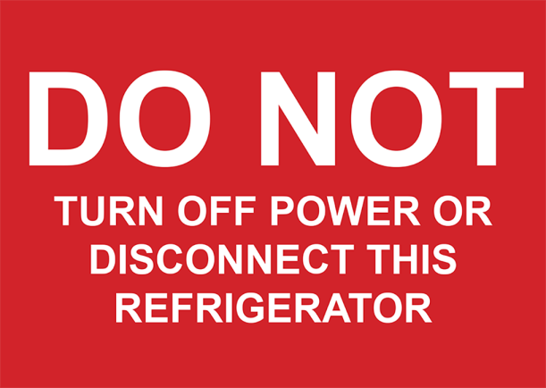 

Refer to Appendix 8 ‘Resource collection’ to order these stickers from the Department of Health, Disability and Ageing website.

* 1. Stabilising the PBVR temperature

Stabilising the PBVR temperature before stocking (e.g. after a PBVR failure, maintenance service, power outage or purchase of a new PBVR) minimises the likelihood of vaccines being exposed to temperature variations outside the recommended range of +2°C and +8°C.

Monitor the PBVR for **at least 48 hours** **before** storing vaccines to ensure that temperatures are maintained between +2°C and +8°C.

It is important that the cold spots in the PBVR are identified (e.g. ice build-up near air vents) by detailed temperature monitoring. This can be done by placing data loggers (see Section 4.2 ‘Data loggers’) or thermometers (see Section 4.5 ‘ Battery powered or digital minimum/maximum thermometers’) in all areas of the PBVR and noting the different temperatures before using the PBVR for vaccine storage. More than one data logger or thermometer will be required.

The key areas to monitor in the PBVR are the location of the vaccines positioned on each shelf from top to bottom, front to back and side to side.

Leave the data logger in the PBVR for a minimum of 24 hours. This will capture any temperature fluctuations that may occur.

Depending on the type and number of monitors you have, comprehensive temperature monitoring may take some time to complete. While assessing the cold spots, use a cold mass (e.g. cooled bottles of water; frozen products must not be used) to imitate a batch of vaccine, because PBVR behave differently when empty.

* 1. Monitoring and recording PBVR temperatures
* Check and record the PBVR temperature (current, minimum, and maximum) manually twice daily (see Appendix 8 ‘Strive for 5 – Vaccine fridge temperature chart’). If the temperatures fall outside the recommended +2°C to +8°C range, immediately implement ‘Cold chain breach protocols’ at   
  Appendix 3. Reset the data logger or thermometer after each reading.

**IMPORTANT**: Before opening the PBVR door, the temperature must be reviewed and recorded at a minimum of twice daily including:

* Checking the temperature history of a PBVR (via the continuous automated temperature monitoring system or data logger) after a period of closure (e.g. if not staffed 7 days per week) before adding or removing any vaccines and temperature-sensitive medications.
* Downloading and check the temperature history on the data logger weekly, and in the event of a suspected temperature breach.
* Reviewing temperatures following a power failure or other cold chain breach.
* Checking temperatures after any routine maintenance on the PBVR, such as minor cleaning.
* Retaining documentation of vaccine temperature recordings according to your state or territory health department policy, and/or your medico-legal and statutory requirements.

**The minimum/maximum display must also be checked visually every time before adding or removing vaccines.**

**Note:** Each PBVR requires its own temperature-monitoring chart/logbook. See Appendix 8for a sample monitoring chart.

* 1. Maintaining the PBVR
* Report breakdowns immediately and arrange for alternative monitored storage for vaccines during repairs.
* Service the PBVR must be serviced every 12 months to ensure that it is in good working order.
* Maintain all documentation and records of PBVR maintenance and services.
* In between the PBVR service period/s monitor:
* Any evidence of fluid leaks.
* If the compressor is operating quietly.
* That the seals are in good condition and sealing tightly.
* The door is closing properly.
* The positioning level of the PBVR (as per manufacturer’s instructions).
* If there are exposed coils on the back of the PBVR, keep them clean and free from dust to improve operating efficiency.
* During cleaning:
* Move the vaccines to a second PBVR (which must be monitored during this time), or
* Store and monitor the vaccines in a prepared cooler (see Section 8.3 ‘How to pack a cooler’).
* Refer to Appendix 8 for a printable version of the ’Mobile and emergency storage’ checklist from the Department of Health, Disability and Ageing website.

1. Vaccine temperature-monitoring devices

To ensure that vaccines have not been stored outside the recommended temperature range of +2°C to +8°C, the temperatures to which vaccines are exposed must be monitored, recorded, and reported throughout the vaccine cold chain.

The following requirements help ensure that vaccine quality is maintained throughout the vaccine cold chain and temperature excursions and any potential impact on the potency of the vaccines are identified early.

* 1. Minimum Requirements
* Immunisation providers must at a minimum have:
* A digital minimum/maximum thermometer (inbuilt or portable) with a digital display. The thermometer must have the capability to show minimum, maximum, and current temperatures to manually record the temperature of the PBVR twice daily.
* A downloadable data logger set to continuously measure PBVR temperatures at minimum 5-minute intervals or automated temperature monitoring systems in the PBVR.
* A portable minimum/maximum thermometer for use in vaccine transportation or in the event of a PBVR failure.
* **Note:** A data logger, remote monitoring system or automated monitoring system is **in addition** to dot point 1 and 3 above.
  1. Data loggers

Temperature data loggers are devices that measure temperatures at preset time intervals and record the results over time. These results can be downloaded and can be viewed and stored as graphs, tables, or raw data. Data loggers can be set to record temperatures at a minimum of 5-minute intervals. Data loggers must be programmed to notify the designated staff member/s via text, alarm, and/or visually when a temperature outside of +2°C to +8°C range is recorded. Data loggers can be inbuilt to the PBVR or portable.

Where the applicable feature exists, data logger information must be downloaded at least once weekly, and the data must be managed in line with your governance requirements. It is important to check the memory storage capacity of the data logger and required frequency for downloading reports without losing data; for example, the memory may only store up to 3 months’ worth of data.

Portable data loggers should be placed where vaccines are stored to ensure accurate temperatures are recorded. Portable data loggers can also be used to construct a ‘temperature map’ for the PBVR (see Section 3.7 ‘Stabilising the PBVR temperature’) and identify which areas are safe for vaccine storage. It is important to identify areas where vaccines may be more susceptible to freezing.

* 1. When purchasing a data logger

The data logger must:

* Be capable of recording temperatures at 5-minute intervals.
* Have alert capabilities and is ideally able to send automated notifications.
* Be able to download and store temperature data.

Checklist for data loggers

* Set the alarm system to send alerts outside the +2°C to +8°C range. Check that the alarm is working.
* Train all staff to recognise the alarm and download information from the data logger.
* Place the data logger inside the PBVR (ideally suspended from a shelf) where it is easily seen and in the middle of the vaccines.
* Download and review/temperatures reports weekly.
* Download and review information as soon as possible after an alarm is activated.
* If recordings are outside the +2°C to +8°C range, follow the cold chain breach protocol at Appendix 3 and notify the relevant state or territory health department. See contact details on the last page of these guidelines.
* Data loggers must be checked for accuracy according to the manufacturer’s recommendation.
* Change the battery according to the manufacturer’s recommendation.
  1. Automated temperature monitoring systems

Automated temperature-monitoring systems are remote or wireless temperature monitoring systems that allow immunisation service providers to access real-time temperature-monitoring data from a connected device such as a computer or phone. In the event of a cold chain breach, an alert is sent by mobile application notification to the registered user.

These systems use wireless monitoring to transmit continuous data to a web server. The temperature readings do not need to be downloaded to a computer, but a report must be reviewed weekly as a minimum requirement.

* Where continuous automated temperature-monitoring systems are **NOT** in place, a data logger is required, at a minimum, for the temperature history.

### Building management system

A building management system (BMS) can be integrated with PBVRs and allows for real-time tracking of vaccine storage conditions. Immunisation providers may have a BMS in place that utilises continuous fluid state temperature monitoring every 5 seconds with 24/7 alarm supervision.

**Note**: The use of a BMS system does not remove the requirement to review reports weekly.

### Back-to-base alarm systems

A back-to-base alarm system is a computer-based control system that alerts staff when a temperature excursion outside the recommended +2°C to +8°C temperature range occurs. Use of back-to-base alarm systems to monitor PBVR temperatures requires temperature readings to be downloaded to a computer and reviewed weekly as a minimum requirement.

**Note:** There is a potential for equipment failure of automated temperature recorders (e.g. data loggers and remote or automated monitoring systems); therefore, current, minimum and maximum temperatures must still be recorded twice daily on the ‘Strive for 5’ – Vaccine fridge temperature chart. These recordings increase the chance of identifying issues and minimise risk if there is a failure of data logger or automated monitoring.

* 1. Battery powered or digital minimum/maximum thermometers

Ensure that the thermometer has a sensor probe. To ensure that the probe is measuring the temperature under the same conditions as for the vaccines, place the end of the sensor probe in an empty vaccine box inside the PBVR. The thermometer must be placed close to the inbuilt thermometer in the centre of the PBVR. Refer to the manufacturer’s recommendations.

* Thermometers must be checked annually for accuracy.
* Batteries must be changed every 6 to 12 months and the date recorded.
* Each PBVR must have a back-up battery operated min/max thermometer in use, in case of power outage or transport of vaccines. (see Appendix 1 ‘Vaccine management protocol’).
  1. How to check the accuracy of a thermometer (‘slush test’)

The slush test is a practical, reliable technique for checking the accuracy of a thermometer at the freezing point of water. By leveraging the stable temperature of an ice-water mixture at equilibrium, users can quickly assess whether a thermometer requires recalibration or replacement. While the test is best suited for routine checks and offers a meaningful snapshot of accuracy, it should be complemented with comprehensive calibration procedures for high-precision applications.

**Conducting the test:**

1. Place a cup of cold water in the freezer until a fine layer of ice forms on the top and small sections of ice form within the fluid (this may take up to 2½ hours). The presence of ice is an indication that the temperature of the water has reached 0°C.

2. Place the temperature probe into the middle of the container (be careful not to let the probe touch the container).

3. Observe the temperature on the display screen after 2 minutes.

4. Document the date of the accuracy check.

**Note**: This test is only for water-proof devices.

### Rationale

The temperature reading will drop quickly at first and then more slowly. The temperature should drop to 0°C within 2 minutes.

An ‘acceptable’ degree of accuracy of a thermometer can vary within ±1°C), so it is recommended to check with the thermometer supplier for the expected accuracy. Even if the thermometer is considered accurate to within ±1°C, the accuracy check could result in 3 possible readings - +1°C, 0°C and -1°C.

Record the results of the accuracy check on your temperature monitoring chart. This information is important, particularly if the PBVR temperature goes outside the recommended range of +2°C to +8°C.

If the temperature reading is more than +1°C above or below 0°C at 2 minutes:

* Replace the battery (record the date).
* Retest.
* If the temperature reading is still not within range, replace the thermometer.

Accuracy checks are recommended:

* After the battery is changed.
* At least every 12 months, for auditing purposes.
* If cold chain issues occur.

The supplier of the thermometer may be able to offer a validation or accuracy check for their product.

* 1. Disposable cold chain monitors received with deliveries

Disposable cold chain monitors detect heat and/or freeze breaches.

* Jurisdictions use different methods of monitoring the cold chain when transporting vaccines to providers (e.g. data logger, thermometer, disposable cold chain monitor).
* All deliveries must be accompanied by a cold chain monitor.
* Do not accept vaccines if there is no cold chain monitor with the delivery.
* Check the monitor and record the temperature upon delivery.

Disposable cold chain monitors **must** be discarded following receipt of vaccines and **must not be used** to monitor vaccines after delivery.

If you are unsure if the cold chain monitor arriving with your delivery is disposable, check with your state or territory health department.

1. Vaccine management protocol and audit

An effective vaccine management protocol will ensure that you are ready **before** an event or issue occurs.

Ensure that the following are in place and included in your protocol:

* All clinical staff must be trained to manage vaccine storage and cold chain management effectively, to ensure that all cold chain issues are identified and addressed in a timely manner.
* Contact names and numbers are readily available for reporting:
* Cold chain breaches and/or data logger maintenance issues.
* Power failures.
* Back-up vaccine storage options are documented and tested.
* A suitably trained, designated person (e.g. staff member) is responsible for coordination of vaccine storage and implementation of protocols.
* A suitably trained back-up person is available to relieve the designated person when required. Use functional role titles rather than individual names.

Contact your state or territory health department to check if cold chain management training is available.

See Appendix 1 for help with writing a ‘Vaccine management protocol’ which should include written instructions for the following items:

**Vaccines**

* Ordering and receiving vaccines.
* Rotating stock so that vaccines with the shortest expiry date are used first.
* Calculating vaccine storage requirements.
* Storing vaccines and diluents.

**Vaccine transport**

* Managing a power failure (see Section 7 ‘Managing a power failure’).
* Packing a cooler (see Section 8.3 ‘How to pack a cooler’).
* Conditioning the ice packs and gel packs (see Section 8.2 ‘Freezing and conditioning ice packs and gel packs’).
* Temperature-monitoring equipment and documentation (see Section 4 ‘Vaccine temperature-monitoring devices’).

**Action and communication**

* Reporting a cold chain breach (see Appendix 3 ‘Cold chain breach protocol’).
* Required action if the PBVR temperature goes outside the recommended range of +2°C to +8°C (including what to do and how to prevent it happening again).
* Ongoing vaccine management education for staff, and orientation of new staff.
* Refer to Appendix 8 to download the ‘Quick reference guide’ poster from the Department of Health, Disability and Ageing website. This poster can be fixed to the PBVR door or in a location close to the fridge.

1. Caring for vaccines during immunisation clinics
   1. Mobile or outreach immunisation clinics

Vaccines must be appropriately packed to maintain the cold chain and be monitored with a min/max thermometer or data logger during transportation and administration in all venues. This includes school-based immunisation clinics conducted by immunisation service providers, and influenza mobile or outreach immunisation sessions held outside clinics (e.g. in nursing homes).

See Section 8 ‘Coolers’ for details on the correct packing and monitoring process.

* For further guidance, see Appendix 5 ‘Preparation for mobile or outreach immunisation clinics’.
* For a mobile service where there is no power supply or PBVR, ensure there is another cooler which contains additional ice packs/gel packs that can replenish melted ice packs/gel packs in the vaccine cooler. Ensure the following:
* Take vaccines from the cooler only as required and administer immediately.
* Place coolers out of direct sunlight and away from other sources of heat and UV light (e.g. fluorescent light).
* Avoid handling vaccines unnecessarily.
* Monitor and record the current, minimum and maximum temperatures of the cooler every hour. Reset the thermometer after each reading.
* At the conclusion of the clinic, return vaccines that have been continuously stored between +2°C and +8°C to the PBVR immediately.

Refer to Appendix 8 and for a printable guide/checklist for preparing for mobile or outreach immunisation clinics and a temperature chart to use during these clinics.

When preparing for long-term storage (i.e. more than 8 hours), or a mobile or outreach immunisation clinic in an extreme storage environment condition (<0°C or >40°C), use a specialised vaccine cooler (see Section 8.4).

**Report all cold chain breaches that occur during mobile or outreach sessions to your state or territory health department in the same way that you would report cold chain breaches within your practice. See** contact details **on the** last page **of these guidelines.**

### Reconstituting vaccines with diluent during a mobile or outreach immunisation clinic

Reconstituted vaccines lose potency over time, even when stored between +2°C and +8°C. Storage rules vary depending on the vaccine being used.

Refer to:

* The online version of the [Australian Immunisation Handbook](https://immunisationhandbook.health.gov.au/#the-australian-immunisation-handbook-provides-clinical-advice-for-health-professionals-on-the-safest-and-most-effective-use-of-vaccines-in-their-practice).
* The current version of the relevant vaccine product information statement which are available at [www.tga.gov.au](https://www.tga.gov.au/).
  1. Community pharmacies

All immunisation service providers who provide a prescription to their patient for the purchase of vaccine/s must advise the client that vaccine/s must be taken directly to their administering healthcare professional for administration or refrigerated storage.

Where appropriate, and in accordance with the prescriber’s directions, the pharmacist may be able to administer the vaccine in the pharmacy. Please refer to your state or territory practice guidelines.

If administration in the pharmacy is not possible/appropriate:

* Advise the client that the vaccine must remain in the pharmacy’s refrigerator (at 2-8C), until it can be taken directly to the administering healthcare professional.
* If there is concern that a vaccine provided by a patient may have been stored outside the recommended +2°C to +8°C range, the vaccine must not be administered. The patient may need to purchase a replacement vaccine dose.

**Note:** Alfoil bags commonly provided in community pharmacies when vaccines are privately purchased are **not** effective in maintaining the cold chain. Immunisation service providers **must** advise patient to return for their vaccination appointment immediately after collecting the privately purchased vaccine from the pharmacy. The vaccine should **not** be left in a car or stored in a domestic refrigerator in alfoil bags.

* 1. Transporting vaccines to another PBVR

In general, it is not recommended to transport vaccines to another PBVR, however, there may be instances where this is required, such as when performing vaccination services in multiple locations. If transporting vaccines to another PBVR (see Section 8.3 ‘How to pack a cooler’). Ensure temperatures are recorded before, during and after the transfer.

1. Managing a power failure

Power failures occur for many reasons. The management of a power failure in your health service will depend on the cause of the power outage, whether prior notice was given and the time of day the outage occurs. The safety and wellbeing of staff must always be top priority when managing power failures, particularly when they occur outside business hours.

Some power companies send letters or provide text message alerts prior to scheduled power outages to allow for necessary planning. Check with your power company to determine whether this service is available in your locality.

Refer to Appendix 8 for a printable version of the ‘Managing a power failure’ checklist from the Department of Health, Disability and Ageing website.

* 1. Back-up plans

Always have a back-up plan and alternative storage that can be used if a power failure occurs. This will allow vaccines to continue to be stored between the recommended temperatures of +2°C and +8°C, thereby minimising vaccine loss and disruption to your facility’s activities.

Alternative storage options may include:

* A back-up power supply (e.g. generator or battery/solar back-up).
* A monitored PBVR offsite (e.g. at a local hospital or pharmacy) - ensure that an agreement has been put in place with the relevant organisation before the event and consider that this organisation may be affected by the same power failure.
* Sufficient coolers for an emergency. If using a cooler, the capacity must be enough to accommodate:
* Vaccines that are loosely packed.
* Ice packs or gel packs.
* Insulating material (e.g. polystyrene chips or bubble-wrap).
* A minimum/maximum thermometer or data logger.

Each immunisation facility must practice implementing its back-up plan, including packing vaccines into alternative storage, to ensure that the plan will work in a real power failure situation. Keep in mind that there may be only a short window of time before the PBVR temperature rises above +8°C and suitable alternative storage must be ready quickly.

* 1. PBVRs during a power failure.

Depending on the quality and design of the PBVR, and the ambient temperature of the facility, the PBVR may rise to >8°C during a power failure. Contact the PBVR manufacturer to discuss this functionality of the PBVR and document as part of your power outage plan.

**Note:** Not all PBVRs continue to display the current temperature during a power failure. To overcome this issue, use a separate battery-operated minimum/maximum thermometer or data logger with a digital display to continuously monitor PBVR temperatures during power outages and once power is restored.

If the temperature of the PBVR is anticipated to exceed +8°C for longer than 15 minutes vaccines will be at risk of becoming compromised. Alternative monitored storage arrangements must be used.

### During business hours

* Leave the vaccines in the PBVR with the door closed. Put a sign on the PBVR door stating - ‘Power out. Do not use vaccines. Keep PBVR door closed.’
* Closely monitor the PBVR temperature using a battery-operated minimum/maximum thermometer or portable data logger. This must be done by using an embedded thermometer that uses a separate battery to the mains.
* If the temperature is approaching +8°C, move vaccines to a prepared cooler or cold box. Ensure that all vaccines are packed and monitored with a digital minimum/maximum thermometer or data logger (see Section 8.3 ‘How to pack a cooler’).
* Ensure that you have a strategy in place for long-term storage dependent on the length of the power outage. Your state or territory health department may be able to assist you.

**Important:**

Never transport vaccines to another PBVR, cooler or cold box without a minimum/maximum thermometer or data logger to monitor the temperature.

**Domestic** refrigerators (including bar fridges, commercial fridges or industrial fridges) **are not built or designed to store vaccines** and **must not be used** for vaccine storage even for a temporary basis. Refer to your state or territory health department for further advice.

If there is no suitable alternative monitored storage option, isolate the vaccines and leave them in the **PBVR** with the door closed for the duration of the power outage. A thermometer will be vital to determine whether the temperature reached **+8°C** or higher when the power is restored.

* 1. When power is restored
* Reset the PBVR temperature when the temperature reaches +8°C or lower.
* Ensure that the PBVR temperature has returned to between +2°C and +8°C before returning vaccines.

**Do not use or discard vaccines until you have received advice from your state or territory health department.**

* Monitor the PBVR hourly for 4 hours to ensure that the temperature is consistently stable, then return to twice daily monitoring.

If necessary, follow the ‘Cold chain breach’ protocol described in Appendix 3. This appendix details important information required when reporting a cold chain breach to your state or territory health department.

1. Coolers

A cooler or esky is a solid-walled insulated container with a tightly fitting lid, or a vaccine-specific soft-walled cooler. The temperature inside can be maintained using ice packs or gel packs. Coolers are usually portable.

High-quality coolers are available from large boating, fishing, or camping suppliers. They have thick refrigerator-grade insulation, and fibreglass or plastic walls. Some may have small ‘feet,’ which ensure that the cooler does not contact warm surfaces such as the floor or a car boot. Check with the manufacturer about the technical specifications and performance of the cooler.

Coolers have a limited ‘cold life’ and are therefore not adequate for vaccine storage for prolonged periods (more than 8 hours) or in extreme conditions. In these circumstances, a specialised cooler must be used for storing and transporting vaccines (see Section 8.4 ‘Specialised vaccine coolers’).

* 1. Tips for using coolers

Immunisation service providers must choose coolers that will meet their facility’s needs. The minimum size cooler recommended for storing vaccines is ten litres as this ensures that air can circulated around the vaccines and maintain the optimal temperature.

Consider the quantity of vaccines stored in your PBVR to determine the minimum number and size of coolers and equipment you will require if you need to transfer your vaccines to prevent a cold chain breach.

* Polystyrene coolers provide limited insulation and are only suitable for storing vaccines for short periods (up to 4 hours). If using a polystyrene cooler, change to a plastic cooler if the polystyrene cooler is not maintaining a stable temperature.
* If using a plastic cooler that is not maintaining a stable temperature, consider upgrading to a higher quality cooler with refrigeration-type insulation, or a specialised cooler.

The number of ice packs or gel packs required will depend on:

* Ambient temperature.
* Type and size of cooler.
* Number of vaccines.
* Cooler size.
* Size and type of ice packs/gel packs.

When using coolers, always do the following:

* Condition the ice packs or gel packs (see Section 8.2 ‘Freezing and conditioning ice packs and gel packs’).
* Correctly pack the cooler to reduce the risk of freezing (see Section 8.3 ‘How to pack a cooler’).
* Pre-chill the cooler before use.
* Insulate the vaccines with appropriate material so they do not come into contact with ice packs/gel packs that are at 0°C, e.g. loosely wrap vaccines in bubble-wrap, allowing cool air to circulate and avoid wrapping tightly.
* Use a battery-operated minimum/maximum thermometer, monitor and record the temperature inside the cooler every 15 minutes for the first 2 hours, then at least hourly, if temperatures are stable. Ensure the thermometer is reset after each reading for accuracy.
* Ensure that the contents of the cooler are packed securely so they cannot move around during transport.
* Keep the cooler out of the direct sunlight during transport.
* Remove vaccines from the cooler only as they are required. Keep lid tightly closed when not in use and minimise the time the lid is open.
* Check that the temperature has remained between **+2°C and +8°C** before administering the vaccine.
  1. Freezing and conditioning ice packs and gel packs

### Ice packs

Ice packs are water filled and can come out of the freezer at a temperature as low as −18°C, which is significantly lower than the freezing point of the ice pack. Achieving the lower temperature will provide a longer cold life for the ice pack.

### How to condition ice packs

Condition ice packs as follows:

* Remove ice packs from the freezer.
* Lay out ice packs in a single row on their sides (where possible), leaving a 5cm space around each ice pack to allow maximum air exposure. This reduces the conditioning time.
* Wait until ice packs begin to sweat which can take up to 1 hour at +20°C.
* The ice pack is conditioned as soon as water begins to ‘slosh’ about slightly inside the ice pack.

### Gel packs

Some types of gel packs contain chemicals that depress the freezing point of the pack and ensure that the gel remains colder than 0°C for longer than water-filled ice packs. Before purchasing gel packs, request documentation from the manufacturer that:

* Validates their claims about the product’s cold life.
* Provides clear instructions on how to freeze and condition the product before use, and how to safely pack a cooler with the gel pack and vaccines.

How to condition gel packs

Usually gel packs will take longer to condition than ice packs.

Follow the manufacturer’s instructions for conditioning the gel pack. Although there is no ‘one rule fits all’ approach, there are some industry standards that can be used to guide conditioning if gel packs have been stored in the freezer at −20°C for a minimum of 36 hours. Conditioning frozen gel packs for the times prescribed below enables the initial chill factor to be removed from the packs.

An alternative to ice and gel packs are ice sheets and ice blankets. Ice sheets and blankets provide faster conditioning time, take up less space with less chance of vaccines freezing.

**Guide to conditioning small and large gel packs**

Gel packs weighing less than 750g:

* If ambient (room) temperature is over +15°C, condition for 45 minutes before use.
* If ambient temperature is under +15°C, condition for 1 hour before use.

Gel packs weighing more than 750g:

* If ambient (room) temperature is over +15°C, condition for 1 hour before use.
* If ambient temperature is under +15°C, condition for 1½ hours before use.
  1. How to pack a cooler

**One of the greatest risks to vaccines is freezing during transport in a cooler.** The risk of freezing increases if the ice packs/gel packs are not correctly conditioned.

Freezing episodes occur easily in all coolers, usually in the first 2 hours after packing. It is important to monitor the temperature every 15 minutes for the first 2 hours, and then at least hourly.

This will minimise inadvertent freeze/thaw cycles that may be undetected otherwise, especially during the initial post-conditioning period.

Option one: Packing vaccines for storage within a cooler (up to 8 hours)

1. Chill the inside of the cooler before use by placing ice packs/gel packs in it for a few hours **(see Figure 1**).

2. Place insulating material on top of ice packs/gel packs **(see Figure 2)**. This eliminates ‘hot’ and ‘cold’ spot formations. Packaging such as polystyrene chips is preferable to bubble-wrap because it promotes air circulation. If using bubble-wrap, avoid wrapping the vaccines tightly.

3. Place *vaccine stock on top of the insulating material **(see Figure 3)**.

4. Place a minimum/maximum thermometer (or a dual time-temperature indicator if they are used in your state or territory) or data logger in the centre of the vaccine stock **(see Figure 4)**.

5. Place the thermometer probe in an empty vaccine box (with the product information intact) to protect it from lying directly on ice.

6. Surround the vaccines with packing material that allows cold air to circulate.

7. Place the conditioned ice packs/gel packs on top of the insulating material **(see Figure 5)**, and close and seal the lid of the cooler. If using a larger cooler, place conditioned ice packs/gel packs around the sides of the cooler as well as on top. Experiment to find the best combination.

8. Ensure that vaccine stock is not in direct contact with the ice packs/gel packs, to minimise the risk of freezing.

9. Place the display screen of the minimum/maximum thermometer on the outside of the cooler for easy monitoring and recording of vaccine temperatures **(see Figure 6)**.

10. Commence monitoring before leaving for the clinic/s. Monitor the temperature every 15 minutes for the first 2 hours, and then at least hourly throughout the immunisation session, and before administering vaccines (see Appendix 8 ‘Checklist and temperature chart for mobile or outreach immunisation clinics, or emergency storage of vaccines’).

**Note: Vaccine types shown in the figures below MAY NOT be current and are for guidance purposes ONLY.**

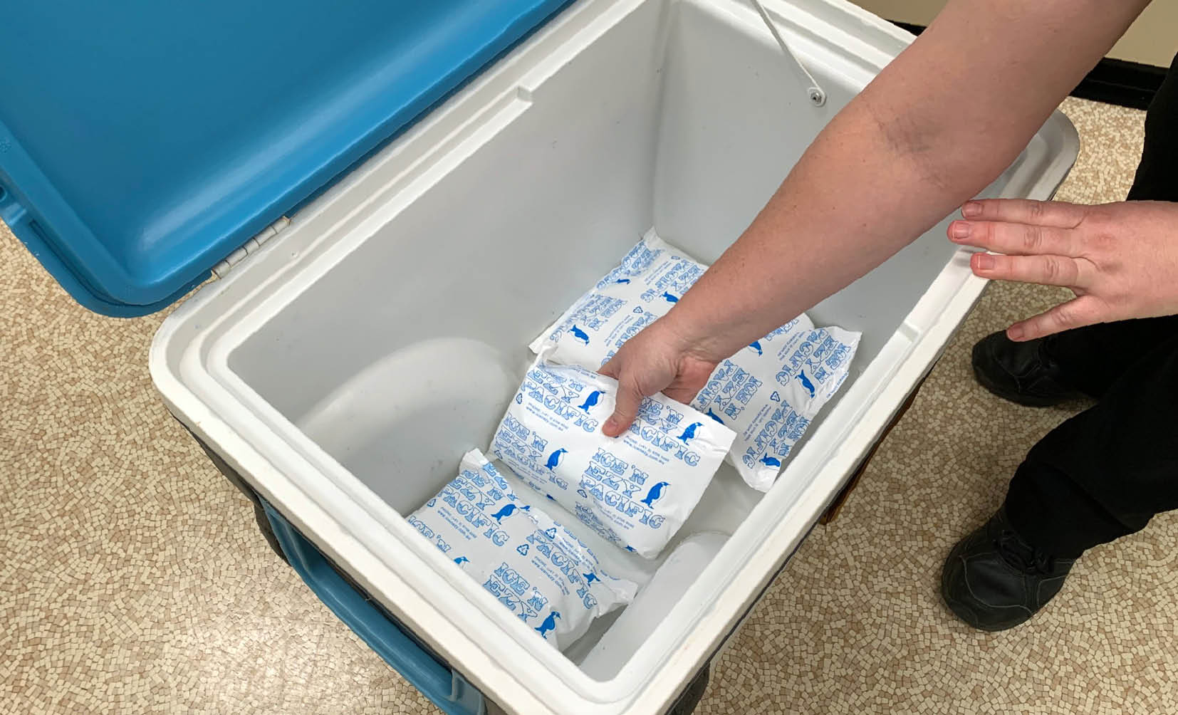

**Figure 1:** Ice packs/gel packs placed in bottom of cooler to chill cooler

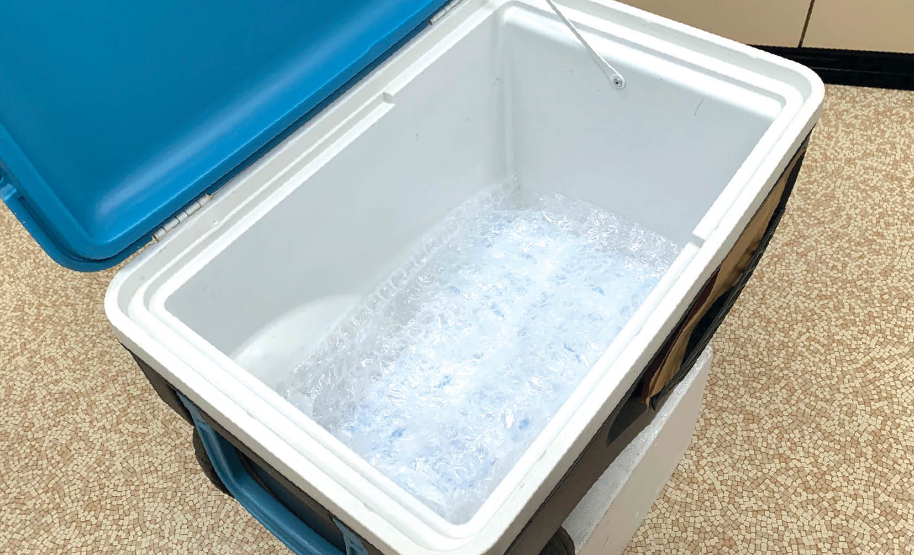

**Figure 2:** Insulating material placed on top of ice packs/ gel packs

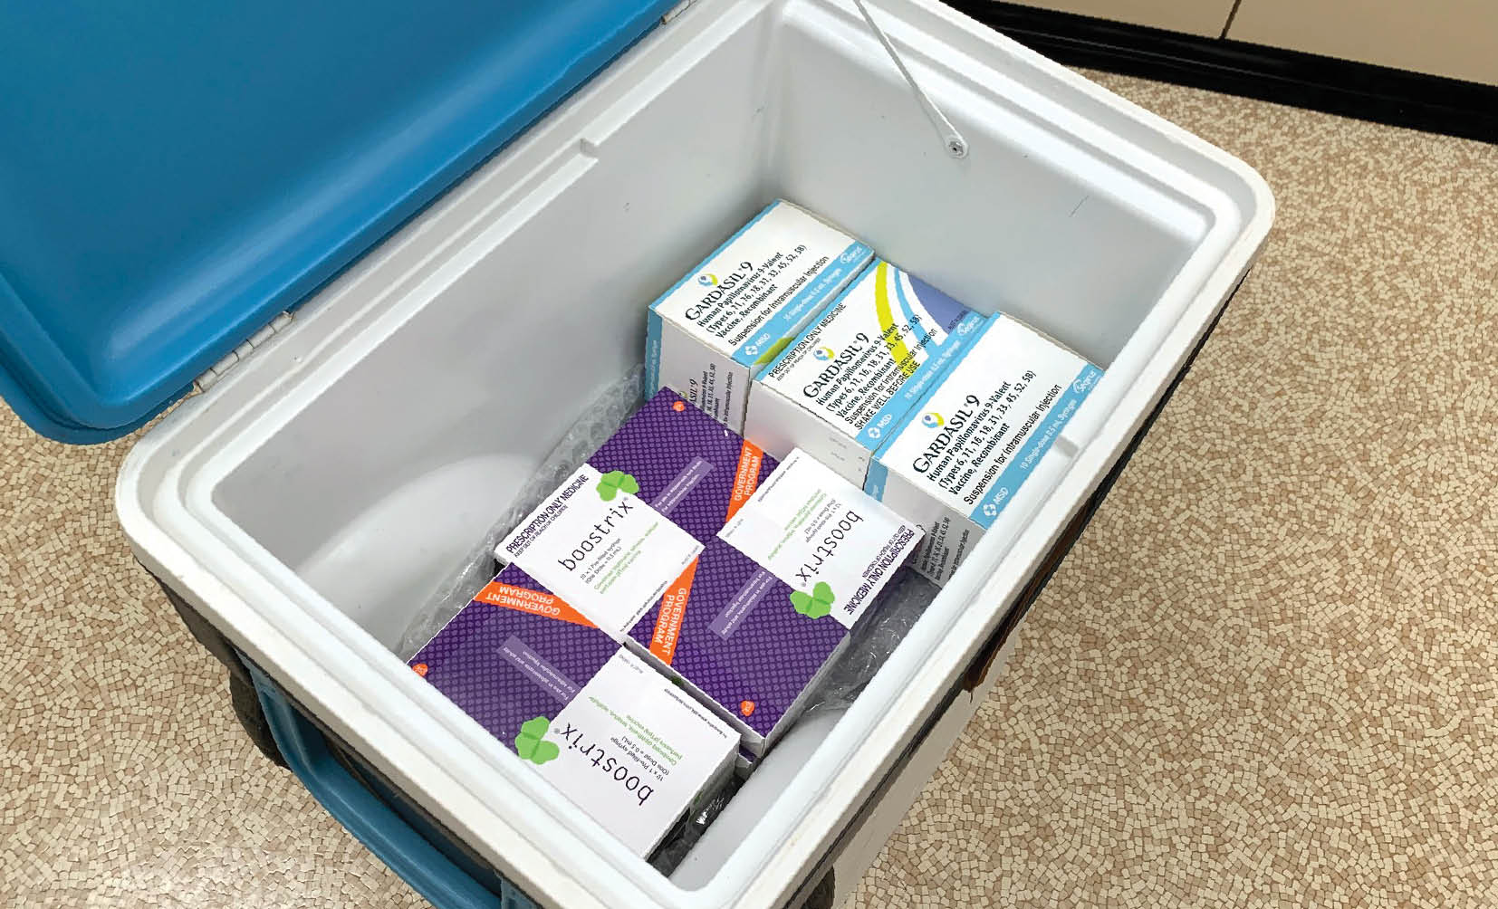

**Figure 3:** Vaccines packed in cooler

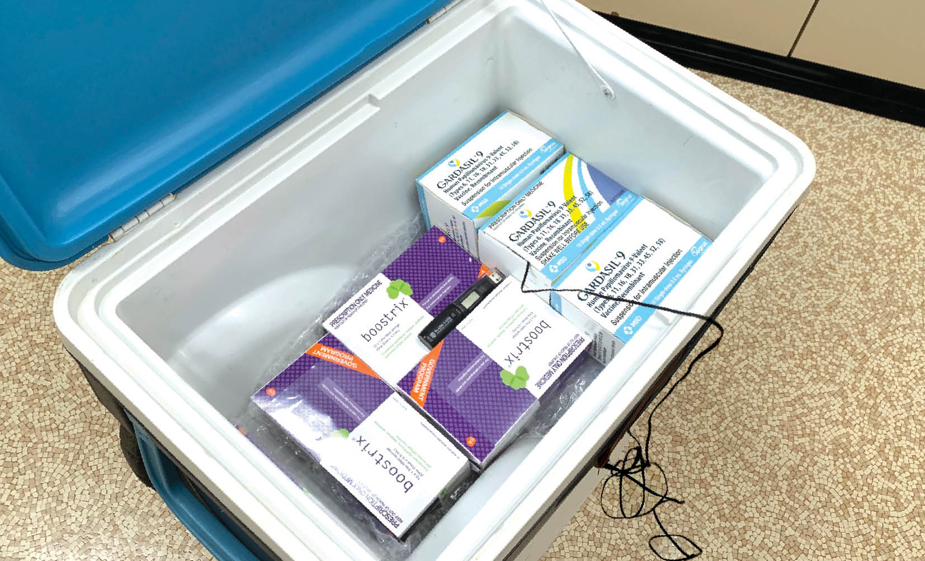

**Figure 4:** Minimum/maximum thermometer placed in centre of vaccine stock

**Note**: A data logger (if available) can also be placed with the minimum/maximum probe.

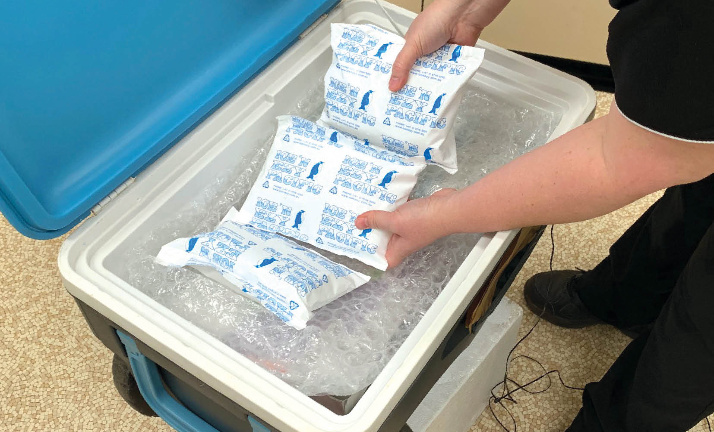

**Figure 5:** Insulating material placed on top of vaccine stock followed by ice packs/gel packs

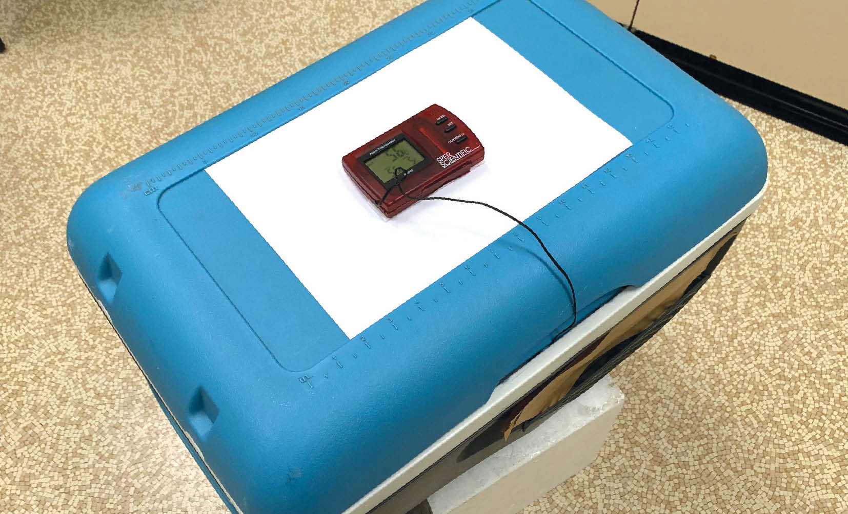

**Figure 6:** Minimum/maximum thermometer display placed outside cooler

Option two: Packing vaccines into a polystyrene container that is then placed into a larger cooler

1. Choose a suitably sized polystyrene container and chill the inside by placing ice packs/gel packs inside for a few hours.

2. Remove the ice packs/gel packs used to chill the inside and replace with conditioned ice packs/gel packs.

3. Place the vaccines and a minimum/ maximum thermometer inside the polystyrene container and secure the lid.

4. Ensure that the minimum/maximum thermometer probe is placed in the centre of the vaccine stock inside an empty vaccine box with the product information intact. The display screen must be placed on the outside of the cooler to allow recording of the temperature.

5. Pack the polystyrene container inside a large cooler and surround it with ice packs/gel packs and secure the lid.

6. Monitor the temperature before leaving for the session, upon arrival, before administering vaccines and at least hourly throughout the immunisation session (see Appendix 8 ‘Checklist and temperature chart for mobile or outreach immunisation clinics, or emergency storage of vaccines’).

* 1. Specialised vaccine coolers

A vaccine cooler is a purpose-built product. It has thick walls and is significantly more expensive than a standard cooler. It can only be purchased from specialist manufacturers.

The cooler insulation must be at least 30mm thick and, if possible, 80mm thick in the walls and lid. Fibreglass coolers with 50mm refrigeration-grade insulation are available.

For long-term storage (i.e. more than 8 hours) or storage in extreme conditions (where the temperature of the storage environment is <0°C or >40°C), a specialised cooler is needed.

A specialised cooler may have a minimum cold life of 120 hours when exposed to temperatures up to +43°C without being opened.

# APPENDIX 1 – Vaccine management protocol

A vaccine management protocol must cover the following.

## Vaccine ordering

* The aim when ordering vaccine/s is to have on hand the **right** amount at the **right** time. A stocktake must be undertaken before ordering and receiving new vaccine/s, including providing details on the ordering process.

## Vaccine delivery

**Note:** Some of the points below may not apply to your facility. Check with your state or territory health department for advice regarding vaccine delivery arrangements.

* A suitably authorised person/s should accept vaccines from the courier.
* Check that a cold chain monitor is in the package. **Do not** accept vaccines if a monitor is not present.
* Vaccines **must** be immediately upon delivery receipt and not left in ambient temperatures. This will ensure the cold chain is maintained and avoid the risk of temperature fluctuations.
* Check all vaccine expiry dates and move vaccines with the shortest vaccine expiry date to the front of the PBVR for use first.
* Maintain vaccines in their original packaging and move to a dedicated PBVR, as soon as the PBVR’s temperature monitors have been checked, and temperature is reading between +2°C and +8°C.
* Record the numbers of vaccines received, vaccine types and batch numbers as well as the date of receipt.
* Record details of who to contact if cold chain monitors show a breach occurring during transportation; noting the difference between government-funded and privately purchased vaccines.
* Report any discrepancies between the vaccines on the delivery paperwork and the vaccines received to your state or territory health department.

## Temperature monitoring and recording

* Place instructions on how to use the data logger and how to download data in your facility’s vaccine management manual. Record where to store data on the computer including date of purchase, date of last calibration, whether the data logger can display the minimum, maximum and current temperatures. Check with your state or territory health department on how long these records are to be stored for.
* A minimum/maximum thermometer is needed if the PBVR doesn’t have a battery backup for its built-in temperature monitoring system, a generator, or an uninterrupted power supply. This is so the temperature can still be monitored during a power outage.
* Ensure that a thermometer is in place to continuously check the temperature in each PBVR.
* Place the thermometer probe in an empty vaccine box on the middle shelf of the PBVR.
* Check the thermometer and manually record the temperature twice daily.
* Record the minimum and maximum temperatures of the PBVR and reset the thermometer after each reading.
* Ensure staff are aware of the location of new temperature recording charts/logbooks.
* Provide instructions for how to reset the minimum/maximum thermometer.
* Record the date of the last accuracy check and battery change.
* Provide details of who to contact for advice during a cold chain breach.

## Documentation

Written procedures, instructions and logbooks must be readily accessible to explain and record equipment maintenance, vaccine transport and staff education. These may be kept electronically and/or in hard copy.

## Equipment maintenance

Include instructions for:

* How and when to change batteries — e.g. the batteries in minimum/maximum thermometers require changing every 6 to 12 months.
* Who to contact for PBVR maintenance or in the event of an issue and include the service contact details.
* When the annual PBVR self-audit is to be performed.
* Cleaning the PBVR.

## Transporting vaccines off-site

Include instructions for:

* How to condition ice packs and gel packs.
* How to correctly pack a cooler.
* How often to monitor the cooler temperature.

## Staff education — vaccine management

Include:

* Procedures for orientating new staff and staff with new roles.
* Evidence of staff mandatory training.

# APPENDIX 2 – Vaccine storage self-audit

A vaccine storage self-audit must be undertaken by immunisation service providers at least every 6 – 12 months or as required and documentation retained according to state or territory health department policy or medico-legal requirements. Self-audits must be carried out more frequently if there have been problems with equipment or cold chain breaches.

**Note**: Some vaccines have a shorter shelf-life than other vaccines and are more than likely received by the immunisation service providers with only 9-12-mths shelf-life left when received.  
**Ensure vaccines with newer expiry dates are placed to the back of the PBVR.**

Refer to Appendix 8 for a printable version of the checklist below from the Department of Health, Disability and Ageing website.

**Self-auditing is important because:**

* It is part of routine quality assurance and as part of risk management processes as issues are highlighted as soon as they occur.
* It enables staff to have confidence that they are providing a safe and effective vaccine.

Nominated person responsible for vaccine management: …………………………………………………………....

Nominated back-up person for vaccine management: …………………………………………………………..….....

Make and model of PBVR/s: ………………………………………………………………………………………………………....

…………………………………………………………………………………………………………………………………………………......

Date of self-audit…………………………………………………………………………………………………………………...........

Person conducting audit: ……………………………………………………………………………………………………………….

PROCEDURES

Checklist for safe vaccine handling and storage

¨ Have all staff received orientation and/or an annual update on vaccine management?

¨ Have vaccine management policies been reviewed in the past 12 months to ensure that procedures are up to date?

Date of last revision:

¨ Is graph/logbook/chart for temperature recording readily available?

¨ Is the temperature of the PBVR recorded twice a day when the facility is open?

¨ Are the contact numbers to report a cold chain breach easily accessible?

¨ Were all temperature excursions outside the +2°C to +8°C range documented and reported to the appropriate state or territory health department?

EQUIPMENT

Purpose-built vaccine refrigerator

¨ Has the PBVR shown evidence of malfunction (e.g. poor seals so that the door opens too easily)?

¨ Is there an appropriate gap between the vaccines and the walls of the PBVR?

¨ Can the PBVR continue to store the required volume of vaccines safely according to these guidelines? (this includes times of increased demand during the influenza season. If ‘No,’ what action is being taken?) ……………………………………………………………………………………………………………….…………….…

Date PBVR was last serviced: …………………………………………………………………………………………………………….

¨ If the PBVR has a solid door, is there a map or guide to where vaccines are stored located on the outside of the door?

¨ Does the power outlet have a sticker **‘Do not turn off power or disconnect this refrigerator?’** Refer to Appendix 8 ‘Resource collection’ to order this sticker from the Department of Health, Disability and Ageing website.

Monitoring equipment

Date the minimum/maximum thermometer/s was purchased: ………………………………………………………

Date the battery for the minimum/maximum thermometer/s was last changed: ……………………………

Date and results of thermometer accuracy check at 0°C:   
(see Section 4.6 ‘How to check the accuracy of a thermometer (‘slush test’)

¨ Is the minimum/maximum thermometer temperature probe/s placed correctly?

Date the data logger/s battery was last changed: ……………………………………………………………………………

Date data logger/s was last serviced: ………………………………………………………………………………………………

Alternative vaccine storage

¨ Is there a readily accessible written procedure for what to do during a power failure?

¨ Is sufficient alternative storage (e.g. cooler, other monitored PBVR) available for vaccine storage, if necessary (e.g. vaccine PBVR breakdown or power failure)?

¨ Are ice packs/gel packs at the correct temperature available?

¨ Is appropriate equipment available to transport vaccines off-site if required e.g. minimum/maximum thermometer and ice/gel packs for each cooler?

¨ Is there enough insulating material e.g. bubble-wrap or polystyrene chips in the bottom of each cooler?

# APPENDIX 3 – Cold chain breach protocol

A cold chain breach occurs when vaccine storage temperatures deviate outside the recommended range of +2°C to +8°C (refer to the product information for storage requirements). The optimal storage temperature for vaccines is **+5°C.**

This appendix outlines the cold chain breach protocol and important information to have on hand when reporting a cold chain breach.

Vaccine temperatures recorded below +2°C or above +8°C must be reported to your state or territory health department. This does not include single temperature excursions in which the temperature reaches a maximum of up to +12°C for less than or equal to 15 minutes such as when restocking the PBVR.

Refer to Appendix 8 to download the ‘Cold Chain Breach Protocol’ poster from the Australian Government Department of Health, Disability and Ageing website.

## Cold chain breach steps

1. Keep vaccines in the PBVR and ensure the temperature is between +2°C and +8°C. Label the vaccine/s with ‘**Do not use / Do not discard’**. Vaccines may need to be transferred to an alternative PBVR or cooler using your back up plan.

2. Contact your state or territory health department as soon as possible (during business hours). They will require affected vaccine details, data logs and twice daily temperature readings to assess the breach.

3. Do not discard any vaccine until advised to do so by your state or territory health department.

4. Take steps to correct the problem and to prevent it from recurring.

5. For privately purchased vaccines, contact the manufacturer for advice.

## Information needed when reporting a cold chain breach

* Date, time and duration of the breach.
* Reason for the cold chain breach (if known) and whether it has been rectified.
* Brand and size of PBVR in which the vaccines are stored (e.g. ABC brand; 381 litres).
* Information for the full breach period downloaded from your data logger. All PBVRs must have continuous data logging set at 5-minute read intervals. Download the data once the temperatures have returned to between +2°C to +8°C.
* Minimum and maximum temperature readings while the vaccines were exposed to temperatures outside the +2°C to +8°C range.
* Length of time the PBVR vaccine storage temperature was outside the +2°C to +8°C range.
* Date the PBVR was last serviced.
* Whether the PBVR has had any maintenance issues recently.
* Length of time that these issues have been occurring.
* Type and number of vaccines in stock.
* Expiry date and batch number of the vaccines.
* Whether any vaccines have been pushed up against the cooling plate or a cold air outlet.
* Whether all vaccines are in their original packaging.
* Whether patients have been vaccinated with potentially affected vaccines.
* Whether the vaccines have previously been exposed to temperatures outside the +2°C to +8°C range.
* Whether there is any visible damage to vaccines (e.g. wet, damaged or soggy packaging).

# APPENDIX 4 – Frequently asked questions

**Q: Why is it important to protect vaccines from hot and cold temperatures?**

**A:** Many vaccines are destroyed when exposed to temperatures outside the recommendedtemperature range of +2°C to +8°C.

**Q: Who is responsible for cold chain management?**

**A:** All people who handle vaccines are responsible for maintaining the cold chain, including receptionists and store persons. It is recommended that a key person in each facility is nominated to oversee vaccine management, with a back-up person to act in the key person’s absence.

**Q: Will I be able to tell if a vaccine has been frozen by looking at it?**

**A:** No. Most vaccines appear normal and can be easily drawn up even after exposure to temperatures of 0°C and below.

**Q: Is the temperature uniform throughout the PBVR?**

**A:** No. Temperatures can vary throughout the PBVR, even on the one shelf.

**Q: If I have a PBVR, do I still need a minimum/maximum thermometer?**

**A:** Yes. You need a minimum/maximum thermometer in case of an event or issue, when you need to transfer the vaccines into a cooler, or to **monitor** the PBVR temperature during a power outage or mechanical failure.

**Q: Why is it preferable to check the minimum/maximum temperatures twice daily rather than just daily?**

**A:** Monitoring and recording the PBVR temperature in the morning before vaccines are used and at the close of business helps to identify a cold chain breach as early as possible so that affected vaccines are not administered.

**Q:** **If I have a data logger, why do I need to record the minimum/maximum temperatures twice a day on a graph or in a logbook?**

A: There is a potential for equipment failure of automated temperature recorders (e.g. data loggers and remote monitoring systems); therefore, current, minimum and maximum temperatures must still be recorded twice daily on the [‘Strive for 5’ – Vaccine fridge temperature chart.](https://www.health.gov.au/resources/publications/national-vaccine-storage-guidelines-strive-for-5-vaccine-fridge-temperature-chart-poster?language=en) These recordings increase the chance of identifying issues and minimise risk if there is a failure of data logger or automated monitoring.

The current temperature must also be checked visually before opening the door and retrieving vaccines. This will ensure staff:

* become familiar with the normal functioning of the PBVR.
* can identify early warning signs of potential PBVR malfunction.
* ensure vaccines have not been subjected to a cold chain breach prior to administration.

**Q:** **The receptionist is the only person here 5 days a week. Can they read the PBVR temperature?**

A: Yes. All staff who have been trained in the management of cold chain and vaccine storage can read and record the PBVR temperature if there are clear policies and procedures for them to follow in the case of a cold chain breach.

**Q:** **What should I do if my PBVR temperature recording shows that it was outside the +2°C to +8°C range?**

A: See Appendix 3 ‘Cold chain breach protocol’ for details of what to do.

**Q:** **What do I do if the maximum temperature rises to +11°C degrees for a few minutes when I am doing a stocktake or restocking?**

A: Note the event on the temperature chart and include the reason for the rise in temperature. Reset the temperature display. This is not a cold chain breach and does not need to be reported. Temperature fluctuations in which the temperature reaches a maximum of up to +12°C for only 15 minutes or less require no further action.

**Q: What should I do if I am having trouble maintaining my PBVR temperature?**

**A:** Contact your PBVR manufacturer or a qualified refrigeration technician to have the PBVR serviced or for advice on how to stabilise the temperature. Consider an alternative refrigeration solution until this is resolved. Contact your state or territory department for advice if you are unsure.

**Q:** **The PBVR temperature keeps going up or is difficult to cool down. What could be the cause of this?**

A: Possible causes include:

* Power failure or blackout.
* PBVR door left open.
* PBVR accidentally turned off or unplugged.
* Overstocked PBVR.
* PBVR faulty and/or malfunctioning/mechanical failure. You should contact your PBVR manufacturer or a refrigeration technician if this issue persists.

**Q:** **Should I cover the front of my glass-door PBVR on hot days?**

A: No. Air must be able to circulate around the sides and back of the PBVR. Never place the PBVR in direct sunlight or in a hot room. Contact your PBVR manufacturer for specific advice on maintaining your PBVR temperature on hot days if the room temperature rises significantly.

**Q:** **Why do I need to check the accuracy of the minimum/maximum thermometer if it reads +1°C?**

A: All minimum/maximum thermometers have a differential of ±1°C. Therefore, it is important to check the accuracy of your portable digital minimum/ maximum thermometer by doing a yearly ‘slush test’ (see Section 4.6 ‘How to check the accuracy of a thermometer (‘slush test’) in case the actual temperature has dropped to 0°C or below.

**Q:** **If temperature-monitoring equipment is in place, including thermostat override devices, is there still a need for staff intervention and monitoring of the cold chain?**

A: Yes. Temperature-monitoring equipment and thermostat override devices do not guarantee the vaccine potency/ quality and are not a substitute for good vaccine storage management.

**Q: I have a PBVR. What should I do if there is a power cut during business hours?**

A: If your PBVR has glass doors, the temperature of vaccines stored within it could rise above +8°C quickly (within approximately 15 to 20 minutes), depending on the circumstances such as outside air temperature and whether the room is air-conditioned. If the power is likely to remain off for that period, enact your plan for managing a power failure and contact your state or territory health department for advice. Also see Section 7 ‘Managing a power failure’.

**Q: I have a PBVR. How do I know what the maximum temperature is when there is no power?**

A: A portable minimum/maximum digital thermometer can be used to monitor the temperature of the PBVR when it does not have a battery back-up for the inbuilt temperature-monitoring system.

**Q:** **What should I do to stabilise** PBVR **temperatures if there is only a small volume of vaccines stored in the PBVR?**

A: All PBVRs must contain sufficient ‘cold mass’ to maintain a stable temperature. Cold mass can be provided using cooled bottles of water. When placing more water bottles in the PBVR, ensure that they are filled with cool water to avoid destabilising the PBVR environment. Frozen products must not be used.

**Q:** Our immunisation service provider **practice is planning to move to a new location — do I need to do anything?**

**A: Yes. You must contact your state or territory health department to inform them of your move and change in contact details. Also see** **Section 6.3** **‘Transporting vaccines to another PBVR’.**

**Q:** **Patients in my practice have been vaccinated with vaccines that have not been stored between +2°C and +8°C. What should I do?**

A: For each of the affected vaccines, you should:

* Contact your State or Territory Health Department.
* Record the patients name, Medicare number DOB, vaccine administered, date and time of administered vaccines, expiry date, date the vaccine was placed in the fridge, batch number and dose number.
* Ask if the patient is pregnant and if they have any medical conditions that have implications for vaccination.
* Record details of the cold chain breach, including temperature reached and length of time.

Important - Contact your state or territory health department as these above requirements may differ.

# APPENDIX 5 – Preparation for mobile or outreach immunisation clinics

The following information can be used as a guide when preparing vaccines for mobile or outreach immunisation clinics:

* Ensure that the cooler ice packs/gel packs you use for mobile, or outreach immunisation clinics have been conditioned before use.
* Monitor all sections of the cooler by simulating packing and storage of vaccines in mobile or outreach immunisation clinic situations.
* Check the integrity of the cooler i.e. good seal, not too heavy, not overcrowded.
* When using coolers for mobile or outreach immunisation clinics, where vaccines are being removed repeatedly, ensure that ice packs/gel packs do not move from their original positions and do not touch vaccines.
* Do not remove vaccines from cooler and original vaccine packaging until they are due to be administered. This will prevent damage from exposure to light and ambient temperature. This includes not pre-drawing vaccines before administration.
* The cooler may be opened frequently to remove vaccines. Ensure that the minimum and maximum temperature of the cooler is checked every hour. Ideally, use both a minimum/maximum thermometer and a data logger for all coolers used to store vaccines.
* If the cooler will hold a large quantity of vaccines and be opened frequently by multiple vaccinators, consider distributing vaccines to multiple smaller coolers and restocking from the main cooler during the vaccination sessions.
* Before conducting a mobile or outreach immunisation clinic, consider a trial run of preparing and monitoring coolers to ensure that temperatures remain between +2°C and +8°C for the required time.

# APPENDIX 6 – Checklist and temperature chart for mobile or outreach immunisation clinics, or emergency storage of vaccines

Refer to Appendix 8 for printable versions of the checklist and temperature chart from the Department of Health, Disability and Ageing website. Ensure these documents are taken to the outreach immunisations clinic/s.

| Step | What to do | Done ü/X |
| --- | --- | --- |
| 1 | Remove ice packs/gel packs from the freezer:   * Place the number of packs you require for your cooler on the bench to ‘sweat’ (see Strive for 5 Section 8.2  ‘Freezing and conditioning ice packs and gel packs’). * Place the ice packs/gel packs in your cooler to chill the inside of the cooler. | ¨  ¨ |
| 2 | Place a layer of insulating material on top of the ice packs/gel packs. | ¨ |
| 3 | Reset the minimum/maximum thermometer and insert the thermometer probe inside an empty vaccine box with the product information intact. | ¨ |
| 4 | Make sure the minimum/maximum temperature is between +2°C and +8°C at the time the vaccines are placed in the cooler. | ¨ |
| 5 | **YOU ARE NOW READY TO MOVE YOUR VACCINES INTO THE COOLER.**  Place the vaccines in the cooler in their original packaging with the packaging closed, until they are administered or returned to a PBVR. This prevents damage from exposure to light and ambient temperature.  Place the thermometer probe in the centre of the cooler in an empty box.  Surround the vaccines with packing material and place conditioned ice packs/gel packs on the top before closing the cooler. Ensure that vaccine stock is not in direct contact with the ice packs/gel packs, to minimise risk of freezing. Close the cooler lid and fix the digital thermometer display to the outside of the cooler. Keep the cooler out of direct sunlight. | ¨ |
| 6 | Record the date, time, and minimum/maximum temperatures on the temperature chart. Then record temperatures at the following times:   * Every 15 minutes for the first 2 hours. * Hourly thereafter, provided the temperatures are stable.   **Note:** Consider removing ice packs/gel packs if temperature is below +2°C as freezing of vaccines can occur in the first 2 hours of storage in a cooler. | ¨ |
| 7 | Ensure that ice packs/gel packs do not become displaced and have direct contact with vaccines — this may freeze the vaccines and render them unviable. Remove vaccines from the cooler only as they are required. | ¨ |
| 8 | Only move vaccines back to a PBVR in which the temperature is between +2°C and +8°C. | ¨ |

**Note:** Change your thermometer battery every 12 months and record the date it is changed. Test the accuracy of your thermometer using the ‘slush test’ method every 12 months (see Section 4.6 ‘How to check the accuracy of a thermometer (‘slush test’)) and record when the accuracy check is done.

## When the vaccines are returned to the PBVR

| Step | What to do | Done ü/X |
| --- | --- | --- |
| 1 | Record the PBVR temperature and reset. | ¨ |
| 2 | Ensure that the PBVR temperature has returned to between +2°C and +8°C before returning vaccines. | ¨ |
| 3 | Transfer vaccines to PBVR. | ¨ |
| 4 | If a data logger has been transported with the vaccines, download the data before using any vaccines. | ¨ |
| 5 | If there are temperatures outside the +2°C to +8°C range, isolate vaccines, clearly mark them ‘Do not use’, and keep them refrigerated in the PBVR between +2°C and +8°C. If a cold chain breach has occurred, report it to your state or territory health department. Include all the information outlined in Appendix 3 ‘Cold chain breach protocol’. | ¨ |
| 6 | Continue to monitor the PBVR closely (e.g. hourly for 4 hours) to ensure that the temperature is consistently stable, then return to twice daily monitoring. | ¨ |

## Temperature chart for mobile or outreach immunisation clinics, or emergency storage of vaccines

| Date | Monitoring times  **P = vaccines packed**  **A = arrived at clinic**  **D = during clinic**  **B = arrived at base** | Time | Current temperature | Minimum temperature | Maximum temperature | Temperatures outside +2°C to +8°C  Yes/No  If yes, must be notified* | Signature |
| --- | --- | --- | --- | --- | --- | --- | --- |
|  |  |  |  |  |  |  |  |
|  |  |  |  |  |  |  |  |
|  |  |  |  |  |  |  |  |
|  |  |  |  |  |  |  |  |
|  |  |  |  |  |  |  |  |
|  |  |  |  |  |  |  |  |
|  |  |  |  |  |  |  |  |
|  |  |  |  |  |  |  |  |
|  |  |  |  |  |  |  |  |
|  |  |  |  |  |  |  |  |
|  |  |  |  |  |  |  |  |
|  |  |  |  |  |  |  |  |
|  |  |  |  |  |  |  |  |
|  |  |  |  |  |  |  |  |

* Insert state or territory health department contact number:

# APPENDIX 7 – Checklist for emergency storage in the event of power or PBVR failure

Your PBVR may warm quickly during a power failure, depending on the quality, design and the ambient temperature of your facility. You may need to contact the manufacturer to establish this time period.

Refer to Appendix 8 for a printable version of the checklist below from the Department of Health, Disability and Ageing website:

| Step | What to do | Done ü/X |
| --- | --- | --- |
| 1 | Immediately isolate the vaccines and keep them refrigerated in the PBVR between +2°C and +8°C. Leave the vaccines in the PBVR with the door closed. Put a sign on the PBVR door stating: ‘POWER OUT / DO NOT USE VACCINES / DO NOT OPEN DOOR.’ | ¨ |
| 2 | Closely monitor the PBVR temperature. Ensure that the display of the minimum/maximum thermometer is outside the PBVR so that readings can be obtained without opening the PBVR door. | ¨ |
| 3 | Immediately begin to condition ice packs/gel packs as per Section 8.2. Begin this process even if you have been informed that the power will return shortly. | ¨ |
| 4 | Place additional ice packs/gel packs in a cooler to pre-chill the cooler. | ¨ |
| 5 | If the minimum/maximum thermometer shows that the temperature of the PBVR is outside the recommended +2°C to +8°C range, you must contact your state or territory health department for advice before transferring vaccines to the cooler. If unable to read the thermometer, transfer vaccines as soon as ice packs/gel packs are conditioned. | ¨ |
| 6 | Pack the cooler as per Section 8.3. Place the probe of the minimum/maximum thermometer in the cooler and the display outside the cooler. | ¨ |
| 7 | Monitor and record the cooler temperature every 15 minutes for the first 2 hours, then at least hourly (provided the temperatures are stable). | ¨ |
| 8 | Ensure that a data logger is placed directly next to vaccines in the cooler. | ¨ |
| 9 | Do not open the cooler until vaccines can be transferred to a PBVR. | ¨ |
| 10 | If more suitable vaccine storage is available (e.g. at a hospital with an essential power generator), transfer vaccines in a cooler to the more suitable option. Ensure that the data logger always stays with the vaccines. | ¨ |
| 11 | If you know that power will be out for more than 24 hours, consider transferring vaccines to alternative vaccine storage, if available, at the nearest facility with power. | ¨ |

The following support systems may assist in managing a power failure:

* Some power networks provide timely power outage alerts to registered customers by text message or email.
* An automated monitoring system can be installed in PBVRs. This system sends an electronic alert to designated phone number/s outside business hours if the PBVR temperature deviates outside the +2°C to +8°C range. The alerted staff member can act outside business hours if it is safe to do so and may be able to prevent vaccine losses. More importantly they can also prevent the administration of potentially compromised vaccines to patients by alerting staff to a potential cold chain breach the next business day.
* A separate battery-operated minimum/maximum thermometer can assist in continuously monitoring PBVR temperatures. During a power failure, not all PBVRs continue to display the current temperature.

Alternative vaccine storage

In the event of a power failure, an alternative means of monitored vaccine storage is recommended to allow vaccines to continue to be stored between the recommended temperature range of +2°C to +8°C, thereby minimising vaccine loss and disruption to businesses. The recommended options may include any of the following:

* A back-up power supply (e.g. generator or battery/solar back-up).
* A monitored PBVR offsite (e.g. local hospital or pharmacy).
* Ensure that an agreement has been put in place with the relevant organisation before the event.
* Also consider that this organisation may be affected by the same power failure.
* A cooler.
* Ensure that the cooler is large enough to accommodate:
* All vaccines and ice packs or gel packs, as well as insulating material (e.g. polystyrene chips or bubble-wrap. DO NOT USE PAPER TOWEL OR CARDBOARD.
* A minimum/maximum thermometer or data logger.
* A cold chain monitor.
* Pack the cooler as per Section 8.3.
* Monitor and record the temperature every 15 minutes for the first 2 hours, then at least hourly (provided the temperatures are stable).

## When the power is returned

| Step | What to do | Done ü/X |
| --- | --- | --- |
| 1 | Record the PBVR temperature and reset the minimum/maximum thermometer. | ¨ |
| 2 | Ensure that the PBVR temperature has returned to between +2°C and +8°C before returning vaccines. | ¨ |
| 3 | Transfer vaccines to the PBVR. | ¨ |
| 4 | If a data logger has been transported with vaccines, download the data before using any vaccines. | ¨ |
| 5 | If the data show temperatures outside the +2°C to +8°C range, isolate vaccines, clearly mark them ‘Do not use’, and keep them refrigerated between +2°C and +8°C. If a cold chain breach has occurred, report it to your state or territory health department. Include all the information outlined in Appendix 3 ‘Cold chain breach protocol’. | ¨ |
| 6 | Continue to monitor the PBVR closely (e.g. hourly) to ensure that the temperature is consistently stable, then return to twice daily monitoring. | ¨ |

# APPENDIX 8 – Resource collection

This collection provides the Department of Health, Disability and Ageing’s web links to the full set of the National Vaccine Storage Guidelines ‘Strive for 5’ resources referenced throughout the guidelines.

POSTERS

PRINTABLE:

* [National Vaccine Storage Guidelines ‘Strive for 5’ — Cold chain breach protocol poster](https://www.health.gov.au/resources/publications/national-vaccine-storage-guidelines-strive-for-5-cold-chain-breach-protocol-poster?language=en)
* [National Vaccine Storage Guidelines ‘Strive for 5’ — Quick reference guide poster](https://www.health.gov.au/resources/publications/national-vaccine-storage-guidelines-strive-for-5-quick-reference-guide-poster?language=en)

ORDER ONLINE:

* [National Vaccine Storage Guidelines ‘Strive for 5’ — Vaccine fridge temperature chart poster](https://www.health.gov.au/resources/publications/national-vaccine-storage-guidelines-strive-for-5-vaccine-fridge-temperature-chart-poster?language=en)

STICKERS

ORDER ONLINE:

* [National Vaccine Storage Guidelines ‘Strive for 5’ — Sticker 1 - About keeping the power connected to refrigerator](https://www.health.gov.au/resources/publications/national-vaccine-storage-guidelines-strive-for-5-sticker-1?language=en)
* [National Vaccine Storage Guidelines ‘Strive for 5’ — Sticker 2 - Vaccine management](https://www.health.gov.au/resources/publications/national-vaccine-storage-guidelines-strive-for-5-sticker-2?language=en)
* [National Vaccine Storage Guidelines ‘Strive for 5’ — Sticker 3 - About not opening refrigerator door until you have located the vaccine you need](https://www.health.gov.au/resources/publications/national-vaccine-storage-guidelines-strive-for-5-sticker-3?language=en)

APPENDICES

PRINTABLE:

* [National Vaccine Storage Guidelines ‘Strive for 5’ — Appendix 2 - Vaccine storage self-audit](https://www.health.gov.au/resources/publications/national-vaccine-storage-guidelines-strive-for-5-appendix-2-vaccine-storage-self-audit?language=en)
* [National Vaccine Storage Guidelines ‘Strive for 5’ — Appendix 6 - Checklist for mobile and emergency storage](https://www.health.gov.au/resources/publications/national-vaccine-storage-guidelines-strive-for-5-appendix-8-checklist-mobile-and-emergency-storage?language=en)
* [National Vaccine Storage Guidelines ‘Strive for 5’ — Appendix 7 - Checklist for managing a power failure](https://www.health.gov.au/resources/publications/national-vaccine-storage-guidelines-strive-for-5-appendix-9-checklist-for-managing-a-power-failure?language=en)

# Additional reading

**Australian Immunisation Handbook**

Provides clinical guidelines for health professionals on the safest and most effective use of vaccines in their practice. Available on the Australian Government Department of Health, Disability and Ageing website:

https://immunisationhandbook.health.gov.au

# Useful contacts

**Australian General Practice Accreditation Limited:** Ph: 1300 362 111

Australian General Practice Accreditation Limited is a leading provider of accreditation and related quality improvement services to general practices.

[www.agpal.com.au](http://www.agpal.com.au/)

**Australian Health Practitioner Regulation Agency (AHPRA):** Ph: 1300 419 495

AHPRA works in partnership with 15 National Boards to implement the National Registration and Accreditation Scheme (the National Scheme). The National Scheme regulates 16 health professions, helping to protect the public by setting standards and policies that all registered health practitioners must meet.

[www.ahpra.gov.au](http://www.ahpra.gov.au)

**The Australian Pharmacy Council (APC):** Ph: (02) 6188 4288

The Australian Pharmacy Council (APC) is the trusted, independent authority that accredits pharmacy education programs and training in Australia. We do this to ensure that pharmacists have the skills and knowledge they need for safe, effective practice.

[www.pharmacycouncil.org.au](http://www.pharmacycouncil.org.au)

**The Royal Australian College of General Practitioners: Ph: 1800 472 247**

The RACGP's mission is to improve the health and wellbeing of all people in Australia by supporting GPs, general practice registrars and medical students through its principal activities of education, training and research and by assessing doctors' skills and knowledge, supplying ongoing professional development activities, developing resources and guidelines, helping GPs with issues that affect their practice, and developing standards that general practices use to ensure high quality healthcare.www.racgp.org.au

**Therapeutics Goods Administration:** Ph: 1800 020 653

The Therapeutics Goods Administration (TGA) is Australia's regulatory authority for therapeutic goods. Product information for all vaccines is freely available on the TGA website.

[www.tga.gov.au](https://www.tga.gov.au/)

**National Immunisation Information Line:** Ph: 1800 671 811

The [information line](https://www.health.gov.au/contacts/national-immunisation-information-line?language=und) provides general advice and information about immunisation, Monday to Friday from 8:30am to 5pm Australian Eastern Standard Time. For individual medical/clinical advice, please consult your GP or other healthcare provider.

**State and territory health department contact details:**

Australian Capital Territory Ph: (02) 5124 9800/ [immunisation@act.gov.au](mailto:immunisation@act.gov.au)

New South Wales Ph: (02) 9391 9000/ 1300 066 055 (for relevant Public Health Unit)

Northern Territory Ph: (08) 8922 8044

Queensland Email: [immunisation@health.qld.gov.au](mailto:immunisation@health.qld.gov.au)

South Australia Ph: 1300 232 272/ Health Direct – Ph: 1800 022 222

Tasmania Ph: 1800 671 738/ Email: [immunisation@health.tas.gov.au](mailto:immunisation@health.tas.gov.au)

Victoria Email: [immunisation@health.vic.gov.au](mailto:immunisation@health.vic.gov.au)

Western Australia Email: [vaccineorders@health.wa.gov.au](mailto:vaccineorders@health.wa.gov.au)

If an immunisation service provider changes their address or contact details, they must contact the relevant state or territory health department to inform them of the move and provide new contact details.