NATIONAL LUNG CANCER SCREENING PROGRAM GUIDELINES SUMMARY

# Overview of the National Lung Cancer Screening Program screening and assessment pathway

The National Lung Cancer Screening Program is a targeted screening program using low-dose computed tomography (low-dose CT) scans to look for lung cancer in high-risk people without any signs or symptoms suggestive of lung cancer. It is targeted to eligible people aged between 50 and 70 with a history of tobacco cigarette smoking.

The program aims to achieve better health outcomes for Australians by detecting lung cancer early and reducing deaths from lung cancer. Early detection can lead to more effective treatment options and improved outcomes for participants.

The purpose of the Program Guidelines is to guide the delivery of a safe, effective, and high-quality National Lung Cancer Screening Program for the Australian community. The guidelines assist healthcare providers and health support workers involved in lung cancer screening to navigate themselves and participants through the screening program.

The program is structured around a screening and assessment pathway that is evidence-based and tailored to the unique Australian context.

Figure 1: National Lung Cancer Screening Program screening and assessment pathway

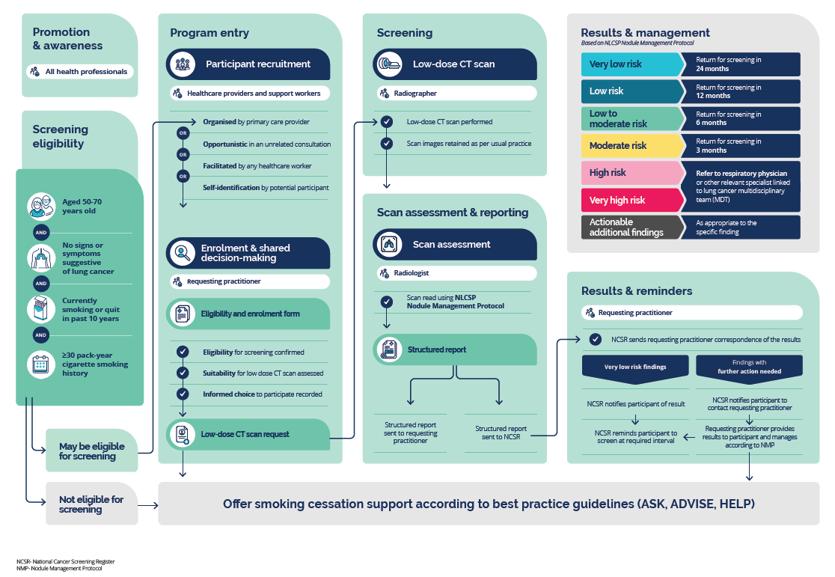

Text alternative for Figure 1

## More information

The National Lung Cancer Screening Program Guidelines can be accessed at [www.health.gov.au/resources/publications/nlcsp-guidelines](http://www.health.gov.au/resources/publications/nlcsp-guidelines).

Additional information and resources for healthcare providers can be accessed via the Department of Health and Aged Care lung cancer screening website: [www.health.gov.au/our-work/nlcsp/for-healthcare-providers](http://www.health.gov.au/our-work/nlcsp/for-healthcare-providers).

## Healthcare provider roles and responsibilities

All healthcare providers and health support workers play a role in delivering the National Lung Cancer Screening Program and ensuring that participants can navigate the screening and assessment pathway. Some healthcare providers have specific responsibilities across the pathway. A summary of healthcare providers’ roles and responsibilities across the pathway is detailed in the Program Guidelines. The National Cancer Screening Register (NCSR) supports the program by providing a safety net to screening participants and healthcare providers to support usual care.

**Requesting practitioners**: Healthcare providers authorised to request low-dose CT scans as part of the National Lung Cancer Screening Program, including general practitioners, medical specialists, consultant physicians and nurse practitioners.

**Healthcare providers:** Any healthcare provider working across primary, secondary, and tertiary healthcare settings. They are integral for the recruitment and delivery of the National Lung Cancer Screening Program but are not all able to request a National Lung Cancer Screening Program low-dose CT scan.

**Health support workers:** Those who play a vital role in health care teams and provide support to people across the screening and assessment pathway.

All of these provider types and their delegates can enrol participants in the NCSR.

Figure 2: Healthcare provider roles and responsibilities

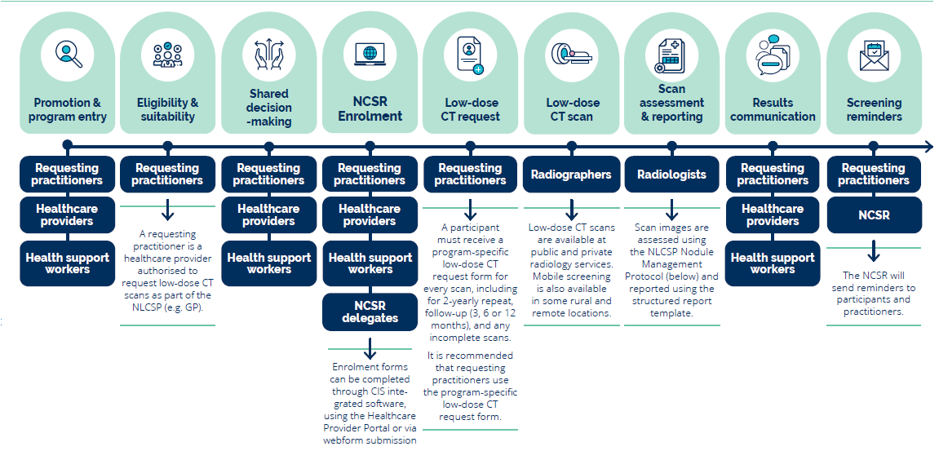

Text alternative for Figure 2

## Simplified NLCSP Nodule Management Protocol flowchart

Low-dose CT scans performed in the National Lung Cancer Screening Program will be reported using the National Lung Cancer Screening Program Nodule Management Protocol which is derived from the Pan-Canadian Early Detection of Lung Cancer Study (PanCan) nodule malignancy risk calculator for reporting baseline scans and the Lung Imaging Reporting and Data System (Lung-RADS®) for reporting follow-up scans.

The protocol contains detailed guidance for the radiologist around reporting lung nodule findings and providing appropriate management recommendations.

The National Lung Cancer Screening Program Nodule Management Protocol has been developed by the Royal Australian and New Zealand College of Radiologists (RANZCR) and the Thoracic Society of Australia and New Zealand (TSANZ). It applies the recommendations made by the Medical Services Advisory Committee (MSAC) to the Australian setting and can be accessed at [www.health.gov.au/resources/publications/nlcsp-nodule-management-protocol](http://www.health.gov.au/resources/publications/nlcsp-nodule-management-protocol).

Figure 3: Simplified NLCSP Nodule Management Protocol flowchart

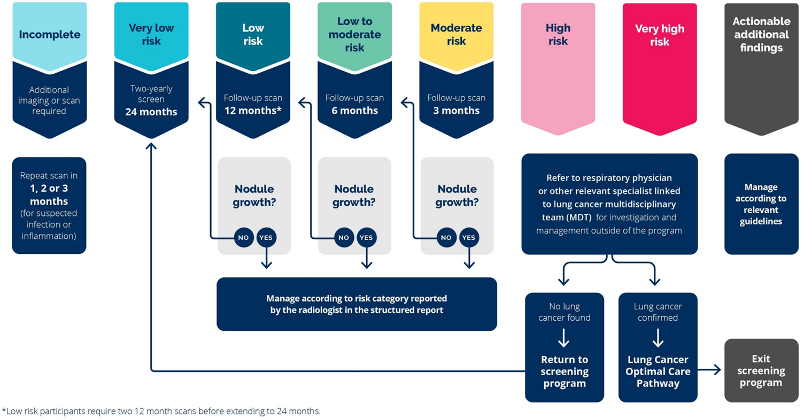

Text alternative for Figure 3

## Text alternatives

### Figure 1: National Lung Cancer Screening Program screening and assessment pathway (text alternative)

The figure is a flowchart summarising the seven key stages in the pathway:

* Promotion and awareness
* Screening eligibility
* Program entry
* Screening
* Scan assessment and reporting
* Results and management
* Results and reminders.

Each stage has additional steps along the pathway.

#### Promotion and awareness

The pathway starts at promotion and awareness. All health professionals can play a role in promoting and raising awareness of the National Lung Cancer Screening Program.

#### Screening eligibility

To be eligible for the National Lung Cancer Screening Program, a person must:

* Be aged 50-70 years old and
* Have no signs or symptoms suggestive of lung cancer and
* Be currently smoking or quit in the past 10 years and
* Have an equal to or greater than 30 pack-year cigarette smoking history.

A person may be eligible for screening if they fulfil all these criteria. If a person is not eligible for screening, they should still be offered smoking cessation support according to best practice guidelines using the Ask, Advise, Help model.

#### Program entry

The first step in program entry is participant recruitment. This means that a person is identified as being potentially eligible for screening by a healthcare provider or health support worker and may occur through four different entry points. Entry may be:

1. Organised by a primary care provider
2. Opportunistic identification in an unrelated consultation
3. Facilitated by any healthcare worker to see a requesting practitioner
4. Self-identification by a participant.

#### Enrolment and shared decision-making

A requesting practitioner is required to complete the NCSR enrolment form (only once), which records that:

* Eligibility for screening is confirmed
* Suitability for a low-dose CT scan has been assessed
* Informed choice to participate has been recorded.

A requesting practitioner then provides the participant with a NLCSP low-dose CT scan request form and offers them smoking cessation support according to best practice guidelines using the Ask, Advise, Help model.

#### Screening

The low-dose CT scan is performed by a radiographer. Scan images are retained as per usual practice in the radiology facility.

#### Scan assessment and reporting

Scan assessment is the responsibility of a radiologist. The scan is read using the NLCSP Nodule Management Protocol.

The scan results are then reported using a structured reporting template. The completed structured report is sent to the requesting practitioner and to the NCSR National Cancer Screening Register.

#### Results and management

The NLCSP Nodule Management Protocol categorises results based on risk and dictates how each category is managed:

* Very low risk means that the participant returns for screening in 24 months.
* Low risk means that the participant returns for screening in 12 months.
* Low to moderate risk means that the participant returns for screening in 6 months.
* Moderate risk means that the participant returns for screening in 3 months.
* High risk means that the participant is referred to a respiratory physician or other relevant specialist linked to a lung cancer multidisciplinary team.
* Very high risk means that the participant is referred to a respiratory physician or other relevant specialist linked to a lung cancer multidisciplinary team.
* Actionable additional findings are managed as appropriate to the specific finding and in addition to one of the above categories.

#### Results and reminders

The requesting practitioner is responsible for communicating results to the participant. However, the National Cancer Screening Register also communicates with the requesting practitioner by sending correspondence of the results to the requesting practitioner.

For very low risk findings, the National Cancer Screening Register notifies the participant of the result. The National Cancer Screening Register also reminds the participant to screen at the required interval (in two years).

For any findings with further action needed, the National Cancer Screening Register notifies the participant to contact their requesting practitioner. The requesting practitioner then provides the results to the participant and manages the results according to the NLCSP Nodule Management Protocol. The requesting practitioner should also offer smoking cessation support according to best practice guidelines (using the Ask, Advise, Help model).

Return to Figure 1

### Figure 2: Healthcare provider roles and responsibilities (text alternative)

The figure describes which healthcare providers are responsible at different steps along the screening and assessment pathway.

The first step is promotion and program entry. Requesting practitioners, healthcare providers and health support workers all play a role in promoting the program and facilitating entry into the program.

The second step is eligibility and suitability. Requesting practitioners are responsible for confirming an individual's eligibility for the program and suitability for low-dose CT scan. A requesting practitioner has an MBS provider number and is authorised to request CT imaging, such as a general practitioner, medical specialist or nurse practitioner.

The third step is shared decision-making. Requesting practitioners or other healthcare providers, such as nurses or Aboriginal Health Practitioners, conduct a shared decision-making discussion about screening with a potential participant. Health support workers can also support participants in this step.

The fourth step is the program participant's enrolment into the NCSR. Enrolment forms can be completed through CIS integrated software, using the Healthcare Provider Portal or via webform submission.

The fifth step is a low-dose CT scan request, which must be made by requesting practitioners. A participant must receive a new low-dose CT request for every scan, including for two-yearly repeat scans, follow-up scans at 3, 6 or 12 months, and for any incomplete scans.

The sixth step is the low-dose CT scan, which is performed by radiographers. Low-dose CT scans are available at public and private radiology services. Mobile screening is also available in some rural and remote locations.

The seventh step is scan assessment and reporting, which is the responsibility of radiologists. Scan images are assessed using the NLCSP Nodule Management Protocol and reported using the structured reporting template specific to the program.

The eighth step is results communication, in which requesting practitioners, healthcare providers and health support workers can all play a role. Communicating results is the responsibility of the requesting practitioner, but in some instances, it may be more appropriate to involve other healthcare providers and health support workers.

The ninth step is screening reminders, where the National Cancer Screening Register and requesting practitioner are responsible for sending reminders about results correspondence and follow-up low-dose CT scans.

Return to Figure 2

### Figure 3: Simplified NLCSP Nodule Management Protocol flowchart (text alternative)

The simplified NLCSP Nodule Management Protocol flowchart illustrates the risk categories defined by the NLCSP Nodule Management Protocol, along with the corresponding actions required for managing low-dose CT scan results.

Low-dose CT scan results are categorised based on nodule risk and other findings. The categories are:

* Incomplete
* Very low risk
* Low risk
* Low to moderate risk
* Moderate risk
* High risk
* Very high risk.

An “Actionable additional findings” modifier can be added to categories for any clinically significant findings unrelated to lung cancer. Actionable additional findings should be recorded alongside a program low-dose CT scan outcome category.

#### Incomplete

If a scan is incomplete, an additional imaging or scan is required.

The participant will need a repeat scan in 1, 2 or 3 months due to suspected infection or inflammation.

#### Very low risk

If a scan is reported as very low risk, a participant will return for a two-yearly screen in 24 months.

#### Low risk

If a scan is reported as low risk, a participant will return for a interval scan in 12 months.

The interval scan in 12 months is then assessed for nodule growth.

##### Nodule growth?

If yes, there is nodule growth, the participant will be managed according to the risk category reported by the radiologist in the structured report.

If no, there is no nodule growth, the participant will return for a follow-up scan in 24 months. Go to two-yearly screen 24 months.

See footnote.

#### Footnote

It should be noted that low risk participants require two 12 month scans before extending to 24 months. Further details are in the NLCSP Nodule Management Protocol.

#### Low to moderate risk

If a scan is reported as low to moderate risk, the participant will return for a interval scan in 6 months.

The interval scan in 6 months is then assessed for nodule growth.

##### Nodule growth?

If yes, there is nodule growth, the participant will be managed according to the risk category reported by the radiologist in the structured report.

If no, there is no nodule growth, the participant will return for a interval screen in 12 months. Go to follow-up scan in 12 months.

#### Moderate risk

If a scan is moderate risk, the participant will return for a interval scan in 3 months.

The interval scan in 3 months is then assessed for nodule growth.

##### Nodule growth?

If yes, there is nodule growth, the participant will be managed according to the risk category reported by the radiologist in the structured report.

If no, there is no nodule growth, the participant will return for a interval screen in 6 months. Go to follow-up scan in 6 months.

#### High risk

If a scan is high risk, the participant is referred to a respiratory physician or other relevant specialist linked to a lung cancer multidisciplinary team for investigation and management outside of the program.

If no lung cancer is found at investigation, the participant will remain in the screening program. The participant’s next scan will be the two-yearly screen 24 months, unless recommended otherwise.

If lung cancer is confirmed, the participant will be managed according to the relevant Lung Cancer Optimal Care Pathway. The participant will exit the program.

#### Very high risk

If a scan is very high risk, the participant is referred to a respiratory physician or other relevant specialist linked to a lung cancer multidisciplinary team for investigation and management outside of the program.

If no lung cancer is found at investigation, the participant will remain in the screening program. The participant’s next scan will be the two-yearly screen 24 months.

If lung cancer is confirmed, the participant will be managed according to the relevant Lung Cancer Optimal Care Pathway. The participant will exit the program.

#### Actionable additional findings

If actionable additional findings are reported as part of the scan results, the participant will be managed according to relevant guidelines. Actionable additional findings should be recorded alongside a program low-dose CT scan outcome category.

Return to Figure 3