National Guidelines for including mental health and wellbeing in early childhood health checks

National Mental Health Commission

Table of Contents

Acknowledgements 3

SECTION 1 5

About the National Guidelines 5

SECTION 2 9

Overview 9

Changing our approach to ECHCs 10

SECTION 3 12

The National Guidelines conceptual model 12

Theme 1: Take a broad and expanded view of children’s mental health and wellbeing 13

Theme 2: Create the conditions for access 15

Theme 3: Ensure ECHCs are a safe experience 21

Theme 4: Build trust and tailor discussions 26

SECTION 4 32

System context 32

Appendix A 36

National Guidelines for Wellbeing Indicators in Early Childhood Health Checks Advisory Group members 36

Explanation of terms 37

References 39

# Acknowledgements

## Acknowledgement of Country

The National Mental Health Commission (the Commission) acknowledges Aboriginal and Torres Strait Islander peoples as the Traditional Custodians of the lands and waters on which we live, work and learn.

## Recognition of Lived Experience

We recognise the individual and collective contributions of those with a lived and living experience of mental health challenges and suicide, and those who love, have loved and care for them. Each person’s journey is unique and a valued contribution to Australia’s commitment to mental health and suicide prevention systems reform.

## Contributors

The Commission has worked closely with a range of people to develop the National Guidelines and would like to thank the following stakeholders for their time and expertise:

* people with lived experience, particularly caregivers – including parents, carers, families and kin – whose perspectives have been invaluable
* members of the National Guidelines for Wellbeing Indicators in Early Childhood Health Checks Advisory Group (see **Appendix A**)
* subject matter experts, including health and allied health professionals; Aboriginal and Torres Strait Islander early childhood professionals; early childhood educators; researchers; organisations that support families with young children; and Australian, state and territory government representatives.

## Support

Support is available if you or someone you care for is in need of assistance. For information on support go to: [www.mentalhealthcommission.gov.au/find-support](http://www.mentalhealthcommission.gov.au/find-support)

## About this report

This report can be downloaded from our website: [www.mentalhealthcommission.gov.au](http://www.mentalhealthcommission.gov.au)

ISBN:978-1-7636173-5-3 (Online)

## Suggested citation

National Mental Health Commission. National Guidelines for including mental health and wellbeing in early childhood health checks. Sydney: NMHC; 2025.

## Learn more about our work

[www.mentalhealthcommission.gov.au/](http://www.mentalhealthcommission.gov.au/)

[](https://www.instagram.com/nmhcaustralia) [](https://twitter.com/i/flow/login?redirect_after_login=%2FNMHC) [](https://www.youtube.com/channel/UC6pWbzRT5EAFbtAH5buUaVw) [](https://www.facebook.com/NMHCAustralia/) [](https://au.linkedin.com/company/national-mental-health-commission)

Creative Commons BY 3.0 Licence Logo

© National Mental Health Commission 2025

This product, excluding the National Mental Health Commission logo, Commonwealth Coat of Arms and material owned by a third party or protected by a trademark, has been released under a Creative Commons BY 3.0 (CC BY 3.0) licence.

The excluded material owned by a third party includes data, images, accounts of personal experiences and artwork sourced from third parties, including private individuals.

You may distribute, remix and build upon this work. However, you must attribute the National Mental Health Commission as the copyright holder of the work in compliance with our attribution policy. Address copyright enquiries to:

Office of the Chief Executive Officer  
National Mental Health Commission  
GPO Box 9848  
Sydney NSW 2001.

# Disclaimer

The National Mental Health Commission (the Commission) developed the *National Guidelines for including mental health and wellbeing in early childhood health checks* (National Guidelines). This work was funded by the Australian Government Department of Health, Disability and Ageing. It was informed by a national consultation process and an Advisory Group.

The National Guidelines have been developed to advise health practitioners and state and territory government departments on how to include mental health and wellbeing in existing early childhood health checks (ECHCs) in a way that meets the unique needs of families and prioritises child and family safety and wellbeing. ECHCs are voluntary and conducted by qualified health practitioners. Most commonly, ECHCs are delivered by primary care practitioners, including general practitioners, child and family health nurses and in some jurisdictions, health workers from Aboriginal Community Controlled Health Organisations. These are not clinical guidelines or practice standards; nor do they prescribe screening or assessment tools for wellbeing in early childhood. Rather, they are a set of guidelines to assist health professionals and state and territory governments in enhancing the approach to mental health and wellbeing in ECHCs – for the benefit of children and their families. The National Guidelines are designed to improve children’s and their families’ experience of ECHCs, thereby increasing their uptake and improving child mental health and wellbeing outcomes.

The ability of service providers and health professionals to apply the National Guidelines depends on the system in which they operate. Ensuring the service system is able to provide appropriate support to families remains an ongoing commitment by Australian, state and territory governments. It will require clearly defined roles and responsibilities; sustainable resourcing; upskilled workforces and continued training; as well as strategies to support collaboration and care coordination at a local level. It is also noted that given the holistic focus of the ECHCs, responses will extend beyond the health sector to the many and diverse range of services that support children and families.

# SECTION 1

# About the National Guidelines

## Background

Evidence indicates that the first 2,000 days of life are a critical period. Providing support during this time can significantly improve a child’s early life experiences, health and development.1 It is recognised that while specific developmental needs and milestones vary from infanthood through to age 5 and beyond, most children’s development tends to follow the same or a similar sequential trajectory. Tracking developmental milestones helps identify whether a child is growing and developing as would be expected2 for an infant or child of their age and creates an opportunity to provide supports if needed.

ECHCs are a longitudinal, continuous and cumulative process3 families may voluntarily undertake with health practitioners to understand a child’s development and determine if they are meeting milestones.4 When a child is developing skills more slowly than other children in the same age group, this may be due to developmental delay.5 More than one in 5 Australian children starting school are ‘developmentally vulnerable’, meaning they do not have the skills (learning, socio-emotional and/or physical) to thrive at school.6

When a child shows signs of a possible developmental delay, it is important to put supports in place for the child and their family. Addressing the social, emotional and psychological impacts of developmental delay can have lifelong benefits for a child’s health and behaviour.7 ECHCs provide a critical opportunity to identify when a child may not be coping, is struggling or feels overwhelmed, and can link children and families with support.

The National Guidelines support the view that it is vital to understand the everyday situations, contexts and relationships that shape a child’s development over time.

The National Guidelines adopt a child’s rights-based approach, drawing on principles from the *United Nations Convention on the Rights of the Child* and the *United Nations Declaration on the Rights of Indigenous Peoples* to ensure all children’s wellbeing needs are considered. They align with the principles of the *National Children’s Mental Health and Wellbeing Strategy.*

## What are the National Guidelines – and why are they needed for mental health and wellbeing in ECHCs?

The National Guidelines – developed through broad stakeholder consultation – are designed to help practitioners think about child mental health and wellbeing and how to engage with children and families in the context of ECHCs. They emphasise mental health and wellbeing as being an integral part of a child’s overall development, alongside existing ECHC developmental domains.

In this context, mental health and wellbeing is not restricted to the presence or absence of a diagnosable mental health condition. It is a broad concept that considers the social, emotional, behavioural and developmental needs of infants and children, which vary according to age, and are likely to be influenced by the wellness of caregivers and families.

All jurisdictions include social and emotional development milestones in some way, but practitioners take a range of approaches to how and when they explore mental health and wellbeing with families.

Improving children’s health and wellbeing – particularly in the early childhood years (ages 0–5) – is a key priority for governments and the health sector throughout Australia. For example, the Australian Government’s *Early Years Strategy* seeks to create a more integrated, holistic approach to the early years and better support the education, wellbeing and development of children. Similarly, the National Guidelines outline a holistic approach that encourages consideration of the broader systems and services that children and families interact with.

Several prominent reports and strategies support the development of the National Guidelines. The *Productivity Commission Inquiry Report: Mental Health* (2020) recommended making the social and emotional development of schoolchildren a national priority. It also advocated expanding the scope of voluntary ECHCs to assess children’s social and emotional development before they start preschool.8

The *National Children’s Mental Health and Wellbeing Strategy* (2021) emphasises early intervention and establishing a national system for pooling key information on a child’s wellbeing gathered via routine developmental checks or vaccinations during the preschool years.

The final report of the Independent NDIS Review, *Working together to deliver the NDIS* (2023), recommended that all Australian governments expand universally available child development checks to ensure early identification of and intervention for children with developmental concerns and/or disability. It recommended implementing this in mainstream services working with children, including maternal child health, early childhood education and general practice.

Notably, significant efforts across states and territories are already underway to improve access to ECHCs and expand their scope towards a broader approach to child mental health and wellbeing. Similarly, it is increasingly being recognised that support for children with complex needs, which are often unlikely to be met by one service or system alone,9 requires healthcare provision to be connected to other services and systems. Health care that considers and is connected to the key touchpoints in a child and family’s life – such as education, housing and other social services – is more likely to improve the child and family’s outcomes.

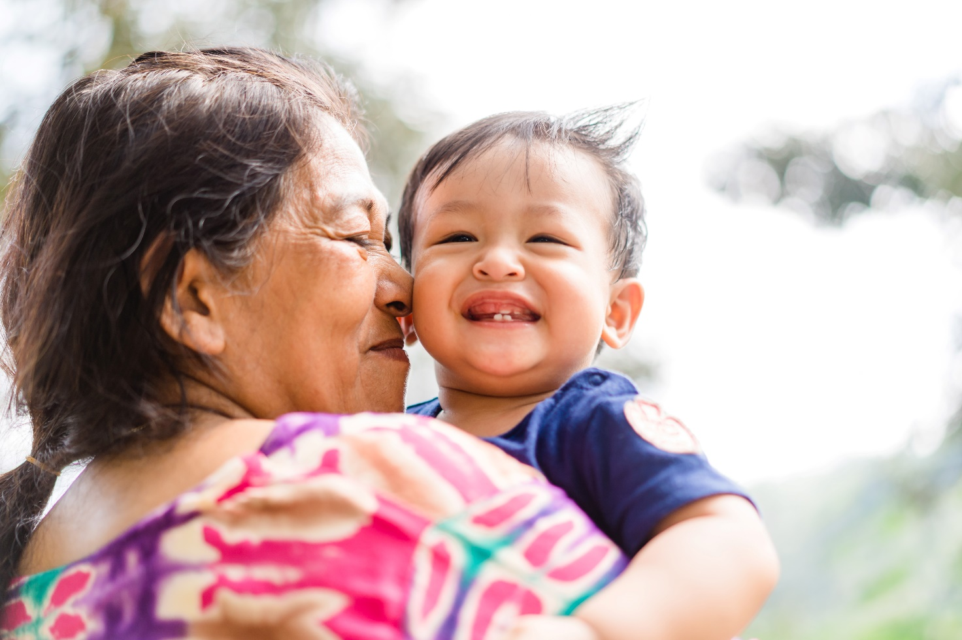

## Purpose of the National Guidelines

The National Guidelines are aimed at health practitioners, service providers and state and territory governments. They provide a framework for a nationally consistent approach to including mental health and wellbeing in existing ECHCs. Their introduction aims to assist in early identification of children who are struggling or feeling overwhelmed, and helping their families access timely support and advice. However, they do not prescribe a nationally consistent approach to screening and assessment tools for ECHCs. These are decisions for state and territory governments and are not within the scope of the National Guidelines.

The National Guidelines recognise the need for practitioners to adapt the delivery of ECHCs to their local context and to the needs and priorities of each child and their family. They outline the key factors for a safe and effective conversation around wellbeing with children and their caregivers. This includes for particular groups such as families with complex and/or co-occurring needs, Aboriginal and Torres Strait Islander families, and families from culturally and linguistically diverse backgrounds.

Having ongoing conversations about mental health and wellbeing with trusted professionals can equip families with tools and supports to understand when their child is ‘good’ or ‘coping’ and identify when they may need further support. Although ECHCs typically cease after a child turns 5 years of age, the need to understand and support children’s mental health and wellbeing is ongoing. Having consistent and ongoing access to ECHCs with trusted professionals in those early years will set families up to understand and identify their child’s mental health and wellbeing needs into the future. Providing a framework for a consistent approach could also help increase the consistent use of ECHCs until children reach 5 years old, as families increasingly value the inclusion of mental health and wellbeing in these discussions.

The National Guidelines are based on a model that considers the child and family journey. It starts before the first ECHC, supports the child and family through their experience of ECHCs, and looks beyond the last ECHC.

Importantly, the National Guidelines are not intended to encourage a disproportionate or unwarranted focus on diagnosing mental illness in children. Rather, they are designed to broaden the focus of existing ECHCs to consider mental health and wellbeing in a holistic, ecological way and provide early support and interventions where needed. The National Guidelines do not prescribe or replace existing clinical standards regarding the diagnostic criteria of mental illness in children – this remains a core practice issue for health and allied health professionals. It is also noted that further screening and attention are often required for children and families with complex needs. For example, First Nations children with disability in out-of-home care may require more sensitive and comprehensive assessment and diagnosis.

## Approach to developing the National Guidelines

From 2022 to 2024, the Commission conducted a 3-phased process comprising an environmental scan, extensive national consultation and additional consultation on the draft National Guidelines.

Across the 3 phases, consultation was undertaken with:

* caregivers including parents, carers and kin
* Australian, state and territory government departments
* health practitioners including primary care providers
* early childhood and early learning organisations and workers
* Aboriginal and Torres Strait Islander non-government organisations, health organisations and health workers
* organisations that support families of children with disability and/or chronic illness
* organisations that support families with refugee status and that are seeking asylum, and families that have recently migrated to Australia
* peak associations
* subject matter experts.

An Advisory Group co-chaired by the (now former) Chair of the National Mental Health Commission’s Advisory Board, Professor Ngiare Brown, and the National Children’s Commissioner, Anne Hollonds, oversaw the project. The Advisory Group included key stakeholders with expertise in child mental health and wellbeing (see **Appendix A**).

Learnings and insights from up to 630 stakeholders involved in the environmental scan and national consultations, and from the Advisory Group, informed the development and drafting of the National Guidelines.

## A note on language

Language surrounding mental health and wellbeing can be powerful and, at times, contested. Preferences are often not homogenous across and between groups of people and there is no single consensus on preferred terminology. Language should always be respectful and preferred by the majority of people it references.

In line with what we heard throughout our consultations, the National Guidelines use:

* ‘mental health and wellbeing’ to collectively refer to the facets of child and family wellbeing (see Theme 1 on pages 13–14)
* ‘early childhood health checks (ECHCs)’ to refer to the regular appointments families attend with health practitioners in all states and territories to discuss how a child is developing
* ‘child’ and ‘children’ as collective terms referring to infants and children from birth to age 5 who are the focus of an ECHC, acknowledging that specific health and developmental needs vary across age groups, particularly for infants
* ‘caregivers’ to refer to adults who are caring for or have cared for a child
* ‘families’ to refer to the family/caring adult/kinship unit around a child or children, including those who do not have a direct caring relationship with the child, such as siblings
* ‘practitioner’ to refer to health professionals who conduct ECHCs with children and families, noting the type of professional who may conduct an ECHC varies across and within states and territories. It may include general practitioners, child and family health nurses or Aboriginal and multicultural health workers
* ‘complex needs’ to refer to children and families that experience multiple, chronic and interconnected challenges. This can include children under the care of the State, or who are experiencing poverty, poor quality or insecure housing or homelessness, family and domestic violence, addiction, disability and additional mental or physical health needs. Often, more than one of these experiences occur at the same time
* person-first language to refer to people with disability
* foundational needs to refer to the basic, essential needs of families. This differs from the concept of ‘foundational supports’, which is widely used in the disability community
* ‘coloured book’ to refer to the parent-held red, yellow, green, purple or blue book, depending on the state or territory, used to record details of a child’s health and development from birth to age 5.

# SECTION 2

# Overview

## Early years

It is critical that children’s social and emotional development is supported early in life as an estimated 50% of adult mental illness begins before 14 years of age.10 While genetic factors contribute to mental illness, it is also strongly linked to adverse childhood experiences.11 These can include parental separation or divorce, experiencing or witnessing violence, sexual abuse, neglect and growing up in a household where there is alcohol and/or substance abuse. Other factors, such as parental mental ill health, can also have a significant impact on the early experience and wellbeing of children.

Early intervention and prevention, focusing on children and their families, is key to setting up children for positive mental health and wellbeing that extends into adulthood. Governments across Australia are increasingly prioritising the health and wellbeing of children through early childhood policies and programs. Although not a specific focus of the National Guidelines, maternity care is an important precursor to ECHCs and provides opportunities for early discussions about the wellbeing of caregivers and families.

Children are not typically diagnosed with mental health conditions before 3 years of age. However, signs that a child might be struggling or feeling overwhelmed can be identified before 5 years of age. Signs can include externalising behaviours (for example, tantrums, defiance, aggression and destructiveness) and internalising experiences (for example, feelings of fear, worry and anxiety). Most children will exhibit these kinds of behaviours and experience these feelings in the early years. However, if these behaviours become severe or affect the child’s everyday routines, activities or interactions, this could be a sign that the child might be struggling or feeling overwhelmed. This is the ideal time for early intervention and support.12 Promoting the mental health and wellbeing of all children from birth enables access to support as early as possible and whenever necessary.

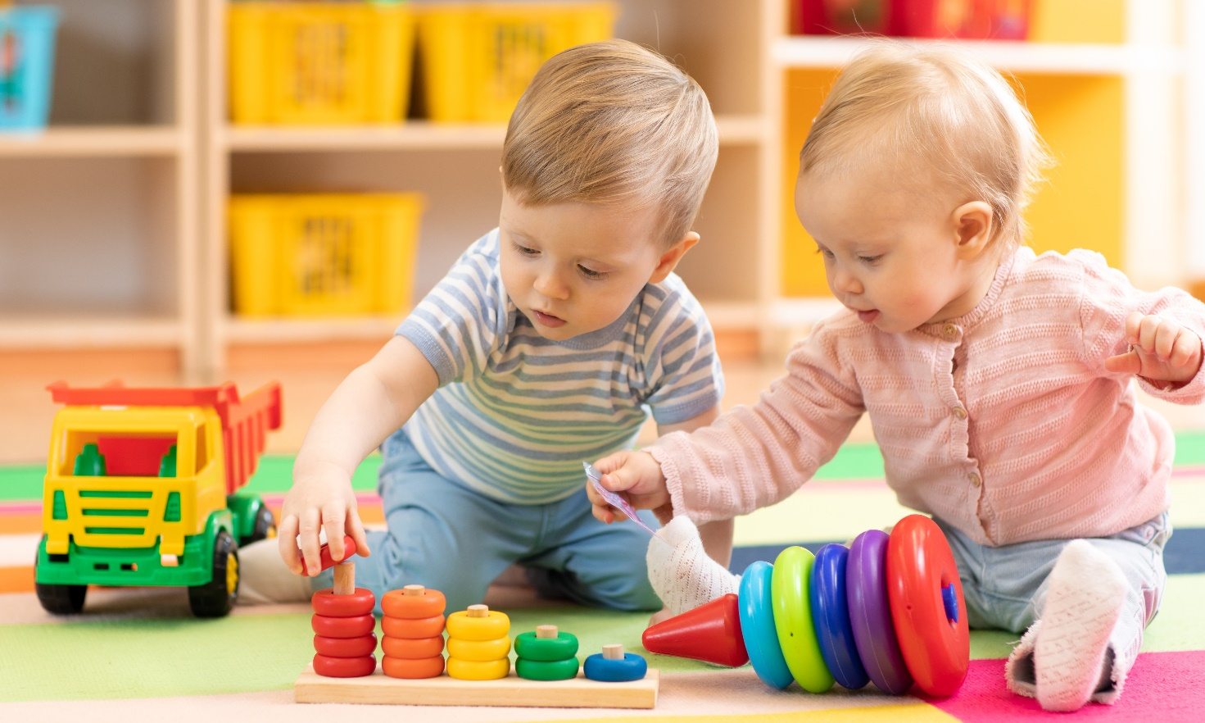

## Monitoring child development

ECHCs are the series of regular, voluntary appointments families attend with health practitioners to discuss how a child is developing. The timing of ECHCs varies, but they start at birth and generally continue until a child begins primary school.

State and territory governments are responsible for delivering ECHCs, and in some jurisdictions, this responsibility is shared with general practitioners, child and family health nurses and Aboriginal Community Controlled Health Organisations.

The National Guidelines are intended to advise health practitioners and service providers, and state and territory governments, on how to expand ECHCs to consistently include mental health and wellbeing in a way that centres the experiences of children and their caregivers and families. Importantly, the National Guidelines apply to existing ECHC schedules and incorporate mental health and wellbeing as integral to a child’s overall development. Expanding these schedules by developing a strengths-based, culturally responsive approach – valuing children and families as experts in their own experiences and recognising how the challenges they face might be impacting their mental health and wellbeing – can improve long‑term outcomes.

## Seeing the big picture

Understanding the whole picture of a child’s context is crucial in supporting their mental health and wellbeing. In practice, this means that when conducting an ECHC, practitioners should focus on building trust with families and ask about the broader social conditions of a child’s environment (often referred to as the ‘social determinants of health’). This can include factors such as housing safety and security; employment and financial security; access to nutritious food, health care, early childhood education and care; education levels; and experiences of family and domestic violence, trauma and substance use. The unique cultural aspects of a child’s life must also be understood and considered as part of any holistic assessment and response. It also means that practitioners undertaking an ECHC must have a sound understanding of the implications and nature of risk and protective factors for child and family wellbeing.

When supporting children with complex needs, an approach that considers the whole picture, and often the systems beyond health, is needed. Evidence suggests that until basic needs – such as access to food and housing – are met, additional interventions to enhance parenting and psychological support are unlikely to work.13 This highlights the importance of approaching health and wellbeing in a holistic way that acknowledges the interrelated nature of a child and family’s health, social, cultural and economic environments. It also elevates the importance of bi-directional communication and care coordination between overlapping and parallel services, such as state-funded child health services and primary care providers, including general practitioners, with social and community support services. Where complex issues require specialist support, families should be referred to an appropriately qualified health practitioner for specialised advice and action. Practitioners should provide information to families and support them to transition to a referred specialist where possible.

# Changing our approach to ECHCs

To enable the inclusion of mental health and wellbeing in ECHCs, system shifts are required. Having a nationally consistent approach to ECHCs across states and territories will provide an opportunity to better understand child wellbeing around the country and identify where greater support and investment may be needed. It is also crucial to address barriers to children and their families accessing ECHCs. This includes ensuring equity of access financially, practically and geographically for both ECHCs and any related services and supports required.

## Ensuring cultural safety

When addressing mental health and wellbeing in ECHCs, conversations need to be culturally safe and responsive, and what this looks like should be determined by the families themselves. This requires practitioners and service providers to commit to their continued and ongoing cultural learning and reflection, which is at the core of culturally safe care.

For Aboriginal and Torres Strait Islander families, this means practitioners should understand and respect the holistic concept of social and emotional wellbeing, and work with families through this lens. Social and emotional wellbeing extends beyond conventional Western concepts of mental health and mental illness, and emphasises the interdependency of the cultural determinants of health (such as relationships with family, kin and community), and connections to land and sea, culture, spirituality and ancestry.14 For families from culturally and linguistically diverse communities, this means practitioners must acknowledge and harness the strength and diversity of the many ways to care for and parent children.

For some families, any ‘check’ by a service can create anxiety about being judged or may draw out an underlying fear that their child could be removed from their care. Practitioners need to be aware of these possible experiences and orientate their approach towards individual family needs and safe conversations. Building trusting relationships between caregivers and practitioners is crucial to having open, honest and safe conversations about mental health and wellbeing.

Every child is different, and understanding each child’s unique family composition, strengths, challenges and experiences is an important part of an ECHC. Discussing mental health and wellbeing as part of an ECHC is not about telling families what they ‘should’ be doing. It is an exploration of the experiences of the child and family, to identify opportunities to strengthen mental health and wellbeing. It should empower caregivers, providing them with tools and supports to understand mental health and wellbeing, identify when their child(ren) may need further support, and build on their existing strengths.

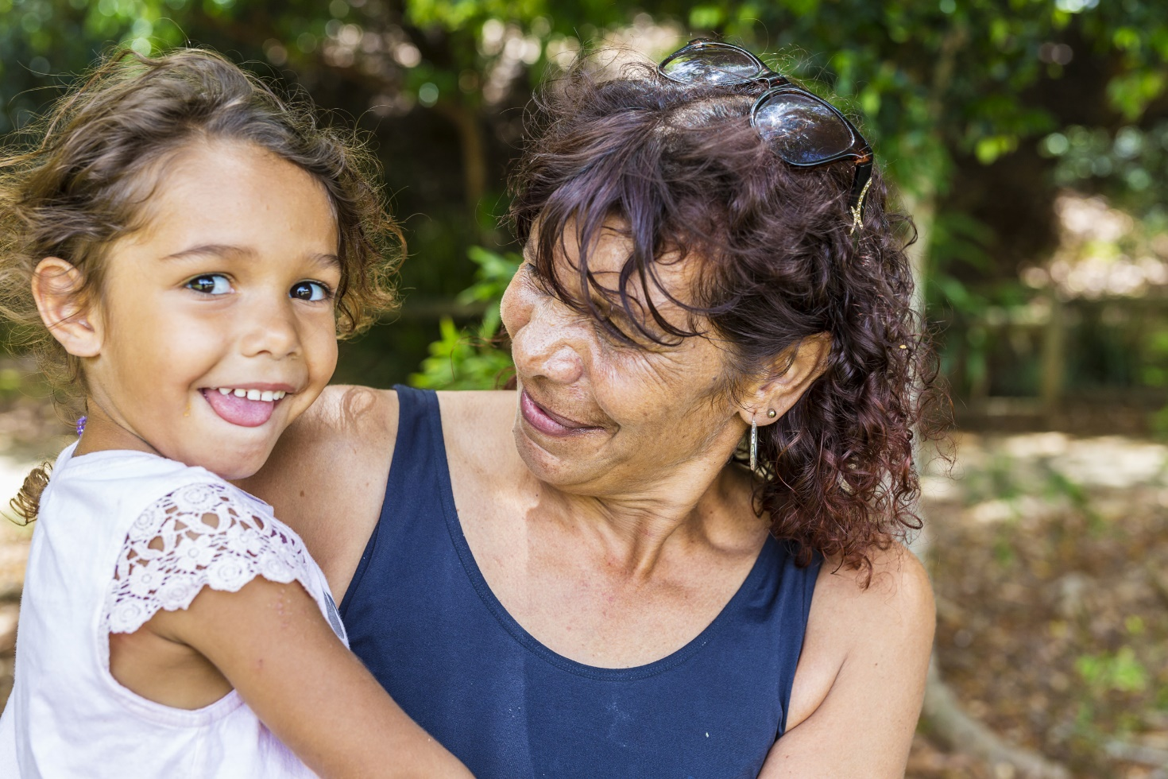

# SECTION 3

# The National Guidelines conceptual model

The National Guidelines reflect the child and family’s journey and centre around the 4 themes shown in Figure 1.

Figure 1:Conceptual model for including mental health and wellbeing in ECHCs

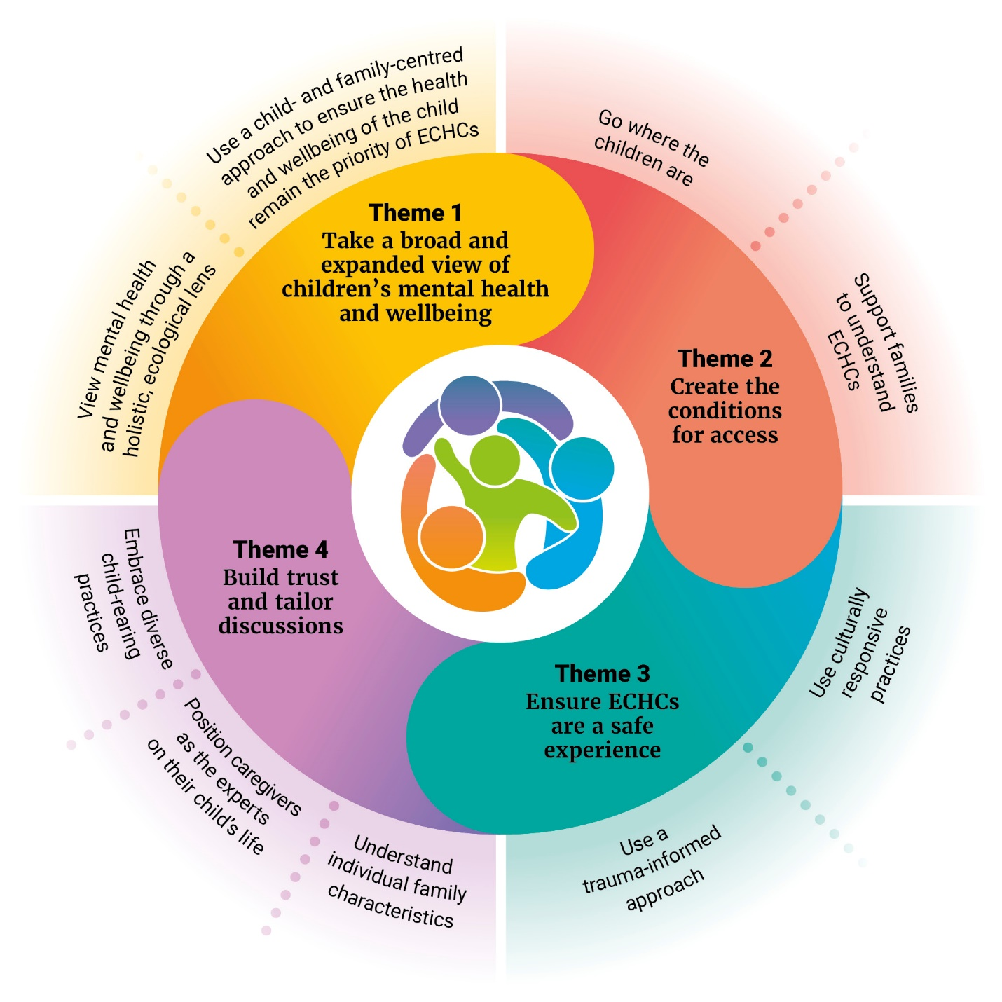

The wheel illustrates the 4 key themes and the guidelines that underpin them. The middle of the wheel depicts the child surrounded by their family unit, which can include parents, carers, siblings and kin. This emphasises the ecological approach to mental health and wellbeing in the National Guidelines.

## 

## Theme 1: Take a broad and expanded view of children’s mental health and wellbeing

### The conceptual model with Theme 1 highlighted in vivid yellow. Theme 1 is 'Take a broad and expanded view of children's mental health and wellbeing,' and the underpinning guidelines 1.1 and 1.2 are shown.Guideline 1.1: View mental health and wellbeing through a holistic, ecological lens

For children to have good mental health and wellbeing, they need to feel safe, happy and supported, and have loving connections with family, friends, culture and community.15 Children’s mental health and wellbeing can vary across days and moments, and a child cannot always be distinctly identified as ‘well’ or ‘unwell’.

When considering how a child is developing, it is critical to consider the impact of biological, environmental and/or contextual factors on their development and mental health. These factors include personal characteristics such as age; relationships with family, carers and kin; physical health including nutrition and physical exercise; community settings including school and early learning; and broader societal, cultural, economic, political and legal influences, as well as the services and structures that surround them.16,17 For many families, this starts with access to nourishing food and adequate housing, a sense of safety and basic material needs being met. Many of these factors are interrelated and should not be considered in isolation, particularly for children with complex needs.

“

The importance of having a healthy environment within a home to ensure that I can best provide for my children. Maintaining that home financially is important as that affects everything around [the family]. – National consultation participant

The scope of mental health and wellbeing aspects covered in ECHCs needs to include a broader range of factors, including social and cultural determinants of health. Currently, social and emotional development in ECHCs focus on a limited range of individual factors (for example, how the child perceives other people’s emotions and how they display their own). Focusing more broadly on mental health and wellbeing is critical as research indicates that social determinants can have a bigger influence on health than either the provision of health care or individual health behaviours.18 As part of this, it is critical that practitioners consider the cultural constructs surrounding the child and family, particularly for Aboriginal and Torres Strait Islander families and those from culturally and linguistically diverse backgrounds. ECHCs must be informed by a thorough understanding of the cultural beliefs and context of each child and family, with a focus on culturally safe care and engagement.

The [Children’s Wellbeing Continuum](https://www.mhips.org.au/resources/news/2023/children-s-wellbeing-continuum/) (see Figure 2) can be used to obtain a snapshot of a child’s social and ‍emotional wellbeing at a point in time. It was designed to support conversations around a child’s emotional wellbeing in a way that is non-stigmatising and non-diagnostic. It has been designed to be simple for adults, including caregivers, educators and health professionals, to use with an individual child (aged 2–12 years). Using it during ECHCs for children aged 0–5 years would offer a common language that would help families and health professionals discuss a child’s emotional wellbeing and reduce the stigma that often accompanies mental health issues. It is important to note that expanding this language to include children under the age of 2 does not minimise the unique developmental needs, circumstances or rights of infants, which evolve through early childhood. Screening and assessment tools should be age appropriate in recognition of the unique and varied development needs of infants and children as they age.

Figure 2:The Children’s Wellbeing Continuum, Centre for Community Child Health (2022), Murdoch Children’s Research Institute and The Royal Children’s Hospital[1]

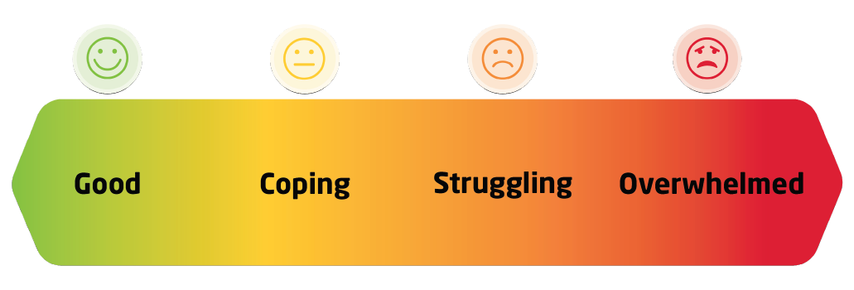

### Guideline 1.2: Use a child- and family-centred approach to ensure the health and wellbeing of the child remain the priority of ECHCs

The child is the focus and priority of ECHCs. Practitioners should encourage, where appropriate, the participation of the child in decisions that affect them and recognise the agency of children to communicate their needs and wishes. During the earlier months and years of life, children communicate their needs, preferences and interests in a range of different ways, including through their gaze, body language and vocalisation.

In practice, this means the aim of ECHCs is to ensure a child’s physical, social and emotional needs are being met, and to identify potential or emerging issues before they progress. Any additional services and supports that are recommended following an ECHC, whether they are for the child or the broader family, should seek to strengthen a child’s everyday surroundings. This also means giving a child information that is relevant to them, where appropriate, and in a way that is meaningful to them. Where possible, children should be supported to participate in decision-making about the care and support they receive.

No child exists in isolation of their environment. Family, carer, kin and community relationships are a key component of a child’s world and are inseparably connected with their mental health and wellbeing. To wholly understand a child’s mental health and wellbeing needs, a holistic focus on caregivers and siblings is also required. Through this lens, the needs of all family members are considered. Any challenges experienced by the family unit are acknowledged as affecting the child.

“

*Parents also need to experience their best possible mental health to enable them to create an environment for their child to flourish. – National consultation participant*

Cultural strengths and resilience can also be used as a foundation to develop solutions when issues are identified. It is important that practitioners understand these concepts as part of culturally safe care practices.

## Theme 2: Create the conditions for access

### The conceptual model with Theme 2 highlighted in vivid orange. Theme 2 is 'Create the conditions for success,' and the underpinning guidelines 2.1 and 2.2 are shown.Guideline 2.1: Go where the children are

Fundamental to a good experience of the mental health and wellbeing component of the ECHC is the location where conversations take place. Community-, child- and family-centred environments (see **Box 1**) are often conducive to open conversations around mental health and wellbeing. Places in the community (including health and social services locations) may be available that are accessible by foot, feel less formal and are often already used by families. Attending ECHCs in locations that are convenient, and feel safe and comfortable, enables caregivers to be more involved in conversations about mental health and wellbeing. Existing touchpoints, such as child vaccination appointments, could also provide opportunities for conversations.

“

Access can further be improved by promoting a flexible, high-quality, accessible and affordable [ECHC] system that suits families and workplaces, and is available across metropolitan and rural Australia. – National consultation participant.

When engaging with children, use child-friendly spaces. This also allows caregivers greater capacity to participate in the conversation. Such spaces can include creches (for children who aren’t the focus of the ECHC appointment), informal rooms with toys, playgroup networks and structures, and community centres and libraries with children’s activities and programs.

When creating a space to engage openly with a child and their caregivers about mental health and wellbeing, the practitioner should explore individual needs and circumstances; for example, by checking in with the caregiver over the phone before an appointment. The practitioner should also be mindful of barriers to accessing ECHCs for those dealing with challenges such as financial stress, mental ill health, disability, or family and domestic violence, catering to their additional needs. Often these families are less likely to be engaged with mainstream settings such as playgroups and early childhood education centres. The onus should not be solely on caregivers to access ECHCs. Rather, service providers should be proactive and flexible in reaching these families.

|  |
| --- |
| Box 1: Community-, child- and family-centred environments During consultations for the National Guidelines, caregivers and practitioners suggested locations for conducting ECHCs that would improve services’ ability to reach children and families and meet their needs (some jurisdictions are already using such locations). Suggestions included:   * early childhood education centres * places that offer free early childhood education and care * locations where playgroups and/or mothers or fathers group sessions are held * libraries (for example, tacking onto story time sessions) * preschools and early primary schools * places of religious worship such as churches, mosques and temples * community-based maternity and early childhood services * community hubs or cultural centres * Aboriginal and Torres Strait Islander Community Controlled Organisations * parenting centres * co-located, one-stop shop models where families can access ECHCs and any supports they require * in-home visits * immunisation clinics * community settings (for example, sporting clubs, shopping centres and pharmacies) * outdoors and/or in nature * community-based sporting events * early childhood hubs. |

Practitioners can also collaborate with other professionals involved with a child and their family who have a unique understanding of their wellbeing needs and supports (for example, early childhood educators, social workers and mental health workers). While non-health professionals may not conduct ECHCs, they can play a vital role in identifying families with additional support needs, promoting participation in ECHCs and providing referrals to support.

### Guideline 2.2: Support families to understand ECHCs

Families should have access to supportive and helpful resources throughout the early childhood journey, not just when attending ECHCs. These should cover all aspects of early childhood and parenting and can play a crucial role in helping families feel listened to, equipping them with the information and tools they need to overcome the challenges of caring for children, and supported in their engagement with ECHCs.

“

*Many parents are very aware of the importance of the immunisation schedule for their child through public health campaigns, apps, save the dates. More work is required to promote the equal importance of developmental screening [as conducted through ECHCs]. – National consultation participant*

### Guideline 2.2.1: Promote what families can do to understand and support mental health and wellbeing

Information that describes mental health and wellbeing, what it looks like for a child, and the link with family wellbeing should be widely available. Resources should cover ways to connect with caregiving peers and offer a sense of community and shared experiences (for example, through social media platforms and parent groups). If a caregiver is interested, practitioners should consider connecting families with groups that are likely to have similar or relatable experiences. This is particularly important for families that have experienced stigma and discrimination.

### Guideline 2.2.2: Ensure families understand why and how ECHCs can support their child and feel confident to attend

The distribution of accessible information about ECHCs needs to be improved for caregivers. It should include information about the way children develop physically, socially and emotionally; the timing and nature of ECHCs; and why they are important at each stage. Caregivers should begin receiving this information before a child is born, adopted or fostered, to allow them time and space to absorb and understand it. This means all health and allied health professionals – not just those conducting ECHCs – should be aware of, understand and promote their benefits.

Caregivers should receive information in accessible formats before each ECHC appointment, so they feel prepared and know what to expect, who will be present, and the scope of the ECHC and conversation. It should be apparent to caregivers that ECHCs are an important part of supporting and raising their child, and thatall children have ongoing ECHCs regardless of where they are in their developmental journey.

This will also allow families to decide which caregivers should attend appointments based on what will be discussed. It should be made clear to caregivers that the mental health and wellbeing component of ECHCs is about the child they care for, and a key element of this relates to the caregivers’ own journeys and experiences.

Resources for preparing young children, particularly those who are apprehensive about interacting with strangers or being touched, should be available and accessible to all families. Practitioners can invite caregivers to share how they think their child will respond to the ECHC and any tips that might ensure a positive experience for the child. This is crucial in reducing family anxiety and stress and improving the experience of ECHCs for children. Practitioners should provide explanations to caregivers (and children, where appropriate) about what will happen during the ECHC and ensure they understand any information provided during the visit.

Practitioners should always endeavour to work with caregivers and families in ways that are meaningful for them, and that demonstrate an appreciation for the unique circumstances and strengths of the family unit. It is also essential that services are inclusive and respect diversity.

Families facing complex challenges, such as housing and financial stress, find it especially difficult to prioritise ECHCs. In addition, mental health and wellbeing can mean different things to different families, particularly culturally and linguistically diverse families where cultural stigma may surround mental health and wellbeing.19,20,21 Therefore, messaging for families should show how discussing mental health and wellbeing during an ECHC can help in identifying and supporting their child and family’s unique needs. For example, it could lead to the provision of additional support for financial stress or being responsive to a range of cultural concepts of wellbeing.

|  |
| --- |
| Box 2: Resources for families To make information as helpful as possible, resources should:   * be available in print and digital format, including video with transcripts * be translated into languages other than English * be accessible for children and families living with disabilities including vision, language or hearing impairment * be culturally appropriate and informed * be developed in consultation with caregivers and children, where possible * be used to support conversations (rather than replacing conversations) * allow caregivers to engage with materials without feeling overwhelmed; for example, by using clear, short, sharp messages and information * allow deeper exploration where desired; for example, by making a summary and a full version available that includes more details * be safe, inclusive and respect diversity * include contact numbers for additional mental health support in each state and territory (for example, helplines such as Lifeline and Parentline) * identify ‘safe spaces’ for families at risk of or experiencing domestic and family violence * be relevant and localised for the community-, child- and family-centred environments where the ECHCs are being held. |

### Guideline 2.2.3: Make sure communication with families is consistent, timely and effective

As a first step in providing effective follow-up for ECHCs, practitioners should clearly communicate information about the next ECHC appointment and what will happen in the meantime. This includes detailing support available within the community and providing an overview of recommended referral pathways. It should be routine practice to book the next ECHC at the end of an appointment.

Having a regular contact person to answer questions or provide clarifications after an appointment would benefit caregivers. This could be the practitioner who conducted the ECHC or another professional within a service, connected to the practitioner, who understands ECHCs.

“

*If we know they’ve gone to access a service for the first time, closing the loop and asking, ‘How did you go?’ Offering to follow up for them [with the service they were referred to] if they haven’t heard anything is useful too. – National Guidelines consultation participant (health practitioner)*

Follow-up support is particularly important if there has been a discussion of assessments or diagnoses, given potential stigma in some communities. Health practitioners should take steps to ensure they provide information in a meaningful way and that it is understood by all families, particularly families from culturally and linguistically diverse communities. Having a follow-up conversation to see how information they shared was interpreted is important in reducing caregiver anxiety and could encourage caregivers to try evidence-informed strategies. Reminders about future ECHC appointments should be communicated well in advance and again just before the appointment to help families organise their schedules.

# What does this mean in practice for service providers and practitioners?

## Inform

Before an ECHC, the practitioner should give the caregiver(s) information about:

* the nature of ECHCs, the reason they are conducted and why they are important for the child and family or caregiver
* what they can expect, the scope of the check and what support can and cannot be provided
* the length of the appointment
* the types of questions they will be asked
* what will happen with the information the caregiver(s) share during the ECHC and the limitations of confidentiality
* what they need to bring to the appointment or think about in advance
* how to prepare their child for the ECHC
* what their child can do during the ECHC; for example, options for play so the caregiver(s) is better able to engage in a conversation
* the process and what will happen during and after the check, so they understand what the practitioner is doing and why
* resources, providing it in different languages and media types (for example, videos and online) and accessible formats (for example, Easy Read versions).

## Enable

To ensure a smooth appointment process, the practitioner should:

* be aware of any child or caregiver hesitancy about the ECHC, and ask if they have any concerns, either in relation to the appointment or previous ECHCs, where appropriate
* where possible, be flexible when scheduling appointments so that the timing works for the family
* check in with the family about how they will get to and from the ECHC and provide support where needed (for example, access to public transport, particularly for people with disability)
* ask about and support families’ accessibility requirements, including providing Auslan and language interpreters where needed (see Guideline 3.2.1), and establish preferred contact methods
* when possible, offer families a choice of practitioners
* send appointment reminders
* extend invitations to all relevant kin and family members.

## Connect

During or after the ECHC, the practitioner should:

* plan and book subsequent appointments or follow-ups
* discuss any next steps, referrals and actions so the family feels a workable and mutually agreed plan of action is in place
* proactively follow up with a family when next steps have been taken or need to be taken, or if a concern was raised in the ECHC about how a child or family was tracking
* offer to follow up with the services the family has been referred to if they are struggling to connect
* conduct additional check-ins, particularly with culturally and linguistically diverse families if there has been any discussion of diagnoses – identifying potential stigmatising attitudes and the need for supportive, practical and ongoing advice
* work collaboratively with other service providers and professionals to:
  + - provide interim supports and/or services that do not have waitlists while a child or family is waiting to see a specialist; for example, group care options that might be suitable and accessed more quickly
    - make warm referrals; for example, introduce the family and a service or practitioner to one another via email, phone or in person, where possible
* where informed consent has been obtained from a family, link with and learn from early education services, given their relationship and regular engagement with the child
* connect the family to parenting groups or online parenting resources, where appropriate
* give the family details about who they can contact for support or information relevant to concerns raised after the ECHC.

## Theme 3: Ensure ECHCs are a safe experience

### The conceptual model with Theme 3 highlighted in vivid teal. Theme 3 is 'Ensure ECHCs are a safe experience,' and the underpinning guidelines 3.1 and 3.2 are shown.Guideline 3.1: Use a trauma-informed approach

To have safe conversations about mental health and wellbeing, practitioners need to consider the unique experiences of families and communities. Failure to do so limits the effectiveness of care and risks re-traumatising children and families who have previously experienced trauma and/or entrenched, systemic disadvantage. This can include Aboriginal and Torres Strait Islander families, people from culturally and linguistically diverse backgrounds who may have experienced trauma, people with disability, people experiencing mental ill health, and people experiencing, or who have experienced, family and domestic violence.

Practitioners who use a trauma-informed approach to mental health and wellbeing in ECHCs can recognise the signs and symptoms of trauma. This approach acknowledges the widespread impact and consequences of trauma on an individual, including how past trauma may have led to a deep mistrust in healthcare services and affect parenting and child behaviour. The practitioner can acknowledge that for some families, previous interactions with the health system have not been safe, and actively work to remedy this. Trauma-informed care is guided by 5 key principles:

* trauma awareness and acknowledgement
* safety and trustworthiness
* choice, control and collaboration
* strengths-based and skills-building care
* cultural, historical and gender issues awareness.22

Due to factors such as the ongoing impacts of intergenerational trauma, people’s mistrust of the government, and/or previous adverse experiences or perceptions that healthcare workers will judge them, mainstream service providers need to overtly demonstrate their safety. They can do this in a number of ways. Examples include having bicultural educators to help families from different cultural backgrounds feel more engaged or having staff with lived experience from different community backgrounds to help communicate with families in their first language and build connection. Aboriginal and Torres Strait Islander families should have a choice of practitioner, and where possible, opportunities to engage with Aboriginal health workers and practitioners should be prioritised and facilitated in recognition of the significant role they play in ECHCs, their provision of holistic, culturally safe, trauma-informed, inclusive care and their recognition of social and emotional wellbeing. Where possible, people should be able to choose the gender of their practitioner.

|  |
| --- |
| Box 3: Key considerations for practitioners engaging with children in trauma-informed ways**23**  * Be curious and open-minded – watching, listening and waiting. * To create a sense of safety, the practitioner should be aware of their own body language, facial expressions and tone of voice. * Watch the child’s body language and facial expressions to gauge whether they feel safe or unsafe. * If a child feels unsafe, the practitioner should prioritise creating a sense of safety for them – they could consider using strategies such as a physical activity (for example, jumping up and down or stretching) or a calming activity (for example, drawing). * Be transparent with the child about why they are engaging with them, where appropriate. |

### Guideline 3.2: Use culturally responsive practices

Practitioners should provide care that respects, and is relevant to, the beliefs, practices, and cultural, linguistic and accessibility needs of diverse populations and communities. They should walk alongside and support each person as they navigate Western-centred healthcare systems and diagnoses. They should seek to form long-lasting relationships, use interpreters, advocate for – but not speak for – the individual and seek to understand them and their experience. In doing so, practitioners are better able to identify and harness cultural strengths, which will improve outcomes in the short and long term, and minimise the potential risks associated with culturally unsafe practices.

Creating a safe and welcoming environment, where all children and caregivers feel comfortable, also requires practitioners to be aware of stigmas that families may be experiencing. Stigma can manifest in many ways. Families may struggle to express that they are not coping due to community expectations or attitudes. They may feel shame due to cultural and historical perceptions about mental health and wellbeing, preconceived ideas around certain diagnoses, or experiences of family violence. Ensuring caregivers are aware of how their information will be handled can assist in these instances. Using appropriate language to support caregivers to engage, and to reduce feelings of stigma or judgement, is also important. With this awareness, practitioners can ask the right questions in the right way to better understand the issues at hand.

“

*Family violence is a sensitive topic to a lot of communities; if you ask … ‘Are you ok at home’, often you will not get the response even if there is something going on. [Practitioners] need to look at a different perspective and ask ‘Are you ok with settlement’; ‘Does your husband have a job’; ‘Are you ok with food’, etc. – National Guidelines consultation participant (organisation supporting families of refugee children, children seeking asylum and children who have recently migrated to Australia)*

To understand child mental health and wellbeing, the practitioner needs to consider the context of caregiver wellbeing. This means that conversations should feel more personal, be free of judgement or critical comments, and show recognition that every child is different. Building rapport and seeking to form long‑term relationships that are characterised by warmth, trust and safety is essential for creating a space where caregivers can be honest and vulnerable about the wellbeing of their child and family.

The perception of a check by a government service can create anxiety or fear for children and their caregivers. This may be heightened for caregivers who have had direct experience with out-of-home care as a child and families who have been the subject of previous child protection notifications.

Fear can also stem from current systemic racism or from historic patterns; for example, some Aboriginal and Torres Strait Islander people experience intergenerational trauma linked to the Stolen Generation:

“

*Our history with the Stolen Generation will make it hard for our First Nations people to be safe in telling us their vulnerabilities. Rather than help them, they will think we are planning to remove their children. – National Guidelines consultation survey participant*

Fear of child removal was also shared by non-Aboriginal and Torres Strait Islander families during National Guidelines consultations. This fear could result in families giving the bare minimum of information during ECHCs to minimise the potential of drawing scrutiny. Service providers and practitioners need to ensure ECHCs are culturally appropriate and explain to caregivers that their purpose is to provide support and guidance as they care for their own children, not to subject them to surveillance.

|  |
| --- |
| Box 4: Key considerations for practitioners and service providers for building trust with caregivers During National Guidelines consultations, building rapport through ongoing, genuine relationships was highlighted as crucial in creating trusting, safe partnerships between practitioners and caregivers. The following are key considerations for practitioners.   * **How might the conversation be framed as positive, beneficial and reciprocal?** Find ways to discuss the joyful and easy parts of parenting and caring as well as the tough parts. * **Does the caregiver feel seen?** This may involve asking how they are; for example, through questions such as ‘Are you getting much sleep?’, ‘Do you feel able to get out of the house’ and ‘Are you seeing friends or family?’ It is important to acknowledge that parenting can be exhausting and relentless. Do this by asking questions such as ‘How can we support you?’ or ‘What would make the biggest difference for you right now as a parent or carer?’ Listen deeply to the responses. * **Is there a warm, safe tone to the conversation?** For example, remove any judging tone that might make a caregiver feel like they’re not creating a safe environment for their child. * **Is there genuine interest?** It is important to ask questions to find out how a family is going, not to complete a checklist. * **Are narrative methods being used?** This could involve aiming to understand the whole picture of a family’s wellbeing and the protective factors that exist. * **Do families feel they have time to share what’s happening for them?** If not, schedule a longer session. * **Do caregivers feel that their concerns are being heard and listened to?** It is important to work with caregivers to find out whether and in what areas they are struggling or feel overwhelmed. * **How might a practitioner tailor their knowledge of the context and community for families?** For example, in a rural context this might involve the practitioner using their knowledge of a recent natural disaster and starting with a question such as ‘How are things on the farm?’ * **Has the practitioner considered the cultural needs and strengths of the family?** To ensure the cultural safety of Aboriginal and Torres Strait Islander families as well as those from culturally and linguistically diverse backgrounds, the practitioner must identify and harness cultural strengths. It is important for practitioners to engage with local people, services and organisations that provide specialist, targeted support. These include Aboriginal and Torres Strait Islander Elders, and religious or community leaders, where appropriate. |

### Guideline 3.2.1: Offer culturally safe interpreters at all ECHCs

While interpreters are often available, particularly through state- and territory-funded services, more consistent use and access are required. For families whose first language is not English, practitioners and service providers should:

* offer phone conversations with an interpreter before the ECHC to explain the purpose and topics it will cover
* offer free interpreters via phone or in person, where possible, to families for every appointment – family members should not be relied on to translate
* explain at the start of the session that the interpreter is there for the practitioner, to reduce the possibility of causing feelings of shame about English language skills
* explain that the conversation is confidential – between the practitioner, family and interpreter – as families may fear that the interpreter will identify them or reveal who they are within the community
* use clear and simple language and limit the use of academic or medical jargon
* ensure all written correspondence is translated.

Universal access to interpreters at ECHCs also includes access to Auslan interpreters for deaf and hard of hearing children and families.

A person holding a baby and standing next to a green hedge with purple flowers. The baby is reaching their arm out towards a flower and is looking at the camera.



# What does this mean in practice for service providers and practitioners?

## Inform

The practitioner should:

* use open, gender-neutral language when first engaging with families (for example, ask questions such as ‘Are there any other support people attending with you?’, not ‘Will Dad be attending today?’)
* introduce themself and be hospitable – acknowledge the efforts the family made to attend the check, and use knowledge of the family to make the experience more personal, as appropriate
* start with open conversational-style questions
* explain the rules around confidentiality and consent, and ensure caregivers are aware of how and when their information may be shared, if at all
* use visual cues in the environment (for example, posters promoting awareness of the mental health and wellbeing aspect of the ECHC) to show families that ECHCs are about broader mental health and wellbeing, and are not a clinical assessment
* use play-based approaches and direct conversation with the child as well as caregivers, where appropriate
* involve all family members by ensuring everyone has a chance to contribute to the conversation
* respond sensitively to any identified concerns or diagnoses, and be clear about available supports and resources ensure family members have a chance to ask questions, or voice worries or concerns that arise during the ECHC.

## Theme 4: Build trust and tailor discussions

### The conceptual model with Theme 4 highlighted in vivid purple. Theme 4 is 'Build trust and tailor discussions,' and the underpinning guidelines 4.1, 4.2 and 4.3 are shown.

### Guideline 4.1: Understand individual family characteristics

Central to a child’s mental health and wellbeing are the foundational and essential needs of their family. These include food, housing, safety, material basics, and connection to culture and community.

Practitioners are required to be aware and sensitive to the factors and experiences that might impact a child’s development and mental health and wellbeing, without making assumptions about the families they work with.

This means having a foundational understanding of, and empathy for, the diversity of family experiences. Awareness of the impact this has on child mental health and wellbeing, as well as the way these experiences interact, is crucial. This includes experiences of systemic racism, disability, poverty, mental ill health, contact with the child protection system, trauma, and family and domestic violence.

During consultations for the development of the National Guidelines, caregivers spoke about the ripple effect of financial pressures and housing issues on the mental health and wellbeing of their child and family. They raised the need to increase awareness of available government support, such as parental payments from Centrelink, and help that is available to navigate areas such as disability support services.

“

*[Practitioners] can’t ask about child development in isolation. [It] needs to be in the context of social determinants and [the] context of the family. – National Guidelines consultation participant (subject matter expert representative)*

These topics are potentially challenging for practitioners and families to discuss. For families, not knowing the practitioner well, not trusting them, or fearing repercussions from child protection systems, might prevent them from answering such questions. For practitioners, such discussions can be difficult if they feel they can’t provide the appropriate support or if the necessary supports are not available for referral. Practitioners are also required to report child safety concerns in line with their jurisdiction’s child protection policies and guidance. Building trust between caregivers and practitioners is essential to overcome these challenges and support conversations, and this may mean working closely with other trauma-informed and culturally safe service providers who can provide specialist support to families. Positive, respectful partnerships allow practitioners to actively listen to caregivers and raise concerns in a way that maintains engagement with the family. It means they walk alongside each other to identify and respond to concerns together.

### Guideline 4.1.1: Understand the family’s foundational and essential needs

Every family attending an ECHC should be asked about their foundational and essential needs as a way of normalising the subject matter and starting conversations. This includes exploring the effect on a child when the child or family’s basic needs are not being met. Often, this can have cascading impacts on the quality of interactions between a caregiver and their child. Practitioners should be able to assist caregivers to identify any impacts, guiding them through the complexities, where needed. It could be helpful to frame this around key aspects that nurture child mental health and wellbeing, including parent–child relationships, emotions and behaviours, routines, communication and meaning making, and support networks.24 For example, examining a child’s emotions and behaviours could help reveal when they might be struggling or feeling overwhelmed.

Once stress and adversity are identified, it is important that the practitioner supports the child and their caregivers to navigate it, drawing on the child and family’s unique strengths. Equally important is normalising such experiences by emphasising that many families navigate different challenges. This can include exploring how a caregiver can stay connected to their child in the face of challenges and promoting caregiver confidence and positive caregiver–child relationships.25

Practitioners should be aware of other services in their local community that could assist in supporting foundational and essential needs, making access to these as easy as possible for families. Being aware of other practitioners and service providers in the local area helps families navigate the system when additional supports are needed and ensures equitable experiences for all families. This should include an awareness of new and existing entitlements under the Medicare Benefits Schedule. In some communities, partnerships with cultural groups and services can play a critical role in supporting the mental health and wellbeing of children and families.



|  |
| --- |
| Box 5: Foundational and essential wellbeing needs Assessing the child and family’s foundational and essential mental health and wellbeing needs can include asking about:   * safe and secure housing * access to nutritious food * physical exercise, movement and play-based activities * financial security * access to health care * access to early childhood education and care * access to education and employment * connection to Country and culture * religion and spirituality * relationships with family, kin and friends, and any other social supports or networks * experiences of caregiver mental ill health * experiences of family, domestic and sexual violence * experiences of substance use * experiences of stigma and discrimination.   However, all families are unique, and discussions about foundational and essential mental health and wellbeing needs will vary. The above list is a guide only, and the practitioner should be led by the family as to which topics are most important or relevant.  The Australian Research Alliance for Children and Youth has developed a child wellbeing framework ([The Nest](https://www.aracy.org.au/the-nest-in-action/the-nest-overview)), which views wellbeing as bringing together the different elements a child needs to thrive. The Nest conceptualises child wellbeing through 6 interconnected domains:   * valued, loved and safe * material basics * healthy * learning * participating * positive sense of identity and culture.   This framework takes a holistic view of children’s lives, meeting them in the places they go and at their age and/or developmental stage. ECHCs can draw from this approach by ensuring applicability beyond the health context and examining the wide array of environments and experiences that contribute to a child’s wellbeing. |

#### Guideline 4.1.2: Understand a family’s unique circumstances and everyday experiences

During National Guidelines consultations there was a clear desire for the mental health and wellbeing component of ECHCs to include conversations about everyday child and family experiences, rather than working through a checklist, which can often feel clinical, generic and impersonal. It was thought this approach would assist the practitioner to form a picture of the child’s mental health and wellbeing, as well as build familiarity and trust. Conversations could be started with prompts such as:

“

*‘When did you last see friends or family?’, ‘How is your child sleeping?’, ‘How are you sleeping?’ and ‘When did you last get a chance to cook yourself a meal?’ to get a picture of the family’s wellbeing, as opposed to ‘How is your mental health?’ or checklists based on ‘standards’. – National Guidelines consultation participant (parent, carer or kin)*

Checklists can play an important role in ensuring information is captured consistently, and aiding practitioner efficiency. However, how they are delivered or used is critical. Conversations should feel open and foster opportunities to engage with children to understand family life from their perspective, finding out what makes them happy or worried. These conversations can include engaging with or asking about siblings who are not the focus of the ECHC.

|  |
| --- |
| Box 6: Everyday experiences of children and families Everyday experiences will vary from child to child and family to family. Topics in relation to everyday experiences that can have significant impacts on mental health and wellbeing can include:   * sleep * emotional regulation and meltdowns * feeding, including breastfeeding and nutrition * exercise, participation in playful activities and fundamental movement skills * children making friends * family dynamics and relationships * attachment and bonds between caregiver and child * sibling relations * screen time * transitioning to preschool or school * transitioning between early childhood education and care providers * navigating bringing home a new baby with other children at home and meeting everyone’s needs * ability to pay attention and focus on tasks * caregivers transitioning to the workforce after parental leave periods * family conflict * different parenting styles and/or preferences and temperament * stressful life events * exposure to natural disasters.   While these are a guide for talking about everyday experiences, the practitioner can bring an awareness that every child, family and household has different routines and timings. For example, they can be aware that feeding and nutrition norms can vary across cultures and experiences (and may be different for a family experiencing poverty compared to a family that is not). |

During conversations, families should be able to voice all concerns and have them taken seriously, rather than feel they are brushed off or set aside. Families should feel their unique circumstances and needs are understood.

### Guideline 4.2: Position caregivers as the experts on their child’s life

Mental health and wellbeing discussions in ECHCs provide an opportunity to position caregivers as experts in their child’s life, with conversations focused on problem solving together. Although it is recognised that infants and children have independent rights and should be supported to participate in decisions about their care, it is also the case that due to their age, practitioners need to rely on caregivers and their knowledge of the child as well as the family unit when conducting ECHCs.

Because practitioners are generally positioned as experts, they can often be perceived as judging the parenting and care of children or dismissing the caregiver or child’s concerns. Practitioners need to actively listen to caregivers and build trust with families to truly understand what is happening in the child’s life.

“

When parents had a sense that something wasn’t ok, they were often told that it was the result of their anxiety and dismissed and then found out 18 months later that there was actually something wrong. – National Guidelines consultation participant (parent, carer or kin).

Caregivers need to be able to direct conversations and discuss the topics that are important or challenging for them. They need to feel there is a balance between receiving advice and giving their input. This means practitioners must actively listen and communicate in considered ways that address caregivers’ concerns, as well as use their own expertise to raise any concerns that have not been identified by caregivers. In these instances, practitioners should be equipped to navigate concerns sensitively with families. This includes creating space for sharing perspectives but not necessarily agreeing on them. Practitioners should be able to recognise when expertise beyond their own is required (for example, a speech or occupational therapist), and be transparent about this.

ECHCs that are a collaborative process give caregivers the space to talk about their child’s foundational and essential needs for mental health and wellbeing, and their family’s unique circumstances and needs. This process also embraces and acknowledges the strengths of diverse child-rearing practices.

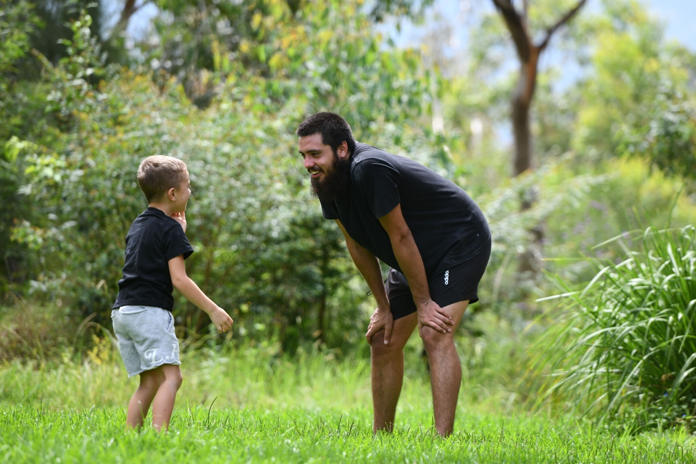

### Guideline 4.3: Embrace diverse child-rearing practices

The mainstream healthcare system is centred around Western standards of parenting and caring for children; for example, adherence to Western perspectives around swaddling, feeding and sleeping. It is crucial for practitioners to respect the different perspectives on wellbeing and family in the populations they service. Practitioners should walk alongside Aboriginal and Torres Strait Islander families, and culturally and linguistically diverse families, embracing the multiplicity of ways to care for and parent children. They should have a strengths-based mindset in their approach to parenting models that sit outside Western standards. Critical to this is moving away from checklists and language that hold communities to a singular, nuclear and Western standard of mental health and wellbeing, and parenting. Knowing a health practitioner is seeking to understand the cultural side of parenting helps caregivers relax.

# What does this mean in practice for service providers and practitioners?

## Understand

The practitioner should:

* seek to understand the family, including:
  + - cultural background
    - any disability, including psychosocial disability or mental illness, experienced by a child or caregiver
    - the composition of the family unit (for example, whether the caregiver has a partner and/or other children), and who will be present at the appointment
    - family challenges such as mental ill health, financial and/or relationship problems, alcohol and/or other drug use and social isolation
* ask about the child and family’s foundational and essential needs, where it’s appropriate and safe to do so
* when working with children and families seeking asylum or who have refugee status, build an understanding of their individual context via any available case notes to avoid re-traumatising the child and their family through re-sharing experiences
* build knowledge of local social and community services and parenting groups to share with families
* build knowledge of new and existing Medicare Benefits Schedule entitlements that may be relevant for children and caregivers.

## Engage

The practitioner should:

* create a safe environment and build trust with the family
* observe the family dynamics and relationships to assess what questions are safe to ask, depending on who is in the room
* provide space for families to:
  + - offload any stressors and release emotional tension that may have built up
    - feel that their parenting is valid, especially if it is perceived to sit outside Western standards
    - feel comfortable about raising the topics they wish to discuss or concerns they might have
    - feel as though their wellbeing is being considered alongside that of their child
    - feel that their concerns are being listened to and they can problem-solve together.

# SECTION 4

# System context

State and territory governments can play a key role in ensuring the systems and structures surrounding ECHCs enable and support services, practitioners and families to have safe, accessible and effective conversations about mental health and wellbeing during ECHCs. System-level considerations that would support meaningful implementation of the National Guidelines were identified throughout the consultations. A number of key themes were identified and these are discussed below.

## National consistency

Participants in the consultations expressed a clear desire for a more connected and less siloed health system. This included having consistency through shared language and processes, continuity of care and shared information between practitioners.

One example provided was the lack of consistency across states and territories in the contents of the coloured books used to record details about a child’s health and development from birth to 5 years of age. These books are retained by parents and include prompts for caregivers to consider social and emotional development before attending an ECHC. Prompts vary depending on the screening tool used in the state or territory.

This presents significant challenges for national consistency, in terms of experiences of ECHCs for children and families and in national data collection on early childhood mental health and wellbeing. While the Australian Early Development Census provides a national measure to assess child development, this is not undertaken until the first year of school. Accessing or collating data from ECHCs is complicated because of the lack of consistency in how the checks are completed. For example, the same jurisdiction may use a mix of hard-copy child health record books and electronic records.

A person holding a baby in a baby carrier. The baby is wearing a white hat. 


Having a nationally consistent approach to coloured books and the associated data collection could also enhance the benefits of including mental health and wellbeing in ECHCs. Future revisions of coloured books should also look to include age-specific child mental health and wellbeing aspects. The NDIS Review also noted the need for a national approach to minimum data requirements for child development checks.26 This would increase data capability nationally, increasing the availability of valuable insights into early childhood in Australia.

## Access

Common barriers that prevent families from accessing ECHCs were raised in the National Guidelines consultations. These need to be addressed to increase uptake and attendance by families.

### Equity of access

It is crucial that all children and their families have equal access to ECHCs. Some families may be willing and able to pay for ECHCs, but not all families have this option. The primary financial constraint raised during National Guidelines consultations was not being able to afford the costs associated with medical appointments, including gap fees to attend a general practitioner for referrals to specialists. High living costs and financial instability can further compound these issues. Providing more information about ECHCs and ensuring families are aware that appointments are free at child and family centres would help overcome cost as a barrier. However, it is important to note that families who are not enrolled in Medicare, including those who have refugee status or are seeking asylum, are unable to access these services for free.

Children with complex needs are more likely to be turned away from support, as providers may not have the skills or resources required.27 Additionally, families experiencing challenges (such as poverty, family and domestic violence and/or social isolation) are often less connected to services and supports (for example, early childhood education or care centres), and are less likely to be able to prioritise attending ECHCs. Working proactively to connect with the families least likely to access ECHCs will ensure an equitable and inclusive experience for all families.

### Transport issues

Many individuals and families find it hard to reach healthcare centres due to a lack of transport. This includes those who do not own a car or cannot afford public transport. Geographical challenges, such as distance and location, can also make getting to health services problematic. Services are not always easily accessible via public transport and for families living in isolated or remote areas, distance from the nearest available services can be a significant barrier. Locating healthcare facilities in easily accessible areas, such as shopping centres or close to public transport, can mitigate this barrier, as can having services within walking distance for families with young children.

“

*Many First Nations families have many siblings and kin and find it hard to keep children engaged and even struggle to get the whole family to the appointment when there is lack of access to safe and public transport. – National Guidelines consultation participant (Aboriginal health practitioner)*

### Physical access and accessibility

Limited access to healthcare services, including the physical availability of clinics or centres, can pose a significant barrier. Accessibility issues, such as a lack of wheelchair ramps, translated information and interpreters for non–English speakers, can also hinder access. Rural and remote areas often lack healthcare practitioners, making it challenging for families to access services. Outreach services can address some barriers by going where families are already attending.

### Appointments and scheduling

Scheduling and attending healthcare appointments can be a barrier when caregivers are working full time, managing multiple jobs, or returning to work soon after childbirth. While some families can access in‑home support after birth, it is not always available. For families with multiple children, or where carers are feeling overwhelmed or experiencing anxiety or depression, not having access to in-home support can be challenging. Delayed appointments when a practitioner is running behind can also be challenging for families, especially when waiting areas are not accessible, or child or family friendly.

“

*When there are competing priorities in the lives of families who are struggling, it is very difficult to attend appointments; checks should be available where families spend time. – National Guidelines consultation survey participant*

### Navigating referrals and supports beyond the ECHC

A key issue raised in consultations was the long wait times and limited services for specialists and other services when additional needs have been identified for a child or family. This was also a concern for stakeholders who raised the issue of the ethics of asking about broader social determinants of health; for example, housing or finances, when they do not have services to refer people to.

Consultation participants identified that some jurisdictions lack specialist mental health services for children under the age of 5. Additionally, early intervention strategies are generally not adequately funded, with the majority of resources apportioned to tertiary and acute services. These issues were noted to be exacerbated in rural and remote locations, which may physically lack the range of support services available in regional towns and cities.

“

*Largely, it’s impossible for families to responsively (and without great expense, so for some this is completely inaccessible) access supports for their child, further exacerbating stress and anxiety and overwhelm for all. There is also no ability to access, without great cost, ongoing support for the mental health of families supporting children with disability, difference and divergence. – National Guidelines consultation participant (organisation supporting families of children with disability and/or chronic illness)*

For ECHCs to be effective, and valued as such, there must be clear and accessible referral pathways and services for children and their families once emerging needs or issues have been identified. Partnerships between health and other social service providers, such as housing, early childhood education and care, are critical when strengthening protective factors and minimising the impact of known risks that may contribute to mental health challenges for children and families. It is also noted that warm referrals, where practitioners actively engage with support services before introducing families, are likely to elicit the greatest success, rather than merely providing contact details to caregivers and expecting them to make contact.

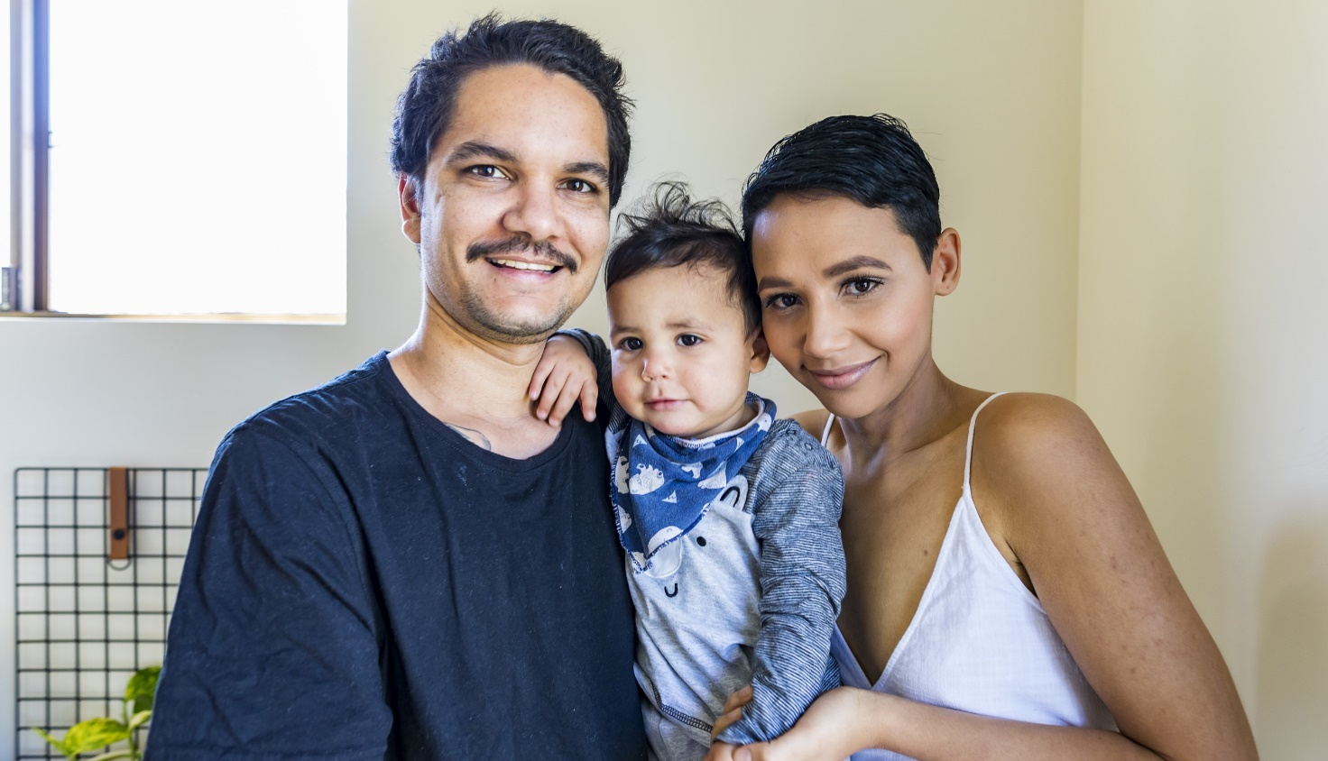

## Workforce capacity

A common issue identified during the public consultation phase related to the capacity of practitioners to complete ECHCs and the need for adequate resourcing to ensure they are appropriately trained and supported to:

* foster trust and collaborative partnerships with caregivers
* adopt approaches that are trauma-informed and strengths-focused
* understand the evolving capacity and developmental needs of infants and children, which naturally vary and develop according to age
* recognise, understand and respond to the underlying biopsychosocial risk and protective factors for mental health and wellbeing
* develop holistic and culturally safe solutions
* help families as they navigate key transition periods and/or specific challenges, including parental mental ill health, domestic and family violence, stigma and discrimination, or other significant changes
* make targeted, timely referrals to the broad range of services that support children and families.

Opportunities to codesign training, resources and system responses with stakeholders should be explored to ensure solutions are effective and best meet the needs of children and families. Efforts to harness the collective insights and expertise of stakeholders might include, at a minimum, working with children and families; people with lived experience of mental ill health; Aboriginal and Torres Strait Islander people; people from culturally and linguistically diverse populations; and people who identify as lesbian, gay, bisexual, transgender, queer, intersex or asexual.

Concerns were raised about limiting ECHCs to qualified health practitioners, with some stakeholders advocating for expanding to other specialisations, particularly the early childhood education and care sectors. Although their contribution to ECHC processes can be valuable, ECHCs are fundamentally health checks, making it essential that they are completed by qualified health professionals.

This does not preclude other professionals from sharing their insights with parents and caregivers or, where authorised, sharing information with health professionals about age-appropriate developmental milestones in their area of expertise. It is also does not dismiss the benefit of collocating health professionals with other sectors that provide services to children and families. Nor does it exclude the possibility of enabling inter-agency information sharing and collaboration. These issues fall outside the scope of the National Guidelines. However, they may be considered as part of implementation planning.

Several submissions advocated for elevating and explicitly acknowledging specific specialisations in the National Guidelines, and clearly articulating roles and responsibilities for implementing the National Guidelines and conducting ECHCs. Although it is acknowledged that several types of health practitioners (such as general practitioners, psychologists, child and family health nurses, and Aboriginal health workers) have a critical role to play, roles and responsibilities vary across jurisdictions and services, and fall outside the scope of the National Guidelines.

Appendix A

# National Guidelines for Wellbeing Indicators in Early Childhood Health Checks Advisory Group members

* Professor Ngiare Brown, co-chair – general practitioner and (former) Chair of the National Mental Health Commission Advisory Board
* Anne Hollonds, co-chair – National Children’s Commissioner
* Kate Armstrong – National Aboriginal Community Controlled Health Organisation
* Representative – Secretariat of National Aboriginal and Islander Child Care
* Professor Valsamma Eapen – UNSW, Academic Unit of Infant, Child, and Adolescent Psychiatry and Southwest Sydney BestSTART
* Bronwyn Field – Department of Health, Disability and Ageing
* Emily Humphreys – parent/carer representative
* Associate Professor Nitin Kapur – paediatrician, Royal Australasian College of Physicians
* Brad Morgan – Emerging Minds
* Professor Frank Oberklaid – paediatrician, Murdoch Children’s Research Institute
* Sharon O’Mara – Children and Young People with Disability Australia
* Dr Marshall Watson – psychiatrist, Telethon Kids Institute
* Dr Nicole White – general practitioner representative
* Louise Wightman – Maternal Child and Family Health Nurses Australia



# Explanation of terms

**Child- and family-centred practice**

This prioritises the child’s health and wellbeing, while acknowledging that the family unit is inextricably linked to the child’s health and wellbeing. It encourages the child to participate in decisions that affect them, where appropriate, and respects and prioritises their agency to communicate their needs and wishes.

Cultural determinants of health

The cultural determinants of health are anchored in Aboriginal and Torres Strait Islander ways of knowing, being and doing that encompass a holistic understanding of health and wellbeing. Culture is central to this understanding and shapes the relationship between self and Country, kin, community and spirituality.28

Cultural responsiveness

The capacity of clinicians to provide care that respects, and is relevant to, the beliefs, practices and cultural and linguistic needs of diverse populations and communities.29

**Cultural safety**

Cultural safety aims to enhance the delivery of health services by identifying the power relationship between the healthcare professional and the person receiving care and empowering the service user to take full advantage of the healthcare service offered.30 It is the outcome of education that enables safe services to be defined by those who receive the service.31

**Developmental delay**

When a child is developing skills more slowly than other children in the same age group, this is known as ‘developmental delay’.

**Developmental milestones**

Broadly, developmental milestones include the following abilities and behaviours:

* **physical:** large body movements, such as sitting and walking, and small body movements such as controlling hands, eating and sleeping, reflexes, vision and other physical abilities
* **social:** how a child reacts to other people around them, including through play and communication
* **emotional:** how well a child is bonding with other people, and how they express their emotions
* **cognitive:** a child’s learning, and how they are engaging with the world
* **language:** including hearing, and making and understanding sounds.32

**Early childhood health checks**

Early childhood health checks (ECHCs) are a longitudinal, continuous and cumulative process33 undertaken to understand a child’s development and determine if milestones are being met.34 In practice, ECHCs are a series of regular appointments between families and health practitioners to discuss how a child is developing. The timing of ECHCs varies between states and territories, but they generally start at birth and continue until a child begins primary school.

**Ecological approach**  
An ecological approach considers the impact of broader social, cultural and environmental factors on a child’s development, mental health and wellbeing. These factors can include (but are not limited to) personal characteristics such as age; relationships with family, carers and kin; physical health; community settings including school and early learning; and broader societal, economic, political and legal influences, as well as the services and structures that surround them.35,36

**Social and emotional development**  
Social and emotional development forms a key component of a child’s mental health and wellbeing and refers to a child’s behavioural and emotional strengths, and their ability to adapt and deal with daily challenges and respond positively to adversity.37 The inclusion of mental health and wellbeing in ECHCs includes, as well as extends beyond, social and emotional development.

**Social and emotional wellbeing**  
This is a holistic concept frequently used to conceptualise mental health in Aboriginal and Torres Strait Islander communities.38 It recognises the network of relationships between individuals, family, kin and community, as well as the importance of connection to land, culture, spirituality and ancestry, and how these affect the individual.39

**Strengths-based approach**

This approach recognises the inherent strengths of children and their families. It recognises the challenges families face today and values families as experts in their own experiences. This includes recognising the strengths of child-rearing practices outside a Western model of parenting.

# References

1. NSW Health, *The first 2000 days framework*, NSW Government, Sydney, 2019. Available from [The first 2000 days of life - Programs (nsw.gov.au)](https://www.health.nsw.gov.au/kidsfamilies/programs/Pages/first-2000-days.aspx#:~:text=The%20First%202000%20Days%20Framework%20is%20a%20strategic,children%20have%20the%20best%20possible%20start%20in%20life.)

2. healthdirect, *Developmental milestones in babies and children*, available from

<https://www.healthdirect.gov.au/developmental-milestones>.

3. K McLean, S Goldfeld, C Molloy and M Wake, *Screening and surveillance in early childhood health: Rapid review of evidence for effectiveness and efficiency of models*, 2014, available from <https://www.health.nsw.gov.au/kidsfamilies/MCFhealth/Documents/screening-and-surveillance-in-early-childhood.pdf>.

4. P Lipkin and M Macias, *Promoting optimal development: Identifying infants and young children with developmental disorders through developmental surveillance and screening*, American Academy of Pediatrics, 2020, 145(1):e20193449, [DOI: 10.1542/peds.2019-3449](DOI:%2010.1542/peds.2019-3449).

5. The Sydney Children’s Hospitals Network, *Developmental delay*, available from

<https://www.schn.health.nsw.gov.au/developmental-delay-factsheet>.

6. Australian Early Developmental Census, *Findings from the AEDC*, available from

<https://www.aedc.gov.au/communities/findings-from-the-aedc>.

7. Australian Early Developmental Census, *Findings from the AEDC*, available from

<https://www.aedc.gov.au/communities/findings-from-the-aedc>.

8. Productivity Commission, *Inquiry into the social and economic benefits of improving mental health: final report*, 2020. Available from: [Inquiry report - Mental Health - Productivity Commission (pc.gov.au)](https://www.pc.gov.au/inquiries/completed/mental-health/report).

9. Social Policy Evaluation and Research Unit, *Families with complex needs: International approaches*, Social Policy Evaluation and Research Unit, Wellington, New Zealand, 2015, available from <https://thehub.swa.govt.nz/assets/Uploads/Families-with-complex-needs.pdf>.

10. RC Kessler, WT Chiu, O Demler, KR Merikangas and EE Walters, ‘Prevalence, severity, and comorbidity of 12-month DSM-IV disorders in the National Comorbidity Survey Replication, *Arch Gen Psychiatry*, 2005, 62(6):617–627. Available from: [Prevalence, severity, and comorbidity of 12-month DSM-IV disorders in the National Comorbidity Survey Replication - PubMed (nih.gov)](https://pubmed.ncbi.nlm.nih.gov/15939839/)

11. National Mental Health Commission, *National Children’s Mental Health and Wellbeing Strategy*, National Mental Health Commission, 2021. Available from: [National Children’s Mental Health and Wellbeing Strategy | National Mental Health Commission](https://www.mentalhealthcommission.gov.au/projects/childrens-strategy)

12. Emerging Minds, *Identifying social, emotional and behavioural difficulties in the early childhood years*, available from <https://emergingminds.com.au/resources/identifying-social-emotional-behavioural-difficulties-in-early-childhood/>.

13. Social Policy Evaluation and Research Unit, *Families with complex needs: International approaches*, Social Policy Evaluation and Research Unit, Wellington, New Zealand, 2015, available from <https://thehub.sia.govt.nz/assets/Uploads/Families-with-complex-needs.pdf>.

14. G Gee, P Dudgeon, C Schultz, A Hart and K Kelly, ‘Aboriginal and Torres Strait Islander social and emotional wellbeing’, in P Dudgeon, H Milroy and R Walker (eds), *Working together: Aboriginal and Torres Strait Islander mental health and wellbeing principles and practice*, 2nd edn, Australian Government, Canberra, 2014, pp 55–68.

15. National Mental Health Commission, *National Children’s Mental Health and Wellbeing Strategy*, National Mental Health Commission, 2021. Available from: [National Children’s Mental Health and Wellbeing Strategy | National Mental Health Commission](https://www.mentalhealthcommission.gov.au/projects/childrens-strategy)

16. Unicef, *Brief on the social ecological model*, available from <https://www.unicef.org/media/135011/file/Global%20multisectoral%20operational%20framework.pdf>.

17. DJ McCloskey, MA McDonald, J Cook, S Heurtin-Roberts, S Updegrove, D Sampson, S Gutter and M Eder, ‘Community Engagement: Definition and organizing concepts from the literature’, in *Principles of Community Engagement*, 2nd edn, 2011.

18. CM Hood, KP Gennuso, GR Swain and BB Catlin, ‘County health rankings: Relationships between determinant factors

and health outcomes’, *American Journal of Preventive Medicine*, 2016;50(2):129–135. Available from: [County Health Rankings: Relationships Between Determinant Factors and Health Outcomes - PubMed (nih.gov)](https://pubmed.ncbi.nlm.nih.gov/26526164/)

19. S Bapat, *Engagement with culturally and linguistically diverse communities to support the development of the National Stigma and Discrimination Reduction Strategy*, 2022. Available from: [Engaging with culturally and linguistically diverse communities to reduce the impact of depression and anxiety: a narrative review - Baker - 2016 - Health & Social Care in the Community - Wiley Online Library](https://onlinelibrary.wiley.com/doi/10.1111/hsc.12241)

20. Embrace Multicultural Mental Health, *Mental health during the COVID-19 pandemic in Italian, Turkish and Vietnamese communities*, Mental Health Australia, 2022. Available from: [Welcome | Embrace Multicultural Mental Health (embracementalhealth.org.au)](https://www.embracementalhealth.org.au/).

21. S Slewa-Younan, K Krstanoska-Blazeska, A Renzaho, I Blignault, B Li and N Reavley, *Understanding Mental Health and Stigma in Congolese, Arabic-speaking and Mandarin-speaking Communities*, Western Sydney University, 2022. Available from: <https://researchers.westernsydney.edu.au/en/publications/understanding-mental-health-and-stigma-in-congolese-arabic-speaki>

22. E Purkey, R Patel and S Phillips, ‘Trauma-informed care: better care for everyone’, *Can Fam Physician*, 2018, 64(3):170–172. Available from: [Trauma-informed care: Better care for everyone - PubMed (nih.gov)](https://pubmed.ncbi.nlm.nih.gov/29540379/).

23. Emerging Minds, *In focus: Trauma-informed care*, n.d., available from <https://emergingminds.com.au/resources/in-focus-trauma-informed-care/>.

24. Emerging Minds, *PERCS Conversation Guide summary*, n.d., available from [https://d2p3kdr0nr4o3z.cloudfront.net/content/uploads/2021/08/13110828/PERCS-Conversation-Guide.pdf](https://emergingminds.com.au/resources/in-focus-trauma-informed-care/).

25. Emerging Minds, *PERCS Conversation Guide summary*, n.d., available from [https://d2p3kdr0nr4o3z.cloudfront.net/content/uploads/2021/08/13110828/PERCS-Conversation-Guide.pdf](https://emergingminds.com.au/resources/in-focus-trauma-informed-care/).

26. Commonwealth of Australia, Department of the Prime Minister and Cabinet, *Working together to deliver the NDIS – Independent Review into the National Disability Insurance Scheme: Final Report*, 2023. Available from: [Working together to deliver the NDIS | NDIS Review](https://www.ndisreview.gov.au/).

27. National Mental Health Commission, *National Children’s Mental Health and Wellbeing Strategy*, National Mental Health Commission, 2021.

28. Lowitja Institute, *Culture is Key: Towards cultural determinants-driven health policy*, policy brief, Lowitja Institute, Melbourne, 2021, available from <https://www.lowitja.org.au/wp-content/uploads/2023/06/Lowitja_CultDetReport_210421_D14_WEB.pdf>.

29. Migrant and Refugee Women’s Health Partnership, *Culturally Responsive Clinical Practice: Working with People from Migrant and Refugee Backgrounds. Competency standards framework for clinicians*, 2019. Available from: [Culturally Responsive Clinical Practice: Working with People from Migrant and Refugee Backgrounds: Competency Standards Framework for Clinicians January 2019 — Monash University](https://research.monash.edu/en/publications/culturally-responsive-clinical-practice-working-with-people-from-)

30. Migrant and Refugee Women’s Health Partnership, *Culturally Responsive Clinical Practice: Working with People from Migrant and Refugee Backgrounds. Competency standards framework for clinicians*, 2019. Available from: [Culturally Responsive Clinical Practice: Working with People from Migrant and Refugee Backgrounds: Competency Standards Framework for Clinicians January 2019 — Monash University](https://research.monash.edu/en/publications/culturally-responsive-clinical-practice-working-with-people-from-)

31. Nursing Council of New Zealand, ‘Guidelines for cultural safety in nursing and midwifery’, in *National Aboriginal and Torres Strait Islander Health Worker Association Cultural Safety Framework*, available from [natsihwa-cultural_safety-framework_summary-1690176047.pdf (naatsihwp.org.au)](https://www.naatsihwp.org.au/storage/natsihwa-cultural_safety-framework_summary-1690176047.pdf).

32. healthdirect, *Developmental milestones in babies and children*, available from

<https://www.healthdirect.gov.au/developmental-milestones>.

33. K McLean, S Goldfeld, C Molloy and M Wake, *Screening and surveillance in early childhood health: Rapid review of evidence for effectiveness and efficiency of models*, 2014, available from <https://www.health.nsw.gov.au/kidsfamilies/MCFhealth/Documents/screening-and-surveillance-in-early-childhood.pdf>.

34. P Lipkin and M Macias, *Promoting optimal development: Identifying infants and young children with developmental disorders through developmental surveillance and screening*, American Academy of Pediatrics, 2020, 145(1):e20193449, [DOI: 10.1542/peds.2019-3449](DOI:%2010.1542/peds.2019-3449)

35. Unicef, *Brief on the social ecological model*, available from <https://www.unicef.org/media/135011/file/Global%20multisectoral%20operational%20framework.pdf>.

36. DJ McCloskey, MA McDonald, J Cook, S Heurtin-Roberts, S Updegrove, D Sampson, S Gutter and M Eder, ‘Community Engagement: Definition and organizing concepts from the literature’, in *Principles of Community Engagement*, 2nd edn, 2011.

37. Australian Institute of Health and Welfare (AIHW), *Australia’s children*, catalogue number CWS 69, AIHW, Australian Government, Canberra, 2020. Available from: [Australia's children, Executive summary - Australian Institute of Health and Welfare (aihw.gov.au)](https://www.aihw.gov.au/reports/children-youth/australias-children/contents/executive-summary)

38. A Day and A Francisco, ‘Social and emotional wellbeing in Indigenous Australians: identifying promising interventions’, *Australian and New Zealand Journal of Public Health*, 2013, 37:350–355, available from <https://pubmed.ncbi.nlm.nih.gov/23895478/>.

39. G Gee, P Dudgeon, C Schultz, A Hart and K Kelly, ‘Social and Emotional Wellbeing and Mental Health: An Aboriginal Perspective’, in P Dudgeon, M Milroy and R Walker (eds), *Working Together: Aboriginal and Torres Strait Islander Mental Health and Wellbeing Principles and Practice – Revised edition*, Australian Government, Canberra, 2014.

.



www.mentalhealthcommission.gov.au

www.mentalhealthcommission.gov.au

1. Further information about The Children’s Wellbeing Continuum is available online at [Centre for Community Child Health: Children’s Wellbeing Continuum (rch.org.au)](https://www.rch.org.au/ccch/research-projects/Children_s_Wellbeing_Continuum/#:~:text=The%20Continuum%20is%20an%20accessible%20tool%20that%20can,Continuum%20is%20not%20a%20screening%20or%20diagnostic%20tool.).