

National Carer Strategy







2024-2034
Action Plan 2024–2027

ISBN: 978-1-921647-53-0 (Online)
ISBN: 978-1-921647-53-6 (Print)


The National Carer Strategy 2024-2034 Action Plan 2024-2027 is licensed under the Creative Commons Attribution 4.0 International Licence
Licence URL: https://creativecommons.org/licenses/by/4.0/legalcode
Please attribute: © Commonwealth of Australia (Department of Social Services) [2024]
Notice:
- If you create a derivative of this document, the Department of Social Services requests the following notice be placed on your derivative: Based on Commonwealth of Australia (Department of Social Services) data.
- Inquiries regarding this licence or any other use of this document are welcome. Please contact: Branch Manager, Communication Services Branch,
Department of Social Services. Phone: 1300 653 227. Email communication@dss.gov.au

Notice identifying other material or rights in this publication:
- Australian Commonwealth Coat of Arms – not Licensed under Creative Commons, see https://www.pmc.gov.au/honours-and-symbols/commonwealth-coat-arms
- Certain images and photographs (as marked) – not licensed under Creative Commons.


Acknowledgement of Country
The Australian Government acknowledges Aboriginal and Torres Strait Islander peoples throughout Australia and their continuing connection to land, water, culture and community.
We pay our respects to the Elders both past and present.

Content warning Aboriginal and Torres Strait Islander readers are advised this document may contain images of deceased persons.

Help and support
Please be aware that this document contains information that may be distressing to readers. It includes information about the experiences of Australia’s carers and the challenges they face. If you need support
to deal with difficult feelings after reading this paper, there are free services available to help you.

Carer Gateway
- Telephone 1800 422 737, Monday to Friday, 8am to 5pm for support and services.
- Visit Carer Gateway.

Beyond Blue Support Service
- Telephone 1300 224 636, 24 hours, 7 days a week or chat online 3pm to 12am AEST, 7 days a week or visit Beyond Blue.

Lifeline Crisis Support
- Provides support if you are feeling overwhelmed, having difficulty coping or thinking about suicide.
- Speak to a crisis support worker by telephone on 13 11 14, 24 hours, 7 days a week.
- Text 0477 13 11 14 or chat online for support, 24/7. Or visit Lifeline Crisis Support.

1800RESPECT
- For support if you are affected by sexual assault or domestic and family violence or abuse.
- Telephone 1800 737 732, 24 hours a day, 7 days a week, chat online 24 hours a day, 7 days a week or visit 1800RESPECT.

13YARN
- First Nations service providing culturally safe crisis support. Call 13 92 76, 24 hours a day, 7 days a week or visit 13YARN.

QLife
- QLife provides anonymous and free LGBTQIA+ peer support and referral for people in Australia
- Call 1800 184 527, open 3pm to midnight, every day or visit QLife - Support and Referrals.

Open Arms Veterans and Family Counselling
- As a carer of a veteran, or a veteran who is a carer, you can contact Open Arms to find out what support and services are available for you or your loved ones
- Call on 1800 011 046 or visit Open Arms - Veterans & Families Counselling.

eheadspace
- eheadspace is a national online and phone support service for young people between 12 and 25. Available 9am – 1am AEST every day.
- Call 1800 650 890 or visit Online & phone support | headspace.

Contents

Introduction: Our commitment to driving change 6
National Carer Strategy on a Page 7
Implementing the National Carer Strategy 8
Action Plan: Improving the lives of unpaid carers 9
How will we measure progress? 17
Appendices 19
Appendix 1: Glossary of terms 19



National Carer Strategy 4



National Carer Strategy 5

Introduction: Our commitment to driving change
At a time when the invaluable contributions of unpaid carers often go unrecognised, our commitment to driving transformative change is more crucial than ever.
The National Carer Strategy 2024-2034 (the Strategy) represents a pivotal step towards acknowledging and supporting these dedicated individuals who play an essential role in our communities. By aligning our actions with the recommendations from the Inquiry into the recognition of unpaid carers report, Recognising, valuing and supporting unpaid carers – Parliament of Australia (aph.gov.au), we aim to create a robust framework that not only recognise their contributions but also empowers them through targeted initiatives and collaborative efforts.
This Strategy is a testament to our dedication to fostering an environment where carers feel valued, supported, and equipped to thrive.
Both the Strategy and the Action Plan 2024-2027 have been developed in consultation with carers and the carer support sector across Australia, including Carer Gateway Service providers and the National Carer Strategy Advisory Committee (the Advisory Committee) consisting of carers from a diverse range of backgrounds.
Both documents have been informed by submissions to, and outcomes of the House of Representatives Inquiry into the recognition of unpaid carers. This action plan supports a number of the Inquiry’s recommendations.
In the first year, the Strategy commits to:
- deliver an outcomes framework
- release an Action Plan
- work with stakeholders to commence development and implementation of initial actions.
Actions outlined in this plan will drive initial positive change for carers, laying a foundation for continuous improvement and the development and implementation of future work to ensure the Strategy’s vision is realised.
This suite of initial actions are items that are able to be developed and implemented in a short timeframe and have immediate positive impact for carers, such as building on the Carer Gateway service offer and a formal review of the Carer Recognition Act 2010. We will seek to better understand the carer landscape through exploring opportunities for enhanced data and evidence collection. We will improve awareness of carers and caring roles throughout the Australian community. We will support carers to achieve financial security through improving opportunities for participation in the workforce, in education and training.
Co-designing with the carer community will ensure that supports and initiatives truly reflect the needs of Australia’s carers. An ongoing Carer Advisory Committee will oversee the development, implementation, monitoring and review of the Strategy and actions.

National Carer Strategy on a Page

Vision
An Australian community in which all carers are recognised, valued and empowered with the support they need to participate fully in society and fulfil their caring role.
Principles
The co-designed principles should guide the coordination and delivery of carer-related and carer-impacting policies, programs and initiatives across Australian Government agencies.
- Carer-centred: The lived experience of carers will be included in the co-design and co-production of policies, supports and services for carers. Carers’ lived experience will be included in evaluation processes.
- Evidence-informed: Carer policies, supports and services will be informed by evidence, and innovation will be used to address challenges experienced by carers.
- Accessible, equitable and inclusive: Carer policies, supports and services will be inclusive and tailored to respond to the needs of carers, at all stages of caring, recognising the diversity of carers, and the importance of cultural and psychological safety.
- Supports personal agency: The design of policies, supports and services for carers will enable choices that suit them.
- Transparent and accountable: Federal government departments will be accountable in delivering the Strategy and transparent in their processes to better recognise and value carers.
Objectives
The objectives are the results we want to achieve for carers.
- Carers are identified, recognised, respected, and valued.
- Carers are empowered to have fulfilling lives while engaging in their caring role.
- Carers’ physical and mental health, safety, wellbeing, and financial security are supported.
Priority outcome areas
The priority outcome areas are where we will focus our efforts to achieve the Strategy’s vision and objectives.
Note: The priority outcome areas are not numbered in order of importance.
They are numbered for ease of reference.
- Government, the community and services see and value carers, recognise their expertise and contribution, and create an environment that enables carers to identify at the earliest opportunity.
- Carers can access supports, services and programs at the right time, right place and in the right way.
- Ensure carers are able to develop knowledge and skills when needed to fulfill their caring role.
- Carers can access, and participate in employment and education or training, including to improve their financial wellbeing.
- Carers have access to supports that safeguard their psychological, physical and social wellbeing.
- Build the evidence base about carers to better understand who carers are, including their diversity, what their experiences are, what works for them and why.
Next steps
- Action – Action plans will be developed incorporating the feedback to date and theory of change
- Measuring success – A monitoring, evidence and evaluation approach will be implemented that includes a theory of change, an outcomes framework and a monitoring and evaluation framework.
- Co-design – The voices and perspectives of carers will inform and guide the Strategy implementation, monitoring and review to ensure outcomes are delivered and objectives are met.

Implementing the National Carer Strategy
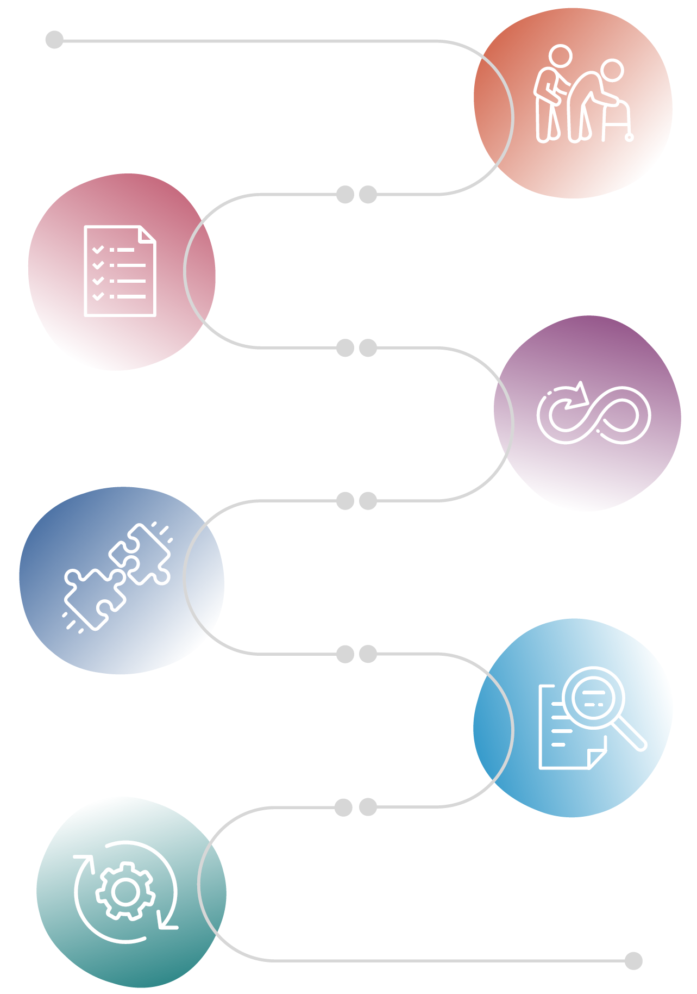

National Carer Strategy

Action Plan 2024-2027

Theory of Change

Outcomes Framework

Evaluation Framework

Continuous action to improve outcomes for carers

Action Plan: Improving the lives of unpaid carers
This Action Plan is informed by the views, perspectives, expert advice and evidence collected during the Strategy’s development, including from unpaid carers and the carer support sector.
In developing the Action Plan, Government heard what carers said was important to them and considered what is achievable within the first three years of the Strategy and available funding mechanisms.
This Action Plan will focus initial efforts on improving wellbeing for carers through the delivery of appropriate support services.
The following suite of actions outlines Government’s commitment to:
- Support the well-being of carers by reviewing and improving:
- specific services offered through Carer Gateway
- the accessibility and inclusivity of Carer Gateway.
- Improve identification and recognition of carers.
- Contemporise the Carer Recognition Act 2010.
- Ensure the lived experience of carers guides continual improvement.
- Support carers to achieve financial security.
- Understand the full carer landscape through improved data capture.
Through cross-government cooperation and ongoing input from carers and carer-sector representatives, delivery of the actions set out in this plan will provide a solid foundation on which future action plans can be built.
Actions will be co-designed with carers and other relevant organisations and stakeholders. In line with the Government’s commitment under the National Agreement on Closing the Gap, actions to address the barriers faced by First Nations people, such as ensuring access to respite care for First Nations carers in rural and remote areas, will be designed partnership with First Nations people.



National Carer Strategy 9

Commitment 1a: Review and improve specific services offered through Carer Gateway to support the wellbeing of carers.

What we will do
  - Increase access to phone counselling services for carers delivered through Carer Gateway by funding up to an additional 10,000 sessions per year.
  - Extend the hours supports and services are available through Carer Gateway and work with Carer Gateway providers to refine the offering that will be available to carers under extended business hours and after hours.
  - Work with the carer sector and other stakeholders to examine how to further improve the access, quality and range of counselling and mental health supports, including linkages and referrals to other mainstream and complementary services.
  - Work with carers, the carer sector and other stakeholders to identify strategies to improve access to respite arrangements in partnership with relevant policy and regulatory agencies including:
    - improve access to respite arrangements both directly through Carer Gateway and in partnership with Aged Care and the NDIS.
    - identifying current models of successful flexible and tailored respite models in service systems that could benefit carers.
    - identify options to ensure respite arrangements are tailored and personalised and address the needs of both the carer and the care recipient.
  - Expand the current peer support arrangements under Carer Gateway and the connection to complementary peer support systems, including through alternative commissioning or partnership arrangements with organisations that have specific expertise and experience dealing with particular populations, to ensure carers can connect with people in similar circumstances in a safe environment, in a way that meets their specific needs.
  - Identify appropriate and culturally safe in-person and online training that will be provided via Carer Gateway to support unpaid carers build the knowledge and skills they need to fulfil their caring role including:
    - manual handling
    - first aid
    - medication management and wound care
    - financial literacy
    - mental health first aid and suicide intervention training modules.
  - Work with relevant stakeholders and the carer sector to research and co-design improved supports for First Nations carers, CALD carers, LGBTQIA+ carers, carers with disability, carers of veterans and young carers that address their unique needs and improve service outcomes.

Commitment 1b: Review and improve the accessibility and inclusivity of Carer Gateway to support the wellbeing of carers.

What we will do
  - In partnership with the carer sector, stakeholders with specific expertise in relation to the targeted cohorts and other stakeholders, leverage existing expertise to develop a ‘blueprint’ for upskilling and enhancing the cultural capability of all service providers through Carer Gateway to ensure appropriate delivery of supports for diverse communities. The blueprint will initially focus on uplifting capability in relation to:
    - First Nations carers
    - culturally and linguistically diverse carers
    - carers with disability
    - carers from LGBTQIA+ communities.
  - Set up a working group of relevant stakeholders to develop and scope options and bring forward recommendations for improving navigation delivered by Carer Gateway to better support carers interacting with different service systems.
  - Work with the carer sector and other stakeholders to:
    - identify and map service system touch points and interactions to help improve pathways to Carer Gateway.
    - identify further opportunities to improve Carer Gateway including addressing:
      - geographic and demographic access
      - cultural accessibility
      - intake and assessment processes
    - develop an implementation plan to deliver those improvements.
Commitments 1a and 1b align with Recommendations 9, 10, 11, 13 and 14 of the Inquiry into the recognition of unpaid carers.
Objectives supported:
Carers are empowered to have fulfilling lives while engaging in their caring role.
Carers’ physical and mental health, safety, wellbeing and financial security are supported.
Priority outcome areas
2 Carers can access supports, services and programs at the right time, right place and in the right way.
3 Ensure carers are able to develop knowledge and skills when needed to fulfill their caring role.
5 Carers have access to supports that safeguard their psychological, physical and social wellbeing.

Commitment 2: Improve identification and recognition of carers.

What we will do
  - Develop and implement a comprehensive communication plan, building on existing efforts, to promote awareness of carers and caring roles, reduce the stigma of caring, and increase awareness of the service offer of Carer Gateway.
  - Work across the Commonwealth and with states and territories to support carers to be identified and provided with information relevant to their caring role and available supports through those working in medical/health systems and education systems such as GPs, pharmacists, hospital liaison officers, educators and school counsellors.
  - Explore ways to improve professional training and resources for health sector professionals to better identify unpaid carers, recognise their expertise, and refer them to appropriate supports.
  - Explore ways to strengthen recognition of carers within government funded service systems.
  - Undertake a review of international best practice for the identification and recognition of unpaid carers and the nature of their caring role within communities and across service systems.
Identify how this could be implemented in an Australian Context to ensure carers’ expertise and experience is acknowledged and the burden on carers to repeatedly explain their circumstances reduced.

Commitment 2 aligns with recommendations 12 and 22 of the Inquiry into the recognition of unpaid carers.
Objectives supported:
Carers are identified, recognised, respected and valued.
Carers are empowered to have fulfilling lives while engaging in their caring role.
Carers’ physical and mental health, safety, wellbeing and financial security are supported.
Priority outcome areas
1 Government, community and services see and value carers, recognise their expertise and contribution, and create an environment that enables carers to identify at the earliest opportunity.
2 Carers can access supports, services and programs at the right time, right place and in the right way.
4 Carers can access, and participate in employment and education or training, including to improve their financial wellbeing.

Commitment 3: Contemporise the Carer Recognition Act 2010.

What we will do
  - Respond to the House of Representatives Inquiry into the recognition of unpaid carers and consult on any proposed amendments to the Carer Recognition Act 2010, to ensure the Act is contemporary and reflects the diversity of Australia’s carers.
  - Undertake work to identify other carer-relevant legislation and policy areas needing to be updated/ harmonised.

Commitment 3 aligns with recommendations 1, 2, 3, 5, 6, 7, and 8 of the Inquiry into the recognition of unpaid carers.

Objectives supported:
Carers are identified, recognised, respected and valued.
Carers are empowered to have fulfilling lives while engaging in their caring role.
Carers’ physical and mental health, safety, wellbeing and financial security are supported.

Priority outcome areas
1 Government, community and services see and value carers, recognise their expertise and contribution, and create an environment that enables carers to identify at the earliest opportunity.
4 Carers can access, and participate in employment and education or training, including to improve their financial wellbeing.

Commitment 4: Ensure the lived experience of carers guides continual improvement.

What we will do
  - Government will appoint an ongoing Carer Advisory Committee to advise and oversee the development of action plans and implementation of the Strategy, including overseeing the monitoring, evaluation, and reviews of the Strategy. The Committee will:
    - operate for the term of the Strategy (10 years) and review period (2 years).
    - provide an annual report to the Minister on the progress implementation, and realisation of the Strategy actions and outcomes.
    - consist of members representing the diversity of carer cohorts, lived experience and expertise.
    - connect with and complement the Parent and Carers Reference Group, where there are areas of overlapping interest, while also delivering on its specific mandate.

Commitment 4 aligns with recommendations 13 and 16 of the Inquiry into the recognition of unpaid carers.

Objectives supported:
Carers are identified, recognised, respected and valued.
Carers are empowered to have fulfilling lives while engaging in their caring role.
Carers’ physical and mental health, safety, wellbeing and financial security are supported.

Priority outcome areas
- Government, community and services see and value carers, recognise their expertise and contribution, and create an environment that enables carers to identify at the earliest opportunity.
- Carers can access supports, services and programs at the right time, right place and in the right way.
- Carers have access to supports that safeguard their psychological, physical and social wellbeing.
- Build the evidence base about carers to better understand who they are, including their diversity, what their experiences are, what works for them and why.

Commitment 5: Support carers to achieve financial security.
What we will do
  - Explore options to improve workforce, education and training participation and employment initiatives for carers including:
    - extending the Carer Inclusive Workplaces Initiative (CIWI) until 30 June 2026, while scoping options for a future program are explored.
    - extend the Young Carer Bursary Program and Young Carer Network to 30 June 2027, and consult with state and territory governments and young carers to explore what a future program to support young carers in their education and training might look like.
    - continue the pre-employment training support offered under the ceasing Tristate Carer Vocational Outcomes Program Pilot (TCVOP) through Carer Gateway in 2025-26 and expand to a national model supporting carers to access training and prepare for employment from 1 July 2026.

Objectives supported:
Carers are identified, recognised, respected and valued.
Carers are empowered to have fulfilling lives while engaging in their caring role.
Carers’ physical and mental health, safety, wellbeing and financial security are supported.

Priority outcome areas
1 Government, community and services see and value carers, recognise their expertise and contribution, and create an environment that enables carers to identify at the earliest opportunity.
2 Carers can access supports, services and programs at the right time, right place and in the right way.
4 Carers can access, and participate in employment and education or training, including to improve their financial wellbeing.

Commitment 6: Understand the full carer landscape through improved data.

What we will do
  - Undertake a process to research, analyse and understand current mechanisms of carer data capture across the country by federal, state/territory, academic and non-government sectors.
  - Develop a plan for improved regular consistent data capture to inform decision making, policy and program development.
  - Work in partnership with Aboriginal and Torres Strait Islander communities and organisations to ensure data sovereignty and data governance is appropriately maintained.

Commitment 6 aligns with recommendation 18 of the Inquiry into the recognition of unpaid carers.

Objective supported:
Carers are identified, recognised, respected and valued.

Priority outcome areas
1 Government, community and services see and value carers, recognise their expertise and contribution, and create an environment that enables carers to identify at the earliest opportunity.
6 Build the evidence base about carers to better understand who they are, including their diversity, what their experiences are, what works for them and why.

How will we measure progress?
Evidence Framework
A robust evidence framework that aligns data, research and evaluation is integral to the development, implementation and impact of the Strategy. This Evidence Framework will be developed by the Australian Institute of Family Studies (AIFS) and will include:
a theory of change
an outcomes framework
a monitoring and evaluation framework.

A theory of change can help hold program owners to account and build trust and confidence in the Strategy, by identifying the actions, processes and conditions needed to facilitate change and achieve desired outcomes.
An outcomes framework will specify the progressive indicators and outcome measures to enable assessment of the Strategy’s progress and impact.
An evaluation framework will be developed and will outline how we will measure the impact of actions towards achieving the Strategy’s vision.
Evaluation activities will be both quantitative (for example: measuring changes in carers’ labour force participation) and qualitative (for example: documenting the positive changes experienced by carers). Evaluation reports will be publicly available.



National Carer Strategy 17




2024-2027: Driving change
This initial action plan has been developed using a considerable evidence base gathered through the development of the Strategy.
2028-2034: Ongoing action
Over the life of the Strategy, additional action will be taken in consultation with carers, the carer support sector and the Commonwealth Government to deliver the Strategy’s vision.
2030-2031: Mid-way review
A mid-way review of the Strategy will assess the impact, effectiveness and appropriateness of the actions undertaken. The review will also consider the alignment with other social reforms to determine the degree of recalibration and refocus of the Strategy to remain responsive to the changing needs of the carer community.
2035-2037: Final evaluation
The Strategy will be reviewed and evaluated to assess the impact and effectiveness of the actions delivered over the life of the Strategy. The review is expected to make recommendations to government on areas for future investment in relation to successes and gaps and areas for focus to be considered in future policy and programs.

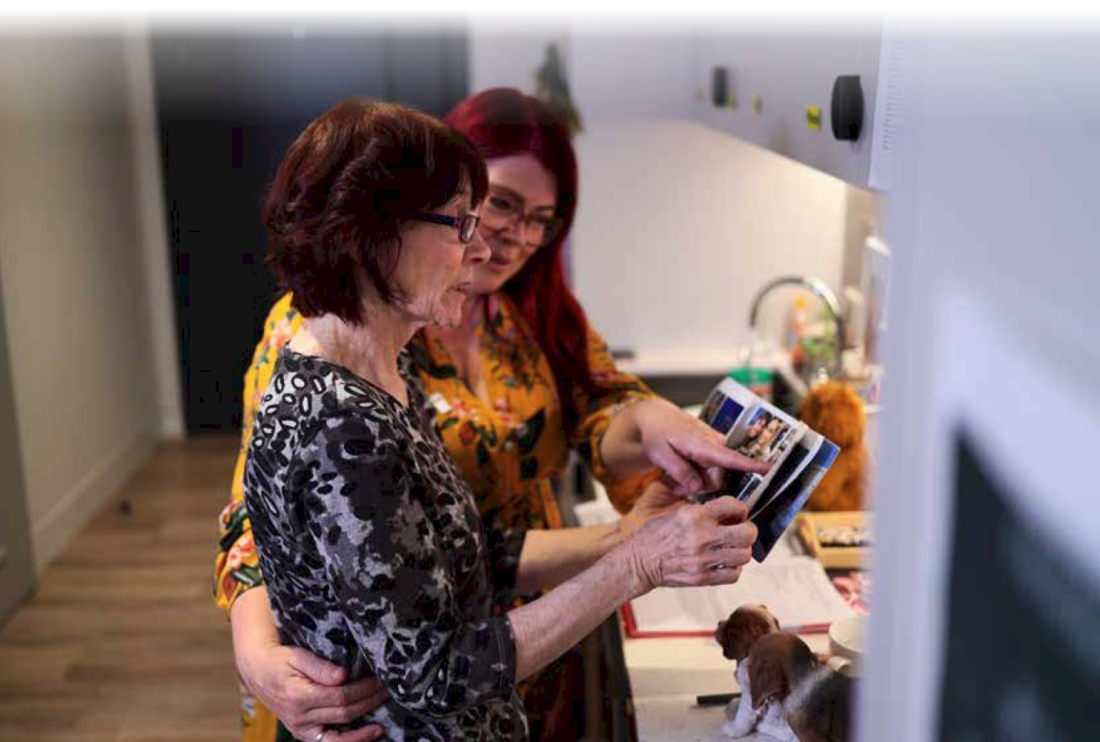

National Carer Strategy 18

Appendices

Appendix 1: Glossary of terms
Term | Description
Accessible | People from a diverse range of backgrounds, abilities, locations and demographics are afforded the opportunity to acquire the same information, engage in the same interactions, and enjoy the same services in an equally effective and equally integrated manner, with substantially equivalent ease of use.
Action Plan | The initial set of strategic actions to be implemented from 2024 to 2027 to support unpaid carers.
Awareness | Community and individual knowledge of the vital role carers play in the communities, the challenges they face and the importance of supporting them.
CALD | Culturally and Linguistically Diverse: refers to individuals and communities from various cultural backgrounds who speak different languages.
Carer-centred | A carer-centred approach means a policy or program emphasises individual care, ensuring that services are tailored to the specific needs and preferences of each person. It promotes dignity, autonomy, and holistic wellbeing, while supporting carers with the necessary resources and training to deliver respectful and effective care.
Carer Gateway | Carer Gateway is an Australian Government program providing free services and support for carers. It can help if family member or friend with disability, a medical condition, mental illness, or who is frail due to age.
Carer landscape | The overall environment and context in which carers operate, including policies, services, and support systems available to them.
Commitment | A promise or firm decision to do something.
Consultation | The action or process of formally consulting or discussing.
Collaborative efforts | Joint initiatives involving multiple parties working together to achieve common goals in supporting carers.
Continuous improvement | Ongoing efforts to enhance services, processes, and outcomes based on feedback and evolving needs.
Data capture | The process of collecting and recording information related to carers and their experiences, needs and services.
Data governance | Indigenous/First Nations Data Governance is the enactment of Indigenous Data Sovereignty and refers to the mechanisms that support First Nations people's decision-making on how data is controlled, collected, interpreted, accessed, stored, and used.
Data sovereignty | Indigenous/First Nations Data Sovereignty is enshrined in the United Declaration of the Rights of Indigenous Peoples and is central to comprehensive and ethical data collective that supports Aboriginal and Torres Strait Islander people's rights to govern their own data, including its creation, collection, and use.
Empowered | Empowered means allowing carers to make decisions and take actions within specific guidelines to improve care and support, enhancing their ability to respond effectively.
Evidence base | Evidence base refers the collection of available data and research that guides decision making to shape and implement policies.
Evidence framework | A structured approach that aligns data, research, and evaluation methods to inform the development and implementation of the Strategy.
First Nations | Indigenous peoples of Australia, including Aboriginal and Torres Strait Islander communities.
Flexible and tailored respite models | Customized respite care options designed to meet the unique needs of both the carer and the care recipient.
Implementation  plan | A strategic outline detailing how identified improvements will be executed, including timelines and responsibilities.
Inclusive | Inclusive approach for all carers by ensuring equal access to resources, support, and opportunities. It outlines how to accommodate diverse needs and backgrounds, fostering an environment where every carer can thrive and contribute effectively.
Inquiry | This establishes guidelines for managing inquiries within the organisation. It defines the process for submitting, tracking, and responding to inquiries to ensure time and accurately handling. It specifies responsibilities, response times, and communication methods to maintain transparency and efficiency. A formal investigation or examination into a particular issue, in this case, the recognition of unpaid carers.
LGBTQIA+ | Refers to lesbian, gay, bisexual, transgender, queer, intersex, asexual, and other sexually or gender diverse people.
National Carer Strategy | A framework aimed at recognizing, valuing and supporting unpaid carers in Australia.
National Carer Advisory Committee | A group of unpaid carers from diverse backgrounds who provide insights and guidance in the development of the Strategy.
Navigation | The process or activity of finding and accessing necessary services and resources effectively.
Outcomes Framework | A structured approach to measure the effectiveness and impact of actions taken under the Strategy.
Outcome measures | Quantifiable data points used to evaluate the effectiveness of the Strategy in achieving its intended goals.
Peer-led | An entity, program, or service is delivered or facilitated by a person with appropriate lived experience. In the context of the Strategy this refers to carer-led or demographic-led support. For example, an LGBTQIA+ support group led by a person who is a member of the LGBTQIA+ community. Another example is an advisory committee consisting of people with relevant lived experience.
Policy | A guideline or strategy aimed at addressing the needs and challenges faced by carers.
Program development | The process of designing and implementing initiatives and services tailored to support carers based on data-driven insights.
Progressive indicators | Metrics that provide information on the advancement of specific goals or outcomes within the Strategy.
Qualitative evaluation | Assessment methods that focus on descriptive data to capture personal experiences and changes such as documenting the impact on carers' lives.
Quantitative evaluation | Assessment methods that involve numerical data to measure outcomes such as changes in carers labour force participation.
Recognition | How the community acknowledges the contributions of carers, aiming to motivate and appreciate those who make this significant contribution to the community.
Respite Care | Respite care provides temporary relief, allowing carers a break to rest, manage stress, or attend to personal tasks.
Respite Arrangements | Temporary care services that allow carers to take a break while ensuring their care recipients are supported.
Service outcomes | The results or impacts of services provided to individuals, particularly in terms of effectiveness and service.
Service system touch points | Specific interactions or points of contact within the service delivery system that carers and recipients experience.
Stakeholders | Individuals or organisations with an interest or investment in the outcomes of the Strategy, including carers, service providers, and advisory committees.
Theory of change | A comprehensive explanation of how and why a desired change is expected to happen, detailing the necessary actions, processes and conditions.
Unique needs | This addresses the specific needs of individual carers by recognising and accommodating the unique requirements. It outlines how to identify and address these needs to ensure effective support and care delivery. It aims to tailor assistance to each carer's circumstances, enhancing their ability to provide quality care.
Unpaid carer | A person who provides personal care, support and assistance to another person who needs it because that other person has a disability, a medical condition (including a terminal or chronic illness), a mental illness, or is frail and aged.  Carers receiving financial support such as the Carer payment or Carer allowance are included under this definition.
Wellbeing | To support physical, mental, and emotional wellbeing of carers. Helps carer maintain a healthy balance between their caregiving responsibilities and personal life, aiming to reduce stress and enhance overall quality of life.
Working group | A collaborative team formed to focus on specific tasks or projects.





