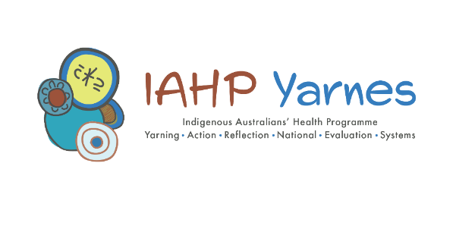
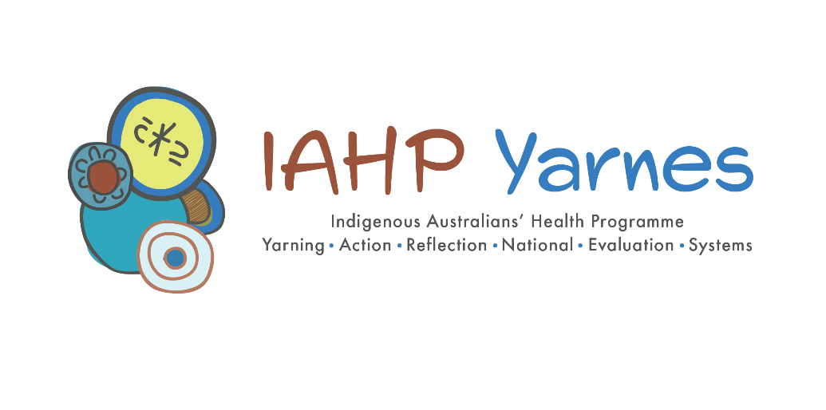

Final report of the evaluation of the Australian Government’s investment in Aboriginal and Torres Strait Islander primary health care through the Indigenous Australians’ Health Programme
Final Report
28 June 2023

This evaluation was undertaken by a consortium led by Allen + Clarke Consulting, University of Queensland, and Monaghan Dreaming.


RECOMMENDED CITATION
Allen + Clarke, Central Queensland University, Monaghan Dreaming, University of Queensland. Final Report of the Evaluation of the Australian Government’s investment in Aboriginal and Torres Strait Islander primary health care through the Indigenous Australians’ Health Programme. 2023.
This report’s lead authors were: Roxanne Bainbridge (Principal Investigator, University of Queensland), Chris Doran (Central Queensland University), Ned Hardie-Boys (Project Lead, Allen + Clarke), Erika Langham (University of Queensland), Sara Lystlund-Hemi (Allen + Clarke), Don Matheson (Consultant), Boyd Potts (Central Queensland University), Mathea Roorda (Allen + Clarke).
The other major contributors to the report were:
Robert Monaghan, National Engagement Lead, Monaghan Dreaming
Michael Costello-Czok, Allen + Clarke
Sarina Solar, Solar Consultancy Services
Robyn Bailey, Allen + Clarke
Julia Carr, GP and public health physician
William Morgan, Allen + Clarke
Celia Schild, Allen + Clarke
Stephen Begg, La Trobe University
Jamie Bryant, University of Newcastle
Alison Gibberd, Hunter Medical Research Institute
Chris Oldmeadow, Hunter Medical Research Institute
Rob Sanson-Fisher, University of Newcastle
Anthony Shakeshaft, University of Queensland
Paul Houliston, Project Sponsor, Allen + Clarke
Hannah Cross, Allen + Clarke
Judy Rangi, Allen + Clarke

About this document
3 documents provide additional material for this Final Report. They are:
- Final Report: Supplementary material
- Final Report: Quantitative Analytical Approach and Findings
- Indigenous Australians’ Health Programme Impact Report prepared by the Australian Institute of Health and Welfare

Allen + Clarke has been independently certified as compliant with ISO9001:2015 Quality Management Systems

Acknowledgements

Emma was part of the evaluation team which designed and set-up the evaluation. Here is her description of the artwork:
Because I don’t speak for every country, and because we are working across many of them, the work seeks to represent Indigenous Australia. I feel that colour makes a statement so I have used colours that can be linked to many of our communities and countries, land or sea based. The colours represent our people and the land they come from – ochres/yellows represent desert and hills and the cliffs where our ochres come from. Blues for ocean and blue greens for rivers.
The circles are universal in the way they represent groups or clans of people, the markings inside some of the circles represent individuals.
The dots and slashes are representational of tracks and time lines. There are a few blank circles – they represent the missing, the lost peoples.
I thought I would try and incorporate the colours to show respect for them.
The evaluation team thank the Aboriginal and Torres Strait Islander health services, Primary Health Networks, site partners, and community members who participated in this evaluation. All gave their time generously and welcomed us into their communities. They shared their knowledge, experience, and ideas to help deepen understanding of how the Indigenous Australians’ Health Programme works and to identify improvements to ensure better primary health care for current and future generations of Aboriginal and Torres Strait Islander people.
The evaluation team are also grateful to participants from the state, territory, and national organisations for making their time available to share knowledge, experience, and ideas to improve the primary health care system for Aboriginal and Torres Strait Islander people.
The team is especially grateful for the Aboriginal and Torres Strait Islander leadership and expertise from participants that has been central to this evaluation. These contributions at a time when the COVID-19 pandemic has impacted on communities, families, and individuals is highly valued and appreciated.
The evaluation team would also like to express our appreciation for the ongoing support from members of the Health Sector Co-design Group and the Department of Health and Aged Care during the implementation of the evaluation. Over the course of the evaluation, the members of the Health Sector Co-design Group included: Kate Thomann, Melinda Turner and Dr Mark Wenitong (who co-chaired the group), Dr Chris Bourke, Karl Briscoe, Dr Dawn Casey, Bob Davis, Sandy Gillies, Rob McPhee, Dr Janine Mohamed, Professor Norm Sheehan, Jess Yamaguchi, Angela Young, Dr Fadwa Al-Yaman, Dr Fui Choong, Kim Grey, Nicki Herriot, Dr Mike Mays, Dr Leanne Morton, Dr Tomoko Sugiura, Karen Visser, and Professor Jeanette Ward. Our gratitude also goes to Astrid Addai, Jane Miller, Dr Hye-Kyung Kim, Kate Laffan, Patrick Gard, Dr Harleen Basrai, and Bonnie Taylor from the Department of Health and Aged Care with whom the evaluation team worked closely.
The evaluation was fully funded by the Australian Government Department of Health and Aged Care.
Disclaimer
All due care and responsibility have been taken in the preparation of this report. This report (including any enclosures and attachments) has been prepared for the exclusive use and benefit of the addressee(s) and solely for the purposes for which it is provided. Allen + Clarke accepts no liability or responsibility if this report is used for an alternative purpose from which it is intended, or by any third party. The information contained in this report is confidential and commercially sensitive.

Contents
Acknowledgements ii
Contents iv
List of tables viii
List of figures viii
List of abbreviations x
Executive summary 1
Overview 1
Background and context 3
Evaluation methodology 4
Summary of key findings 8
Looking ahead 14
Recommendations 15
Part A: Background 28
Overview of Part A 29
1 Introduction 30
1.1 About the IAHP 30
1.2 About the National Agreement on Closing the Gap 31
1.3 About this evaluation 33
1.4 Evaluation focus and scope 35
1.5 Context for the evaluation 36
2 Evaluation methodology 48
2.1 Overview 48
2.2 Phase One – Evaluation design and planning 48
2.3 Phase Two – Evaluation implementation 50
2.4 Approach to data collection 50
2.5 Overview of activities across each evaluation cycle 56
2.6 Approach to data analysis 60
2.7 Sense-making, integration and analytical synthesis 63
2.8 Strengths, limitations and adaptations 67
2.9 Data collection, recording and storage 72
3 Understanding the IAHP 73
3.1 Overview 75
3.2 About the IAHP 75
3.3 IAHP funding arrangements 85
3.4 Distribution of funding to organisations in evaluation sites 95
Part B – Values and experiences 96
Overview of Part B 97
4 Understanding what Aboriginal and Torres Strait Islander people value in health care 98
4.1 Overview 99
4.2 Babuny: a framework of what Aboriginal and Torres Strait Islander people value in health service design and delivery 101
4.3 Place based and contextually relevant health care 103
4.4 Delivery of primary health care from easily identified and accessible spaces 105
4.5 Governance and resourcing of primary health care 108
4.6 Responsibility and resistance 112
4.7 Holistic care 114
5 Understanding how Aboriginal and Torres Strait Islander People experience the health system 127
5.1 Overview 128
5.2 Dominant cultural norms shape the health experiences of Aboriginal and Torres Strait Islander people 128
5.3 Moving across health care systems presents challenges for Aboriginal and Torres Strait Islander people 130
5.4 People’s experiences of care and interactions across the broader health system are diverse 131
5.5 People generally experience a better quality of care in ACCHSs 133
5.6 People identified quality of care concerns across the health system 134
5.7 ACCHSs are ‘doing their best to bridge the gaps’ within and between systems 139
5.8 Contrasting outcomes 140
Part C: Evaluating the IAHP 142
Overview of Part C 143
6 How well is the IAHP enabling the PHC system to work for Aboriginal and Torres Strait Islander people? 144
6.1 Overview 145
6.2 Contribution of IAHP to enabling holistic comprehensive primary health care 146
6.3 Contribution of the IAHP to PHC system access and navigation 153
6.4 Contribution of IAHP to stronger communities and a stronger community-controlled sector 163
6.5 Contribution of IAHP to delivering equitable access to primary health care 173

7 What difference is the IAHP making to the PHC system? 182
7.1 Overview 184
7.2 Orientation of the IAHP within the primary health care system 185
7.3 Influence of grant making arrangements 197
7.4 Contribution of the IAHP to primary health care workforce capacity 203
7.5 Governance and leadership across the primary health care system 211
7.6 Influence of data and knowledge sharing processes on primary health care system 213
8 What difference is the IAHP making to health and wellbeing? 219
8.1 Overview 220
8.2 Effects of health service activity on hospitalisations and mortality 221
8.3 Risk factors, health service use, and outcomes in the evaluation sites 228
8.4 Relative contributions of social determinants and primary care activity on health outcomes 238
8.5 Complex relationships between variables and health outcomes 242
9 What needs to change and improve? 249
9.1 Overview 250
9.2 Increase autonomy and responsiveness 250
9.3 Increase investment in primary care 258
9.4 Strengthen health system integration 261
9.5 Enhance the use of knowledge and information 267
Part D: Looking ahead 270
Overview of Part D 271
10 Evaluative Assessment 272
10.1 The IAHP and its evaluation 272
10.2 Explicit answers to the evaluation questions 273
11 Implications of the evaluation findings 282
11.1 Embedding self-determination and genuine partnerships 283
11.2 A strategic focus for the IAHP 284
11.3 Resourcing that matches ambition 286
11.4 Delivery of mainstream services 288
11.5 Putting the values and experiences of people at the centre of program design and delivery 290
11.6 Using data and information to inform care 291

12 Recommendations 293
12.1 Introduction 294
12.2 Foundational recommendation 297
12.3 Formal partnerships and shared decision-making 298
12.4 Strengthening the community-controlled sector 301
12.5 Transforming government organisations 305
12.6 Shared access to data and information at a regional level 309
12.7 Ensuring IAHP implementation success 311
Glossary 314
References 317

List of tables
Table 1-1. Health-related Closing the Gap outcomes, targets, and current state 32
Table 3-1. Activities and programs funded through the IAHP 80
Table 7-1. Characteristics of ACCHSs and dependency on IAHP funding 188
Table 7-2. Health service income by funding source, 5 ACCHSs, 2021-22 190
Table 7-3. Changes in the proportion of staff aged ≥45 years from 2013-2019, by workplace, for sites and across Australia 207
Table 7-4. Changes in the proportion of staff aged ≥45 years from 2013-2019, by staff Indigenous status, for sites and across Australia 207
Table 7-5. Changes in proportion of staff who were female from 2013-2019 by Indigenous status, for sites and across Australia 209
Table 7-6. Changes in the number and proportion of staff who were Indigenous from 2013-2019, for sites and across Australia 210
Table 8-1. Relationship between nKPI and hospitalisation rates for diabetes (unit of observation is the evaluation sites) 226
Table 8-2. Relationship between service-hospitalisation correlation and diabetes mortality for evaluation sites (Central Australia, Katherine East removed) 227
Table 8-3. Changes in individual nKPI by life stage, 16 evaluation sites, 2017-2019 230
Table 8-4. Changes in nKPIs across the evaluation sites, June 2017 to December 2019 232
Table 8-5. Socio-economic Indexes for Areas (SEIFA) 239
Table 8-6. Standardised regression coefficients (in decreasing order) by time point and direction of effect for hospitalisations 244
Table 8-7. Standardised regression coefficients (in decreasing order) by time point and direction of effect for PPH 245
Table 8-8. Standardised regression coefficients (in decreasing order) by time point and direction of effect for ED presentations 246
Table 8-9. Standardised regression coefficients (in decreasing order) by time point and direction of effect for mortality 247
Table 8-10. Standardised regression coefficients (in decreasing order) by timepoint and direction of effect for normal birthweight 248
Table 12-1: Intended outcomes of the evaluation’s recommendations 296

List of figures
Figure 0-1. Methods, analysis and data set diagram 7
Figure 1-1. Evaluation sites and site partner organisations 34
Figure 1-2. Circular framework of the Health Plan’s vision 40
Figure 2-1. Methods, analysis and data set diagram 52
Figure 2-2. Evaluation activities and number of participants by cycle design 57
Figure 2-3. Approach to contribution analysis 66
Figure 3-1. National IAHP grant funding expenditure by funding stream, 2018-19 to 2020-21 83
Figure 3-2. National and Australian Government health spending, constant prices, 2014-15 to 2020-21 84
Figure 3-3. IAHP proportion of health expenditure, constant prices, 2014-15 to 2020-21 84
Figure 3-4. IAHP funding flows to funded organisations 86
Figure 3-5. IAHP funded organisations (% of funding), 2021-22 87
Figure 3-6. IAHP PHC Program funded organisations (% of funded organisations), 2022-23 87
Figure 3-7. IAHP funding by state and territory, 2021-22 88
Figure 3-8. IAHP funding per Indigenous person by state and territory, 2019-20 89
Figure 3-9. Number of clients of IAHP funded organisations and total Aboriginal and Torres Strait Islander population by state and territory 90
Figure 3-10. Total IAHP grant funding expenditure per client by state and territory, 2019-20 90
Figure 3-11. National IAHP grant funding expenditure, 2014-15 to 2020-21 91
Figure 3-12. Total IAHP grant funding expenditure, constant prices, 2014-15 to 2020-21 92
Figure 3-13. Number of clients and client contacts at organisations receiving IAHP funding, 2014-15 to 2019-20 92
Figure 3-14. Total IAHP funding expenditure by client, constant prices, 2014-15 to 2020-21 94
Figure 3-15. Total IAHP funding received directly through grants from the Department of Health and Aged Care, year ending 30 June 2021 95
Figure 4-1. Babuny framework showing what Aboriginal and Torres Strait Islander people value in health service design and delivery 102
Figure 4-2. Babuny framework spotlight on flexible and responsive 103
Figure 4-3. Babuny framework spotlight on awareness, affordable, accessible, available, accessible 105
Figure 4-4. Babuny framework spotlight on governance and resourcing 108
Figure 4-5. Babuny framework spotlight on self-determination 109
Figure 4-6. Babuny framework spotlight on responsibility and resistance 112
Figure 4-7. Babuny framework spotlight on holistic care 114
Figure 4-8. Babuny framework spotlight on choice of care 115
Figure 4-9. Babuny framework spotlight on quality of care 116
Figure 4-10. Babuny framework spotlight on cultural safety 119
Figure 4-11. Babuny framework spotlight on consistency of care 120
Figure 4-12. Babuny framework spotlight on services and support 122
Figure 4-13. Babuny framework spotlight on staying healthy for mob 123
Figure 4-14. Babuny framework spotlight on wellbeing 124
Figure 6-1. The fragmented funding system 149
Figure 7-1. Total IAHP funding received directly through grants from the Department of Health and Aged Care as a proportion of total reported revenue, 2020-21 187
Figure 7-2. Proportion of clinicians retained to the following year across all sites under two assumptions, by Indigenous status 206
Figure 8-1. Traffic light framework for observed changes 223
Figure 8-2. Traffic light framework for observed change and evidence (regression coefficient) 223
Figure 8-3. Traffic light framework and simple correlation for morbidity-mortality 223
Figure 8-4. Associations between PHC activity and change in hospitalisation rate at the site level (the dots represent the site datapoints) 225
Figure 8-5. Distribution of the correlation coefficient between MBS chronic care activity rates and diabetes hospitalisation rates for the evaluation sites 227
Figure 8-6. Dendrogram of hierarchical clustering of all nKPIs within sites 234
Figure 8-7. Trend over time for nKPI PI03: MBS health assessment for clients aged 0-4 years 236
Figure 8-8. Trend over time for nKPI PI03: MBS health assessment for clients aged ≥25 years 236
Figure 8-9. Number of Aboriginal and Torres Strait Islander residents who had an MBS health assessment per 1,000 residents by site, 2012-13 to 2018-19. 237
Figure 8-10. Overall relative importance of explanatory variables 241
Figure 8-11. Effects of primary care activity and social determinants on hospitalisations at Time 1 (2011) and Time 2 (2016) 243
Figure 8-12. Effects of primary care activity and social determinants on potentially preventable hospitalisations at Time 1 (2011) and Time 2 (2016) 244
Figure 8-13. Effects of primary care activity and social determinants on emergency department presentations at Time 2 (2016) 245
Figure 8-14. Effects of primary care activity and social determinants on mortality at Time 1 (2011) and Time 2 (2016) 246
Figure 8-15. Effects of primary care activity and social determinants on birthweight at Time 1 (2011) and Time 2 (2016) 248

List of abbreviations
Term | Definition
ACCHO | Aboriginal Community Controlled Health Organisation
ACCHS | Aboriginal Community Controlled Health Service
ACR | Albumin-to-Creatinine Ratio
AHPPC | Australian Health Protection Principal Committee
AHPs | Aboriginal and Torres Strait Islander Health Practitioners
AHWs | Aboriginal and Torres Strait Islander Health Workers
AIHW | Australian Institute of Health and Welfare
AMS | Aboriginal Medical Service
ANFPP | Australian Nurse Family Partnership Program
ARF | Acute Rheumatic Fever
AUDIT-C | Alcohol Use Disorders Identification Test
CDNA | Communicable Diseases Network Australia
COAG | Council of Australian Governments
COPD | Chronic Obstructive Pulmonary Disease
CPI | Consumer Price Index
CQI | Continuous Quality Improvement
CVD | Cardio-Vascular Disease
DFA | Data Feasibility Assessment
DSS | Department of Social Services
eGFR | estimated Glomerular Filtration Rate
ENT | Ear, Nose and Throat
ERP | Estimated Resident Population
FNHD | First Nations Health Division
FTE | Full-time Equivalent
GP | General Practitioner
GPMP | GP Management Plan
HSCG | Health Sector Co-design Group
IAHP | Indigenous Australians’ Health Programme
IEO | Index of Education and Occupation
IER | Index of Economic Resources
IRSAD | Index of Relative Socio-economic Advantage and Disadvantage
IRSD | Index of Relative Socio-economic Disadvantage
IHPO | Indigenous Health Project Officer
IPAG | Implementation Plan Advisory Group
IRSEO | Indigenous Relative Socioeconomic Outcomes index
ITC | Integrated Team Care
IUIH | Institute for Urban Indigenous Health
KEQ | Key Evaluation Question
KPI | Key Performance Indicator
LHN | Local Health Network
MBS | Medicare Benefits Schedule
MOICDP | Medical Outreach Indigenous Chronic Disease Programme
NACCHO | National Aboriginal Community Controlled Organisation
NDIA | National Disability Insurance Agency
NDIS | National Disability Insurance Scheme
NGO | Non-Government Organisation
NHLF | National Health Leadership Forum
NIAA | National Indigenous Australians Agency
nKPI | National Key Performance Indicator
NSW | New South Wales
NT | Northern Territory
OATSIH | (Australian Government) Office of Aboriginal and Torres Strait Islander Health
OSR | Online Services Report
PBS | Pharmaceutical Benefits Scheme
PHC | Primary Health Care
PIP IHI | Practice Incentive Program Indigenous Health Incentive
PHN | Primary Health Network
PPH | Potentially Preventable Hospitalisations
RAHC | Remote Area Health Corps
RFDS | Royal Flying Doctor Service
RHD | Rheumatic Heart Disease
SA | Statistical Area
STI | Sexually Transmitted Infection
TCA | Team Care Arrangement
TIS | Tackling Indigenous Smoking
UNICEF | United Nations Children’s Fund
UNDRIP | United Nations Declaration on the Rights of Indigenous Peoples
WHO | World Health Organization
YPLL | Years of Potential Life Lost


Executive summary

Executive summary

Overview
This report sets out the findings and recommendations of a 6-year evaluation of the Indigenous Australians’ Health Programme (IAHP) from 2017 to 2023. The evaluation was undertaken by a consortium led by Allen + Clarke Consulting, the University of Queensland and Monaghan Dreaming. It was fully funded by the Australian Government Department of Health and Aged Care.
The IAHP is the Australian Government’s largest investment in Aboriginal and Torres Strait Islander peoples’ health. The objective of the IAHP is to ensure Aboriginal and Torres Strait Islander people have access to effective, high quality, comprehensive, and culturally appropriate primary health care (PHC) services in urban, regional and remote locations across Australia. The IAHP recognises that PHC is essential to closing the gap and improving health and wellbeing outcomes for Aboriginal and Torres Strait Islander people.
To support improvements to health outcomes for Aboriginal and Torres Strait Islander people, the IAHP provides funding to support the delivery of health care to Aboriginal and Torres Strait Islander people across 5 key themes:
- Comprehensive PHC, through funding Aboriginal Community Controlled Health Services (ACCHSs) and other health services to deliver PHC to Aboriginal and Torres Strait Islander people.
- Improving access to PHC, by increasing the capacity of ‘mainstream’ health care services to provide culturally appropriate care and by improving outreach, coordination and referral services to connect Aboriginal and Torres Strait Islander people to the full range of services appropriate to their health needs.
- Targeted health activities such as anti-smoking, mental health, eye and ear health, blood borne viruses and sexually transmitted infections, chronic conditions such as diabetes, renal disease, cancer, heart disease, respiratory disease and rheumatic heart disease.
- Capital works, including upgrading and maintenance of IAHP funded PHC facilities and residential staff accommodation.
- Governance and system effectiveness, including funding of information systems, system support, data, evaluation, and continuous quality improvement.
The aim of the evaluation of the IAHP was to strengthen the appropriateness and effectiveness of comprehensive PHC systems for Aboriginal and Torres Strait Islander people and communities. The objectives of the evaluation were to:
- develop an improved understanding of consumers’ and health care providers’ perspectives and experiences of the health system in terms of what they value.
- evaluate the appropriateness and effectiveness of the Australian Government’s investment in Aboriginal and Torres Strait Islander PHC considering the broader PHC system in a range of contexts.
- support informed policy, planning, and decision-making that will enable improvements to be incorporated into the IAHP as it is implemented through practical, timely and evidence-based findings and recommendations.
The evaluation focused on the investment in Aboriginal and Torres Strait Islander PHC under the IAHP PHC Program. This investment included funding for PHC services delivered by ACCHSs, Aboriginal Medical Services, state and territory services, and mainstream services. The evaluation took a systems approach and considered how the PHC Program and the wider IAHP ‘enabled, interacted and influenced’ other parts of the PHC and wider health systems.
The evaluation was guided by a process of co-design. A Health Sector Co-design Group (HSCG) was established in 2017 to provide advice on the processes of co-design and engagement and ongoing advice, guidance and leadership on the implementation of the evaluation. The HSCG included people with expertise, experience, and perspectives from across the PHC system, and in evaluation and research with Aboriginal and Torres Strait Islander people.
The key evaluation questions (KEQs) developed with the HSCG were:
- How well is the IAHP enabling the PHC system to work for Aboriginal and Torres Strait Islander people?
- What difference is the IAHP making to the PHC system?
- What difference is the IAHP making to the health and wellbeing of Aboriginal and Torres Strait Islander people?
- How can faster progress be made towards improving the health and wellbeing of Aboriginal and Torres Strait Islander people?
Importantly, while many of the services funded through the IAHP PHC Program are ACCHSs, the evaluation was not an evaluation of the services delivered by ACCHSs. Rather, the evaluation was about the funding program (the IAHP) that supports the delivery of PHC to Aboriginal and Torres Strait Islander people within the broader health care system.

Background and context
Ensuring that Aboriginal and Torres Strait Islander people are provided with access to comprehensive, culturally safe and responsive, and equitable health care is an essential element for the elimination of health inequality and achieving the targets of the National Agreement on Closing the Gap. Investment in PHC to address health inequality is consistent with international best practice approaches.
The commitment to improving health outcomes for Aboriginal and Torres Strait Islander people is reflected in the National Aboriginal and Torres Strait Islander Health Plan 2021-2031 and Australia’s Primary Health Care 10 Year Plan. Several policy frameworks also identify actions to support improved health outcomes through action to support workforce, increase cultural safety, and monitor the performance of the health system for Aboriginal and Torres Strait Islander people. Outside the health system, there are also various commitments to address the social and cultural determinants of health for Aboriginal and Torres Strait Islander people, including housing, employment, education and justice outcomes.
Over the course of the evaluation, it was clear that there are gaps between policy intentions and the experience of real, meaningful, and lasting change for Aboriginal and Torres Strait Islander people. While the momentum and promise of the National Agreement on Closing the Gap and the National Aboriginal and Torres Strait Islander Health Plan will likely drive improvements, more work needs to be done. Currently, the Closing the Gap targets are not on track to be reached by 2031.
Aboriginal and Torres Strait Islander people value comprehensive, holistic PHC that is adapted to place and adapted to context. These values are aligned to Aboriginal and Torres Strait Islander approaches to health and wellbeing that are far broader than the biomedical model that dominates approaches to care in health systems in Australia. For many Aboriginal and Torres Strait Islander people, to be healthy is to be connected to culture, Country, family and community and supported in spiritual, cultural, mental, emotional and physical wellbeing. This holistic approach requires health care that is grounded in – and connected to – the elements that support health and wellbeing for Aboriginal and Torres Strait Islander people.
This evaluation identifies opportunities to give practical effect to existing policy commitments and support informed policy, planning and decision-making that will enable improvements to be incorporated into the IAHP to improve health and wellbeing outcomes for Aboriginal and Torres Strait Islander people. The evaluation acknowledges the strength of Aboriginal and Torres Strait Islander people who continue to share knowledge about what needs to happen to improve health and social outcomes for Aboriginal and Torres Strait Islander people.

Evaluation methodology
The evaluation used a multi-phase iterative mixed method design, employing both qualitative and quantitative methods of research. This approach enabled flexibility and adaptability across the different evaluation phases, sites, and settings to understand the IAHP and its interactions within the wider health system.
Significant processes of co-design informed the methodology and conduct of this evaluation. The methodology for the evaluation was grounded in:
- co-design processes to involve participants in decisions on the design and implementation of the evaluation.
- emergent design to ensure the evaluation remained responsive to changing circumstances and contexts.
- participatory action research to work with participants in generating knowledge, lessons, solutions and actions.
The evaluation used multiple data sources to shape the evaluation findings. This included quantitative data from routinely collected administrative and clinical data sets; qualitative data generated through yarning, individual and small group semi-structured interviews; sense-making, emerging findings and collective action workshops; and review of documents, research and evaluation sources. A summary of the data generation and analysis methods is shown in Figure 0-1.
The evaluation worked closely with site partners in 17 evaluation sites that were selected to provide a range of places where Aboriginal and Torres Strait Islander people live, work and receive health care. Importantly, the selection of sites was not intended to deliver a representative sample of IAHP funded services and organisations, but was intended to support the generation of qualitative and quantitative data and understanding across different settings.
The evaluation engaged with 1,089 people across Australia. As part of these deep listening and engagement processes, the evaluation engaged with 452 participants in community and individual health journey yarns to better understand Aboriginal and Torres Strait Islander people’s experiences of the PHC system. The evaluation team also engaged with leaders in Aboriginal and Torres Strait Islander health services, Primary Health Networks (PHNs), peak bodies and with the Australian, state and territory governments. The breakdown of evaluation participants is shown on page 6.
Over the period of the evaluation, the methodology adapted and changed to respond to changing circumstances. This included the impact of the COVID-19 pandemic on face-to-face engagement activities at evaluation sites. Despite the need to adapt the approach to engagement and rescope some activities, the reach of the engagement and the strong relationships forged with site partners shows the value of the various participatory methods embedded in the design of the evaluation and the importance of co-design and partnership in building the evidence and insights that have informed this evaluation.
The findings and recommendations in this evaluation report are shaped by the expertise of Aboriginal and Torres Strait Islander people. While this report refers to people who contributed to this evaluation process as ‘participants’, the evaluation team recognises that Aboriginal and Torres Strait Islander people are the knowledge holders for what will improve health outcomes for Aboriginal and Torres Strait Islander people. The use of ‘participants’ in this report is not intended to diminish the leadership and expertise of Aboriginal and Torres Strait Islander people within their communities and throughout this evaluation process.
A note on the use of data
The evaluation acknowledges the data included in this report cannot provide a full picture of health and wellbeing outcomes for Aboriginal and Torres Strait Islander people. The evaluation also acknowledges the real stories, people and experiences which sit behind the qualitative and quantitative data in this report.
The evaluation team respectfully acknowledge that the use of quantitative data cannot replace deep listening to understand the stories and experiences of Aboriginal and Torres Strait Islander people and that the diverse and living experiences of Aboriginal and Torres Strait Islander people should not be reduced to numbers and numerical trends.
The evaluation also notes that descriptions of health conditions in this report follow the descriptions used in key data sources. In some cases, we recognise that these labels do not reflect best practice approaches of discussing specific health issues, including mental health conditions, and may not reflect Aboriginal and Torres Strait Islander approaches to understanding and talking about health and wellbeing within their communities. The evaluation has made recommendations to shift the knowledge transfer processes for the IAHP to align with Aboriginal and Torres Strait Islander approaches to health and wellbeing.
The evaluation adopts the metaphor of the bottle tree, Brachychiton rupestris or Babuny to represent what Aboriginal and Torres Strait Islander people value for health care. This approach was adopted because metaphor is consistent with Aboriginal and Torres Strait Islander epistemologies and the bottle tree enables the specific elements of care that are valued by Aboriginal and Torres Strait Islander people to be depicted in a dynamic, connected system that grows and transforms in connection to place.

xx

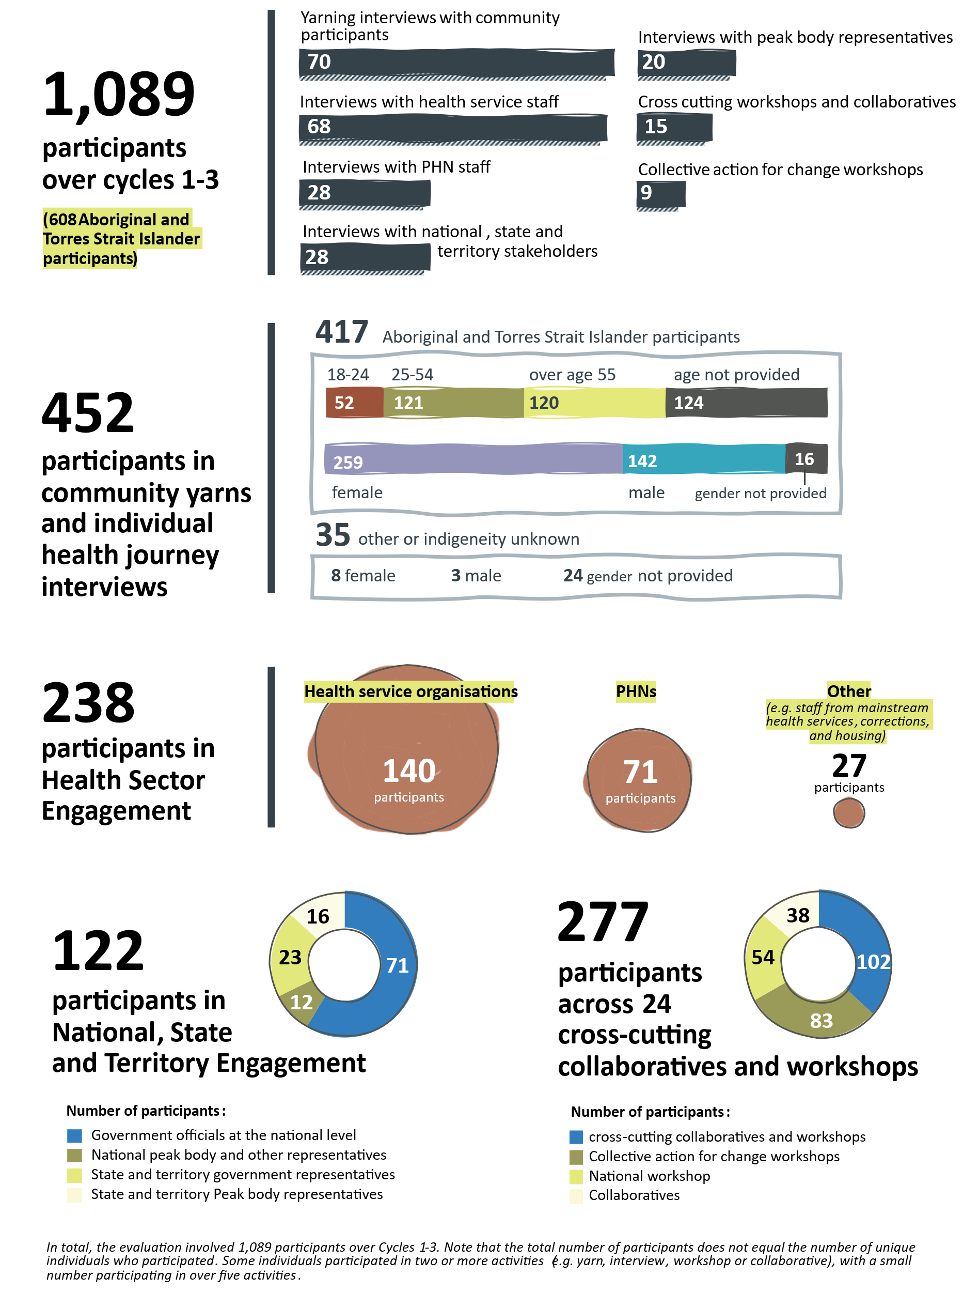
Engagement Snapshot

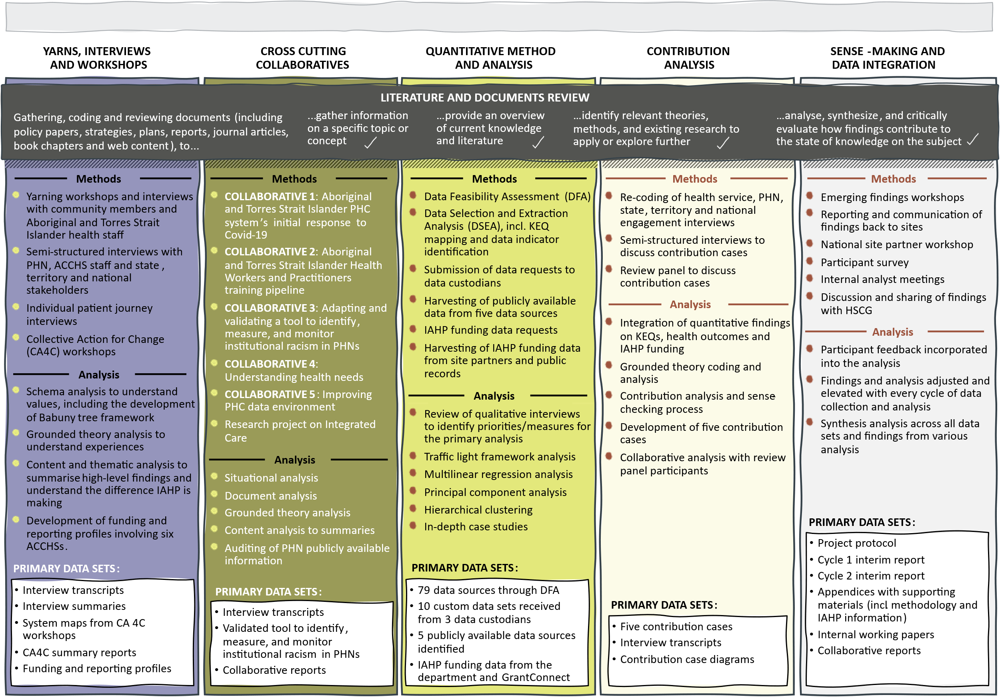
Figure 0-1. Methods, analysis and data set diagram

Summary of key findings
For many people and organisations that contributed to the evaluation, reflecting Aboriginal and Torres Strait Islander ways of understanding health and wellbeing requires a PHC system that adopts a whole of person and whole of life course approach to health and wellbeing.
These findings are built on the qualitative and quantitative data generated across the 3 cycles of the evaluation. The evidence base is shaped by direct experiences and expertise of Aboriginal and Torres Strait Islander people.
The findings focus on the PHC Program of the IAHP, being the delivery of funding to ACCHSs and other organisations to deliver comprehensive PHC to Aboriginal and Torres Strait Islander people. However, the evaluation locates this funding program within the IAHP as a whole and considers the interface between the IAHP and the broader health system to identify findings and recommendations that advance the systems-level focus for the evaluation.
An overview of the key findings identified across the evaluation is included below. Further detail on the evidence supporting these findings is included in the main body of the report.

The IAHP provides critical investment in PHC for Aboriginal and Torres Strait Islander people
The evaluation found that the IAHP is valued for providing essential support to ACCHSs to deliver health care that aligns with what Aboriginal and Torres Strait Islander people value in health care. While there are opportunities to extend the impact of this investment, the evaluation found that without the IAHP, access to comprehensive PHC for Aboriginal and Torres Strait Islander people would be affected as many ACCHSs would no longer be funded to deliver core services to their communities.
The evaluation also found that the IAHP contributes to overall system access and navigation through specific interventions for people with chronic disease.

People value comprehensive, holistic, high-quality health care

Aboriginal and Torres Strait Islander people value holistic, high quality health care that is connected to their communities. Drawing on the resources available, a health service should provide spaces, programs, and services where individual and collective wellness is supported, creating stronger communities, and strengthening health determinants.
Further detail in
Part B - Section 4
Following Aboriginal and Torres Strait Islander ways of understanding holistic, connected health and wellbeing, what people value in health care design and delivery extends to an expectation for the ways government systems and services should work to create the conditions for Aboriginal and Torres Strait Islander people to thrive.
While people shared many different experiences, the evaluation found that many Aboriginal and Torres Strait Islander people were more likely to experience close alignment between what they value for health care design and delivery and the models of care associated with Aboriginal and Torres Strait Islander community-controlled health service delivery.

People do not routinely experience health care that aligns with what they value in health care design and delivery
Primary health care is delivered through a challenging, complex health system. For many Aboriginal and Torres Strait Islander people the disease burden is high and they experience complex care needs. As a result, accessing the care people need to manage their health means engaging in services across the primary, secondary, and tertiary care systems. Many of the services that Aboriginal and Torres Strait Islander people need require them to move beyond the safety net of ACCHSs.
There were diverse experiences reported to the evaluation. The evaluation found that people reported better quality and experiences of care in ACCHSs than in mainstream settings. While the evaluation found that negative experiences were concentrated in mainstream health services, people receiving health care through ACCHSs also reported experiences where the care did not align with what people value in health care design and delivery. These issues were frequently connected to timely access to appointments and services, especially specialist services, and the impacts of workforce issues on cultural safety, quality and continuity of care. These issues are not confined to ACCHSs; people also experienced these issues in mainstream health settings.
Further detail in
Part B - Section 5

ACCHSs carry significant responsibility within their communities
The evaluation found that ACCHSs are relied upon to bring the community together and respond to community wellbeing needs in ways that extend beyond the delivery of services to support physical health. Many Aboriginal and Torres Strait Islander services identified the role that ACCHSs play in supporting health and wellbeing through non-clinical community supports and services. Examples include innovative and creative approaches used by a number of services in the response to COVID-19. There are also many, everyday examples where this caring, creative and community connected approach to service delivery made the difference to health outcomes and the experience of people in their care.
Further detail in
Part C - Section 6
The evaluation found that the critical role of ACCHSs in the community, including health promotion and prevention programs, is not fully enabled in funding through the IAHP. While the IAHP allows services to use funding for health promotion and prevention programs, ACCHSs reported that they needed to prioritise clinical service delivery within available funds. The evaluation found that the level of funding provided through the IAHP does not sufficiently support ACCHSs to deliver the model of care that is valued by Aboriginal and Torres Strait Islander people, which includes a focus on prevention and community wellbeing.
The evaluation found that people valued access to care delivered by Aboriginal and Torres Strait Islander people, and that the roles of Aboriginal and Torres Strait Islander Health Workers and Health Practitioners were particularly valued.

Mainstream health settings cannot reproduce the experience of community-driven, place-based care
Aboriginal and Torres Strait Islander people value holistic PHC delivered in culturally safe ways. In primary care, Aboriginal and Torres Strait Islander people often experience selective PHC driven by a biomedical model. In the broader health system, Aboriginal and Torres Strait Islander people frequently experience a fragmented, under-resourced, culturally insensitive and racist health system.
Further detail in
Part B - Section 5
Part C - Section 6
The supplementary care provided through the Integrated Team Care program for people experiencing chronic disease assists to overcome barriers to accessing health services and contributes to reducing system fragmentation. The evaluation identified a clear opportunity to extend the benefits of this program to reach more Aboriginal and Torres Strait Islander people to assist in preventing the progression of chronic health conditions.

IAHP funding is too low for services to consistently deliver values-aligned care
The evaluation evidence suggests that many funded services do not receive sufficient resourcing to move beyond selective PHC. While the investment in the IAHP has grown, based on the experiences of ACCHSs, the evaluation found that this investment is still not enough to meet the demand for services or deliver the comprehensive, holistic PHC through ACCHSs that aligns with what Aboriginal and Torres Strait Islander people value.
The evaluation found that the current IAHP funding model for the PHC Program does not sufficiently support ACCHSs to deliver services in a way that aligns with the values of the community as limited funding is usually directed towards clinical, episodic care rather than a more holistic approach that focuses on long term health outcomes and preventative care.
Further detail in Part C - Sections 6 and 7
Additionally, despite the flexibility under the PHC Program, the IAHP grant making and reporting arrangements as a whole do not follow approaches to health and wellbeing that are valued by Aboriginal and Torres Strait Islander people. Instead, the prioritisation of disease management and the splintering of funding into clinical responses to specific body parts or physical health issues undermines the ability of ACCHSs to deliver health care that aligns with the values of Aboriginal and Torres Strait Islander people.
The evaluation also identified that accessing funding through the IAHP had enabled many services to attract funding from other sources. The evaluation found that services that had access to multiple sources of funding were more able to respond to community need in a flexible way and were better placed to deliver PHC that aligned with what Aboriginal and Torres Strait Islander people value in health care.

Reporting and administrative burden has improved under the IAHP but remains too onerous for many services
Recent administrative and reporting arrangements for the IAHP have improved and recent changes were welcomed by ACCHSs contributing to the evaluation. This includes extensions to the PHC Program funding agreements, including a shift to 4-year agreements from 1 July 2024, and improved reporting processes. Despite these improvements, the evaluation found that the administrative burden associated with grant making and reporting requirements across multiple funders and programs continues to strain limited resources within ACCHSs. The evaluation found that the IAHP adds to the administrative burden.
Further detail in
Part C - Section 7
The transactional nature of funding and reporting for Aboriginal and Torres Strait Islander health care has a cumulative impact on services. The evaluation found that many funded services do not receive enough support to build capability or enable capacity to use insights from reporting data to contribute to continuous quality improvement processes. The evaluation found limited evidence of how data and knowledge generated through the IAHP was used to inform decision-making by ACCHSs. This was associated with a perception that some data had limited relevance for health service planning and decision-making.

Orientation and role of the IAHP in broader primary care system lacks clarity
The evaluation found that the role of the IAHP within the broader health system could be clearer. While funding through the IAHP is essential to support the core operations of ACCHSs, there is uncertainty about the extent to which funding delivered through the IAHP is intended to deliver the full funding required to make comprehensive PHC available to Aboriginal and Torres Strait Islander people.
The evaluation found that services funded through the IAHP increase the accessibility of PHC through the provision of support to access and navigate health care services. Responsibility for overcoming the barriers and interfaces that exist between systems should be met with resources from the mainstream system rather than relying on the limited pool of funding available through the IAHP. The evaluation found that the IAHP funding should focus on directing funding to ACCHSs to ensure Aboriginal and Torres Strait Islander people have access to comprehensive PHC and receive enough funding to improve health outcomes through direct service delivery that aligns with what Aboriginal and Torres Strait Islander people value.
Further detail in
Part C - Section 7
The evaluation found examples of positive partnerships between PHNs and ACCHSs and promising approaches to the commissioning and delivery of primary care to deliver more integrated health responses for Aboriginal and Torres Strait Islander people.

Administration of the IAHP is not well integrated to the broader health policy and funding landscape
Fragmentation in the delivery of PHC was mirrored in governance and funding arrangements. Participants across all evaluation sites spoke about the challenges of working with the rest of the PHC system. Participants discussed the complex division of funding responsibilities and performance accountabilities between different levels of government and how this impacted service delivery, including services funded through the IAHP.
The evaluation found a lack of system-wide or joined-up policy and practice to support the delivery of PHC that meets the needs of Aboriginal and Torres Strait Islander people. While there is an existing partnership between NACCHO and the department, ACCHSs and other funded organisations reported experiencing isolation from the development and implementation of the IAHP, and that their voices were largely unheard.
Further detail in
Part C - Section 7
The IAHP is administered as a funding mechanism and the evaluation found that there are opportunities to strengthen the integration of the IAHP in overall sector development and government policy decision-making processes. The IAHP funding arrangements are highly transactional which can limit ongoing development of relationships, partnerships between government and the community, or stimulate opportunities for community-led decision-making.
The evaluation identified an opportunity for the First Nations Health Division of the department to strengthen partnerships with community and across government to strengthen primary health care for Aboriginal and Torres Strait Islander people and integrate the role and contribution of IAHP into whole-of-government policy responses.

Client journeys and outcomes are not tracked through data and reporting processes
The evaluation found that the IAHP data and reporting processes do not model Aboriginal and Torres Strait Islander approaches to health and wellbeing. The current approach to data adopts a selective approach to recording and reporting health care information that is not aligned with the holistic, comprehensive model of health valued by Aboriginal and Torres Strait Islander people and services delivered through ACCHSs.
The evaluation found that data and reporting arrangements should adopt appropriate indicators of health and wellbeing that are developed by and for Aboriginal and Torres Strait Islander people to better capture the model of comprehensive PHC and the health outcomes of service users.
Further detail in
Part C - Section 7

There are complex relationships between primary care activity, social determinants of health and health outcomes
The evaluation found that higher levels of primary care activity were associated with people being connected to hospital care. Taken together, primary care activity and access to tertiary care showed a positive impact on mortality (that is, more health service activity was associated with lower mortality).
Across the evaluation sites, just over one-third of nKPIs showed improvement over time while around half indicated no meaningful change over time. The proportion of Aboriginal and Torres Strait Islander people who received a health assessment increased over time, and health assessments were positively associated with other primary care activity (for example, more testing and high immunisation rates) and improvements in health behaviours (for example, reduced smoking).
Further detail in
Part C - Section 8
The evaluation found that, of a number of primary care activity, demographic and socio-economic variables, being in the Northern Territory, remoteness and age were most associated with health outcomes within the evaluation sites. Examining the direction of the associations between these variables, having greater economic resources and higher relative socio-economic outcomes were the most important variables in explaining lower morbidity and mortality. All of the socio-economic measures (education and occupation, economic resources, and socio-economic advantage and disadvantage) were positively associated with normal birthweight.

Looking ahead
The evaluation supports the continued investment in comprehensive PHC through the IAHP. The evaluation also identified opportunities to enhance the current strategic approach to the IAHP, its governance, and operational activities, to achieve meaningful systems change to improve the implementation of the IAHP and to strengthen the appropriateness and effectiveness of comprehensive PHC systems for Aboriginal and Torres Strait Islander people.

Implications of the evaluation findings
The evaluation findings and the evaluative assessment against the KEQs identified the following strategic and program implications to improve the appropriateness and effectiveness of the Australian Government’s investment in PHC for Aboriginal and Torres Strait Islander people through the IAHP:
- Developing a strategic approach to the funding and implementation of the IAHP.
- Embedding self-determination and genuine partnerships.
- Delivering resourcing that matches need and ambition.
- Supporting the delivery of mainstream services by Aboriginal and Torres Strait Islander people and organisations.
- Putting the values and experiences of Aboriginal and Torres Strait Islander people at the centre of program design and service delivery.
- Enhancing the use of data and information to support improved outcomes, continuous quality improvement and decision-making.

Recommendations
The evaluation recommendations identify opportunities to advance the contribution of the IAHP to improving health and wellbeing outcomes for Aboriginal and Torres Strait Islander people consistent with the Priority Reforms under the National Agreement on Closing the Gap and the objectives of the IAHP.
At the centre of the National Agreement are 4 Priority Reforms designed to change the way governments work with Aboriginal and Torres Strait Islander people. The National Agreement makes a commitment to changing the way that governments work to deliver the outcomes required to close the gap for Aboriginal and Torres Strait Islander people. The Priority Reforms aim to:
- Strengthen and establish formal partnerships and shared decision-making.
- Build the Aboriginal and Torres Strait Islander community-controlled sector.
- Transform government organisations so they work better for Aboriginal and Torres Strait Islander people.
- Improve and share access to data and information to enable Aboriginal and Torres Strait Islander communities to make informed decisions.
The evaluation has adopted the framework of the Priority Reforms to structure the recommendations to foster strong alignment between the ongoing implementation of the IAHP, the implementation of the recommendations, and whole-of-government action to support Closing the Gap.
The recommendations in this evaluation report have been shaped by deep engagement and discussion with Aboriginal and Torres Strait Islander health service and PHN site evaluation partners over the course of the evaluation.
The evaluation recommends that the department continue to invest in the delivery of comprehensive PHC for Aboriginal and Torres Strait Islander people through the IAHP. This recommendation provides the foundation for recommended changes to the administration and governance of the IAHP to improve its impact on health outcomes for Aboriginal and Torres Strait Islander people. The continued funding of PHC through the IAHP recognises:
- The contribution of comprehensive PHC for Aboriginal and Torres Strait Islander people.
- The value placed on comprehensive PHC delivered by Aboriginal and Torres Strait Islander people for Aboriginal and Torres Strait Islander people.
- The enduring barriers for Aboriginal and Torres Strait Islander people who access health services in mainstream settings.

The evaluation found that the improvements required to make faster and more lasting progress toward improving health and wellbeing for Aboriginal and Torres Strait Islander people are:
- Formal partnerships and shared decision-making – an increased emphasis on self-determination and responsiveness to local need, through strengthening of governance, policy, decision-making and engagement processes and shared decision-making with Aboriginal and Torres Strait Islander people in the design and delivery of IAHP.
- Building the community-controlled sector – increased investment in PHC through an approach to the IAHP that fully scopes and delivers the investment required to deliver comprehensive PHC and to accelerate improvements to health and wellbeing for Aboriginal and Torres Strait Islander people through strengthening the community-controlled sector.
- Transforming government organisations – purposeful integration of the IAHP with health system governance and reducing system fragmentation through supporting integrated models of care, and building processes for information sharing and collaboration.
- Shared access to data and information at a regional level – better use of knowledge and information to track and monitor outcomes, support continuous quality improvement and decision-making.
The evaluation also recommends creating ongoing governance and administrative conditions for the IAHP to achieve its objectives and to ensure IAHP implementation success.
There are 13 recommendations developed to build on the strengths of the existing investment and ensure the IAHP is well positioned to contribute to whole of government activity to eliminate health inequality and deliver improved health outcomes for Aboriginal and Torres Strait Islander people. The recommendations cover changes, actions and improvements to support faster progress towards improving the health and wellbeing of Aboriginal and Torres Strait Islander people. This includes:
- recommendations to strengthen the design and implementation of the IAHP
- recommendations to strengthen the health system context in which the IAHP operates – action on these recommendations will support the delivery of PHC services funded through the IAHP.

Foundational recommendation
1
The Department of Health and Aged Care continue to invest in the delivery of comprehensive PHC services to Aboriginal and Torres Strait Islander people through the IAHP.
Continuation of this targeted investment recognises:
- The importance of comprehensive PHC for Aboriginal and Torres Strait Islander people.
- The value placed on comprehensive PHC delivered by Aboriginal and Torres Strait Islander people for Aboriginal and Torres Strait Islander people.
- The enduring barriers for Aboriginal and Torres Strait Islander people who access health services in mainstream settings.
 | Immediate term – Ongoing

Recommendations: Formal partnerships and shared decision-making
2
The Department of Health and Aged Care to strengthen the alignment of the IAHP to a shared decision-making partnership with Aboriginal and Torres Strait Islander people.
To enable greater self-determination in the IAHP, the Department of Health and Aged Care to embed shared decision-making at the whole-of-program level. The shared decision-making partnership will strengthen co-design processes, and bring increased coherency, capability, transparency and accountability to decision-making relating to the funding of programs and activities through the IAHP.
In implementing this recommendation, the evaluation suggests:
- Growing and adapting existing partnerships to embed shared decision-making relating to the IAHP, rather than creating a new partnership arrangement specifically for the IAHP.
- Strengthening the connections between the IAHP and existing health reforms and priorities, including priorities in the National Agreement on Closing the Gap and the National Aboriginal and Torres Strait Islander Health Plan.
- Ensuring the composition of the partnership includes Aboriginal and Torres Strait Islander people with expertise in health service management, primary care clinical roles, public health, policy making, consumer experience and cultural expertise.
- Reporting directly to the executive level of the Department of Health and Aged Care to support increased accountability for the delivery of improved health and wellbeing outcomes for Aboriginal and Torres Strait Islander people.
- Creating accountability measures and processes based on the advice of Aboriginal and Torres Strait Islander people to support tracking and regular reporting on IAHP funding and program impacts and outcomes.
Immediate term
3
Co-design an investment strategy for the IAHP to improve access to comprehensive PHC and health and wellbeing outcomes for Aboriginal and Torres Strait Islander people.
To ensure the IAHP achieves its objectives and supports the delivery of significant health and whole-of-government policy commitments to improve outcomes for Aboriginal and Torres Strait Islander people, the Department of Health and Aged Care co-design an investment strategy for the IAHP with Aboriginal and Torres Strait Islander people.
The investment strategy should define the purpose and expected outcomes of the IAHP, as well as its theory of change – or the strategy, actions, conditions and resources required to facilitate change and achieve the agreed purpose and expected outcomes. The investment strategy needs to position the IAHP within the wider PHC system context, including other investments to improve the delivery of comprehensive PHC for all Aboriginal and Torres Strait Islander people. The strategy is intended to guide IAHP investments, including how funding will be mobilised, within the context of the wider PHC system.
In implementing this recommendation, the evaluation suggests:
- Ensuring that the IAHP investment strategy is connected to the realisation of Closing the Gap targets by 2031.
- Recognising that meeting existing policy commitments to improve outcomes will require substantial increased investment in Aboriginal and Torres Strait Islander comprehensive PHC.
- Increasing investment in comprehensive PHC through the IAHP is expected to support increased prevention and early intervention activity for Aboriginal and Torres Strait Islander people which will reduce the impact of chronic health conditions on the public health system as a whole.
- Ensuring that the investment required to achieve the IAHP’s objectives and outcomes reflects:
- commitments to grow, support and retain the Aboriginal and Torres Strait Islander health workforce, consistent with the National Aboriginal and Torres Strait Islander Health Workforce Strategic Framework and Implementation Plan
- commitments to building the Aboriginal and Torres Strait Islander community-controlled sector, consistent with the National Agreement on Closing the Gap
- differences in service delivery across different community and geographical settings
- changes in the costs of service delivery across different community and geographical settings, including changes in population health needs.
This recommendation supports action that is consistent with the realisation of commitments to improving health outcomes under the National Agreement on Closing the Gap and the National Aboriginal and Torres Strait Islander Health Plan through ensuring that health services are appropriately resourced to achieve these policy commitments
Immediate – Medium term

Recommendations: Building the community-controlled sector
4
Continue to invest in improved health and wellbeing outcomes for Aboriginal and Torres Strait Islander people through increasing IAHP funding to support the delivery of Aboriginal and Torres Strait Islander community-controlled comprehensive PHC.
To enable ACCHSs to fully implement their model of comprehensive PHC and meet the health and wellbeing needs of their communities, the Department of Health and Aged Care to build on the strength of the IAHP by directing additional resourcing to community-controlled health services.
In implementing this recommendation, the evaluation suggests:
- Increasing the focus of the IAHP on funding programs and activities delivered by ACCHSs.
- Increasing the amount and the proportion of the IAHP funding allocated under the PHC Program (to address current policy commitments and population health needs the rate of funding increase needs to be significantly more than the current commitment of 3% per year).
- Ensuring that IAHP funding contributes to the growth and stability of ACCHSs, including the scope of services provided in relation to cultural and other health determinants.
- Ensuring that IAHP funding supports ACCHSs to function well through strengthening organisational governance, management and other ‘back-office’ functions that support the delivery of high-quality care.
- Considering fully funding ACCHSs that rely significantly on the IAHP as their primary funding source to ensure existing service capacity is invested in service delivery instead of additional fund-raising.
This recommendation supports action that is consistent with the development of the Core Services and Outcomes Framework, and commitments in the Health Sector Strengthening Plan to develop a needs-based funding model.
Medium term
5
Increase investment to support the development of a strong and stable Aboriginal and Torres Strait Islander PHC workforce.
To ensure a strong and stable workforce is available to support the delivery of community-controlled PHC services funded through the IAHP, the Department of Health and Aged Care to coordinate across the department (and with other government agencies with accountability for workforce training and regulation), to secure and build investment and improve conditions of employment for the Aboriginal and Torres Strait Islander PHC workforce.
In implementing this recommendation, the evaluation suggests:
- Undertaking a pay parity review, and subsequently acting on the review’s findings, to better understand salary inequities for Aboriginal and Torres Strait Islander Health Workers and Health Practitioners working in different workplace settings, including ACCHSs and mainstream health services.
- Strengthening incentives for employing, training and retaining a larger and more diverse (for example, gender diversity and across a range of roles) Aboriginal and Torres Strait Islander health workforce (for example, recognising skills, training, unique roles and cultural load through micro-credentialling and conditions of employment).
- Continuing to factor in costs associated with community-controlled health services hosting Aboriginal and Torres Strait Islander health worker trainees who require supervision and mentoring.
- Considering the need to also grow and sustain the Aboriginal and Torres Strait Islander health workforce across mainstream services.
Medium term
6
Support ACCHSs to connect regionally with other organisations to build partnerships and alliances that strengthen the community-controlled sector.
To enable community-controlled health services to build capability and support more integrated ways of working, funding through the IAHP to support ACCHSs to continue to lead the development of formal partnerships and alliances at a regional level. These partnerships and alliances may target different health system enablers – such as service delivery, governance, workforce, information and data sharing – that strengthen the operational context for the IAHP.
In implementing this recommendation, the evaluation suggests:
- Considering the role of the IAHP in addressing funding requirements to support ACCHSs to engage in formal partnerships.
- Respecting ACCHSs rights to determine partnership arrangements (not forcing partnerships through conditional funding or other mechanisms).
- Considering the benefits of supporting partnerships that go beyond ACCHSs (for example, between ACCHSs and mainstream organisations such as PHNs and local hospital networks).
Medium term
7
Increase the flexibility and coherency of funding, including through the IAHP, to support the delivery of comprehensive PHC to Aboriginal and Torres Strait Islander people and communities.
To further enable self-determination and more streamlined and integrated policy responses to Aboriginal and Torres Strait Islander comprehensive PHC, the Department of Health and Aged Care to coordinate across the department (and with other funders of comprehensive PHC) to develop more flexible and coherent funding and reporting systems. This will strengthen the alignment between the IAHP and other government funding programs.

In implementing this recommendation, the evaluation suggests:
- Developing needs-based and outcomes-based approaches to IAHP funding that accommodate flexibility in how services and activities are delivered and empowers decision-making at the community level. Under outcomes-based approaches, funded organisations would be required to deliver, and report against, pre-defined outcomes. There would be flexibility in how these outcomes were achieved.
- Maintaining a level of prescription to how services and activities are delivered where the model of care is supported by contextually-relevant evidence.
- Identifying opportunities to work across governments and government-funded services to develop more integrated approaches to funding PHC.
- Strengthening the delivery of comprehensive PHC by re-integrating social and emotional wellbeing and alcohol and drug program funding into the IAHP.
- Reviewing reporting frameworks for government funding provided to the ACCHS sector to identify opportunities to minimise and/or streamline reporting requirements while maintaining accountability (for example, strengthening of outcomes-based performance measures, consistent reporting timeframes and language, reducing redundancy, and opportunities for digitalisation.
- Designing reporting requirements for new programs and activities in partnership with providers ACCHSs to account for context of their overall reporting requirements and so that opportunities to streamline with existing reporting is maximised.
This recommendation recognises the comparative strengths of the IAHP within a complex funding system across multiple governments (Australian, state and territory) and agencies, and the opportunity to build on the strengths and the experience of the IAHP to support further improvement across government agencies involved in funding Aboriginal and Torres Strait Islander health services.
Immediate – Medium term

Recommendations: Transforming government organisations
8
Support partnerships between mainstream health organisations and Aboriginal and Torres Strait Islander people to improve the delivery of culturally safe and responsive services across the health system.
To improve the safety and responsiveness of mainstream health services and improve health and wellbeing outcomes across the patient journey, the Department of Health and Aged care to work with state and territory governments and Aboriginal and Torres Strait Islander people and organisations to partner in health service governance, commissioning, and delivery processes.
In implementing this recommendation, the evaluation suggests additional funding be made available by the department to enable:
- Partnerships between mainstream services, PHNs and Aboriginal and Torres Strait Islander organisations and people to identify opportunities to influence outcomes for Aboriginal and Torres Strait Islander people across the patient journey.
- Strengthened participation of Aboriginal and Torres Strait Islander people in governance and leadership arrangements in mainstream health services, including local hospital networks.
- Increased leadership and participation by Aboriginal and Torres Strait Islander communities in the commissioning of mainstream health services that are used by Aboriginal and Torres Strait Islander people, including in assessing needs, planning services, procuring services and monitoring the quality of services.
- The development of health service and operational responses that improve the quality, appropriateness and integration of care across health service settings. This may include, for example, partnerships between ACCHSs and local hospital networks to facilitate integrated care arrangements, including, where appropriate, the transfer of specific, hospital-based services to community-controlled health services.
- Increased investment in the ITC program to strengthen the ability of ACCHSs to support patients’ journeys through the health system. This may involve expanding eligibility under the ITC program to increase access to support services, including services across the patient journey such as hospital and outpatient care.
This recommendation is consistent with recommendations by the Strengthening Medicare Taskforce to grow and invest in ACCHSs to commission primary care services for their communities; and to support local health system integration and person-centred care through PHNs working with local hospital networks, local practices, ACCHSs, pharmacies and other partners to facilitate integration of specialist and hospital services with primary care, and integrate primary care with mental health, aged care, community and disability services.
Medium – Long term

9
The Department of Health and Aged Care to strengthen Aboriginal and Torres Strait Islander health policy capability and capacity across the department, including in the specialist First Nations Health Division, to support shared policy decision-making, governance and accountability processes.
To strengthen the administration of the IAHP and embed health policy expertise and capability that enables the Department of Health and Aged Care to maintain strong and effective partnerships with Aboriginal and Torres Strait Islander people, the department continue to build Aboriginal and Torres Strait Islander health policy capability, including through a dedicated team.
In implementing this recommendation, the evaluation suggests:
- Strengthening workforce strategies to attract and retain staff with experience and expertise in Aboriginal and Torres Strait Islander health care and programs, including as a priority, Aboriginal and Torres Strait Islander staff.
- Embedding and practising cultural safety within the First Nations Health Division and across the Department of Health and Aged Care to support culturally responsive decision-making, stronger relationships and understanding of key issues affecting the administration of the IAHP and the delivery of PHC to Aboriginal and Torres Strait Islander people.
- Improving engagement with Aboriginal and Torres Strait Islander funded organisations and communities to build collaborative relationships and understand context specific issues affecting local service delivery.
- Strengthening formal connections between Aboriginal and Torres Strait Islander health policy expertise in the department and in Aboriginal and Torres Strait Islander peak bodies and ACCHSs.
- The First Nations Health Division continue to focus on engagement across the Department of Health and Aged Care and with central agencies to ensure collective responsibility for health outcomes for Aboriginal and Torres Strait Islander people.
- Strengthening Aboriginal and Torres Strait Islander health expertise at the most senior levels of departmental leadership and decision-making.
This recommendation is consistent with existing commitments in the National Agreement on Closing the Gap to transform government organisations, and the value identified in the evaluation of having a specialist, dedicated Aboriginal and Torres Strait Islander division (the First Nations Health Division) within the Department of Health and Aged Care.
Immediate term – Ongoing
10
The Department of Health and Aged Care to work with PHNs to strengthen the PHC system to improve care for Aboriginal and Torres Strait Islander people.
To continue to transform PHNs to be more accountable, culturally safe and responsive to the needs of Aboriginal and Torres Strait Islander people, the Department of Health and Aged Care to support and encourage PHNs to improve commissioning processes and the integration of local health care services.

In implementing this recommendation, the evaluation suggests:
- Supporting PHNs to strengthen governance and accountability processes for organisational transformation, including involving Aboriginal and Torres Strait Islander people and organisations in leadership and governance arrangements.
- Ensuring PHN commissioning processes are transparent and responsive to the identified needs of Aboriginal and Torres Strait Islander people within their community.
- Supporting PHNs and ACCHSs to engage in health service co-commissioning processes.
- Supporting alliances between PHNs, mainstream health services and Aboriginal and Torres Strait Islander organisations, communities and people, including through adequate resourcing to engage in collaboration and co-design activity.
- Ensuring outcomes and indicators in the PHN Program Performance and Quality Framework reflect the Priority Reforms in the National Agreement on Closing the Gap.
This recommendation is consistent with a recommendation in the Strengthening Medicare Taskforce to strengthen the role of PHNs to support the adoption of successful, locally designed models of care.
Medium term

Recommendations: Shared access to data and information at a regional level
11
Invest in Aboriginal and Torres Strait Islander communities to lead community health needs assessments to strengthen decision-making on health service planning, design and delivery.
To enable improved locally-responsive decision-making to support the planning, design and delivery of the IAHP and other programs and activities, the Department of Health and Aged Care to fund ACCHSs to lead health needs assessments in their local communities.
In implementing this recommendation, the evaluation suggests:
- Enabling Aboriginal and Torres Strait Islander communities to define the measures, processes and reporting for health needs assessments, and data capture, knowledge transfer and other reporting and accountability processes.
- Making sure that the IAHP and other funding programs are responsive to the outcomes of health needs assessments.
- Supporting the capacity of ACCHSs to collect and use data relating to health needs in their communities (for example, for CQI processes and to support service design and improvement), and to exercise their sovereignty over how data is used and interpreted (for example, whether it contributes to a PHN or local hospital network health needs assessment).
- Providing Aboriginal and Torres Strait Islander communities with access to locally-relevant data and information to support their health needs assessments, consistent with commitments to Indigenous Data Sovereignty and Indigenous Data Governance.
- Supporting ACCHSs (for example, through resources and training) to participate in research to generate evidence in relation to comprehensive PHC services and delivery.
This recommendation supports action that is consistent with the development of the needs assessment and outcome component of the Core Services and Outcomes Framework. This component is under development.
Medium – Long term
12
Improve the relevance and use of IAHP data and reporting processes to support shared accountability and decision-making on health service planning, design and delivery.
To strengthen the relevance and use of IAHP data, the Department of Health and Aged Care to work with the Aboriginal and Torres Strait Islander communities to ensure that IAHP data and reporting processes reflect ACCHSs’ models of care and community aspirations for health and wellbeing.
In implementing this recommendation, the evaluation suggests:
- Revising the nKPIs to broaden its focus to capture additional indicators that are useful for communities, including outcomes and people’s experience of care, and the practice of community control. This would include reviewing and managing the reporting burden and resourcing required to capture and report on additional indicators.
- Increasing transparency around the purpose of the IAHP data collections (nKPIs and OSR) and communicating to ACCHSs and communities when and how this data is used by the department.
- Ensuring all IAHP data uphold principles of Indigenous Data Sovereignty and Indigenous Data Governance.
Medium term

Recommendation: Ensuring IAHP implementation success
13
The Department of Health and Aged Care to provide active and continuous leadership and management of the ongoing implementation of the IAHP, including regular reporting to partners on progress against the co-design investment strategy.
To ensure that the IAHP is successful and achieves its objectives, the Department of Health and Aged Care to strengthen processes to support early, informed and systematic consideration of program issues, including the identification of actions and recommendations to inform program growth and improvement.
In implementing this recommendation, the evaluation suggests:
- Ensuring the proposed shared decision-making partnership has oversight of the ongoing implementation of the IAHP.
- Identifying and actively managing risks to the continued implementation of the IAHP.
- Identifying partners and stakeholders and how they will be engaged, including through co-design processes.
- Identifying resource requirements and managing constraints early.
- Establishing effective monitoring, review and evaluation processes to support active management of the ongoing implementation of the IAHP.
- Publishing outcome measures for the IAHP and performance against these to increase program transparency.
- Establishing annual measurement and reporting of government investment in the IAHP and in Aboriginal and Torres Strait Islander PHC.
Immediate term – Ongoing

Part A: Background

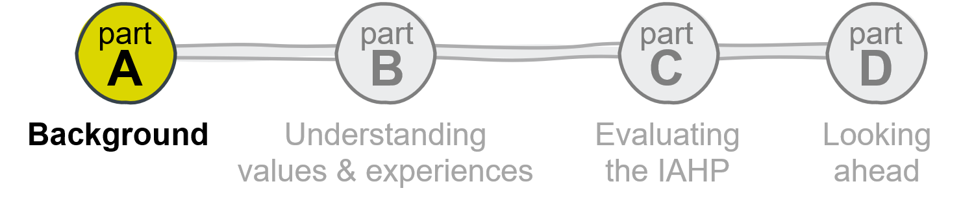
Overview of Part A
This Part sets out the background to the evaluation and key policy and administrative context for the operation of the IAHP. Part A includes the following sections:
- Section 1 – Introduction sets out the purpose and objectives of the IAHP, the National Agreement on Closing the Gap, the evaluation process, and the background and context for the IAHP and the evaluation. It outlines the role of PHC and the key policy frameworks and commitments that influence the landscape for primary health services for Aboriginal and Torres Strait Islander people.
- Section 2 – Evaluation methodology sets out the methodology for the evaluation, including the approach to the collection and analysis of qualitative and quantitative data.
- Section 3 – Understanding the IAHP provides detailed information about the IAHP, including the funding arrangements, activities and programs that are funded under the IAHP, and the overall investment in the IAHP.
The core purpose of Part A is to introduce important policy, operational and funding context to situate the analysis and findings of the evaluation that follow in Parts B and C.

Introduction
This report sets out the findings and recommendations of the 6-year evaluation of the Australian Government’s investment in Aboriginal and Torres Strait Islander PHC through the Indigenous Australians’ Health Programme (IAHP).
The Australian Government commissioned this evaluation of the IAHP to support improvements to the IAHP, to improve Aboriginal and Torres Strait Islander peoples’ health and wellbeing, and to meet targets under the National Agreement on Closing the Gap (Coalition of Aboriginal and Torres Strait Islander Peak Organisations and Australian Governments (COAG), 2020a).

About the IAHP
The IAHP is the overarching Aboriginal and Torres Strait Islander health program of the Commonwealth Department of Health and Aged Care (the department). The IAHP is a funding program that supports PHC for Aboriginal and Torres Strait Islander people. Through the IAHP, the Australian Government funds Aboriginal Community Controlled Health Services (ACCHSs), state and territory-managed primary care services, Primary Health Networks (PHNs), other non-government organisations and mainstream health services.
The objective of the IAHP is to ensure Aboriginal and Torres Strait Islander people have access to effective, high quality, comprehensive, and culturally appropriate PHC services in urban, regional, and remote locations across Australia. The program recognises that access to effective, high quality, comprehensive and culturally appropriate PHC is essential to closing the gap and improving health outcomes for Aboriginal and Torres Strait Islander people.
The IAHP was originally formed through the consolidation of 4 existing funding streams for Aboriginal and Torres Strait Islander health. These predecessor programs were:
- primary health care funding
- child and maternal health programs
- Stronger Futures in the Northern Territory (Health)
- programs covered by the Aboriginal and Torres Strait Islander Chronic Disease Fund.
Over time, the operation of the IAHP has evolved to accommodate new and emerging health priorities through a variety of programs and activities focused on local health needs, as well as targeted responses to particular health issues and activity across the life course. IAHP programs and activities are configured across 5 key themes:
- Comprehensive PHC, through funding Aboriginal Community Controlled Health Services and other health services to deliver PHC to Aboriginal and Torres Strait Islander people.
- Improving access to PHC, by increasing the capacity of ‘mainstream’ health care services to provide culturally appropriate care and by improving outreach, coordination and referral services to connect Indigenous Australians to the full range of services appropriate to their health needs.
- Targeted health activities such as anti-smoking, mental health, eye and ear health, blood borne viruses and sexually transmitted infections, chronic conditions such as diabetes, renal disease, cancer, heart disease, respiratory disease and rheumatic heart disease.
- Capital works, including upgrading and maintenance of IAHP funded PHC facilities and residential staff accommodation.
- Governance and system effectiveness, including funding of information systems, system support, data, evaluation, and continuous quality improvement.
The IAHP also seeks to influence the health system more broadly so that it works well for Aboriginal and Torres Strait Islander people. The IAHP is expected to contribute to the Priority Reforms and targets under the National Agreement on Closing the Gap.
Under the IAHP, the department provides around $1 billion each year to services and programs across Australia.
More detail about the operation of the IAHP is included in Section 3.

About the National Agreement on Closing the Gap
The objective of the National Agreement on Closing the Gap is to enable Aboriginal and Torres Strait Islander people and all governments to work together to overcome the inequality experienced by Aboriginal and Torres Strait Islander people, and to achieve life outcomes equal to all Australians.
The National Agreement recognises that Aboriginal and Torres Strait Islander people have been saying for a long time that:
- they need to have a much greater say in how the programs and services are delivered to their people, in their own places, and on their own Country.
- community-controlled organisations deliver the best services and outcomes for Closing the Gap.
- government agencies and institutions need to address systemic, daily racism and promote cultural safety and transfer power and resources to communities.
- they need to have access to the same information and data as governments to drive their development.
At the centre of the National Agreement are 4 Priority Reforms that focus on changing the way governments work with Aboriginal and Torres Strait Islander people.

The 4 Priority Reforms are:
- Formal partnerships and shared decision-making.
- Building the community-controlled sector.
- Transforming government organisations.
- Shared access to data and information at a regional level.
The National Agreement on Closing the Gap makes a commitment to take tangible, measurable action to meet targets that reduce the enduring inequality experienced by Aboriginal and Torres Strait Islander people. This includes addressing the structural drivers of health and social inequalities that contribute to lower life expectancy and high rates of chronic health conditions in Aboriginal and Torres Strait Islander people.
The National Agreement is intended to reflect a new approach so that policy making that impacts on the lives of Aboriginal and Torres Strait Islander people is done in full and genuine partnership between government and Aboriginal and Torres Strait Islander people. It recognises that changing the way that governments work and listen to the voices and aspirations of Aboriginal and Torres Strait Islander people is essential to shifting the future and closing the gap for Aboriginal and Torres Strait Islander people.
Relevant updates and changes to the National Agreement are agreed by Joint Council, comprised of the Coalition of Peaks organisations, federal, state and territory governments and land councils' representatives.
Improvements to the delivery of PHC for Aboriginal and Torres Strait Islander people is one of a collection of actions designed to close the gap on life expectancy.
There are 3 outcomes specifically relevant to this evaluation given the role and responsibilities of the department. These outcomes and their associated targets and current state are shown in Table 1-1.
Table 1-1. Health-related Closing the Gap outcomes, targets, and current state
Outcome | Target | Current state (March 2023)
1: Aboriginal and Torres Strait Islander people enjoy long and healthy lives | Close the Gap in life expectancy within a generation, by 2031 | Improvement but not on track to be met
2: Aboriginal and Torres Strait Islander children are born healthy and strong. | By 2031, increase the proportion of Aboriginal and Torres Strait Islander babies with a healthy birthweight to 91% | Improvement but not on track to be met
14: Aboriginal and Torres Strait Islander people enjoy high levels of social and emotional wellbeing | Significant and sustained reduction in suicide of Aboriginal and Torres Strait Islander people towards zero | Worsening

The most recent report on the implementation of the National Agreement found that, once again, key targets will not be met.
These Closing the Gap reports tell the same story of failure every year.
Pat Turner, Chair, Coalition of Peaks

About this evaluation
The aim of this evaluation was to strengthen the appropriateness and effectiveness of comprehensive PHC systems for Aboriginal and Torres Strait Islander people and communities. The objectives of this evaluation were to:
- develop an improved understanding of consumers’ and health care providers’ perspectives and experiences of the health system in terms of what they value
- evaluate the appropriateness and effectiveness of the Australian Government’s investment in Aboriginal and Torres Strait Islander PHC considering the broader PHC system in a range of contexts
- support informed policy, planning, and decision-making that will enable improvements to be incorporated into the IAHP as it is implemented through practical, timely and evidence-based findings and recommendations.
The evaluation involved in-depth engagement with over 1000 participants across Australia, including community members and staff in 37 partner organisations within 17 evaluation sites, and with representatives of state, territory, and national organisations. The evaluation sites and site partner organisations are shown in Figure 1-1.

Figure 1-1. Evaluation sites and site partner organisations
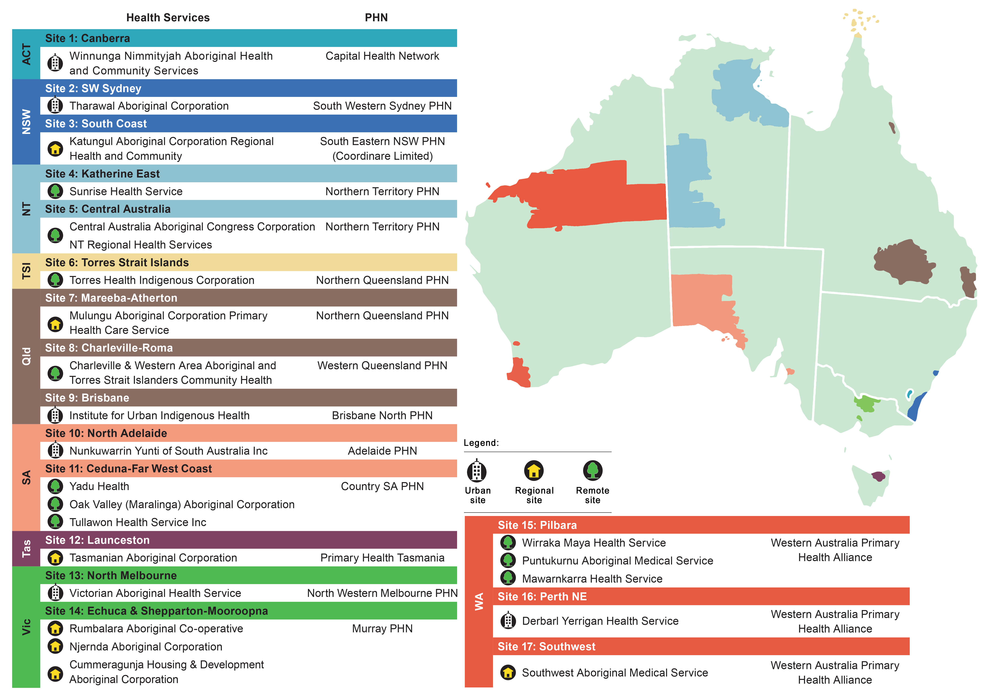

Evaluation focus and scope
The evaluation focused on the IAHP PHC Program which funds organisations to deliver high quality, comprehensive, and culturally appropriate PHC. However, the evaluation locates the PHC Program within the context of the IAHP as a whole (investments across the 5 themes) and nested within the wider PHC and health systems. This involved evaluating how well the PHC Program and the IAHP:
- enables health services to provide better comprehensive PHC for Aboriginal and Torres Strait Islander people
- interacts with and influences other parts of PHC and wider health systems to provide better comprehensive PHC for Aboriginal and Torres Strait Islander people.
The approach to the evaluation and the consideration of the IAHP as an element within the broader health system was deliberate and ensures a systems approach is adopted. This systems level approach was specified by the department and supported by participants.
... we should maximise this evaluation to speak to that sort of key policy framework that's been set under Closing the Gap .… I know I'm talking like big picture stuff, but I just think that unless we get this, these fundamental changes, we're going to still have conversations about why can't we get discharge care planning happening between the hospital and primary health care services. You know, we need we actually need key drivers, system enablers, that are going to, that will push people, nudge people into making those changes, not leave it at a local level to sort out.
ACCHS, Remote location
That’s why everyone is keen to provide feedback to an evaluation that is actually looking at the broader system, because in some ways it’s almost the only place that can be fixed.
PHN, Metropolitan location
Importantly, while many of the health services and organisations funded by the IAHP are Aboriginal Community Controlled Health Services, this was not an evaluation of the services delivered by ACCHS. Rather, this evaluation was about the funding mechanism that supports the delivery of PHC to Aboriginal and Torres Strait Islander people and how this contributes to outcomes for Aboriginal and Torres Strait Islander people within the broader health system.
This evaluation report builds on previous reports developed as part of evaluation processes. A description of these reports is included in Final Report Supporting Material: Appendix B.
More information about the specific methodology for the evaluation is included in Section 2 and Final Report Supporting Material Appendix C.

Context for the evaluation
To ensure the evaluation was responsive and adapted to its context and objectives, it was essential to understand the IAHP and the key evaluation questions within the context of the PHC system in Australia. This includes understanding the approaches and values of Aboriginal and Torres Strait Islander people to health and wellbeing.
This section provides background and context to the IAHP and the evaluation. It includes the various government commitments and frameworks supporting the operation of the PHC system and specific initiatives designed to support the National Agreement on Closing the Gap and improved health outcomes for Aboriginal and Torres Strait Islander people.

About primary health care

The role of primary health care
Facilitating improved health outcomes through accessible, effective, and efficient PHC services is fundamental to reducing health inequalities between Aboriginal and Torres Strait Islander people and other Australians.
According to the World Health Organization, ‘primary health care is a whole-of-society approach to effectively organise and strengthen national health systems to bring services for health and wellbeing closer to communities (World Health Organization & United Nations Children’s Fund (UNICEF), 2018a). This includes 3 key components.
- Integrated health services to meet people’s health needs throughout their lives.
- Addressing the broader determinants of health through multisectoral policy and action.
- Empowering individuals, families and communities to take charge of their own health (World Health Organization & United Nations Children’s Fund (UNICEF), 2018a).
Comprehensive PHC is a core part of any health system. International evidence suggests that a strong PHC system correlates with better health outcomes, a reduced national health care expenditure, and lower infant mortality rates (Bailey et al., 2018; Davy et al., 2016a; World Health Organization & United Nations Children’s Fund (UNICEF), 2018a).
There is also evidence that PHC contributes to reduced morbidity from chronic disease through primary, secondary, and tertiary prevention, and appropriate referral and follow-up (Zhao et al., 2013). Increased PHC resources also offset some of the harmful effects of socio-economic disadvantage and inequality.

Primary health care service delivery in Australia
In Australia, primary care refers to ‘those services in the community that people go to first for health care: general practices, ACCHSs, community pharmacies, allied health services, mental health services, drug and alcohol services, community health and community nursing services, maternal and child health services, sexual health services and oral and dental services’ (Australian Department of Health and Aged Care, 2022a).
The responsibility for PHC service delivery is shared across governments. Broadly, the Australian Government is responsible for setting national policy, the arrangement for Medicare, the funding of pharmaceuticals through the Pharmaceutical Benefits Scheme, and funding community controlled Aboriginal and Torres Strait Islander primary health care.
State and territory governments manage the public hospital system and regulate the private hospital system, as well as responsibility for arranging public, community -based and primary health services (including mental health, dental health, and drug and alcohol services). Local governments deliver some community-based health and support services, including public health and health promotion activities. There are several responsibilities shared across government, including workforce regulation, education and training, safety and quality of health care, and the funding of Aboriginal and Torres Strait Islander health services.

Primary health care for Aboriginal and Torres Strait Islander people
For many Aboriginal and Torres Strait Islander people, PHC is anchored in culture and requires an intimate knowledge of the community and its health problems, active community participation to address these health problems, and promotive, preventive, curative and rehabilitative services (National Aboriginal Community Controlled Health Organisation, 2021a).
Aboriginal and Torres Strait Islander knowledge systems and ways of advancing health and wellbeing in their communities are not aligned with the dominant Western knowledge systems and structures that influence the current design, funding, and delivery of PHC in Australia.
… under the Aboriginal model of care it's holistic, it's from birth to death and it encompasses everything. Your emotional wellbeing, your cultural wellbeing, your spiritual wellbeing, your physical wellbeing, your community, your family.
State or territory peak body
… the primary health care way of looking is not a black way of looking …. Aboriginal way of looking is your housing, your education, your drug and alcohol, your dental, you know, approach it's everything. But with this funding, it's strictly this is what you're delivering as a clinical primary setting that's a full stop. And drug and alcohol does not come into it, dentistry not come into it, dialysis don't come into it.
ACCHS, Remote location
The findings about what Aboriginal and Torres Strait Islander people value about health care is included in Section 4.

Aboriginal and Torres Strait Islander community-controlled health organisations have a critical role in the delivery of PHC to Aboriginal and Torres Strait Islander people in rural, remote, and urban settings. Significant funding for Aboriginal and Torres Strait Islander primary health care is provided to ACCHSs through the IAHP. Other primary health programs that support primary health care for Aboriginal and Torres Strait Islander people through the department (Australian Department of Health and Aged Care, 2022d) include:
- Primary Health Networks across Australia to improve access to coordinated care, including the improvement of Aboriginal and Torres Strait Islander health as a key priority area.
- Incentive payments for GP practices to help them provide better health care for Aboriginal and Torres Strait Islander people using their service who have, or are at risk of developing, a chronic disease.
Other programs, including annual health checks funded by Medicare, specific ear and eye health support, healthy living initiatives, mental health and suicide prevention, chronic disease support, and access to medications are also part of the PHC landscape for Aboriginal and Torres Strait Islander people.

Current primary health policy frameworks
In addition to the commitments recorded in the National Agreement on Closing the Gap, there are several current policy frameworks that shape the delivery of health care and health-related services for Aboriginal and Torres Strait Islander people. Many of these are national policy frameworks that have been recently renewed. Key frameworks include the:
- Health Sector Strengthening Plan under the National Agreement on Closing the Gap.
- National Aboriginal and Torres Strait Islander Health Plan 2021 to 2031
- National Strategic Framework for Aboriginal and Torres Strait Islander Peoples’ Mental Health and Social and Emotional Wellbeing 2017-2023
- National Aboriginal and Torres Strait Islander Health Workforce Strategic Framework and Implementation Plan 2021-2031
- Aboriginal and Torres Strait Islander Health Performance Framework
- Primary Health Care 10 Year Plan.

Health Sector Strengthening Plan
The Health Sector Strengthening Plan was agreed in principles by Joint Council in December 2021 as part of the implementation of the National Agreement on Closing the Gap. The Health Sector Strengthening Plan recognises that the Aboriginal and Torres Strait Islander community-controlled health sector plays a unique service delivery and leadership role in Australia’s health system. It notes that the Aboriginal and Torres Strait Islander community-controlled health sector holds ‘a unique and valued place in Australia’s health system, implementing models of care and achieving outcomes that others seek to emulate.
The Health Sector Strengthening Plan sets out 17 transformative sector strengthening actions to support the Aboriginal and Torres Strait Islander community-controlled sector. All of the actions under the Health Sector Strengthening Plan are relevant to the IAHP given the high proportion of IAHP funding directed towards PHC delivery by the community-controlled sector. Actions include developing a needs-based funding model, developing the workforce to secure additional Aboriginal and Torres Strait Islander doctors, nurses and allied health professionals and other actions to achieve the following outcomes:
- The Aboriginal and Torres Strait Islander community-controlled health sector is further strengthened through reliable funding streams to provide holistic, evidence-based and culturally safe services.
- The Aboriginal and Torres Strait Islander community-controlled health sector achieves its own workforce targets including for recruitment and retention in clinical and non-clinical positions in conjunction with implementation of the National Aboriginal and Torres Strait Islander Health Workforce Strategic Framework and Implementation Plan 2021-2031.
- Provision of health care by Aboriginal and Torres Strait Islander community-controlled services occurs in modern, accredited physical facilities equipped to offer telehealth and other digitally enabled services irrespective of location or socioeconomic status of the community.
- The Aboriginal and Torres Strait Islander community-controlled health sector continues to lead, innovate, expand and excel in delivering services to Aboriginal and Torres Strait Islander peoples.
- The Aboriginal and Torres Strait Islander community-controlled health sector meets the highest standards of corporate, fiduciary and clinical governance.
- Increased representation and shared decision-making through structural reform to ensure Aboriginal and Torres Strait Islander peak bodies function as equal partners with governments to improve Aboriginal and Torres Strait Islander health and wellbeing.

National Aboriginal and Torres Strait Islander Health Plan 2021-2031
The National Aboriginal and Torres Strait Islander Health Plan 2021-2031 (Health Plan) is the main external policy instrument that supports the health outcomes in the National Agreement on Closing the Gap. The Health Plan was developed by the Australian Government in partnership with Aboriginal and Torres Strait Islander health leaders and experts. It provides a policy framework intended to improve health outcomes for Aboriginal and Torres Strait Islander people over 10 years. The plan presents a vision that Aboriginal and Torres Strait Islander people enjoy long, healthy lives that are centred in culture, with access to services that are prevention-focused, culturally safe and responsive, equitable and free of racism (Australian Department of Health, 2021a).
To support the Health Plan’s vision, the framework is founded on a holistic approach to health and wellbeing for Aboriginal and Torres Strait islander people, the cultural determinants of health, the social determinants of health, and taking a life course approach (Figure 1-2).
Figure 1-2. Circular framework of the Health Plan’s vision
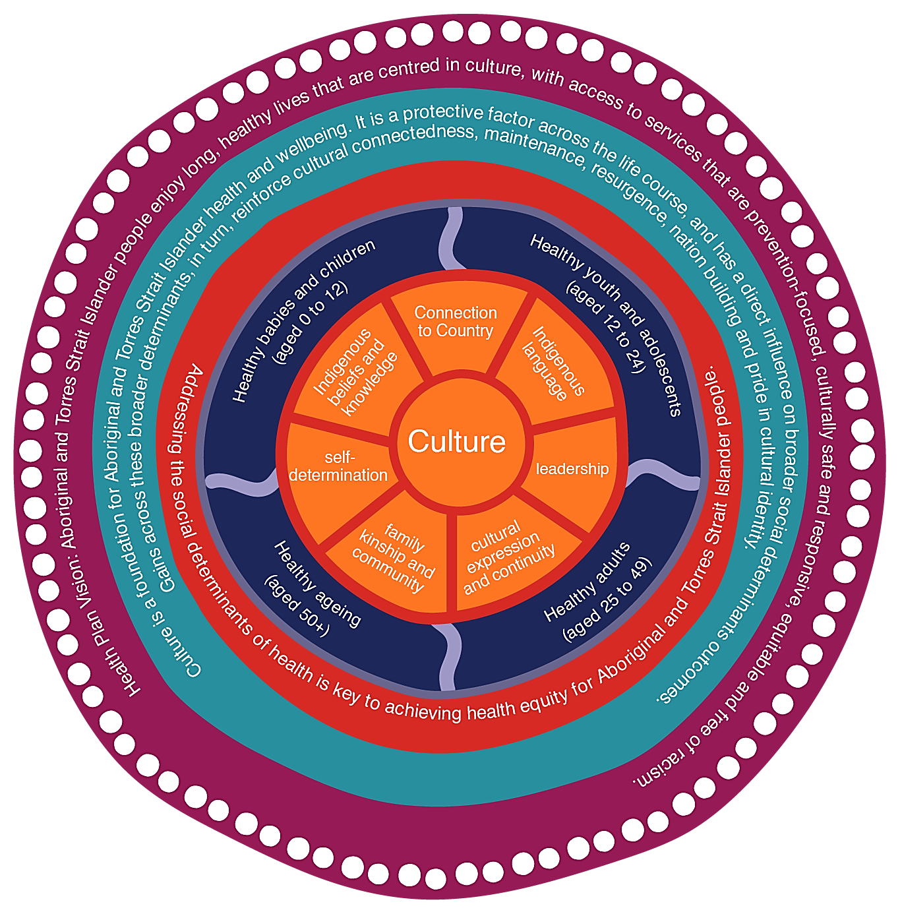
Source: National Aboriginal and Torres Strait Islander Health Plan 2021-2031 (Health Plan)

The Health Plan contains 12 priorities, grouped into enablers for change (governance and workforce), prevention (including social and emotional wellbeing, and trauma aware healing informed approaches), improving the health system (racism, person and family centred, and mental health and suicide), and a culturally informed evidence base.

National Aboriginal and Torres Strait Islander Health Workforce Strategic Framework and Implementation Plan 2021-2031
The National Aboriginal and Torres Strait Islander Health Workforce Strategic Framework and Implementation Plan 2021-2031 (the Workforce Plan) (Australian Department of Health and Aged Care, 2022b) was co-designed between Aboriginal and Torres Strait Islander health peak bodies and governments. The Workforce Plan shares the vision of the National Aboriginal and Torres Strait Islander Health Plan and includes a target to increase the representation of Aboriginal and Torres Strait Islander people in the health workforce from the current 1.8% to 3.43% by 2031.
The Workforce Plan includes 6 overarching strategic directions that address workforce barriers and support the ongoing development of the size, capability, and capacity of the Aboriginal and Torres Strait Islander health workforce. These include actions to attract, recruit, and retain workers across all roles, levels, and locations within the health sector.

National Strategic Framework for Aboriginal and Torres Strait Islander Peoples’ Mental Health and Social and Emotional Wellbeing 2017-2023
The purpose of the National Strategic Framework for Aboriginal and Torres Strait Islander Peoples’ Mental Health and Social and Emotional Wellbeing (the SEW Framework) (Commonwealth of Australia, 2017a) is to guide and inform Aboriginal and Torres Strait Islander mental health and wellbeing reforms.
The SEW Framework has 9 guiding principles that recognise key issues influencing health and wellbeing outcomes including the connection between mental, physical, cultural and spiritual health, the role of self-determination in the provision of health services for Aboriginal and Torres Strait Islander people, the impact of trauma, loss and racism, stigma, environmental adversity and social disadvantage on mental health and wellbeing, disruption to mental health caused by failure to recognise and respect human rights and the centrality of family and kinship to Aboriginal and Torres Strait Islander’s health and wellbeing.
The 5 action areas under the SEW Framework are:
- Strengthen the foundations.
- Promote wellness.
- Build capacity and resilience in people and groups at risk
- Provide care for people who are mildly or moderately ill.
- Care for people living with a severe mental illness.
The SEW Framework aims to assist decision-makers, governance processes, the health and allied health workforces, health services, and health clients to make decisions that improve health and wellbeing outcomes for Aboriginal and Torres Strait Islander people. This includes decision-making in relation to the commissioning of services by PHNs. The SEW Framework clearly recognises the diversity of Aboriginal and Torres Strait Islander cultures and communities, and supports acknowledging and responding to the different needs with locally developed, specific strategies (Australian Institute of Health and Welfare, 2020a; Commonwealth of Australia, 2017a).

Future focused primary health care: Australia’s Primary Health Care 10 Year Plan 2022-2032
The Australian Government developed a plan for the future of the primary health system, including measures to support Closing the Gap. Australia’s Primary Health Care 10 Year Plan 2022-2032 (the 10 Year Plan) (Australian Department of Health and Aged Care, 2022a) was developed as part of the Australian Government’s commitments under the Long-Term National Health Plan (Australian Department of Health, 2019a). The 10 Year Plan sets out 7 objectives.
- Access: Support equitable access to the best available primary health care services.
- Close the Gap: Reach parity in health outcomes for Aboriginal and Torres Strait Islander people.
- Keep people well: Manage health and wellbeing in the community.
- Continuity of care: Support continuity of care across the health care system.
- Integration: Support care system integration and sustainability.
- Future focus: Embrace new technologies and methods.
- Safety and quality: Support safety and quality improvement.
The 10 Year Plan identifies 5 key enablers to support the objectives of the plan: people – at the centre of care; funding reform; innovation and technology; research and data; and leadership and culture.
The 10 Year Plan was developed through consultation with individuals and organisations across the country and provides a framework for decision-making for, and reform of, PHC services. It proposes a shift in the delivery of primary care.

Aboriginal and Torres Strait Islander Health Performance Framework
The operation of the health care system for Aboriginal and Torres Strait Islander people is assessed by the Health Performance Framework (Australian Institute of Health and Welfare, 2020a). This includes a reporting framework for the assessment of health and wellbeing outcomes across 3 domains. The Health Performance Framework was developed as part of the implementation of the previous National Aboriginal and Torres Strait Islander Health Plan to provide an approach for the assessment of outcomes.
The Health Performance Framework monitors progress in Aboriginal and Torres Strait Islander health outcomes, health system performance, and the broader determinants of health. There are 3 tiers of performance measures under the Health Performance Framework.
- Tier 1 – Health Status and Outcomes which includes health conditions, human function, life expectancy, wellbeing, and deaths.
- Tier 2 – Determinants of Health which includes assessment of environmental factors, socio-economic factors, community capacity, health behaviours, and person-related factors.
- Tier 3 – Health System Performance, which includes assessment of the effectiveness, responsiveness, accessibility, continuity, capability, and sustainability of care.
An annual report is published against the measures in the Health Performance Framework. The AIHW also prepares reports based on the Health Performance Framework.

Cultural Respect Framework 2016-2026 for Aboriginal and Torres Strait Islander Health: A national approach to building a culturally respectful health system
The Cultural Respect Framework was developed by the Australian Health Ministers’ Advisory Council’s National Aboriginal and Torres Strait Islander Health Standing Committee in 2016.
The aim of the Cultural Respect Framework is to support the corporate health governance, organisational management, and delivery of the Australian health system to further embed safe, accessible, and culturally responsive services. The Cultural Respect Framework includes 6 domains and focus areas to support culturally accessible, responsive, and safe health service delivery. These are to:
- acknowledge the crucial role of the entire health sector in providing leadership and commitment to cultural respect
- recognise that communication is the foundation for the delivery of accessible, responsive and safe health care
- support the fact that effective, culturally appropriate service delivery is premised on a highly skilled and capable workforce
- recognise the importance of Aboriginal and Torres Strait Islander consumer participation and engagement
- acknowledge that meaningful and effective partnerships and feedback from Aboriginal and Torres Strait Islander people and organisations underpin health equality
- recognise that these efforts are part of an ongoing journey, informed by good data and evidence.

Other policy mechanisms and reform processes
There are other policy and reform processes that shape and influence the policy, operational, and governance landscape for the administration and governance of the IAHP. This includes the establishment of the National Indigenous Australians Agency with a clear mandate to coordinate effort to implement the National Agreement, the internal governance and accountability processes supporting the National Agreement on Closing the Gap, and the implementation of the Health Plan, the taskforce examining the Medicare system.
More generally, there is a constitutional change process to create an Indigenous voice to Parliament and other governance and policy commitments relating to growing and supporting the Aboriginal and Torres Strait Islander workforce in the Commonwealth Public Service.

Establishment of the National Indigenous Australians Agency
The National Indigenous Australians Agency (NIAA) was established in 2019. The functions of the NIAA include to:
- lead and coordinate Commonwealth policy development, program design and implementation, and service delivery for Aboriginal and Torres Strait Islander people
- provide advice to the Prime Minister and the Minister for Indigenous Australians on whole-of-government priorities for Aboriginal and Torres Strait Islander people
- lead and coordinate the development and implementation of Australia’s Closing the Gap targets in partnership with Indigenous Australians
- lead Commonwealth activities to promote reconciliation.
Within the structure of the NIAA there are specific role holders dedicated to (i) Closing the Gap and (ii) Health and Wellbeing.
The NIAA includes an Aboriginal and Torres Strait Islander health policy function and a health and wellbeing programs function. The NIAA funds some of the same organisations funded by the department under the IAHP. This includes funding for Aboriginal and Torres Strait Islander mental health and alcohol and drug programs. The NIAA also funds employment, housing and disability programs and activities.

Internal departmental policy and governance mechanisms
The department has formed a Closing the Gap Steering Committee to lead structural change required to align its operations and services with the Priority Reforms in the National Agreement on Closing the Gap. This includes reviewing and driving implementation of the department's Closing the Gap Framework for Action, and decision-making about funding allocations and resourcing to support Closing the Gap activities.
The Steering Committee includes membership from departmental executives (Deputy Secretaries and First Assistant Secretaries) across the department and met for the first time in November 2022.
The department is also currently working on other reform activities, including an investment strategy.

Recommendations of the Strengthening Medicare Taskforce
In December 2022, the Strengthening Medicare Taskforce released a report (Australian Department of Health and Aged Care, 2022c) outlining the most pressing investments in PHC to support the implementation of the Primary Health Care 10 Year Plan. The Taskforce articulated a vision for future-focused health care through person-centred PHC, supported by additional funding and reform. This vision is of a primary care system where:
- all Australians are supported to be healthy and well, through access to equitable, affordable, person-centred primary care services, regardless of where they live and when they need care, with financing that supports sustainable PHC, and a system that is simple and easy to navigate for people and their health care providers
- coordinated multidisciplinary teams of health care professionals work to their full scope of practice to provide quality person-centred continuity of care, including prevention and early intervention; and primary care is incentivised to improve population health, work with other parts of the health and care systems, under appropriate clinical governance, to reduce fragmentation and duplication and deliver better health outcomes
- data and digital technology are better used to inform value-based care, safely share critical patient information to support better diagnosis and health care management, empower people to participate in their own health care and drive insights for planning, resourcing, and continuous quality improvement
- the PHC sector is well supported to embrace organisational and cultural change, and to support innovation, consumers are empowered to have a voice in the design of services to ensure they meet people’s needs, particularly for disadvantaged groups, and all levels of government work together to ensure the benefits of reforms are optimised.
To support increased access to PHC, the Taskforce recommended growing and investing in ACCHOs to commission primary care services for their communities, building on their expertise and networks in local community need (Australian Department of Health and Aged Care, 2022c, p. 5). The Taskforce also recognised the value of a diverse health workforce that can support team-based models of primary care and care coordination. It recommended that work to build the workforce, including Aboriginal and Torres Strait Islander Health Workers, be fast tracked and that funding systems more effectively support team-based care models. It also identified ‘outer metropolitan’ as an area of need, in addition to rural and remote areas (Australian Department of Health and Aged Care, 2022c).

Uluru Statement from the Heart and First Nations voice to Australian Parliament
In 2017, Aboriginal and Torres Strait Islander leaders shared the Uluru Statement from the Heart (Commonwealth of Australia, 2017b). The Statement from the Heart is a petition calling for a First Nations voice enshrined in the Australian Constitution and a Makarrata Commission to support truth telling and agreement-making.
There are also state and territory processes relevant to voice, truth telling, and treaty, including the establishment of the First Peoples’ Assembly of Victoria to advance treaty negotiations and the Yoorrook Justice Commission for truth telling. In March 2023, South Australia became the first jurisdiction in Australia to create an Indigenous voice to parliament. South Australia’s First Nations Voice to Parliament will have the ability to speak on legislation that it chooses to at the second reading stage of a bill.

International standards and laws for primary health care
The right to health is a fundamental human right recognised in international human rights laws and treaties. This includes the right to a system of health protection. Article 12 of the International Convention on Economic, Social and Cultural Rights recognises the right of everyone to the enjoyment of the highest attainable standard of physical and mental health. There are also health rights contained in the Convention on the Elimination of All Forms of Discrimination Against Women the Convention on the Rights of the Child and the Convention on the Rights of Persons with Disabilities.
There are also additional, specific rights of Aboriginal and Torres Strait Islander peoples that relate to health and wellbeing and the provision of health care services. The relevant rights under the United Nations Declaration on the Rights of Indigenous Peoples (UNDRIP) are set out below.
- The right, without discrimination, to improvement of their economic and social conditions, including, inter alia, in the areas of education, employment, vocational training and retraining, housing, sanitation, health and social security. (Article 21)
- The right to determine and develop priorities and strategies for exercising their right to development. In particular, Indigenous peoples have the right to be actively involved in developing and determining health, housing and other economic and social programmes affecting them and, as far as possible, to administer such programmes through their own institutions. (Article 23)
- The right to their traditional medicines and to maintain their health practices, including the conservation of their vital medicinal plants, animals and minerals. Indigenous individuals also have the right to access, without any discrimination, to all social and health services. (Article 24)
- An equal right to the enjoyment of the highest attainable standard of physical and mental health. States shall take the necessary steps with a view to achieving progressively the full realisation of this right. (Article 24)
These rights and responsibilities in international law assist to map existing requirements for access, quality, and safe health care for Aboriginal and Torres Strait Islander people.

Evaluation methodology
This section summarises the evaluation methodology. Further details about the methodological approach and the evaluation processes and activities are included in Final Report Supporting Material: Appendix C.

Overview
The overall aim of the evaluation was to strengthen the appropriateness and effectiveness of comprehensive PHC systems for Aboriginal and Torres Strait Islander people and communities. In commissioning the evaluation, the department specified that the evaluation should take a whole-of-system, consumer-oriented lens, that included highly participatory evaluation practices to maximise system learning.
The evaluation focused on evaluating the IAHP as an ‘enabler, interactor and influencer’ in providing appropriate and effective comprehensive PHC for Aboriginal and Torres Strait Islander people.
The evaluation design was grounded in the knowledges, values, experiences and aspirations of Aboriginal and Torres Strait Islander people. The evaluation used co-design approaches to ensure the design and implementation of the evaluation was shaped by health sector expertise. Co-design processes facilitated shared decision-making, knowledge sharing and translation throughout the evaluation. The implementation of the evaluation across 3 cycles enabled data collection and analysis to build and test the evidence base to support the evaluation findings.
A note about language
The findings and recommendations in this evaluation report are shaped by the expertise of Aboriginal and Torres Strait Islander people. While this report refers to people who contributed to this evaluation process as ‘participants’, the evaluation team recognises that Aboriginal and Torres Strait Islander people are the knowledge holders for what will improve health outcomes for Aboriginal and Torres Strait Islander people. The use of ‘participants’ in this report is not intended to diminish the leadership and expertise of Aboriginal and Torres Strait Islander people within their communities and throughout this evaluation process.

Phase One – Evaluation design and planning
Phase One commenced in October 2017. This involved establishing and planning the evaluation with a Health Sector Co-design Group (HSCG) and participants from across the PHC system, including community members, health care providers, state, territory, and national organisations.

Phase One included the following activities:
- Review of literature and documents: A literature review was conducted to provide up-to-date information on PHC, health systems’ thinking, system-level evaluation, and evaluation in the context of Aboriginal and Torres Strait Islander people’s health.
- Establishing the HSCG: The HSCG was established in 2017, comprising people with expertise, experience, and perspectives from across the PHC system and in evaluation and research with Aboriginal and Torres Strait Islander people.
- Sector engagement: The evaluation design was the result of a multi-layered co-design process that involved participants from across the PHC system, including community members, health care providers, and state, territory, and national organisations.
- Developing the evaluation design: The evaluation adopted a multi-phase iterative mixed method design, combining a variety of qualitative and quantitative methods of data generation and analysis. The design phase culminated in the development of a Monitoring and Evaluation Design Report (Bailey et al., 2018).
- Ethics approval: Ethics approval processes were undertaken to ensure all the evaluation activities were in accordance with the ethical standards of the relevant institutional and national committees. These processes occurred in 2 stages with 13 different health and human research ethics committees. The first stage had a focus on site engagement, and the second stage on approval for data generation activities to answer the evaluation questions.
- Site selection and establishment: The original evaluation design recommended establishing 20-24 evaluation sites (and 16 at a minimum) as the primary unit for generating data and analysis. An evaluation site was defined as places where Aboriginal and Torres Strait Islander people live, work, and seek to receive (or not) PHC and other services. Sites were selected using agreed criteria which stipulated that sites would cover a range of geographic, population, funding, service delivery settings. The selection of sites was intended to enable evaluation across a diverse range of PHC contexts, including for example differences across remote, regional and urban areas, as well as differences in service models and in Aboriginal and Torres Strait Islander populations. This multi-sited approach to data collection contributes to a rich, contextual and whole-of-system evidence base, which is essential to understand the operation of the IAHP across different settings. The findings from the evaluation sites are not intended to be generalisable across all settings in Australia.
As part of the evaluation design and planning in Phase One, the KEQs were developed through a process of co-design with the Health Sector Co-design Group. The 5 KEQs are:

Key evaluation questions
- How well is the IAHP enabling the PHC system to work for Aboriginal and Torres Strait Islander people?
- What difference is the IAHP making to the PHC system?
- What difference is the IAHP making to the health and wellbeing of Aboriginal and Torres Strait Islander people?
- How can faster progress be made towards improving the health and wellbeing of Aboriginal and Torres Strait Islander people?
- How well are the methodological approaches used in the evaluation achieving its aims?

The evaluation design and the KEQs were endorsed by the (then) Minister for Indigenous Affairs.

Phase Two – Evaluation implementation
Phase Two involved implementing the evaluation in 17 geographically based evaluation sites across Australia, across 3 participatory action research (PAR) data collection cycles, including engagement at state, territory, and national levels.

Approach to data collection
Consistent with ethics approval and the Monitoring and Evaluation Design Report, a mixed-methods approach was used to generate qualitative and quantitative data and develop the evidence base to support the response to the KEQs.
The evaluation acknowledges the data included in this report cannot provide a full picture of health and wellbeing outcomes for Aboriginal and Torres Strait Islander people. The evaluation also acknowledges the real stories, people and experiences which sit behind the qualitative and quantitative data collection processes for this evaluation.
The evaluation team respectfully acknowledge that the use of data cannot replace deep listening to understand the stories and experiences of Aboriginal and Torres Strait Islander people and that the diverse and living experiences of Aboriginal and Torres Strait Islander people should not be reduced to numbers and numerical trends.
The methods and data gathering processes adopted by the evaluation are intended to ensure that the values, knowledge systems, expertise and experiences of Aboriginal and Torres Strait Islander people were at the centre of the evaluation.
The methods of data generation and analysis and the primary datasets used across the evaluation are summarised in Figure 2-1.

Figure 2-1. Methods, analysis and data set diagram

Qualitative data
Key qualitative methods used across the evaluation included:
- Community yarns: The evaluation team drew from yarning as a methodology (Bessarab & Ng’Andu, 2010; Fredericks et al., 2011) to design and implement interviews and conversations with Aboriginal and Torres Strait Islander community members and staff from Aboriginal and Torres Strait Islander health services. Interviews and yarns were conducted through facilitated roundtable discussions that employed cultural protocols. This included Aboriginal and Torres Strait Islander community yarns to generate data on what Aboriginal and Torres Strait Islander people value in health care and how people experience the health care system.
- Individual patient journey yarns and interviews: The evaluation team held individual interviews with community members. The purpose of the interviews was to hear and include the stories of people in ‘hard-to-reach’ groups or those with complex needs. Individual interviews were held onsite at the health services and there was a balance of genders. Participants were primarily people with complex health needs who had experienced PHC and the broader health system, and variously understood how different system parts interact. The interviews focused on a single episode of care or a person’s experiences with repeat visits for the same health concern. Participants were recruited through the site partner ACCHS and often in liaison with the local evaluation coordinator (LEC). In some cases, participants were recruited through the community group yarns, when community members suggested people who might be relevant to talk to. Ethical consent and information about the procedures of a patient journey interview were discussed with participants prior to the interview.
- Interviews with site partner staff and other site-based representatives: Semi-structured interviews were undertaken in each evaluation cycle with health service and PHN staff, including chief executive officers (CEOs), other senior executives, practice managers, commissioning managers, chief medical officers, and other clinical staff. These interviews focused on gathering staff perspectives and experiences of IAHP and how the IAHP works to support the delivery of comprehensive PHC and the operation of Aboriginal and Torres Strait Islander health care organisations. The interview questions were structured around the KEQs and evolved over the evaluation cycles from a focus on understanding how the IAHP operated in each site (Cycle 1), to understanding the difference the IAHP was making (Cycle 2), to understanding the actions and changes needed to improve the IAHP and the wider system (Cycle 3). The interviews were also tailored to each site in relation to identified information gaps, and inconsistencies or nuances in need of further explanation.
- State, territory and national level interviews and engagement: Semi-structured interviews were undertaken with participants from state, territory and national organisations across the evaluation. Across the evaluation, this included staff from peak bodies for Aboriginal and Torres Strait Islander community-controlled health services, state and territory government departments, staff from the department, the National Indigenous Australians Agency (NIAA), the AIHW’s Indigenous Group, the Department of Social Services and professional organisations working within Aboriginal and Torres Strait Islander health.
- Collective action for change workshops: Collective action for change (CA4C) workshops were an important part of the PAR approach. The purpose of CA4C workshops was to bring data and findings back for discussion with site partners and other stakeholders, provide an opportunity to share knowledge and understanding between organisations and services, identify PHC implementation enablers and barriers, and to identify spheres of influence for change (to leverage strengths and overcome barriers). Ten site CA4C workshops were held, one CA4C workshop was held at the national level, and two cross site CA4C workshops were convened to discuss: (1) partnerships, networks and alliances, and (2) funding.
- Cross-cutting collaboratives: Five cross-cutting collaboratives were undertaken as part of the evaluation. The collaboratives were intended to focus on system-level issues and bring together groups of stakeholders to problem solve and identify actions to address a common issue. The need for specific collaboratives arose through the analysis of data and information gathered through the 17 site studies and the state, territory and national engagements. The collaboratives also emerged from stakeholders expressing a strong interest in working on a specific issue that aligned with the evaluation aims, objectives and questions. The cross-cutting collaboratives examined (1) COVID-19 response (2) Aboriginal and Torres Strait Islander Health Worker and Health Practitioner training pipeline (3) institutional racism (4) understanding health needs (5) improving PHC data.

Quantitative data
The approach to quantitative data collection and analysis commenced with a data feasibility assessment guided by a conceptual causal framework. The framework was developed through the identification and mapping of key constructs, indicators, and assumptions inherent in the IAHP program logic and funding models.
An environmental scan was undertaken to identify and consider data sets. Five strategies were utilised to maximise the potential data sources identified, and to ensure the relevance and comparability of evaluation findings.
- An examination of the evaluation documents, including materials provided by the department in relation to the IAHP.
- Data sources used for the Aboriginal and Torres Strait Islander Health Performance Framework were captured.
- A systematic interrogation of key data custodian sources was undertaken. This included the Australian Bureau of Statistics (ABS), the Australian Institute of Health and Welfare (AIHW) and the department.
- A series of face-to-face and telephone meetings were conducted to identify any additional data sources that had not already been identified. This consultation was with representatives from the department (including the First Nations Health Division), the HSCG, the AIHW, the ABS, and other data experts. In addition to the identification of potential data sets, issues relating to the process, timeframes, costs, and security requirements of access were discussed.
- Expert consultation was undertaken to draw on the knowledge and networks of the broader data assessment team to support data identification and quality assessment.
Five assessment criteria were developed and applied to each identified data source to determine fitness for purpose for use in the evaluation:
- relevance in addressing the 5 KEQs
- relevance to Aboriginal or Torres Strait Islander people
- geography
- timeliness
- demographic characteristics.
Based on these criteria, each dataset was given an overall rating as fit for purpose, not fit for purpose, or conditionally fit for purpose. Each dataset rated as fit for purpose was also assessed according to its accessibility for utilisation according to the following 3 categories: publicly available, available via special request from the data custodian, or accessible via secure access through a data platform. Through this process a total of 79 data sources were identified.
Following the data feasibility assessment process, 10 customised datasets were requested and subsequently received from data custodians. These datasets were:
- MBS data
- National Health Workforce data
- PIP data
- Australian Childhood Immunisations Register
- National Perinatal Data Collection
- National Hospital Morbidity data
- nKPI data
- OSR data
- Cause of death data
- Estimated Residential Population (ERP)
IAHP funding data were also formally requested from the department, however the department did not provide this data due to concerns over data accuracy. The department agreed to provide higher-level data aggregated to the level of state, territory and national level for the period 2014-15 to 2020-21; and IAHP grant funding data by funding stream at the state and territory level for the three-year financial period 2018-19 to 2020-21.

Overview of activities across each evaluation cycle
The approach to the evaluation involved a multi-phased approach that continued to layer and build data and analysis to support the evaluation across 3 cycles.
The main evaluation activities across the 3 cycles and the number of participants involved are shown in Figure 2-2.

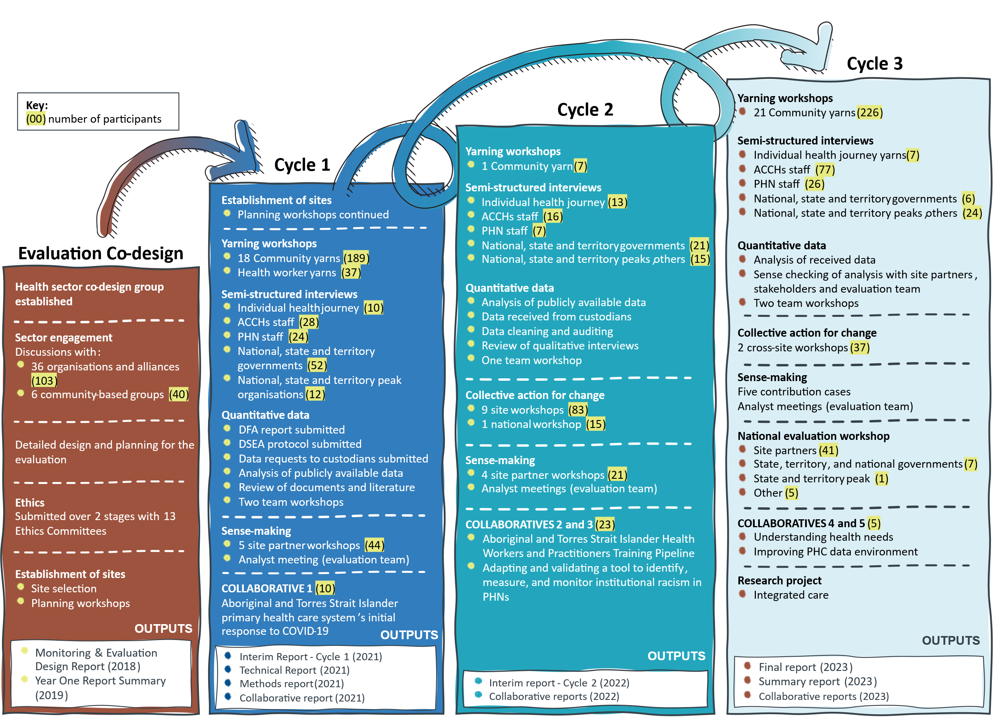
Figure 2-2. Evaluation activities and number of participants by cycle design

Cycle 1
In Cycle 1, both qualitative and quantitative data were generated or collected. The focus was to generate a baseline description of what Aboriginal and Torres Strait Islander people value in health service design and experience, and how people experience the health system; create site system maps and contextual descriptions; as well as gather a set of local and system level indicators and baseline data to plan, monitor, and measure change.
The main evaluation activities in Cycle 1 were:
- all of team data collection preparation sessions and workshops
- reflective and future focused community yarning workshops at 12 sites
- individual patient experience journey interviews at 6 sites
- reflective and future focused Aboriginal and Torres Strait Islander health service staff yarning workshops held with 44 health services staff at 12 sites
- semi-structured and KEQ-based interviews with Aboriginal and Torres Strait Islander health service leadership staff across all sites.
- semi-structured and KEQ-based interviews with managerial staff from 13 PHNs
- semi-structured and KEQ-based interviews with stakeholders from site, state and territory, and national organisations across all sites and jurisdictions

Cycle 2
In Cycle 2, the evaluation built on the data gathered in Cycle 1, particularly in those areas where gaps, inconsistencies and a need for sense-checking had been identified. Where Cycle 1 focused on generating a baseline description of IAHP, Cycle 2 focused on exploring the contribution of the IAHP. As with Cycle 1, engagement with site partners, community members and other evaluation participants was impacted by the COVID-19 pandemic in Cycle 2. The majority of interviews and workshops were held online.
The main evaluation activities in Cycle 2 were:
- Collective Action for Change workshops across 8 sites and with the department. These involved mapping the health system in each site; discussing what is working well and the challenges; and identifying what needs to change and (in some cases/sites) an action plan to drive change.
- Interviews, workshops and analyses as part of 3 cross-cutting collaboratives. The collaboratives were on:
  - the Aboriginal and Torres Strait Islander PHC system’s initial response to COVID-19
  - the training pipeline for Aboriginal Health Workers and Health Practitioners
  - adapting and validating a tool to identify, measure and monitor institutional racism in PHNs.
- Yarns and interviews with Aboriginal and Torres Strait Islander people who access mainstream PHC services or who do not access PHC at all.
- Interviews with managers and staff from ACCHSs, AMSs and PHNs targeting specific information gaps.
- Interviews with stakeholders not engaged in Cycle 1, including from state and territory peak bodies for community-controlled health services and government health departments.
- Analysis of new data collected through interviews at site level.
- Analysis of routinely collected data sets at state, territory, and site levels.
- Analysis about the contribution of the IAHP to strengthening comprehensive PHC for Aboriginal and Torres Strait Islander people. This included re-analysis of Cycle 1 site partner interviews and was achieved through the development of ‘contribution cases’ to test the contribution of IAHP to expected changes (see Final Report Supporting Material: Appendix C for more detail on contribution case analysis).
- Workshops with site partners to interpret and validate the emerging findings.

Cycle 3
The focus of Cycle 3 was the collaborative development of recommendations and solutions to respond to the key findings about the IAHP. The evaluation team also tested, revised, and strengthened contribution cases through discussions with site partners and other subject experts over Cycle 3.
The main evaluation activities in Cycle 3 were:
- Group yarns with hard-to-reach populations (prison population).
- Sense checking of findings on what people value about health service design and delivery through group yarns with community members.
- Interviews with health service and PHN managerial staff focus on change needed to the IAHP and the wider system.
- Interviews with mainstream PHC providers and other non-ACCHS stakeholders engaging with IAHP-funding organisations.
- Final interviews with site partners and stakeholders at state, territory, and national levels with a focus on changes needed to the IAHP and the wider system.
- Strengthening of contribution cases through sense-checking interviews with health service partners, PHNs and others.
- Facilitation of a contribution review panel providing feedback on the contribution cases and exploring nuances, gaps, and alternative explanations.
- Revision and analysis of contribution cases and write up of overarching contribution narrative.
- Facilitating two cross-site collective action workshops on specific topics: partnerships and funding.
- Completion of two collaboratives on: (1) identifying and piloting approaches to assessing health needs and indicators for health needs within the community; and (2) developing recommendations to improve the PHC data environment.
- Completion of a sub-project that identified what is needed for PHC organisations and health professionals to establish coherent integrated care models at funding, administrative/ governance, organisational, service delivery and clinical levels.
- Facilitation of a national workshop for site partners in Melbourne/Naarm to share and sense check the evaluation findings and recommendations and to promote learning across different sites and levels of the health system.
- Development of funding profiles for 5 site partner ACCHSs to demonstrate organisational capacity, funding and contracts, and burden of reporting.

Approach to data analysis

Qualitative data
Different analysis methods were applied to different types of qualitative data and according to purpose and usage. These methods are discussed below.

Grounded theory analysis
An inductive grounded theory methodology inspired the overarching analytical approach. Grounded theory is a systems method of analysis, designed to explore and understand the nature and occurrence of complex social phenomenon (Bainbridge et al., 2019). The approach ensures that the values, preferences and priorities of participants are reflected and ground the evaluation, captures Indigenous voices, and makes transparent the process of development and model generation from verbatim concepts. It also ensures that explanations are developed ‘from the ground up’ and not based on a priori assumptions.
This approach was used to identify codes and categories, with memos used to capture important insights. Constant comparative methods enabled exploration of issues to establish points of consensus and dissent and to saturate categories. Throughout the analytic process questions were asked like, what power is in this situation and under what specific conditions is it enabled/enacted? How is it manifested, by whom, when, where, how, with what consequences (and for whom or what)? And with what intensity? (Flyvberg, 2001).
Data segments in the initial coding were larger than normal for grounded theory, representing incident, foci, or discursive junctions.

Situational analysis
Analysis of community yarns and interviews with ACCHS staff members was undertaken predominantly using situational analysis, a relational form of grounded theory (Clarke et al., 2017). Situational analysis grounds the analysis in the broader situation of the inquiry, centres on social processes, incorporates non-human actors, manages complexity, and seeks differences or absent positions within the data. Situational analysis is an optimal method to understand the ecology of what Aboriginal and Torres Strait Islander people value in health service delivery and design because of the inseparability of knowledge from the socio-cultural, historical, and political situations in which it is created.
Data generated from the Aboriginal and Torres Strait Islander community yarns, patient experience journey interviews and Indigenous ACCHS staff member yarns were used to address the question of ‘what Aboriginal and Torres Strait Islander people value in terms of health service design and delivery’. The community yarns and patient experience journey interviews were the primary data sources, whilst data from the staff member yarns were used to provide explanatory or confirmatory power to the analysis.

System mapping and explanatory metaphors
The framework of what Aboriginal and Torres Strait Islander people value in health service design and delivery was visualised using the pictorial conceptual metaphor (Fredericks et al 2015) of a tree. Metaphor is consistent with Indigenous epistemologies, provides greater explanatory value of relationships between concepts than box and arrow diagrams, and is a way of sharing social knowledge (Moreton-Robinson 2017, p.16-18). Trees share several valuable characteristics consistent with primary health services. The framework uses the metaphor of the bottle tree, Brachychiton rupestris or Babuny. The bottle tree has medicinal properties (Thabet et al 2018) and specific characteristics (Reynolds et al., 2018) that reflect important elements of what Aboriginal and Torres Strait Islander people value in health service design and delivery.
The model was developed on the basis of data generated in Cycle 1 of the evaluation and tested and refined using abductive analytic cycles (Strübing, 2007), through further data generation and consultation with communities and site partners during subsequent cycles. The analyst engaged in ongoing dialogue with the Aboriginal site leads and the Principal Investigator and prioritised Aboriginal and Torres Strait Islander theories throughout this process to ensure that Aboriginal and Torres Strait Islander world views were embedded in the resultant framework.

Content analysis and top line summaries
The evaluation team also applied a more deductive method of analysis – content analysis (Downe-Wambolt, 1992), which was guided by the interview guides and KEQs and aimed to produce top-line summaries. Content analysis is a framework approach based on pre-set codes and analytical structure (e.g. developed from research questions or interview topics). This approach to analysis facilitates both descriptive and interpretive content, focussing on the subject and context whilst emphasising variation (Graneheim et al., 2017). The evaluation analyst team used this method when analysing interviews with health service managers, PHN managers, state and territory and national organisations, and CA4C workshops.

Quantitative data
Different analysis methods were applied to different quantitative data according to purpose and use. These methods are discussed below.
Sites were categorised as major cities, inner regional, outer regional, remote and very remote, based on the Australian Statistical Geography Standard (ASGS) Remoteness Structure (ARIA+) for the geographical areas nominated by the sites as the areas within their catchment of interest to them for this evaluation. Remote and very remote were combined due to small numbers of sites in each category. As the catchment areas for some sites included more than one ARIA+ category, sites were assigned based on the remoteness category of the residential mesh blocks in their catchment. Most sites were wholly contained in one or two remoteness categories and were assigned to the category of the majority of mesh blocks. One site included 3 remoteness categories and was categorised as remote.

Health workforce data
Health workforce data came from two sources: National Health Workforce Dataset and OSR data. Data were obtained from 2013 to 2020 by site and by Statistical Area 3 (SA3) level. Health Workforce Data included details of health care staff working throughout Australia in a range of settings including Aboriginal health organisations, hospitals, and private practice. A trend analysis of staff by age group, sex, Indigenous status and profession was undertaken at the SA3 level. OSR data were obtained from organisations receiving IAHP funding by site. OSR data included total counts of paid staff, unpaid staff, and vacant positions. Publicly available OSR data by state and territory was also downloaded as the publicly available data included an additional year of data.

IAHP grant funding data
Total funding over time was reported for Australia and by state and territory. Funding was reported both for dollars not adjusted for CPI and for dollars adjusted for CPI using the ABS health index, with the Consumer Price Index (CPI) for each financial year calculated by averaging index across the relevant four quarters (ABS (2023). 6401.0 Consumer Price Index, Australia, Canberra, ABS). Dollars are expressed as constant 2019-20 to allow for comparison with the latest (at time of analysis) AIHW health expenditure data.

Health care activity and outcome data
For all analyses, data from 2020 onwards were excluded to remove the effect of the COVID-19 pandemic on health service utilisation. nKPI and MBS data were treated separately, as nKPI data included regular clients of IAHP funded Aboriginal and Torres Strait Islander health services, whereas MBS data included all Aboriginal and Torres Strait Islander residents living within the geographical areas nominated by evaluation sites as geographical areas in their catchment areas and geographical areas of interest to them for this evaluation. Various analytical methods were applied to the data, including:
- A traffic light framework analysis to synthesise publicly available data into a single framework so data could be compared, appraised, and communicated at a high level, acknowledging the limitations of the available data.
- In-depth case studies to examine the effects of health service activity on hospitalisations and mortality, including linking diabetes care, hospitalisations and mortality.
- Modelling of nKPIs over time using a mixed effects logistic regression model to explore protective/risk factors, health outcomes and health service use for the perinatal period, middle life and later life.
- Hierarchical clustering and principal component analysis to examine correlations between nKPIs to identify which were most similar to each other, and to determine associations between 715 health assessments and clusters of nKPIs.
- Multilinear regression analysis to model health outcomes as a function of demographics, socio-economics, health service availability, and primary health care activity for geographic areas (i.e. ecological study) at two discrete time points (cross-sectional design), and for changes between time points (difference in differences analysis).

Sense-making, integration and analytical synthesis
Interpretation and sense-making activities occurred continuously throughout the evaluation process. This included integration and reflection workshops with the evaluation team members and interpretation and sense-making workshops with evaluation partners.
The purpose of these activities was to support the integration of data generated across the evaluation activities, the testing of preliminary findings and identifying the implications of those findings for the IAHP.

Integration and reflection workshops
To support data analysis and integration, a series of integration and reflection workshops were held by the evaluation team. The integration and reflection workshops were structured around the KEQs. Each workshop followed a format of discussing and integrating the key findings from the analysis of each data source relevant to each KEQ. A description and discussion on the context for sites was then provided to facilitate the team’s shared understanding and support connections between data sets and streams of analysis.
As part of the internal reflection and data integration processes, the evaluation team developed working papers to inform the direction and recommendations in the Final Report.

Interpretation and sense-making workshops with site partners
To enable the team to share the structured findings from the integration and reflection workshops with site partners, a series of emerging findings workshops were held with site partners. These workshops provided an opportunity for site partners to check our interpretation of evaluation findings, connect with other evaluation partners across sites, learn and share knowledge, and consider what the findings mean for policy and practice. Workshop attendees and evaluation team members were invited to reflect on (1) the emerging findings content and (2) the process used to bring site partners together.
The workshop discussions challenged site partner participants to consider if the findings were consistent with their own experiences and/or data within the project and identify any divergent or unexpected findings that needed to be more closely considered. Integration of the findings for each KEQ was through a facilitated discussion to identify the significance or importance of the findings for each KEQ and the implications of those findings for the IAHP and recommendations to better enable the PHC system to work for Aboriginal and Torres Strait Islander people.

National evaluation workshop
A national workshop was held with site partners in February 2023 at the conclusion of Cycle 3. The purpose of the workshop was to facilitate participatory analysis and share the evaluation findings and check how they resonate with the evaluation partners to inform further interpretation and explanation building.
The workshop involved presentations from the evaluation team and site partner participants as well as an interactive session discussing the quantitative data and process of analysis. A key purpose of the national workshop was to present the framing and intention of draft recommendations and share the evidence base supporting the findings with site partner participants.
The contributions from site partners and other participants were recorded through a process of graphic recording to identify the key themes and directions. These graphic recordings are reproduced in Final Report Supporting Material Appendix L.
Feedback from the national workshop was incorporated into the final evaluation recommendations and report.

Data integration - Contribution analysis
The evaluation required an assessment of the extent to which the IAHP contributed to different outcomes within the health system. The evaluation adopted a grounded theory approach to contribution analysis. This approach was applied to purposefully generate narrative data about the contribution of the IAHP to strengthen comprehensive PHC for Aboriginal and Torres Strait Islander people.
Adopting a grounded theory approach meant that the evaluation team was able to analyse IAHP’s contribution in a way that:
- legitimises the experiences of Aboriginal and Torres Strait Islander people as a valid source of knowledge
- facilitates the development of theory directly interpreted from the words expressed by Aboriginal and Torres Strait Islander people
- considers the influence of contextual social processes and structures
- recognises the diversity of experience
- assumes regard for the relational aspects of the evaluation.
Grounded theory as an analytic method has much to offer in thinking about decolonising methodology and it addresses many Indigenous critiques of Western research and evaluation approaches.
Grounded theory avoids treating the evaluation phenomena (the IAHP) in isolation from the broader historical, socio-economic, cultural, and political systems in which it occurs. Grounded theory is a method that can connect these domains and develop theoretical arguments about an intervention that are grounded in the experiences of the people involved. Grounded theory is also a strengths-based approach that inherently focuses on the strengths of a situation and speaks to Indigenous aspirations, self-determination, values, and nation-building.
The focus of the analysis was on re-assessing the data in relation to the qualities of good health care that Aboriginal and Torres Strait Islander health services were striving to deliver, and community participants said they valued.
There were multiple steps to the contribution analysis. Figure 2-3 shows the steps in the grounded theory approach to contribution analysis undertaken in the evaluation, alongside Mayne’s (2008) six steps of contribution analysis.
Figure 2-3. Approach to contribution analysis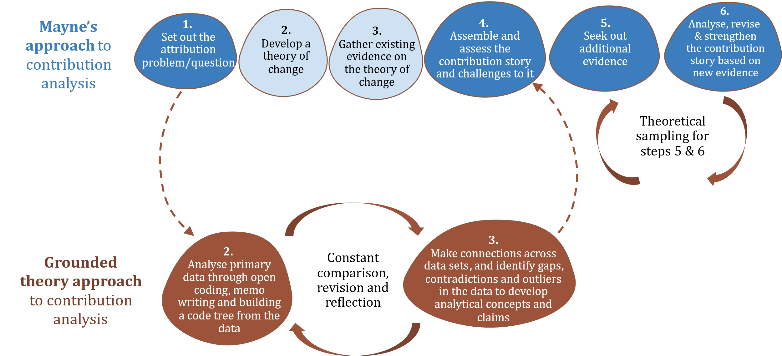

The 6 steps involved:
- Setting an overarching contribution question, which was:
How is IAHP contributing to the PHC system and improving the health and wellbeing of Aboriginal and Torres Strait Islander people?
- Recoding (re-analysing) Cycle 1 interviews with health service managers, PHN managers, and state, territory, and national participants. Through a process of coding, key points, issues, and topics were able to be grouped and compared.
- Focusing in on specific contribution claims and writing up contribution cases.
- Returning the cases to site partners to discuss and sense-check. The purpose was to sense-check whether the contribution claims and observations between IAHP and specific outcomes were reasonable and aligned with what people were experiencing in different sites.
- Presenting the cases to a review panel of two health sector professionals and academics. The main findings from checking the cases with site partners were presented to the panel, and further nuances were discussed. More general issues of the contribution analysis were also discussed with the panel.
- Collating all 5 cases into one overarching contribution narrative, including the feedback, input, and nuances added by site partners and the review panel.
Further detail about the applied approach to the contribution analysis, including detail about the specific techniques and tools used to support the analysis is included in Final Report Supporting Material Appendix C.

Strengths, limitations and adaptations
This section discusses the strengths, limitations and adaptations that apply across the evaluation, including observations about data sources, the practical implementation of the evaluation design, sampling issues and the impacts of the broader health, social and political landscape over the duration of the evaluation. These observations are used as material for critical reflections about how the methodological design worked in practice, including challenges, benefits and creative ways of adapting to changing circumstances.
Evaluation of how well the methodological approaches used in the evaluation achieved the evaluation’s aims is addressed in a separate report on KEQ5.

Strengths
Reflecting on the design and implementation of the evaluation there were significant strengths in the way it was approached and applied.
A cyclic and iterative approach to enrich the interpretation of data and facilitate quality improvement
The iterative and cyclic PAR processes were designed to ensure the values and experiences of Aboriginal and Torres Strait Islander people were central in interpreting and making sense of data, fostering effective partnerships and joint learning.
Continuing engagement with site partners allowed the evaluation team to collaborate locally to ensure the evaluation was shaped by what was important in the sites. Moreover, the participatory analytical processes which took place at the various sense-making workshops and interviews were particularly helpful in considering the evaluation's implications and ensuring that recommendations stayed relevant and meaningful to Aboriginal and Torres Strait Islander communities and health services.
The national co-design process with the HSCG which provided rigour to the evaluation design process and the ongoing meetings with the group added strength to final processes of analysis and data integration and synthesis.
Centring Aboriginal and Torres Strait Islander stories and the importance of culture
The generation of data through yarns with Aboriginal and Torres Strait Islander people provided rich personal and narrative data on community members’ needs and what they valued about health service design and delivery. The evaluation design recognises the centrality of culture to health outcomes and the specific expertise needed to work across diverse Aboriginal and Torres Strait Islander communities.
The co-design process created structured opportunities for input from Aboriginal and Torres Strait Islander health sector experts and community groups, and others with expertise, responsibility and leadership roles at all levels of the health system.
Moreover, the qualitative data collection methods and analytical approaches supported Aboriginal and Torres Strait Islander voices and centred people’s needs and aspirations. For example, the use of a grounded theory approach to analysis of the IAHP’s contribution ensured that Aboriginal and Torres Strait Islander people’s stories and experiences were set as a baseline for assessing the appropriateness and effectiveness of the IAHP.
Creating spaces for learning
The CA4C workshops, emerging findings workshops, and the cross-cutting engagement activities (like the collaboratives and the national workshop) were beneficial in creating opportunities for evaluation partners to create new relationships, share information and learn from discussions with other service providers and organisations.
Evaluation team members reflected that the most effective workshops were those that brought people from Aboriginal and Torres Strait Islander health services and PHNs together. This enabled conversations and learnings across different segments of the PHC system.
A diverse range of perspectives
The evaluation scale and mixed methods design allowed for issues to be explored in depth, and with a wide range of Aboriginal and Torres Strait Islander people. Particularly the place-based approach to data collection, using a multi-site approach, provided opportunities to examine how the IAHP has been implemented in different locations (urban, regional and remote), across organisational boundaries, and within different local settings (for example, geographic, economic, social and political) and population groups.
Health care systems, including primary care services, are increasingly understood to be components within complex social systems, composed of networks of interconnected components that influence each other, and the outcomes generated from such systems cannot be understood by looking at elements within the system in isolation (Ellis, 2013; Matheson et al., 2018; Pourbohloul & Kieny, 2011; van Olmen et al., 2012; Walton et al., 2011). An examination of multiple perspectives of health care and interactions across locations, demographics, organisations and levels of the health care system, provides a robust way of evaluating a complex system level initiative like the IAHP.
The cross-cutting collaboratives, site workshops and the networks developed during the evaluation also enabled additional perspectives, such as voices from particular Aboriginal and Torres Strait Islander advisory and advocacy groups, to be included.
A system-level focus
The evaluation takes a systems approach that recognises health system complexity and accounts for the interactions between different forms of investment and multiple contextual influences. Sites include a range of communities and service providers, including community-controlled and state and territory-operated Aboriginal and Torres Strait Islander health services, general practices and other services, in a range of different contexts. Thus the evaluation gathered data at local, state, territory and national levels and the number of sites allowed a geographical spread across urban, regional and remote areas.
This was a valuable way to explore the influence of the IAHP on the wider health system. It was also a valuable way to identify unintended effects, how better to support the community-controlled sector and to engage the resources of ‘mainstream services’ more effectively in accelerating progress.
The system-level findings that the evaluation provided align with the objective of the IAHP and are designed with the IAHP theory of change and program logic in mind.

Limitations
Sampling of qualitative data
The sampling of participants created natural limits to the evaluation focus and findings. Due to the reliance on ACCHSs to support the identification of community members for participation in the evaluation, the cohort of participants were generally people accessing PHC services through ACCHSs. While the sample did include some people who only accessed mainstream services and staff who work in mainstream PHC services, they were a minority. However, all participants reflected on their experiences of health care broadly and beyond the ACCHS settings, including experiences from accessing mainstream GPs, hospitals, and other specialist services.
There is limited information in the qualitative data from Aboriginal and Torres Strait Islander people that are not connected – or rarely connect – to the health system, either through ACCHSs or mainstream settings. This limits data to inform understanding of what more can be done to ensure equitable access to services based on the needs and aspirations of Aboriginal and Torres Strait Islander people that are not currently obtaining regular health care. The evaluation did, however, engage with a small number of marginalised and vulnerable cohorts of people, including people with disabilities and people who had recently been in prison.
There were no participants in the evaluation under the age of 18 years. However, issues related to health care for people aged under 18 years were examined and the evidence for this examination was based on information told by adults and young people (over the age of 18). There were over 50 participants in community yarns and interviews who were 18-24 years old.
Duration of the evaluation
This evaluation was conducted in 2 phases – design and implementation – and 3 implementation cycles over a period of 6 years. The duration of the evaluation – in combination with the shifting health, social and political landscape – created some challenges that required agility in evaluation approach and implementation.
The duration of the evaluation made it difficult to sustain active engagement with all site partners. The evaluation was affected by changes in staff in site partner organisations, the evaluation team and the department. While staffing changes are not unexpected over this duration, this did require continuing investment in relationship building and understanding of the evaluation over the course of the evaluation.
Shifts in the health, social and political landscape resulted in changes to the IAHP within the evaluation period. In addition to the changes to the IAHP there were significant developments in Aboriginal and Torres Strait Islander health and the PHC system more generally. A new National Aboriginal and Torres Strait Islander Health Plan was finalised within the evaluation period. There were also changes to the National Agreement on Closing the Gap and the establishment of other review and reform processes, some with overlapping parameters, during the evaluation period.
Cultural safety
The nature and scope of the evaluation required advice and leadership from Aboriginal and Torres Strait Islander site partners and evaluation team members to guide safe participation and provide cultural supervision throughout the evaluation process. The limited number of Aboriginal and Torres Strait Islander people in the evaluation team resulted in these team members carrying a high cultural load and experienced strong reliance from non-Indigenous team members for cultural advice and guidance across the evaluation.
Coordination of local engagement
The evaluation team included a number of Local Evaluation Coordinators to build stronger connections between the evaluation team and the local communities in the evaluation sites. These roles were not used consistently across all evaluation sites which may have influenced the nature of engagement with communities and services at different evaluation sites.
Impacts associated with the COVID-19 pandemic
The duration of the evaluation included the period of the COVID-19 pandemic and associated public health measures. This influenced the ways of working across the evaluation and restricted travel to evaluation sites, for a period, to complete face-to-face engagement with site partners and community members. While some engagement moved to online platforms, this mode of engagement limited the delivery of the culturally-informed approaches to knowledge transfer contemplated in the evaluation methodology.
There were also indirect limitations due to the need for site partners to deliver an intensive health response within their communities, limiting engagement with the evaluation at key stages. This indirect impact also impacted engagement from participants involved in the COVID-19 response at other levels of the system, including state, territory and national level health sector participants.

Adaptations
As the evaluation progressed a number of necessary adaptations were made to ensure the delivery of the evaluation. The cyclic mixed method design collecting qualitative and quantitative data over a long period of time required an adaptive approach that was responsive to changing circumstances. Several adaptions were made during the implementation of the evaluation in response to changing circumstances.
COVID-19 adaptations
The main adjustments were made in response to COVID-19, where engagement activities, such as emerging findings workshops and interviews, were frequently adapted to an online platform due to travel and gathering restrictions. Moreover, in relation to the selection of collaborative topics, additional criteria were added to minimise the need to engage with site partners because they were having to prioritise time on the COVID-19 response and many also experienced a shortage of staff.
Inclusion of patient experience journey interviews
Yarns with Aboriginal and Torres Strait Islander community members and health service staff were used to generate data on what is valued in health service design and delivery, and what ‘good’ health systems and service delivery looks like. To ensure a diverse range of perspectives, the yarning method was adapted to a patient experience journey interview. This provided an additional way to generate more in-depth information about the experiences of people in ‘hard-to-reach’ groups or those with complex needs.
Adapting the CA4C workshops
In seeking knowledge about the priorities for evaluation partners at different levels of the health system and how improvements for change could be created and actioned to meet their goals and aspirations, the plan was to facilitate regular participatory workshops for partners and other organisations to come together, share and learn. However, the planned level of participation through workshops and networking forums was not feasible in the pandemic environment. Instead, the workshops were adapted to online workshops. In Cycle 3 these were further adapted to include participants from across the evaluation sites, rather than site-specific workshops.
Adapting the contribution analysis to suit a flexible and multi-programmed investment like the IAHP
A central part of the evaluation was to assess the contribution of the IAHP and the extent of this contribution. Based on Cycle 1 findings and information gathered about the IAHP, it was not possible to quantitatively follow the flow of money from the funder to specific activities (outputs) at a health service level, and to changes in the PHC system and the health and well-being of Aboriginal and Torres Strait Islander people (health outcomes). This was, primarily, limited by two factors: (1) the inability to source funding data at the health service or evaluation site level, and (2) had this data been available, the difficulty in attributing PHC Program funding data, which can be spent on a wide range of activities and supports, to specific health service interventions, particularly when the program represents one of many funding streams into a health service.
It was clear that the contribution analysis had to rely on qualitative data and a more narrative approach to assessing IAHP’s intervention was needed. Moreover, it was necessary to conduct the assessment of IAHP in a way that was anchored in Aboriginal and Torres Strait Islander values and aspirations. To account for these requirements, the evaluation applied a grounded theory approach to contribution analysis, which drew on both quantitative and qualitative data, were grounded in community values, and involved the development of contribution cases that were built up and validated through a step-by-step method of testing and sense-checking with participants and a review panel.

Re-purposing of Objective 4
Objective 4 of the evaluation required the evaluation ‘to recommend an approach for monitoring and evaluation over the longer term (5-10+ years). This is to include consideration of developing a future accountability framework that measures the public value and health outcomes of the Australian Government’s Aboriginal and Torres Strait Islander-specific PHC investment’ (Bailey et al., 2018, p. 38).
In May 2022, the department decided that it was no longer appropriate or necessary for the evaluation to address Objective 4. The department indicated that there was other work progressing aligned to this objective.
As a result, work planned under Objective 4 was re-purposed to design a framework that incorporated the care processes and the identification of elements needed to support integrated care models that are valued by Aboriginal and Torres Strait Islander people in comprehensive PHC. This included developing a model that reflects the identified foundations, principles, processes and elements of value-based integrated care for Aboriginal and Torres Strait Islander people.

Data collection, recording and storage
All primary qualitative data and quantitative dataset extractions were confidential to the evaluation team. As part of the secure storage of all notes and transcripts from the group yarns, interviews, and workshops, the interview recordings and transcripts were allocated a code along with the removal of identifying individual and site details. The code was only available to nominated analytical members of the evaluation team, who needed to (1) analyse the qualitative data in relation to the context and (2) ensure the reported analysis and findings does not lead to the reidentification of individuals or adversely impact on services and other organisations. When de-identified, all data were loaded into NVivo for coding. Miro board was also used as an analytical tool, being specifically useful for system mapping exercises, high-level analysis, visualisation and online collaboration.

Understanding the IAHP

Key findings
1 | Over 2018-19 to 2020-21 there were 37 activities and programs funded through the IAHP.
2 | Over 2018-19 to 2020-21 almost two-thirds (64%) of IAHP funding was allocated through a PHC Services funding stream which includes the PHC Program.
3 | Over 2015-16 to 2020-21, IAHP expenditure accounted for around 1.0% of Australian Government health spending and around 3% of Australian Government PHC spending. In 2016-17, IAHP accounted for 25% of Australian Government health expenditure for Aboriginal and Torres Strait Islander people.
4 | The funding pathways between the Department of Health and Aged Care and primary care services and organisations creates a complicated and interconnected landscape. Funding for some activities and programs flows directly to health services while other funding flows indirectly through intermediary organisations such as PHNs.
5 | In 2021-22, the majority (70%) of funding went to Aboriginal and Torres Strait Islander organisations.
6 | In some states and territories, organisations funded under the PHC Program deliver services to one-third to a half of the Aboriginal and Torres Strait Islander population in those locations. In the NT, the majority of the Aboriginal and Torres Strait Islander population is serviced by a funded organisation.
7 | IAHP funding has increased over time. From 2014-15 to 2020-21, IAHP expenditure increased at an average rate of 6.2% per year (CPI adjusted). Half of this increase occurred in the first year. Since 2015-16 IAHP expenditure has increased at an average rate of 3.3% per year (CPI adjusted).
8 | The amount of activity undertaken by organisations that receive IAHP funding increased from 2014-15 to 2019-20 with more clients and more client contacts. Client numbers increased 7.8% over 2014-15 to 2019-20, while client contacts increased 8.3%.
9 | IAHP funding per client increased 32% between 2014-15 and 2019-20 from $1,390 to $1,831 per client.
10 | Across the 17 evaluation sites, all 23 ACCHSs, the one government primary care service, and all 13 PHNs received IAHP funding. For the 23 ACCHSs, on average, each organisation received $6.3 million total IAHP funding in the year to 30 June 2021. There was a significant range in funding for each organisation, from less than $1 million to more than $30 million.
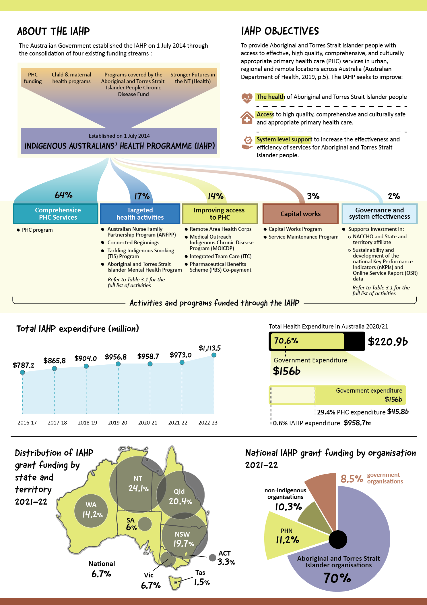

Overview
This section provides detailed information about the IAHP, including its objectives, the programs and activities that the IAHP supports, and on funding, including changes in funding over time. This section helps to build an understanding of how the IAHP operates, including the mix of initiatives being funded by the IAHP (Evaluation Question 2.1).

Data sources and methods
This section draws on publicly available financial information and additional IAHP funding data provided by the department. Data on health service clients and population data are sourced from the nKPI and OSR data collections and ABS population statistics. Detailed site level IAHP funding data were not available. Other site level data has been de-identified in accordance with the evaluation’s ethical requirements.

About the IAHP
The objective of the IAHP is to provide Aboriginal and Torres Strait Islander people with access to effective, high quality, comprehensive, and culturally appropriate PHC services in urban, regional and remote locations across Australia (Australian Department of Health, 2019c, p. 5).
The IAHP seeks to improve:
- the health of Aboriginal and Torres Strait Islander people
- access to high-quality, comprehensive and culturally safe and appropriate PHC
- system level support to increase the effectiveness and efficiency of services for Aboriginal and Torres Strait Islander people (Australian Department of Health, 2019c, p. 5)
Through the IAHP, the Australian Government funds:
- health services to deliver culturally appropriate PHC services and initiatives
- health services to provide targeted health activities (including for eye, ear, and oral health, mental health, drug and alcohol use sexually transmitted infections, and chronic diseases)
- Primary Health Networks (PHNs) to improve access to coordinated care and organisations to provide outreach services
- the building, repair, or upgrading of facilities such as Aboriginal Community Controlled Health Service (ACCHS) clinics and housing for staff (Australian Department of Health, 2020c).
The IAHP funds programs and activities as part of a complex and overlapping interconnected system of funding and programs across the health care system. Most notably, many programs and activities are not solely funded by the IAHP and may receive funding from other areas such as workforce, the Medicare Benefits Scheme (MBS), the Pharmaceutical Benefits Scheme (PBS) or Practice Incentive Program (PIP) Indigenous Health Incentive (IHI).
A program theory and logic model for the IAHP was developed by the department’s First Nations Health Division in 2015. This is included in Final Report Supporting Material Appendix E. The program theory and logic were developed to guide the design of this evaluation and supported the framing of the key evaluation questions. The theory and model supports understanding about how different elements of the IAHP are intended to work alongside each other to support health outcomes for Aboriginal and Torres Strait Islander people.

IAHP funding streams and activities
The IAHP includes a range of programs and activities. The programs and activities funded through the IAHP are not static and the IAHP evolves to accommodate new and emerging priorities. The configuration of IAHP programs and activities under different areas has evolved over the evaluation period. The evaluation reports on programs, activities and funding under 5 themes and 9 funding streams. The 9 funding streams align with funding data provided by the department.
To support improvements to health outcomes for Aboriginal and Torres Strait Islander people, the IAHP provides funding to services to deliver health services to Aboriginal and Torres Strait Islander people across 5 themes:
- Comprehensive PHC services, through funding ACCHSs and other health services to deliver PHC to Aboriginal and Torres Strait Islander people.
- Improving access to PHC, by increasing the capacity of ‘mainstream’ health care services to provide culturally appropriate care and by improving outreach, coordination and referral services to connect Aboriginal and Torres Strait Islander people to the full range of services appropriate to their health needs.
- Targeted health activities such as anti-smoking, mental health, eye and ear health, blood borne viruses and sexually transmitted infections, chronic conditions such as diabetes, renal disease, cancer, heart disease, respiratory disease and rheumatic heart disease.
- Capital works, including upgrading and maintenance of IAHP funded PHC facilities and residential staff accommodation.
- Governance and system effectiveness, including funding of information systems, system support, data, evaluation, and continuous quality improvement.
Between 2018-19 and 2020-21 there were 37 activities and programs funded through the IAHP. These are set out in Table 3-1.

PHC, including comprehensive PHC
The central pillar of the IAHP is funding for the delivery of comprehensive PHC for Aboriginal and Torres Strait Islander people. The IAHP funds Aboriginal Community Controlled Health Services and other health services to deliver PHC through the PHC Program.
The objective of the PHC Program is to contribute to closing the gap in life expectancy within a generation and to halve the gap in mortality rates for Aboriginal and Torres Strait Islander children under five within a decade through the provision of high quality, comprehensive, culturally appropriate PHC (Australian Department of Health and Age Care, 2019). Funding is provided to a range of organisations, including ACCHSs, to support and deliver comprehensive, culturally appropriate PHC services to Aboriginal and Torres Strait Islander people.
Further details of the PHC Program are set out in Final Report Supporting Material Appendix F.

Improving access to PHC
The IAHP supports improvements to the delivery of PHC to Aboriginal and Torres Strait Islander people in mainstream settings. Programs and activities under this theme aim to improve access to PHC and improve the capacity of mainstream services to deliver culturally safe services to Aboriginal and Torres Strait Islander people.
This theme includes investment in:
- the Remote Area Health Corps program, which aims to address critical short-term workforce shortages in remote communities in the NT by recruiting urban-based health professionals for short term deployments.
- the Medical Outreach Indigenous Chronic Disease Program (MOICDP), which aims to improve access to health services for Aboriginal and Torres Strait Islander people living with chronic disease through subsidising health professionals providing outreach services.
- the Integrated Team Care (ITC) program, which funds the coordination of care for people with chronic disease and assists them to access care, and supports mainstream health services to provide more culturally appropriate care for Aboriginal and Torres Strait Islander people.
- the PBS Co-payment, which subsidises the cost of PBS medicines for eligible Aboriginal and Torres Strait Islander people living with, or at risk of, a chronic disease.
Case study – Integrated Team Care
The Integrated Team Care (ITC) program aims to contribute to improving health outcomes for Aboriginal and Torres Strait Islander people with chronic health conditions through better access to coordinated and multidisciplinary care; and contribute to closing the gap in life expectancy by improved access to culturally appropriate mainstream primary care for Aboriginal and Torres Strait Islander people.
The ITC program supports people with complex chronic diseases through providing supplementary services funding to pay for medical and allied health services, transport services, and medical aides; and through one-to-one assistance by care coordinators and outreach workers.
The Integrated Team Care program is managed by PHNs which commission Aboriginal and Torres Strait Islander and mainstream health organisations to deliver the services.

Targeted health activities
To respond to the prevalence of chronic disease and other conditions in Aboriginal and Torres Strait Islander people, the IAHP also funds targeted health activities to reduce the disproportionate burden of disease for Aboriginal and Torres Strait Islander people.
Programs and activities under this theme include programs relating to smoking, kidney health, ear and eye health, cardiac health, rhematic fever, cancer screening, sexual and reproductive health, nutrition, oral health, crusted scabies and chronic disease. The funding is responsive to emerging priorities and is provided to funded services for the delivery of specific programs, rather than general clinical service delivery.
Case study – Australian Nurse Family Partnership Program
The Australian Nurse Family Partnership Program is a nurse-led home visiting program for Aboriginal and Torres Strait Islander women who are pregnant or women pregnant with an Aboriginal or Torres Strait Islander child. It supports women from around 16 weeks gestation to 2 years of age. The program aims to improve pregnancy outcomes by helping women engage in preventive health practices; support parents to improve their child’s health and development; and help parents develop a vision for their own future, including continuing education and finding work.
.

Capital works
The IAHP capital works theme aims to ensure that Aboriginal and Torres Strait Islander people have access to safe and effective essential health services through the provision of culturally appropriate, fit for purpose health infrastructure, including clinics, staff accommodation and facilities for the delivery of renal services. Investment in capital works through the IAHP can range from the purchase of a new facility, refurbishment or existing facilities, building of a new clinic and/or staff housing.
This theme includes investment in:
- the Capital Works Program, which aims to improve access to PHC services through safe and accessible, fit-for-purpose health infrastructure, and safe and secure clinical staff housing
- the Service Maintenance Program, which aims to improve the safety and accessibility of ACCHS clinics for Aboriginal and Torres Strait Islander people by addressing emergency repairs, urgent maintenance and upgrade issues.

Governance and system effectiveness
In addition to supporting direct service delivery through program and infrastructure investment, the IAHP also provides funding for investment in information systems, system support, data, evaluation, CQI and measures to strengthen the quality and safety of health care provision to Aboriginal and Torres Strait Islander people. This theme includes funding to NACCHO and its state and territory affiliates.

Other related programs
There are also programs that intersect with programs funded under the IAHP, including the PIP IHI, and directly influence the funding and service delivery landscape for IAHP funded organisations. For example, elements of the Indigenous Chronic Disease Package, including the PIP IHI, are an important funding stream for ACCHSs and mainstream GP practices.

Table 3-1. Activities and programs funded through the IAHP
Funding stream | Objective(s) | Activities and programs
PHC Services | To contribute to closing the gap in life expectancy within a generation and to halve the gap in mortality rates for Aboriginal and Torres Strait Islander children under 5 within a decade through the provision of high quality, comprehensive, culturally appropriate PHC | PHC Program, New Directions Expansion, Australian Nurse Family Partnership Program (ANFPP), Connected Beginnings
Improving Access to PHC for Aboriginal and Torres Strait Islander People | To improve access to PHC and to improve the capacity of mainstream primary care services to deliver culturally safe services to Aboriginal and Torres Strait Islander people | Remote Area Health Corps, Medical Outreach Indigenous Chronic Diseases Program (MOICDP), Integrated Team Care (ITC), Services of Concern
Targeted Health Activities | To improve health outcomes by targeting high prevalence or emerging health conditions in the Aboriginal and Torres Strait Islander population | Indigenous Renal, Indigenous Ear Health, Indigenous Eye Health, Indigenous Cardiac Care, Indigenous Rheumatic Fever Strategy, Indigenous Health Promotion, Indigenous Health Protection, Bowel Cancer Screening, Cervical Cancer Screening, Sexual Health, Nutrition, Oral Health, Youth, Indigenous Chronic Disease Programs, Crusted Scabies, Emerging Priorities, Indigenous Workforce
Tackling Indigenous Smoking (TIS) | To reduce smoking rates among Aboriginal and Torres Strait Islander people by increasing both the number of smokers who choose to quit and the number of people who have never smoked | TIS Program. 37 targeted regional tobacco control grants, supported by the National Best Practice Unit (NBPU) and Quitskills brief intervention training
Mental Health | To improve access to culturally appropriate mental health services for Aboriginal and Torres Strait Islander people | Funding provided to respond to the National Mental Health Commission’s Review of Mental Health Programmes and Services (2015) for Indigenous specific mental health services commissioned through PHNs
Capital Works | To increase Aboriginal and Torres Strait Islander people’s access to safe and effective essential health services through the provision of culturally appropriate, fit for purpose health infrastructure, including clinics, staff accommodation and facilities for the delivery of renal services | Capital Works Program, Service Maintenance Program
Governance and System Effectiveness | To improve health outcomes for Aboriginal and Torres Strait Islander people by:  - supporting improvements in core essential health service delivery across the health sector  - strengthening integration between the ACCHS sector and mainstream health services to improve referral pathways for the patient journey across the health sector  - strengthening governance and effectiveness of the ACCHS sector including supporting ACCHSs to provide assessable, responsive, high quality comprehensive, culturally appropriate PHC services  - contributing to the development and implementation of appropriate and effective Aboriginal and Torres Strait Islander health policy | National Indigenous Continuous Quality Improvement (CQI), Indigenous Monitoring and Evaluation, Indigenous Remote Service Delivery Traineeship, Australian Health Ministers’ Advisory Council contribution, Implementation Plan, Regionalisation (Transition to Community Control in NT only)
NACCHO and Affiliates | The Aboriginal Community Controlled Health Sector Support Network grant (National Funding Agreement) aims to build on existing arrangements with the National Aboriginal Community Controlled Health Organisation (NACCHO) and the Aboriginal Community Controlled Health Sector Support Organisations (SSOs) to align programs and service delivery of the Aboriginal Community Controlled Health Services (ACCHSs) with broader health reforms for Aboriginal and Torres Strait Islander peoples. This includes, but is not limited to ensuring implementation is in line with current and emerging direction under the National Agreement on Closing the Gap (National Agreement); the National Aboriginal and Torres Strait Islander Health Plan 2021-2031 (Health Plan); and the National Aboriginal and Torres Strait Islander Health Workforce Strategic Framework and Implementation Plan 2021-2031 | Indigenous peak body and state and territory affiliate funding agreements, and other costs associated with supporting affiliate activities
National Aboriginal and Torres Strait Islander Flexible Aged Care Program | Funds aged care services to:  - deliver a range of services to meet the changing aged care needs of the community  - older Aboriginal and Torres Strait Islander people close to home and community  - improve access to aged care services for Aboriginal and Torres Strait Islander people  - improve the quality of culturally appropriate aged care services for Aboriginal and Torres Strait Islander people  - develop financially viable cost-effective and co-ordinated services outside of the existing mainstream programs | Expansion of the program to provide around 900 additional aged care places to benefit up to 1,000 Indigenous people

Distribution of IAHP funding across funding streams
Figure 3-1 shows the distribution of the IAHP funding across funding streams for all of Australia, aggregated across 3 years. PHC Services accounts for the largest proportion of total IAHP expenditure (63.8%). Funding under PHC Services includes funding for the PHC Program, New Directions Expansion, Australian Nurse Family Partnership Program, and Connected Beginnings.
Figure 3-1. National IAHP grant funding expenditure by funding stream, 2018-19 to 2020-21

Source: Data provided by the Department of Health and Aged Care, March 2022.

IAHP as a proportion of total health expenditure
At $958.7 million in 2020-21, the IAHP represents a small proportion of total health expenditure. In 2020-21, total health expenditure in Australia (including government and non-government sources) was $220.9 billion, of which $156.0 billion (70.6%) was government expenditure (Australian Institute of Health and Welfare, 2022b). For PHC, total government expenditure in 2020-21 was $45.8 billion.
Figure 3-2 and Figure 3-3 shows the expenditure on IAHP over 2014-15 to 2020-21 compared with other health expenditure. Over 2015-16 to 2020-21, IAHP expenditure as a proportion of Australian Government health spending was fairly stable at just over 1.0%. IAHP expenditure as a proportion of national total health expenditure was also fairly stable at around 0.5%. As a proportion of Australian Government spending on PHC, IAHP expenditure declined from 3.3% in 2018-19 to 2.9% in 2020-21. Note that dollars have been adjusted for CPI using the ABS health index and the Consumer Price Index and are expressed as constant 2019-20 dollars.
Figure 3-2. National and Australian Government health spending, constant prices, 2014-15 to 2020-21
Source: Data provided by the Department of Health and Aged Care, March 2022; AIHW Health Expenditure Database; Health Portfolio Budget Statements.
Figure 3-3. IAHP proportion of health expenditure, constant prices, 2014-15 to 2020-21

Source: Data provided by the Department of Health and Aged Care, March 2022; AIHW Health Expenditure Database; Health Portfolio Budget Statements.
Estimated IAHP expenditure in the most recent year (2022-23) of $1,114 million indicates a 14% increase on 2021-22 expenditure, which is the highest annual increase since the IAHP was established in 2014.
The IAHP is a significant proportion of government health expenditure for Indigenous Australians. In 2016-17, total Australian Government health expenditure per person for Indigenous Australians was estimated at $3,585 per person. For all governments (Australian, state, and territory) health expenditure for Indigenous Australians was estimated at $7,844 per person (Australian Institute of Health and Welfare, 2021a). For the same year (2016-17), IAHP expenditure was $882 per Indigenous person. Therefore, the IAHP equated to 25% of the Australian Government’s health expenditure for Indigenous Australians, and 11% of all governments’ health expenditure for Indigenous Australians.

IAHP funding arrangements
As a funding mechanism, understanding how funding moves from the department into PHC service delivery is critically important. It also assists to contextualise how services interact with the IAHP and how the IAHP is located within the broader PHC landscape. For that reason, this section includes some analysis of funding data to support and contextualise the evaluation findings that follow in later sections.
IAHP funding primarily moves through 3 main pathways.
- Funding goes directly to service providers or organisations (for example, ACCHSs, NT Regional Health Services, other Aboriginal health services and organisations, and non-Indigenous private health services and organisations).
- Funding reaches PHC service and other providers indirectly via jurisdictional-level and regional bodies (for example, PHNs for ITC and mental health funding; Medical Outreach Indigenous Chronic Diseases Program (MOICDP) via, for example, NSW Rural Doctors Network, CheckUp Australia in Queensland, and Tasmania Department of Health).
- Funding includes specific streams for the NT (for example, oral health as part of the Indigenous PHC services funding and the Remote Area Health Corps (RAHC), which is managed by Aspen Medical).
The nature of these funding flows under IAHP creates a complicated, and interconnected funding landscape. This is depicted in Figure 3-4 which shows the main funding flows from 5 IAHP funding streams on the left to funded organisations on the right. The arrows on the right-side of the diagram illustrate the onwards funding or indirect funding relationships. For example, the distribution of ITC funding from the department to a PHN who then commission an ACCHS or other organisation to deliver the service.
Figure 3-4. IAHP funding flows to funded organisations
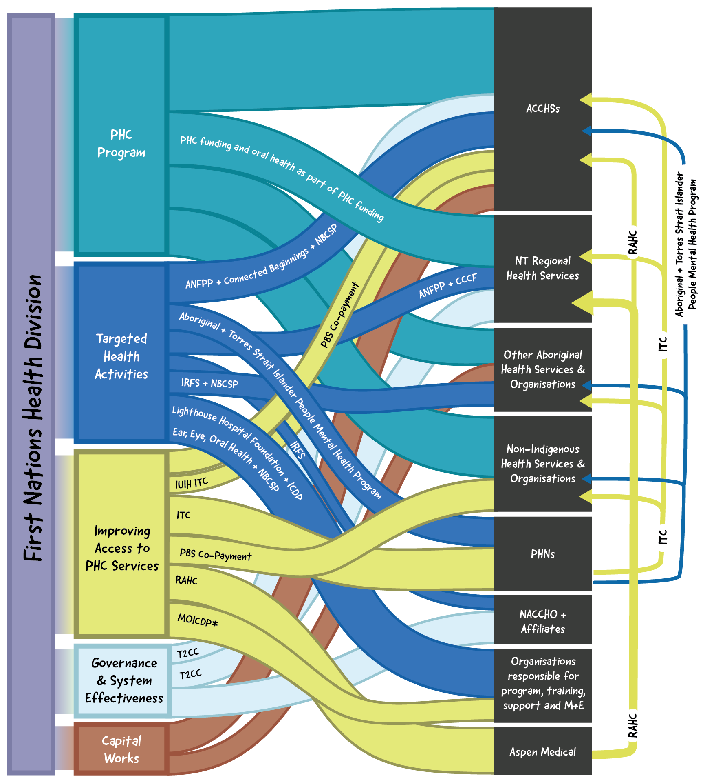
* Funding is managed by single fundholders in each jurisdiction

The majority of IAHP funding goes to ACCHSs
Most of the funding distributed under IAHP goes directly to ACCHSs. There is also a further portion of funding that flows indirectly to ACCHSs through PHNs.
In 2021-22, 70.0% of total IAHP funding went to Aboriginal and Torres Strait Islander organisations, including ACCHSs and other Indigenous organisations (Figure 3-5). The remaining funding went to PHNs (11.2%), non-Indigenous organisations (10.3%), and government organisations (8.5%). Some of this funding went indirectly to ACCHSs, for example through PHNs commissioning ACCHSs to deliver services under the mental health funding stream and the ITC program.
In 2022-23, the PHC Program funded 162 organisations, of which 132 (81.5%) were ACCHSs (Figure 3-6).
Figure 3-5. IAHP funded organisations (% of funding), 2021-22

Figure 3-6. IAHP PHC Program funded organisations (% of funded organisations), 2022-23

IAHP funding by state and territory
In 2021-22, organisations in the NT received the highest proportion of IAHP funding at 24.1%, followed by Queensland (20.4%), NSW (19.7%) and WA (14.2%) (Figure 3-7).
Figure 3-7. IAHP funding by state and territory, 2021-22

Source: Data provided by the Department of Health and Aged Care, March 2022.
Note: Figures are calculated based on the state or territory of organisations’ business address.

IAHP funding by population
On a population basis, total IAHP grant funding expenditure was significantly higher in the NT than other states and territories (Figure 3-8), at $2,878 per Aboriginal or Torres Strait Islander person. This compares with a national average of $1,005 per Aboriginal or Torres Strait Islander person in 2019-20. This reflects several factors, including that the vast majority of the Aboriginal or Torres Strait Islander population in the NT receives primary care services from ACCHSs or NT government clinics, both of which receive IAHP funding. Furthermore, the majority of ACCHSs in the NT are in remote or very remote areas and therefore attract a higher weighting under the PHC Program funding model.
Figure 3-8. IAHP funding per Indigenous person by state and territory, 2019-20

Source: Data provided by the Department of Health and Aged Care, March 2022; ABS Estimates and Projections, Aboriginal and Torres Strait Islander Australians, 2006 to 2031.
Note: Figures are calculated based on the state or territory of organisations’ business address.

Figure 3-9 shows client numbers for organisations that are funded under the IAHP to deliver comprehensive PHC. It illustrates the high proportion of clients in the NT, and to a lesser extent WA and Queensland, who attend non-ACCHS IAHP funded organisations (predominantly state and territory government primary care clinics). It also shows the high proportion of the Aboriginal and Torres Strait Islander population that attend any IAHP funded service in the NT; in this case the number of clients is higher than the total NT Indigenous population. In other states and territories (NSW/ACT and Victoria/Tasmania in particular) it shows that less than half of the Aboriginal and Torres Strait Islander population attend IAHP funded organisations.
Figure 3-9. Number of clients of IAHP funded organisations and total Aboriginal and Torres Strait Islander population by state and territory

Source: Data from OSR; ABS Estimates and Projections, Aboriginal and Torres Strait Islander Australians, 2006 to 2031.

Figure 3-10 shows total IAHP funding per client of IAHP funded organisations. The variation across states and territories is considerably less than by total Aboriginal and Torres Strait Islander population. Nevertheless, there is still a large variation between $1,336 per client in Queensland and $2,378 per client in SA.
Figure 3-10. Total IAHP grant funding expenditure per client by state and territory, 2019-20

Source: Data provided by the Department of Health and Aged Care, March 2022; OSR
Note: Figures are calculated based on the state or territory of organisations’ business address.

Increases in IAHP grant funding
There has been growth in the level of grant funding under the IAHP. Data indicates that IAHP grant expenditure has grown steadily from $506 million in 2014-15 to $893 million in 2020-21, as shown in Figure 3-11.
Figure 3-11. National IAHP grant funding expenditure, 2014-15 to 2020-21
Source: Data provided by the Department of Health and Aged Care, March 2022.
After accounting for CPI, with prices expressed as constant 2019-20, IAHP grant funding expenditure increased from $604 million in 2014-15 to $868 million in 2020-21, an increase of 44% (or 6.2% per year). Half of the increase in spend (22%) occurred in the first year, 2014-15 to 2015-16 (Figure 3-12). Since then, total IAHP expenditure has increased at a rate of 3.3% per year.
Figure 3-12. Total IAHP grant funding expenditure, constant prices, 2014-15 to 2020-21

Notes: Figures are calculated based on the state or territory of organisations’ business address.
Source: Data provided by the Department of Health and Aged Care, March 2022.

Increase in client activity
An analysis of OSR data shows that the number of people supported by services receiving IAHP funding to deliver comprehensive PHC services has grown. The number of client contacts with IAHP funded services has also increased.
The amount of activity undertaken by organisations that receive IAHP funding increased from 2014-15 to 2019-20 with more clients and more client contacts (Figure 3-13). Nationally, client numbers have increased from 434,610 in 2014-15 to 468,500 in 2019-20, an increase of 7.8%. Client contacts increased over the same period from 5,022,709 to 5,440,291, an increase of 8.3%. There was a drop in 2019-20, which may be a result of the beginning of the COVID-19 pandemic. Queensland had the highest number of clients and South Australia the fewest. Nationally, the Aboriginal and Torres Strait Islander population increased by approximately 17% over this same period (2014-15 to 2019-20).
Figure 3-13. Number of clients and client contacts at organisations receiving IAHP funding, 2014-15 to 2019-20
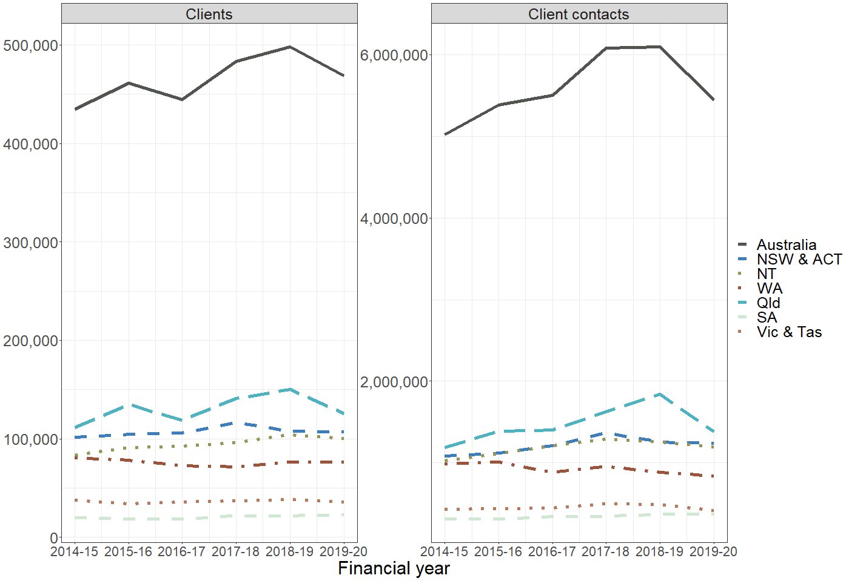
Source: OSR data provided by the Department of Health and Aged Care.

IAHP funding per client at IAHP funded organisations increased from $1,390 to $1,831 (32%) between 2014-15 and 2019-20, adjusted for CPI (Figure 3-14). Around half of this growth (15%) occurred in the first year, 2014-15 to 2015-16. In 2019-20, South Australia received the greatest funding per client and Queensland the least. IAHP funding also increased per client contact at organisations receiving IAHP funding from 2014-15 to 2019-20, from $120 per client in 2014-15 to $158 in 2019-20, adjusted for CPI (constant 2019-20).
Figure 3-14. Total IAHP funding expenditure by client, constant prices, 2014-15 to 2020-21

Note: Figures are calculated based on the state or territory of organisations’ business address.
Source: Data provided by the Department of Health and Aged Care, March 2022; OSR.

Distribution of funding to organisations in evaluation sites
To understand funding arrangements relevant to the evaluation sites, the evaluation assessed the distribution of IAHP funding to organisations across the 17 sites. Across the sites, all 23 ACCHSs, the one government primary care service, and all 13 PHNs received IAHP funding. All but one health service, Torres Health, received IAHP PHC Program funding and ITC program funding. In the 5-year period 2018-19 to 2022-23, 10 sites received IAHP capital works funding, 8 sites received funding for Tackling Indigenous Smoking and 5 sites received ANFPP funding. IAHP programs and activities in each site is included in Final Report Supporting Material Appendix J.
For the 23 ACCHSs across the sites, total IAHP funding received through grants made directly from the department in the year ending 30 June 2021 ranged from less than $1 million to more than $30 million per annum (average of $6.3 million, median of $4.5 million). The distribution of funding is shown in Figure 3-15, with over half of the ACCHSs receiving less than $5 million. For most ACCHSs, the majority of the IAHP funding through direct grants was under the PHC Program, with the exception of Torres Health which received no funding under the PHC Program.
Figure 3-15. Total IAHP funding received directly through grants from the Department of Health and Aged Care, year ending 30 June 2021

Source: Based on data provided by the Department of Health and Aged Care, March 2023

Part B – Values and experiences


Overview of Part B
Part B outlines findings relating to the values and experiences of Aboriginal and Torres Strait Islander people. This Part includes the following sections:
- Section 6 – Understanding what Aboriginal and Torres Strait Islander people value in health care uses the Babuny – or bottle tree – to explain what Aboriginal and Torres Strait Islander people value in health service design and delivery.
- Section 7 – Understanding how Aboriginal and Torres Strait Islander people experience the health system sets out the findings in relation to experiences of the health system for Aboriginal and Torres Strait Islander people. This includes people’s experiences across the health system; in Aboriginal and Torres Strait Islander community-controlled health settings and mainstream health settings.
Importantly, the analysis and key findings in this Part relate to the values and experiences of Aboriginal and Torres Strait Islander people across the health system and are not confined to experiences of PHC funded through IAHP.
This Part draws on qualitative analysis to develop evaluative criteria to inform responses to the KEQs. Developing an improved understanding of consumer perspectives and experiences of the health system based on what Aboriginal and Torres Strait Islander people value was essential to shape the approach to the evaluation of how well the PHC system was working for Aboriginal and Torres Strait Islander people.
Building a detailed understanding of consumer perspectives was also essential to shape the evaluative criteria to assess the contribution of the IAHP to enabling the PHC system to work for Aboriginal and Torres Strait Islander people, and approach key questions relating to the impact of this investment on health and wellbeing outcomes and improvements to experiences of PHC for Aboriginal and Torres Strait Islander people.
The findings in this Part provide important foundation to understanding the extent to which the IAHP supports the delivery of PHC that aligns with what Aboriginal and Torres Strait Islander people value in health care.
Specific findings relating to the IAHP are set out in Part C.

Understanding what Aboriginal and Torres Strait Islander people value in health care

Key findings
Aboriginal and Torres Strait Islander people value health service design and delivery that:
1 | is place based, flexible and contextually relevant, including health care that considers local environmental, social and cultural contexts and create wellness through prevention, early intervention, and social determinants of health.
2 | is accessible in a broad sense, including people being aware of health services, an ability to access services, affordable care, care that is available when needed, and health care that is provided in an acceptable way.
3 | is underpinned by self-determination and Aboriginal and Torres Strait Islander leadership so that health services can meet community needs.
4 | provides equitable funding for health care that is ongoing, provides for appropriate infrastructure, and supports the employment and career development of Aboriginal and Torres Strait Islander people.
5 | supports an ethic of responsibility and care that extends beyond services to the system level (i.e. across all decision-making and actions on policy and resourcing that influence health care from government to frontline clinicians).
6 | responds to the whole person which includes all the interrelationships with family, community, and the environment.
7 | adopts collective approaches to health and wellbeing; and enables choice in how, where and by whom care is provided.
8 | provides quality care, is culturally safe, and provides consistent programs, services and continuity of care support.
9 | connects people to the support they need and cares for people across the life course.

Overview
This section outlines what Aboriginal and Torres Strait Islander people value in health service design and delivery. This is one of the evaluation questions (1.1) and is critical to understanding how well the IAHP is enabling the primary health care system to work for Aboriginal and Torres Strait Islander people (KEQ1). This section sets out a framework, using the metaphor of Babuny – bottle tree – to visualise and represent the interconnected elements and characteristics of what Aboriginal and Torres Strait Islander people value in health service design and delivery.
This section is framed around values in health service design and delivery associated with:
- Place based and contextually relevant care.
- Identifiable and accessible places.
- Governance and resourcing of health care.
- Responsibility and resistance.
- Holistic care.
While this section refers to what Aboriginal and Torres Strait Islander people value in health service design and delivery, this does not suggest that there is a singular or representative view from Aboriginal and Torres Strait Islander people on what is valued. The values for health service design and delivery identified in this section are informed by the yarning with community members for the purpose of informing and guiding the evaluation.
Findings in relation to the experiences of Aboriginal and Torres Strait Islander people within the health system are outlined in Section 5.

Data sources and methods
This section draws on data generated through community and individual yarns held between March 2021 and November 2022. Yarning was used as the primary method to facilitate the active voices of Aboriginal and Torres Strait Islander people as knowledge holders. 452 Aboriginal and Torres Strait Islander community members participated in these yarns. The data generated included people’s explicit statements of what they valued in health service design and delivery, the use of rich experiential narrative that provides context, and dialogue that creates meaning from the evidence being shared within the yarn.
Data were initially inductively coded using an adapted Schema analysis (Rapport et al., 2019). Each transcript was coded in larger fragments (or ‘chunks’) reflecting segments or incidents rather than individual lines. Data interrogation was conducted by asking, ‘what does this tell us about what the community values in health service design or delivery?’ This approach supported the summative nature of Schema analysis and ensured that the codes generated were neutral statements of what is valued.
Coding from each group yarn were visualised to provide feedback to contributing knowledge-holders in group yarns in Cycle 1. The codes were written as shorter labels using more accessible language. Situational analysis analytic mapping tools were then applied to progress the analysis. During this part of the analytic process questions were asked like, ‘what are the conditions in which this is enabled/enacted?’, ‘what are the mechanisms of power in this situation? And ‘how does this manifest and under what conditions?’ (Flyvbjerg, 2001). Further coding and mapping were undertaken to examine and capture the relational nature of the concepts and develop them into a framework. The analysis also considered any divergence between sites and the dynamic nature of the health system.
In Cycle 3, the values of health service design and delivery within a draft Babuny framework were shared and sense-checked in group yarns with community members to check for resonance and explore nuances between sites. These discussions were also used to check that the framework for what Aboriginal and Torres Strait Islander people value in health care design and delivery – Babuny – resonated with community members.

Babuny: a framework of what Aboriginal and Torres Strait Islander people value in health service design and delivery
The evaluation’s findings about what Aboriginal and Torres Strait Islander people value in health service design and delivery have been explained using the metaphor of a tree. This approach was selected because metaphor is consistent with Aboriginal and Torres Strait Islander epistemologies, provides an appropriate way to explain relationships between concepts, and is a way of sharing social knowledge (Fredericks et al., 2015; Kwaymullina & Kwaymullina, 2010; Moreton-Robinson, 2017; St. Clair, 2000).
The framework uses the metaphor of the bottle tree, Brachychiton rupestris or Babuny. The bottle tree has medicinal properties (Thabet et al., 2018) and specific characteristics that reflect important elements of what Aboriginal and Torres Strait Islander people value in health service design and delivery. The framework is illustrated in Figure 4-1.
A bottle tree represents a dynamic system that is connected to, and part of, place. A bottle tree transforms its resources - such as water and nutrients - to create shelter and other resources. It supports the survival of other living things and creates growth and wellbeing of individuals and the landscape by returning resources to people and place.
Similarly, when contributing to the evaluation Aboriginal and Torres Strait Islander community members stated a good quality health service should connect to, and be part of, the communities it serves. Drawing on the resources available, a health service should provide spaces, programs, and services where individual and collective wellness is supported, creating stronger communities, and strengthening health determinants.
The appropriateness of the tree metaphor for the framework was supported by community members who provided feedback on the Babuny framework. Trees have always been places to access resources, shelter, and gather. As one Elder stated:
And trees are good. I believe with trees. Trees can help you with birthing. They grow and they're grounding, and they help support you when you need them.
Community Elder
From the data shared by community knowledge holders, the core characteristics of care and connection are woven throughout Babuny. Care and connection manifest in the resources that support health care, the sharing of power for self-determination and community leadership, through to the way services are designed and delivered.

Figure 4-1. Babuny framework showing what Aboriginal and Torres Strait Islander people value in health service design and delivery
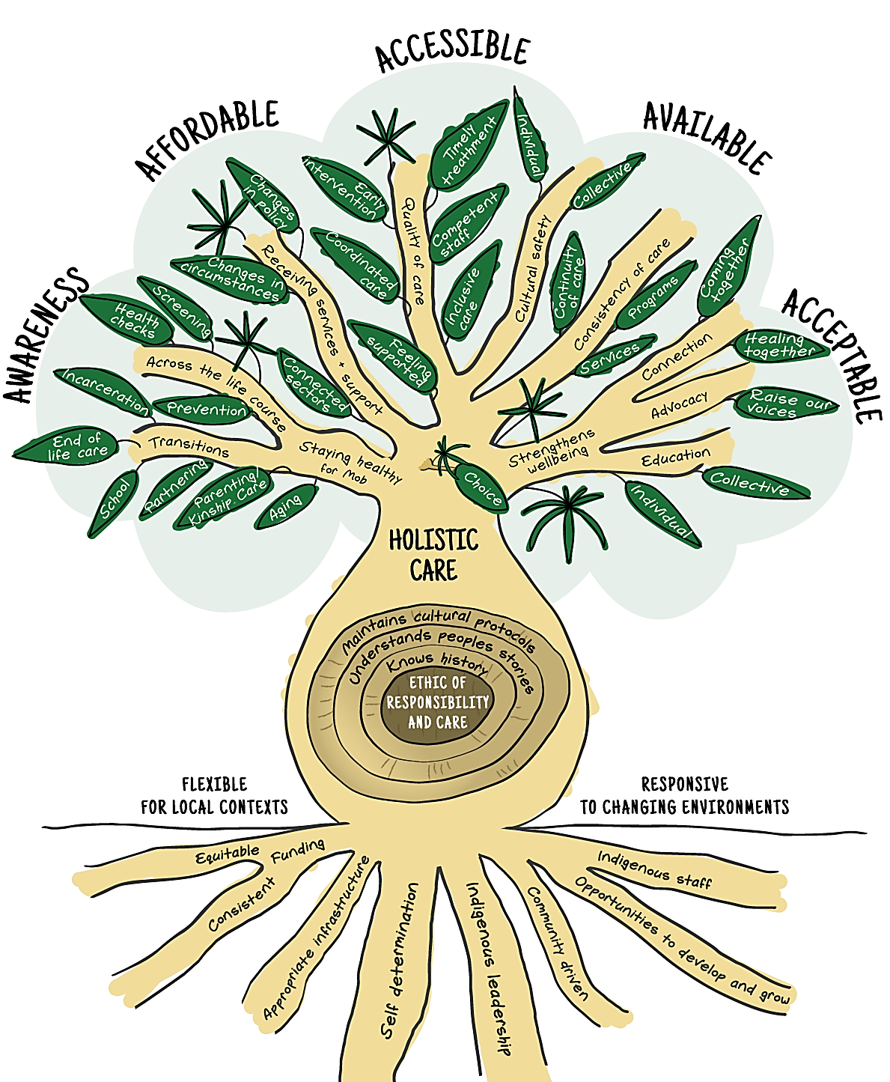

Place based and contextually relevant health care
Comprehensive health services that are designed and delivered to respond to health need and create wellness are valued by community members. These place-based responses are demonstrated through how services operate and interact with local contexts regarding prevention, early intervention, and social determinants of health. This is reflected in the way a bottle tree has adapted to, and interacts with, its environment through constituent and responsive characteristics (Reynolds et al., 2018). These two place-based characteristics of health care design and delivery are identified on Babuny with labels of flexible for local contexts and responsive to changing environments.
Figure 4-2. Babuny framework spotlight on flexible and responsive
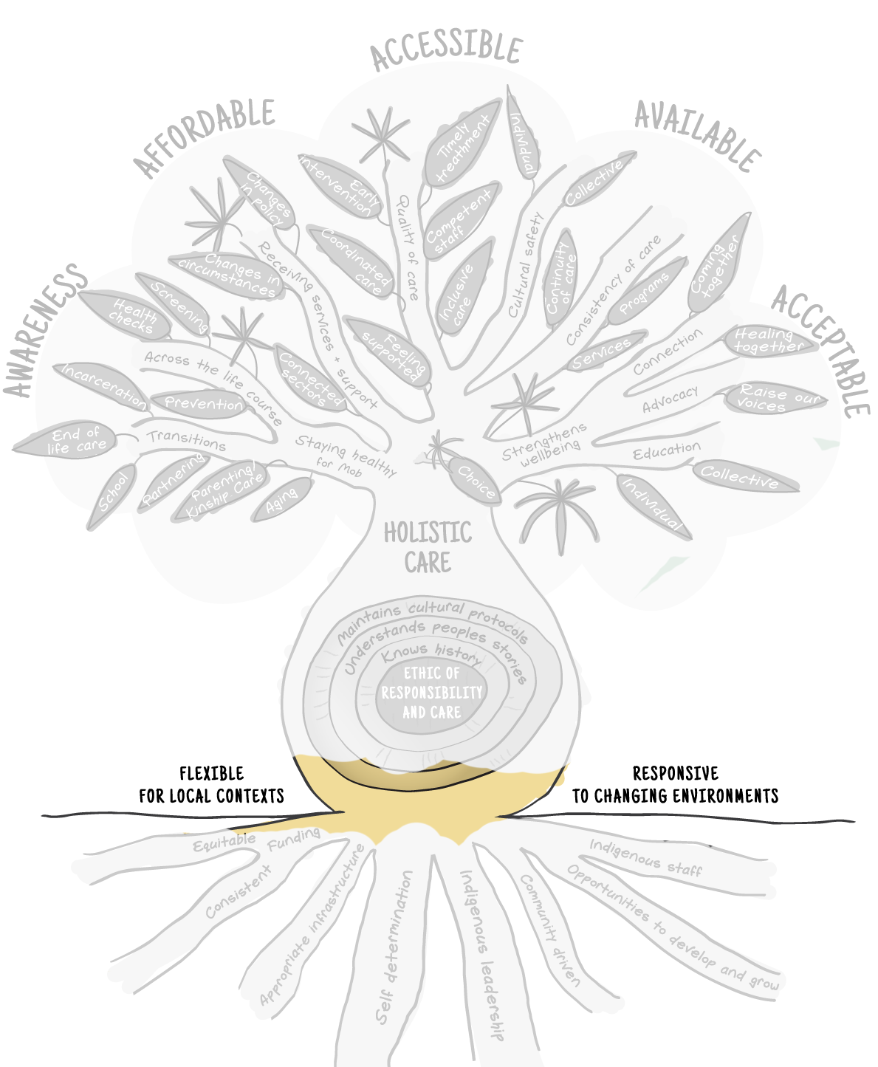
Place-based service design and delivery that incorporates a nuanced understanding of local contexts beyond broad geographic differences (urban, regional, remote), and considers environmental, social, and cultural differences between Aboriginal and Torres Strait Islander communities are valued by Aboriginal and Torres Strait Islander people that contributed to the evaluation. Similarly, bottle trees vary between locations as long-term adaptation creates constituent characteristics that are responsive to local environments, such as tougher leaves in areas of persistent lower rainfall (Reynolds et al., 2018).
Aboriginal and Torres Strait Islander people value health care design and delivery that is flexible enough to respond to the diversity of their communities and experiences. This flexibility can be shown through diverse approaches to health service delivery through to individual program design. The value of flexibility was explained by one Elder for how different models of health care delivery might respond to the challenges of lower population density:
You got to think differently about different areas. . . it depends on the area. You go to Dubbo, you go to Cairns, you go to, you know, you go to Katherine or something like that. There's a concentration of Aboriginal people in one area. . . there's you know thousands living around, they're not far away from it. But here where we've got an AMS, we're scattered. We've got communities that are small and scattered. Right. So having a big AMS in one area is not the solution. That's my belief, right? Yeah. And I always thought it should, should be like a brokerage type service in an area like this.
Community member
The importance of place-based program delivery relevant to local contexts was also identified by participants in community yarns. Community members explained the importance of tailoring or adapting programs that are being scaled up or rolled out to ensure their uptake and success in different communities. This was illustrated by an Elder’s concerns about programs being rolled out to their community without consideration of adaptation to local need and context.
Red dust isn’t our Country. But you know that us fellows here, Kooris. We've got a different language and different ways to the Noongars, to the Bardi people. You know, all around. We got that different way of addressing how our people are and how we feel. It’d be well worth it to adapt it to that area.
Community Elder
Health service design and delivery that is agile enough to respond to local cyclic (cultural protocols, seasonal influences) or emergent changes (social or economic changes, or disaster response) is valued by Aboriginal and Torres Strait Islander people. Similarly, the bottle tree can quickly respond to changes in its environment through responsive characteristics such as those that allow it to swiftly reduce water loss (Reynolds et al., 2018).
The COVID-19 pandemic, disasters such as fires and floods, and social or economic influences such as the Cashless Debit Card had created impactful and recent experiences of situations that forced health systems to stage a quick response. Community members shared experiences from each of these diverse circumstances as evidence of the importance of agile and responsive health care. Health care responses that were most valued by participants during these crises were those that helped people meet basic needs, provided clear communication of information and health advice relevant to the situation, and adapted the way services were provided or could be accessed. One community representative described how their ACCHS responded to support the health and wellbeing of Elders during COVID lockdown:
In the last 12 months, through the pandemic, one of the ways we’ve distinguished ourselves from other services, is we have the Elder support program. The Elder support program was almost a, just a safety net from the heart health program. We couldn’t engage with the community anymore, because of what’s that, physical restrictions. They couldn’t come to us, in our conference room, but we’re aware that there is a health risk when people are socially isolated, that they are not engaging with health services. So, we came up with a strategy of looking at supporting elders in the community. We would go out to their homes, support them in … their basic health needs. For example, there was a time, almost the whole of [location] ran out of toilet paper, and we would purchase that and assist the elderly clients to be able to have those basics. They don’t have to leave home. They don’t have to be questioned. That can trigger some post-traumatic stress for some people. Also, they are still engaged with us and we’re able to look after their health.
Community representative
Often what was most valued by community members was health services staff checking in on people’s wellbeing and ensuring they remained connected and cared for.

Delivery of primary health care from easily identified and accessible spaces
Aboriginal and Torres Strait Islander people value health services that are accessible in a broad sense of the term. Five components of accessibility were distinguished within the data that interacted and varied in how they manifested in different contexts. Health care services need to ensure people are: (1) aware of health services, (2) able to access the service, (3) with the resources available to them, and that services are provided (4) when people need them, and (5) in an acceptable way.
These elements of accessibility are represented by the canopy of Babuny. A tree’s canopy can be seen across the landscape and is recognised as a potential space of shelter and resources if you are able to reach it.
Figure 4-3. Babuny framework spotlight on awareness, affordable, accessible, available, accessible
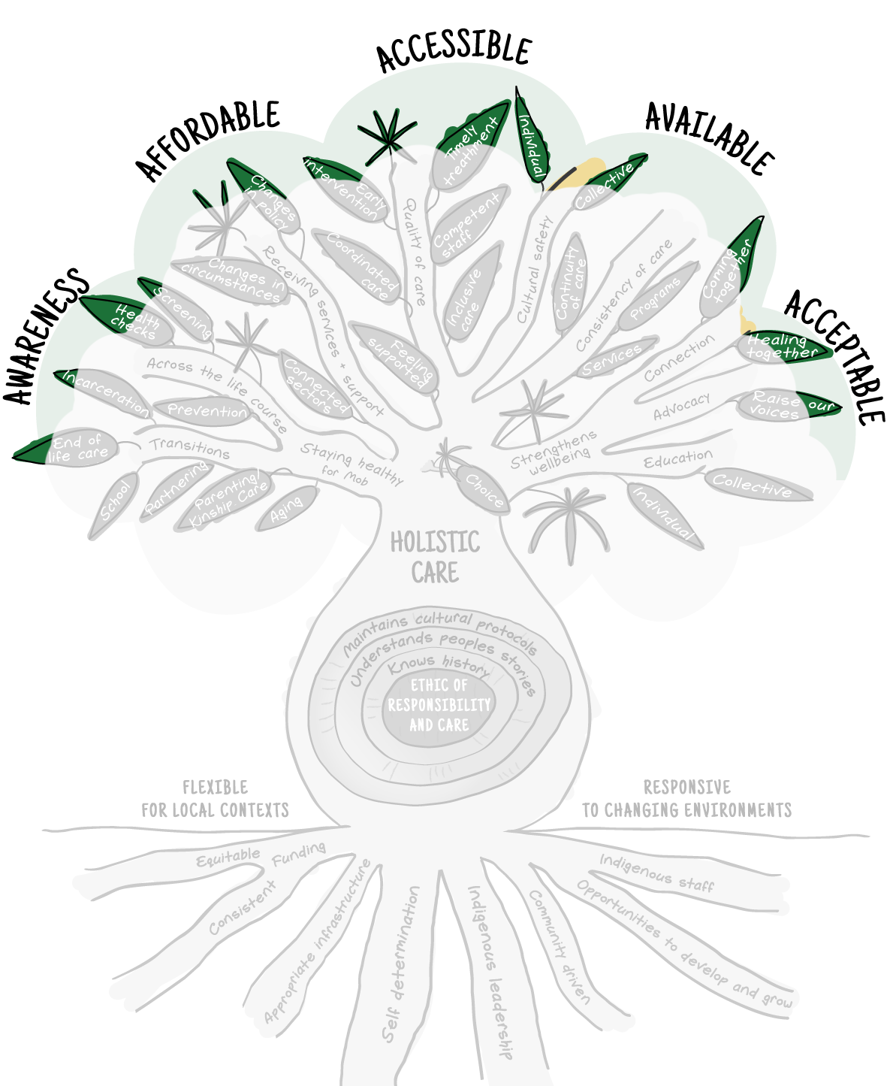

Awareness
The visibility of health services, including increasing awareness through outreach, participation and word of mouth, was valued by community members. People value being made aware of the services that can support their health and wellbeing and that different forms of communication are used to achieve this. Services’ social media accounts were commonly referenced within the yarns with community members, but alternate communication approaches that meet the needs of people without access to social media were also appreciated. The importance of increasing people’s awareness was often evidenced through side discussions between community members during the yarns sharing information about services people were utilising. ACCHSs were identified as a place for community members to find out about other health services and support.
It's important that we know what's available, whereas I think most people start off by just going to the medical centre, but they don’t really know what else there is.
Community member

Accessible
Community members value services that are available in terms of people’s capacity to attend services at the location safely. The importance of access was highlighted across all evaluation sites. There is already significant support across PHC to facilitate access through support with transport including bus pickups, taxis vouchers, and travel subsidies. These options are valued by community members.
However, community members reported less understanding and capacity within the PHC system to address access issues created by a person’s own health or caring responsibilities. People who are living with poor health have less capacity to access health services and may need additional accommodations (including different modalities of transport or an accompanying support person). This was described by a community member living with a chronic illness:
Some of them [appointments] I cancel because I just can't. I haven't got the energy to get there. Most of them I try to make it. But the other ones, I just have to cancel because I know how much of a struggle it is to get this oxygen bottle in and out.
Community member
Health service delivery that supports the ability to attend services through access to transport and responds to the influence of disability and health conditions on access requirements is valued because it empowers people to engage with health services.

Affordable
Health care that is affordable in a way that addresses health inequities is valued by Aboriginal and Torres Strait Islander people. Affordability and accessibility were often intertwined for community members, reflecting the importance of understanding individual experiences and needs. Affordability relates not only to the cost of any service provision, but the cost of attending. The cost includes direct costs such as travel and parking, and indirect costs such as loss of income or caring costs. Both direct and indirect costs increase when people have to travel further to access health services, have to remain in a different location, and if they are accompanied.

One young woman from a remote location described the concerns about costs of ongoing care in a city:
But the thing is that we have to go down like a month. So that's my partner out of work. I'm not too sure if we actually have to pay for our accommodation or not. But then again, hopefully we don't because that's a long time. But we have to pay for everything. And we don't, like we're not working. That's probably another thing I'm worried about.
Community member
From a health equity perspective, it is also important to consider the interactive effect of health conditions with other social and economic factors. These factors often leave people with limited resources to meet out of pocket medical expenses. Affordable health care is valued when it addresses health inequities, such as removing the need for upfront payments instead of just offering reimbursement. This was particularly evident in discussions about the ITC program in some locations. As one community member recounted:
The amount of people that come up and say, Oh, thank God for [ITC health support service]. We'd be dead now without it. I say you're exaggerating things like that, and they say, ‘No, we're fair dinkum’.
Community member

Available
Health care that is available when people require it (for example, urgent care), and around other commitments such as employment and caring requirements (non-urgent care) is valued. Community members were aware of the impact of workforce shortages on access to services but noted that wait times were significantly longer for services or individual doctors who were affordable (bulk billed) or provided good quality of care. People shared the need to trade-off between availability, affordability, and quality of care when obtaining health care.
Challenges of availability were particularly evident in out of hours care where people reported limited (or no) choice of care provider due to availability or affordability. Community members said they were more likely to experience poor levels of care from mainstream services. This includes experiences of racism contributing to poor experiences of care. Out of hours services need to be accessible, affordable, and provide acceptable standards of care, particularly in relation to safety, including cultural safety.

Acceptable
Health services where people feel welcome, supported, comfortable, and safe, regardless of whose traditional lands they reside on can provide acceptable care that is valued by Aboriginal and Torres Strait Islander people. Whilst community members appreciated mainstream services’ inclusion of Aboriginal and Torres Strait Islander artwork and design elements in the décor, it was the behaviour of health service staff that was most valued. People valued the behaviour and environment that made them feel welcome and comfortable and spaces that were more relaxed and less clinical from the reception through to the consultation.
One participant described the feeling as:
Well that’s sort a known fact that when an Aboriginal walks into an Aboriginal habitat like that, it feels good, comfortable. When you walk into a big white society with the big doctors and then they come out and they are jamming down words that you’ve got to push around in a wheelbarrow and you don’t understand them. You just need someone that you can talk to them on their own terms to them.
Community member
Simply incorporating Aboriginal and Torres Strait Islander artwork is insufficient to make a service acceptable. Acceptability is about the way people are treated. As one Elder stated:
People go places where they feel welcome.
Community Elder

Governance and resourcing of primary health care
People value health care that responds to the needs of the community. The governance and resourcing required for health care that aligns with what Aboriginal and Torres Strait Islander people value includes self-determination, Aboriginal and Torres Strait Islander leadership, and for health services to be driven by the needs of the community. Resourcing that aligns with what people value and the needs of the community has to be supported by equitable and consistent funding, appropriate infrastructure, and Aboriginal and Torres Strait Islander staff who have opportunities to develop and grow in their work. These are represented by the roots that anchor Babuny to place and secure the resources it needs to survive and thrive.
Figure 4-4. Babuny framework spotlight on governance and resourcing
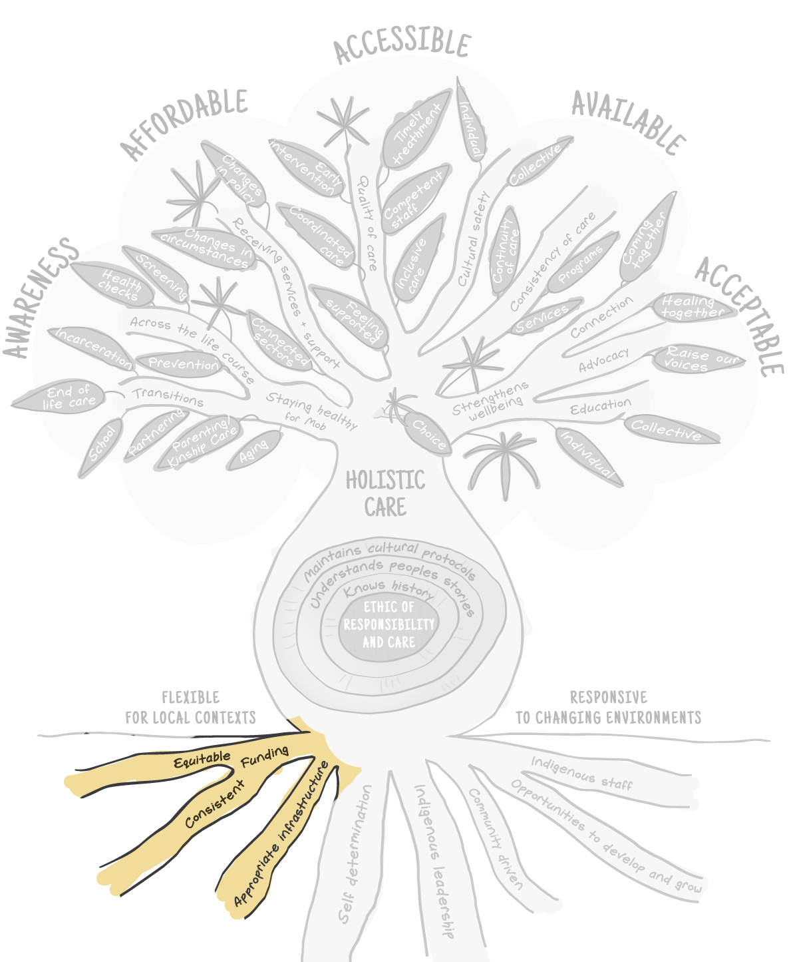

Self-determination
Figure 4-5. Babuny framework spotlight on self-determination
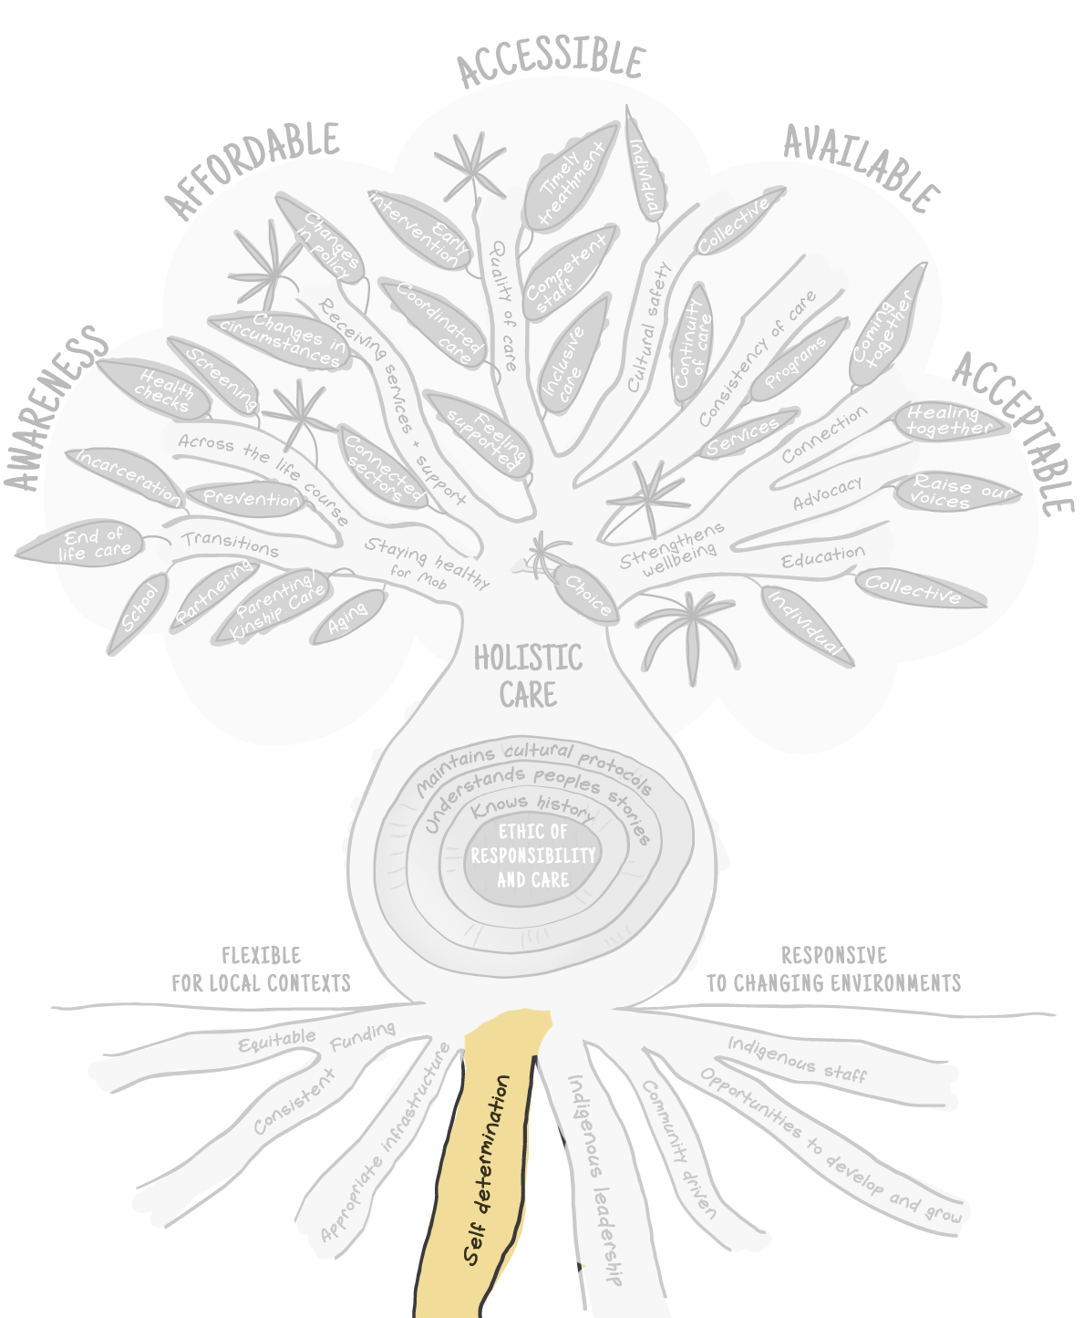
Self-determination is valued by community members as necessary to ensure that health services can meet the needs of Aboriginal and Torres Strait Islander people. The taproot on Babuny represents self-determination, the right of Aboriginal and Torres Strait Islander people to exercise meaningful control over their lives and requires a substantive shift in the sharing of power by governments.
Community members value community-controlled health services as an expression of self-determination. However, some participants were critical of the constraints and control still exercised by different levels of government on the provision of health services in community-controlled settings. As one Elder described the current situation:
Yeah, but the white people don't make suggestions, they tell us what to do. You have to do this.
Community Elder
The difference in power and accountability between governments and the community was referenced by many community members who expressed the need for this to change:
But at the end of the day, no one is taking the moral thing and accepting that our health is falling behind. It’s not about your power, it’s not about your bucket of money; it’s about our health, and empowering the whole damn lot of us, to get on a same level as what a white person is born with.
Community member
Entwined with self-determination is the need for Aboriginal and Torres Strait Islander leadership within and beyond the community-controlled sector. Aboriginal and Torres Strait Islander leadership shapes health systems by embedding what people value and the ways of being of Aboriginal and Torres Strait Islander communities into institutional decisions and processes. Community members recognised the challenges for Aboriginal and Torres Strait Islander leaders working to meet the needs of their communities. These roles are understood and valued as an expression of care for community through shaping how health care was delivered and experienced.
Aboriginal and Torres Strait Islander people value health service design and delivery that draws on knowledge, understanding, and respect to ensure safe and appropriate health care experiences and outcomes that meet the community’s needs. This occurs when health care has active and meaningful community participation to allow input to influence service design and delivery, particularly beyond the ACCHS sector.

Resourcing
Community members identified appropriate resourcing as including equitable, ongoing funding, having appropriate infrastructure, and the employment of Aboriginal and Torres Strait Islander staff who had opportunities for career progress and development. Community members are aware of the influence of funding, in particular its short-term nature and erosion over time. Woven through the yarns with community members were experiences of highly valued programs and services that had been implemented, were starting to create health gains, and then defunded or cancelled. These experiences of defunding were often unexpected and disempowering as reflected by community’s members descriptions of the work involved in designing, resourcing and delivering programs, the observations of improvements in health and wellbeing, followed by the blunt ending:
So what did the government do, pull the funding on the lot.
Community member
Community members do not value short-term funded programs and some participants reported not bothering to start programs that they think will not continue. They do, however, value funding that enables the appropriate and ongoing delivery of clinical services and programs within their community and with a consistency that allows health benefits to be realised and embedded. Community members also appreciated the consistency of funding as an important enabler for the ongoing employment of Aboriginal and Torres Strait Islander people, particularly health workers.
Community members value having health care provided in single locations where they felt welcome and safe. Co-location was valued because it was associated with ease of access, better care coordination, and supported a comprehensive health care model. Building design that incorporated spaces for people to connect was highly valued by community members. At several ACCHSs, buildings include simple courtyards and meeting rooms that were used for community events, delivering health education and promotion programs, and supporting other community initiatives. Courtyards provided safe spaces where people could connect with others whilst visiting the service or waiting for transport.

One Elder described how the courtyard at their ACCHS provided a space for people to connect:
When you come here and sitting in medical you see them walk in the door and you all sit there [courtyard] and have a yarn while you wait to see the doctors.
Community Elder
Community members highly value Aboriginal and Torres Strait Islander staff in a health service, as well as the positive influence those staff have on service design and delivery when given opportunities for progress and influence. The latter is related to service design processes and environments that support Aboriginal and Torres Strait Islander self-determination and leadership that are highly valued by the community. Community members value Aboriginal and Torres Strait Islander clinicians and operations staff for the cultural safety and familiarity they provide, in addition to their professional skills and knowledge. Community members spoke with pride of Aboriginal and Torres Strait Islander staff and how the contributions and achievements of these staff also created longer term impact.
And it encourages Aboriginal people then, because that becomes self-sufficiency, self-determination. And people don't understand that is a part of our cultural practice.
Community member
Having Aboriginal and Torres Strait Islander staff created a feeling of welcome, safety, and understanding. Aboriginal and Torres Strait Islander staff are valued for the benefit to community members in terms of the care they receive as well as the opportunity employment offered, particularly for young people. Aboriginal and Torres Strait Islander staff were often those identified as ‘going the extra mile’, and community members want to see them better supported and rewarded for the work they do.
Those people that are … I don’t want to say good, but they’re the doers in the community. They have that many hats, and you know, you have to be really, really strong to just not get burnt out.
Community member

Responsibility and resistance
Health services and systems develop their capacity over time, beyond the physical assets are the processes, policies, culture, and ways of doing that all institutions possess. A health service transforms these resources into services whilst power and influence are transformed into institutional structures such as policies and processes. Similarly, a tree’s trunk is the conduit that moves the water and nutrients to sustain the branches, leaves and produce of the tree and provides the tree’s strength and structure. Babuny’s distinctive trunk forms over a number of years fed from the resources drawn from its roots and acts as a buffer to fluctuations in the availability of resources, reflecting its resistance and capacity.
Figure 4-6. Babuny framework spotlight on responsibility and resistance
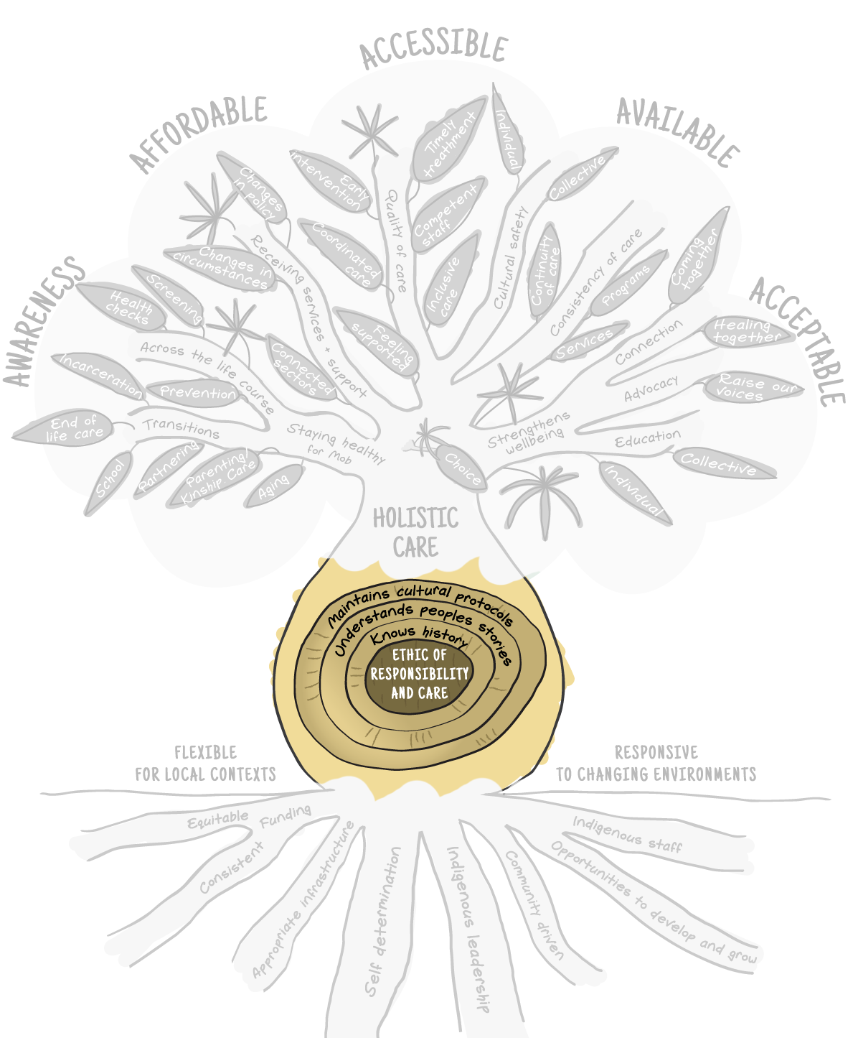

An ethic of responsibility and care
Aboriginal and Torres Strait Islander people value health service design and delivery that draws on knowledge, understanding, and respect to ensure safe and appropriate experiences and outcomes for Aboriginal and Torres Strait Islander clients. The pathway for this transformation is through an ethic of responsibility and care. Aboriginal and Torres Strait Islander people value an ethic of responsibility and care that underpins the design and delivery of health care.
This ethic extends beyond individual services to the system level and should be present in all decision-making and actions on policy and resourcing that influence health care from government to frontline clinicians. An ethic of responsibility and care is about how Aboriginal and Torres Strait Islander individuals, families, and communities are valued and subsequently treated.
Community members experience differences in the quality of care based on the judgements and choices clinicians make in how they engage with their clients. Community members often described being treated as ‘just a number’, ‘invisible’, that they ‘did not matter’ in services that did not show this ethic of responsibility and care and act upon a person’s humanity and inherent value.

When one community member was asked if this was about cultural competency or safety they responded:
I think it’s about just treating us as a human being.
Community member
Intersections of racism, classism and discrimination based on health conditions also contribute. Labels given to people such as ‘frequent flyers’ reflect the dehumanising attitudes of individuals and institutions towards those in their care. Community members saw this attitude demonstrated across the system, beyond individuals and organisations, and reflected in policy and resourcing choices. They were cynically aware of performative approaches by individuals and institutions committing to improving health outcomes that were at odds with daily experiences of Aboriginal and Torres Strait Islander people engaging with the health system.
The ethic of responsibility and care valued by community members can be in conflict with health care delivery as a business. People distinguished between service delivery based on a responsibility to look after the wellbeing of communities and a responsibility to look after the financial interests of business owners.
Community members value the care provided through ACCHSs because these services show an ethic of responsibility and care. Community members value the efforts taken by these organisations to seek out and secure scarce resources and transform community-led services into holistic health care practices. The importance of this ethic was reflected in what community members identified as the distinguishing characteristic of valued non-Indigenous staff delivering care. Describing a highly valued, non-Indigenous staff member at an ACCHS, one community member stated:
She cares for us. She cares for her community.
Community member
Community members value a health service that is embedded in care for the wellbeing and empowerment of themselves as individuals, their families, and communities. This manifests in decisions of policy, resourcing, and self-determination at individual and collective levels.

Resistance through knowing
Community members discussed the value of feeling understood by health care services. Knowing history allows services and systems to provide culturally safe and appropriate care, through an understanding of collective experiences and influences on people’s lives. Knowing history manifests in care experiences that demonstrate an understanding of the impact of ongoing colonisation, institutional abuses, and different forms of racism. The importance of services and systems knowing history is reflected by the hardwood in the trunk that provides strength and structure to Babuny.
At a local and individual level this is reflected in understanding peoples’ stories and factors that impact local communities. Community members discussed how they would delay seeking care until they could access their ACCHS because of how this knowledge and understanding influences the approach to health care delivery:
I'm not going to go to the hospital because there might be whitefellas there. They don't understand me. They don't know what I'm talking about. They're too hard to talk to, you know? So the opposite of that is we come here to [ACCHO]. We know people. They know how to talk to us. They know what's going on in my community.
Community member
Knowing history also incorporates institutional histories at all levels of the health system, understanding how health service design and delivery has been shaped, what works and why. A number of community members recounted rich histories of the successes and failures of the health system over their lives. People clearly identified the influence of political cycles and continual changes in government structures that had influenced their experiences of health care. People value organisations and institutions that learn from the past and leverage that knowledge to provide culturally safe health care for Aboriginal and Torres Strait Islander people.

Holistic care
Figure 4-7. Babuny framework spotlight on holistic care
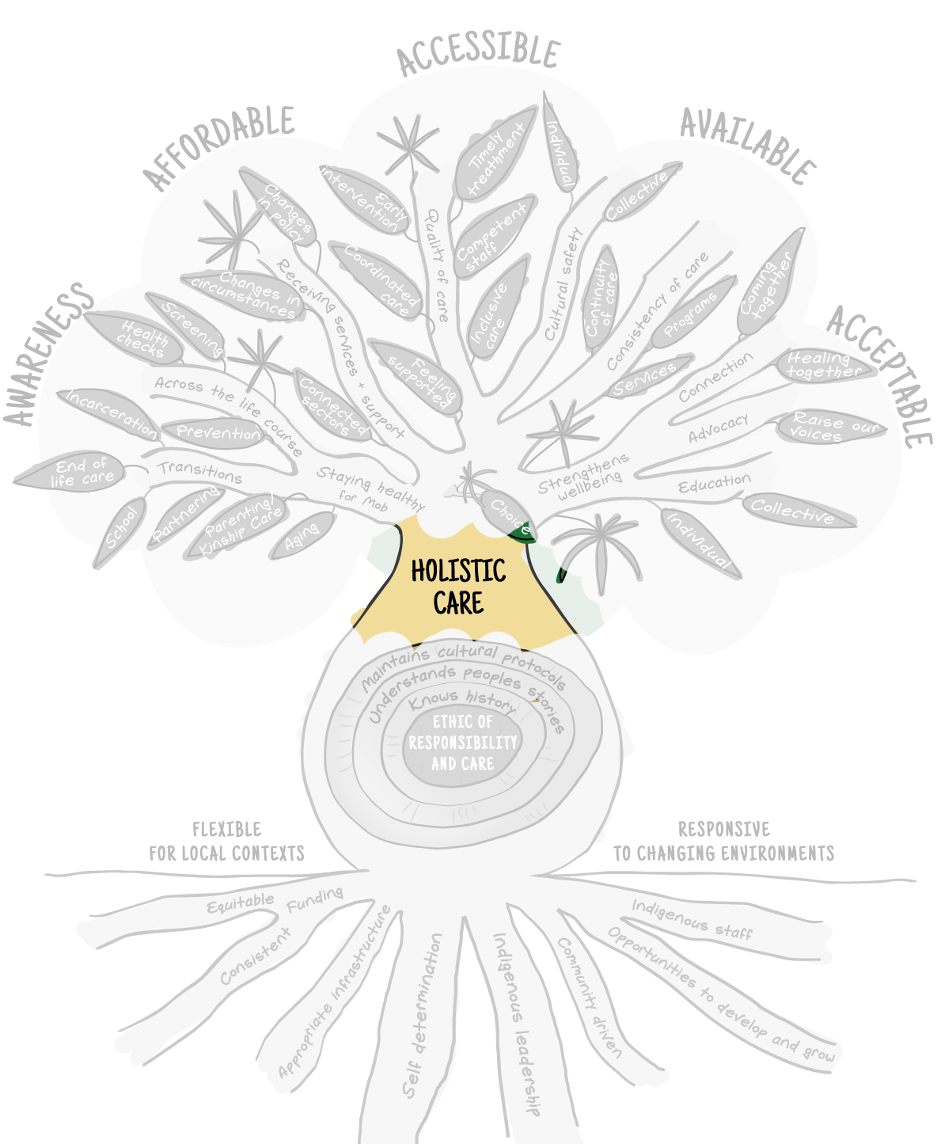
Aboriginal and Torres Strait Islander people value being treated as a whole person which includes all the interrelationships with family, community, and their environment.
Holistic care as understood and valued by Aboriginal and Torres Strait Islander people extends beyond the diagnosis or physical being into connection with others, the environment, and community roles. It is broader than the term ‘holistic care’ that is used within the mainstream health system. The mainstream framing of holistic care generally relates to joined up care beyond a single body part of diagnosis.
Community members value and view holistic care that aligns with how Aboriginal and Torres Strait Islander people understand holistic health and wellbeing as the foundation for effective experiences and outcomes. This different way of being was expressed by a number of community members, and put simply by one contributor as:
So you have this aged care, disability, mental health, primary health and then you know, everything is so disjointed especially in a white world. Why do they have them separately in a white world. In a black world, they don’t sit apart in any way, shape or form.
Community member
The importance of holistic care for Aboriginal and Torres Strait Islander people cannot be overstated. Health care can only be determined to be holistic if it is consistent with Aboriginal and Torres Strait Islander ways of being and meets their needs for wellbeing.

Improving health and wellbeing for all
Aboriginal and Torres Strait Islander people value health care that improves health and wellbeing for all. This manifests in health services providing the places and resources to nurture the health and wellbeing of their community. This supports and strengthens that community into the future. Similarly, the branches and leaves of a Babuny tree provide shelter and resources to their environment and eventually become resources that feed the landscape.

Choice of care
Figure 4-8. Babuny framework spotlight on choice of care
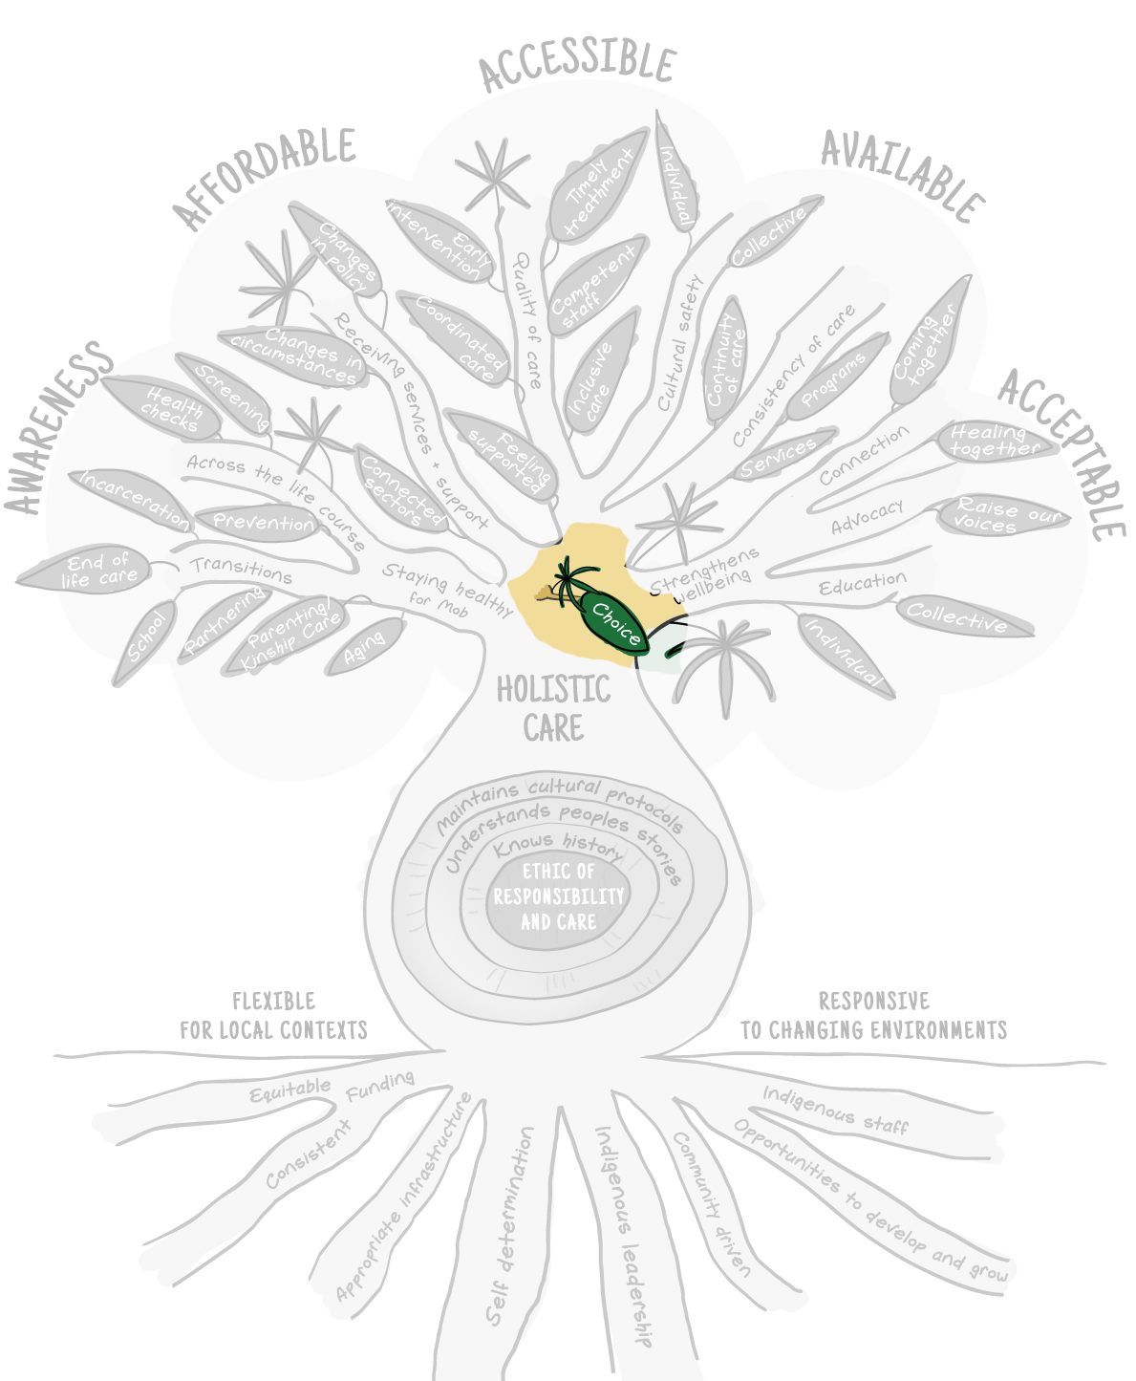
Community members value having choice in how, where, and from whom they receive their health care. Choice can be influenced by a person’s location and capacity to access services based on awareness, affordability, availability, appropriateness, and accessibility. Choice is a mechanism of empowerment for Aboriginal and Torres Strait Islander people. Choice is represented on Babuny as a branch from which people can then leverage to the type of health care services and experiences that best meet their individual needs. The services and experiences are illustrated in Babuny’s branches and leaves. Choice as a mechanism of empowerment was described by one community member:
I do also think that it still needs to come back to that choice. I think there needs to be options and there needs to be choices. With choice comes agency and with that comes safety.
Community member

Innovation
Woven throughout the yarns with community members was the regard people have for the innovation shown by health services in using limited resources to adapt and meet the community’s health needs. Community members value the effort and innovation required to ensure services are adapted to local needs, but still fit within funding budgets and conditions. Innovation is represented on Babuny by new growth sprouts on the branches.

Quality of care
Figure 4-9. Babuny framework spotlight on quality of care
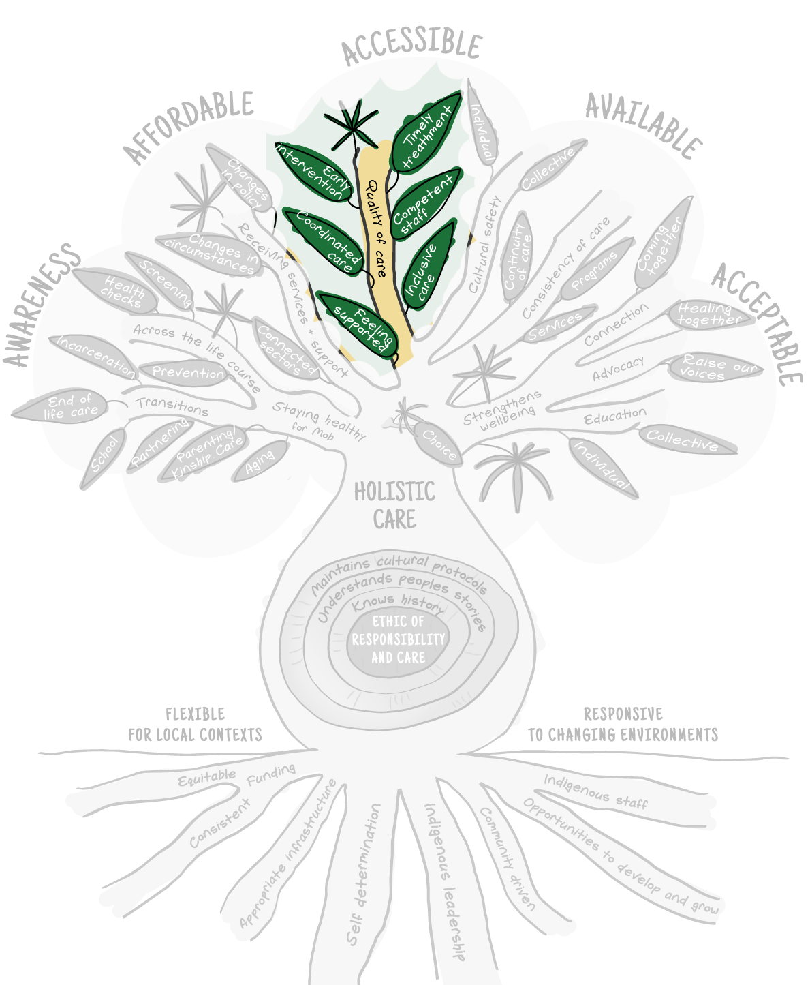
Community members value quality of care in health services. People experienced this as timely treatment, early intervention, coordinated care, and feeling supported, informed, and included in their care by competent and caring staff.
The value of timely treatment and early intervention were often identified from discussions about negative experiences of late diagnosis or health issues not being diagnosed due to people experiencing racist or dismissive interactions with clinicians. People shared the various impacts of loss, complications, disability, and even deaths. Community members recognised the effect of staff shortages and community demand on wait times within services but appreciated innovative approaches taken by services to ensuring timely treatment. In one remote setting this included securing support from the local paramedics when they were available:
And we’ve got the ambulance mob come over there, the paramedics, they come over to the day centre and that. And a lot of people that come there, we get about 30, 40 people in there every day, in the mornings and at lunch time. And the paramedics deal with them there, which anything that’s major wrong with them, they will bring them straight to the hospital.
Community member
Programs and staff that assisted with care coordination are strongly valued by community members. Navigating the health system can be complicated and it is even harder for people who experience complex health issues, caring responsibilities, or accessibility barriers. Elements of coordinated care that are valued include sharing of information such as referrals, medical histories, and follow-up care. The value of coordinated care was also evidenced for shorter term care programs such as the antenatal programs being run through community-controlled services. One community member contrasted her experiences of antenatal care between her two pregnancies in different care settings:
When I had my first son, I just went like with regular midwives and stuff and I thought it was all right until I had my second one. And I found out there was like an Aboriginal midwife team and I went through them and it was so much better, like having the same midwife every single time. I just felt like I never even knew about the midwife program with my first ….. Like had they came to your house instead of going into the hospital and like you never had to wait to like sit around and do blood tests and things like they'd come to your house, do it for you, which made it. Like I feel like you. You weren't just like a number sitting in the waiting room. Like they knew everything about you. Like they would come over and, like, play with my son and knew him, like, by his first name. Like, yeah, like [other participant] said, it was a lot more like, informal. Like it wasn't. You weren't scared sitting there in, like, a big waiting room for an appointment.
Community member
People felt supported by good quality health care. This can include the provision of timely treatment, early diagnosis, and coordinated care. The value placed on good quality health care was illustrated by one Aboriginal mother’s experience with getting help for her toddler:
Besides here, the paediatrician at [hospital] was amazing with my youngest daughter. Absolutely amazing. She listened to me. I expressed I think she had actually something wrong with her because she's 17 months and can't walk, can't crawl, can't do anything most children can do. And she actually took the time to look into it and give me a diagnosis. And then between [ACCHS] and paediatrician they got me involved with [NDIS provider] and got me the extra support that she actually needed.
Community member
Community members consistently identified the relational aspects of their health care experience as contributing to quality of care. When staff are dismissive, overly clinical, or rushed they cannot deliver quality, holistic care that aligns with the relational elements of health care that are valued by community members. Ensuring that people feel supported and experience quality care requires health service staff (both clinicians and administrative/support staff) that take the time, listen, and care about the person. When asked what good care looks like, community members often shared descriptions that included these characteristics:
I reckon the best service I ever got from a doctor was here. When I went here, like it didn't feel like the appointment was rushed, so, like, I could ask questions and they could actually give me answers. When you go to, like, I don't know, like a white doctor. Like it's just like, it's like, it feels like they like downplaying whatever you have or whatever questions you have and they try and get you out as quick as possible. At [ACCHS] I felt it was like, you can have a conversation with the doctor, ask questions and actually get answers.
Community member
Relational practices of taking the time, listening, and seeing the ‘patient’ as a person were valued by community members. People identified approaches that including seeing the patient as a person as relating to things such as the consideration of the impact of ill health and understanding the importance of interrelatedness through kinship and country. Community members value staff who use accessible language and explanations when communicating about their health. Community members value staff with communication and relational competencies as much as their clinical or professional competencies. Describing a valued GP, one community member shared:
And she's one of those doctors that knows the, like, the difference between being professional and having that personal connection with someone. Like she knows boundaries for both. Like, she can do both really well with the person.
Community member

Cultural safety
Cultural safety that extends beyond basic cultural competency training for staff, is embedded in service design and delivery and reflects Aboriginal and Torres Strait Islander ways of being, knowing and doing, is valued by community members. This is created and sustained through knowing and understanding the history and experiences of individuals and communities and it manifests as quality of care.
Figure 4-10. Babuny framework spotlight on cultural safety
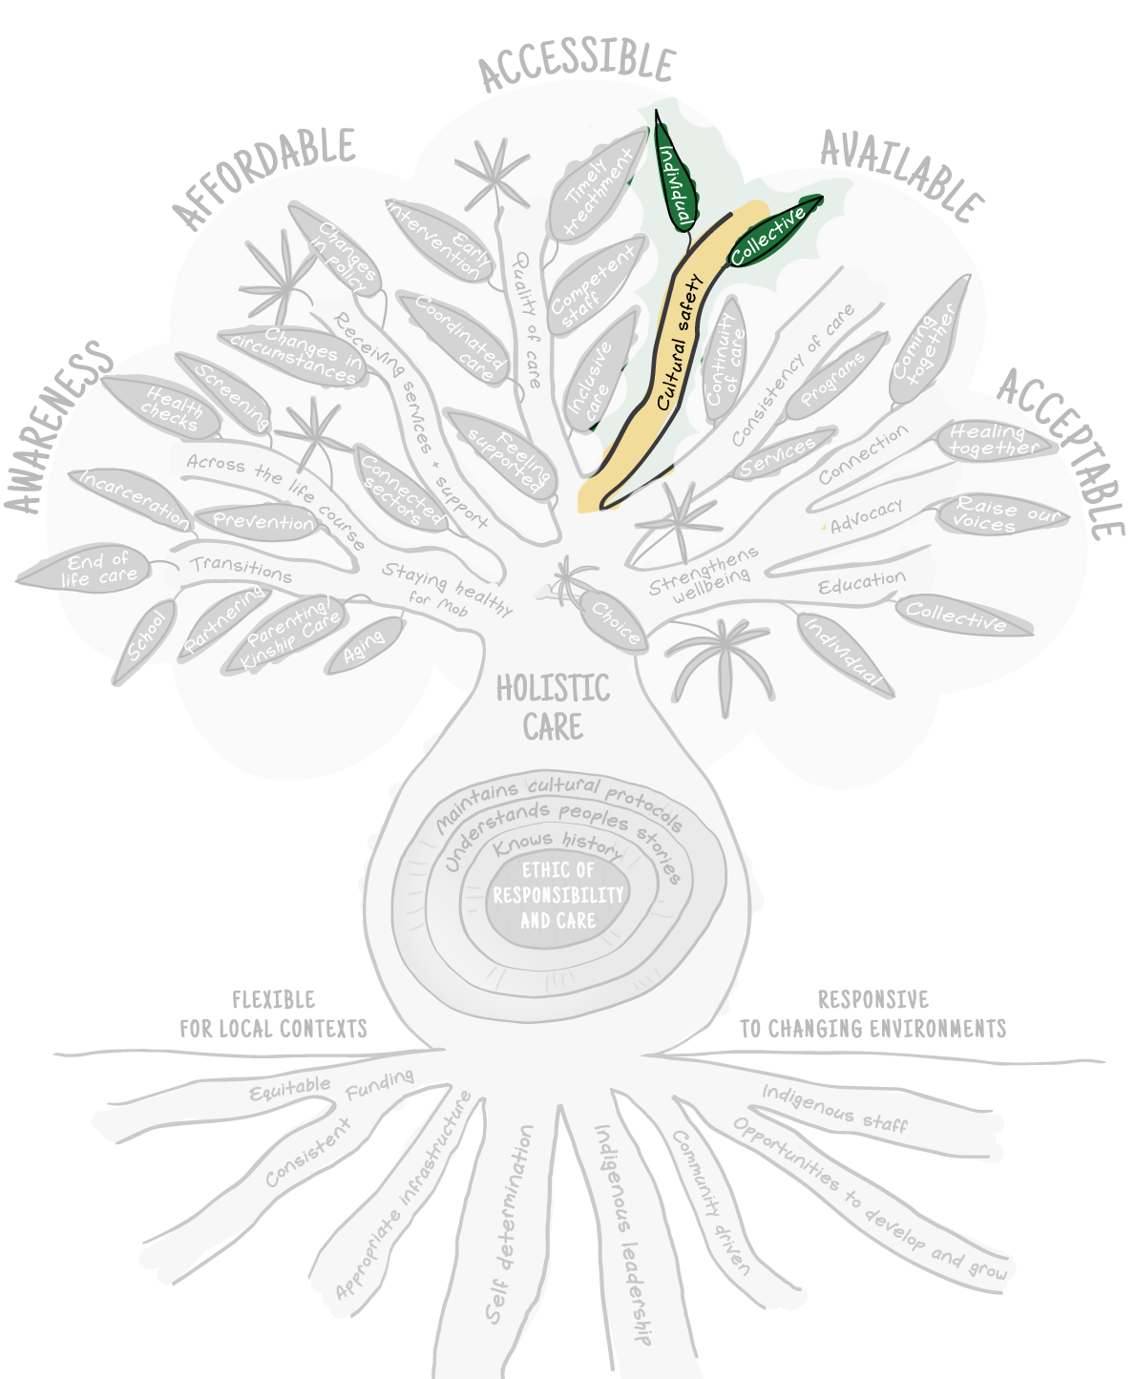
Aboriginal and Torres Strait Islander people value care that demonstrates cultural understanding, such as appropriate treatment of Elders, understanding when someone would feel comfortable to speak up, the nature of relationships and roles, and collective ways of addressing problems. People value care that reflects an understanding about how experiences of dispossession and colonisation impact individuals and communities including fear of government agencies. Health care that demonstrated the cultural understanding and culturally embedded practices that are valued by the community was evidenced through experiences of ACCHSs supporting community members during disasters and the pandemic. This included through a culturally embedded practice of resource sharing to ensure that people were not retraumatised through trying to access basic needs.
The compartmentalisation of health care funding and delivery can operate as a barrier to achieving cultural safety in health care and is why many Aboriginal and Torres Strait Islander people value the comprehensive PHC model of the community-controlled sector. The concept of ‘one stop shops’ is more than just a convenience of co-location. Integration of health care across the life course provides people with the institutional structures to facilitate culturally safe health care and support the wellbeing of Aboriginal and Torres Strait Islander people. One community member described the push to place a family member into residential care:
They said, ’Put him in a home’, and I said, ‘No, no.’ We never put old people in a home. We looked after them. That was the responsibility of the family, and the Elders in the Aboriginal community. You know, I mean, we had … I was only talking the other day, we had our Aunty, she was disability, and she was young, welfare wanted to put her in a home; one fella said, ‘No way, you’re not taking her to the home.’ She lived until she’s 85 years old. She outlived Granny and Grandfather. She outlived Mum, too. Mum was the eldest, and this was the family that took care of her. If they would have put her into a home, you know. She would just become a vegetable there, I think, you know. But part of our job was taking her around, swimming the drains [irrigation channels], that was part of our … he’d say ‘take her now and look after her’. Everybody looks after.
Community member
Aboriginal and Torres Strait Islander people value health care design that provides culturally appropriate choices and services to support wellbeing, including access to traditional healing and wellbeing practices. Cultural safety in health care provision is not about duplication or segregation, but it is about bringing things together. As one community member explained:
We want to have our own plants and be able to make our own medicines in that and in the hospitals as well. I know in [state] they’ve actually hired Aboriginal healers to go through the hospital, and I hear it’s doing wonderful. So, to have [our] medicines and stuff actually at [ACCHS], and [name] knows all about that type of stuff. To learn that and bring it in together, absolutely, bring it together, it’s not pushing one aside, it’s bringing it together.
Community member

Consistency of care
Figure 4-11. Babuny framework spotlight on consistency of care
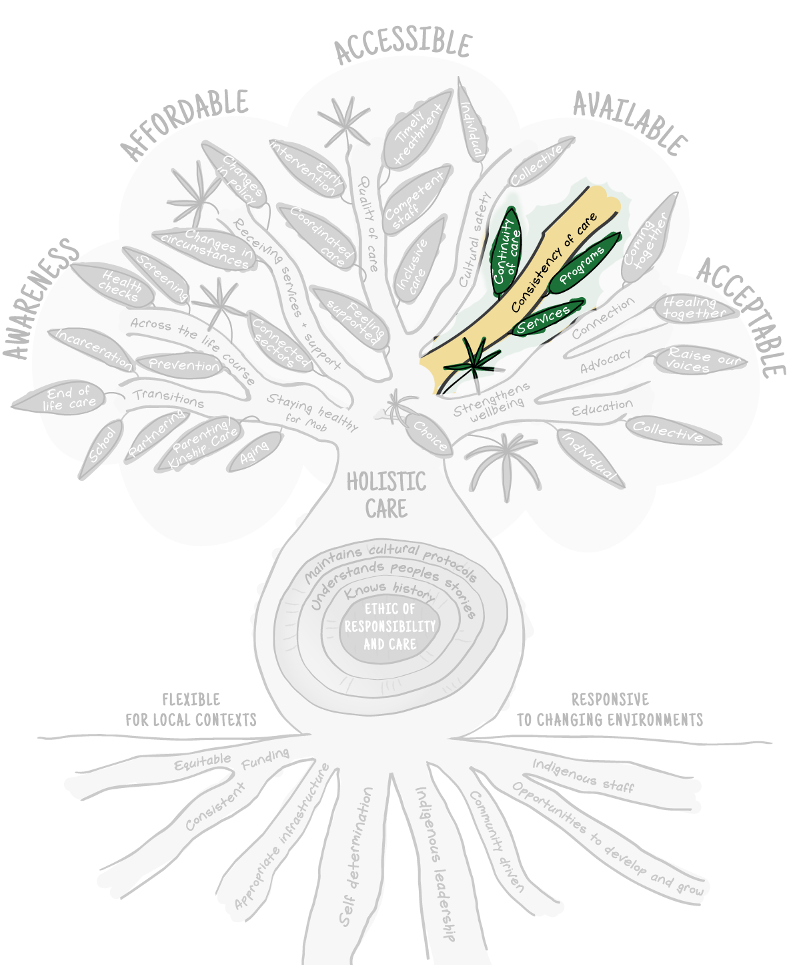
Aboriginal and Torres Strait Islander people value the consistency of programs and services and continuity of care when accessing health care. Service consistency and continuity of care support improved health outcomes through the quality of care received and by eliminating the client's need to repeat their health story to another clinician. This was evident in the contrasting experiences of community yarn participants who were able to access the same clinicians compared to those who were not:
I use my doctor right. Now. I use my doctor for a couple of reasons. One is I think I get a good service. He's got a history. He's, I've been with him for a long time. He knows my history and I can talk to him easier.
Community member
They don’t have the same doctor all the time so we have to tell our story over and over its hard to tell it and sometimes I miss things out that are important to my health.
Community member
Continuity of care allows people to build a therapeutic relationship based on trust and understanding and contributes to feelings of safety and better experiences of care. True holistic care is premised on continuity of care because clinicians are able to get to know the person in terms of the health and wellbeing and the network of relationships and circumstances that influence it. For people with complex health needs and experiences of trauma this is even more important.
Similarly, community members value health promotion programs delivered consistently and are frustrated and less likely to engage when programs can be short-lived or change eligibility. Community members appreciate the efforts of individual services to maintain programs and staff employment through seeking alternate funding options but acknowledged the work required to do this was not insignificant.

Ensuring people receive services and support
Figure 4-12. Babuny framework spotlight on services and support
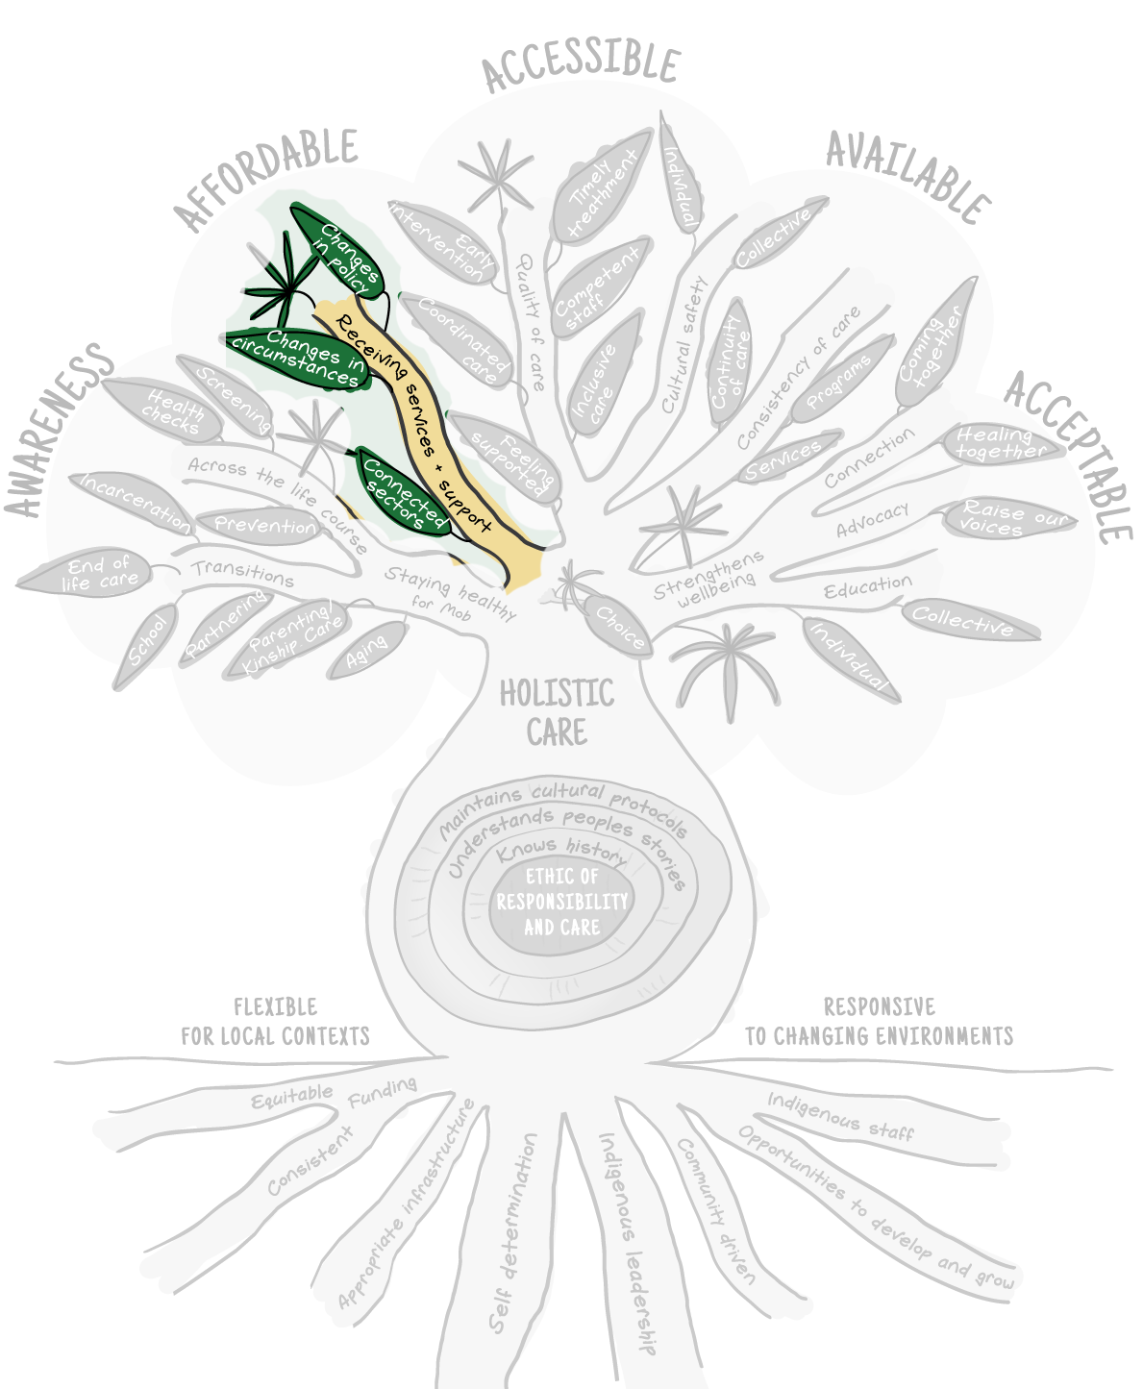
Navigating the health system is difficult and increasingly complex for people dealing with multiple morbidities or connected sectors such as aged care or disability support. The combination of changes in individual circumstances and policy settings can create further complexity, at times when people are unwell. Community members value a health service that is connected and supportive enough to ensure that people receive the services and supports they are entitled to based on their health needs. As one community member shared:
There are some people out there who does care. But if I didn't come to this place, I wouldn't find out about all this stuff. I would not find out about the eye specialist, getting glasses, diabetic or all that stuff. If it wasn't for [ACCHS], I would not find out about all this stuff. I would still be paying $400 and $500 for my tablets if it wasn't for me to find out about Close the Gap. Like wow.
Community member
Increasing awareness of different services and supports alone, however, is insufficient to ensure people experience access to those services. Application processes frequently require literacy, digital literacy, access to a consistent contact point (usually phone or email), and feeling safe to share sensitive personal information with institutions. Community members value the system navigation role performed by ACCHSs to support their community members to access information and services to support wellbeing. The provision of this type of support is consistent with holistic, culturally safe, comprehensive PHC and highly valued by community members.

Staying healthy for mob
Figure 4-13. Babuny framework spotlight on staying healthy for mob
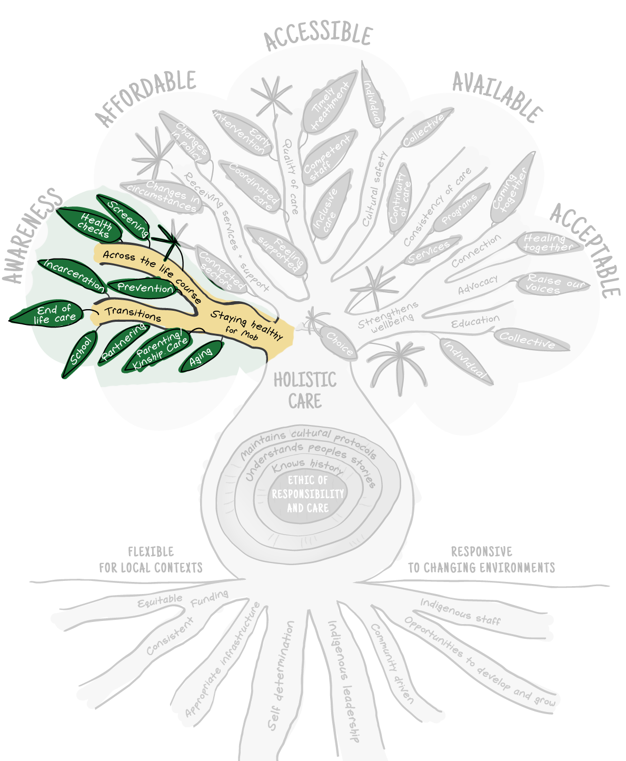
Aboriginal and Torres Strait Islander people value their wellbeing beyond the individual benefits of keeping well. Individual wellbeing cannot be separated from the wellbeing of people’s families, communities, and environment. Individual wellbeing also enables people to support family and community through formal and informal roles. When asked why it is important to have good health and wellbeing, one community member replied:
You got to keep being fit and being there for your family and your kids and especially community. So, yeah, that's me.
Community member
Community members value health services that support their wellbeing across the life course, including prevention programs, screening, and health checks. The annual health check was often referenced by participants as something that they did for others more than for themselves. Community members framed the health check as a responsibility or obligation. Whilst health checks and screening programs could be intrusive or uncomfortable, community members appreciated the support of health services to have these checks completed and the value of preventative health. Community members linked being able to access health checks and screening with their families living longer. One community member recounted:
With all the assessments and all the follow-up stuff that’s happening to us over the years, it’s making us more aware of what we can do ourselves for our own bodies. And that’s a great thing. And a lot of the stuff that’s put on at the hall and different stuff with brochures and advice and seeing doctors continually and health workers, it’s just made such a big ... Like I was saying before, mum’s 95, I’m 68 and the baby of the family is 55. So it’s because we’re all having these checks. But I’ve said, you know, we’re doing it fine. We’re going along great, but like I said there are others that are on a different path to what we are on and they’re ones that we should be actually talking about it eh, that have the issues and problems.
Community member
Availability of a range of programs and services that support important life transitions such as early childhood, sexual health, parenting, ageing, end of life care were valued. In addition, programs that provide support to people with experiences of out of home care or incarceration are also valued by community members. These programs and services extend beyond health education and often intertwine with care coordination, accessing services and entitlements, and supporting wellbeing through connection with community.

Strengthens wellbeing
Figure 4-14. Babuny framework spotlight on wellbeing
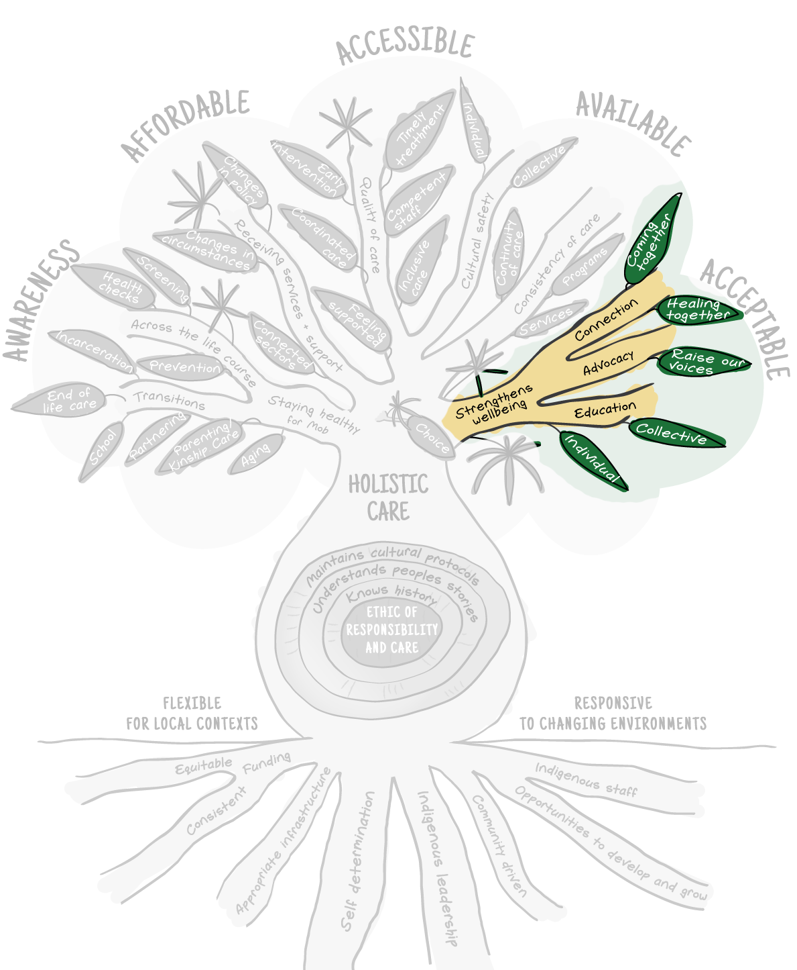
Aboriginal and Torres Strait Islander people value health care that strengthens wellbeing through advocacy, education, and connection within their community. Community members valued both collective and individual health education tailored for local and personal contexts. Education should occur individually through the delivery of quality care by clinicians as well as through formal and collective programs and campaigns. Education is valued because it empowers individuals and communities to improve wellbeing both directly (health literacy, empowerment in their care) and indirectly (social determinants, self-determination). The value of education as both prevention and empowerment was highlighted by one person’s experience:
I’ve gone through cancer, you know, but I was very fortunate, I knew what to look for, what to do, and I questioned and I asked and I followed up on everything. Now I look at that and I think, well, I’ve lost family members that were afraid to ask, if they would have only asked earlier, if they only managed to have someone there to talk with them, but you cannot get that service anywhere.
Community member
Individual and collective wellbeing strengthens when there are opportunities for Aboriginal and Torres Strait Islander people to come together. Collective health education events and programs provided health gains through the sharing of knowledge, the specific benefits of programs such as exercise classes, but also in a large part through connection. Health care that facilitates connection in the design of treatment and prevention services and programs is highly valued by community members. Connection is foundational to individual and collective wellbeing. As one Elder described:
Yeah, it was just socialisation. We'd go out the back and there was a barbecue at the back thing. We had a barbecue once. We just sat around and yarned at the barbecue, and sometimes they'd bring guest speakers in and talk because it's a good program, but it's a bit of organisation.
Community Elder
The effects of access to transport, lockdowns during the pandemic, and the various impacts of different health conditions or caring responsibilities can have impacts on people’s capacity to connect with others. Health care that facilitated opportunities and spaces for connection was highly valued by community members due to the positive impact this had on wellbeing. When asked to identify what they most valued in health care, programs that supported health through connection were often the first thing people identified. These programs included groups for Elders, men, women, young people, and mums and bubs. In one yarn with community members, a group of older men shared the thing they appreciated most about their health service, the men’s group.
Men’s group. I love men’s group. It’s the bomb. Yeah.
Social health.
Yeah, love men’s group.
I just like, you know, good environment, having all the black faces greeting you, or seeing you, and being able to connect to them and everything. Able to connect to them is a good thing.
Community members
Consistent programs and spaces that facilitate community connection are a culturally appropriate way of supporting wellbeing. Aboriginal and Torres Strait Islander cultures are inherently communitarian and coming together is fundamental to supporting health and wellbeing. Programs run through community-controlled services offered people welcoming and safe spaces connected to the community. These spaces were valued by Aboriginal and Torres Strait Islander people. The ACCHS was often the only ‘black space’ for all Aboriginal and Torres Strait Islander people living in that community regardless of their traditional lands. Consistent with a holistic view of health, ACCHS’s role in facilitating connection was valued by community members as a critical part of health care.
Connection was seen as something that both maintains and restores health, and many community members identified the value of programs where people could heal together.
I think it would be good to have like more informal groups, I guess like so people know, you know, you're not the only person that's feeling like this certain way instead of like, Oh, you've got to have a doctor's appointment and sit there alone. You know, like, I feel like more groups and open discussions would be easier.
Community member

Understanding how Aboriginal and Torres Strait Islander people experience the health system

Key findings
1 | Aboriginal and Torres Strait Islander people have diverse experiences of the health system.
2 | The elements of health care that are valued by Aboriginal and Torres Strait Islander people are not well supported at the various levels of care across the different parts of the health system.
3 | Discordance was predominantly experienced when people left community-led service settings to access health care that is not available in primary care settings, such as specialist services and tertiary care.
4 | People experience Aboriginal and Torres Strait Islander Health Workers as the backbone of health services. Health workers were often people’s first point of contact with a health service, their translator, support person, advocate, and navigator in the health service and across the health system.
5 | ACCHSs made people feel welcome, comfortable and safe because they were places that provided care that aligned with what people value in health care and provided a place of connection to culture and to other Aboriginal and Torres Strait Islander people.
6 | Experiences of poor quality care and care that was unsafe and traumatising were most commonly reported in tertiary care settings and people attributed these poor experiences to racism, cost, staff negligence and lack of competency.
7 | While many Aboriginal and Torres Strait Islander people experienced better quality of care in ACCHSs, some people also reported issues with health care at ACCHSs. People reflected on wait times, difficulties in seeing the same doctor, or a doctor at all, a lack of other specialist services, and perceived risks to confidentiality.
8 | Aboriginal and Torres Strait Islander people identified various quality of care concerns across all health care settings including a lack of access to health care because of location; a lack of choice about their health care; limited resourcing which resulted in the withdrawal of GPs, visiting specialists and programs; an absence of holistic approaches to care; feeling unvalued as a result of experiences of paternalism, discrimination and racism; poor communication between health professionals and clients; poor access to a comprehensive suite of services; and experiences of culturally-unsafe care.
9 | As a consequence of their experiences of the health system, people reported feeling compelled to take more responsibility for their own health and the health of their family and community. People reported that their experiences make them feel concerned for future generations of Aboriginal and Torres Strait Islander people.

Overview
This section examines how Aboriginal and Torres Strait Islander experience the health system (Evaluation Question 1.2). This includes people’s experiences in a range of health settings across primary, secondary, and tertiary care in the broader Australian health system. These health care settings include the range of mainstream and Aboriginal and Torres Strait Islander community-controlled services that people have contact with on their health care journeys.

Data sources and methods
This section draws on data generated through community and individual yarns held between March 2021 and November 2022. Yarning was used as the primary method to facilitate the active voices of Aboriginal and Torres Strait Islander people as knowledge holders. 452 Aboriginal and Torres Strait Islander community members participated in these yarns. This section also draws on data generated through yarns with Aboriginal and Torres Strait Islander staff in primary care services.
An inductive grounded theory methodology inspired the overarching approach to analysing this qualitative data. Grounded theory is a systems method of analysis, designed to explore and understand the nature and occurrence of complex social phenomenon (Bainbridge et al., 2019). The approach ensures that the values, preferences and priorities of participants are reflected and ground the evaluation, captures Aboriginal and Torres Strait Islander voices, and makes transparent the process of development and model generation from verbatim concepts. This approach also ensures that explanations are developed ‘from the ground up’.
This approach was used to identify codes and categories within the qualitative data. Constant comparative methods enabled exploration of issues to establish points of consensus and dissent and to saturate categories.

Dominant cultural norms shape the health experiences of Aboriginal and Torres Strait Islander people
Aboriginal and Torres Strait Islander concepts of holistic health and wellbeing differ from Western-derived concepts of health and illness. As a result, Aboriginal and Torres Strait Islander people commonly experience more barriers to gaining access and achieving desired health outcomes through their encounters with health service providers. Aboriginal and Torres Strait Islander people understand health as living lives well, as determined by them. This includes having basic human needs met, and experiencing a balance of physical, social, emotional, cultural and spiritual wellbeing through which people express an ethic of care and responsibility for Country, self and community. The significance of relatedness was described by community members.

Spiritualness definitely for me comes into my health, if I feel like I'm coming, like if I, if I'm, if I feel like a lot like not connected with the land or something like that. And I feel like my spiritual side is getting unhealthy I notice my own body is getting unhealthy as well. And usually the spiritualness is showing you that you're getting unhealthy before you actually are unhealthy.
Community member, regional location
Contact with the Australian health care system is often a complex interaction for Aboriginal and Torres Strait Islander people. The health system is largely a challenge for many people to understand and navigate, despite the system being designed to respond to individual needs by providing safe, effective, accessible and appropriate treatment and services. Dominant cultural norms enforced through the structure and function of the mainstream health system, made the experience of navigating the system almost impossible for many participants in community yarns without support. As a result, Aboriginal and Torres Strait Islander people frequently reported experiencing significant consequences in their health care journeys.
Aboriginal and Torres Strait Islander people reported that their understanding of health was not well supported through direct experiences of various levels of care across the different parts of the health system. Discordance was predominantly experienced when people left the system of ACCHSs to access health care through specialist services and tertiary care. However, because Western medical science predominates in ACCHSs through the employment of non-Indigenous health and medical staff and Western-trained Aboriginal and Torres Strait Islander staff, people also experienced incongruence in ACCHSs, but it was experienced in these settings to a much lesser degree.
The circumstances under which Aboriginal and Torres Strait Islander people encountered health care influenced the health care experiences reported by community members. This included the nature of their care, care pathways, and outcomes. Individual care experiences had a flow-on effect on how people approached and engaged in future health care encounters and influenced how other people in their lives viewed the health system and engaged in care. Discordance between how Aboriginal and Torres Strait Islander people viewed health and wellbeing and different approaches to care contributed to people’s health trajectory by stifling opportunities to define and realise their health needs.
Community members’ narratives reflected a biomedical approach to care. In these interactions, the medical profession maintains power dynamics by functioning in silos, treating disease instead of creating health, taking a body part approach to treatment rather than working with the whole person, and not partnering with people in their health care by maintaining power through a lack of knowledge-sharing and appropriate communication. This has consequences for how people experience the system, including treatment being imposed on people rather than considering client’s preferred options, and conducting procedures without informed prior consent. These experiences occurred when people were seeking health care across all settings within the health system, including ACCHS and mainstream services.
The ways in which medical staff relate to and influence the care of clients were motivated by the rules of overarching systems. Community members discussed health care encounters with medical staff where staff frequently took a paternalistic approach. These experiences were common regardless of whether the staff were located in an ACCHS or mainstream service.
We can be free walking around, but mentally we're still enslaved to the system. They control us every day of what we eat and how we do things all the time. So we have to wake up.
Yeah, but the white people don't make suggestions, they tell us what to do. You have to do this.
Community members
People experienced attitudes of some medical staff that were shaped by stereotypical assumptions about Aboriginal and Torres Strait Islander people and a lack of knowledge about the culture and context in which they were working. Community members experiences reflected medical staff not regularly working with people as partners in their own health care journeys, not listening to clients’ concerns, and not providing clear explanations of diagnoses and treatments. These experiences were evident across urban, rural and remote settings, but were more prevalent in the experiences of younger people.
Traversing the mainstream health system can send people on a trajectory that is detrimental to health. People frequently reported various consequences from finding themselves in the mainstream system without someone by their side who can help them translate, interpret and navigate the system. These consequences included not presenting for appointments and discharging against medical advice. The following story of two older men who did not return home after receiving care highlights the critical need for the support of navigators, after care and transport as part of accessible health care for Aboriginal and Torres Strait Islander people.
Our people go by themselves. No one did a thing last time, but a year ago two old fellas went down. Back with the walk, they can't communicate or anything like that. That was in Perth after they've seen doctors. After seein’ doctors they got let free so they lost their accommodation, they didn't see a social worker, they were living in the park until someone came to the park and spotted them. They were hungry they were cold, they had no rugs or anything like that. They were down there for 6 months. Until someone, a Black person went there, went there to the park and seen them. So if they were allowed an escort, who know the language who, or, you know, a Blackfella anyway. Yeah, take the old people, take the people who don't understand English properly.
Community member

Moving across health care systems presents challenges for Aboriginal and Torres Strait Islander people
Many Aboriginal and Torres Strait Islander people experience a high disease burden and have complex care needs. Accessing the care Aboriginal and Torres Strait Islander people need to manage their health means engaging in the Australian health system broadly – across primary, secondary, and tertiary care settings. For many people, this involves moving beyond the community-led health services delivered by ACCHSs into mainstream health care settings.
When required to navigate health care across multiple systems, Aboriginal and Torres Strait Islander people discussed experiences that reflected a disconnected, fractured and insensitive systems. At an operational level, many people experience two parallel systems – the ACCHS sector and the mainstream sector. The different values and knowledge systems embedded across these systems present difficulties for people who must traverse both systems to obtain essential health care.
Dominant cultural norms contribute to the health care experiences and trajectories of Aboriginal and Torres Strait Islander people. Colonial histories set the socio-economic and cultural norms across policy and practice. These dominant cultural norms shape the Australian health system, and the influence can negatively affect the experiences of people with different worldviews and cultural norms. The user interface where differences between Aboriginal and Torres Strait Islander expectations and perceptions of health and care and the dominant societal way of doing business occur, are significant determinants of health. As a health determinant, it sits alongside other contributors such as clinical care, health risk factors and socio-economic and historical determinants.
The Australian health system does not consistently provide holistic, person-centred, integrated, culturally safe mainstream services which has serious implications for the health and wellbeing of Aboriginal and Torres Strait Islander people. People can experience reduced choices when accessing care. For example, people’s choice of health care provider influences the nature of care accessed and received, can contribute to experiences of discrimination and racism, and limits affordability of care and continuity of care. All of these factors influence people’s health care experiences and health outcomes. Some of these constraints are also experienced within ACCHSs, but to a much lesser degree, when delivering comprehensive PHC.

People’s experiences of care and interactions across the broader health system are diverse
Aboriginal and Torres Strait Islander people’s experiences of care and interactions across the broader health system are diverse and sit along a continuum that ranges from no care - to poor quality care that is unsafe and traumatising - to good and exceptional quality care.
The nature of people’s experiences depends on the touchpoints encountered as they traverse the health system. Largely, Aboriginal and Torres Strait Islander people experience a good quality of care in ACCHSs. Experiences outside this care environment are often sub-optimal. Particular subgroups of the Aboriginal and Torres Strait Islander population, such as those experiencing poor mental health, women and young people, also experienced care through ACCHSs that did not provide appropriate and adequate access or meet their health needs. Some of the gaps in the reach of comprehensive PHC for Aboriginal and Torres Strait Islander people are discussed further in Section 6.5.

Exceptional care – taking health care to the people
ACCHSs were praised by many community members for providing appropriate and committed care. ACCHSs made people feel welcome, comfortable and safe because it was a place that provided care that aligned with people’s views of health, provided a place of connection to culture and to other Aboriginal and Torres Strait Islander people. People reported that they felt they were important and that their health mattered. Despite some misgivings, that were mainly recognised as beyond the control of ACCHSs, ACCHSs were endorsed for taking health to the people where possible. The lack of care in other health care encounters is so pervasive that people were surprised when genuine care was experienced at the ACCHS.
Yeah. Like he... it's like he actually cared kind of thing as well.
Community member
Some community members credited the experience of accessing health care through ACCHSs for completely turning their lives around.
Changing lives through ACCHS outreach services
One community member talked about receiving optimal care in the right way and at the right time in their life even though they never walked through the door of the ACCHSs. This person was identified through outreach care initiated by ACCHS staff who adopted an inclusive, whole-of-community approach to providing care to the community.
This person experienced addiction and serious ill health with complex chronic conditions. They were cared for and supported on their journey towards good health by dedicated health workers and medical staff. With the ongoing support of the ITC program, they transitioned from a life of dependency and illness to becoming a key contributor to society with well-managed health concerns. Importantly, this person then used their own experience of receiving support to help other people in similar situations.

No care, poor quality care, and care that is unsafe and traumatising
Some community members reported being turned away from care and sent back to the ACCHS when seeking care in the mainstream health system. These encounters included people of different ages and stages of illness. Similarly, many people spoke of experiencing treatment with which they disagreed, or of being sent home with paracetamol, only to return with advanced diagnoses or worse. These experiences were most commonly reported in tertiary care and mainly attributed to racism, costs, staff negligence and health professional incompetencies.
Others community members spoke about long wait times, frequently accessing care without receiving treatment and bearing the long-term costs of systemic neglect, racism and discrimination because of misdirected assumptions of health professionals.
You have to make an appointment if you seriously sick. Doctor's overloaded. Say sorry, no appointment, got to wait another week or two till you see a doctor. I'm saying I need to see a doctor. Need. This is serious. You know? And that's the number one thing… but yet you're still waiting two weeks, you could be dead by then. So that's serious what I'm saying.
Community member
Assumptions and decisions to deny or delay treatment contributed to trauma, lifetime disability, and death were also discussed by participants. These kinds of experiences shaped decisions about future access to health care for people and significant others who witnessed their health journeys.
It's always anxious because you always have that anxiety or the first time you go, coz you don't know what you're walking into. There's plenty of times I've been referred and just didn't turn up because I get anxiety.
Community member
Community members often reported experiencing this fear and mistrust of health systems from a young age and this having a huge influence on future access, timely care, and health outcomes. Where people experience this fear and mistrust, a lack of understanding from medical professionals can result in people being dismissed as non-compliant and difficult.
Many Aboriginal and Torres Strait Islander people continue to mistrust mainstream and government services. People accessing these services reported experiences of poor-quality care.
And blackfellas don't like to communicate with whitefellas, right? Yeah. Because they don't have that trust.
Community member
People shared experiences of racism, discrimination and lack of decision-making options and communication around their care. These experiences reinforced distrust and contributed to a reluctance to attend specialist or hospital appointments. These experiences also compromised compliance with recommended treatment, including hospital stays and medications for those people that did access care.

People generally experience a better quality of care in ACCHSs
People reported that when they receive care at ACCHSs, they feel like someone cares about them, treats them with dignity and respect and understands health in its broadest sense. People feel safer accessing care and are welcomed by seeing and connecting with other Aboriginal and Torres Strait Islander people in the immediate environment. Under these conditions, people experience a sense of shared strength and solidarity as they traverse the highs and lows of life. People emphasised that ‘seeing other Black faces’ at the reception desk made them immediately feel more comfortable, welcome and safe.
While in the main, Aboriginal and Torres Strait Islander people experience a better quality of care in ACCHSs, people sometimes described their experience as ‘good, but…’. Where historical, and cultural tensions existed, people had been prevented from accessing care.
People also reported a sense that ACCHSs had recently shifted ‘to a business model’. They stated that services appeared to focus on income-generating practices, while their preferences were for more holistic, integrated, person-centred health care that aligned with their concept of health.
They don't care, they're not worried about your health. They're not there for that. They're only there for the dollar sign. And we've had a few bad experiences here. We have been made to feel very poor.
Community member
ACCHS clients recognise that not all services have the resources to provide the kind of access, care and programs they value. People reflected that wait times are sometimes long and that it is difficult to see the same doctor all the time, or a doctor at all, and that specialist services are not always available. As a service offered within the community, people perceived risks to confidentiality, that ACCHSs can be places of nepotism and lateral violence, and that not everyone’s needs are well addressed. However, people also recognised that community-controlled services will not suit all people all of the time. Where these issues were of greatest concern was in areas where there were no other providers to access.
Accessing mainstream services can involve additional layers of complexity and difficulties for Aboriginal and Torres Strait Islander people. As previously noted, challenges primarily sit at the interface of two different approaches to care – one that takes a more traditional biomedical approach – predominantly experienced through Western-trained medical staff – and the other a holistic value-based, person-centred integrated care model that ACCHSs strive to deliver. Poor experiences were expereinced at higher rates when people leave the relative safety of ACCHSs.

People identified quality of care concerns across the health system
While there were differences in people’s experiences, the underlying causes were often similar. People still needed to engage with the same issues and complexities that characterise the broader health system such as discrimination, racism and system complexities.

Location
Some elements of quality in health care arose specifically because of location, such as access and choice of provider. The nature of variance across rural, remote, and metropolitan locations manifests in irregularities in the timeliness and access to particular care, especially dental, mental health, drug and alcohol, dialysis, optometry, psychology, youth care, aged care, physiotherapy, continuity of care, transport, prevention and early intervention, and care coordination.
In some cases, people seeking health care experience a long wait for GP services, and in extreme cases, there are no available GP services. Lack of services accessible services limits choice and forces people to access mainstream GP services or hospital Emergency Departments where they often receive less than optimal care.
Think the hospitals need to be able to treat everyone the same and make our people welcome. Don't shun them. Don't look down at them.
Community member

Lacking choice
People spoke about feeling unheard and lacking choice and input into how health care should look for them. People reported a lack of choice about their health care provider and nature of care, treatment options, or point of care. This experience was accentuated in regional and remote areas where there are few health service options. People reported experiences of care that did not meet their needs or was culturally insensitive, going without care, or being required to access mainstream services where appropriate and safe care was largely unavailable.
People reported having little input into their health care., People regularly experienced ‘prescribed’ care rather than care developed in partnership or by informed choice, especially in hospital settings. However, ‘prescribed’ care was also experienced by people accessing health care at ACCHSs.

Competing for care
People also experienced challenging accessing services through ACCHSs. In some instances, people suggested that non-Indigenous clients receiving care through ACCHSs increased wait times for these services. People felt that they were relegated to the back stalls yet again. These people experienced the ACCHSs’ inclusion of non-Indigenous clients as influencing their quality of care. However, people were also aware that non-Indigenous clients generated Medicare Benefits Schedule (MBS) funding and that this funding would also support their own care and access to programs at other times.

Influence of limited funding on care
Aboriginal and Torres Strait Islander people were acutely aware of funding limitations and recruitment issues that resulted in the withdrawal of GPs, visiting specialists, and programs, and had resulted in some clinics closing or operating with reduced opening hours. People often referenced lacking continuity of care when talking about the churn of doctors and specialists in ACCHSs. However, people experienced these issues across health service settings and consistently complained about the situation and blamed it largely on the lack of available funding to bring a steady competent medical workforce.
And more doctors. We need more doctors .… Not a minimum funding. The proper funding. Enough to have the proper doctors and not fly-in / fly-out. A week here, week of no doctors. One doctor.
Community member
People observed that ACCHSs showed creativity in how they bridged gaps in the health system. For example, many ACCHSs use technologies to maintain continuity of care with specialist doctors and overcome the tyranny of long-distance travel for clients. People reported that telehealth brought specific benefits and made access more straightforward and manageable, especially when a person was unwell, or travel distance was a factor. However, some people, both young and older, noted that while telehealth was convenient during COVID-19, they still preferred to access in person care.
I don't like telehealth because they talking to you over a bloody video camera where I'd like to have it in person where they can see you, your body language, your everything, physical thing.
Community member

Limited access to holistic care
When Aboriginal and Torres Strait Islander community members discussed their experiences of health care, it was apparent that holistic approaches to care that align with their values were not available across the system. People reported that doctors frequently treated the disease rather than caring for the person in a holistic way – for example, treating issues such as mental health, chronic disease, or drug and alcohol issues in isolation rather than as a whole. Instead, the treatment of single conditions was experienced as being independent of the treatment of other health issues. People did not appreciate being treated as a disease and acknowledged that poorer health outcomes would remain until policy addressed the full spectrum of health determinants, and met their basic human needs.
People reflected on the inextricable links between social determinants such as housing, income, employment and health and wellbeing. People also spoke about the indifference they had experienced from health personnel to the social determinants and lack of action to address these issues alongside their health needs.
And like, we want people to come there and see how we live in those houses. Yeah. And yeah. And like there is drains smelling. And some of our kids got asthmatic and like you know, even old people. Yeah. And when the health people come there, they just have a look and do nothing about it.
Community member

Struggling to be counted and feel valued
People reflected on experiences of care in mainstream services that ‘make them feel less than human’, ‘like a statistic’, ‘like a number’, and are places where they have experienced paternalism, discrimination and racism. Stories ranged from being turned away from hospitals to poor care and neglect that resulted in distress, death or lifetime disability. Many people reported that they tried to avoid hospitals altogether.
And white hospitals. You get treated like shit, so. That's why we don't go to them. At the hospital. But you sit in there all day all night.
Community member
Many people put the reason for poor care down to health services operating like a business.
Because that's, that's how they make their money, see if they call it click clack in and out. They have about 15 minutes to do a consult. So the next one waiting come in click clack, the next one waiting. So that's how they generate their funds, which is, you know, if you're an Aboriginal person and you want to sit down and have a yarn about, you know, your holistic health, that's not going to work, is it?
Community member

Varying levels of communication
People reported experiences of poor communication between health professionals and clients, and between different levels of the system. Health information from health professionals such as GPs or specialist doctors to clients often remains unexplained, not communicated in plain language, or expressed appropriately, for example, not expressed in a language accent that people understood. This can be particularly challenging for people with poor health literacy. People most often sought alternate ways to understand those health explanations, such as consulting Aboriginal and Torres Strait Islander Health Workers, books, and the internet.
A lot of the time you look at them books, they'll tell you. They tell you better than what the doctors say.
Community member
People discussed experiencing inconsistencies between ACCHSs and mainstream systems regarding, for example, discharge, follow-up treatment, and the transfer of results. Communication, including information sharing between services and across systems, including data systems, is often incompatible and, in some cases, non-existent. People reporting experiencing delays accessing care when travelling to other locations and needing health care due to poor communication and information sharing across systems.
Aboriginal and Torres Strait Islander Health Workers work tirelessly to help to fill these communication gaps. People regularly reported that, if not for the follow-up by Aboriginal and Torres Strait Islander Health Workers, people would not meet their appointment schedule, understand their health diagnoses, receive their medical results from other parts of the system, or understand what medications they should take.

Accessing a comprehensive suite of services and programs
People noted that they experience poor access to a consistent, comprehensive suite of services and programs that meet their needs. They described the ad-hoc nature of service delivery in ACCHSs. People often described the withdrawal of government funding for programs and services that were beneficial making them no longer available, for example, transport, dental service, and health promotion programs.
Community programs like from ACCHS or from anyone really, that are funded only for a short time. People want programs that funded or go. Either for a short time or public course funded for a short amount so cater for 10. So first 10 then that's the peak.
Community member
People also pondered the gaps in service delivery, such as youth programs, and celebrated the opportunities where additional services such as medical imaging were available under one roof. ACCHS clients also contrasted the quality of care and opportunities available at different locations, such as the varied availability of programs between satellite clinics and the home centre or hub of the health service operating the satellite clinics. People reflected that these programs were not always equitably distributed.

Experiencing culturally-unsafe care
Experiences of culturally-unsafe care were most commonly reported with specialist doctors, GPs and hospital staff. Experiences of discrimination, racism and stereotyping regularly led to changes in access, trauma, misdiagnosis, leaving hospital against medical advice, and missed appointments. Despite the position that ACCHSs are generally more culturally-safe places to access health care for Aboriginal and Torres Strait Islander people, the reliance on a non-Indigenous workforce can also create environments that are culturally-unsafe for Aboriginal and Torres Strait Islander people. People reported experiencing culturally unsafe care and interactions with a non-Indigenous workforce that does not always have the right qualifications, knowledge, and skills to provide appropriate, safe, quality health care for Aboriginal and Torres Strait Islander people. People repeatedly questioned whether these non-Indigenous staff had the professional and cultural competencies to deliver health care to Aboriginal and Torres Strait Islander people.

Aboriginal and Torres Strait Islander Health Workers provide essential support
ACCHSs provide continuity of care through Aboriginal and Torres Strait Islander Health Workers. Community members experienced Aboriginal and Torres Strait Islander Health Workers as the backbone of the ACCHS and the glue that holds the delivery of care together. Aboriginal and Torres Strait Islander Health Workers were identified as a person’s first point of contact with a health service, their translator, support person, advocate and act as their navigators in the health service and across the health system and improved the experiences of accessing care.

Navigating the health system
Navigators facilitate, translate and advocate for people through the system. People experienced this essential navigation support from family members, Aboriginal and Torres Strait Islander Health Workers and other health service staff, and ITC care coordinators. These roles are often informal and mainly unfunded and invisible in the system. People appreciated the ITC program, which is primarily but not exclusively delivered through ACCHSs. Without the support of ITC care coordinators and other navigators, most people would find the system impossible to navigate outside ACCHSs. Hospital Liaison Officers are also greatly appreciated by community members but are stretched to capacity and cannot meet the demand for support.

Feeding into service design and delivery
Many ACCHS clients reported being unaware of opportunities for community input into decisions about the provision of care and programs delivered. Other people found the opportunities for input inappropriate or that some people were given a more significant say in ACCHSs. Some people also expressed providing negative feedback in this context risks repercussions for themselves or family members. As a result, people feel their needs and aspirations for care were not always heard.
The situation for reporting neglectful care was not ideal across all settings. People shared experiences of being afraid to share negative feedback or make complaints because their complaint would not actioned or they would personally wear the consequences. For example, some people shared experiences of submitting a formal complaint at their local hospital and receiving no response and no changes were made despite people in leadership roles personally supporting and following-up their claim.

ACCHSs are ‘doing their best to bridge the gaps’ within and between systems
People experienced the health system in silos that delivers discrete episodes of care that do not support a seamless client journey and improved quality of life. In this scenario, people experienced ACCHSs usually doing all the heavy lifting without other providers taking responsibility for contributing to integrated person-centred care. People are also astutely aware that ACCHSs’ staff bear the consequences of ‘bridging the gaps’ and staff suffer burnout. The extended role of ACCHSs, bridging gaps within the system, was recognised through positive expereinces by people receiving this support.

Contrasting outcomes
The experiences of Aboriginal and Torres Strait Islander people in the health system have contributed to two main outcomes for how Aboriginal and Torres Strait Islander interract with health systems.

Assuming an ethic of responsibility and care
Aboriginal and Torres Strait Islander people acknowledge that to improve their health care experiences, they need to take more control over their own health, that of their family, and community and more control over resources and institutions that challenge them.
What I'd love to see in our AMS. Is to let it come back to an AMS. Just Aboriginal people only and Torres Strait Islanders, no non-Aboriginal people.
Community member
People are assuming an ethic of responsibility and care for themselves, family and the community to ensure that control over services is increased. For instance, some people were taking on positions on hospital, PHN and institutional boards to change the situation for themselves, their children, and future generations. People spoke about engaging in efforts to support young Aboriginal and Torres Strait Islander people to take up training as doctors, nurses and health workers.
All our grandkids and all that and our kids. We need to do it so they are doctors and the nurses and for future doctors.
Community member
Other people discussed action taken to provide more welcoming spaces for Aboriginal and Torres Strait Islander people who access hospitals. Conversely, other people spoke about descending on Canberra in protest of the quality of care available to them.

Fearing for future generations
People shared the influence and flow-on effects of mistrust and previous traumatic experiences of poor health service design, treatment and health care – such as unwarranted suffering, adverse health outcomes, and grief and loss. The continuing effects of these experiences further entrench mistrust, perpetuate the levels of disengagement in the health system, and contribute to ill health.
While people sought increased control over the things that affect them, people lamented that successive governments had not made any ground regarding the health and wellbeing of Aboriginal and Torres Strait Islander people. People spoke about not having access to the right services at the level they need, in the ways they want them delivered, at the time they need them, or in the right location. People shared expereinces of not being able to afford the costs of accessing health care services, particularly in rural-remote locations. People are well aware that these issues emerge from an under-resourced health system. People continue to have harrowing experiences of paternalism, discrimination and racism. People were concerned for future generations.
They haven’t got it right for our grandparents, they haven’t got it right for us, and we’re worried for our children and grandchildren.
Community member

Part C: Evaluating the IAHP


Overview of Part C
This Part sets out the findings relating to the IAHP. Part C includes the following sections, which are structured by KEQs 1-4:
- Section 6 – How well is the IAHP enabling the PHC system to work for Aboriginal and Torres Strait Islander people? examines how well the IAHP enables the delivery of comprehensive PHC to Aboriginal and Torres Strait Islander people. It outlines the contribution of the IAHP to access and navigation within the PHC system, and it identifies gaps in the coverage of primary care services.
- Section 7 – What difference is the IAHP making to the PHC system? situates the IAHP within the broader PHC system and examines how the IAHP interacts with the broader health system, considering key health system levers including funding, workforce, governance and leadership, and knowledge and information.
- Section 8 – What difference is the IAHP making to health and wellbeing? sets out findings from the analysis of key health datasets to assist in understanding the contribution of the IAHP to health and wellbeing outcomes for Aboriginal and Torres Strait Islander people.
- Section 9 – What needs to change and improve? outlines the key opportunities identified by participants in the evaluation to accelerate progress towards improved health and wellbeing outcomes for Aboriginal and Torres Strait Islander people.

How well is the IAHP enabling the PHC system to work for Aboriginal and Torres Strait Islander people?

Key findings
1 | The IAHP directly contributes to people being able to access and navigate the health system. The ITC program, in particular, has a positive effect on health care access and navigation for eligible people who are able to access support. The evaluation concludes that there is an opportunity to scale the ITC program by widening eligibility.
2 | While the IAHP funding intends to enable access to a holistic models of primary health care that meet the needs of Aboriginal and Torres Strait Islander people, the funding provided through the IAHP is mostly applied by ACCHSs to the delivery of clinical services. This largely reflects the high demand for clinical services coupled with limited resources to deliver health promotion and prevention activities outside of clinical services.
3 | In efforts to provide wrap-around support to clients through a comprehensive suite of services, ACCHSs work creatively to access multiple funding streams in addition to the IAHP and to build connections with other services to coordinate people’s care. In doing this, ACCHSs work against general health care funding constraints – including insufficient funding, and fragmented funding systems and programs – and broader system barriers to the delivery of holistic care, including the availability and accessibility of referral services, and a lack of a systematic approach to the coordination and integration of care across the health system.
4 | The way that the IAHP is implemented does not always align with the philosophy and practice of Aboriginal and Torres Strait Islander community control. For example, ACCHSs’ relational nature of care and deep care and commitment to the wider community is not adequately valued; and autonomy and self-determination are limited by the centrally-prescribed and rigid nature of some programs that have been designed to be delivered in a specific way. The PHC Program is an exception and the flexibility and stability in this program is highly valued by ACCHSs.
5 | While the IAHP makes a significant contribution to the delivery of primary health care services to Aboriginal and Torres Strait Islander people, there are significant unmet needs across the system. The main gaps identified relate to the accessibility of primary health services. This includes gaps for vulnerable population groups, including transient populations, people experiencing incarceration, and people requiring mental health support. Meeting the needs of young people was also found to be a significant gap.

Overview
This section considers how well the IAHP is enabling the PHC system to work for Aboriginal and Torres Strait Islander people (KEQ1). By asking how well the IAHP is enabling the system to work, KEQ1 is explicitly evaluative. The core of the question is how the IAHP, as a program, enables, or makes it possible, for the PHC system to work. The question, therefore, requires an understanding of how the IAHP interacts with the broader PHC system. Critically, the question is about the PHC system working for Aboriginal and Torres Strait Islander people. This requires an understanding of what is important for Aboriginal and Torres Strait Islander people in terms of a PHC system (Section 4) and an understanding of their experiences of how well things are currently working (Section 5).
This section covers how well the IAHP contributes to:
- Enabling holistic comprehensive PHC for Aboriginal and Torres Strait Islander people.
- Supporting people to confidently access and navigate the primary care system.
- Enabling stronger communities and a stronger community-controlled sector.
- Equitable access to comprehensive PHC.

Data sources and methods
This section draws primarily on data generated through interviews with managers and staff from Aboriginal and Torres Strait Islander health services and PHNs across the 17 evaluation sites, and through Collective Action for Change workshops with representatives of these site partner organisations. It also draws on data generated through yarns with Aboriginal and Torres Strait Islander community members, and through discussion on contribution cases that examined the contribution of the IAHP to meeting its objectives. Interviews with government and community-controlled representatives in state, territory, and national organisations have also contributed to this section. Health workforce data, at the national and site level, and national survey data on health service access has also informed this section.
These data were analysed, primarily, through content and contribution analysis. While contribution analysis was used to analyse data across this section, it was the primary method of analysis on the IAHP’s contribution to PHC system access and navigation and is discussed further in Section 6.3.

Contribution of IAHP to enabling holistic comprehensive primary health care
As discussed in Section 4, Aboriginal and Torres Strait Islander people value health service design and delivery that:
- is place based, contextually relevant, and accessible in a broad sense
- is Aboriginal and Torres Strait Islander-led and connected to, and part of, the communities it serves
- provides equitable funding for health care, including for the employment and development of Aboriginal and Torres Strait Islander staff
- treats people with kindness, understanding, and empathy in their health care interactions
- treats the whole person considering people’s physical, emotional, social, and spiritual health and wellbeing needs and that of their families and communities
- provides spaces, programs, and services where individual and collective wellness is supported, provide for choice in care, cultural safety is embedded, provides for consistent programs and services and continuity of care support; connects people to the support they need; and cares for people across the life course.
Many ACCHS staff reported that their organisations strive to deliver comprehensive PHC aligned to what people value in service design and delivery. The need to fund the delivery of comprehensive care that supports Aboriginal and Torres Strait Islander people with issues beyond clinical care to address social and cultural determinants of health is also recognised by the IAHP Grant Opportunity Guidelines issued by the department. This reflects clear recognition and understanding that the concept of health in Aboriginal and Torres Strait Islander communities differs from mainstream.
It is not just about physical health and wellbeing, but also includes the social, emotional and cultural wellbeing of individuals, families and communities. This means that programs, policies and services need to move beyond physical and medical health and include the social determinants and cultural determinants of health. Social and cultural determinants of health – the conditions that people are born into and live in – affect people’s health and wellbeing (Australian Department of Health, 2021c).
The evaluation findings demonstrate that there are elements of alignment between the Australian Government’s understanding of comprehensive, safe, and appropriate PHC for Aboriginal and Torres Strait Islander people and the concepts, priorities and practices that ACCHSs identify as important to the delivery of primary care in their communities.
This section discusses how well the IAHP is enabling the PHC system to meet people’s holistic health needs. It was clear over the course of the evaluation the circumstances, practices, and challenges of service delivery vary significantly between ACCHSs and across sites.

Services must source and combine funding from different programs to enable delivery of wrap-around care
Aboriginal services don’t treat [people like that] they treat the whole part of the Aboriginal person.
ACCHS, Remote location
Throughout the site engagement activities, people told the evaluation team about how ACCHSs were delivering wrap-around support to clients, families, and communities and how this was a critical part of the ACCHS offering. Staff from many ACCHSs discussed their organisation’s goal to provide wrap-around support through a comprehensive suite of services, such as child day care, family support, child protection, and housing services, alongside their core health service. Others ACCHS staff spoke about their emphasis on building connections with other organisations who provide these services, such as NDIS service providers, youth mental health services and aged care facilities, to deliver a coordinated response.
At a practical level, the way that many ACCHSs provide health care naturally takes a whole of person approach that looks beyond medical needs to consider a person’s wider social and emotional wellbeing needs along with the needs of their family and community. This was evidenced through yarns and interviews with community members about their experiences of care, as discussed in Section 5.
Participants shared that supporting ACCHSs to provide multiple support services within one organisation enables services to minimise the need for referrals and keep clients engaged. This assists to ensure that people remain connected to services and do not fall between the cracks of services, for example, if a person is required to move between a community-controlled and mainstream service to access the care they need.
The minute they hear that you’re referring them out and you’re trying to explain to them ‘it’s because they will help with this, this and this’ and they’re thinking that you’re outing them, and then when they have one bad experience with them [mainstream providers] they come back to you and then they’ll say ‘Don’t ever…’.
ACCHS, Metropolitan location
ACCHSs reported working creatively to build connections with other services to better coordinate care. This could be anything from a formal relationship with a local hospital network to coordinate referrals and discharges, to an informal arrangement with a local store to support health and nutrition by promoting fresh fruit and vegetables and discouraging sugary drinks. Some ACCHSs built connections with local prisons or correctional staff to ensure people were connected to health and social services on their release.

As discussed in Section 5, based on people’s experiences of care, taking a whole of person approach depends, somewhat, on the individual health service practitioner. Nevertheless, it is an approach that is clearly evident in ACCHSs.
… we had a lady with chronic conditions and mental health given a diagnosis, given a community treatment order and inpatient facility admission, no contact with an Aboriginal health organisation to support this lady. So she's come out in absolute crisis. We've gone in … to support her, and they've heard us and the diagnosis was removed and the cultural symptoms and the cultural considerations were finally brought into her care plan. And she made a huge transition to health, a healthy lifestyle …. It does not work in the medical model, doesn't always work. There's a place for it, but it has to be a combined effort.
ACCHS, Metropolitan location
By supporting the core clinical operations of ACCHSs, the IAHP contributes to organisations’ ability to provide wrap-around care.
Without having the clinic on the ground … we wouldn't have the referral pathways to then refer these mothers and babies and families into that specialist program. We certainly wouldn't have a mechanism for obstetrics and visiting specialists around child health paediatricians to come in and see children and families on site. So again, IAHP supports that to happen.
ACCHS, Remote location
However, the level of overall health funding ACCHSs receive, and the way funding programs are organised, does not align well with the provision of wrap-around care. This can include:
- Insufficient funding for the level of need, particularly in areas like mental health, alcohol and drug services, dental care. Several ACCHS managers spoke about the overwhelming demand for clinical acute care precluding all other care.
- Fragmented funding system which impacts capacity to address clients’ holistic needs, including social and emotional wellbeing and the social and cultural determinants of health. ACCHSs need to access multiple funding programs across multiple funders. These funders and programs often operate in silos, leaving ACCHSs with the responsibility and burden to source and combine funding through different programs to deliver holistic care. Even within the IAHP there are multiple program ‘plug-ins’ with their own sets of objectives and performance measures that operate alongside the PHC Program as the central comprehensive PHC funding stream. This fragmented funding model is illustrated in Figure 6-1.
- Competition for funding within many funding programs leads to funding for different aspects of comprehensive care being allocated across different organisations, at a local level, leaving these organisations to connect up to provide holistic care. This creates a demand on time (applying for funding, building relationships with other providers, etc) and also assumes value-alignment across organisations, in terms of striving to deliver holistic care.
Figure 6-1. The fragmented funding system
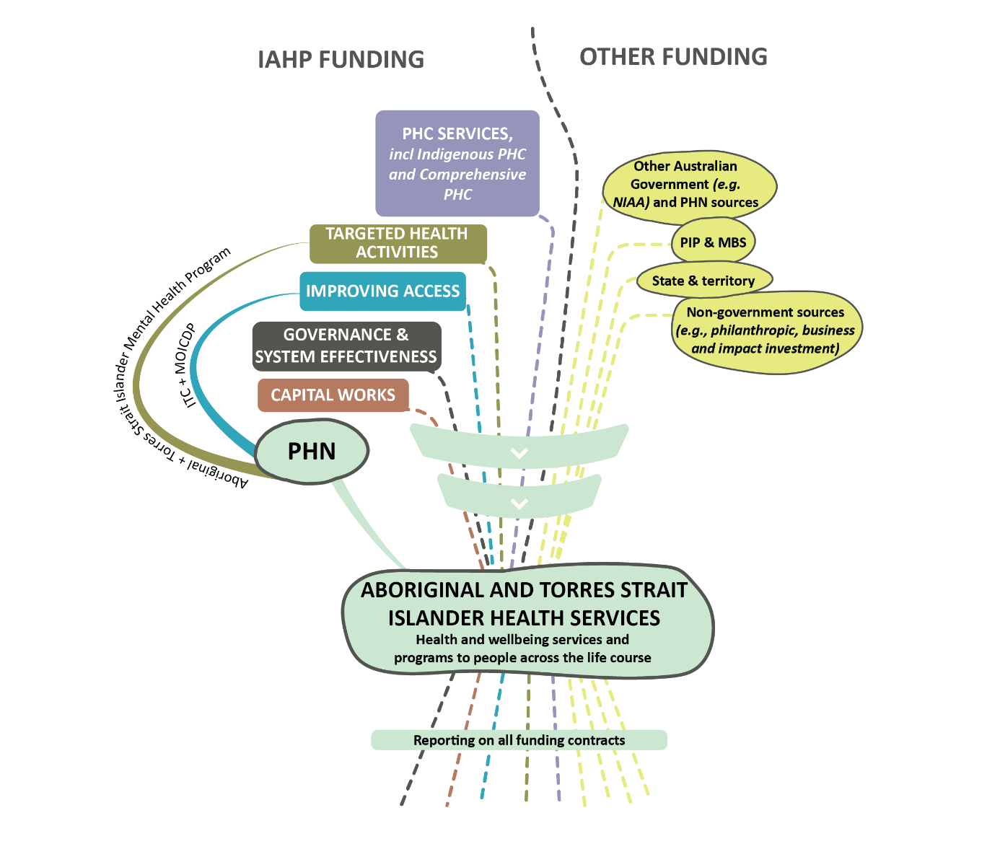
In addition, there are other factors that, while beyond the direct remit of the IAHP, were reported by site partners as significant barriers to delivering wrap-around support, including:
- The availability and accessibility of culturally safe and appropriate referral services. For example, staff from an ACCHS reported that they were unable to refer clients to a local psychiatrist because of cultural safety concerns.
- The strength of relationships between ACCHSs and these other health and wellbeing service providers, including personal connections. For example, an ACCHS had cut ties with its local PHN because they felt disrespected and this had affected their ability to provide coordinated care for some clients and access to transport assistance through the ITC program.
- The absence of a systematic approach to the coordination and integration of care between health and other social support providers leading to the reliance on individual partnerships and relationships.
These factors combine to work against a holistic approach to PHC by splintering the model of care across funding streams and reporting arrangements. It can get in the way of organisations expanding and developing broader and more effective systems of wrap-around and integrated care.
Importantly, not all ACCHSs experience these factors to the same degree. There are examples of organisations working together to overcome these barriers to create effective solutions. These solutions often revolve around successfully accessing multiple funding streams (for example, ACCHSs delivering headspace youth mental health services) so services can integrate care, or establishing strong networks with other ACCHSs to share resources and build relationships between services to support referral pathways. These creative solutions are not directly encouraged or incentivised by the IAHP funding model.
One ACCHS articulated its vision for the future.
We need to develop a system of care, where we can see these systems as linked, so we can understand the navigation of the systems. There is only ITC that sort of looks to help people navigate the systems, but this service should be family-based or individual based …. We need a lot more care co-ordinators and navigators to help people and families navigate the multitude of services that they need. No one sees one program; they see multiple programs. If we were able to plan from a systems place-based approach it would be more effective … instead of a responsive application to a tender that has come out of a tiny bit of money, where the funders aren’t interested in how this little bit links to the wider system.
ACCHS, Regional location

A clinical focus does not match what ACCHSs are trying to do
What drives people into services? Social determinants. Yet we spend all the money on clinical services.
ACCHS, Metropolitan location
The clinical orientation dominates all things health. There is no wriggle room to do more beyond that. With mental health, for example, you can only do cognitive therapy – so you have got to be creative with what you should be doing and fit that into that clinical box. Bringing a holistic approach to these highly stringent and sometimes stipulated clinical guidelines is hard …. We need to loosen to reins.
PHN, Regional location
IAHP funded organisations have the flexibility to spend PHC Program funding on a range of activities and services, including funding for clinical services, population health programs, and activities that support the delivery of clinical services. However, in practice, the majority of organisations reported that they applied PHC Program funding to the provision of clinical services, with comparatively minor amounts spent on population health programs and PHC support activities. Only larger organisations, and those that receive substantial other funding, including Medicare funding and untied funding, reported being able to use PHC Program funding flexibly.
Most of the funding goes into clinical services. Clinical care.
ACCHS, Remote location
ACCHS staff see the clinical approach to health as too narrow and at odds with a more holistic approach to health care that Aboriginal and Torres Strait Islander people value and need. They recognised that the funding is insufficient to support more holistic care.
I do strongly believe that IAHP should be about keeping people healthy. But, at the moment, because of the lack of funding coming through, it's emergency department. So until we can address that need, we're going to continue. We'll never close the gap. We'll just never will. You know, don't even talk to me about closing it because it's not going to happen until it's properly resourced.
ACCHS, Metropolitan location
Numerous ACCHS staff reported that the services and activities funded under the IAHP are still structured according to western clinical understandings of PHC, which compartmentalises the process of diagnosis and treatment. This, in turn, creates silos and what people refer to as ‘body-part’ funding, which works against the multi-faceted and integrated approach to health care that ACCHSs strive to facilitate.
…that's the issue because the primary health care way of looking is not a black way of looking. It's a clinical model, and that's the way we're going to do business. The Aboriginal way of looking is your housing, your education, your drug and alcohol, your dental, you know, the approach is everything. But with this funding, it's strictly this – what we're delivering is a clinical PHC setting, that is it, full stop.
ACCHS, Remote location
Participants emphasised the importance of non-clinical levers for improving health and wellbeing outcomes.
It's not as clinical out here because at the heart of it if you want to make the change, it's a behaviour change with our community, not a clinical change.
ACCHS, Remote location
To a lesser extent, ACCHS staff also reported that PHC Program funding covered some support roles such as receptionists, drivers, cleaners, and CQI workers. Similarly, some ACCHSs identified population health programs that received support from PHC Program funding, such as men’s and women’s groups, seniors or elders’ groups, physical activity programs and Outback, on-country or fishing trips. These tended to run intermittently and were dependent on having the staff confident in running these types of programs. Some ACCHSs reported a decline in these types of activities and a re-focus on clinical services.
The intent of the IAHP matches what ACCHSs are trying to achieve – the delivery of holistic comprehensive PHC. However, there appears to be misalignment in implementation reflecting an inadequacy of funding and the siloed nature of funding programs. This includes the 35+ programs and activities funded under the IAHP (as discussed in Section 3.2), as well as the myriad of other programs supporting health and wellbeing funded from elsewhere.

More funding is required to enable preventative programs outside clinical service delivery
Having the ability to work preventatively is a crucial part of delivering the holistic care that Aboriginal and Torres Strait Islander people value. It is also a critical lever for alleviating the health crisis associated with the growing prevalence of chronic conditions. ACCHSs consider preventative care to be an essential part of their preferred model of care.
We're in the game of keeping people healthy. That's our business. We want to keep people healthy. The way it's running right now is we're trying to get people healthy.
ACCHS, Metropolitan location
While support provided through clinical service delivery may have preventative purposes (such as through the provision of 715 health checks), working preventatively includes proactive activities such as doing health promotion, health education, pre-engagement check-ups, and screenings, as well as running early intervention programs. ACCHSs are delivering many of these activities and services but the overwhelming message reported by most ACCHSs is that they are constantly working in crisis mode, struggling to meet targets and keep up with the demands in the community. Fundamentally, ACCHS participants discussed that limited funding, including through the IAHP, required them to make choices about what activities to undertake, and clinical services, understandably, were prioritised over health promotion and preventative programs.
ACCHS staff also talked about other barries to the delivery of preventative programs. This includes a degree of apathy from clients towards preventative care.
… they [our clients] may not be buying it. Yeah, they might say ‘go away I don't need you, only when I get sick do I need you?’ But we need to put the living back in Aboriginal people. Aboriginal people know that they're born, they live and they die. We need to put the living back.
ACCHS, Regional location

Contribution of the IAHP to PHC system access and navigation
Aboriginal and Torres Strait Islander people value health care that is welcoming, accessible, available, safe, flexible, affordable, appropriately designed and resourced, and responds to changing needs across the life course and supports the wellbeing of the whole person. People told us they value health care services that are easily recognised and in spaces connected directly to the place they live.
The IAHP funds several programs and activities that include a focus on improving access to PHC for Aboriginal and Torres Strait Islander people. This includes the PHC Program and the Integrated Team Care (ITC) program.
The findings reported in this section draw heavily on contribution analysis, adapted from John Mayne’s (2008) and combined with a grounded theory approach. The evaluation’s approach to contribution analysis is discussed below.
Approach to contribution analysis
Contribution analysis is a systematic and rigorous approach to establish (or discount) a plausible association between inputs (such as IAHP funding) and observed changes. It does this by demonstrating contribution rather than proving causality.
The evaluation used contribution analysis based on yarns and interviews with Aboriginal and Torres Strait Islander community members, ACCHS staff, PHN staff, other site-based organisations, and national, state and territory participants.
A grounded theory approach to contribution analysis involves an iterative process of building and refining the interpretations and understandings of observed contributions up through the data. It also enabled the contribution of the IAHP to be assessed against the values and aspirations of Aboriginal and Torres Strait Islander people, rather than against a pre-existing theory of change (which is typically the purpose of contribution analysis).
The process of analysis included the development of five contribution cases through a grounded theory (including open coding, theoretical memoing, comparative analysis, and inductive reasoning) analysis of Cycle 1 and 2 qualitative data. It also included two review and sense-checking stages. First, the cases were taken back to sense-check with community members, ACCHS and PHN staff in the 17 evaluation sites. Second, the cases were presented to a review panel of health sector professionals, who critiqued and discussed the claims made by the evaluation about the IAHP’s contribution and the concepts/typologies used to describe the different types of contribution.
The review stages ensured that the contribution analysis captured the fullest construction of concepts and their theoretical development. The review stages also allowed for the gaps and nuances of the IAHP’s contribution to be considered and to gain a deeper understanding of the implications of recommendations informed by the analysis.

The PHC Program contributes to people accessing and navigating the health system
The IAHP PHC Program is critical to improving access to PHC services. Central to this is the contribution the PHC Program makes to the service capacity of ACCHSs.
The PHC Program contributes to people accessing and navigating the health system in the following ways.
- Supporting people to travel: Most ACCHSs have a driver and vehicles to assist clients with transport to and from the health service and/or to and from specialist appointments. ACCHS staff also shared examples of compensating clients’ use of public transport.
- Supporting home visits: Some health services said clients have the opportunity to have their health checks and treatments done in their homes. This happens particularly for older clients and those who are disabled or too sick to easily leave home.
- Providing low cost or free health care: All ACCHSs bulk bill and provide access to subsidised PBS medicines so health care is free or provided at a reduced cost. Some ACCHSs have opening hours that support people who cannot attend a clinic during the daytime. Further, most health services provide care in remote communities through outreach clinics and/or mobile clinics (for example, a health bus). The availability of such services in remote communities (even if for a limited number of days) is important for those who are not able to commute to towns with large health hubs.
- Accessing care through Telehealth: Access to telehealth was expanded in March 2020 to reduce the risk of community transmission of COVID-19. This meant MBS items could be claimed through telehealth. As of 1 January 2022, MBS Telehealth arrangements became ongoing (Australian Department of Health, 2020b). For some remote ACCHSs who don’t have a GP available, this has made it easier to get MBS claims signed off by a GP. A nurse or an Aboriginal and Torres Strait Islander Health Worker can go through the consultation with the client and then add 10 minutes for a GP to attend and finish off through telehealth. Further, ACCHSs aim to avoid referrals and make specialists available and accessible to the community.
- Appointment times: ACCHSs reported that they deliberately set longer appointment times for clients to facilitate stronger engagement.
While the evidence identifies that the PHC Program supports people to confidently access and navigate PHC systems, participants raised several factors that inhibit this contribution.
First, staff in all ACCHSs shared a concern that there are many areas of health that they are unable to cover efficiently. They raised strong concerns about the lack of funding for health promotion and preventative care. They also described that they were not able to reach the most vulnerable in their communities. For example, many reported that young people, elders, transient populations, pregnant women, and people experiencing mental health illnesses were missing out on services. These gaps in access to services are considered further in Section 6.5.
Second, some staff in ACCHSs said that funding is insufficient to meet the needs of their communities and make services as affordable as needed. While bulk billing is not normally an issue for ACCHSs, some staff spoke of challenges in finding qualified specialists that will bulk bill. If health services are not able to find specialists that can bulk bill it will often lead to clients having to go on long waitlists in the public system.
Third, despite the availability of subsidies and compensation for transport costs, health services cannot cover all costs associated with specialist appointments and treatment, which can result in clients missing out or choosing not to engage.
Finally, although ACCHS and other PHC Program funded organisations reach some remote communities, the issue of remoteness continues to be a significant barrier to accessing health care.

The ITC program makes a direct contribution to health care access
The ITC program assists Aboriginal and Torres Strait Islander people with complex chronic diseases to manage their health conditions. The program has two main aims:
- To contribute to improving health outcomes for Aboriginal and Torres Strait Islander people with chronic health conditions through better access to coordinated and multidisciplinary care.
- To contribute to closing the gap in life expectancy by improved access to culturally appropriate mainstream primary care for Aboriginal and Torres Strait Islander people.
To be eligible for ITC, Aboriginal and Torres Strait Islander clients must be enrolled for chronic disease management in a general practice or an Aboriginal or Torres Strait Islander health service, have a management plan, and be referred by their GP. An eligible condition is one that has been, or is likely to be, present for at least 6 months. Priority is given to clients with complex chronic care needs who require multidisciplinary coordinated care to manage their disease.
There are two main mechanisms through which ITC supports people with complex chronic diseases: (i) through supplementary services funding, and (ii) through one-to-one assistance by care coordinators and outreach workers. ITC services are commissioned by PHNs, with the exception of services in South East Queensland where, since July 2022, the funding is provided directly from the department to a regional ACCHS.
While the evaluation does not focus on the experience of the ITC program, participants shared many perspectives on the program. People identified the ITC program as an initiative that directly targets many of the challenges associated with a fragmented health system.

Supplementary services funding contributes to affordable and timely health care
ITC supplementary services funding covers:
- Fees for service: Enabling people to directly access medical specialist and allied health services, where these services are not otherwise available in a clinically acceptable timeframe. Funds may also be used to directly pay fees for services by allied health providers or to pay in full or meet the difference between MBS rebates and fees charged by private specialists or allied health providers (Australian Department of Health, 2019d).
- Transport: Enabling eligible people to directly access the closest regionally available health care professionals in a clinically appropriate timeframe (Chakraborty et al., 2021).
- Medical/health aids: Enabling eligible people to directly access assisted breathing equipment, blood sugar/glucose monitoring equipment, dose administration aids, medical footwear, mobility aids, and spectacles (Chakraborty et al., 2021).
The funding directly addresses barriers to accessing health care experienced by many Aboriginal and Torres Strait Islander people influenced by a range of social determinants of health related to income, access to health care systems and transportation (Chakraborty et al., 2021). Its contribution is significant and can have life-changing outcomes.
We’ve recently been able to access some treatment in private rooms to support people with cataracts. Which you know, that’s amazing. People then can see properly again.
PHN, Metropolitan location
Several ACCHS and PHN participants described situations where people, including those in urban locations, had faced delays in accessing allied health care due to long wait lists and the cost of private specialists. A PHN participant noted that some people become regular admittees through the hospital emergency department:
They didn’t have the funds before to go to the specialist appointments to manage their illness. They became worse and became frequent flyers within the hospital system. I used to be the hospital liaison officer and before the (ITC) program there was a lot of frequent flyers that came in with chronic disease to the emergency department. And now…there’s been quite a bit of decrease in the presentations.
PHN, Regional location
Similarly, a comment from an ACCHS participant highlights the difficulties people have accessing specialist treatment, and the role of ITC in accessing timely care.
If that separate bucket of money wasn't available, then we wouldn't have that access to specialist services here in [city]. And there are ridiculously long waitlists to see specialists, even if you could get into a public specialist.
ACCHS, Metropolitan location
Access to affordable public transport was reported as a key benefit by several evaluation participants. Where cost is a barrier, eligible patients may receive bus tickets or taxi vouchers that are funded through ITC. This enables people to be as independent as possible. ITC workers may work with allied services to ensure that appointments align with public transportation.
A patient of ours goes to [town], via bus. The bus gets there at 11.30. Because we ring up [service] … and we tell them that we’ve got a client, because they need to catch that 3 o’clock bus, can you make sure that they get in before, so that they can go get something to eat and jump on that bus.
ACCHS, Remote location
In other situations, ITC staff work proactively with people to ensure they attend appointments.
The transport driver phones twice before picking up a patient. As a result, the percentage of ‘no shows’ has dropped from 80% to 20% in one site.
ACCHS, Regional location
Health service users who need to travel to access care may face additional barriers, including the unreliability of public transport, and needing to travel long distances while unwell. In response, funding through ITC enables a holistic approach to support, enabling outreach workers to travel with people.
You have [an outreach worker] taking you to the appointment; they…help you out (at the appointment), they are there when you’re finished. It’s not like some of the horror stories that you hear, when people get flown out, and they get discharged in the middle of the night.
ACCHS, Remote location
Accommodation for the person needing care and family members can also be covered by the supplementary services funding. This is considered important for people needing to travel for weeks at a time to access treatment such as radiation.
When you send people out there for operations, we send a driver up…to take the family, accommodate them, and that’s all done as a support mechanism, when we haven’t got the specialist service available.
ACCHS, Regional location

There are challenges to accessing supplementary services funding
Many Aboriginal and Torres Strait Islander people living in remote and regional communities do not have a stable GP service. Where this is the case, it can be difficult for eligible people to be referred to ITC (as people require a GP management plan and a referral by a GP). This was a common challenge reported by evaluation participants.
There is also evidence that the supplementary services funding is insufficient to meet demand. For example, in one remote site, 45% of Aboriginal and Torres Strait Islander people have two or more chronic illnesses. However, just 3.4% of this group had been referred to supplementary services.
We did … try and get some more dollars around the supplementary services, because we know it is making a huge difference, but there are just not enough dollars to go around.
ACCHS, Remote location
Participants in several sites (urban, regional, and remote) reported that transport was a key contributor to supplementary services funding being ‘chewed up’.
Access to affordable and culturally safe accommodation was also raised as a barrier, particularly for people living remotely who need to attend specialist treatment in a regional centre. Where this accommodation does exist, for example Aboriginal-managed hostel facilities, these can provide critical support to people, however they are often fully booked.
Access to ITC supplementary services funding is also time bound. A PHN participant commented on one of the program reporting indicators that asks ‘how many people are being discharged from the program?’ They questioned the assumpton in this indicator that people will get better and no longer need support.
What happens when a person is discharged and they can no longer access supplementary services for glasses, and footwear, and Webster-packs?
PHN, Remote location

ITC funding has the potential to make a wider contribution
Participants commented on two ways that the ITC program eligibility criteria limits its potential to make a wider contribution. Eligibility is prioritised for people with complex chronic diseases. Participants recognised that eligibility criteria were required to manage demand for what is a limited resource.
Evaluation participants identified people with mental health or substance use issues, young children, people with a disability and those requiring birthing services as groups that are also likely to benefit from access to equivalent programs that support integrated care to access health services.
Well, if you don’t come under any of them programs like through the ITC, if you don’t fit any of them criterias and you need to go down and see specialists. Well, you got to pay your own way.
ACCHS, Remote location
Secondly, there are services that cannot be accessed through ITC. Some participants noted the link between chronic disease and poor dental health. They identified access to dentists as an area of unmet need, particularly in remote sites but also in many regional areas. Given dental services are not covered, ITC clients cannot access supplementary services funding to support transport and accommodation costs associated with dental care.

ITC workers’ create safe pathways for people to (re)engage in health care
The ITC program supports 3 health worker positions aimed at assisting people to access culturally safe health care – outreach worker, care coordinator, and Indigenous Health Project Officer (IHPO). Final Report Supporting Material Appendix H includes a description of the roles and skill requirements associated with each of these positions. The positions and their roles are prescribed in the ITC program implementation guidelines. However, there is some flexibility in the location and mix of roles in each PHN region. For example, in two regional evaluation sites, the IHPO position is located within the PHN and other roles are contracted out to ACCHSs or other NGOs. In two sites the IHPO position is located within the peak body for community-controlled health services. In some regions, the outreach worker and care coordinator roles are combined.
Some aspects of the ITC worker role descriptions provide implicit recognition that mainstream services can be difficult to navigate and be culturally unsafe. For example, outreach workers are expected to help with identifying barriers to health services. When people do not feel safe they may be reluctant to access services.
The contribution of ITC workers to improving access to high quality, comprehensive, and culturally appropriate PHC occurs primarily because workers (particularly outreach workers and care coordinators) are attuned to local need and care deeply for their community. These workers facilitate eligible people to engage in services and in managing their health conditions by walking alongside them. Outreach workers are described by PHN and ACCHS respondents as ‘community engagers’. They have a presence in the community, and are on alert for people who need support but are reluctant to access health care.
I was able to provide the clinical support being a nurse, but the outreach workers were actually able to be on the ground. And you know, there was a lot of times the outreach workers would go and take a client for a drive for coffee, and in the end we're able to convince somebody to go to a medical appointment, which two weeks prior they're like, ‘I'm not going to the GP. I'm not going to do this.
PHN, Metropolitan location
Outreach workers have a critical role in engaging people in health care through safe pathways. Such an approach involves an overarching ethos of care and respect. Engaging with community is not timebound.
You can spend three hours with a client if you need to, to do that relationship building, which then allows them to access medical treatment.
ACCHS, Metropolitan location
Cultural safety and respect are paramount, where the focus is on building meaningful rapport and trust. Outreach workers may engage with community in culturally safe spaces for women’s and men’s business, where connection to culture and community are nurtured.
… the outreach worker would go and collect a couple of men and off they'd go for the morning and do their fun activities together. Same with the women as well. And there was the grannies group, which outreach workers would often attend just to even go listen, come back and be like: ‘Actually, so and so's in strife.’ … sometimes we couldn't get a hold of our clients. But then the outreach workers were able to connect through other means to access them, which was great.
PHN, Metropolitan location

ITC workers empower people with information
Care coordinators run health education events. Evaluation participants reported holding events covering topics such as the difference between different types of health care clinics, and what is involved in a health assessment. Care coordinators also provide information and education to people about their underlying health conditions so that they understand the seriousness of these and discuss their medications.
Before the care coordinator came along, clients were just taking medications because that's what they doctor said. They didn’t know what they were for. They didn't know they could say to the doctor that makes me feel sick, is there something else? So we've got these care coordinators that are actually looking with the patient into everything and giving them some education on their meds as well.
PHN, Regional location

ITC workers help people to navigate the system
ITC workers help eligible people to navigate and engage with services across the health system. This can involve walking alongside clients as they access allied health services of specialist hospital services. Reportedly, this supports smooth transitions across the primary-hospital care interface and makes clients more inclined to engage in their care.
An evaluation respondent who had worked as an ITC care coordinator described the role as including helping people to navigate hospital treatment such as dialysis, chemotherapy, and radiation therapy. Much of the role involved ensuring people have a voice and are confident to ask questions about their condition and care. She described a situation of supporting a young man who was being treated for throat cancer. The specialist was telling the young man that he had a life expectancy of 6 months, even with treatment. However, the young man was smiling as what he heard the specialist say is that he would need to stay in hospital for 6 months of treatment, after which he would have a normal life expectancy.
… it’s really supporting people to truly understand the information that’s being provided. This situation happens every day. It happens with medications and with allied health treatment. You know, you have a foot ulcer and you need to make sure that you have this dressing, or make sure that you don’t walk on it. That you take this antibiotic regularly. It’s really supporting health professionals, specialists, allied health, GPs to understand the cultural barriers for our people, and then also that our clients truly understand what’s happening with their health and their treatments and with their ongoing chronic disease management.
PHN, Metropolitan location

ITC workers help to change mindsets within mainstream services
The IHPOs provide opportunities for mainstream PHC services to undertake cultural awareness training. This may occur through formal workshops. It can also occur informally working one-on-one with a PHC service, for example through an informal yarn with the practice nurse, practise manager, reception staff, and whomever else is available.
One ACCHS participant noted that the challenges when this work is contracted to Indigenous organisations.
It's a really hard gig to ask one of our mob to get into a mainstream service, get the GP to talk to them, if you're the only Aboriginal person going in. I've experienced that myself. Like, that is hard, like a hard ask and should that be the role of the ACCHOs to educate the other GPs?
ACCHS, Regional location
Participants in 5 sites referred to Indigenous and non-Indigenous organisations being commissioned to run cultural education and capacity building. Mainstream services receive the training as part of signing up to the Practice Incentives Program (PIP) Indigenous Heath Incentive (IHI). Participants said they had concerns about the effectiveness of this training, which is often a short, one-off course. They were also concerned that the IAHP funding is being used to educate mainstream services about cultural safety. Cultural education training is an area that two PHNs said they are reviewing.
There’s a lot of investment in cultural safety training, but we’re not seeing a lot in translation. So how do you move from having the cultural safety training, which gives you some awareness, to actually better insight about how you need to translate or adapt your practice to be culturally safe … so that’s a gap.
PHN, Metropolitan location

There is value in having Aboriginal and Torres Strait Islander people as ITC workers
Being Aboriginal or Torres Strait Islander is not a prerequisite for the ITC worker positions but guidelines note that Aboriginal and Torres Strait Islander people should be engaged in the IHPO and outreach worker roles wherever possible. Evaluation participants said there was value of having Aboriginal and Torres Strait Islander people in these roles. They commented that this made the clients feel more comfortable, meaning clients are more confident in asking questions, and Aboriginal and Torres Strait Islander workers can dive deeper into questions around client’s broader wellbeing and situation.
I do think that if we didn’t have Aboriginal workforce in [ITC] we’d be in strife.
PHN, Metropolitan location

Supporting access through capital works and facility upgrades
The IAHP also supports access to PHC in other ways. For example, the Capital Works Program supports services to build new clinics and staff accommodation, and to do major upgrades. The Service Maintenance Program supports services to renovate clinics and accommodation. These programs contribute to better resourced and more appropriately designed health service facilities that visibly appear more welcoming and culturally safe. The benefits of these kinds of investment were visible as the evaluation team visited different sites across urban, regional, and remote locates.
Across the 17 evaluation sites there were some ACCHSs with new or renovated facilities, sometimes part-funded through the IAHP. At some sites it was clear that the design of health care facilities can influence the delivery of culturally safe care and improved health care access. For example, some services have been able to design and develop clinics that accommodate gender-sensitive health care through providing access to separate male and female facilities.
Other services have built extensions to their clinics that provide spaces for cultural practice and connections, family accommodation, and healing ceremonies to take place, as well as incorporating Indigenous artwork, signs, and languages. Some facilities also have community spaces for art, cooking and sewing. The design of some new facilities has helped to create and build connection and ownership by Aboriginal and Torres Strait Islander communities in their health service.
However, there are locations that need access to funding to support upgrades to their health facilities to support staff and patient safety. For example, one service visited by the evaluation team had a collapsing ceiling and asbestos in the structure. Other facilities were not accessible. There is a need to support physical access through greater investment in capital works to support more accessible service delivery and improve safety.

Contribution of IAHP to stronger communities and a stronger community-controlled sector
There are a range of ways that Aboriginal and Torres Strait Islander community-controlled organisations are distinct from mainstream health services. Most importantly, this includes the focus on supporting collective health and wellbeing across the community. ACCHSs are not just organisations delivering health services to clients within a specific community. They work for the whole population and the outcomes of Aboriginal and Torres Strait Islander people more generally.
ACCHS staff consider that the history and role of community-controlled organisations is not recognised in the IAHP funding arrangements. In particular, commissioning arrangements that treat ACCHSs as mere service providers were said to minimise the leadership and responsibility associated with community-controlled organisations for health outcomes in the communities they serve.
While many ACCHSs apply elements of IAHP funding to support a multidisciplinary workforce, they reported that there was insufficient funding to support and build a strong and stable Indigenous health workforce that meets the demand for services. Comments around the insufficiency of funding to support workforce were not necessarily directed at the IAHP. These comments reflect the primacy of IAHP funding to ACCHSs and the way that they combine funding sources to meet needs.
Many ACCHSs adopt a leadership role in the community on a range of issues that contribute to social and cultural determinants of health. To varying degrees, ACCHSs also seek community input into health service design and planning. Through the evaluation, participants reported that IAHP funding does not value and support these activities or enable ACCHSs to participate in community engagement activities.

The relational nature of care is not adequately valued and recognised
Well, just like when your family member die, you know, because we know everybody here, know the family things. So we'll come across for assistance like for food and for coffee, sugar, milk and biscuits, you know just to help the family. It’s just part of the work. You just do it.
ACCHS, Remote location
Health care in most ACCHSs goes beyond clinical treatment and support; it is about a deep care and commitment to the community. This population wide responsibility differs from mainstream PHC service delivery. It involves the ACCHS taking care of their entire community, whether they are clients of the service or not. This includes providing care to non-Indigenous people. This commitment was reflected during the COVID-19 pandemic with ACCHSs looking after the whole community and responding to a wide range of non-medical needs (for example, checking in on families, securing food supplies, etc).
We care for our mob regardless of where they choose or where they’re required to access care.
ACCHS, Metropolitan location
Many ACCHS staff refer to their clients as their people or ‘their mob’ and feel a strong connection to the people they serve. It is seen as necessary to ‘go above and beyond’ for the community. ACCHS staff describe this as ‘normal’ and ‘expected’ of them as part of their role in the community.
Many of these attributes and responsibilities apply to government primary care clinics too, which are operating in communities where there is no ACCHS. However, it is more dependent on the individual staff involved as opposed to a deep commitment within the context of a community-controlled organisation.
These responsibilities demand strong and trusting relationships with communities and people.
The community really respects and trusts us. So, they will actually come, because if you don't have engagement with the community, you just have a building, really.
ACCHS, Remote location
ACCHSs described their approach to making sure that clinics are welcoming spaces and that clients feel safe and comfortable. This can involve, for example, taking time to yarn with a person before and after an appointment, making a cup of tea for someone, making sure people have understood their treatment, picking someone up for an appointment, having a kids play area, and letting family members support clients. It also involves being highly responsive to the needs of client.
[We get clients saying] ‘I don’t want to come in today, but I need something changed on my leg’. [So we go] ‘Okay we’ll get the nurse in the car straight out and do … that wound management.’ That doesn’t happen elsewhere.
ACCHS, Metropolitan location
Hosting and facilitating community events are important ways health services build strong and trusting relationships with the community. Community BBQs, social basketball, and cultural festivals are examples of some of the events facilitated by ACCHSs. These enable health promotion and help to bring people together and feel a sense of belonging to the health service. Community engagement also enables health service staff to get to know clients as part of their wider community and to understand the importance of context.
The IAHP does not adequately recognise or resource the amount of work that goes into maintaining and building connections and trust with clients and the wider community. This work relies on passion, goodwill, and voluntary work. ACCHS staff reported that it comes at the cost of staff burnout. They described IAHP as being too narrowly focused on ‘numbers’ (for example, clinical activities and episodes of care) and not accounting for the more relational approach to care and service delivery which they strive to apply.
It's [IAHP] very much a clinical model. It's very much data - bums on seats [episodes of care], you know, like, rather than that self-determination, that, yeah, modelling that we do so well, as community-controlled organisations. It's outside the medical model and, as a clinician, I was always frustrated that I'm here, the person in front of me - it's not just the person that's sitting there to see me, it's that family around them, and so I want to invest that time with them …. I never wanted to see the person in front of us as a dollar figure or as a statistic, but that's how the funding is driving it.
ACCHS, Regional location
Moreover, it is hard for health services to measure and report on the work they do to support people and their community. The first example below is of an elder who needed support as she had a house inspection and was at risk of losing her home.
So I don't know how they work it out [at] their [department’s] end. It might not have come out of the IAHP funding, you know what I mean, but we would have found some way for it. But that's what's important to our community. So how do you account [for] that sort of thing? Three staff helping one of the old ladies tidy up a house, sort her clothes out. You know what I mean?
ACCHS, Metropolitan location
The numbers don’t tell you the story of the patients. It just tells you that one person came in at this time, and you might see 35 people in a day, but it doesn't tell you what you have to do for those 35 people.
ACCHS, Remote location
The department acknowledges that ACCHSs provide this type of support, that it is required, and that it is likely funded, in part, through the PHC Program, as the flexible component of IAHP funding. PHC Program funding agreements set out the types of activities that are eligible for funding but are not explicit in terms of how these activities are delivered.

Explicit support to attract and retain Aboriginal and Torres Strait Islander staff is not a current feature of IAHP funding
A flourishing Aboriginal and Torres Strait Islander workforce is an operating principle in the model of Aboriginal and Torres Strait Islander community-controlled comprehensive PHC:
Aboriginal and Torres Strait Islander staff will flourish in ACCHSs as work environments placing high value on their skill sets, their connections within communities and their knowledge of culture (p.13, National Aboriginal Community Controlled Health Organisation, 2021a).
Evaluation participants (community members and ACCHS staff) discussed how Aboriginal and Torres Strait Islander Health Workers and Health Practitioners were central to the ability of health services to deliver culturally safe and appropriate care, thereby supporting the realisation of the IAHP’s objectives. As discussed in Section 6, Aboriginal health workers and practitioners are often people’s first point of contact with an ACCHS, helping them to navigate services.
Community participants reported that they feel safer when they connect with other Aboriginal and Torres Strait Islander people in a health service. Some ACCHS managers observed that people were more likely to discuss their health when Aboriginal and Torres Strait Islander staff were present. Aboriginal health workers and practitioners are also well positioned to support clients’ health literacy.
The most important part of AMS is what happens when they (the patient) come in behind a closed door with an Aboriginal health practitioner who takes time to listen to them about how hard things are and provides compassion and empathy, as well as deliver some health promotion that is easy to understand. This is what makes them (patients) want to come back and see that same health practitioner again. Then this becomes a safe place to come to and it becomes a pleasant experience to come here.
ACCHS, Remote location
Many site partners reported that they wanted to increase the employment of Aboriginal and Torres Strait Islander staff. In addition to supporting the delivery of culturally appropriate and holistic care, having Aboriginal and Torres Strait Islander staff inspires other Aboriginal and Torres Strait Islander staff and community members.
It goes to show, well, if our mob can do it, I can do it too.
ACCHS, Regional location
The number of Aboriginal and Torres Strait Islander staff in the health workforce has increased rapidly, doubling between 2013 and 2019 nationally to 7,894 people. However, the proportion of all staff who were Aboriginal and Torres Strait Islander was only 1.2% in 2019, well below the proportion of the Aboriginal and Torres Strait Islander population. Within the evaluation sites, Aboriginal and Torres Strait Islander staff made up 1.5% of the health workforce.
Within ACCHSs, the proportion of staff who were Aboriginal and Torres Strait Islander was much higher. Nationally, in 2013 the percentage was 14%, and in 2019 the percentage was 20%. This indicates that ACCHSs are successfully recruiting Aboriginal and Torres Strait Islander staff. Note, the Health Performance Framework reports that, in 2018, Aboriginal and Torres Strait Islander people made up 54% of the total workforce of Commonwealth-funded Aboriginal and Torres Strait Islander PHC organisations. This includes all staff working in services, not only staff in clinical roles, and is a count of FTEs (Australian Institute of Health and Welfare, n.d.-a).
Evaluation participants discussed how Aboriginal and Torres Strait Islander health staff walk in two worlds and often take on the hurt and stress of the community. An experienced doctor and an Aboriginal health worker who had both worked across multiple health services, talked about Aboriginal and Torres Strait Islander health staff experiencing vicarious trauma from hearing about their clients’ experiences. On one side, Aboriginal and Torres Strait Islander staff navigate the western mainstream medical system, and, on the other, they translate and communicate with Aboriginal and Torres Strait Islander worldviews. For example, ACCHS participants reported having to translate the scope of a program and services and explain to clients why certain things are funded while others are not. Their work is said to never stop (for example, replying to texts and calls out of hours) and they feel obligated to ‘go above and beyond’ for the community they serve. One interview participant talks about getting images of ‘sores and boils’ on a regular basis.
I think it's just in blackfellas nature. You see somebody need your help. And other people, they don't get that and they don't get why we do that. And you actually see in their face when over at a hospital and you go above and beyond to help that person. You see a little bit of a look of confusion on their face, like why you go to that extent to help.
ACCHS, Metropolitan location
Some Aboriginal and Torres Strait Islander staff may also experience personal health and trauma issues, while also having to care for others. This can make them prone to stress and burnout, and requires a supportive collegial and leadership environment, as well as appropriate support systems. It can also require additional resourcing and contribute to staffing costs. In yarns with Aboriginal and Torres Strait Islander staff at health services, participants discussed types of support that they would value. This included having dedicated time for culturally appropriate support, such as having time together to yarn, process and support each other, and leave to spend time on Country, and having support to access traditional healing. They also discussed the need for support systems to be determined locally, as opposed to, for example, a top-down programmatic response.
Funding provided through the IAHP contributes significantly to the employment of staff, including Aboriginal and Torres Strait Islander staff.
There's no doubt about it. It [IAHP] absolutely contributes to culturally competent care because it enables us to employ Aboriginal staff who are vital in providing that care.
ACCHS, Regional location
However, the IAHP does not currently have explicit levers to support the employment and retention of Aboriginal and Torres Strait Islander staff.
There are broader factors affecting organisations’ ability to recruit and retain Aboriginal and Torres Strait Islander staff. Some of these factors are outside the current sphere and influence of the IAHP but they are important system levers and directly influence the effectiveness of investment through the IAHP. Key issues related to workforce identified by site partners included:
- A shortage of Aboriginal and Torres Strait Islander staff was identified in most sites, particularly those in remote and rural areas, and health services reported challenges with staff retention and high turnover. In the NT, a participant from the NT Department of Health reported that the number of Aboriginal and Torres Strait Islander Health Workers had declined form 450 in 1995 to less than 50 in 2022.
- Training pipelines for Aboriginal health workers and practitioners are confusing and hard to access, deterring Indigenous students from pursuing this pathway.
- The employment conditions for Aboriginal health workers and practitioners are less financially desirable compared to other health care professions like nursing and general practice. Often the cultural skills and competencies that characterise these professions are not recognised in salaries and career pathways.
- There is external competition for Indigenous staff from organisations that offer better remuneration (for example, hospitals and government services).
While the IAHP does not set out contract or payment rates for employees, the capacity of services to deliver the intended outcomes of the IAHP is directly connected to the level of funding available to ensure the workforce is stable and well supported.

The IAHP treats ACCHSs as service providers
Many ACCHS staff described that the way the IAHP funding is mobilised positioned ACCHSs as ‘contract-takers’ or service providers, rather than recognising their combined role as both a service provider and representative of their community. In this respect, IAHP funding was not seen as significantly different from any other funding mechanism.
ACCHSs commonly described a competitive and contractual environment of tender processes and grant application, requiring skilled submission writers and reporting against performance indicators. They also described the push towards increasing Medicare billing and operating within a commercial environment. Participants variously described this environment as reflective of ‘outdated Western thinking’ and as diverting them away from a community-controlled model of care.
It's more about the care of community that lacks because of the funding, because we've kind of got to run off a business model rather than a community-controlled model now. It's actually taken away, you know community used to be able to access us, now they can't even get into appointments because we have so many non-Aboriginal people use the service, because that's what we have to have to run the clinic. Because if we don't have our appointment spots full, we make no money and we'll have to close.
ACCHS, Regional location
This leaves ACCHSs to work out ways to ‘juggle’ between behaving like a business to gain access to funding, and providing a service based on communities’ values and worldviews. ACCHS and PHN staff discussed the challenges this presented for ACCHSs – having everything set by time, with no time for walk-ins or yarning to clients. This approach was seen as at odds with the approach Aboriginal health workers and practitioners were trained for. Participants reported impacts from operating in this dual space, including staff feeling disenfranchised and burnt out, and struggling to balance budgets with community needs.
One participant described the IAHP as operating within a funding system where the government and ACCHSs have a service-led relationship, based on money, grant contracts, and reporting. They noted that this had turned away from a relationship based on advocacy and partnership.
Many organisations are trapped in a very confined service paradigm [because they need money].
Staff member, National Indigenous Australians Agency
An ACCHS manager reflected on accountability processes directed at governments and the corresponding apparent absence of value placed on accountability to community and clients. They spoke of being seen ‘just as a provider’ and this missed the fundamental difference between a community-controlled organisation and a mainstream provider. They also suggested the need for a KPI to reflect the value of community-control.
… community control in itself is supposed to be an intervention …. The fact that people can control and run services is something there's this extra kind of element and there's no KPI for that …..There's no value being placed on the community control KPI ….So we spend less time, I think, the danger is with our community, and more time dealing with the needs of public servants.
ACCHS, Metropolitan location

Service autonomy and self-determination can be limited by the IAHP
Let us do what we do. We're the subject matter experts here. We're Aboriginal community control, we know community …. We run a strict, you know, a tight ship here …. We don't have to be constantly having to prove ourselves.
ACCHS, Metropolitan location
The role of Aboriginal and Torres Strait Islander community-controlled PHC as an act of self-determination is critical (National Aboriginal Community Controlled Health Organisation, 2021a). The way that ACCHSs are funded, limits health service and community autonomy and self-determination. Participants discussed that these limits apply to most funding arrangements, including under the IAHP, although they acknowledged that some arrangements provide for more autonomy than others.
ACCHS staff reported feeling that they are not given a seat at the table, and that requirements are forced upon them by top-down program funding processes and guidelines that do not recognise Aboriginal and Torres Strait Islander self-determination and responsibilities for partnerships and community engagement. ACCHS staff do not always feel trusted and recognised for their particular skills and knowledge in Aboriginal and Torres Strait Islander PHC.
Some ACCHS staff reported that communication with government is not as close and genuine as they would like. They spoke of the need to communicate with many different contract managers, including for IAHP funding, across different departments, and with high staff turnover it is hard to keep track of who is in charge of what.
Every contract it seems has a different contract manager. And they change all the time and then there's also the financial contract manager and then you'll sometimes find somebody else as well. So it's almost, it's really hard for us to keep up to speed on who the right people to contact is.
ACCHS, Remote location
One PHN has moved to area-based commissioning managers so ACCHSs have a single point of contact. In another evaluation site the ACCHS had invited the PHN manager out to visit the service and better understand what they do. This had fostered a better relationship.
They've gotten better as far as helping us determine or letting us determine what we need. They're getting better. Because 4 or 5 years ago, the reports used to just bounce back, bounce back, bounce back, bounce back …. we were saying, look, I turn around and look send your project officer down here instead of emails emails send them down here. Go out with the team or chronic disease team whoever or whatever service agreements we got and who they sit with get the project officer to come out, visit, go out with the teams, see what they do. They can read between the lines. Because in an email you can't communicate properly until you explain what the program is. But if the person comes out and spends more time on the ground having that partnership relationship with the project team, you get better outcomes.
ACCHS, Remote location
Having greater flexibility and authority over how funding programs are designed and implemented is considered key to working in partnership with government and supporting self-determination. ACCHSs contributing to the evaluation said they want government to sit down with them before prescribing what a program would look like, and work in ways that are more collaborative and relational.
…having more flexibility around or input around how the funding might be divvied up or expenditure wise [is key]. So how we see we live, we breathe community and the clients we work with so we know what's best for our mob in community. So as I say, you know, the recent Closing the Gap refresh, you know, do with us, not for us. So I guess … along those lines … have more conversations with the ACCHOs and those that are managing the program about what works best for us on the ground and in community.
ACCHS, Remote location
While participants acknowledged greater flexibility with the IAHP PHC Program, other IAHP programs were singled out as being overly rigid. For example, ACCHS staff commented on not being able to do one to one consultations with clients under their TIS program funding despite this delivering better quit outcomes for their clients. Another ACCHS participant spoke about restrictions with the ANFPP, such as only being able to support first-time mothers and having to run the consultations in a set way. Similarly, another participant cited restrictions in IAHP funding received for mental health which targeted clinical treatment and did not permit early intervention or health promotional activities that they considered were vital to delivering outcomes.
Participants from the department explained that certain IAHP programs, such as the ANFPP, have a level of prescription to ensure implementation fidelity. These programs target specific outcomes and it is considered critical that the programs be implemented as intended to preserve the integrity of the program model.

Community engagement and other activities are not enabled by the IAHP
Our community pretty much tell us what we need to do .… We are completely open to the community.
ACCHS, Metropolitan location
ACCHSs and government primary care clinics use a mix of formal and informal mechanisms to engage with their communities. While the evaluation did not examine these mechanisms in detail, the evaluation team observed a range of examples of community engagement – both things that were working well and where engagement was less effective. Fundamentally, the IAHP does not directly enable community engagement activities in the evaluation sites.
Some ACCHSs have established ways of engaging with their communities. This includes, for example, seeking advice from elders, collecting community feedback through surveys and yarns, and using community groups or boards to get input into health service decision-making and planning. Informally, it is also common for ACCHSs to seek feedback from their staff members who are also part of the local community and to have a relatively ‘open door’ in terms of being receptive to community members approaching health service managers and leaders with ideas and feedback. ACCHS boards also provide a mechanism for community members to be involved in health service governance.
Government primary care services seek community engagement through similar informal approaches as ACCHSs. Evaluation participants discussed recent attempts to resurrect health advisory communities as a more formal way to generate community input into planning and decision-making within government services.
The effectiveness of the various approaches to community engagement is, to a significant extent, dependent on health service leadership and their ability to facilitate an inclusive and open approach to engagement that allows community perspectives to be heard and incorporated into decision-making. Having the time and resources to facilitate community engagement is also a critical success factor, and something that is commonly reported as being in short supply.
It’s not just about the amount of money, by any means. I think it’s listening to the community more, and self-determination. Really, you throw a lot of money at something, but if you are not listening to the community and taking advice from the community, I think that could be just a big waste of time and money …. If people are able to direct you, in your health service, if you are directly accountable to and take on their feedback and act on that feedback, then I think that you’d probably find things are a bit more productive, and you will get greater buy-in to whatever you are trying to do, if you just listen and take direction.
ACCHS, Remote location
In some evaluation sites, community engagement processes were not functioning well. This was sometimes highlighted when community members asked the evaluation team to engage with the health service leadership to advocate for something on their behalf because the established, generally informal, processes did not feel safe or effective to them.
ACCHSs reported a lack of space (time and timing) to engage effectively with their community to understand their needs and priorities. In two sites (metro and remote), ACCHS staff described situations where they were constantly focused on engaging with funders (reacting upwards) and did not have the space to proactively engage outwards with their community. This put them on a back footing – they were responding to funders requirements as opposed to feeding community needs and priorities upwards.
Another challenge that ACCHSs experience around community engagement is its perceived ability to make a difference. Health services and community members spoke about not feeling they have the power or authority to make a difference and experiences of not being listened to. This leads to disempowerment and makes future engagement more difficult. This was acknowledged by government participants.
The problem is that there’s good engagement but the lack of follow-through because it needs to fit with the existing national program. Ticking the box on engagement and show that there’s an agreement but this approach is problematic; we haven’t listened very hard …. They ask for a horse and then we go back and do the design work and deliver a camel.
Staff member, National Indigenous Australians Agency
While the IAHP does not directly support community engagement, the increased emphasis on governments sharing decision-making with Aboriginal and Torres Strait Islander people, including through establishing place-based partnerships to respond to local priorities (for example. in the National Agreement on Closing the Gap) suggests there may be a future role here for the IAHP.

Contribution of IAHP to delivering equitable access to primary health care
The IAHP funding model is designed to support access to health care for Aboriginal and Torres Strait Islander people across urban, regional, and remote locations across Australia. There are gaps in PHC coverage and access for some groups of Aboriginal and Torres Strait Islander people. The evaluation team’s discussions with evaluation participants highlighted the entrenched influence of health inequities in creating barriers to Aboriginal and Torres Strait Islander people accessing PHC.
Additional data on health service access for Aboriginal and Torres Strait Islander people is included in the supporting document The Indigenous Australians’ Health Programme Impact Report prepared by the Indigenous Group of the Australian Institute of Health and Welfare. This includes:
- self-reported data on usual source of health care
- the location of IAHP funded health services by indicators of socio-economic disadvantage
- the location of IAHP funded health services by remoteness
- the location of IAHP funded health services by an index of per-capita need for primary health care for Aboriginal and Torres Strait Islander people
- drive times to IAHP funded health services.

Determining primary care coverage and access is complex
There are several challenges in statistically determining the coverage of PHC for Aboriginal and Torres Strait Islander people, and differences in the purpose, scope, or sampling for different data collections do not capture all groups of Aboriginal and Torres Strait Islander people.
Determining the factors that affect accessibility of PHC is also challenging. Accessibility can include availability, affordability, ability to engage, acceptability, and approachability. The range of barriers to access are recognised in the Health Performance Framework (Australian Institute of Health and Welfare, 2020a). This also includes transport-distance challenges, cost, and cultural appropriateness of services.
Data published in the Health Performance Framework (Australian Institute of Health and Welfare, 2020b) indicate that in 2018-19, 12.5% of Aboriginal and Torres Strait Islander persons did not go to a doctor in the last 12 months despite evidence of need (7.9% remote; 13.5% non-remote). Of these:
- 2.2% indicated that the service was unavailable in their area (10.2% remote, 0.9% non-remote)
- 13.8% reported transport/distance as a reason for not attending (22.9% remote, 12.7% non-remote)
- 15.7% reported that the waiting time was too long, or service was not available at the time required (23.7% remote, 15.2% non-remote)
- 7.4% reported cost as the reason for not attending (5.9% remote, 7.8% remote)
- 33.4% reported reasons relating to the cultural appropriateness of the health service as the reason for not attending (26.2% remote, 35.1% non-remote) (Australian Institute of Health and Welfare, 2020b).
Similar patterns of barriers to access were reported for other health professionals, dentists, and counsellors, although cost was reported more often as a barrier for each of these groups (other health professional 36.2%, dentist 41.6% and counsellor 13.6%).
Available data may only provide a partial picture of the accessibility of health care. People who are not engaged with the health system are not going to be identified by data collection processes within the health system. Survey design may also exclude certain perspectives. For example, it is important to note that the National Aboriginal and Torres Strait Islander Health Survey (as with other ABS household surveys), does not include visitors to private dwellings, people who live in non-private dwellings such as hostels, hospitals, nursing homes, or short-stay accommodation, people who are incarcerated, or people experiencing homelessness within the sample (Australian Bureau of Statistics, 2019). Importantly, these groups match many of the groups where unmet need was identified over the course of the evaluation.
Understanding the experiences of Aboriginal and Torres Strait Islander people within the health system is also dependent on data collection, recording, and reporting processes about a person’s identity as an Aboriginal and Torres Strait Islander. Even where this information is recorded, it may not provide any information about an Aboriginal and Torres Strait Islander’s Country, community, and cultural connections.

Unmet need persists for some vulnerable cohorts
Aboriginal and Torres Strait Islander community members, ACCHS staff, and PHN staff are concerned about too many ‘unmet needs’ and an inability to ‘fill those gaps’. They identified the following population groups and service areas with enduring unmet needs:
- transient populations (including people on the move for cultural events, and those with chronic illnesses who it is then hard to provide continuity of care)
- pregnant women (mainly in remote sites)
- school-aged children and young people (this is further discussed in the next section)
- elders in aged care facilities, including respite care
- chronic disease patients, especially those living remotely and those requiring diabetes care
- prisoner populations, and those leaving prison
- clients with mobility issues
- mental health and child psychology
- drug and alcohol support
- dental care
- hereditary illness
- eye health.
ACCHS managers advised that they often continue to see and treat many people with complex health needs without the proper funding to provide the quality care needed. The implications of these unmet needs and the inability to fill these gaps include health service staff physically and emotionally burning out from attempting to do everything they can to support the community, but not having the resources to provide care at the level a person requires.

Primary health care is not meeting the needs of many young people
During interviews with ACCHS staff, Aboriginal and Torres Strait Islander young people were consistently identified as a missing cohort regarding equitable, effective, accessible, acceptable, and appropriate health care. Participants discussed their concerns for sustainable and equitable health outcomes at the population level and cultural continuity for Aboriginal and Torres Strait Islander people without a specific focus on young people, who constitute a large proportion of the population. Despite this, participants reflected that efforts to engage young people were frequently failing. Some ACCHS staff reported that the number of young people who access their services was relatively high, however it was still a challenge to engage young people in their health care.
In yarns with community members, participants also reflected on the health care experiences of young people. Evidence from these yarns indicates that young people are deeply influenced by the care experiences of family members. From a very early age, young people experience the health system either directly or vicariously through family members, friends, or community exposure. The mistrust and fear evoked by witnessing others’ traumatic health experiences weigh heavily on young people. In turn, their own experiences confirm their fears and instil mistrust of health systems in their consciousness.
These experiences affect young people’s future access and most basic interactions with the health system, such as making appointments.
I was like ‘mum I don't know what I'm doing and what I'm saying’ she's like ‘just tell them what you told me’. But yeah, took me a while to just get the confidence. And I was just scared.
Community member (Young person)
Young people shared an almost universal consensus that the health system is not equitable, affordable, accessible, acceptable, appropriate, relatable, or effective for them. From a care perspective, young people voiced that they are largely disengaged from the current system of response and support because they are not respected and welcomed, care is fragmented and time-consuming, they cannot access care when required, and care is not delivered in youth-friendly ways.
Young people described being reluctant to seek care and only accessing services when absolutely necessary given negative experiences.
When I come in, it's mainly with my, like, my family stuff. I'll hold off going to as much as I can.
Community member (Young person)

When accessing care for their own health needs, some young people described hostile and dismissive attitudes when trying to access essential care.
Pretty much like probably most young kids don't want to go there because they get judged you know.
Community member (Young person)
Some young people also expressed that they were continuously being talked down to by doctors and health service staff, which affected their willingness to engage.
They feel like if they come in like, you know, they’re going to be judged at the front desk, not even about like why they’re there. Like, just like what they look for, like what they look like, sorry, and stuff.
Community member (Young person)
For young people accessing health services, some experienced forced or unwanted medical interventions.
Well, doctor [x] put me on the pill when I was a virgin. More or less. I know. She just thought I was, like, then asked if I was seeing anyone, I was like ‘nah I’m a virgin’. And she just looked me up and down and more or less thought I was lying to her .… But I still felt insulted, you know, because I knew she thought I was a loser. But or that thought I got around. When I was still a virgin.
Community member (Young person)
A young mother also described her experience of childbirth and the poor-quality care she received, including her requests for pain relief being denied.
So my contractions started at 6:00, 7:00 Tuesday morning and I went to the hospital like 8:30 Tuesday night and told her that they were getting closer. And I couldn’t I thought she was coming soon and I was just sent home. And then a half an hour later, my water was broken. I had to go back up there. And so I got to like six and a half centimetres dilated without any pain relief. And then I had asked her for some pain relief and she tried to say that women 3000 years ago didn’t have the option of pain relief. And that’s how they did it. Until I abused her and told her that I wanted something. So she eventually gave me the gas while she was getting ready. She just gave me a shot of morphine just to help relax. But she. Yeah, I nearly went through full labour with no pain relief just because she thought that I could have done it. But I had to like a scream and abuse her to get it in the end. Yeah, it wasn’t a good experience.
Community member (Young person), Remote location

This example also highlights the risk that people will be dismissed as non-compliant or abusive when they are simply advocating for their own health care needs. When accessing services in mainstream settings, young people told the evaluation they did not feel culturally safe and that services lacked cultural competency.
Went to rehab a couple of months ago, and I would've stayed longer, but I didn't stay because I felt like it wasn't a culturally safe place, even though name is Indigenous name and they have reconciliation action plan in place. Just totally tokenistic. Because just the approach to like the residents like there they just treat you like drug addict. Just talk down to you and just say things like they were just educated on Blackfella issues, but they didn't come across wrong like they think I had come across the wrong way. And like terminology that we use, which is that lack of education and understanding.
Community member (Young person)
Cycles of poor care over time and space can lead to further disengagement from the health care system and shape future decisions about accessing care. Working toward solutions can only be effectively gained by listening to young people's voices and understanding their views. The evaluation team yarned with young people in urban, rural, and remote areas across the evaluation sites and listened to their stories about how they experience the health system and what they value in terms of health service design and delivery.
Young people told the evaluation that they value:
- youth-centric care
- places where they are welcomed, respected, and included in decision-making
- being treated as partners in their own care
- places where they have a voice and are heard
- timely good quality care
- holistic integrated care options
- age-appropriate spaces
- flexibility and appropriate location for improved access
- separate places of connection with other young people
- application of youth-friendly principles and approaches
- support to navigate their fears and systems
- age-appropriate communication
- affordable and accessible services
- privacy and confidentiality
- places where staff demonstrate cultural and medical competencies.
These findings indicate that a closer orientation of health systems to what young people value will encourage stronger connection with health services.
The IAHP and MBS administrative data sourced through the evaluation were not disaggregated by age. MBS data on Indigenous health checks and follow-ups shows that, in 2020-21, the age group with the lowest rate of health checks were 15-24 year-olds, at 22% (compared with 27% of all Aboriginal and Torres Strait Islanders) (Australian Institute of Health and Welfare, 2022c). Further disaggregated by sex, rates for females were lowest among those aged 5-14 years (23%) and for males aged 15-24 and 25-34 years (18%). Young people (15-24 years) were also the age group with the longest period between health checks and the lowest follow-up rates. The web report (2022c) notes that this may in part reflect differences in the need for follow-up care among different age groups.

Services are not always available when people need them
Among the various dimensions of health service accessibility, the availability of services without significant travel or waiting periods was of particular concern.
Travel distances, and the particular health and wellbeing implications for Aboriginal and Torres Strait Islander people who are required to travel away from their communities to access essential health care, was a particular area of concern. For more vulnerable cohorts or people with complex needs, the barriers created by distance can be even more acute.
For example, the evaluation participants discussed an example of a regional town that is more than 4 hours’ drive from where the community can access specialists. However, this service will not always see children. Therefore, children aged under 8 years who need to have their tonsils removed are required to travel to the city (more than 8 hours travel by road) to access essential care.
When our kids need to get their tonsils out, they need to stay in (the city) for 10 days after the procedure and yet they’ve got no accommodation, no nothing. So yeah, the kids are a big gap around children’s health.
ACCHS, Remote location
A shortage of staff and corresponding waitlists limited access to specialist and multi-disciplinary services at several evaluation sites. Of particular concern is the experience in remote communities where some people were required to wait between 6-12 months to see a specialist, including, for example, ENT, dental, mental health, pediatrics, or podiatry. The delays reported for people accessing specialist mental health support were particularly concerning, especially given the prevalence of mental health concerns and some of the highest rates of suicide in the world.
Even six months, if you have a problem today you've got a mental health problem and want to talk to someone. You can't wait six months.
ACCHS, Remote location

The lack of a core multi-disciplinary PHC team on-the-ground and reliance on visiting PHC services (for example, GPs) in remote areas was also a particular concern in some sites. This impacted timely access to services. The reliance on visiting services also meant that client care time was lost to travel.
There’s all these [visiting] ‘support’ jobs … but nothing to support. Need primary health carers out there, doing the work.
ACCHS, Remote location
An ACCHS manager noted that the understanding of gaps in health service accessibility is based on an understanding of the population serviced by health services, and that little is understood about needs in underserved populations. This includes populations with poor access to PHC services (for example, people living a long distance from an ACCHS or other PHC service), people who do not attend hospitals and people who do not disclose their health needs.

Services that eliminate barriers to accessing the health system are critical
The IAHP includes programs that target some of the barriers to accessing health services reported above. For example, the ITC program help people to navigate the system and supports transport and service costs, the PBS Co-payment targets affordability of medicines, and the Remote Area Health Corps and Medical Outreach Indigenous Chronic Disease Program target the availability of services through providing workforce solutions. However, many barriers to equitable access to PHC endure. This can include specific cohorts who have more limited access as well as limitations on the range of services that may be available to people as part of a comprehensive PHC response.
As discussed in Section 6.3.2, the ITC program makes a direct contribution to health care access. However, the ITC program is constrained by limited capacity that requires eligibility to be prioritised. PHNs reported ‘topping up’ ITC funding with other funds, including to support clients with transport costs, to extend its reach. The evaluation found that these services are essential support for Aboriginal and Torres Strait Islander people with chronic disease. As noted elsewhere, there was strong support for retaining this program with broader eligibility criteria to extend the benefits and adopt a stronger prevention focus in relation to other complex medical conditions.
Evaluation participants shared potential solutions to improve PHC accessibility. For example, health service managers highlighted the importance of transport as a mechanism to remove barriers to accessing PHC. The way transport is provided, therefore, needs to be responsive to potential barriers across the various dimensions of accessibility, such as timeliness (availability), cost (affordability), and convenience (acceptability).

IAHP funded organisations provide primary care services to around half of the Aboriginal and Torres Strait Islander population
The evaluation notes that IAHP funded organisations provided services to around 443,000 Aboriginal and Torres Strait Islander clients in 2021-22 which represents 45% of the total estimated Aboriginal and Torres Strait Islander population. This indicates that around 55% of the population do not access PHC services at ACCHSs or other IAHP funded primary care organisations. The IAHP has limited influence over access to PHC services for this population. The implications of this are discussed in Section 11.

What difference is the IAHP making to the PHC system?

Key findings
1 | The IAHP makes a critical contribution to the operation of PHC services and organisations funded under the IAHP are an essential part of the Australian primary care system. IAHP funding enables health services to keep their doors open, employ health staff, and keep their day-to-day clinical services running.
2 | There are different understandings about how the IAHP is intended to work with the broader PHC system, including over the scope of activities it should support and its role in strengthening primary care for Aboriginal and Torres Strait Islander people through mainstream organisations.
3 | In practice, IAHP funding to ACCHSs supplements other funding, making up, on average, around 35% of services’ total reported revenue. IAHP funding can leverage other funding through providing ACCHSs with the core capability needed to deliver clinical services and to employ a workforce who are able to generate other funding. However, not all services have the same ability to leverage other funding sources.
4 | While IAHP funding makes a critical contribution to service delivery, the amount of funding is insufficient to meet the demand for primary care services. IAHP funding is also stretched over a wide scope of activity and a wide range of organisations beyond ACCHSs.
5 | IAHP grant making processes can be challenging for ACCHSs. There is high value placed on funding arrangements that provide for flexibility and stability, such as under the PHC Program. Recent and emergent grant making and commissioning processes demonstrate what can be achieved and provide promising practice to build upon. This includes enabling more flexibility in IAHP funding provisions as part of the response to COVID-19, program co-design processes, and new commissioning relationships with ACCHSs.
6 | There has been an increase in the health workforce across the evaluation sites. However, workforce shortages present significant challenges to the implementation of the IAHP, with acute shortages in some areas contributing to reduced primary care service delivery. Across the health system, the number of Aboriginal and Torres Strait Islander staff in the health workforce has increased significantly. However, retention rates for Aboriginal and Torres Strait Islander staff in clinical roles are lower than for non-Indigenous staff and some sites reported significant challenges in recruiting and retaining Aboriginal and Torres Strait Islander Health Workers.
7 | There is an absence of formal system-level governance processes sitting over the IAHP and some concern that decision-making processes are not informed by a diverse range of community perspectives.
8 | There have been improvements to IAHP reporting systems and processes. However, reporting remains a significant burden for ACCHSs who have multiple grants and associated reporting requirements, across multiple funding organisations. The nKPIs do not capture many things that ACCHSs are doing that they consider to be relevant and meaningful. ACCHS staff reflected that they infrequently used this data and information to inform health service decision-making.

Overview
This section focuses on KEQ2 and locates the IAHP within the broader PHC system. In answering KEQ2 (’what difference is the IAHP making to the PHC system?’), the evaluation was guided by the sub-questions under this question. These sub-questions indicate the dimensions of the PHC system of specific focus for the evaluation, including funding, service delivery, governance, knowledge and information, and workforce. The sub-questions also indicate the direction and type of difference of interest to the evaluation. For example, there are questions about the contribution of the IAHP to the system and questions about how the system enables the implementation of the IAHP, therefore covering change in both/dual direction(s). Many of the questions also include words such as enabling, contributing, informing, supporting, working with, interacting and supplementing which have guided the type of difference the IAHP is expected to make.
This section covers:
- the IAHP’s contribution to the capacity of the PHC system
- the influence of grant making arrangements on the implementation of the IAHP
- the interactions between the IAHP and health workforce issues, including workforce barriers and enablers to the implementation of the IAHP
- how well system governance, leadership and management processes enable the implementation of the IAHP
- the influence of data and knowledge systems on the implementation of the IAHP

Data sources and methods
This section draws on data generated through interviews with managers and staff from Aboriginal and Torres Strait Islander health services and PHNs across the 17 evaluation sites, Collective Action for Change workshops with representatives of these site partner organisations, and through interviews with government and community-controlled representatives in state, territory, and national organisations. Discussions on contribution cases that examined the contribution of the IAHP to meeting its objectives, have also informed this section. These data were analysed, primarily, through content and contribution analysis. This section also draws on an analysis of quantitative data on health workforce, funding, contracts and reporting.

Orientation of the IAHP within the primary health care system
Consideration of how the IAHP interacts with the broader PHC system and services requires an understanding of the core purpose and objectives of the IAHP. Over the course of the evaluation, it was clear that there were different perspectives and understanding on the role of IAHP and the orientation of IAHP within the PHC system.
Discussions on how well the IAHP was working with the rest of the PHC system raised some fundamental issues around how IAHP was intended to work with the wider system, especially in relation to the delivery of PHC for Aboriginal and Torres Strait Islander people in mainstream settings.

There are different understandings of how the IAHP is intended to work within the primary care system
The need for greater focus and clarity around the intention of the IAHP was commonly reported by ACCHS and PHN evaluation participants. This includes how the IAHP is positioned within the wider PHC system. The lack of clarity about the role of the IAHP can create challenges for assessing how IAHP works to support capacity and influence the operation of the broader PHC system to improve health outcomes for Aboriginal and Torres Strait Islander people.
Other non-government participants reported a lack of clarity around the intention and orientation of the IAHP. People reported that the 4 streams of funding that operated prior to consolidation into the IAHP had a clearer purpose that had been largely lost in the transition to the IAHP.
Participants also provided their perspectives on the role of the IAHP. These perspectives varied significantly along a vast spectrum.
Most ACCHS participants described the IAHP as a program that provides ‘core’, ‘base’, or ‘backbone’ funding. This meant different things to different people, suggesting varying ideas on the role of the IAHP. For example, these descriptors were used variously to indicate that IAHP funding:
- represented an organisation’s single largest source of funding
- funded clinical and clinical support services (sometimes described as an organisation’s ‘core business’), including staff salaries
- included funding not organised around or tied to a specific program or activity that services had, in theory, some discretion over (in reference to the IAHP PHC Program funding)
- represented a comparatively stable and long-term source of funding (again in reference to PHC Program funding which most organisations had received continuously since 2014 and earlier through predecessor programs)
- funded high-cost, high-profile activity such as new infrastructure.
ACCHS and PHN participants also reported hearing the IAHP funding described as ‘supplementary’, ‘complementary’, or ‘compensatory’. This suggests that the IAHP can be considered as supplementary or complementary to mainstream sources of funding, such as Medicare, and compensatory to mainstream funding failures and gaps to support more equitable access to services for Aboriginal and Torre Strait Islander people. Participants also described the IAHP as being ‘gap funding’ or ‘equity funding’ in respect of the National Agreement on Closing the Gap – enabling the provision of additional funding to ‘close the gap’.
Staff from the department described the way that the IAHP functioned in similar terms. From their perspective, the IAHP was used to complement other funding streams and programs, and at times, also to compensate for when mainstream funding was not meeting a particular need.
There were mixed perspectives on the lack of specificity of the role and nature of IAHP funding. The lack of specificity was seen by some participants as an advantage of the IAHP – the ability to be flexible in its intent and ‘supplement around the edges’ of mainstream funding. However, the inherent risk of this approach was also identified by participants. That is, as long as the IAHP is characterised as a flexible and responsive fund that is available to meet these needs, the mainstream health system will not be pushed to fund services that are funded through the IAHP. Participants recognised the potential tension and, in a practical sense, the need to get the right balance between what the IAHP funds and where mainstream funding needs to be more responsive.
Greater clarity around the intent of the IAHP will help to manage this risk. It will also assist in leveraging new opportunities through clarifying what mainstream funding should be expected to deliver. Staff in the department spoke about the opportunity to be more targeted with the IAHP funding in the context of the Priority Reforms and targets in the National Agreement on Closing the Gap.

IAHP makes a critical contribution to the operation of primary health care services
While there might be a lack of shared understanding of the intention of the IAHP, it was clear that the funding provided by IAHP makes a critical contribution to the day-to-day operation of most Aboriginal and Torres Strait Islander health services. ACCHSs rely on funding from the IAHP to support service delivery.
Without IAHP funding, many Aboriginal and Torres Strait Islander health services reported that they would not be able to operate and the gap in access to health care for Aboriginal and Torres Strait Islander people would grow. This was regardless of how much IAHP funding their organisation received, and despite services receiving funding from multiple other sources.
So, without that core funding, we wouldn't operate basically, you know, it [funds] our employees, all our staffing and our GPs and, you know, essentially pays all our bills.
ACCHS, Metropolitan location
The strong reliance on IAHP funding was reflected in the estimates provided by health service managers that IAHP funding represented a majority of their total reported revenue. Many estimated that IAHP funding, in totality, represented anywhere from 60% to 90% of their organisation’s total revenue.
However, when considering the proportion of IAHP funding through data analysis, it was clear that many site partners overestimated the contribution of IAHP to their total funding. Funding data indicates that the IAHP accounted for between 6% and 58% of the total reported revenue of the funded organisations in the 17 evaluation sites in 2020-21, with an average of 35%.
There are likely to be various reasons why the total value of IAHP funding was overestimated by site partners. For example, it could be because the distinction between funding sources and funding streams is not always clear, or health service managers could be responding in terms of the IAHP’s overall contribution to core clinical service delivery. In addition, many ACCHSs provide services well beyond ‘health’ services (such as housing or NDIS supports), and the higher estimate may reflect an organisation’s ‘health’ funding.
The distribution of funding across the 23 ACCHSs is shown in Figure 7-1. Funded organisations’ total funding in 2020-21 ranged from around $1 million to $120 million, with an average of $20 million and median of $14 million.
Figure 7-1. Total IAHP funding received directly through grants from the Department of Health and Aged Care as a proportion of total reported revenue, 2020-21

Source: Based on data provided by the Department of Health and Aged Care, March 2023; ACCHS annual financial reports.
To understand the role of IAHP funding within these services, the evaluation team examined characteristics of ACCHSs (size and location) to test if these were associated with reliance on IAHP funding, using an assumption that a higher proportion of an organisation’s total reported revenue from IAHP equates to a higher reliance on the IAHP. Because of the skewed distribution of the data, the evaluation looked at the median as a measure of central tendency. Smaller ACCHSs (based on total reported revenue) and/or ACCHSs in remote locations appear to be more dependent on IAHP funding (Table 7-1). Of the 8 small ACCHSs, 7 were in remote locations and none were in metro locations. There were, however, large ACCHSs across the remoteness areas.
Table 7-1. Characteristics of ACCHSs and dependency on IAHP funding
ACCHS characteristic | Number of organisations | Median income derived from IAHP
Small (total annual revenue less than $10 million) | 8 | 49%
Large (total annual revenue more than $20 million) | 6 | 29%
Remote | 11 | 49%
Metro | 6 | 26%
Notwithstanding this analysis, the overwhelming feedback from health service managers indicates that all funded organisations rely on IAHP funding.
So, we know IAHP is basically the core of most services, not all services, but the majority of the services say if we didn't have IAHP, we would most likely wouldn't be able to open our doors.
ACCHS, Metropolitan location
[IAHP] is the core funding. It's the basis of providing primary health care - basic primary health care - clinical services. It's what we build everything from …. if we didn't have that funding that supports the recruitment of clinicians, Aboriginal health practitioners, RANS and our GPs, well, we couldn't provide a service.
ACCHS, Remote location
When asked about the benefits of the IAHP, health service managers referred to scenarios of what would happen if they did not get the funding. They reflected on the likely impact on the delivery of care and their ability to keep clinics operating at current or even significantly reduced levels of staffing. The discussions clearly indicate how crucial IAHP’s contribution is to the existence of Aboriginal and Torres Strait Islander health organisations and the continuing presence of health services within many communities.
When considering what might happen if IAHP funding was no longer available, many services noted that they would not be able to operate on Medicare funding alone. ACCHSs are typically bulk billing services and they would struggle to cover the operational costs of clinical services through Medicare payments alone. The IAHP is seen to ‘boost’ the operation of PHC and functions as an additional resource to cover operational and other costs that are not covered through Medicare payment arrangements.
So, the doctor earns about what the Medicare rebate is. And the practice then has to balance the rest. In mainstream practices, it is about 50 bucks a consult to run the practice. What we do, because we're bulk billing, we only receive the 30 bucks …and that's before we pay the doctor. So what IAHP does for us is that it … makes up for that 50 bucks that we miss out on compared to a mainstream non-bulk billing practice. Pure and simple. Without IAHP, we would not have medical practices. I can't be plainer than that.
ACCHS, Regional location

IAHP funding supplements other funding sources
The two critical chunks (of funding) are IAHP, needed to run programs and pay medical staff, and SEWB. Another 10-15 contracts make up 50% of the funding.
ACCHS, Metropolitan location
As noted above in relation to Medicare, ACCHSs rely on the IAHP supplementing other funding sources, including from Australian, state and territory governments, non-government, and private organisations, to sustain their operations. As noted in the previous section, for the 23 ACCHS site partners, IAHP funding represented, on average, 35% of their total reported revenue for the year ending 30 June 2021.
To support service delivery, many ACCHSs source funding through a range of different avenues and combine this funding to support the delivery of holistic care.
Analysis of grant funding from Australian Government agencies showed that organisations that received IAHP PHC Program funding (at least once since 2018) were awarded, on average, 16 other Australian Government grants over the 5-year period to 31 December 2022. The range of additional Australian Government grants was wide, from 1 to 48 grants per organisation, with a total of 3,647 grants. This analysis is limited to grants administered through GrantConnect which excludes, for example, onward grants made by organisations such as PHNs that commission services with Australian Government funding (for example, under the ITC program). Combined with other funding sources, it is likely that the number of funding programs that contribute to service delivery for ACCHSs is much larger.
The reliance on multiple funding sources is evident in data shared by 5 ACCHS site partners – two metro, one regional and two remote services (Table 7-2).

Collectively, for the 5 ACCHSs:
- The IAHP accounted for approximately 14% of direct funding sources and one-third (34%) of total income, making IAHP the single largest source of income.
- Grants from state and territory government agencies was the next largest income source, at 27%.
- Australian Government agencies accounted for more than one-third (37%) of all funding sources and just under half (45%) of total income for the 5 ACCHSs.
- Medicare contributed approximately 5% of income, similar to PHNs.
Table 7-2. Health service income by funding source, 5 ACCHSs, 2021-22
Funding source | Number of grants^{(a)} | Total value of grants/income^{(b)} | Grants as % of total
 |  |  | Number | Value
IAHP grants | 22 | $31 million | 14% | 34%
Other Department of Health and Aged Care grants | 20 | $6 million | 13% | 7%
Other Australian Government agency grants | 17 | $4 million | 11% | 4%
Total Australian Government | 59 | $41 million | 37% | 45%
State or territory government grants | - | $25 million | - | 27%
PHN grants | - | $5 million | - | 5%
Medicare | na | $5 million | - | 5%
Other income | - | $16 million | - | 17%
Total | 160 | $92 million | 100% | 100%
^{(a)} The number of grants by funding source was not available for all sites. Data gaps are shown by a dash.
^{(b)} Data on the value of grants/income has been rounded and is approximate.
For these 5 ACCHSs, the 22 IAHP grants included grants under the PHC Program, PHC Services Expansion Funding, TIS program, Connected Beginnings, Sexual Health program, Emerging Priorities, and funding for capital works and maintenance. Funding from other Australian Government agencies was largely from the NIAA, DSS, and NDIA. Other income in Table 7-2 includes funding from NACCHO, state and territory peak bodies, PIP, NGOs, the private sector and universities.
Data for the 5 ACCHSs indicates that the IAHP grants are, on average, larger than grants from other sources (14% of grants by number but 34% by value) with an average value of $1.4 million.
One ACCHS that had 62 contracts reported that 27 of these were less than $100,000 in value. The number of funding grants or contracts per ACCHS ranged from 20 to 62, with an average of 32. With an annual average income of $18 million, this sample of 5 ACCHSs has a similar average income to the average for all 23 ACCHS site partners ($20 million).
While the IAHP supplements other funding sources, participants largely saw the IAHP as operating as a parallel funding system. People discussed the complex division of funding responsibilities and performance accountabilities between different levels of government. Similarly, they spoke about the variable capacities of Australian, state, and territory governments to meet the growing costs of services, and the current separation of responsibilities meant that no level of government had a detailed understanding of the PHC funding system, or the specific funding needs to deliver quality PHC for Aboriginal and Torres Strait Islander people. There was a perception that connections across funders and funding programs tended to be ad hoc with no formal coordination mechanisms or integration of decision-making.

The IAHP can leverage other funding
Many ACCHS managers noted that the IAHP funding provides their service with a certain ‘professional’ status. For example, one manager reflected on the ‘buying power of IAHP’ that enabled the service to access other resources by supporting their medical services and organisational infrastructure. Some ACCHS managers also said the IAHP enabled better contracts with other health providers and relationships with local businesses and community agencies, as it provides the organisation with a certain stability and financial capability. A health service manager shared with the evaluation that they were invited to apply for other funding sources due to the foundation enabled through IAHP funding.
This leveraging into other funding, has, in some instances, led to a significant increase in the overall funding available to some health services.
Yes, [IAHP has helped us leverage other funding] … we were invited to apply for other funding and our funding has grown significantly. I've been here 10 years, and the funding has grown hugely in 10 years, we’ve had a very rapid growth. So yes, I think it certainly does.
ACCHS, Metropolitan location
The IAHP has also, for some organisations, supported their ability to claim MBS funding and access PIP incentives. It does this by enabling services to employ GPs and other medical professionals, who are then able to claim MBS income.
… without the IAHP funding, we wouldn’t be able to generate MBS funding. So it is very, very important. We are registered under section 19(2), so we can claim Medicare.
ACCHS, Regional location
Income generated through MBS and PIP is seen as a health service’s ‘own money’. This creates flexibility on how this money can be spent. For many health services this income is viewed as essential, as it enables them to pay for specific programs (for example, treatment on Country or a fitness centre), the salary of backroom staff (for example, CEOs, consultants, grant writers, and operational managers) and infrastructure projects (purchase of land, buildings, and new equipment).

Leveraging MBS funding is not always feasible or reasonable for services
ACCHSs’ capacity to realise the benefits of the IAHP funding depends heavily on the ‘mix’ of funding streams a service has access to, and how well a health service can manage the different funding streams alongside MBS-generated income. The expectation that health services use the IAHP to leverage funding under the MBS is not feasible for all ACCHSs. Some services are too small and/or lack the capacity and resources to work as an income-generating business. Others see a focus on generating MBS income as working against their values and the kind of holistic care they aim to provide within their communities.
I never wanted to see the person in front of us as a ‘dollar figure’ or as a statistic, but that’s how the funding is driving it.
ACCHS, Remote location
The ability to access MBS funding also depends on access to workforce. For many remote health services this is an ongoing struggle. Remote services often work on a nurse-led model of care, with permanent nurses and Aboriginal and Torres Strait Islander Health Workers and Health Practitioners supported by visiting GPs. However, most MBS items associated with general health assessment and check-ups are only available to be claimed by GPs. While practice nurses and Aboriginal and Torres Strait Islander Health Workers and Health Practitioners can claim a limited number of MBS items (follow-up for a patient who has received an Aboriginal and Torres Strait Islander peoples’ health assessment), these items do not generate the same amount of funding as the items a GP can claim for (for example, the follow-up generates $25.35, while the 715 health assessment generates $224.40).
Leveraging MBS funding is particularly challenging for ACCHSs who have experienced GP shortages. The ability to complete some MBS items through telehealth has helped, but not all claimable items can be completed virtually.
And without then having that 715 done, then the rest of the checks that can be claimed after that for the next annual rotation can't be claimed. So that's a huge amount of funding where we're lacking as a consequence.
ACCHS, Remote location

The IAHP funding is insufficient to meet demand for services
It just doesn't go far enough because of the volume and the demands.
ACCHS, Metropolitan location
While IAHP provides critical backbone funding, evaluation participants reported that people were still missing out – or waiting long periods – for services due to the growing demand for services. Health service managers described their organisations as having expanded over the last decade, partly because of an increase in funding. Participants point to increased uptake of patients, more episodes of care, a growing number of staff, opening of new clinics and provision of a wider range of programs and services, including disability and aged care services.
Expanded capacity was matched by increased demand for services. Across all sites, ACCHS staff reported that they are unable to keep up with the demand for their services. A consistent message was that funding does not reflect the cost of what is required to deliver good quality comprehensive PHC to Aboriginal and Torres Strait Islander people.
The numbers don’t tell you the story of the patients. It just tells you that one person came in at this time, and you might see 35 people in a day, but it doesn't tell you what you have to do for those 35 people .… But just because we get funded on the numbers doesn't mean to say that (a) you give good care, or (b) it doesn't mean that you can give good care because you don't get the funding for what you actually do.
ACCHS, Remote location
Specific issues raised by health service managers in relation to the limitations of current funding include:
- The actual needs and circumstances of the Aboriginal and Torres Strait Islander population are not accurately captured in data that informs funding determinations. For example, the PHC Program funding model regulates for burden of disease (using years of potential life lost, YPLL) and health care needs (using the Indigenous Relative Socioeconomic Outcomes index, IRSEO). ABS population data is used in calculating these measures; however, this data does not accurately count local population demographics.
- Concerns about the way the costing of service delivery is calculated in major cities which, under the PHC Program funding model, do not currently attract a location multiplier. An ACCHS manager reported this as problematic as it does not account for specific conditions that may impact the cost of service delivery in cities, like workforce, population growth, and the impact of social and cultural determinants on urban Aboriginal and Torres Strait Islander populations, including disconnection from Country.
…it's a relatively urban population as compared to others. Geographically, there is access to hospitals, there is access to, you know, a large number of community-controlled health organisations …. [But] If you ask anyone from [state name removed] you will see that, you know, the historical determinants of health and wellbeing here are remarkably different compared to other jurisdictions. The impacts of colonisation … were profound, it's the reason why we have the distribution of population that we have today, and the disconnection from Country, culture, kinship, all of the intergenerational trauma. Geographic proximity to a hospital does not mean better access.
ACCHS, Metropolitan location
Fundamentally, ACCHS managers noted that the IAHP is a capped pool of money and the PHC Program funding model focuses on the horizontal distribution of funding based on an assessment of relative (not actual) need. That is, funding provided to one organisation reduces the amount of money available for other organisations. Regardless of how the amount of funding for each service is determined, the available funding is capped. While the funding is intended to be broadly responsive to the health needs of Aboriginal and Torres Strait Islander people, it is not currently designed as a needs-based funding model, or to be responsive to changes in demand, population growth or organisational expansion.
This top-down model of ‘here's a bucket of money for rheumatic heart disease or syphilis or whatever’. It's not true primary health care, actually what you should be doing is building up an appreciation of needs from the ground up with your data, with your community needs assessment.
State or territory government
While there has been growth in the investment in IAHP, participants had strong views that the past growth rate was not sufficient to achieve the targets in the National Agreement on Closing the Gap. As noted in Section 3.3.4, total IAHP expenditure increased at a rate of 3.3% per year from 2015-16 to 2020-21 (CPI adjusted).
It’s deadly, but it’s nowhere near enough to do the work that’s required in order to, you know, not even just meet the needs of our people now, but particularly … close the gap over the next 10 years.
ACCHS, Metropolitan location
While this growth was welcomed by many participants, the expenditure on IAHP remains a small fraction of the total PHC expenditure. Notably, one of the elements of the National Agreement on Closing the Gap (Clause 55b) is that:
Where new funding initiatives are decided by governments which are intended to service the broader population across socio-economic outcome areas of the Agreement, that a meaningful proportion is allocated to Aboriginal and Torres Strait Islander organisations with relevant expertise, particularly community-controlled organisations (Coalition of Aboriginal and Torres Strait Islander Peak Organisations and Australian Governments (COAG), 2020b).
This signals recognition that targeted growth in the funding of health care for Aboriginal and Torres Strait Islander people must be a feature of the funding landscape to achieve greater equity in health outcomes.

IAHP funding is stretched over a wide scope of activity
Not all funding through IAHP is provided to Aboriginal and Torres Strait Islander community-controlled health services or allocated to the specific delivery of comprehensive PHC services. Other activities funded through IAHP include support for specialist care pathways through the ITC program and the refurbishment of community renal dialysis unit facilities.
ACCHS staff recognised the value of these activities to support improved access to health care for Aboriginal and Torres Strait Islander people, and they wanted to be involved in supporting their patients with complex health conditions through coordinated care pathways. However, there was concern that the limited pool of IAHP funding was being directed towards activities that should be funded by other parts of the health system, such as mainstream PHC funding or the public hospital system. People considered that funding through IAHP diluted already limited PHC funding. Several ACCHS participants spoke about the need for the IAHP to refocus on its core purpose of supporting the direct delivery of comprehensive PHC.
There was also a strong view among some staff in ACCHSs and community-controlled peak organisations that the IAHP funding should only fund Aboriginal and Torres Strait Islander PHC organisations. Participants worried about funding going to non-Indigenous providers because they do not consider these providers have sufficient competence in caring for Aboriginal and Torres Strait Islander people or appropriate accountability structures, including to the Aboriginal and Torres Strait Islander community and to government. For example, non-Indigenous providers do not have community governance boards and, unless they receive IAHP PHC Program funding, are not required to report nKPI data to government. Some ACCHS staff said they have to ‘pick up the slack’ when IAHP funded non-Indigenous organisations had failed to deliver.
The way we look at it, in terms of accountability and everything else, that money belongs to our people.
ACCHS, Metropolitan location
Moreover, ACCHS staff also questioned why cultural competence/awareness training and other capacity building to support mainstream providers to be culturally safe was the responsibility of the Aboriginal and Torres Strait Islander community and funded from the ITC program within IAHP. A general view among many ACCHS staff is that mainstream providers should have ‘their own’ funding available and that the IAHP, since it is a relatively small and fixed bucket of money, should be quarantined for the Aboriginal and Torres Strait Islander community-controlled sector. The main exception to this position is where the IAHP funds a state or territory government health clinic to address a gap in ACCHS service coverage and there is a policy to ultimately transition these services to community-control (that is, it as an interim measure).
Equally, there are views expressed by staff in ACCHSs and PHNs that IAHP funding should not be limited to community-controlled organisations. Some participants identified potential risks associated with a complete focus on the ACCHS sector, including a lack of focus on the Aboriginal and Torres Strait Islander population that does not use ACCHSs and a risk of reducing Indigenous health and wellbeing as a separate Indigenous ‘problem’.
I think that the self-determination control in Aboriginal hands is critical, but how do we within that model honour that some Aboriginal people want to go to a mainstream service for whatever reason, I don't know.
PHN, Metropolitan location
These findings indicate an opportunity to clarify the overarching intention of the IAHP and ensure that funding decisions are aligned with an agreed purpose. This is discussed in Part D of this report.

PHNs play an important role in supporting mainstream services
Several PHN staff discussed the potential for their organisations to play a greater role in influencing mainstream delivery to better meet the needs of the Aboriginal and Torres Strait Islander people. They recognised that this could be achieved through the PHN’s role in commissioning health services, including under the IAHP. They also saw the role of PHN’s in coordinating and integrating health services at a local level as an opportunity to influence service delivery.
What can we offer into the Aboriginal community-controlled space that isn't dollars funding related? What we can offer is bringing mainstream to the conversation and building their capacity to be culturally safe.
PHN, Regional location
Some PHN staff also spoke about the commitment within their organisations to influence mainstream services across all programs, not only through Aboriginal and Torres Strait Islander specific programs. The evaluation saw evidence of PHNs supporting mainstream services (for example, GPs, nurse navigators, and local hospital networks) to build cultural competence and influence outcomes in various ways, including:
- sharing understanding about why it is important for a person’s Aboriginal and Torres Strait Islander identity to be registered and how to do it
- providing education and mentoring about what referral processes are available to Aboriginal and Torres Strait Islander clients, how they work, and what a patient journey for an Aboriginal and Torres Strait Islander person may be
- providing education and mentoring about what specific programs are available for Aboriginal and Torres Strait Islander people, how to access these programs and/or how to deliver these programs and/or register people to participate
- providing education about specific MBS items for Aboriginal and Torres Strait Islander people – what is available and how these are done (for example, how to a 715)
- encouraging and supporting services to employ Aboriginal and Torres Strait Islander Health Workers, understanding what this involves and how this can provide support to Aboriginal and Torres Strait Islander people using their services
- creating and maintaining stable and strong pathways and relationships between mainstream health providers and ACCHSs.

Influence of grant making arrangements
IAHP grants come with varying levels of prescription; with flexible grants being preferred by funded organisations. Grant application processes are often a challenge, especially for smaller ACCHSs with limited capacity to develop high-quality proposals. Evaluation participants discussed emerging funding and commissioning processes under the IAHP that were valued or showed promise.

The IAHP is administered in line with Commonwealth grant rules and guidelines
The IAHP is primarily governed, administered, and funded by the Department of Health and Aged Care through its First Nations Health Division. The department and the Department of Social Services (DSS) manage different aspects of the grant application and assessment process.
The department designs the funding programs, agreements, and performance frameworks (contracts) for IAHP. It also selects organisations to deliver activities under the IAHP funding streams through the awarding of grants.
The DSS acts as an administering agent to the department and issues the grant funding agreements (offer and execute) and manages the agreements and performance procedures on behalf of the department. The DSS is not involved with the funding that goes to PHNs; this is managed directly by the department. The DSS also advises grant holders on areas of risk and compliance.
The IAHP funding application assessment process is administered in line with the 2017 Commonwealth Grant Rules and Guidelines (Australian Department of Health, 2018). Grant Opportunity Guidelines are formulated for each program based on the Commonwealth Grants Policy Framework and Commonwealth Grant Rules and Guidelines. The Grant Opportunity Guidelines outline the specific schedule, requirements and application processes for IAHP grants and programs.
Most IAHP grant opportunities are advertised on GrantConnect. The department uses different processes to award grants, including:
- Open processes where any eligible organisation can apply.
- Closed processes where only invited organisations can apply.
- Competitive selection processes where applications are assessed and the department may select to fund some or all applicants.
- Non-competitive selection processes where the department typically funds all applicants that meet eligibility and selection criteria. This process is used for the IAHP PHC Program.
Further details on the grant application and award processes are outlined in Final Report Supporting Material Appendix G, including definitions of the grant opportunity processes.

There have been changes to funding processes over the course of the evaluation
Funding processes used for the IAHP have continued to develop and evolve over the course of the evaluation. Significant changes include:
- a new funding model for the IAHP PHC Program from 1 July 2020. The purpose of the new funding model is ‘to distribute funding fairly and transparently, based on activity levels, the cost of delivering services and the relative health needs of locations’ (Australian Department of Health, 2019b). Further details on the funding model are in Final Report Supporting Material Appendix G.
- longer term funding agreements under the PHC Program. The new funding model implemented in July 2020 resulted in 3-year funding agreements which have been extended for a further year until 30 June 2024. NACCHO and the Department of Health and Aged Care are working together to develop 4-year PHC rolling funding agreements, due to commence 1 July 2024.
- open competitive funding rounds in 2019-20 and 2021-22 for ‘Emerging Priorities’. This enabled organisations to submit funding proposals for initiatives that did not fit under existing or planned grant opportunities (Australian Department of Health, 2020a)
- closed (invitation only) competitive funding rounds in 2020-21 and 2022-23 for ‘IAHP Primary Health Care Service Expansion Funding’. This grant opportunity aimed to improve PHC service delivery and ‘expand access to comprehensive PHC services to Aboriginal and Torres Strait Islander people, through investing in priority health areas in regions of high health need or high population growth, taking into account gaps in existing service delivery’ (Australian Department of Health, 2020c)
- COVID-19 flexibility provisions within existing funding arrangements. This enabled IAHP funded organisations to use PHC Program funding to respond to COVID-19, and to use PHC Program underspends in previous years for COVID-19 activities. It also made reporting of OSR and nKPI data voluntary for a period.
Example of promising practice – changes to program and service commissioning under the IAHP
There have been changes to the way specific programs and services are commissioned under the IAHP. These are positive examples of what can be achieved through relationships and partnerships brokered within the context of IAHP funding arrangements.
- The department and NACCHO partnered to establish the parameters and structure for new IAHP infrastructure programs (Capital Works Program and Service Maintenance Program). Under this partnership, the department and NACCHO developed and approved the Grant Opportunity Guidelines and Assessment Plans, co-chaired grant assessment committees, and jointly approved grant outcomes. NACCHO was also funded to support ACCHS capacity to write competitive grant applications.
- In 2021, NACCHO was funded under the IAHP Rheumatic Fever Strategy to develop a new governance structure and implementation plan for the strategy and to commission ACCHSs to deliver ARF and RHD prevention and treatment activities. NACCHO has funded six ACCHSs to deliver services under this program.
- The funding arrangement for the ITC program in one urban location shifted away from the standard practice of the department funding PHNs to commission services. Since July 2022, the department now funds the regional ACCHS directly. This removes the four PHNs in the region from the commissioning – or intermediary – relationship. Notably, within this region, the PHNs and the ACCHS had already developed a regional approach whereby the four PHNs pooled funding and one PHN commissioned the regional ACCHS to deliver ITC services. There was mutual recognition that the indirect arrangement was not creating value and the PHNs and ACCHS worked towards a transition to a direct commissioning model. There is an ongoing national review into the funding arrangements for the ITC program which is expected to report on options for future arrangements in late-2023.
- Beyond the IAHP, it is notable that the department has also funded an evaluation site partner ACCHS to commission certain services nationally. This has included the commissioning of aged care services to support elders in capital cities in NSW and Victoria as part of the COVID-19 response, providing welfare checking, meals and other support. Under a separate funding agreement, the ACCHS provides aged care organisational capacity building support to several other ACCHSs to build their capacity to provide aged care support in the future. This includes direct support with models of care and aged care service delivery standards, building on the ACCHSs experience, as well as funding for workforce training.

ACCHSs value funding arrangements that enable flexibility and provide stability
The IAHP includes flexible funding, including under the PHC Program, and more rigid funding including that under targeted funding programs. ACCHS managers reported positively on the flexibility within the PHC Program in comparison to their other funding streams. A few managers recalled an increase in flexibility when the PHC Program was first established.
We just get a lump sum, and then, I guess, we have to provide comprehensive primary health care, so it [the funding contract] does not dictate what that looks like.
ACCHS, Remote location
I think it’s definitely one of the strengths of the IAHP funding, that it has more flexibility in its application than many of the other funding streams that we have.
ACCHS, Metropolitan location
People also reported, however, that the flexibility and freedom to spend funding based on organisational need is not enabled by other IAHP funding streams, such as targeted health activities (TIS, ANFPP) and funding through PHNs (ITC and mental health funding). These streams are not as flexible as the IAHP PHC Program and allow little flexibility over how the funding can be directed as the funding is provided for the delivery of specific programs. The prescriptive nature of these targeted programs is required for program fidelity, with these programs being designed to deliver specific health outcomes.
ACCHS managers also commented positively on the greater financial stability and security provided under the new 3-year funding agreements. This contributed to greater workforce stability and the possibility of longer term and more sustainable planning and development. Again, the IAHP PHC Program was considered to be far more secure when compared to other funding streams.
It's the most secure source we have.
ACCHS, Regional location
The recent decision to develop 4-year PHC Program funding agreements was considered a particularly significant achievement by ACCHSs.
… one of the structural reforms that we've gained, is that community-controlled health services have ongoing funding. That's extraordinary. It's the only organisation sector in the country. Even PHNs only have three-year funding.
Peak body
More broadly, ACCHS managers continue to worry about the precarious and insecure nature of government funding programs, which means that funding plans, programs and processes can change rapidly as a result of government elections or policy shifts. In other examples grants are extended incrementally (for example, by 6 or 12 months) while funders develop longer term funding strategies. This deprives services of the opportunity to approach long term service planning with certainty, even though they may end up delivering incrementally-funded services over a long period of time.
ACCHS managers also expressed frustration at the apparent disconnect between performance and funding agreements. Several managers gave examples of where they had collected and reported data and evidence to demonstrate a funded program’s achievements, for example through an evaluation or review, but this did not appear to have any bearing on subsequent funding decisions to extend or expand successful programs. For example, an ACCHS discussed its struggles to secure funding to scale-up a Birthing on Country service despite a study demonstrating its clinical effectiveness. While the service was not funded under the IAHP, the ACCHS had tried to secure further funding for the service through the IAHP.
Similarly, ACCHS managers discussed accountability requirements that appeared to operate in one direction – accountability for results does not translate to future funding.
[There is no] security of funding, you know, like you’ve got to do the reporting but still, we don’t know whether we’re going to be able to do the same thing. We’ve got to jump through the hoop, [in fact] we’re already jumping through it, we’re jumping way over the hoop, but then, we still don’t quite know…
ACCHS, Regional location

Grant application processes can be challenging
ACCHS managers told us about challenges they experienced with IAHP grant and management processes.
The most common challenge people discussed was having the capacity, skills and time to develop strong grant proposals to secure funding. This played out differently for different organisations. Some organisations clearly have strong capability and skills in this area, although grant processes still demanded the time of senior staff which created opportunity costs. Many organisations, particularly smaller ACCHSs, reported that they struggled with having access to the right capability and skills to develop funding proposals, in addition to finding the time required to develop high-quality funding proposals alongside service delivery priorities. To help address this challenge, as noted in the promising practice example provided earlier in this section, IAHP funding was used to support ACCHS capacity to write competitive grant applications under the Capital Works Program.
Lengthy and complicated grant processes were seen as particularly problematic. These contributed to gaps in service delivery or a barrier to health services to continue to access funding for services being delivered. One ACCHS manager provided an example of an IAHP funding round for Emerging Priorities where there was a 9-month lag between being told their application was successful and having a funding agreement in place. Another evaluation participant from a peak body commented on the gap between Emerging Priorities rounds, implying that by the time the next round came around the particular issue that the funding was designed to address was no longer an ‘emerging’ priority.
They came up with a great idea of having the emerging priorities round but you can't do that once every three years. Priorities emerge every six months.
Peak body
A commissioning manager at a PHN recognised that some of their organisation’s commissioning practices could be improved. For example, trying to spend program underspends before the end of the financial year was identified as a regular occurrence. These opportunities generally involved small sums of money over short timeframes; neither of which was an attractive proposition for ACCHSs. The PHN commissioning manager also offered a novel solution – over-commit budgets for commissioned services by 10% to avoid having an underspend.
The competition generated by the funding arrangements was frequently cited as a challenge by ACCHS managers. Some evaluation sites reported that this had led to a breakdown in relationships between organisations. More often, competition for funding limited the opportunity to work collaboratively with other services. Smaller ACCHSs reported being disadvantaged from competitive processes, having to compete with organisations, including non-Indigenous organisations that had significantly more capacity to prepare high quality funding applications.
Many ACCHS managers also spoke about the competitive dimension under the PHC Program funding model. While they acknowledged that the funding was allocated under a non-competitive process, they recognised that, as a distribution model for a capped fund, more PHC Program funding allocated to one organisation equated to less funding available across the system for other organisations. The competitive dimension often arose in discussions around the location multipliers built into the funding model, whereby clinics in major cities have a multiplier of 1.0 which increases with remoteness to 1.75 in very remote areas. ACCHS managers acknowledged that the need was high across all remoteness areas and the funding model created some unhelpful ‘tensions’ in the sector around relative need.
The centralised nature of IAHP commissioning processes was also raised by some participants as an opportunity for improvement. Some ACCHS managers reported that the increased centralisation since the DSS became involved in the grant management process contributed to a loss in the relationship between funded organisations and the state and territory-based departmental staff. This had also contributed to confusion in relationships, with some ACCHSs reporting that they were unsure when to contact the DSS and when to contact the Department of Health and Aged Care. ACCHSs wanted to experience more relational commissioning processes, where they are recognised and valued as long-term partners rather than simply health service providers.

Contribution of the IAHP to primary health care workforce capacity
The evaluation has previously reported that Aboriginal and Torres Strait Islander health services face workforce shortage and distribution challenges that are experienced across the Australian health system (Bainbridge et al., 2021). These challenges remain and, in many cases, have been exacerbated over 3-years of the COVID-19 pandemic. The IAHP’s potential contribution to workforce capacity must be seen within this context.
So, on our organisation chart, we kind of identify which positions IAHP has funded for, so all the costs that are associated with a position – travel, training, computers, vehicles etc.
State or territory government clinic, Remote location
The health workforce quantitative data reported in this section primarily came from two sources: National Health Workforce Dataset and OSR. Data was obtained from 2013 to 2020 by site and by Statistical Area 3 (SA3).
Data from the National Health Workforce Dataset included details of health care staff working throughout Australia in a range of settings including Aboriginal health organisations, hospitals, and private practice. After excluding staff who were not working in their profession in Australia (but retaining those listed as on leave for 3 months or more and those with unknown work status/non-respondent), a trend analysis of staff by age group, sex, Indigenous status (both those born in Australia and those born overseas) and profession was undertaken at the SA3 level.
OSR data was obtained from organisations receiving IAHP funding by site. OSR data included total counts of paid staff, unpaid staff, and vacant positions. Publicly available OSR data by state and territory was also downloaded as the publicly available data included an additional year of data.

Workforce has increased but remains a substantial challenge
There are a range of workforce challenges for the delivery of PHC to Aboriginal and Torres Strait Islander people across urban, regional, and remote locations. Health service managers highlighted shortages, retention, and ageing workforce as issues that create workforce challenges. Workforce challenges in some areas, for example in the remote NT sites, were reported to be particularly acute. The evaluation observed disruption to primary care services in some communities with clinic closures and part-time opening hours to manage workforce shortages. This is discussed further below.
Workforce data indicates that there was an increase in the number of staff in IAHP funded organisations from 7,359 FTE in 2014-15 to 8,831 FTE in 2021-22. This is a national workforce increase of 20%. Over the same period, IAHP expenditure increased by 44%, while episodes of care remained stable (decreasing by 0.4%).

Workforce vacancies
Many ACCHS staff spoke about challenges in filling vacancies, including the maldistribution of the health workforce across Australia which presented particular challenges for services in regional and remote locations. Participants reported on the challenges attracting permanent staff to remote locations, particularly when they had to compete with generous terms and conditions offered to fly-in/fly-out staff (for example, salaries, travel, and associated costs).
The availability of suitable housing was also a common barrier reported in regional and remote sites. Vacancies in some areas, such as the remote NT, had reportedly been impacted by the pandemic when a significant number of health service staff departed to return to families living elsewhere in Australia or internationally.
Data confirms the growth in the number of staff vacancies across IAHP funded organisations. Across all IAHP funded organisations in the evaluation sites, vacant health positions increased from 36.8 FTE in 2015 to 90.4 FTE in 2020. Vacant positions for other staff increased from 6 FTE in 2015 to 46.6 FTE in 2020. Over half of this increase in vacant positions, for both health positions and other positions, occurred in the last year (2018-19 to 2019-20). Further, one site (remote NT) alone accounted for over half of this increase in vacancies over the last year. In the same period, the filled positions in evaluation sites also increased. This may suggest that the vacant positions were new positions (and possibly related to COVID-19).
In 2014-15, for every vacant health position, 21 positions were filled. In 2019-20, the equivalent ratio was 12 positions filled per vacant position.
Data also confirms the particular impact of workforce vacancies within the NT. Nationally, at 30 June 2022, the AIHW reported 780 vacant FTE positions in IAHP funded organisations. One-third (34%) of these vacancies were in the NT, almost one-third (29%) were in very remote areas, and the majority (87%) were in ACCHSs. The number of vacant positions had almost doubled from 408 FTE in 2019-20 to 780 in 2021-22.

Retention
The challenge of attracting and retaining Aboriginal and Torres Strait Islander clinicians was noted by several ACCHS staff, including those in regional and metropolitan areas.
Post-COVID… government agencies pay a lot better than [us] .… We don’t pay overs. The award for Aboriginal health workers isn’t great, so it can be difficult to attract .… So people will come and take up other opportunities because they’ll get paid better essentially. That’s something for [state] Health to really think about how they remunerate people and the Aboriginal health worker award and how we make it attractive.
ACCHS, Metropolitan location
The lack of resources available for upskilling and professional development was reported as a barrier to retaining clinical staff. This included having sufficient resourcing for backfilling staff to enable people to attend training. Growing their own staff was seen by some ACCHS managers as an important part of the community-controlled movement, and a key factor in the sustainability of ACCHSs and the sector more generally.
The evaluation team analysed data from the National Health Workforce Dataset to understand the patterns of workforce retention in Aboriginal health organisation settings in the evaluation sites. The data included Indigenous and non-Indigenous staff and was available at SA3 level. The analysis was limited to staff with clinical job roles. Estimates were made based on two sets of assumptions, as outlined in the methodology (Final Report Supporting Material Appendix C), as individual-level data were not available. Under the optimistic assumption, just under two-thirds of staff were retained (year-on-year) at the participating sites. Under the pessimistic assumption, just over half of staff were retained each year.

Staff retention was similar for sites in major cities, inner regional, outer regional and remote/very remotes areas. Data across all sites combined indicated that retention of non-Indigenous clinicians was higher than Indigenous clinicians (Figure 7-2).
Figure 7-2. Proportion of clinicians retained to the following year across all sites under two assumptions, by Indigenous status
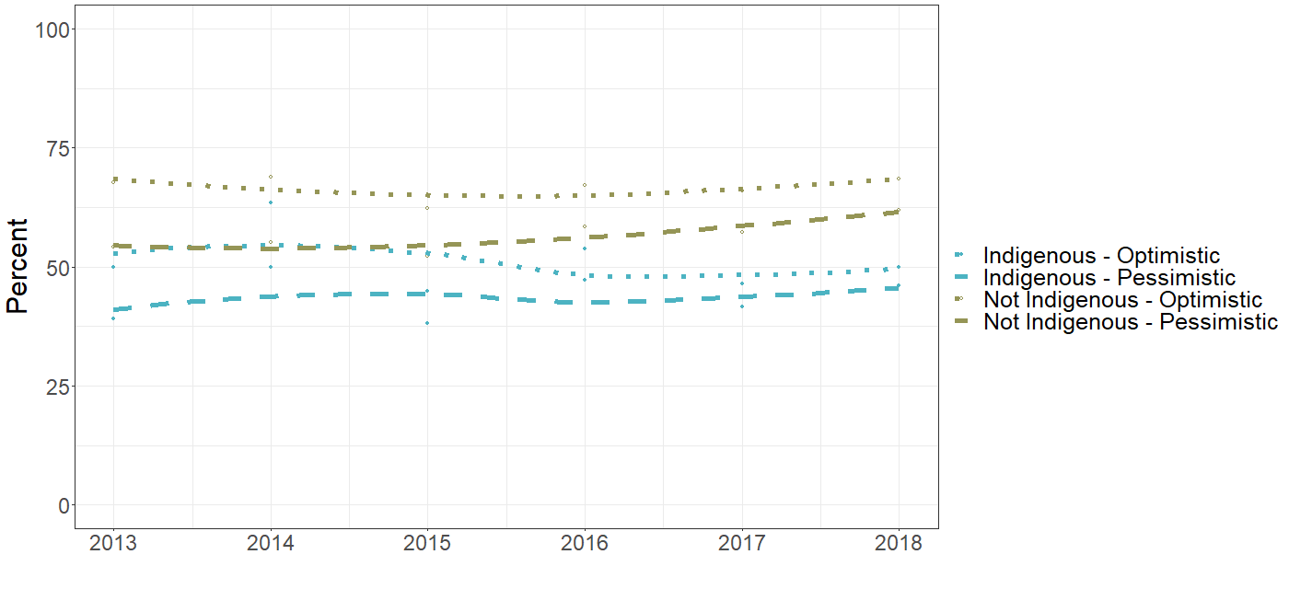

Source: Data sourced from the National Health Workforce Dataset.
The challenges of an older workforce were noted in interviews with health service managers. This included the loss of workforce due to retirement, older staff having a high burden of disease themselves, and older staff having caring responsibilities for Elders. Some participants noted that the high burden of work was also more challenging for their older staff.
We know that nurses, especially remote area nurses, the average age is like 60 …
ACCHS, Remote location
The National Health Workforce Dataset was used to examine the age of staff at Aboriginal health organisations and non-Aboriginal health organisations in the participating sites and across Australia. This included an analysis of Indigenous and non-Indigenous staff. Again, the analysis was limited to staff with clinical job roles. Aboriginal health organisations were more likely to have older staff than other workplaces. In 2019, 56% of staff were aged 45 years or older nationally, compared to 42% at other organisations (Table 7-3). For both Aboriginal and non-Aboriginal health organisations, the proportion of staff 45 years or older decreased between 2013 and 2019.

Table 7-3. Changes in the proportion of staff aged ≥45 years from 2013-2019, by workplace, for sites and across Australia
Level | Organisation type | % staff ≥45 years in 2013 | % staff ≥45 years in 2019 | OR (95% CI) | P
Participating sites | Aboriginal health organisation | 55.7 | 50.6 | 0.98 (0.94, 1.02) | 0.35
 | Other | 44.3 | 40.6 | 0.97 (0.96, 0.98) | <0.001
Australia | Aboriginal health organisation | 59.4 | 55.8 | 0.99 (0.98, 1.00) | 0.01
 | Other | 45.8 | 42.2 | 0.98 (0.98, 0.98) | <0.001
Source: Data sourced from the National Health Workforce Dataset.
Analysis of workforce demographic suggests that at both the site and national levels, Indigenous staff were less likely to be aged 45 years or older compared to non-Indigenous staff. The proportion of non-Indigenous staff aged 45 years or older decreased significantly between 2013 and 2019 at both the site and national levels (Table 7-4).
Table 7-4. Changes in the proportion of staff aged ≥45 years from 2013-2019, by staff Indigenous status, for sites and across Australia
Level | Staff Indigenous status | % staff ≥45 years in 2013 | % staff ≥45 years in 2019 | OR (95% CI) | P
Participating sites | Indigenous | 39.2 | 37.1 | 0.99 (0.97, 1.02) | 0.52
 | Non-Indigenous | 44.4 | 40.7 | 0.98 (0.97, 0.99) | <0.001
Australia | Indigenous | 41.9 | 39.2 | 0.99 (0.76, 1.28) | 0.92
 | Non-Indigenous | 45.9 | 42.3 | 0.98 (0.98, 0.98) | <0.001
Source: Data sourced from the National Health Workforce Dataset.

Workforce gender
A gender responsive workforce that can respond to gendered understandings of health and wellbeing is important for the observance of cultural protocols and cultural safety for Aboriginal and Torres Strait Islander people.
The National Health Workforce Dataset was used to examine the split between male and female staff, on the assumption that an appropriate workforce would have a mix of genders. Results were analysed for all settings (Aboriginal health organisations, hospitals, and private practice) in participating sites and across Australia, and for Indigenous and non-Indigenous staff. Again the analysis was limited to staff with clinical job roles. Among participating sites, 80% of Indigenous staff were female in 2019, compared to 75% of all staff (Indigenous, non-Indigenous and unknown Indigenous status). This indicates that it is likely to be more challenging for clients to see male clinicians than it is to see females. There was no change over time in the proportion of staff that were female (

Table 7-5).

Table 7-5. Changes in proportion of staff who were female from 2013-2019 by Indigenous status, for sites and across Australia
Level | Staff Indigenous status | % staff female in 2013 | % staff female in 2019 | OR (95% CI) | P
Participating sites | Indigenous | 80.9 | 80.1 | 1.00 (0.96, 1.04) | 0.94
 | Indigenous and non-Indigenous | 75.4 | 74.9 | 1.00 (0.99, 1.00) | 0.26
Australia^{(a)} | Indigenous and non-Indigenous | 75.1 | 74.7 | 1.00 (1.00, 1.00) | 0.51
Source: Data sourced from the National Health Workforce Dataset.
^{(a)} Results are not shown for the per cent of Indigenous staff that were female across Australia because the confidence interval could not be estimated with the random effects model. However, a fixed effects model with site included as a fixed effect also found no significant change over time.

The number of Aboriginal and Torres Strait Islander staff in the health workforce has increased significantly
Aboriginal and Torres Strait Islander people identified the delivery of health care by other Aboriginal and Torres Strait Islander people was valued. Many ACCHS managers said they were committed to growing their Indigenous workforce. They told the evaluation about the important message that having an Aboriginal and Torres Strait Islander workforce signalled to the community.
So, as I mentioned, we'll soon have four Aboriginal doctors as part of our GP team, and of that we've got two of our Aboriginal health practitioners, that are now moving into the medical stream. So it does - it goes to show, well, if our mob can do it, I can do it too.
ACCHS, Regional location
Overall, the National Health Workforce Dataset records a significant increase in the number of Aboriginal and Torres Strait Islander staff working across the health system. Data were used to calculate the proportion of staff who were Aboriginal and Torres Strait Islander in a range of settings (including Aboriginal health organisations, hospitals, and private practice) in participating evaluation sites and the rest of Australia from 2013 to 2019. The analysis was limited to staff with clinical job roles.
The National Health Workforce Dataset suggest that the proportion of the health workforce recorded as Aboriginal and Torres Strait Islander has increased significantly over time (Table 7-6). Nationally, the number of Aboriginal and Torres Strait Islander staff doubled between 2013 and 2019. As a proportion of the total health workforce across Australia, Aboriginal and Torres Strait Islander staff increased from 0.7% to 1.2%. Increases were similar for participating sites and throughout Australia.

Table 7-6. Changes in the number and proportion of staff who were Indigenous from 2013-2019, for sites and across Australia
Level | Indigenous staff in 2013  n (%) | Indigenous staff in 2019  n (%) | OR (95% CI) | P
Participating sites | 767 (0.8) | 1,492 (1.1) | 1.08 (1.05, 1.10) | <0.001
Australia | 3,910 (0.7) | 7,894 (1.2) | 1.08 (1.08, 1.09) | <0.001
Source: Data sourced from the National Health Workforce Dataset.
The proportion of Aboriginal and Torres Strait Islander staff working in health services increased with increasing remoteness. Across Australia (at the SA3 level), Northern Australia (NT, Top End) had the highest proportion of the health workforce who identified as Aboriginal and Torres Strait Islander in 2013 and 2019.
After restricting to staff working at Aboriginal and Torres Strait health services, the proportion of staff who identified as Aboriginal and Torres Strait Islander was much higher. In 2013, the percentage recorded across Australia was 14% and in 2019, the percentage was 20%. The proportion of staff working in Aboriginal health services who identified as Aboriginal and Torres Strait Islander was similar in each remoteness category.
Nurses and midwives made up more than half of all Aboriginal and Torres Strait Islander health care workers in 2019, numbering 5,200 and comprising 1.4% of all nurses and midwives across Australia. Medical practitioners had the next highest count of Aboriginal and Torres Strait Islander staff, numbering 688. Proportionally, Aboriginal and Torres Strait Islander medical practitioners made up less than 1% of all practitioners in 2019. Aboriginal and Torres Strait Islander health workers and practitioners numbered 572 in 2019.
These results from the National Health Workforce Dataset relate to staff in clinical roles. However, IAHP-funded organisations employ staff in a wide range of professions and OSR data indicates that, at 30 June 2022, 51% of staff in IAHP funded organisations were Aboriginal or Torres Strait Islander (Australian Institute of Health and Welfare, n.d.-b). This is equivalent to 4,500 FTE. The direct economic impact of the IAHP on local communities and on Aboriginal and Torres Strait Islander communities and families is significant.

Governance and leadership across the primary health care system
Governance, management and administrative processes across the system as well as processes specific to the IAHP have an influence on the implementation of the IAHP. The influence of these processes on enabling the implementation of the IAHP was discussed by participants at all levels of the evaluation, including site partnering ACCHSs and PHNs, and participants from state, territory and national organisations. Participants discussed:
- the absence of dedicated system-level governance processes to support coordination and integration of Aboriginal and Torres Strait Islander health initiatives
- the administration of the IAHP.

Formal system-level governance processes appear to be absent
Earlier in the evaluation process, the evaluation team reported that existing high-level architecture for the governance of Aboriginal and Torres Strait Islander health at national and state and territory levels provided a strong foundation for enabling the implementation of the IAHP (Bainbridge et al., 2021). This included through the functions of the Implementation Plan Advisory Group (IPAG), the National Health Leadership Forum (NHLF), and jurisdictional Health Partnership Forums.
There has been a distinct loss of momentum in these groups nationally, with some jurisdictional exceptions. For example, governance supporting the IPAG has not met formally since October 2021. Similarly, the NHLF last met in December 2021. A number of state and territory partnership forums have also been in hiatus. In contrast, the NT Aboriginal Health Forum has continued to meet regularly. Participants reported that the need to prioritise responses to the COVID-19 pandemic had disrupted the functioning of many partnership forums. Since early 2022, the Commonwealth Partnerships Team within the department has been in discussions with each state and territory government and community-controlled peak body to discuss reconvening the partnership forums.
Meanwhile, other processes have emerged, including cross-sector Closing the Gap partnerships and alliances at the national and jurisdictional levels. ACCHSs and their peak bodies have played a key role in these partnerships. Strategic alliances have also emerged in some jurisdictions with a specific health focus, such as the Aboriginal Health and Wellbeing Partnership Forum in Victoria.
While there is an absence of formal system-level governance processes for Aboriginal and Torres Strait Islander PHC and the IAHP, the department has been working in close partnership with NACCHO and its affiliated state and territory peak bodies. This partnership is central to the department’s commitment to the National Agreement on Closing the Gap Priority Reforms and is supported by a formal funding agreement. The reliance on NACCHO for advice demonstrates the strength of this partnership. However, while NACCHO is a representative organisation, member services reported that an unintended consequence of this partnership is the centralising of governance and decision-making and that this does not guarantee the inclusion of a diverse range of government, service and consumer perspectives. This includes a lack of a mainstream health service advice and perspectives on key decision-making relating to IAHP and PHC for Aboriginal and Torres Strait Islander people.
The National Aboriginal and Torres Strait Islander Health Plan notes that new governance arrangements will be developed embedding Aboriginal and Torres Strait Islander leadership and cross-jurisdictional partnership (Australian Department of Health, 2021a). The department has advised that it is continuing to develop a governance arrangement for the Health Plan.

The administration of the IAHP
While the evaluation did not have a specific focus on assessing the management and administration of the IAHP, discussions with site partners indicated that there are opportunities to strengthen the administration of the IAHP and more closely integrate the administration of IAHP with primary health policy and planning processes.
Participants from ACCHSs and from state, territory and national organisations reflected on the benefits of having a specialist, dedicated Aboriginal and Torres Strait Islander division (the First Nations Health Division) within the department. For example, participants talked about the value of centralising knowledge and expertise within the department in terms of the visibility and profile of Indigenous health, and the leveraging opportunities. Health policy functions are concentrated in mainstream sections of the department which can limit attention to First Nations perspectives in the development of health policy. Participants reported that people working within the First Nations Health Division may not have specific primary health expertise or experience working in Aboriginal and Torres Strait Islander health service delivery.
This perception was shared by people working within ACCHSs. One ACCHS manager identified the need to build the profile and status of the First Nations Health Division through more senior leadership within the hierarchy of the department. The benefit of access to more senior decision-makers within the department was demonstrated during the COVID response.
Another concern expressed by participants was the rate of staff turnover within the First Nations Health Division and the DSS (which has responsibilities for elements of IAHP contract management) and the impact on contractual relationships and the loss of institutional knowledge. This impact was compounded by turnover within ACCHS.
We have contract managers but like us, they change all the time.
ACCHS, Remote location
Some ACCHS managers commented on fragmentation in IAHP policy, grant-making and grant performance management functions, with these being located in separate parts of government (for example, the department, DSS, PHNs). They found this frustrating and inefficient. Other evaluation participants, however, commented on the perceived benefits in separating these functions – for example, enabling potentially uncomfortable discussions about a grant or performance to be separate from engagement on a policy or program query.

Influence of data and knowledge sharing processes on primary health care system
Discussions on the use of knowledge and information focused on reporting and on the relevance of data collected under the IAHP. In relation to the relevance of data, discussions covered how data were used to strengthen local understanding of Aboriginal and Torres Strait Islander health and wellbeing, for continuous quality improvement (CQI) processes, and how it informed policy and decision-making on IAHP.

Funded organisations have several reporting requirements
IAHP funded organisations have the following reporting requirements. The specific requirements are adjusted in proportion to the complexity, risk, and level of funding delivered through each grant funding agreement.
- Activity work plan: this report sets out the intended IAHP activities for the next 12 months.
- Performance report: reports on the funded organisation’s progress and major achievements and challenges in implementing the activities over the previous 12 months. These reports are largely narrative based. Grant recipients are able to provide one combined IAHP report covering multiple IAHP grants.
- National Key Performance Indictors (nKPIs): reports against 19 process-of-care indicators and 5 health-outcome indicators. Organisations funded under the PHC Program are required to submit reports twice a year (January and July). Reports are submitted via the web-based Health Data Portal aligned with the service’s client/health management systems.
- Online Services Report (OSR): reports contextual information about each funded organisation and data on number of clients, episodes of care, and workforce FTEs. Organisations funded under the PHC Program are required to submit reports once a year (July). As with the nKPIs, reports are submitted via the Health Data Portal.
- Income and expenditure report: tracks eligible expenditure incurred to date and any underspends of the grant over the previous 12 months. This report provides a declaration that the grant money was spent in accordance with the grant agreement.
- Final report: required when the grant activity has been completed, this report must identify if and how outcomes have been achieved; include the agreed evidence as specified in the grant agreement; and identify the total eligible expenditure incurred.

Reporting has improved under the IAHP, but reporting to multiple funders remains a significant burden for ACCHSs
As reported in Cycle 2 of the evaluation (Bainbridge et al., 2021), the department has implemented initiatives to streamline reporting under the IAHP. This includes further development of the Health Data Portal to enable a single upload of OSR and nKPI data, commissioning clinical systems’ vendors to create nKPI and OSR reports compatible with the data portal, and shifting the IAHP Activity Work Plan and Performance Report into the portal. As well as simplifying the submission of data and reports, these developments enable health services to view data in a single platform and compare progress against national and state and territory averages and against Closing the Gaps targets.
The department reported that more than 90% of funded organisations submit nKPI data directly from their clinical information systems and, in 2022, all nKPI and performance reports were submitted and 98% of OSR reports. ACCHS managers were generally positive about improvements to the IAHP data collection process.
In addition to the various IAHP reporting requirements outlined in the previous section, funded organisations are required to report across other funding agreements and contracts, beyond the IAHP and beyond the department. Many ACCHS managers described the burden associated with reporting and some thought very carefully about whether to apply for funding, especially small amounts of funding, because of the reporting burden.
The nightmare comes back into this building when we've got to work out who did this job for how long, and how do we report that back. Financially and numbers and words.
ACCHS, Metropolitan location
In terms of the IAHP, reporting to PHNs on the ITC program and the mental health minimum data set was consistently identified as particularly onerous. This reporting burden continues to be experienced despite some PHNs pulling back on the amount of reporting they require (from quarterly to 6-monthly).
ACCHSs reported the following challenges associated with having multiple reporting systems:
- Having multiple reporting portals – for example for NIAA, NACCHO and state and territory government grants, in addition to IAHP.
- Reports regularly being required all at the same time.
- The frequency of changes to reporting templates.
- The lack of standardised reporting templates, and the timing – for example, some ‘progress reports’ are due quarterly, some every 6-months, and others annually.
- The lack of standardised language – for example, different meaning for ‘data report’, ‘progress report’, ‘financial report’, ‘performance and progress report’, ‘program report’, etc.
The concerns and challenges that many participants raised about reporting must not be equated to funding organisations rejecting reporting. Reporting was recognised as important and a critical element of an accountability relationship.
To further understand the reporting burden, the evaluation collected detailed data on reporting requirements from 3 ACCHS site partners. Collectively, these services had 113 funding agreements or contracts over 2020-21. Over this year, these agreements required 392 reports to the funding organisations (average of 3.5 per funding agreement). Of these reports, 47 (12%) were for IAHP funding and a further 50 (13%) were for the department. For a single health service, this averages at 38 funding agreements, 130 reports, 16 of which are for IAHP funding. One ACCHS site partner also shared data on their funding applications over 2020-21. Of 50 funding applications submitted, 36 (72%) were successful, 10 (20%) unsuccessful, and the remainder were yet to be confirmed.

Data and information being collected does not provide a full picture of health service activity and processes
The nKPIs and OSR are the two data collections for organisations receiving funding under the IAHP PHC Program. These collections are unique to IAHP funded organisations; there are not similar collections covering mainstream primary care services. The primary purpose of the nKPIs is ‘to provide reporting organisations with data they can use for continuous quality improvement (CQI)’ (Australian Institute of Health and Welfare, 2021b). The data are also used at a national level to support policy, planning and progress.
The evaluation team heard that data collected under the IAHP is used to inform funding allocations in the PHC Program funding model (the funding model uses OSR data on client numbers and episodes of care). Some ACCHS managers reported using the nKPI dashboard within the data portal to compare their KPIs against state, territory, and national benchmarks. Staff in some ACCHSs also described using nKPI and OSR data in their clinical management meetings for CQI and service planning, and with their boards to track progress. One ACCHS manager reported using data as part of program evaluations which they undertook or commissioned themselves.
Alongside these examples of how data and information collected under the IAHP was used, many ACCHS staff reported that the data were not of sufficient value to understand community needs and was not being used to inform health service decision-making.
A common weakness with the data identified by ACCHS staff was that the reporting framework did not reflect the community-controlled approach to service delivery and/or did not capture all the things that services are doing that were considered relevant. Often this related to the relevance of translating comprehensive, customised, holistic care to a number or a templated report that is ‘never going to tell you the story’. The way reporting siloed care was also seen as problematic. For example, ITC program data reports on services provided by ITC workers under the program; but this misses the other services and activities those workers did, and the care coordination undertaken by other staff. So programs do not actually work in the isolated way that the reported data might suggest.
If they actually knew what we did and we could just be honest with them, they would probably be like, ‘well, that's way bloody better. Can you write that?
ACCHS, Metropolitan location
Some ACCHS staff reported not using the data reported under IAHP as they had concerns about its accuracy and validity. These concerns commonly revolved around deficiencies in how the data counts people accessing a service, including the inability to meaningfully count transient populations in the current framework.
The problem is that the KPIs for ACCHOs are meaningless …. Because our population is so mobile and they go from one community to another and we have three times the number of diabetics according to the Commonwealth KPI versus [our] own KPI …. They want me to, you know, point out what is the current KPI, where we're going to go for, get a percentage of what we think is going to be next year and then what our strategies are to improve it. When, you know, we can't even interpret them.
ACCHS, Remote location
Many ACCHSs reported not having the capacity or capability to engage with data. This is significant within the context of Priority Reform 4 in the National Agreement on Closing the Gap which commits governments to supporting Aboriginal and Torres Strait Islander communities and organisations to build capability and expertise in collecting, using, and interpreting data in a meaningful way.
We don’t have time for that…we’re relying on outside people, when they do research and stuff, giving us back our own data to use. But we haven’t got anyone that can sit down and put all that together for us.
ACCHS, Metropolitan location
Similarly, some health service staff reported not having the capacity to engage in CQI activities, despite the primary purpose of the nKPIs being to provide organisations with data they can use for CQI. Ironically, an ACCHS manager said that the burden of reporting reduced the time available for services to engage in CQI. The reported lack of capacity for CQI may reflect the timing of the evaluation and the priority and workload associated with the COVID-19 pandemic response.
At the moment [CQI] is squeezed in around the edges of the emergency department sort of grind of everyday coming what's going through the door. And nobody's given quarantined time to look at their data in facilitated conversations and have purposeful conversations about goals, strategy and systems of how to improve and strengthen care.
State or territory government

Data and reporting do not support assessment of health outcomes
Another common concern expressed by ACCHS and PHN staff was that IAHP data did not reflect and record what was valued by communities in terms of health needs and what is important in the delivery of health care. This relates to the data being activity focused as opposed to capturing outcomes of benefit to local communities. This includes the absence of data on actual patient experiences within the reporting framework. The activity focus was often associated with funding and billing driving data collection, as opposed to it having a clinical purpose.
I can tell you how many clients they’ve got coming and getting coordinated care; I can tell you how many aids they’ve bought. But essentially, I can’t tell you if that is changing somebody’s life.
PHN, Regional location
In its performance audit of the IAHP PHC Program, the Australian National Audit Office recommended the department include measurable performance targets in funding agreements that ‘are aligned with program outcomes’ (Australian National Audit Office, 2018). The audit noted that the department was developing an outcomes-based PHC policy framework that had the potential to inform a revised performance framework for the PHC Program. At the time of reporting, we are not aware that an outcomes-based framework has been implemented by the department. However, the Health Sector Strengthening Plan (Joint Council on Closing the Gap, 2021a) does commit governments to review reporting frameworks for funding, including the IAHP, and to produce an outcomes-focused program and implementation plan to improve reporting.
There is also concern that a shift in reporting approach may increase the reporting burden on ACCHSs. PHN staff reported having discussions with ACCHS partners about incorporating more outcome-orientated indicators into current reporting arrangements. This became fraught as it would have involved reporting on an additional set of indictors and adding to the existing reporting burden that has already been raised as a challenge by ACCHSs.

What difference is the IAHP making to health and wellbeing?

Key findings
1 | Higher levels of primary care activity were most often associated with increased care in hospitals. Similarly, higher rates of MBS chronic care activity were accompanied by higher rates of diabetes hospitalisation.
2 | Strong correlations between MBS chronic care activity and hospital care were associated with lower rates of mortality for diabetes, indicated that when people receive care it makes a positive difference.
3 | Within the evaluation sites, one-third of the nKPIs of protective/risk factors, health outcomes, and health service use showed improvement over time. There was significant variability in nKPIs within and between sites. Client nKPI outcomes tended to cluster within sites with scores on one measure systematically corresponding to scores on other measures.
4 | Within IAHP funded organisations in the evaluation site, more than half of adults and more than one-third of children had a health assessment. There was no clear evidence that this had changed over time. The proportion of all Aboriginal and Torres Strait Islander site residents who received a health assessment had increased over time.
5 | Of a set of primary care activity, demographic and socio-economic variables, being in the NT, remoteness and age were the most important variables for explaining differences in health outcomes within the evaluation sites. Changes in rates of GP attendance over time was the most important variable for explaining changes in health outcomes over time,
6 | Of the same set of variables, having greater economic resources and higher relative socio-economic outcomes were the most important variables in explaining lower morbidity and mortality. All of the socio-economic measures (education and occupation, economic resources, and socio-economic advantage and disadvantage) were positively associated with normal birthweight.

Overview
This section examines the difference the IAHP is making to the health and wellbeing of Aboriginal and Torres Strait Islander people (KEQ3).
The section begins by examining associations between PHC activity, hospitalisations and mortality. Evaluation site level data is then analysed for evidence of whether risk factors, health service use and health and wellbeing outcomes are changing over time. Lastly, this section examines associations between social determinants of health, primary care activity, and health and wellbeing outcomes.
Full details of the analytical approach and findings are in the separate document Final Report Quantitative Analytical Approach and Findings and the methodology is described in Final Report Supporting Material Appendix C.

Data sources and methods
Ten routinely collected administrative and clinical quantitative data sets were identified through a data feasibility assessment (DFA) and accessed through data custodians. There was limited data available on IAHP funding, including no data at the site level. This limited the ability to attribute health and wellbeing outcomes to IAHP activities and programs.
Several analytic approaches were applied to complete the analysis of the quantitative data.
- The development of a custom traffic light approach for publicly available data to examine high-level effects of health service activity on hospital care and mortality.
- The analysis of routinely collected data sets at state, territory and site levels.
- Clustering was used to explore which nKPIs were most similar to each other.
- Principal Components Analysis (PCA) was used to reduce the dimensionality of the data set by clustering items into a smaller set of uncorrelated variables (the principal components (PCs)).
- Multiple linear regression analysis to quantify the relative contributions of social determinants and PHC on health outcomes for Aboriginal and Torres Strait Islander people.
In conducting this quantitative analysis, the evaluation acknowledges the limitations of quantitative data sets and recognises that the data included in this analysis cannot provide a full picture of health and wellbeing outcomes for Aboriginal and Torres Strait Islander people. The evaluation also acknowledges the real stories, people and experiences which sit behind this quantitative data.
The evaluation also notes that descriptions of health conditions in this section follow the descriptions used in key data sources. In some cases, we recognise that these labels do not reflect best practice approaches of discussing specific health issues, including mental health conditions, and may not reflect Aboriginal and Torres Strait Islander approaches to understanding and talking about health and wellbeing within their communities. The evaluation has made recommendations to shift the knowledge transfer processes for the IAHP to align with Aboriginal and Torres Strait Islander approaches to health and wellbeing.

Effects of health service activity on hospitalisations and mortality
Publicly available data at the state and territory level was used to identify changes in key indicator measurements over time and any associations between health service activity and health outcomes (morbidity and mortality). Data included:
- hospitalisation rates, analysed as health outcomes, for 11 key disease groups and other variables in the Health Performance Framework, including discharge from hospital at own risk and potentially preventable hospitalisations (PPH)
- mortality rates for 22 cause groups, analysed as health outcomes
- MBS utilisation rates for items that are specific to Aboriginal and Torres Strait Islander people
- nKPI data.
The quality of the publicly available data used in these analyses was reduced by a number of factors. These include that data came from multiple sources, had been published in different formats, relate to different reporting periods, were sourced from different jurisdictions, and were often summary statistics only.
Data were generally not available below the level of state and territory, limiting the number of observations to a maximum of eight and as few as 5 for some measures. Often a single point-estimate (e.g. crude rate, age-standardised rate, or numerator) was provided with no measure of spread (e.g. standard deviation). Data points in the Health Performance Framework reports were published to one decimal place and no difference could be detected where an indicator changed by less than .05 and in some cases .09 (e.g. observations of 10.05 and 10.14 would both be published as 10.1). For some tables (e.g. hospitalisation rate), statistics were flagged with a warning that the standard error is above a given threshold, e.g. 50%, and are considered unreliable for analysis. Several observations were reduced to ‘not-published’ or ‘n.p.’ in the data, commonly used to indicate a low count. This is inadequate for statistical tests; the probability that an effect would be correctly identified at this sample size is .13 for large effects and .05 for small effects. That is, only extremely large effects would be detectable at the .05 level of statistical significance.
Moreover, given the nature of low-denominator rates and high standard errors, effect sizes such as rate ratios or differences could generate misleading results and interpretations and as such were not pursued in this analysis.
Changes were categorised as either increase, decrease, or no change according to the difference measured between two discrete time points for each indicator, for each state and territory with available data (as published in the 2017 and 2020 Health Performance Framework reports). For MBS utilisation rates, the linear trend of the annual time series from 2012-13 through 2019-20 for each state and territory was categorised as either increase, decrease or no change accordingly. The strength of evidence for change was derived from the percentage-change and the proportion of the maximum absolute difference for discrete observations, and the statistical significance of the slope coefficient for time series observations at the .05 level.
Further details on how this method was applied and the results are available in a Technical Report (Langham et al., 2021) produced in Cycle 1 of the evaluation. This method was applied in Cycle 1 as a proof of concept to be applied to better quality data at the SA3 and site level (received in Cycle 2).
A summary of key findings from the state and territory analysis is reported below and should be regarded as tentative and requiring proper investigation via prospective studies and/or linked data at the patient level.

There was variability in associations between changes in morbidity and mortality
In terms of associations between changes in morbidity and mortality, positive relationships (where both mortality and morbidity increased or decreased together for a given state or territory) were observed between hospitalisations for malignant neoplasms and mortality for breast cancer, kidney disease morbidity and mortality, and diabetes hospitalisations and mortality for endocrine-metabolic-nutritional disorders (of which diabetes is a sub-category). The relationship between diabetes hospitalisations and diabetes mortality was less consistent. Diseases of the circulatory system showed a relatively consistent negative correlation (mortality and morbidity inversely increased/decreased).
A custom ‘traffic light’ framework based on the indicators’ observed changes over time was developed (Figure 8-1). Where data were published as an unbroken time series (for example, annual), the first traffic light reflected the direction of the regression coefficient (slope) for the time series. A second light was assigned based on the statistical significance (0.05) for the regression coefficient (slope) of the time series to indicate the strength of evidence for the observed change (see Figure 8-2).

Figure 8-1. Traffic light framework for observed changes
Observed decreased

Observed increased

No observed change

Figure 8-2. Traffic light framework for observed change and evidence (regression coefficient)
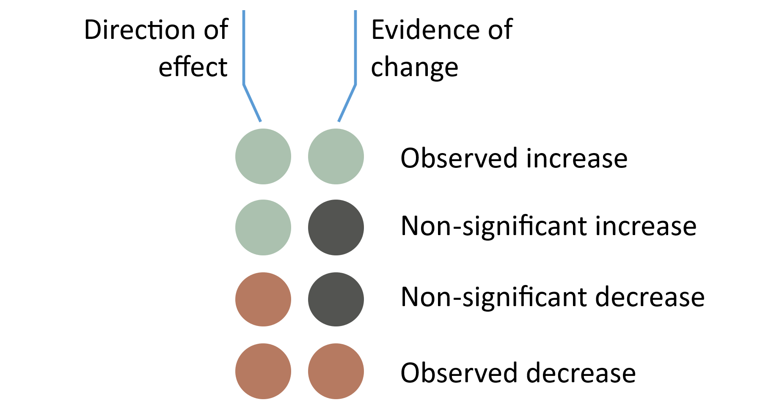

Results are shown graphically in Figure 8-3. The summary effect represents the average effect (positive association = 1, negative association = -1) over the 5 reporting jurisdictions.
Figure 8-3. Traffic light framework and simple correlation for morbidity-mortality
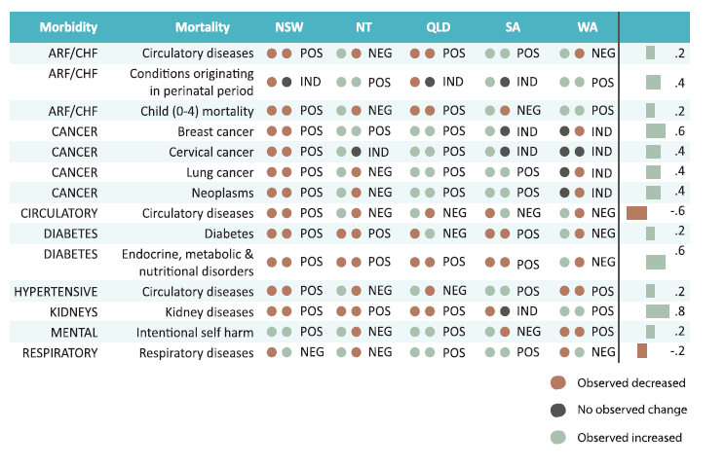
Summary effect

Higher levels of primary care activity were associated with increased levels of tertiary care For associations between primary care service activity and health outcomes, state and territory nKPI data were compared with hospitalisation and mortality outcomes. The analysis examined whether states and territories with better relative performance in nKPIs showed favourable changes in health outcomes. Again, it must be noted that the state and territory level of analysis provided too few data points for clear effects to be observed.
The effects of health service activity on hospitalisations and mortality were further examined using evaluation site-level data received in Cycle 2. These analyses looked to, again, examine associations between nKPIs and hospitalisation, and to conduct in-depth case studies using diabetes nKPIs and MBS chronic care and hospitalisations data to mitigate some limitations of the data.
Areas with higher levels of primary care activity were associated with increased hospitalisations for principal diagnoses of substance use, acute rheumatic fever (ARF) and rheumatic heart disease (RHD), depression and intentional self-harm, eyes and ears, lifestyle factors, respiratory health, and STI/blood-borne diseases (Figure 8-4). Higher overall primary care activity was associated with decreased hospitalisations only in chronic kidney disease.
In many cases, the relationship was found to be different depending on whether principal diagnosis (PDX) or additional diagnosis (ADX) was used. The underlying causal mechanisms of these results are not ascertainable given these data. Appropriate prospective studies or analysis of linked data are required.

Figure 8-4. Associations between PHC activity and change in hospitalisation rate at the site level (the dots represent the site datapoints)
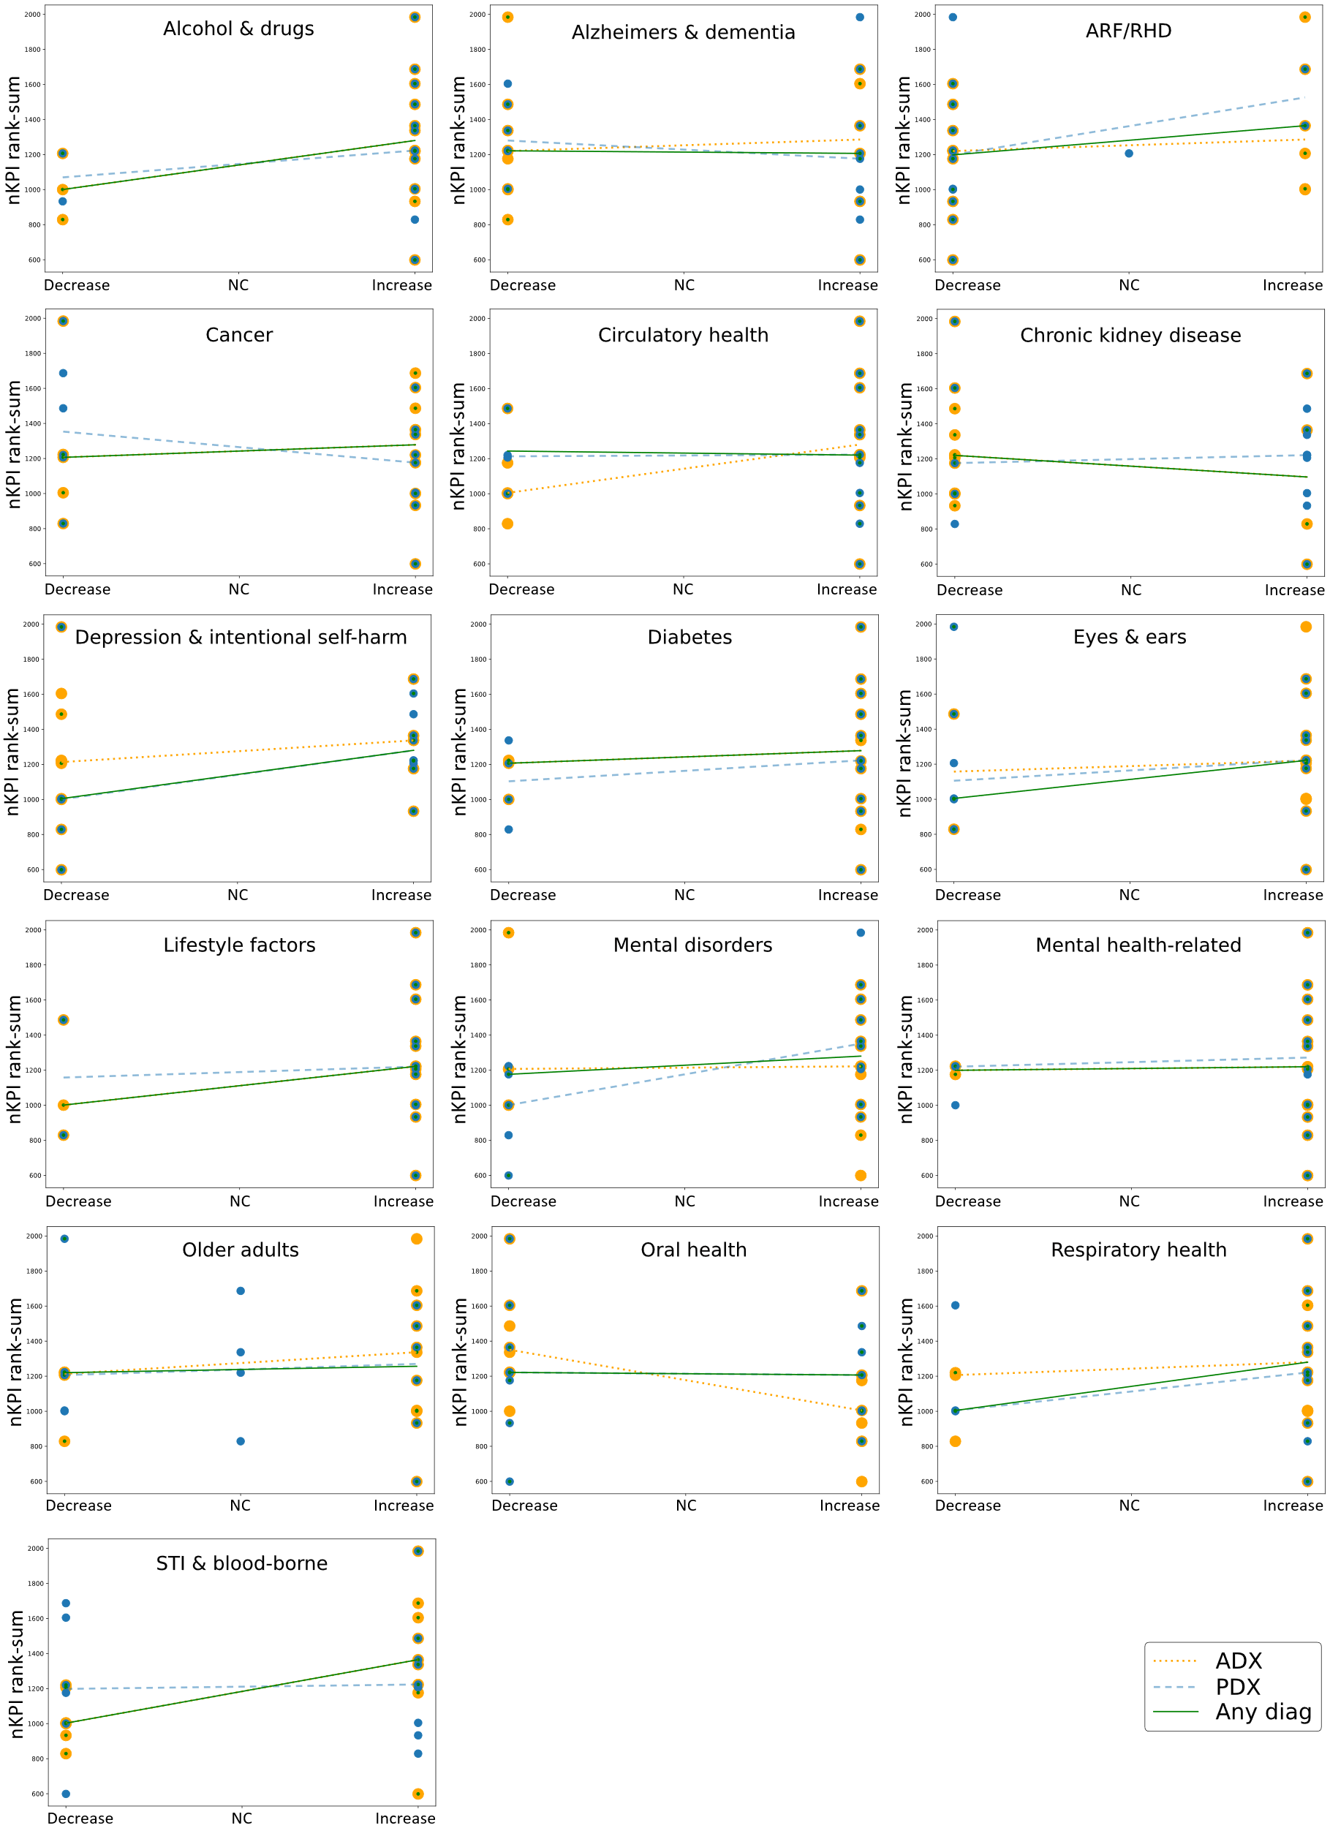

This analysis is limited by two key factors: the breadth of both the activities covered by the nKPI and the health conditions coded in the hospitalisations data, and the inclusion of hospitalisations for people who were not provided care reported in the nKPI (for example, if they are not a regular patient of a reporting health service).

The association between diabetes-related primary care activity and rates of diabetes hospitalisation varied
To mitigate the limiting factors identified above (breadth of activity and different populations represented in nKPI and hospitalisation data), the evaluation undertook a more in-depth case study analysis restricted hospitalisations for a principal diagnosis of diabetes, and diabetes-related indicators from the nKPI (PI05, PI07, PI08, PI15, PI18, PI23; see Table 8-1) and MBS. The MBS items included the items in the MBS Item Group ‘Chronic disease and complex care needs management and review’ which includes 4 activities: GP Management Plan (GPMP, item 721), Team Care Arrangement (TCA, item 723), GPMP review (item 732), and Domiciliary Medication Management Review (item 900).
A weak, non-significant negative correlation between the relevant nKPI and hospitalisations for diabetes was observed across sites; that is, sites with higher rates of service appeared to have lower rates of hospitalisations, on average (Table 8-1).
This was also found for the correlation between the rates of MBS services for the chronic disease item group. However, the correlations between rates of MBS activity and hospitalisations for diabetes for all available years within each site showed mostly positive associations (higher rates of MBS activity are accompanied by higher rates of diabetes hospitalisation in all years) (Figure 8-5).
Table 8-1. Relationship between nKPI and hospitalisation rates for diabetes (unit of observation is the evaluation sites)
nKPI | Slope | Intercept | Correlation | p
PI05: HbA1c result recorded | -0.76 | 73.94 | -0.26 | 0.33
PI07: General Practitioner Management Plan | -1.32 | 66.90 | -0.35 | 0.18
PI08: Team Care Arrangement | -1.09 | 62.19 | -0.29 | 0.28
PI15: Immunised against influenza—clients with Type 2 diabetes | 0.06 | 33.25 | 0.01 | 0.96
PI18: Kidney function test—clients with Type 2 diabetes | -0.71 | 69.86 | -0.23 | 0.40
PI23: Blood pressure recorded—clients with type 2 diabetes | -0.13 | 69.76 | -0.05 | 0.85

Figure 8-5. Distribution of the correlation coefficient between MBS chronic care activity rates and diabetes hospitalisation rates for the evaluation sites
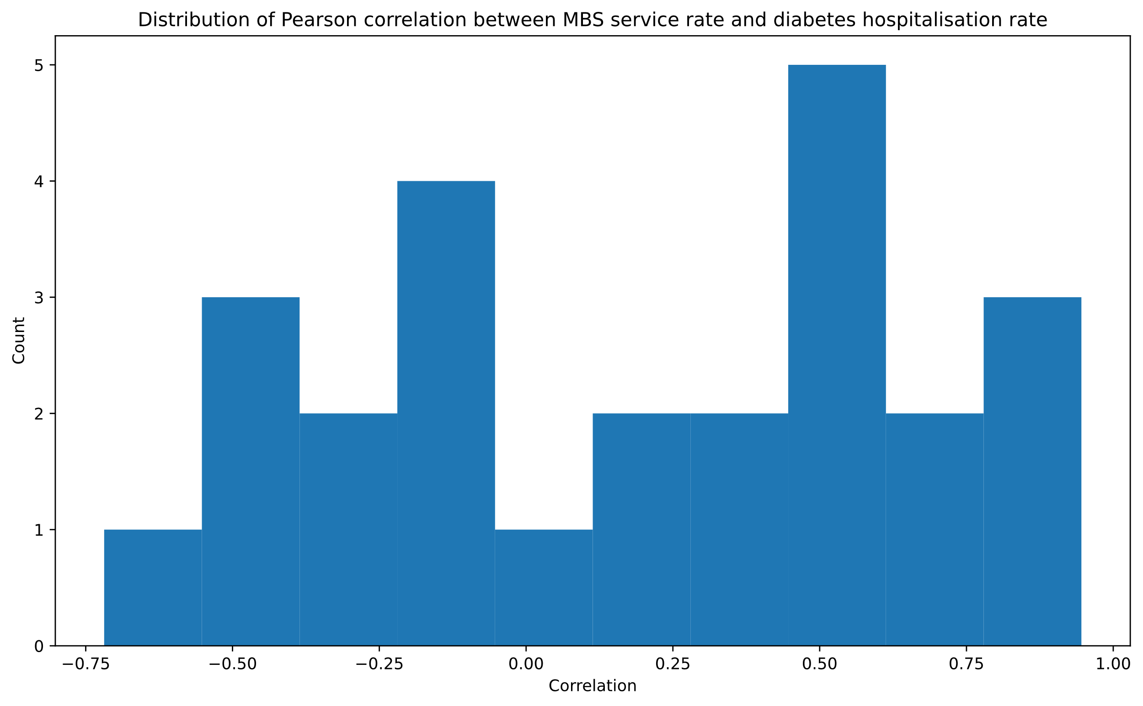

Stronger correlations between MBS activity and hospitalisation were associated with lower rates of mortality for diabetes
The MBS-hospitalisations case study was extended to investigate its relationship with mortality for diabetes. This involved comparing the relationship between rates of service activity (MBS) and rates of hospitalisations for financial years 2012-13 through 2019-20 with rates of mortality for any death in which diabetes was present in the death record in 2015-16 and 2016-17. Mortality data were not available for the entire time series. Stronger, more positive correlations between MBS and hospitalisations were associated with lower rates of mortality across evaluation site areas (Table 8-2).
Sites in the NT presented clear outliers to this relationship, with both high levels of activity and high levels of mortality. As part of the Cycle 2 emerging findings feedback with site partners, discussions with an expert in NT epidemiology indicated that the high burden of diabetes in the territory is the likely reason for this pattern: the health services in the NT are highly effective with respect to health checks and testing activities which are driven by the high Aboriginal and Torres Strait Islander population and high disease burden.
Table 8-2. Relationship between service-hospitalisation correlation and diabetes mortality for evaluation sites (Central Australia, Katherine East removed)
FY | Slope | Intercept | Correlation | p
2015-16 | -0.474 | 0.723 | -0.440 | 0.036
2016-17 | -0.445 | 0.690 | -0.289 | 0.181

Risk factors, health service use, and outcomes in the evaluation sites
nKPI data, MBS data on number of 715 health assessments, and Estimated Resident Population (ERP) data was used to understand whether Aboriginal and Torres Strait Islander people receiving appropriate health care maintain good health and wellbeing. The analysis explored 3 questions.
- What are the risk factors, health outcomes, and health service use among Aboriginal and Torres Strait Islander people attending Aboriginal health services?
- What proportion of Aboriginal and Torres Strait Islander clients received 715 health assessments, and did the proportion vary between sites and over time and what proportion of all Aboriginal and Torres Strait Islander people received MBS items 704, 706, 708, 710, and 715 combined, and did the proportion vary between sites and over time?
- How are risk factors, health service use, and health outcomes among Aboriginal and Torres Strait Islander people attending Aboriginal and Torres Strait Islander health services associated with each other and 715 health assessments?
For all analyses, unless stated, data from 2020 onwards were excluded to remove the effect of the COVID-19 pandemic on health service utilisation. nKPI and MBS data were treated separately, as nKPI data includes regular clients of Aboriginal and Torres Strait Islander health services receiving IAHP funding, whereas MBS data includes all Aboriginal and Torres Strait Islander residents living within the geographical areas defined by the evaluation sites. Data covered 16 evaluation sites.

One-third of the indicators of protective/risk factors, health outcomes, and health service use showed improvement over time
nKPI data were used to explore changes in protective/risk factors, health outcomes, and health service use across the 16 evaluation sites. 24 indicators were selected to correspond with life stages – for the perinatal period, middle life, and later life. Data covered the period June 2017 to December 2019 (nKPI data is reported 6-monthly, in June and December).
Changes in individual nKPIs at the 16 evaluation sites are summarised in Table 8-3. Firstly, for each of the 16 sites, the percentage of regular clients who met the nKPI was calculated and the median of these 16 percentages was reported at two time points, June 2017 and December 2019. Secondly, the estimated odds ratio (OR) is reported, which represents the average odds of a client experiencing the outcome in one year compared to the previous year, along with the corresponding 95% confidence interval. Logistic mixed models were used, incorporating a random intercept for service to address repeated measures over time.
Table 8-3. Changes in individual nKPI by life stage, 16 evaluation sites, 2017-2019
Life stage | nKPI outcome | Median %  Jun 2017 | Median %  Dec 2019 | OR (95% CI) | P-value
Perinatal | Birthweight recorded | 75 | 85 | 1.02 (0.85, 1.21) | 0.85
 | Birthweight result (normal) | 89 | 88 | 1.03 (0.95, 1.12) | 0.45
 | Smoking status of women who gave birth in the previous 12 months (non-smoker) | 51 | 57 | 1.07 (1.03, 1.11) | <0.001
 | Antenatal visit timing (<13 weeks) | 49 | 52 | 1.03 (0.88, 1.21) | 0.73
Middle life | Smoking status recorded | 88 | 90 | 0.98 (0.84, 1.13) | 0.74
 | Smoking status result (non-smoker) | 46 | 46 | 1.01 (1.00, 1.02) | 0.23
 | Alcohol consumption recorded | 68 | 70 | 1.02 (0.95, 1.09) | 0.58
 | AUDIT-C result (low risk) | 48 | 53 | 0.96 (0.92, 1.00) | 0.05
 | BMI result (overweight/obese) | 72 | 74 | 1.03 (1.01, 1.05) | 0.003
 | Cervical screening (within previous 5 years) | 42 | 41 | 0.92 (0.88, 0.97) | 0.001
Later life | Immunised against influenza (clients aged ≥50) | 29 | 37 | 1.20 (1.15, 1.25) | <0.001
 | Immunised against influenza (clients with COPD) | 27 | 40 | 1.15 (1.04, 1.27) | 0.01
 | Immunised against influenza (clients with Type 2 diabetes) | 27 | 33 | 1.15 (1.07, 1.24) | <0.001
 | CVD risk factors recorded | 46 | 53 | 1.13 (1.07, 1.19) | <0.001
 | CVD risk assessment result (low risk) | 56 | 64 | 1.06 (1.03, 1.10) | <0.001
 | Kidney function test (clients with CVD)* | 59 | 62 | 1.17 (1.05, 1.32) | 0.01
 | Kidney function test (clients with Type 2 diabetes)* | 65 | 66 | 1.06 (1.00, 1.13) | 0.06
 | Normal eGFR test result (clients with CVD)* | 77 | 76 | 1.04 (0.98, 1.10) | 0.19
 | Normal eGFR test result (clients with Type 2 diabetes)* | 80 | 83 | 1.04 (0.99, 1.09) | 0.15
 | Normal ACR test result (clients with type 2 diabetes)* | 85 | 84 | 1.01 (0.99, 1.04) | 0.21
 | Blood pressure recorded (clients with type 2 diabetes) | 68 | 69 | 1.03 (0.97, 1.09) | 0.35
 | Normal blood pressure (clients with type 2 diabetes) | 36 | 40 | 0.95 (0.89, 1.01) | 0.09
 | HbA1c result recorded (within previous 6 months) | 51 | 55 | 1.02 (0.99, 1.05) | 0.15
 | HbA1c normal (clients with type 2 diabetes) | 41 | 40 | 0.98 (0.96, 1.01) | 0.25
Median %: median of the 16 site percentages. OR: odds ratio. CI: confidence interval. * Median % reported in the June 2017 column refers to December 2017 as data were not available for this nKPI in June 2017.

As shown in Table 8-4, just over one-third of indicators (9) showed meaningful improvement over the period: Smoking status of women who gave birth in the previous 12 months, Immunised against influenza (3 indicators), Cardio-vascular disease (CVD) risk (factors recorded and assessment result), Kidney function test (clients with CVD and clients with Types 2 diabetes), Blood pressure 130/80 mmHg or less (clients with Type 2 diabetes). Three indicators showed a worsening situation: BMI result, Cervical screening, and AUDIT-C result.
The 3 influenza immunisation indicators showed significant improvement. The increase in the proportion of people with low CVD risk may be a real increase or may be because clients with lower risk are increasingly having their CVD risk factors recorded. There were indications of a decrease in low risk alcohol consumption among those clients with an AUDIT-C assessment. There was no information on who is offered an AUDIT-C assessment and it is possible that this has changed over time towards more clients with more risky consumption being assessed. With the exception of the recording of CVD risk factors, there was little change in the recording of client health markers (birthweight, HbA1c, or blood pressure) or behaviours (smoking and alcohol consumption) and little change in birthweight, antenatal visit timing, estimated glomerular filtration rate (eGFR), albumin-to-creatinine ratio (ACR), HbA1c, and blood pressure test results. The data only covered a two-and-a-half-year period (and less for some nKPIs) so the power to detect gradual change was limited.

Table 8-4. Changes in nKPIs across the evaluation sites, June 2017 to December 2019
Stronger evidence changed in a favourable direction | Weak indication changed in a favourable direction | No meaningful change | Weak indication changed in a non-favourable direction | Strong evidence changed in a non-favourable direction
Perinatal period
Smoking status of women who gave birth in the previous 12 months (non-smoker) |  | Birthweight recorded  Birthweight result (normal)  Antenatal visit timing (<13 weeks)
Middle life
 |  | Smoking status recorded  Smoking status result (non-smoker)  Alcohol consumption recorded | AUDIT-C result (low risk) | BMI result (overweight/ obese)  Cervical screening (within previous 5 years)
Later life
Immunised against influenza (clients aged ≥50 years)  Immunised against influenza (clients with chronic obstructive pulmonary disease, COPD)  Immunised against influenza (clients with Type 2 diabetes)  CVD risk factors recorded  CVD risk assessment result (low risk)  Kidney function test (clients with CVD) | Kidney function test (clients with Type 2 diabetes)  Blood pressure 130/80 mmHg or less (clients with Type 2 diabetes) | eGFR test result ≥60 (clients with CVD)  eGFR test result ≥60 (clients with Types 2 diabetes)  ACR test results ≤25 (males) and ≤35 (females) (clients with Types 2 diabetes)  Blood pressure recorded (clients with Types 2 diabetes)  HbA1c result recorded (within previous 6 months)  HbA1c result (clients with Type 2 diabetes)

There was variability in nKPIs within and between sites
Some nKPI results varied significantly within sites, year-on-year. This included birthweight result, which likely reflects a relatively low number of babies born at some sites in a particular reporting period and the large impact of whether birthweight is recorded or not. Other indicators varied significantly across sites, including birthweight recorded (with some sites recording for around half and others recording for almost all), antenatal visit timing (with some sites reporting less than 25% and others over 75% each year), alcohol consumption recorded (with some sites recording consumption for most clients and others recording for fewer than half), and recording of HbA1c test results. Some variability may be explained by site remoteness, noting that the number of sites was limited. For example, results showed:
- consistently higher recording of birthweight in inner regional sites
- clients assessed by AUDIT-C were less likely to be low risk in outer regional sites
- relatively high levels of cervical screening in some inner regional, remote, and very remote sites
- lowest recording of CVD risk factors in major city sites
- CVD risk highest in remote and very remote sites
- ACR test result (clients with type 2 diabetes) were more likely to be normal in major city sites than remote and very remote sites.
Some nKPIs had high variability within each remoteness classification, including antenatal visit timing, smoking status result (non-smoker), normal eGFR test result (clients with CVD), and recorded HbA1c result.

Client nKPI outcomes tended to cluster within sites
Variable clustering techniques are used to group different measures that are statistically related to each other. That is, scores on one measure systematically correspond to scores on other measures in the cluster. Correlations between nKPIs were analysed for clustering (Figure 8-6 ). There was some clustering by health outcomes. For example, sites with a higher proportion of clients with a low CVD risk assessment were also more likely to have a higher proportion of diabetic clients with normal ACR test results. There were also clusters around health care activity. The nKPIs that were the most correlated within sites were (from top to bottom in Figure 8-6):
- eGFR test results for clients with CVD and eGFR test results for clients with type 2 diabetes.
- General Practitioner Management Plans and Team Care Arrangements.
- CVD risk assessment results and ACR test results of clients with type 2 diabetes.
- CVD risk factors recorded and Cervical screening.
- Kidney function test for clients with type 2 diabetes, HbA1c result recorded and Blood pressure recorded for clients with type 2 diabetes.
- Immunisation against influenza for clients aged 50 years and over, for clients with COPD, and for clients with type 2 diabetes.
- MBS health assessments for clients aged 0-4 years and MBS health assessments for clients aged 25 years and over.
That is, taking the last cluster as an example, sites with high proportions of clients aged 0-4 years having MBS health assessments are also more likely to have high proportions of clients aged 25 years and over having MBS health assessments.
Figure 8-6. Dendrogram of hierarchical clustering of all nKPIs within sites
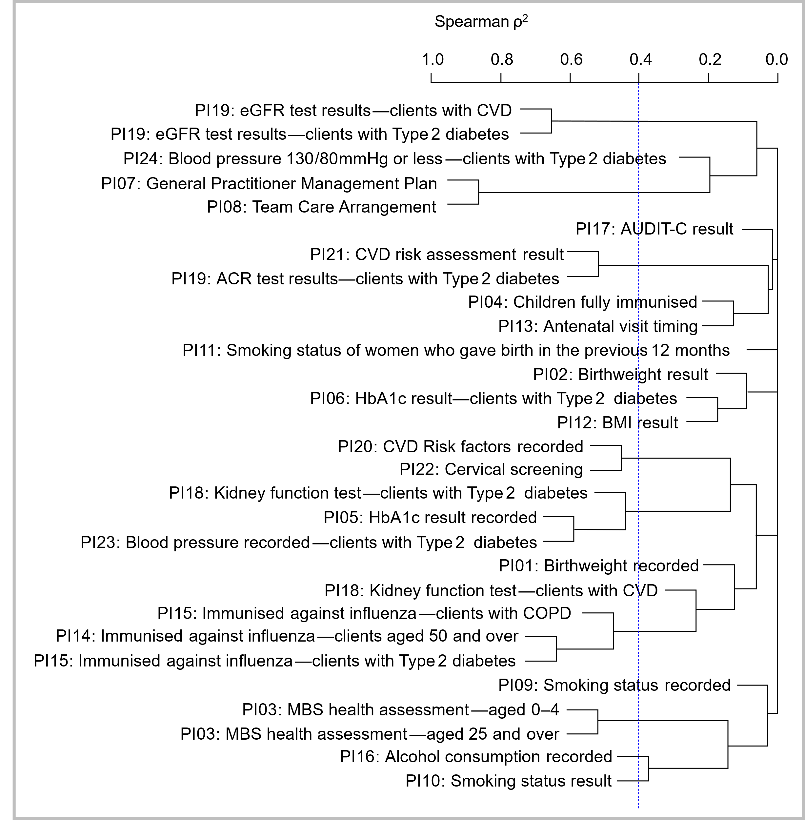
An additional clustering technique (Principal Components Analysis) was used to to reduce the dimensionality of the data set by clustering items into a smaller set of uncorrelated variables. The nKPIs (proportion of clients) each year at each of the 16 sites were used to form the principal components. That is, multiple indicators can be represented by a smaller set of composite variables that are statistically distinct. This permits further analyses of the relationship between the nKPI and other variables.
Using this technique, the nKPIs could be quantitatively represented by a smaller set of 4 principal components. These 4 clusters explained 71% of the variation of the included nKPIs. This can be interpreted as how representative the 4 components are of the whole nKPI data set. These clusters have been interpreted as:
- Health care activity: higher values indicate that higher levels of GP management plans, team care arrangements, testing (kidney function, cervical screening), immunisation and recording of data (for example, test results, CVD risk factors).
- Health behaviours: higher values indicate higher levels of recording of health behaviours (smoking status, alcohol consumption), non-smoking, overweight/obese, and an HbA1c result for clients with type 2 diabetes of 53 mmol/mol or less.
- Health outcomes (diabetes and CVD): higher values indicate good HbA1c and ACR test results for clients with type 2 diabetes and low risk of CVD, and good eGFR test results for clients with CVD.
- Health outcomes (kidney): higher values and indicate good eGFR test results and team care arrangements. This cluster also includes AUDIT-C results.

More than half of adults and one-third of children had a health assessment
The per cent of clients who had a 715 health assessment was calculated for each of the 16 sites and then the mean (standard deviation) and median (interquartile range) of these 16 percentages was calculated. Children aged 0-4 years were much less likely to have health assessments than clients aged 25 years and over; in December 2019, the median per cent across sites was only 35% for children aged 0-4, compared to 59% for adults aged 25 or more. There was little evidence of change over time. After removing the June 2020 data due to possible effects of COVID-19, the odds of a health assessment for 0-4 year olds changed by an estimated -2.9% per year (95% CI: -9.7%, 4.5%). The per cent of the total variance explained by clustering by site was 5%. For clients 25 years and older, the odds changed by an estimated 2.2% per year (95% CI: -5.0%, 10.1%). The per cent of the total variance explained by clustering by site was 9%.
Variation in health assessments across the evaluation sites for clients aged 0-4 years and clients aged ≥25 years are provided in Figure 8-7 and Figure 8-8. For both groups of clients, variability between sites was high, particularly at the start of the period (June 2017). The variation in health assessments for clients 0-4 years was at least 33 percentage points, and it was at least 43 percentage points among clients 25 years and over. Variability between sites was not explained by remoteness. There was high variability among sites in major cities and sites in remote/very remote areas.
Figure 8-7. Trend over time for nKPI PI03: MBS health assessment for clients aged 0-4 years | Figure 8-8. Trend over time for nKPI PI03: MBS health assessment for clients aged ≥25 years
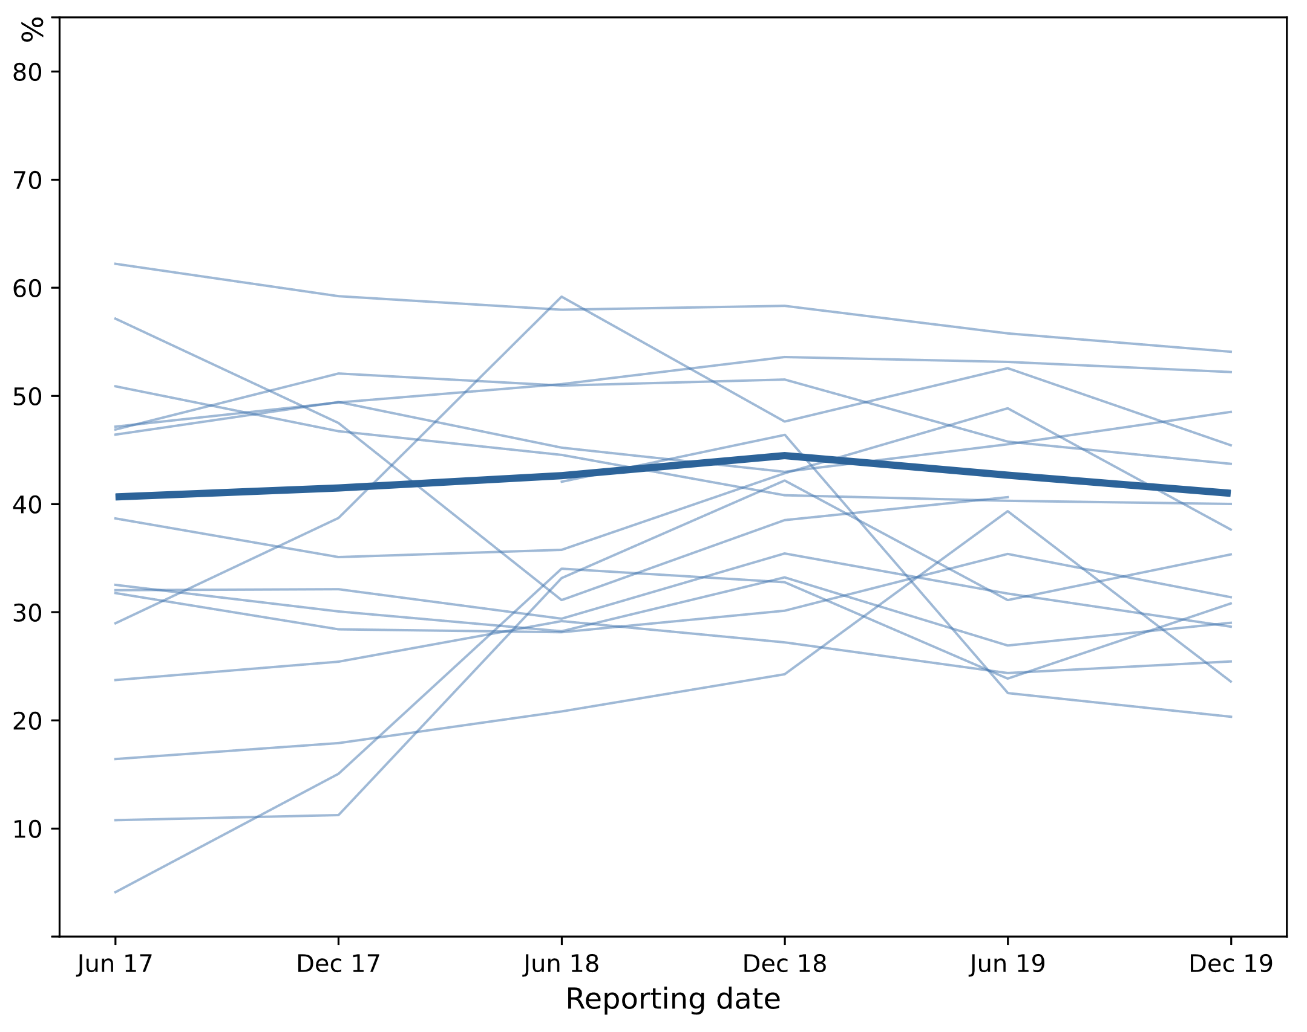 | 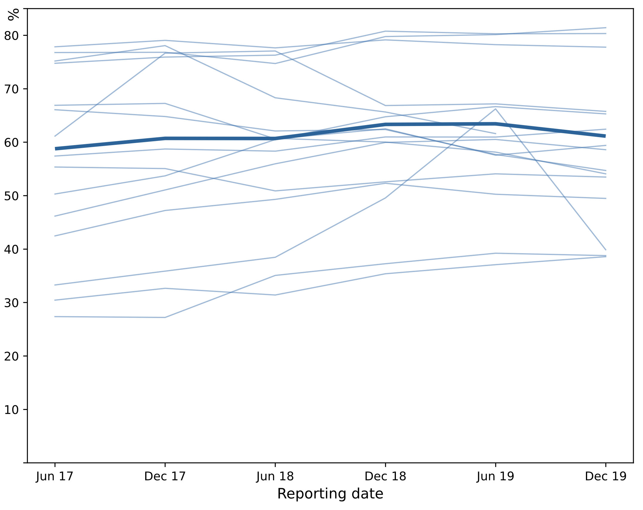
Light lines: % clients at individual sites; Dark line: % clients at all sites combined

There was an increase in the proportion of site residents who received a health assessment
The proportion of Aboriginal and Torres Strait Islander residents of all ages living in the geographical areas that made up the sites who received health assessments (MBS items 704, 706, 708, 710, and 715 combined) increased between 2012-13 and 2018-19 (Figure 8-9). The odds of having a health assessment increased by an estimated 14% over this period (95% CI: 12%, 16%). The per cent of the total variance explained by clustering by site is 14%. The proportion of Aboriginal and Torres Strait Islander people having a health assessment increased with time from a median of 157 to 280 residents per 1,000 receiving services by 2018-19. Some sites in outer regional areas had higher numbers of residents having assessments.
Figure 8-9. Number of Aboriginal and Torres Strait Islander residents who had an MBS health assessment per 1,000 residents by site, 2012-13 to 2018-19.
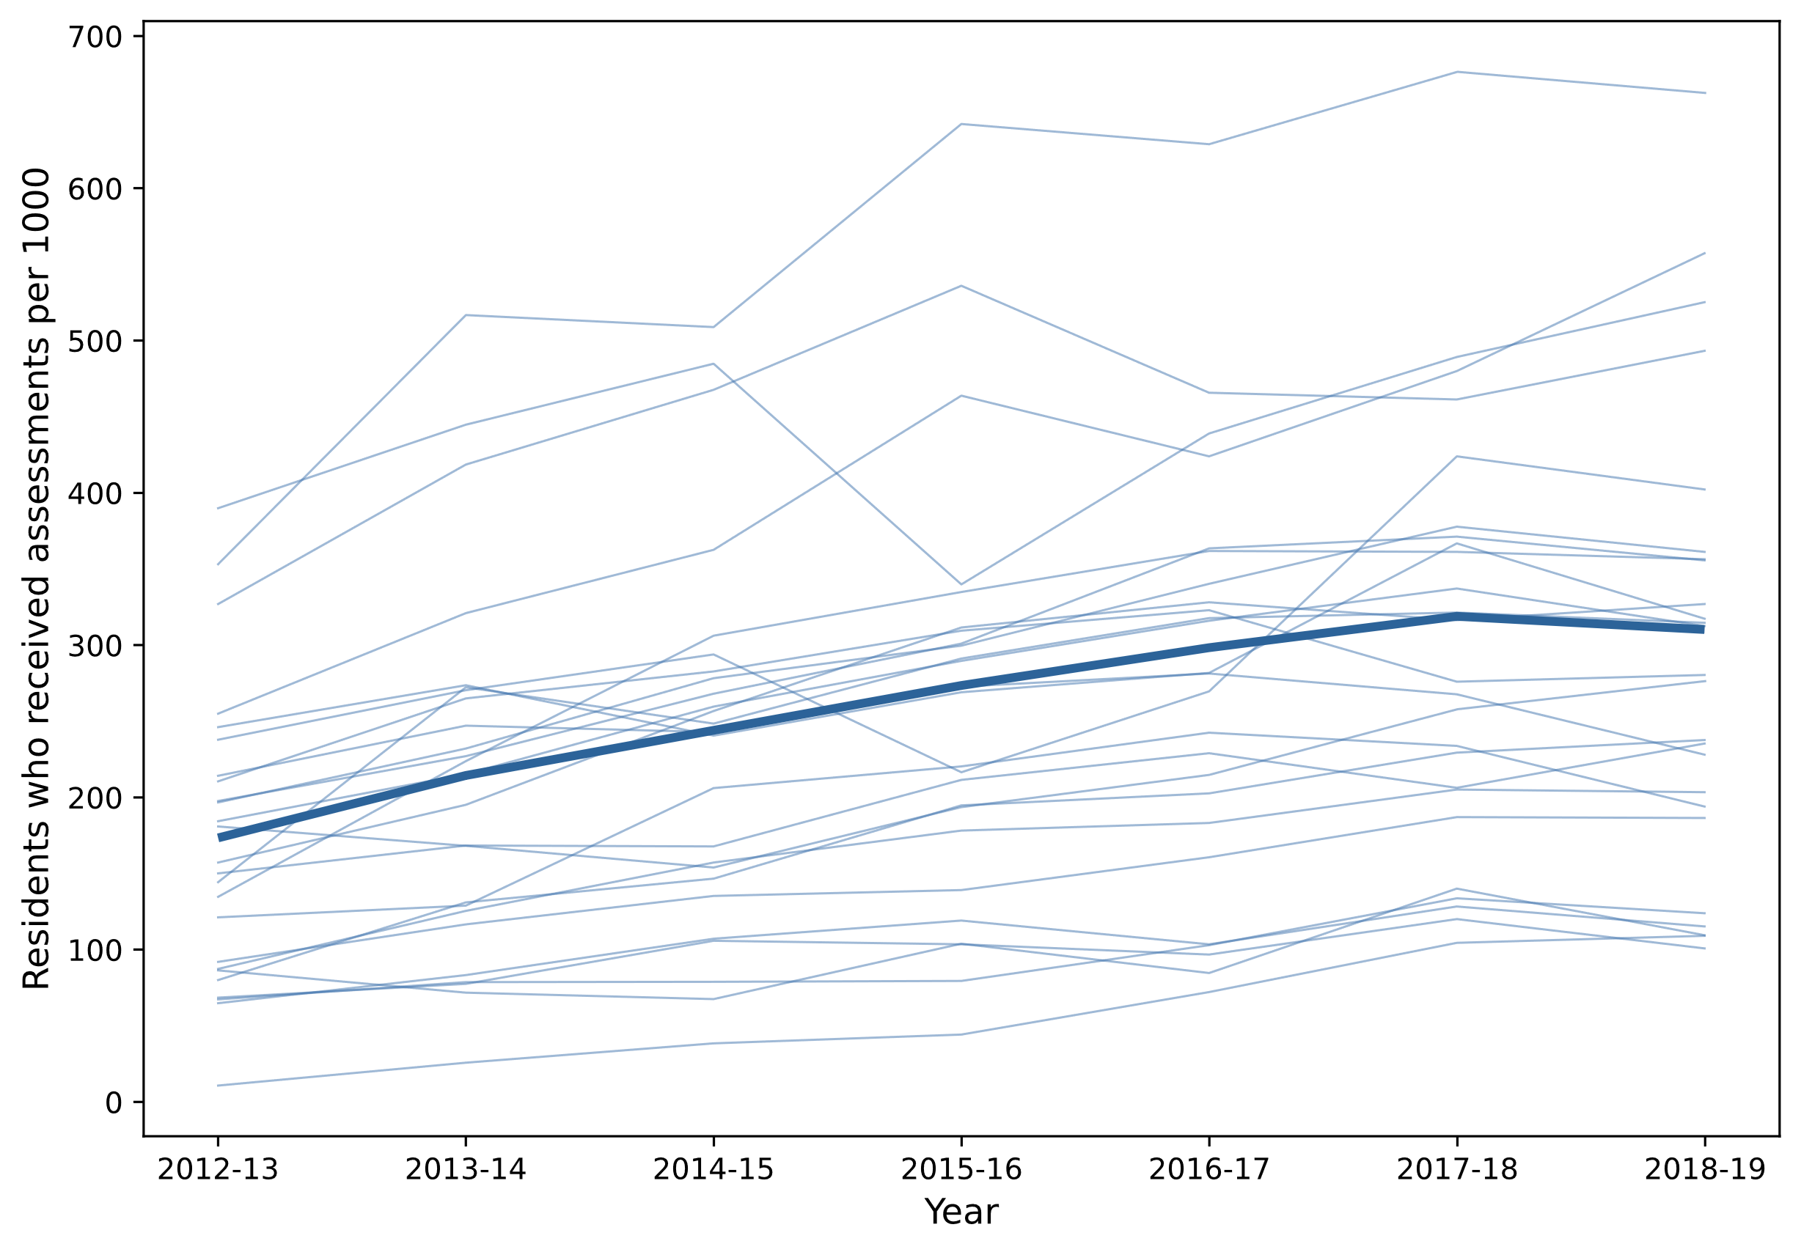

Health assessments are positively associated with the identified clusters
Following principal component analysis, there was evidence that sites with a higher proportion of clients undergoing 715 health assessments had, in the same year:
- higher scores for the first principal component (‘health care activity’, including more GP management plans, team care arrangements, testing, immunisation, and recording of data) (linear regression coefficient: 0.05, 95% CI: 0.00, 0.10)
- higher scores for the second principal component (‘health behaviour’, including recording of health behaviours, non-smoking, and overweight/obese, and normal HbA1c result for clients with type 2 diabetes (linear regression coefficient: 0.05, 95% CI: 0.01, 0.10)
- higher scores for the third principal component (including better diabetes and CVD outcomes, but less recording of CVD risk factors (linear regression coefficient: 0.04, 95% CI: 0.00, 0.07).
These associations may indicate that sites which are able to offer clients timely 715 health assessments also have the systems and staff in place to provide a range of other services.
When looking at associations between health assessments conducted in the previous year (rather than the same year), there was evidence that sites with higher levels of 715 health assessments the previous year had:
- lower scores for the health care activity principal component the following year (linear regression coefficient: -0.09, 95% CI: -0.14, -0.03)
- higher scores for the health behaviours, non-smoking, and overweight/obese principal component the following year (linear regression coefficient: 0.09, 95% CI: 0.02, 0.15)
- higher scores for the fourth principal component (better kidney function results) the following year (linear regression coefficient: 0.06, 95% CI: 0.02, 0.11).

Relative contributions of social determinants and primary care activity on health outcomes
Multiple linear regression was used to model health outcomes as a function of demographics, socio-economic factors, health service availability and primary health care activity for Statistical Area 3 geographic areas (i.e. ecological study). The full method and technical detail is described in Final Report Supporting Material Appendix C. A summary discussion of these analyses and results follows.
Health outcomes examined included hospitalisations for primary care-related conditions, PPHs, emergency department presentations for primary care-related conditions, mortality for primary care-related conditions and birthweight for areas (Statistical Area 3). These conditions were identified from reports of the Aboriginal and Torres Strait Islander Health Performance Framework (Australian Institute of Health and Welfare, 2020a) and the National Guide to a Preventative Health Assessment for Aboriginal and Torres Strait Islander People (Royal Australian College of General Practitioners, 2018).
The explanatory variables covered:
- primary health care activity (MBS services for non-referred GP attendances, Practice Incentive Program activity, childhood immunisation)
- demographics (age, sex, remoteness, state and territory)
- socio-economic measures (see Table 8-5).
- health service availability for the area.
Table 8-5. Socio-economic Indexes for Areas (SEIFA)
Index | Description
Index of Education and Occupation (IEO) | Reflects the educational and occupational level of communities. Low scores indicate relatively lower education and occupation status of people in the area.
Index of Economic Resources (IER) | Summarises variables relate to income and wealth, excluding education and occupation, to index the financial aspects of relative socioeconomic advantage and disadvantage.
Index of Relative Socio-economic Advantage and Disadvantage (IRSAD) | Relates to the economic and social conditions of people and households. Low scores reflect relative disadvantage and high scores reflect relative advantage.
Index of Relative Socio-economic Disadvantage (IRSD) | Summarises information related to the economic and social conditions of people and households and measures only relative disadvantage. Scores on this index range from most- to least-disadvantaged, unlike other indexes which range from relative disadvantage to advantage.

Two time points were analysed separately, reflecting Census years 2011 and 2016 as closely as possible (within the constraints of the available data), in a cross-sectional approach. That is, the differences in outcomes between geographical areas were modelled as a function of the comparable differences in their attributes. For example, areas of greater remoteness were on average also areas with higher rates of potentially preventable hospitalisations compared to less-remote areas.
Additionally, a difference-in-differences analysis modelled each area’s change in outcomes between the two time points as a function of each area’s respective change in its attributes. For example, areas that increased the rate of GP attendances between time points tended to be areas that observed an increase in the rates of potentially preventable hospitalisations.
The effects on health outcomes attributable to each variable were operationalised as the standardised slope coefficient (β). The slope coefficient quantifies the difference in the outcome measure that is associated with an increase of one standard-deviation in the explanatory variable. A positive value of β indicates that measures on the outcome and explanatory variables increase and decrease together. A negative value of β indicates that the outcome and explanatory variables have an inverse relationship where one increases as the other decreases and vice versa.
Variable blocks (primary health care activity, demographics, service availability, socio-economics) were modelled hierarchically, generating distributions for β over an ensemble of regression models. These distributions encapsulate all direct, indirect, and controlled effects that can be elicited from the available data. This quantifies the plausible extent to which primary health care activities can affect health outcomes given the influence of other factors beyond the influence of primary care services identified in the available data.
Complete models (with all explanatory variables entered) accounted for between 19% and 57% of the variance in health outcomes. Models for birthweight outcomes performed the poorest (19-31%) and had the smallest sample. Models for potentially preventable hospitalisations performed best (46-57%).
The relative importance of each variable with respect to health outcomes was computed using a comparison of the median value of its slope coefficients across all hierarchical models for all outcomes. The median for each explanatory variable was compared to that of every other explanatory variable. A variable’s overall importance was given as the proportion of comparisons in which that variable exhibited the larger effect.

Being in the NT, remoteness and age were the most important explanatory variables for differences in health outcomes between sites
Figure 8-10 summarises the relative importance of each explanatory variable. For cross-sectional models, being in the NT, remoteness and age were most associated with health outcomes for areas. Childhood immunisations, economic resources, and socioeconomic outcomes also showed strong associations. GP attendances and socio-economic advantage and disadvantage were the least associated with health outcomes for areas.

Change in rates of GP attendance was the most important explanatory variable for change in outcomes within sites
For the difference-in-differences models, changes in the rates of GP attendances were most associated with changes in health outcomes. Larger changes in health outcomes were observed for areas in Victoria, Queensland, and the NT. Changes in socio-economic measures of advantage and disadvantage were more strongly associated with changes in health outcomes compared to the static differences on these measures between areas analysed in the cross-sectional models. Changes in demographic variables such as the proportion of males and mean age of an area had less influence on changes in health outcomes compared to their relative importance in cross-sectional models.
The difference is that hospitals used to have heaps and heaps of [our] people and babies. But now they go here [ACCHS] and get treated, so they don’t have to go to the hospital …. And people don’t like to go to the hospital …. Now they go to [ACCHS] before it gets so bad.
Community member, regional site
Figure 8-10. Overall relative importance of explanatory variables
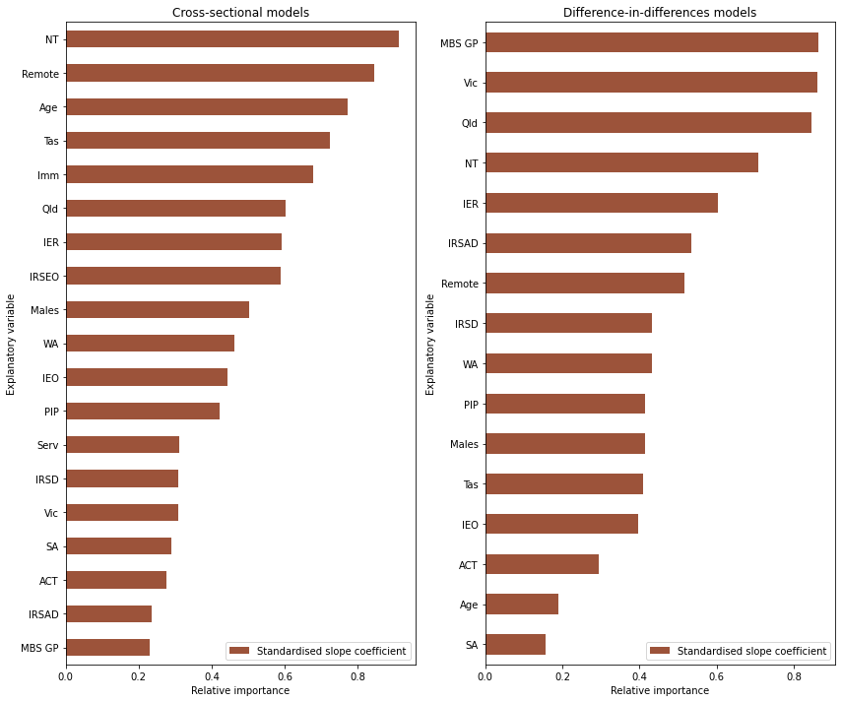

Complex relationships between variables and health outcomes
The above overall analysis shows the relative importance of each explanatory variable across all models of all outcomes. It ignores the direction of the association (positive/negative β); focusing only on the magnitude.

Effects of individual variables on morbidity and mortality outcomes were complex
The distributions for the effects of individual variables are displayed in:
- Figure 8-11 for effects on hospitalisations for primary care-related conditions
- Figure 8-12 for effects on potentially-preventable hospitalisations
- Figure 8-13 for effects on emergency department presentations for primary care-related conditions
- Figure 8-14 for effects on mortality for primary care-related conditions
The accompanying tables (Table 8-6 to Table 8-9) show the positive and negative effects in order of importance (magnitude of β). Figures for difference-in-difference analysis are included in the Quantitative Analytical Approach and Findings supporting document to this report.
As might be expected, age and remoteness were positively associated with hospitalisations for primary care-related conditions, PPH, emergency presentations, and mortality. Also, higher rates of childhood immunisations were associated with lower rates of these outcomes.
However, primary care activity such as the Practice Incentive Program (PIP) was also positively associated with morbidity and mortality (that is, increased PIP activity was associated with increased morbidity and mortality). Furthermore, increased PIP activity over time was associated with increased morbidity and mortality. One interpretation is that PIP activity represents a primary health system response to the health needs (for example, burden of disease) for areas: higher care activity necessarily follows high need.
The Index of Economic Resources (IER) and the Indigenous Relative Socio-economic Outcomes index (IRSEO) presented an inverse relationship with morbidity and mortality, indicating that areas with greater economic resources and higher relative socio-economic outcomes had lower morbidity and mortality on average. Looking at change in outcomes within each area (difference-in-differences), improvements in economic resources were associated with decreases in mortality and PPH, but not with decreases in hospitalisations for primary care-related conditions. Changes in relative socio-economic outcomes (IRSEO) were not available. The Index of Employment and Occupation (IEO) was positively associated with morbidity and mortality between areas, but not in the difference-in-differences analysis.

And another woman who didn’t have her own home for 20 years, was in and out of mental health institutions, since she’s got her own home for 5 years now, has not had one episode in a mental health institute, down to, me going and putting her blinds up on the weekend, you know? Getting her a washing machine, buying her a broom. It’s things like that, which are outside our normal model of care, is what’s keeping our community happy and out of hospital, you know? Because that’s one thing we have now, is a housing team, because [CEO] understood, if you haven’t got a home, you’ve got nothing, you know?
ACCHS, Metropolitan location
The rate of non-referred GP attendances for areas was overall positively associated with hospitalisations, but was not associated with PPH, emergency presentations or mortality in cross-sectional models. However, increases in GP attendances was strongly associated with increases in hospitalisations and PPH in difference-in-differences models. Prospective studies or the analysis of linked data are required to understand the causal effects behind this observational finding.
Figure 8-11. Effects of primary care activity and social determinants on hospitalisations at Time 1 (2011) and Time 2 (2016)
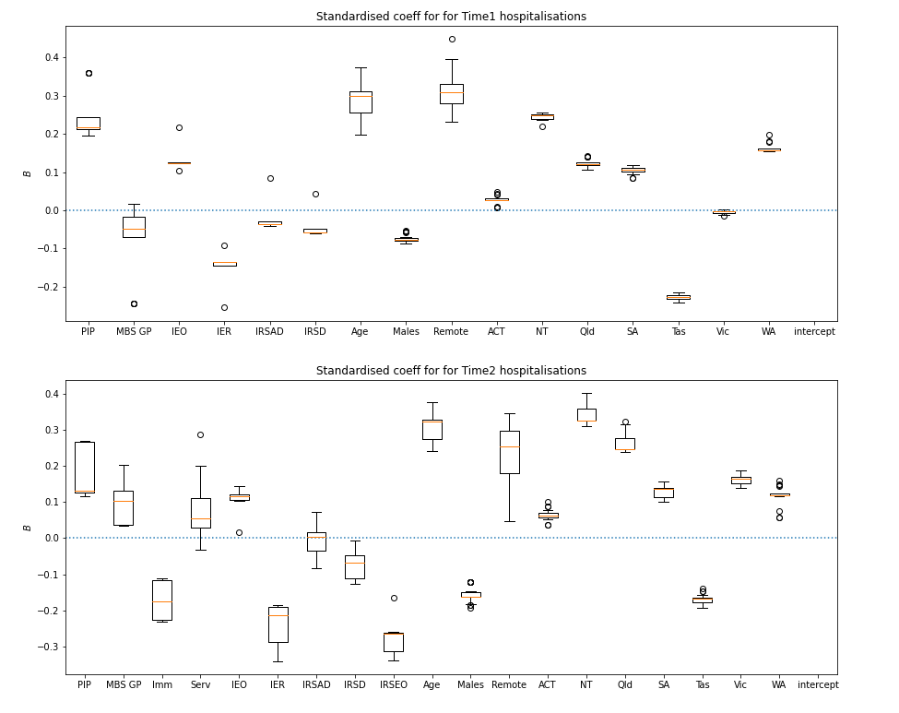

Table 8-6. Standardised regression coefficients (in decreasing order) by time point and direction of effect for hospitalisations
Time 1 |  |  |  | Time 2
Positive |  | Negative |  | Positive |  | Negative
Variable | β median (min,max) | Variable | β median (min,max) | Variable | β median (min,max) | Variable | β median (min,max)
Remote | .31 (.23,.45) | Tas | -.23 (-.24,-.21) | NT | .33 (.31,.40) | IRSEO | -.27 (-.34,-.16)
Age | .30 (.20,.37) | IER | -.13 (-.25,-.09) | Age | .32 (.24,.38) | IER | -.21 (-.34,-.19)
NT | .25 (.22,.26) | Males | -.08 (-.09,-.05) | Remote | .25 (.05,.35) | Imm | -.17 (-.23,-.11)
PIP | .22 (.20,.36) | IRSD | -.06 (-.06,.04) | Qld | .25 (.24,.32) | Tas | -.17 (-.19,-.14)
WA | .16 (.15,.20) | MBS GP | -.05 (-.24,.02) | Vic | .16 (.14,.19) | Males | -.16 (-.19,-.12)
IEO | .12 (.10,.22) | IRSAD | -.04 (-.04,.08) | SA | .14 (.10,.16) | IRSD | -.07 (-.13,-.01)
Qld | .12 (.11,.14) | Vic | -.00 (-.01,.00) | PIP | .13 (.12,.27)
SA | .11 (.08,.12) |  |  | WA | .12 (.06,.16)
ACT | .03 (.01,.05) |  |  | IEO | .12 (.02,.15)
 |  |  |  | MBS GP | .10 (.03,.20)
 |  |  |  | ACT | .06 (.04,.10)
 |  |  |  | Serv | .05 (-.03,.29)
 |  |  |  | IRSAD | .00 (-.08,.07)
Figure 8-12. Effects of primary care activity and social determinants on potentially preventable hospitalisations at Time 1 (2011) and Time 2 (2016)
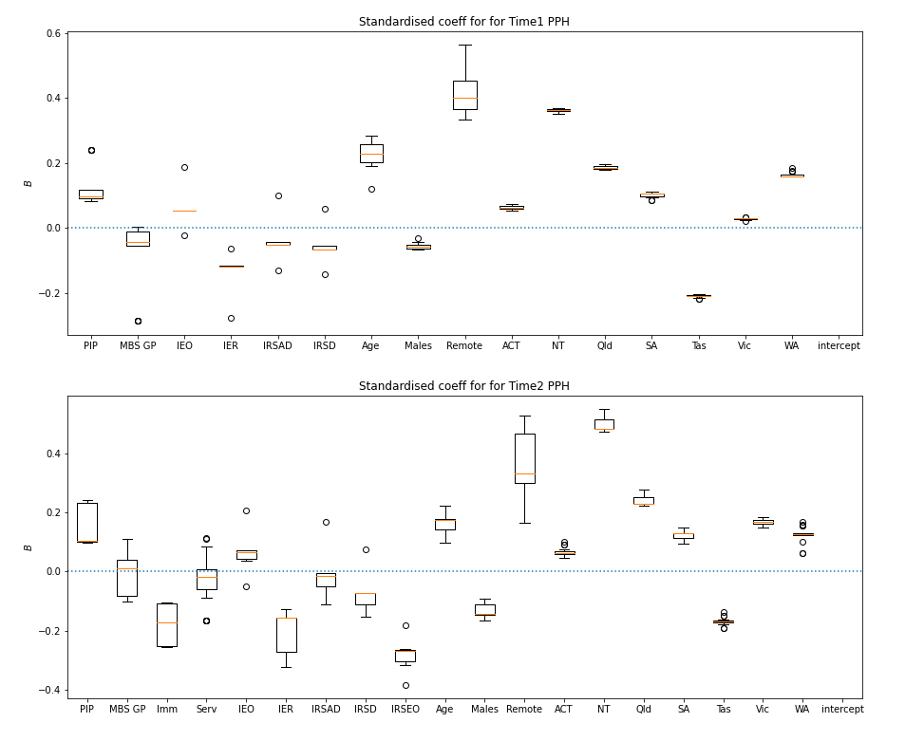
Table 8-7. Standardised regression coefficients (in decreasing order) by time point and direction of effect for PPH
Time 1 |  |  |  | Time 2
Positive |  | Negative |  | Positive |  | Negative
Variable | β median (min,max) | Variable | β median (min,max) | Variable | β median (min,max) | Variable | β median (min,max)
Remote | .40 (.33,.56) | Tas | -.21 (-.22,-.20) | NT | .48 (.47,.55) | IRSEO | -.27 (-.38,-.18)
NT | .36 (.35,.37) | IER | -.12 (-.28,-.06) | Remote | .33 (.16,.53) | Imm | -.17 (-.26,-.10)
Age | .23 (.12,.29) | IRSD | -.07 (-.14,.06) | Qld | .23 (.22,.28) | Tas | -.17 (-.19,-.14)
Qld | .19 (.18,.20) | Males | -.06 (-.07,-.03) | Age | .18 (.10,.22) | IER | -.16 (-.32,-.13)
WA | .16 (.16,.18) | IRSAD | -.05 (-.13,.10) | Vic | .17 (.15,.19) | Males | -.14 (-.16,-.09)
SA | .10 (.09,.11) | MBS GP | -.04 (-.29,.00) | SA | .13 (.09,.15) | IRSD | -.07 (-.15,.08)
PIP | .10 (.08,.24) |  |  | WA | .13 (.06,.17) | Serv | -.02 (-.17,.11)
ACT | .06 (.05,.07) |  |  | PIP | .10 (.10,.24) | IRSAD | -.02 (-.11,.17)
IEO | .05 (-.02,.19) |  |  | IEO | .07 (-.05,.21)
Vic | .03 (.02,.03) |  |  | ACT | .06 (.05,.10)
 |  |  |  | MBS GP | .01 (-.10,.11)

Figure 8-13. Effects of primary care activity and social determinants on emergency department presentations at Time 2 (2016)
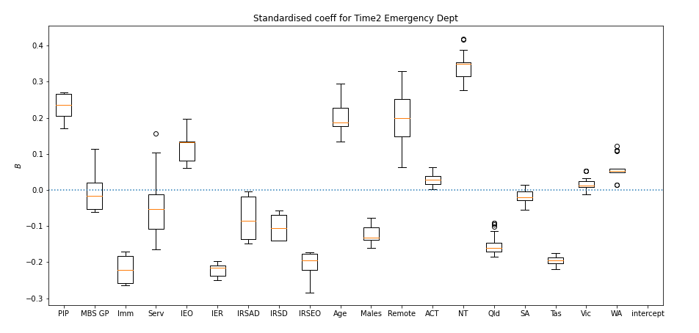

Table 8-8. Standardised regression coefficients (in decreasing order) by time point and direction of effect for ED presentations
Time 2
Positive |  | Negative
Variable | β median (min,max) | Variable | β median (min,max)
NT | .35 (.28,.42) | Imm | -.22 (-.27,-.17)
PIP | .24 (.17,.27) | IER | -.22 (-.25,-.20)
Remote | .20 (.06,.33) | Tas | -.19 (-.22,-.18)
Age | .19 (.13,.30) | IRSEO | -.19 (-.28,-.17)
IEO | .13 (.06,.20) | Qld | -.16 (-.18,-.09)
WA | .05 (.01,.12) | Males | -.13 (-.16,-.08)
ACT | .03 (.00,.06) | IRSD | -.10 (-.14,-.06)
Vic | .01 (-.01,.05) | IRSAD | -.09 (-.15,-.00)
 |  | Serv | -.05 (-.17,.16)
 |  | SA | -.02 (-.05,.01)
 |  | MBS GP | -.02 (-.06,.11)

Figure 8-14. Effects of primary care activity and social determinants on mortality at Time 1 (2011) and Time 2 (2016)
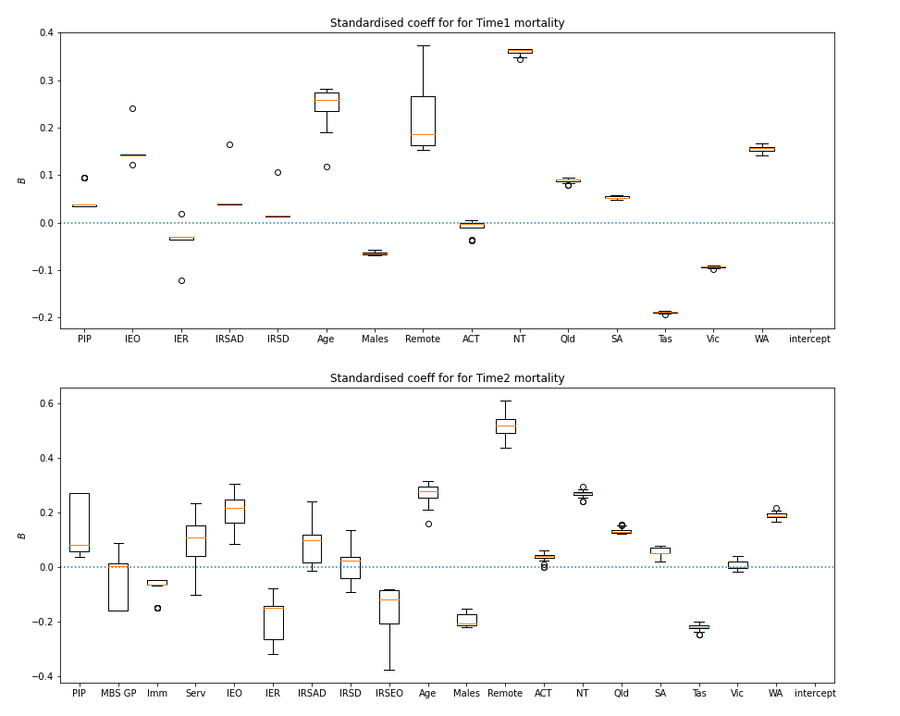
Table 8-9. Standardised regression coefficients (in decreasing order) by time point and direction of effect for mortality
Time 1 |  |  |  | Time 2
Positive |  | Negative |  | Positive |  | Negative
Variable | β median (min,max) | Variable | β median (min,max) | Variable | β median (min,max) | Variable | β median (min,max)
NT | .36 (.34,.37) | Tas | -.19 (-.19,-.18) | Remote | .52 (.44,.61) | Tas | -.22 (-.24,-.20)
Age | .26 (.12,.28) | Vic | -.09 (-.10,-.09) | Age | .28 (.16,.31) | Males | -.21 (-.22,-.15)
Remote | .19 (.15,.37) | Males | -.07 (-.07,-.06) | NT | .27 (.24,.29) | IER | -.15 (-.32,-.08)
WA | .16 (.14,.17) | IER | -.03 (-.12,.02) | IEO | .22 (.09,.31) | IRSEO | -.12 (-.37,-.08)
IEO | .14 (.12,.24) | ACT | -.00 (-.04,.01) | WA | .19 (.17,.22) | Imm | -.06 (-.15,-.04)
Qld | .09 (.08,.09) |  |  | Qld | .13 (.12,.16)
SA | .05 (.05,.06) |  |  | Serv | .11 (-.10,.24)
IRSAD | .04 (.04,.16) |  |  | IRSAD | .10 (-.01,.24)
PIP | .04 (.03,.09) |  |  | PIP | .08 (.04,.27)
IRSD | .02 (.01,.11) |  |  | SA | .05 (.02,.08)
 |  |  |  | ACT | .04 (.00,.06)
 |  |  |  | IRSD | .02 (-.09,.14)
 |  |  |  | MBS GP | .01 (-.16,.09)
 |  |  |  | Vic | .00 (-.02,.04)

There were mixed relationships between variables and normal birthweight
PIP activity had an inverse association with normal birthweight, indicating that areas with more PIP activity tended to have lower rates of normal birthweight. GP attendances, however, were positively associated with normal birthweight (that is, areas with more GP attendances had higher rates of normal birthweight). All of the socio-economic measures (education and occupation, economic resources, and socio-economic advantage and disadvantage) were also positively associated with normal birthweight. And remoteness had an inverse association, with areas of higher remoteness associated with lower rates of normal birthweight.
However, in the difference-in-differences analysis, improvements on socio-economic measures were associated with decreases in normal birthweight. Also, increases in remoteness was associated with increases in normal birthweight.
The influence of different states and territories showed Queensland areas as having higher rates of normal birthweight, and NT areas having lower rates of normal birthweight (at both time points). However, the difference-in-differences analysis showed increases in normal birthweight for all states and territories except South Australia and Victoria (between the two time points).
The distributions for the effects of all variables are displayed in Figure 8-15. Table 8-10 shows the positive and negative effects in order of importance (magnitude of β). Figures for difference-in-difference analysis are included in in the Quantitative Analytical Approach and Findings supporting document to this report.
Figure 8-15. Effects of primary care activity and social determinants on birthweight at Time 1 (2011) and Time 2 (2016)
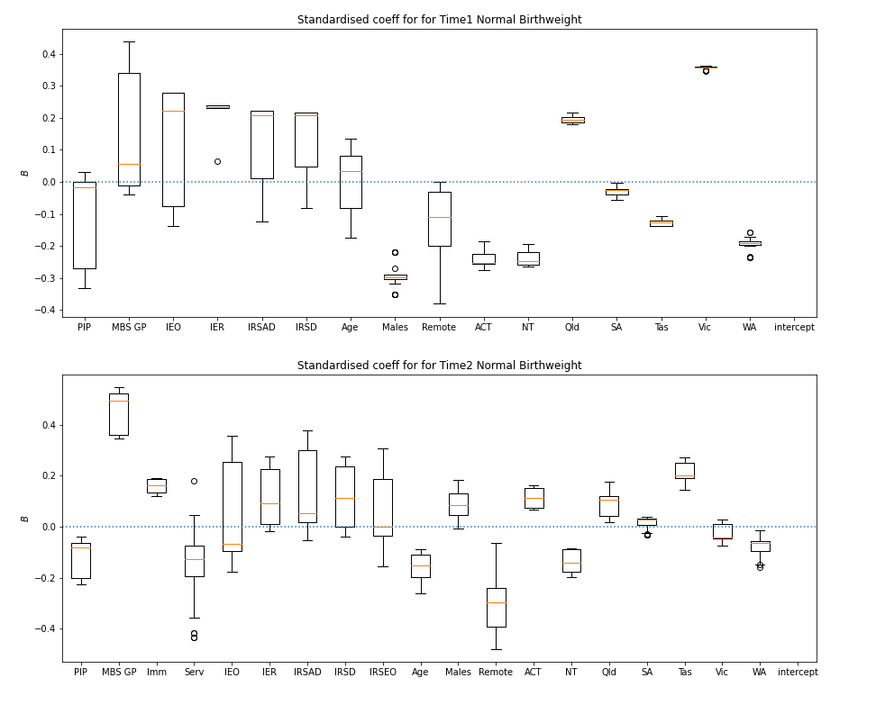
Table 8-10. Standardised regression coefficients (in decreasing order) by timepoint and direction of effect for normal birthweight
Time 1 |  |  |  | Time 2
Positive |  | Negative |  | Positive |  | Negative
Variable | β median (min,max) | Variable | β median (min,max) | Variable | β median (min,max) | Variable | β median (min,max)
Vic | .36 (.35,.36) | Males | -.30 (-.35,-.22) | MBS GP | .49 (.35,.55) | Remote | -.30 (-.48,-.06)
IER | .23 (.06,.24) | ACT | -.25 (-.28,-.18) | Tas | .20 (.15,.27) | Age | -.15 (-.26,-.09)
IEO | .22 (-.14,.28) | NT | -.25 (-.26,-.20) | Imm | .16 (.12,.19) | NT | -.14 (-.20,-.08)
IRSAD | .21 (-.12,.22) | WA | -.19 (-.24,-.16) | ACT | .11 (.07,.16) | Serv | -.13 (-.43,.18)
IRSD | .21 (-.08,.22) | Tas | -.13 (-.14,-.11) | IRSD | .11 (-.04,.28) | PIP | -.08 (-.22,-.04)
Qld | .19 (.18,.22) | Remote | -.11 (-.38,.00) | Qld | .11 (.02,.18) | IEO | -.07 (-.17,.36)
MBS GP | .06 (-.04,.44) | SA | -.02 (-.06,-.00) | IER | .09 (-.02,.27) | WA | -.06 (-.16,-.01)
Age | .03 (-.17,.14) | PIP | -.02 (-.33,.03) | Males | .09 (-.01,.18) | Vic | -.04 (-.07,.03)
 |  |  |  | IRSAD | .05 (-.05,.38)
 |  |  |  | SA | .03 (-.03,.04)
 |  |  |  | IRSEO | .00 (-.16,.31)

What needs to change and improve?

Key findings
1 | There is a need to increase self-determination, autonomy, and responsiveness within the IAHP and the broader health system, including through strengthening governance, shared decision-making and accountability arrangements. To support effective partnerships, there is a need to improve processes for engaging Aboriginal and Torres Strait Islander health services and communities in program and service design, and to strengthen dedicated Aboriginal and Torres Strait Islander health policy capability within the department. Commissioning processes then need to be adapted to enable partnerships, shared decision-making, and community-led responses. There is recent practice in adapting commissioning processes to build upon.
2 | There is a need to scale up investment in the IAHP and Aboriginal and Torres Strait Islander primary health care more broadly. Increased investment needs to take account of the cost of delivery comprehensive primary health care to Aboriginal and Torres Strait Islander people and communities, health workforce requirements, and the current lack of investment applied to prevention activities.
3 | There is a need to strengthen the integration of the IAHP with the health system and reduce system fragmentation through supporting integrated models of care, and building processes for information sharing and collaboration.
4 | There is a need to enhance the use of knowledge and information to reflect what Aboriginal and Torres Strait Islander communities value about health care and their needs, to track and monitor outcomes, and to support decision-making and continuous quality improvement.

Overview
This section examines how faster progress can be made towards improving the health and wellbeing of Aboriginal and Torres Strait Islander people (KEQ4). The section reports on what needs to change with the IAHP and what needs to change in broader policy settings and processes, and at different levels of the system, based on participant views.

Data sources and methods
This section draws on data from discussions with ACCHS and PHN site partner leaders, and with government and community-controlled representatives in state, territory, and national organisations. Data were also generated in Collective Action for Change workshops with site partners, including site-level workshops and online workshops involving partners from across sites. This section is also informed by data generated in discussion on contribution cases that examined the contribution of the IAHP to meeting its objectives.
Lastly, each of the 5 cross-cutting collaboratives conducted during the evaluation generated ideas on potential solutions and improvements and these have contributed to the data and findings in this section.

Increase autonomy and responsiveness
Increasing self-determination, autonomy, and responsiveness of the health system was a priority for many evaluation participants. People wanted changes at a governance and policy level, and improvements at the program and place-based level. Opportunities identified by participants to increase autonomy and responsiveness included:
- Strengthen governance and shared decision-making arrangements, including through the establishment of a national governance and accountability mechanism for Aboriginal and Torres Strait Islander health.
- Strengthen dedicated Indigenous health policy capability within the department.
- Support engagement by health services and communities in program and service design.
- Align commissioning processes.
The National Agreement on Closing the Gap is driving a new approach which requires that policy that impacts on the lives of Aboriginal and Torres Strait Islander people is made in full and genuine partnership. It includes commitments to build and strengthen structures that empower Aboriginal and Torres Strait Islander people to share decision-making authority with governments to accelerate policy and place-based progress against Closing the Gap. Notably, change to increase the autonomy and responsiveness of the system through a stronger partnership approach is well aligned with the Closing the Gap commitments with several people commenting that ‘the time was right’.

Strengthen governance and policy mechanisms
Within a context of significant history of partnership, recent experience in shared decision-making, and the opportunity for a reset, evaluation participants shared ideas on how national governance and policy mechanisms could build on existing partnerships and move towards genuine shared decision-making, consistent with Closing the Gap Priority Reforms.
Participants identified the governance arrangements put in place during the COVID-19 response as a valuable example of driving better outcomes for Aboriginal and Torres Strait Islander people through close partnership and collaboration between community organisations and government agencies. Participants also noted a lack of dedicated national partnership mechanisms for Aboriginal and Torres Strait Islander PHC and for the IAHP.
There is work underway to refresh governance arrangements for Aboriginal and Torres Strait Islander health. New governance and accountability mechanisms under the National Aboriginal and Torres Strait Islander Health Plan are in development.
The Aboriginal and Torres Strait Islander community-controlled health sector continues to demonstrate leadership in national, state, and territory governance mechanisms supporting the implementation of Closing the Gap Priority Reforms, through NACCHO and state and territory affiliates.
The absence of dedicated governance processes to support and facilitate shared decision-making prompted support from a number of evaluation participants to establish specific national governance arrangements for the IAHP program as a whole. This is because of a perceived lack of government accountability and transparency across the IAHP and Aboriginal and Torres Strait Islander health more generally.
Evaluation participants identified a need for the establishment of a national governance and accountability mechanism that sits over the IAHP. Ideas for the features and functions of the mechanism included:
- Oversight of IAHP funding and responsibility for holding the government and funded organisations to account for program outcomes.
- Operating in an advisory capacity in its initial stages, while still bringing essential transparency and accountability. Power for decision-making functions could be transferred over time.
- Making national-level decisions on program resource allocations, such as how TIS program funding should be distributed.
Participants generally thought the mandate of a governance and accountability mechanism should extend beyond the IAHP and include oversight of all Aboriginal and Torres Strait Islander targeted PHC expenditure, including from state and territory governments. Some suggested it should also function as the governance and accountability mechanism for the Health Plan and, potentially, other strategies and plans such as the Health Sector Strengthening Plan and the National Aboriginal and Torres Strait Islander Health Workforce Strategic Framework and Implementation Plan. These participants commented on the general lack of clear accountability for the delivery of outcomes under these plans, particularly at a state and territory level. Similarly, participants said a national governance and accountability mechanism could also monitor and report on the status of the implementation of recommendations, including the recommendations made by evaluations and other review processes (including this evaluation).
Participants shared ideas around the form of a governance and accountability mechanism or group:
- Establishing a tripartite national forum similar to the state and territory Health Partnership Forums with representation from the community-controlled sector, the department, and state and territory health departments. It was seen as critical to have both tiers of government at the table to bring transparency, accountability and enable system coherence. Some participants felt that the NIAA needed to be at the table too, given its funding for health and wellbeing services.
- Establishing an independent body such as an Aboriginal Productivity Commission which had a wider remit (beyond health): ‘We need an Aboriginal specific one if we are really serious about closing the gap and doing the right thing’.
Participants also reflected on the effectiveness of the COVID-19 response and suggested that a national governance and accountability mechanism could include sub-groups (for example, advisory groups or working groups) with responsibility for specific issues such as disease outbreaks and workforce that could provide advice and report to the national governance and accountability mechanism.
Participants from the department recognised the need to rebuild governance around the IAHP and more broadly. They acknowledged current inconsistency in how far government shared decision-making with the community-controlled sector, often reflecting the strength and assertiveness in the sector. They recognised that this approach was not good enough.
Example of promising practice – Community-led response to COVID-19
The partnership set up to respond to COVID-19, through establishing the Aboriginal and Torres Strait Islander Advisory Group on COVID-19, offers promising insights on shared decision-making, accountability, and transparency. The group was co-chaired by NACCHO and the department, and included membership from the ACCHS sector, state and territory government representatives, and Aboriginal and Torres Strait Islander communicable disease experts. The group’s advice was conveyed through the Australian Health Protection Principal Committee (AHPPC) to National Cabinet.
The evaluation collaborative on the COVID-19 response found that the Aboriginal and Torres Strait Islander Advisory Group on COVID-19 mobilised the right mix of capability, bringing together cultural authority, ACCHS leadership, public health expertise, state and territory expertise, and knowledge of the policy-making and cabinet processes. Participation of Australian, state and territory governments, and the ACCHS sector meant everyone heard one consistent message in a safe place. This approach supported discussion and debate and the building of a collective voice to address specific health issues. (Note, because of the small number of participants interviewed for this collaborative (n=10), care has been taken not to identify participants in the quotations).
That level of transparency is where the [community controlled] sector want us to get – with state and Commonwealth working together in alignment and not pulling the poor ACCHO in the middle in different directions or having to feel like they have to duplicate or an extra burden of reporting.
Grateful for the advisory group providing collective voice otherwise we are just a very small voice in a much larger space. Previously it has been separate conversations: NACCHO will have a conversation with commonwealth, commonwealth will have a conversation with state, etc. This was everyone together and it was very welcome.
Although led at the national level, we had everyone in the room – NACCHO and affiliates and state representatives. We didn’t really get lost in ‘that’s a federal responsibility or that’s a state responsibility’ because we were all there. It was like ‘let’s just have the discussion’.
Aboriginal and Torres Strait Islander Advisory Group on COVID-19 participants reported experiencing unprecedented levels of cooperation between governments and the community-controlled sector, including shared decision-making, power-sharing, and two-way communication. This way of working activated Aboriginal and Torres Strait Islander self-determination, Indigenous leadership and empowerment, creating opportunities for Aboriginal and Torres Strait Islander people to define the issues, determine the priorities, and make recommendations in a culturally appropriate governance structure.
In a way, the Advisory Group was an early adopter of the – yet to be signed – Closing the Gap framework, for example, shared decision-making, community control, using data to inform decisions, and affecting mainstream systems. We were already incorporating this into the advisory group and pandemic response.
Example of promising practice (continued)
The Aboriginal and Torres Strait Islander Advisory Group on COVID-19 operated in an open and transparent manner in contrast to government business as usual, where policy is often formulated through cabinet-in-confidence processes. Access to data and information supported rapid decision-making and informed policy positions.
We’ve challenged the traditional notion of how the public service enacts and develops policy. We never had a position before going into the meetings – no cabinet-in-confidence
We didn’t wait for the policy to be finished and then consult around the edges.
These findings demonstrate the potential for agility within formal government systems to support adaptive practice consistent with principles of self-determination. They provide important lessons and a blueprint for forging other partnerships between governments and Aboriginal and Torres Strait Islander people, communities, and organisations to deliver solutions for Closing the Gap. These ways of working are consistent with the clear commitments for shared decision-making within the National Agreement on Closing the Gap, aligning closely with commitments under Priority Reform 1 and 3.

Strengthen Aboriginal and Torres Strait Islander health policy capacity
Some ACCHS participants discussed the importance of embedding and increasing the profile of Aboriginal and Torres Strait Islander health across department. They spoke about the value of having a First Nations Health Division, and the need to further strengthen the department’s health policy capability to enable it to build on its experience as an effective partner in policy-making. People reflected that:
- The status of the specialist Aboriginal and Torres Strait Islander health division within the department had diminished over time since it transitioned from the Office of Aboriginal and Torres Strait Islander Health (OATSIH) to the Indigenous and Rural Health Division around 10 years ago. This included perceptions that the division was more siloed from the rest of the department than it was under OATSIH.
- The status of the First Nations Health Division needed to be elevated to achieve its goal of having influence and leverage over other parts of the department with responsibility for decision-making that influences the operation of the health system and health outcomes for Aboriginal and Torres Strait Islander people.
Participants recommended elevating the position of the division within the department to increase the focus on Aboriginal and Torres Strait Islander health at the most senior executive level of the department.
Staff from the First Nations Health Division reported that they play an important leveraging role across other parts of the department, and that the refreshed National Agreement on Closing the Gap has strengthened these leveraging opportunities. It was clear that some ACCHS evaluation participants were not aware that the division was playing a significant leveraging role. Others called for more of this.
I don’t mind that. They [the First Nations Health Division] should facilitate. They don’t do that enough.
ACCHS, Remote location

Support community engagement in program and service design
- Evaluation participants shared experiences of how health service organisations and communities have been engaged in the design of programs and services, including through co-design processes. There was a widespread view that current processes do not work well for everyone and there is significant opportunity for improvement. This is important for the IAHP given the evaluation has found that some programs are not sufficiently flexible to be responsive to local circumstances. Participants discussed gaps and opportunities at two levels.

Local community engagement on Aboriginal and Torres Strait Islander health and wellbeing needs and potential solutions
- Evaluation participants spoke about the need for health service organisations to have the space and resources to engage directly with their communities to understand the health and wellbeing requirements of Aboriginal and Torres Strait Islander people before commencing program co-design discussions with funding organisations.
We need our own space as Aboriginal people to be able to, and as an organisation in this respect, say this is how it looks for us for the next 10 years. This is our roadmap, this is how we see we can actually address the health issues in our community, you know, and then we're looking at co-design from there.
ACCHS, Metropolitan location

- Participants told the evaluation that this is an essential step for self-determination and community-control over health care for Aboriginal and Torres Strait Islander people. It was also seen in terms of honouring the Alma-Ata Declaration on PHC which states: ‘people have the right and duty to participate individually and collectively in the planning and implementation of their health care’ (World Health Organization, 1978).
We've got to build this virtuous cycle of deep listening and being responsive to what the community needs and aspirations are.
State or territory government
- Participants expressed how engaging with communities has ripple effects in terms of Aboriginal and Torres Strait Islander people being engaged in their health care, having wider community agency, and building understanding about the health service. It also enables innovations to surface, for solutions to be created and supported by the community, and can foster stronger health service accountability to community.
- While ACCHSs have processes for engaging with communities, many ACCHS staff and community members reported the need to strengthen these commitments. A government-run health service reported on a recent initiative to re-establish health advisory groups across its communities to better understand how it should communicate with the Aboriginal and Torres Strait Islander community and how it could deliver services in a more culturally appropriate way. Participants reflected on the absence of mechanisms for the government to hear from health service consumers, including on their experiences of health care.

Engagement with funders to design programs and services to meet the health and wellbeing needs of Aboriginal and Torres Strait Islander people
- Many participants had recent experience in co-design processes for specific programs and services, including programs under the IAHP. This includes co-design processes with the department and NACCHO, with state and territory peak body affiliates and governments, and with PHNs and local hospital networks. There is a growing body of practice to learn from and participants identified several areas for improvement to co-design processes based on recent experiences.
- Transfer decision-making on program and service design as far as possible to the local community level to strengthen ownership and alignment with community values and needs. Too often, program and service design parameters are set before community co-design resulting in misalignment. Fundamentally, there is a need for clear expectations on what program or service parameters can be co-designed and what are fixed, and how much authority co-design partners have. Participants discussed the value of having a framework to design within, with an understanding of why there are boundaries (for example, there might be a policy basis for a particular focus).
- Officers/staff in the funding organisation need to spend sufficient time listening to people in the community. This will assist to build understanding of the people the service or program is supporting and to enable deep conversations with community, ‘not just time in the boardroom’. It is particularly important that funders recognise Aboriginal and Torres Strait Islander people and communities’ aspirations for health and wellbeing and the existing knowledge about what works within their communities.
- Ensure that enough time is allowed to develop a clear understanding of what co-design means for a particular community, and provide clarity around what that means in terms of appropriate processes, scope of participation and cultural protocols that need to be followed.
- Support genuine participation in co-design processes through providing sufficient time and resourcing for Aboriginal and Torres Strait Islander people, communities, and services to actively participate and contribute to the co-design process.
- Adopt a range of different ways to engage directly with people. Some participants reported that surveys and lengthy documents are not working for them.
- Participants raised questions about who funding organisations should be co-designing with. In principle, many supported localised co-design but also recognised the reality that many local ACCHSs, for example, would not have the capacity to engage extensively in the co-design of programs and services. Participants questioned how co-design should work at other levels, with state and territory affiliates and, nationally, with NACCHO. Several ACCHSs shared perspectives on the co-design partnership between the department and NACCHO for new IAHP infrastructure programs (Capital Works Program and Service Maintenance Program). NACCHO had engaged them in the process, which was appreciated and valued. However, they felt there was potential for tensions and that there would be other times where co-design should be undertaken by the department in partnership with the state and territory affiliates or directly with health services.

Align commissioning processes
There are recent examples of commissioning practices that are consistent with enabling partnerships, shared decision-making, and community-led responses. This includes the co-design partnership between the department and NACCHO on the parameters and structure for the new infrastructure programs (referred to in the previous section), flexible funding allocated to ACCHSs as part of the COVID-19 response, and the funding of aged care services in ACCHSs. Again, these experiences provide a platform to build on and participants identified areas for further development and improvement.
- Developing a clear and transparent commissioning strategy for the IAHP that reflects the intent of the various programs and activities, the intent of Closing the Gap and the Health Plan, and outlines best practice principles for Indigenous commissioning. Note the department is developing an IAHP Investment Strategy, including funding principles, which aims to fulfil this function.
- Ensuring all commissioners factor realistic administrative costs into grants. One ACCHS participant reported a recent experience of a grant with NACCHO that had no administrative fee factored into it.
- Ensuring all commissioners run fair and transparent commissioning processes and that decisions reflect need. Some ACCHS participants raised concerns about the risk of commissioning processes being influenced by the strength of personal relationships with purchasing/funding organisations.
- Ensuring clear separation of commissioning decisions from other, potential conflicting, relationships. This was a particular concern expressed by some ACCHS participants as NACCHO took on commissioning roles which involved decision-making on grants for its members, such as under the new IAHP infrastructure programs. They felt this has the potential to ‘muddy the waters’ between NACCHO and its membership organisations. A PHN participant who was involved in commissioning services also commented on how the commissioner-provider relationship changed the nature of relationships.
- Strengthening partnerships through relational commissioning. A number of ACCHS and PHN participants commented that the service relationship with government has evolved to be very transactional, driven by the contract or funding agreement: ‘It's very, you know, blah, blah, send a document, send a policy, send a, you know, send some report. It's not relational anymore’. They described the commissioning relationship as ‘very surface level’, and ‘very thin’. As a result, they felt there was less trust and flexibility within the relationship.
There is some current uncertainty around the future role of NACCHO and state and territory affiliates in commissioning services, and there is uncertainty around the future role of PHNs in commissioning IAHP programs. ACCHS participants’ views on the role of these organisations varied significantly. Some rejected the concept of ‘middle men’ in the commissioning process altogether, wanting a direct funding relationship with the department. The positive experience with different commissioning models and the potential opportunities were also recognised by participants.

Increase investment in primary care
There was a high degree of consensus among evaluation participants, from all parts of the PHC system, that the level of investment in Aboriginal and Torres Strait Islander PHC is insufficient to meet Closing the Gap objectives. For ACCHSs, IAHP funding was seen as critical to maintaining service delivery but was not enough to improve health outcomes. Funding is not enough to meet increasing and more complex needs, or keep pace with population growth and the corresponding need to grow services. One participant reported that, when adjusted for inflation, their service’s PHC Program funding was going backwards.
To truly invest in close the gap for Aboriginal life, it's going to take a lot of time and a lot of bloody money.
ACCHS, Remote location

It's [PHC investment] not even close in, let alone all the complexities …the 20% growth in chronic conditions in the last 2 years alone. This funding model cannot keep up to speed with the rapid acceleration of care needs that we're experiencing.
State or territory government
There was also widespread recognition that the IAHP funding model is about ‘divvying up a bucket’ of funding, based on a capped budget as opposed to a demand-driven model that fully accounted for health care need within Aboriginal and Torres Strait Islander communities. Furthermore, participants from state and territory PHC services considered that the funding model also failed to take a population-based approach. These services receive a different level of PHC Program funding than ACCHSs and, reportedly, did not have the same access to other funding for specific programs (for example, funding to control the syphilis outbreak).
You don't win at a population level if you differentiate on who's paying salaries in terms of organisations…. Why disadvantage the 30% of the population who don't have the choice to attend an ACCHO. There's only one service provider by default … why would you freeze them out of any of these programs?
State or territory government
Participants identified steps to increase investment in PHC and some key areas where there was a need for specific investment and focus.

Fully cost the delivery of comprehensive PHC to Aboriginal and Torres Strait Islander people and communities
One of the fundamental steps discussed by participants was to fully cost the delivery of comprehensive PHC. This reflects a commitment to develop a needs-based funding model in the Health Sector Strengthening Plan (Joint Council on Closing the Gap, 2021b), and building on the recently agreed Core Services Framework (National Aboriginal Community Controlled Health Organisation, 2021b). A participant from the department noted that it was important that the costings be developed in a way that was acceptable to the Department of Finance and Treasury. The evaluation team suggests, therefore, that it is critical that government works in partnership with the ACCHS sector in developing any costings. The implications of this are discussed in Section 11.

Develop an investment strategy
Agreeing the approach to costing was considered a critical first step. ACCHS participants discussed how this would then form the basis for the development of an investment strategy identifying, for example, how much governments would fund, including what might be funded through the IAHP and through mainstream sources. The investment strategy would also inform discussions around the long-term growth of the community-controlled sector, with some ACCHS participants insistent that existing services needed to be funded adequately before looking to expand or add to services: ‘Let’s get us to square one first’. The investment strategy would also need to factor in population growth which was, reportedly, rapid in some suburban and peri-urban populations.

Scale existing programs with proven benefits
Participants highlighted the need to build and bring to scale programs that had proven successful. As discussed in Section 5.6, many participants commented on the effectiveness of the ITC program and recommended it be scaled up. A PHN participant reported that they commissioned ITC services for 2,000 people but there were another 10,000 people with chronic disease in their region who would benefit from support.

Increase investment in workforce initiatives
In order to expand access to comprehensive PHC, participants discussed the need to increase investment in workforce initiatives. This included the training of staff (particularly to offset the effects of an ageing workforce); initiatives to retain staff (such as incentive payments or other conditions to retain remote staff); and pay and tenure equity mechanisms to mitigate competition between the government and non-government sectors (again to assist with staff retention). A number of participants also discussed the need to grow the capability of ACCHS board members and senior management to enable the sector to grow and to retain a focus on quality.

Provide sufficient funding for prevention activities
Participants also discussed the need for sufficient funding for preventative health initiatives to mitigate the amount of chronic disease. Until the level of disease in the community can be turned around, participants reported that the amount of funding would never be able to keep pace with need. One suggestion put forward was to focus on engaging young people with their health, which was seen as a key gap.
There's maternal child health programs, there's programs when you're in school, but the minute you leave school, you become disenfranchised from health until you're having a baby yourself or you've got a chronic disease or you've got a cancer or something.
Peak body

Strengthen health system integration
The evaluation found that navigating the complexity and fragmentation of the Australian health system is a dominant feature of Aboriginal and Torres Strait Islander peoples’ experiences of the system. ACCHS staff told us about the challenges they face from a fragmented system, including the need to understand system connections so that staff can provide their clients with more holistic care. Often this required combining multiple funding sources and programs to deliver the care that Aboriginal and Torres Strait Islander people require. The evaluation identified 3 opportunities to strengthen health system integration:
- Reduce fragmentation of the funding system.
- Support integrated models of care.
- Strengthen mechanisms for information sharing and collaboration.

Reduce fragmentation in the funding system
The fragmentation that people and health service providers experience in the health system reflects the fragmentation of funding streams. Service providers often need to navigate multiple funding sources, agencies, and funding agreements to obtain the resources required to deliver appropriate care. This requires effort across all levels of government and regional agencies. Some ACCHSs have become savvy at navigating the complex layers of a fragmented funding system, particularly ACCHSs with a higher level of organisational maturity and capability. Nevertheless, a requirement to dedicate limited resources to identifying and securing funding imposes opportunity costs on ACCHSs through diverting effort away from service delivery and can add to personal workload and burnout.
Participants from ACCHSs and Australian, state, and territory governments shared ideas for making the funding landscape less fragmented and less piecemeal. The main ideas revolved around opportunities to pool or bundle programs together to simplify the program and funding landscape. The effect of this would be to widen the scope of programs and increase the opportunity to meet the holistic needs of Aboriginal and Torres Strait Islander people. There will also be a reduced administrative burden for health service providers, including reducing the number of reports that services must prepare to satisfy funding arrangements. Ideas for reducing service and funding fragmentation included:
- Bringing together some of the special-purpose IAHP grant programs, often referred to as ‘body part funding’, into the IAHP PHC Program to increase the level of block funding and reduce the number of tied programs.
- Bringing NIAA funding for social and emotional wellbeing into the IAHP, thereby expanding its scope. Some participants noted that this money had previously transitioned away from the department and some ACCHS staff strongly opposed this shift.
- Strengthening the alignment in funding between the Australian, state, and territory governments, including funding across the primary care and hospital and specialist care interface. Participants from two ACCHSs went beyond this: one suggested establishing a national funds pooling authority for Aboriginal and Torres Strait Islander PHC that pooled funding from the Australian, state, and territory governments; the other suggested treasuries to bring together funding at a regional level.
Reducing fragmentation through greater alignment and coherence across the funding system – without requiring agencies and services to pool or bundle funding – was identified by participants as another opportunity to strengthen the funding system. Alignment in government funding agreements and reporting systems was raised as a potential solution by a number of participants in the evaluation.
Opportunities to simplify and streamline governance and administrative processes associated with funding arrangements were also shared by ACCHS and government participants. For the IAHP, the need to reduce fragmentation in the management of funding agreements across agencies and staff was a clear priority for many participants. Funded organisations reported the need for greater clarity about the respective functions of the department and the DSS relating to grant management. Funded organisations spoke of the challenges associated with having multiple contract managers within the funding agencies, and the regular changes in contract manager: ‘It’s really hard for us to keep up to speed on who the right people to contact are'. One solution proposed was for each funded organisation to have a single point of contact in each funding or contract managing agency. This had been implemented by some funders (for example, a PHN) and has contributed to more relational engagement between funders and service providers.
Example of promising practice – Development of outcomes-based funding arrangements
Participants from a state community-controlled peak body described reforms in its funding arrangements with the state health department. The organisation has 62 individual sources of funding, each with a separate contract and different reporting regime, including monthly, 6-monthly and 12-monthly. Around 40 of these contracts are with the state health department. They were working with the department on a pathway to an outcomes-based funding framework, which included bundling these 40 contracts into agreements that ‘can be counted on one hand’. Funding for core activities will be through a 3-year rolling agreement. The proposed reporting will involve two verbal check-ins each 12 months and a report every 12 months describing how the funding has been invested and its outcomes and impacts. They will not be required to report on specific activities or outputs.

Support integrated models of care
Integrated models of care have the potential to reduce fragmentation and complexity across the health system and to facilitate access to holistic care valued by Aboriginal and Torres Strait Islander people. Reforms already underway in the Australian PHC system are moving towards integrated and person-centred care (Australian Department of Health and Aged Care, 2022a) (Australian Department of Health and Aged Care, 2022c). The orientation of the ACCHS sector towards person-centred, comprehensive PHC, is already well-positioned to support more integrated models of care. More integrated models of care are more closely aligned with Aboriginal and Torres Strait Islander approaches to holistic health and wellbeing. Many ACCHSs already integrate family and community services into their health care services.
The IAHP does not generally enable system integration. The ITC program, however, does enable care coordination for eligible clients. The ITC program is highly valued because it provides additional supports for people to navigate the health system and access the specialist care they need.
Many evaluation participants viewed the ITC program as a bandaid for a broken system. However, until there is transition to a model that facilitates genuine coordination and integration of care, the participants view the ITC as an essential element to improve outcomes and support care coordination. For that reason, many ACCHS and PHN evaluation participants, as well as community members, supported to expansion of the ITC program to assist the program to meet the current levels of demand and expand access to other Aboriginal and Torres Strait Islander people who experience barriers to accessing specialist services and medical equipment.
Participants at several evaluation sites outlined examples of good practice in local health system integration that could inform further system reform.
Example of promising practice – Formal partnership between ACCHS and local hospital
At one metropolitan evaluation site, integrated care is built on a formal partnership between the local hospital network and the ACCHS. The partnership operates at several levels, including involving the ACCHS in the hospital network’s governance and in research collaborations. The governance relationship extends to partnership and representation in the governance of the local hospital.
There is also partnership in the delivery of specialist services using various integrated delivery models. This includes systems for Aboriginal and Torres Strait Islander health care users to access eye surgery, an ENT pathway, and collaborations across mental health services, chronic care, and child and family health to review and coordinate support for Aboriginal and Torres Strait Islander clients. For specialist hospital services, the ACCHS makes the referrals and the hospital network manages data entry across both ACCHS and hospital systems to ensure all the patient’s care is captured. The collaboration has recently extended to the creation of a metabolic clinic to support Aboriginal and Torres Strait Islander clients with weight loss. The model for delivery of services at the metabolic clinic at the local hospital, involving a multi-disciplinary team of endocrinologists, dieticians, physios, psychologists, psychiatrists, etc, has been replicated at the ACCHS. The initiative aims to break down some of the cultural, social, communication, and structural barriers that Aboriginal and Torres Strait Islander people face in accessing specialist services in mainstream settings.
We've taken that clinic, in its entirety, and replicated it at [name of ACCHS] …. it's got all of those health professionals and clinicians …. it’s really changing people's sort of health and life trajectory.
State or territory government

Example of promising practice – Use of telehealth to support remote service delivery
In a contrasting remote evaluation site, telehealth is being used to support more integrated models of care for Aboriginal and Torres Strait Islander people. At that location, the ACCHS reflected that sending clients to the distant regional centre for specialist appointments can present real challenges and many things can go wrong for community members when navigating the health system. Since the introduction of telehealth people are able to stay in the community, the ACCHS can provide wraparound support to the client, and provide access to the clinic so that a person has support during the consultation with the specialist via telehealth. In future, there is a hope that the specialist will be able to visit the local community at regular intervals to deliver health care services rather than requiring clients to travel to access these specialist services. Notably, this is now occurring in an ACCHS in a neighbouring regional centre – the specialists are visiting the clinic at the ACCHS rather than expecting the client to go to the mainstream hospital setting which they may be unfamiliar with and where they may feel uncomfortable.
You know, it's just quite a little sort of slight change in the way things are delivered that suddenly can make a huge difference.
State or territory government

Strengthen mechanisms for information sharing and collaboration
A practical and relatively simple step towards supporting health system integration, raised by many evaluation participants, is to strengthen opportunities for sharing information and collaborating across health services and other organisations. There is a perception that increasing these opportunities will address issues associated with different services and agencies working in silos and a reported lack of transparency and accountability over what funders and providers are doing.
The state and territory Health Partnership Forums are a potential mechanism for driving increased information sharing and supporting collaboration at the jurisdictional level. However, there is wide variation in the current status of these forums. This, in part, reflects the impact of the COVID-19 pandemic. Some Health Partnership Forums are continuing to meet regularly to share information and collaborate on planning, while others are in hiatus. There is also considerable variation in how these forums did function when they were all running regularly, including the membership of the forums. For example, while all forums involved a tripartite partnership between the state or territory peak body, and the Australian and state or territory government, some also involved PHNs and other organisations such as the NIAA.
Where Health Partnership Forums were active, participants described them as being open and collaborative, focused on consensus building, and attended by senior staff with authority to make decisions. Participants suggested the function of the forums could be expanded to take on a more strategic role. For example, making strategic decisions on what new funding to pursue as a system. Other participants said the forums need to go further than this and enable shared decision-making consistent with the Closing the Gap Priority Reforms.
If we're talking about being at the table and being equal partners, then it's not advisory anymore…. We want to be able to make joint decisions, that we both come to.
ACCHS, Remote location
The evaluation also observed formal partnerships and alliances that went beyond information sharing and collaborating. This includes partnerships between ACCHSs, partnerships between ACCHSs and PHNs and partnerships between ACCHSs and local hospital networks. Participants in a Collective Action for Change workshop on partnerships discussed how successful partnerships grew organically, developed in response to different issues in different places, usually formed over a single issue but expanded the scope of activities. These arrangements also depended on the nature, history and key personnel of the organisations involved. The workshop found that, although ‘one size does not fit all’ in partnership development, the value that successful partnerships conferred on participating organisations was not in dispute.
Example of promising practice – Coordination and information sharing across regions
At a regional evaluation site, a group of non-Indigenous organisations established a system partner liaison group to share information about what each organisation was doing, and on shared issues of interest. This was not a decision-making or planning group but focused on supporting communication and coordination and, ultimately, on reducing fragmentation or inconsistency in the experience of ACCHSs and clients. The group was established to address challenges reported by ACCHSs – primarily that funding partners worked in disjointed ways and that this impacts directly on the work of ACCHSs.
In a remote evaluation site, three ACCHSs established an alliance with staff and a board of directors to manage regional projects, apply for funding, coordinate research projects, and advocate and make representation to government. This enabled the health services to focus on their core function of providing primary care services. The alliance has given the services a stronger collective voice at regional forums. It’s been built on ‘trust, common goals, continuous meaningful consultation and delivery’ (CEO of the alliance). The alliance operates on funding received from non-government sources, including lotteries and the extractives sector. This funding is welcome, but the security of operational funding is also a challenge.

Enhance the use of knowledge and information
Participants discussed opportunities to improve the use and transfer of knowledge and information under the IAHP and across the PHC system. People reported some of the perceived shortcomings related to current data systems, such as reporting requirements being too onerous and KPIs not being directly relevant from a health service operational and clinical sense.
We see them [nKPIs] purely as a means to secure IAHP funding. But there's no clinical need. So it's an administrative burden with no positive impact on patient outcomes.
State or territory government health service
More than this, however participants identified an opportunity to turn knowledge and information systems on their head, to get much more serious about the use of data and information and to build a different culture around the use of data. These ideas came from a small number of participants with specialist knowledge of information systems and use, and an understanding of the capability of new information technologies.
Reflecting on the current system, including the IAHP, participants described top-down funding systems and requirements that drove the approach to the collection and use of data and influenced the approach and behaviour of health professionals in the delivery of health care. For example, output-based funding systems based on episodes of care that incentivise health services to see clients regularly.
You constantly say to them [clients], you need to come back in, you need to come back in. Ultimately, what I'm feeding is my dashboard to show that we engage with the patients.
ACCHS, Regional location
The proposed solution is to rebuild the system based on data ‘from the ground up’ that reflects what communities value about health care and their needs; use data on a true understanding of need to drive programs, services and funding systems; and incentivise health professionals to record accurate data and to focus on addressing needs to achieve health outcomes (rather than capture and report on the activity supporting those outcomes).
My model … was to go away from funding, was to see the patient less but do more when they attend.
ACCHS, Regional location
Then they get more done and less visits who wouldn't like that, right? You wouldn't like a holistic care model twice a year rather than [episodic care] 55 times a year?
State or territory government health service

Participants discussed how data on addressing needs would provide more useful information to them, as health care professionals, and would be more useful for the department in terms of understanding the return on its investment and projected future needs. They also discussed related opportunities.
- Building a system that enables data to be used in real-time for operational decisions, disease surveillance, clinical decision support, and quality improvement. For quality improvement, real-time data were seen as particularly crucial in areas with high staff turnover where there is inconsistency in staff across nKPI reporting cycles and a corresponding lack of ownership of nKPIs.
- Making the funding system more responsive to the data by connecting it to burden of disease, including funding systems being responsive to changes in burden of disease.
- Establishing systems to link PHC data with hospital service data in each jurisdiction in real-time through health information exchange technology platforms. This was described as ‘the future state we need to get to’. But it was also acknowledged that the technology exists to do this now and participants cited the Lumos program in NSW, funded under the Australian Government’s Health Innovation Fund, that links general practice data with hospital data and provides insights on the patient journey through the system.
Participants acknowledged that suggested changes to how services engage with data will require a level of sophistication but that there are also sufficient people with the appropriate capability to utilise a more sophisticated data system. It would require building a stronger culture of learning in health services and across the entire system, including within the department, where data is used in a strengths-based way. It would also require working through privacy considerations and an effective governance structure with strong Aboriginal and Torres Strait Islander representation. However, they were adamant that ‘this is where we need to get to’.
Suggestions on how to enable better use of knowledge and information include:
- Strengthening recognition and use of community expertise, including valuing the relationships, connections, and knowledge about community leverage points that Aboriginal and Torres Strait Islander Health Workers and Health Practitioners bring to a service: ‘You couldn’t buy that for $1 million’.
- Reinvigorating CQI activities. Participants reported that CQI activity had digressed in many regions and suggested that it needed stronger championing from NACCHO, support with structure, tools and practice guides, and adequate release time and resourcing.
- Integrating government reporting requirements into a single hub with standardised reporting measures.
Participants saw the opportunity for the IAHP to fund some of these improvements in information and knowledge systems as an alternative to business-as-usual which was not seen as particularly valuable. This included the opportunity to fund some pilot initiatives that could be scaled-up if successful.

Part D: Looking ahead

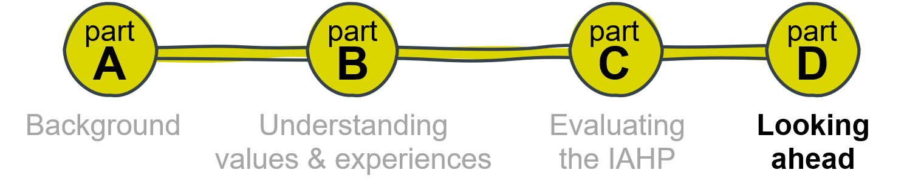
Overview of Part D
Part D draws on the findings set out in Parts B and C to identify opportunities to strengthen the impact of the investment in primary health care for Aboriginal and Torres Strait Islander people through the IAHP. Part D includes the following sections:
- Section 10 – Evaluative assessment provides explicit answers to the 4 KEQs and considers the overall appropriateness and effectiveness of the IAHP.
- Section 11 – Implications of the evaluation findings discusses the implications of the evaluation findings for strengthening the appropriateness and effectiveness of comprehensive PHC systems for Aboriginal and Torres Strait Islander people, and for the IAHP and the context in which it operates.
- Section 12 – Recommendations supports continuing investment in the IAHP and makes specific recommendations to improve the implementation and operation of the IAHP to ensure it realises the program objectives. The key recommendations are connected to the Priority Reforms in the National Agreement on Closing the Gap to ensure that the IAHP is closely aligned to priority outcomes and activity under the National Agreement.

Evaluative Assessment
This section provides the overall answers to the KEQs. This section moves beyond what the evidence generated in the evaluation says, to what this evidence means for the evaluation of the IAHP.

The IAHP and its evaluation
The IAHP seeks to provide Aboriginal and Torres Strait Islander people with access to effective, high quality, comprehensive, and culturally appropriate PHC services in urban, regional and remote locations across Australia. The IAHP aims to improve: (1) the health of Aboriginal and Torres Strait Islander people; (2) access to high-quality, comprehensive and culturally safe and appropriate PHC; and (3) system level support to increase the effectiveness and efficiency of services for Aboriginal and Torres Strait Islander people.
Around 64% of the IAHP grant funding (approximately $575 million per annum) is spent under a PHC Services funding stream which includes funding for the PHC Program, New Directions Expansion, Australian Nurse Family Partnership Program, and Connected Beginnings. The remaining 36% of IAHP grant funding (approximately $320 million per annum) is spent across multiple programs and activities in 8 other funding streams. This includes programs to improve access to PHC, targeted health activities, the Tackling Indigenous Smoking program, mental health programs, and capital works programs. The majority (70%) of IAHP funding goes to ACCHSs and other Aboriginal and Torres Strait Islander organisations.
The PHC Program is the focus of this evaluation. However, the evaluation locates the PHC Program within the context of the IAHP as a whole, and the wider PHC and health systems. This involves evaluating how the PHC Program and the IAHP: (1) enables health services to provide better comprehensive PHC for Aboriginal and Torres Strait Islander people; and (2) interacts with and influences other parts of the PHC and wider health systems to provide better comprehensive PHC for Aboriginal and Torres Strait Islander people.

Explicit answers to the evaluation questions
This section provides explicit answers to KEQs 1-4. These KEQs are the big picture questions about how well the IAHP is enabling the PHC system to work and the difference it is making. Answering these questions requires lifting the analysis of evidence up a level to consider the overall appropriateness and effectiveness of the IAHP. Providing explicit, and succinct, answers to the KEQs involved attenuating some of the complexity within the IAHP and the contexts in which it operates, to identify system-level changes and impacts consistent with the scope of the evaluation. The evaluation acknowledges that this risks minimising some of the complex elements at play and the way these elements interact.

KEQ1: How well is the IAHP enabling the PHC system to work for Aboriginal and Torres Strait Islander people?
By asking how well the IAHP is enabling the system to work, KEQ1 is explicitly evaluative. The core of the question is how the IAHP, as a program, enables, or makes it possible, for the PHC system to work. The question, therefore, requires an understanding of how the IAHP interacts with the broader PHC system. Critically, the question is about the PHC system working for Aboriginal and Torres Strait Islander people. This requires an understanding of what is important for Aboriginal and Torres Strait Islander people in terms of a PHC system, an understanding of their experiences of the health system, and of the interactions between Aboriginal and Torres Strait Islander communities and the health system.
The evaluation found that Aboriginal and Torres Strait Islander people value comprehensive PHC that is delivered seamlessly by health professionals who demonstrate an ethic of care and responsibility, and who understand and are responsive to local contexts. That is, Aboriginal and Torres Strait Islander people value the type of health care that originally drove the community-led establishment of ACCHSs and continues to shape the models of care that ACCHSs strive to deliver.
Aboriginal and Torres Strait Islander people’s experiences of health care are diverse. Using what people value about health care as a benchmark, the performance of the health system as a whole is inconsistent and is not meeting this standard overall. However, people’s experiences are generally better in ACCHSs and the discordance is predominantly experienced when people move across health service systems and access specialist services and hospital-based care. Therefore, through providing critical funding to ACCHSs, the IAHP enables this part of the PHC system to work better for Aboriginal and Torres Strait Islander people. There are still inconsistencies, however, in how well the IAHP is enabling funded organisations to deliver care that meets people’s needs.
Critically, the IAHP PHC Program funding provides medium-term and stable funding that enables funded organisations, the majority of which are ACCHSs, to operate, employ health professionals and deliver services to Aboriginal and Torres Strait Islander people. These services are mostly delivered in ways that meet the needs of Aboriginal and Torres Strait Islander people better than mainstream health services. The IAHP also directly contributes to Aboriginal and Torres Strait Islander people being able to navigate the health system, primarily through the ITC program. This is an important contribution, given the poor experiences Aboriginal and Torres Strait Islander people reported when accessing services and moving across health service systems.
The evaluation found that there are opportunities to increase the role of IAHP funding to enable the health system to deliver PHC that aligns with what Aboriginal and Torres Strait Islander people value. This evaluation identified two core factors that appear to constrain the realisation of this objective. The first is that while the IAHP provides critical funding to ACCHSs, the amount of funding does not consistently enable funded organisations to provide the comprehensive PHC services that are valued by Aboriginal and Torres Strait Islander people. For example, in practice, PHC Program funding is mostly applied by ACCHSs to the delivery of core clinical PHC services.
Supporting the delivery of clinical services to Aboriginal and Torres Strait Islander people is an essential feature of the IAHP and one that is valued and prioritised by funded services. The delivery of clinical services is essential to supporting access to health care and community-based responses to the disproportionately high burden of disease experienced by Aboriginal and Torres Strait Islander people. However, the pool of funding available through the IAHP does not consistently enable funded services to build this clinical offering into a model of care than includes holistic services and support that aligns with what Aboriginal and Torres Strait Islander people value. This would include the community engagement, health promotion and prevention programs and activities that are characteristic of comprehensive PHC models and aligned to the way that many services want to work more proactively to support early intervention and improve health outcomes in their communities. The gap in expenditure on health care for Aboriginal and Torres Strait Islander people has been estimated through research commissioned by the NACCHO. This research reported the gap in total recurrent health expenditure at $4.4 billion (National Aboriginal Community Controlled Health Organisation & Equity Economics, 2022).
Improvements to the quantum and administration of IAHP funding may further enable the influence of the IAHP to be extended to improve the PHC system for Aboriginal and Torres Strait Islander people. The way that the IAHP funding is mobilised can mirror some of the system fragmentation that undermines the capacity of the health system to deliver effective, high quality, comprehensive and culturally appropriate services for Aboriginal and Torres Strait Islander people. This is not unique to the IAHP. However, the impact of this fragmented approach directly conflicts with Aboriginal and Torres Strait Islander approaches to health and wellbeing and the expression of what Aboriginal and Torres Strait Islander people value in health care identified in this evaluation. This also places limitations on the capacity of funded services who experience resourcing implications associated with multiple funding and reporting arrangements over various funding streams and programs, including programs that target highly specific health needs. While the recent shift in approach to funding through longer funding arrangements has alleviated some of the direct impact of funding and reporting arrangements for the IAHP, most services are still operating in a PHC system that requires them to source multiple streams of funding to meet the identified needs in their communities and deliver the type of holistic care that is valued by Aboriginal and Torres Strait Islander people in those communities.
The IAHP is administered through standard commissioning processes with centralised program design, standard application and assessment processes, and grant management and reporting requirements. These top-down and transactional approaches to funding do not reflect the relational way that most funded organisations (the majority of whom are ACCHSs) work and do not give effect to the right to self-determination. Critically, revised commissioning approaches have emerged under the IAHP, such as co-design processes, and the PHC Program does provide a degree of flexibility and ‘untied’ funding to enable services to make choices about how to allocate the PHC funding. These approaches have considerable potential to shape how the IAHP enables the PHC system to work for Aboriginal and Torres Strait Islander people through supporting community-led decision-making about service design and delivery. Notably, however, this choice-making is still constrained by the limited pool of funding and the reporting and administrative requirements associated with grant funding.
The IAHP recognises that ACCHSs are a critical part of the PHC system. The IAHP enables funded organisations, the majority of which are ACCHSs, to operate and provide PHC services to Aboriginal and Torres Strait Islander people. In this way, the IAHP is enabling the PHC system to work for the clients of these funded organisations (currently representing around 45% of the total Aboriginal and Torres Strait Islander population) through the provision of PHC that is more likely to be aligned with their values than services delivered through mainstream settings. However, the IAHP is not consistently enabling the PHC system to work well for Aboriginal and Torres Strait Islander people when assessed by the identified values and needs of Aboriginal and Torres Strait Islander people.
Current constraints in the way that IAHP funding is mobilised may be addressed through new commissioning processes. However, improved commissioning will only be effective if the significant resource gap is also addressed. This will require a strategic approach to funding this part of the sector, that enables the resource gap to be closed.

KEQ2: What difference is the IAHP making to the PHC system?
In answering KEQ2, the evaluation was guided by the sub-questions under this KEQ. These sub-questions indicate the dimensions of the PHC system of specific focus for the evaluation, including funding, service delivery, governance, knowledge and information, and workforce. The sub-questions also indicate the direction and type of difference of interest to the evaluation. For example, there are questions about the contribution of the IAHP to the system and questions about how the system enables the implementation of the IAHP, therefore covering change in both/dual direction(s). Many of the questions also include words such as enabling, contributing, informing, supporting, working with, interacting and supplementing which have guided the type of difference the IAHP is expected to make.
The evaluation found a lack of clarity about how the IAHP is intended to work with the rest of the PHC system and, therefore, uncertainty over the difference the IAHP is expected to make to the PHC system. This has important implications when attempting to make judgements about the difference that the IAHP is making in this area.
In terms of different dimensions of the PHC system:
- The IAHP makes a critical contribution to the service delivery capacity of funded organisations. These organisations deliver primary care services to around 45% of the Aboriginal and Torres Strait Islander population. The counterfactual (no IAHP) would have significant implications for Aboriginal and Torres Strait Islander people’s access to effective, high quality, comprehensive, and culturally appropriate PHC services. Without IAHP funding, many of the funded services would not be able to operate. This demonstrates the critical value of the IAHP.
- From a health workforce perspective, the difference the IAHP makes can be interpreted differently. On the one hand, a significant proportion of IAHP funding is directed towards employing staff and the counterfactual (no IAHP) is that health services would need to significantly reduce staffing levels. On the other hand, current workforce challenges are significant across the health system and the ability of the IAHP to make a difference given current supply issues and other challenges, such as pay equity, is limited. Other than providing funding to services to employ a workforce, the IAHP currently has few policy levers to influence health workforce development. Given the significance of workforce issues to the health system, there is an opportunity for the IAHP to increase activity in this area to ensure there is investment in a workforce that can meet the health care needs of Aboriginal and Torres Strait Islander people. There are certainly implications for the effectiveness of the IAHP if the organisations funded to deliver comprehensive PHC do not have access to a competent, appropriate and stable workforce.
- In terms of system governance and leadership, the evidence indicates that the IAHP is not integrated with whole-of-systems processes. As a consequence, the opportunity to draw on the strengths of the IAHP to deliver integrated policy responses to whole-of-system and whole-of-government commitments has not been fully realised. This is not to say that there is no governance and leadership oversight over the IAHP; there are processes for specific programs and activities and committed individuals and strong partnerships. There is an opportunity to extend on this to build whole-of-IAHP governance and leadership, and strengthen processes for shared decision-making, including at regional and local levels. The department continues to address this gap and is building the mechanisms to support a more active and inclusive partnership with funded services, consistent with self-determination.
- From a knowledge and information perspective, the IAHP contributes to significant data and information about funded organisations and on process-of-care indicators. The knowledge and information processes for the IAHP have been streamlined and improved, including a shared process with ACCHSs to revise the OSR and nKPIs. While there have been improvements to the reporting arrangements for IAHP, the need to supplement funding from other sources resulted in services feeling overburdened by multiple reporting requirements. Moreover, while there is support for effective data and knowledge transfer processes to support continuous improvement, there is a perception that current arrangements do not provide this opportunity and are driven by compliance rather than being orientated towards improvement and learning. Any future effort to improve the data and knowledge transfer processes for the IAHP should focus on delivering transformational change to support community-led decision-making through relevant, outcomes-driven data collection and transfer processes.
There has been considerable investment in the knowledge and information systems around the IAHP, notably the OSR and nKPI data collections, and there is improved balance between data collection and reporting burden. Any decisions on managing perceived shortcomings need careful consideration. At the same time, achieving an acceptable return on this investment in knowledge and information is paramount. There is work going on beyond the IAHP on the PHC minimum data set. This will deliver incremental improvements but perhaps not the transformational change needed to drive access to, and the capability to use, locally-relevant data and information, as committed to in the National Agreement on Closing the Gap.
It is clear that the IAHP makes a strong contribution to system capacity to deliver primary health services to Aboriginal and Torres Strait Islander people. There is less clarity on how well the IAHP enables activity in other parts of the PHC system. Equally, reflecting the dual direction of many of the evaluation questions, there are also inconsistencies in how well the rest of the PHC system is enabling the IAHP to work. Overall, there is evidence that the limited integration of the IAHP with the wider PHC system has an influence on how the IAHP is expected to contribute to whole of system impacts and outcomes.

KEQ3: What difference is the IAHP making to the health and wellbeing of Aboriginal and Torres Strait Islander people?
The evaluation considered how the health and wellbeing of Aboriginal and Torres Strait Islander people is changing over time. The evaluation also examined how PHC activity was associated with changes in health and wellbeing outcomes, and the influence of other determinants on outcomes. There was limited ability to attribute changes in health and wellbeing to IAHP investments.
Trends in the health and wellbeing of Aboriginal and Torres Strait Islander people
The evaluation findings align with other data indicating mixed results in trends in Aboriginal and Torres Strait Islander health and wellbeing. The burden of disease among Aboriginal and Torres Strait Islander people is 2.3 times greater than the burden among non-Indigenous Australians (Australian Institute of Health and Welfare, 2022a). This relative gap in burden remained stable between 2003 and 2018 although the absolute gap between Aboriginal and Torres Strait Islander people and non-Indigenous Australians decreased (DALY rate differences of 263 and 222 per 1,000 people).
Five disease groups accounted for almost two-thirds (63%) of the total disease burden among Aboriginal and Torres Strait Islander people: mental and substance use disorders, injuries, cardiovascular diseases, cancer and other neoplasms, and musculoskeletal conditions. In 2018, 49% of the burden of disease in Aboriginal and Torres Strait Islander people could potentially have been prevented by avoiding exposure to modifiable risk factors (Australian Institute of Health and Welfare, 2022a). The risk factors contributing to the most burden were tobacco use (11.9% to total burden), alcohol use (10.5%), overweight, including obesity (9.7%) illicit drug use (6.9%), and dietary risks (6.2%).
The evaluation found that over one-third (9 of 24) of nKPI process-of-care and health outcome indicators showed meaningful improvement across the evaluation sites over June 2017 to December 2019. Three indicators showed change in a non-favourable direction over this period. Nationally, of 23 nKPI measures, between June 2017 and June 2022, 3 showed improvement, 5 showed no (or limited) change, 10 had not improved, and trends for 5 could not be calculated.
National data on health-related Closing the Gap outcomes and targets indicates:
- Improvements in life expectancy for Aboriginal and Torres Strait Islander people between 2005-07 and 2015-17 and a narrowing of the gap between Aboriginal and Torres Strait Islander people and non-Indigenous Australians (from 11.4 years to 8.6 years for males and from 9.6 years to 7.8 years for females). However, the 2031 target (closing the gap) is not on track to be met.
- No overall change in the proportion of Aboriginal and Torres Strait Islander babies with a healthy birthweight (89%) between 2014 and 2020. The 2031 target (91%) is not on track to be met.
- An increase in the suicide mortality rate for Aboriginal and Torres Strait Islander people between 2009 and 2021. The 2031 target (significant and sustained reduction towards zero) is not on track to be met.
The influence of primary care activity on the health and wellbeing of Aboriginal and Torres Strait Islander people
Primary health care is a core part of any health system, with international evidence indicating that a strong PHC system correlates with better health outcomes, reduced national health care expenditure, and lower infant mortality rates (Starfield & Shi, 2002). The evaluation found high variation in health care activity, such as health assessments, GP management plans, testing, immunisation and recording of data across the evaluation sites, and that higher levels of activity tended to cluster together. Across the evaluation sites, the proportion of Aboriginal and Torres Strait Islander people who received health assessments increased between 2012-13 and 2018-19, from a median of 157 to 280 per 1,000 Aboriginal and Torres Strait Islander people. This is similar to the national rate which increased from 161 to 288 over the same period. There has been a decline over the past 2 years to a rate of 272 per 1,000 Aboriginal and Torres Strait Islander people.
The evaluation found that higher levels of primary care activity were associated with increased levels of hospital care for many diagnoses. Taking a case study of diabetes, the evaluation found that increased primary care activity, couple with increased hospital care was associated with lower rates of mortality for diabetes. Therefore, taken together, more primary and hospital care was contributing to improved mortality outcomes.
Potentially avoidable deaths and potentially preventable hospitalisations are used in Australia as performance indicators for the accessibility and effectiveness of the health system, including hospital, primary and community care. Deaths of Aboriginal and Torres Strait Islander people determined as potentially avoidable represent 79.3% of all deaths at all ages; this is 2.5 times the proportion for non-Indigenous Australians. Moreover, Aboriginal and Torres Strait Islander people experience potentially preventable hospitalisations (PPH) at a rate 3 times as high as non-Indigenous Australians (Australian Institute of Health and Welfare, 2020c). In 2017-18, there were nearly 45,000 PPH for Aboriginal and Torres Strait Islander people. Between 2012-13 and 2017-18, the rate of PPH for Aboriginal and Torres Strait Islander people increased by 25%, compared with a 15% increase for non-Indigenous Australians. PPH rates often increase with increasing remoteness and socioeconomic disadvantage. The PPH gap between people living in very remote areas and major cities widened between 2012-13 and 2017-18. Similarly, the gap between people living in the lowest and highest socioeconomic areas widened for a number of conditions (Australian Institute of Health and Welfare, 2020c).
The evaluation finding of the association between higher levels of primary care activity and hospitalisations is not uncommon (for example, Starfield, 1991). When PHC access is gained in a community it is not unusual to see hospitalisation climb, as people are more likely to be referred to hospital. Evidence from linked primary care clinic and hospital data for Aboriginal and Torres Strait Islander people in the remote NT (Zhao et al., 2013) shows a U-shaped association between number of PHC visits and hospitalisations – there was an inverse association between PHC visits and hospitalisations for people with less than 4 primary care clinic visits per year, but a positive association for those visiting the clinic four times or more.
The evaluation findings on the relative influence of other determinants of health on outcomes, such as economic resources and socioeconomic advantage, are well understood. For example, the Health Plan (p.20, Australian Department of Health, 2021) reports that social determinants of health account for 34% of the total gap in health outcomes between Aboriginal and Torres Strait Islander people and non-Indigenous Australians.
The various health and wellbeing measures discussed here require action on both health care and its determinants. If the model of Aboriginal and Torres Strait Islander community-controlled comprehensive PHC is fully applied, more favourable health and wellbeing outcomes could be expected. Notably, much of the data referenced above refers to the whole Aboriginal and Torres Strait Islander population, rather than the approximate 45% who attend an Aboriginal and Torres Strait Islander health service. As reported in this evaluation, many ACCHS staff discussed their focus on the initial acute response to meeting the needs of their communities, and similarly talked about the clinical focus of the IAHP. They also discussed their interest in engaging in wider health determinants.

KEQ4: How can faster progress be made towards improving the health and wellbeing of Aboriginal and Torres Strait Islander people?
In answering KEQ4, the evaluation was guided by the sub-questions under this KEQ which ask about the changes, actions and improvements required to the IAHP and the context in which it operates that will contribute to improved health and wellbeing for Aboriginal and Torres Strait Islander people.
To support faster progress towards improving the health and wellbeing of Aboriginal and Torres Strait Islander people, evaluation participants identified the need to:
- strengthen governance and accountability processes across the IAHP
- strengthen shared decision-making processes and formal partnerships with ACCHSs and communities, including in the commissioning of IAHP programs and activities
- scale up investment to support the delivery of comprehensive PHC
- strengthen the coordination between the IAHP and the rest of the health system, including through supporting integrated models of care and to reduce the fragmentation in funding
- improve the use of knowledge and information, including to better reflect what Aboriginal and Torres Strait Islander people value, to recognise and incorporate culturally-relevant knowledge systems to monitor outcomes, and to support health service decision-making.
Specific changes, actions and improvements to support faster progress towards improving the health and wellbeing of Aboriginal and Torres Strait Islander people identified by the evaluation are included in the evaluation’s recommendations (Section 12).
The IAHP is being implemented within a landscape of policy reform and refresh. These changes have the potential to reorientate the health system in ways that strengthen access to comprehensive PHC services for all Aboriginal and Torres Strait Islander people. The ACCHS sector provides a platform for change. Over the past 50 years, the ACCHS sector built much of the system architecture, experience and capability required as a foundation for change and improvement. This architecture and capability has been built with support from the IAHP and its predecessor programs. Recent experience with the COVID-19 pandemic response demonstrated the value of the sector and its ability to mount an agile response to an immediate threat.
Implementation fidelity is critical to successfully translating policy into practice. The recommendations from the evaluation must consider important contextual factors. Tweaking the IAHP will not, on its own, bring the change needed to close health inequities. Solutions need to recognise the complexity of the system and the lack of significant progress on outcomes for some time, despite considerable effort. This includes macro changes that will require time to implement and embed. To be successful, the implementation of changes needs to be actively managed.
Solutions must come from genuine engagement and partnerships with all partners and stakeholders. Solutions must also be person-centred – place people’s experiences of care and people’s-reported health and wellbeing outcomes at the centre of decision-making and system changes.

Implications of the evaluation findings
This section discusses the implications of the evaluation findings for strengthening the appropriateness and effectiveness of comprehensive PHC systems for Aboriginal and Torres Strait Islander people, and for the IAHP and the context in which it operates. These are the evaluation’s strategic implications. Addressing these requires strategies and tactics directed at health system complexities. The time is right to tackle these challenges as evidenced by current political ambition, a strong policy framework, strong leadership and capability within the Aboriginal and Torres Strait Islander community-controlled health sector including an existing systems architecture, recent experience in new ways of working, and ongoing reform work across the Australian PHC system that is seeking to strengthen the system in similar ways.
The strength and capability of the Aboriginal and Torres Strait Islander community-controlled sector, as the main service delivery partners of IAHP programs and activities, is particularly relevant in considering the implications of the evaluation findings. The largest ACCHSs have well over 500 staff with significant capability in health policy, public health, data and research and, increasingly, in health service commissioning. These organisations have diverse sources of funding and are consistently able to attract mainstream funding sources, including Medicare funding. They also report how critical the IAHP funding is to their operations. These organisations often have direct lines of communication with policy-makers and funders and do not rely on support from intermediaries such as PHNs and peak bodies.
On-the-other-hand, there are also many small ACCHSs, servicing small local communities and with limited capability in areas like policy and data and research. This evolving configuration of the community-controlled sector is important context. The increasingly diverse capacity and capability of the community-controlled sector requires a nuanced central policy and funding response, including how to leverage the depth of expertise that is now in these larger local organisations, as well as directly supporting smaller organisations to build their capability.
The evaluation also heard about the growth in regional partnerships and networks of ACCHSs who are collaborating to, variously, strengthen coordination and pool resourcing (see Section 9.4, for example).
There is an expectation that the Aboriginal and Torres Strait Islander community-controlled sector will be supported to continue to play a significant role in Closing the Gap for Aboriginal and Torres Strait Islander people. This is evidenced through the priorities and actions in the National Agreement on Closing the Gap, the National Aboriginal and Torres Strait Islander Health Plan and the Primary Health Care 10 Year Plan.
The expertise and knowledge systems in the community-controlled sector have value beyond the delivery of health care to Aboriginal and Torres Strait Islander people. Mainstream PHC reform processes, including the Primary Health Care 10 Year Plan and strengthening Medicare reforms, present a vision for PHC that strongly aligns with the model of Aboriginal and Torres Strait Islander community-controlled comprehensive PHC. This includes, for example, a focus on multidisciplinary team-based care and empowering consumers to have a voice in the design of services. The legacy, creativity, capability and experience across the ACCHS sector has the potential to contribute to whole-of-population reforms.

Embedding self-determination and genuine partnerships
There was a high degree of discussion across the evaluation around partnerships and shared decision-making. This included participants sharing experiences of partnership working, such as in co-design processes, as part of the response to the COVID-19 pandemic, and health services and PHNs forming regional alliances and networks. There are strong commitments across the current policy framework to sharing power and decision-making, and these are mirrored by growing expectations across Aboriginal and Torres Strait Islander communities for genuine partnership working. At the highest level, these commitments and expectations reflect Aboriginal and Torres Strait Islander people’s rights to self-determination, coupled with increased transparency and accountability in the relationship between governments and Aboriginal and Torres Strait Islander people.
In terms of the implications of the findings for the IAHP and the context in which it operates, the evaluation identified some strong practice to build on and some important principles to enable the IAHP to meet government policy commitments and the rights and expectations of Aboriginal and Torres Strait Islander people and communities. These include:
- Enable shared decision-making partnerships at all levels of the health system, from the individual through to national policy and funding decisions.
- Grow and adapt existing partnerships. The IAHP does not need entirely separate partnership approaches which silo decision-making off from the rest of the health system. For example, at the national level, the administration of the IAHP could sit within a broader partnership covering the implementation of the National Aboriginal and Torres Strait Islander Health Plan.
- Support decision-making processes as close to the health service client and community as possible. As a general principle, decision-making partnerships should be place-based, recognising the unique circumstances and contexts of Aboriginal and Torres Strait Islander communities. Acknowledging that this is not always feasible, the IAHP should be guided by Aboriginal and Torres Strait Islander community led mechanisms and structures for decision-making such as alliances, networks and peak bodies.
- Where centralised decision-making mechanisms and structures are used, ensure that there are genuine opportunities for direct participation by community and regional partners.
- Enable Aboriginal and Torres Strait Islander communities to lead. Communities and ACCHSs know what works in their community. This was strongly demonstrated in the COVID-19 response. In the context of the IAHP, communities and ACCHSs need to be enabled to lead community health needs assessment as a basis for informing service design. IAHP programs and activities then need to be sufficiently adaptable and flexible to respond to locally-defined needs.
Overall, transitioning to this new way of working under the IAHP requires the department to shift the balance of power to enable shared decision-making with Aboriginal and Torres Strait Islander communities. This will require more relational commissioning processes, including co-designing programs and activities with ACCHSs, providing longer-term and integrated funding agreements, providing more flexibility within funding agreements to support local decision-making, and shifting accountability arrangements to recognise the value and role of ACCHSs beyond contracted service providers and to address reciprocal accountability. It will also require sufficient capability within ACCHSs and the department to implement effective partnership working.
Encouragingly, there is strong basis of partnership working under the IAHP and elsewhere, for example the COVID-19 pandemic response, to build on. The ACCHS sector has the knowledge and skills to work in partnership with governments. The ACCHS sector can bring both national and local place-based experiences and solutions to the table, which transform the governments’ response in a timely, evidence-based and effective way. The COVID-19 response is a demonstrated example of shared decision-making and pooling of knowledge between the Australian, state and territory governments and the ACCHS sector to develop and execute a timely, effective, evidence-informed response to this crisis. This response kept thousands of people safe. The COVID-19 experience strengthened the long-standing working relationship between the department and NACCHO, and built confidence and trust in the ACCHS sector. Partnerships and shared decision-making need to be formalised and systematised across the IAHP and at all levels of the health system.

A strategic focus for the IAHP
There is a strong policy framework to support improvements to the delivery of comprehensive PHC and support improved health and wellbeing outcomes for Aboriginal and Torres Strait Islander people. Across this policy framework there are core commitments to:
- self-determination through transfer of power, decision-making, and resources to Aboriginal and Torres Strait Islander communities
- strengthening the community-controlled sector
- delivering holistic, person-centred approaches to health and wellbeing
- investing in addressing inequities in access and outcomes, including for Aboriginal and Torrs Strait Islander people
- linking policy commitments and activity to clearly defined and measurable outcomes
- ensuring that government is publicly accountable for targets and key outcomes through public reporting processes
- accountability to community through Aboriginal and Torres Strait Islander-led processes of monitoring and review
- recognition that improving health outcomes requires attention and action to address social and cultural determinants of health.
There is close alignment between policy framework commitments and the expectations and aspirations of site partners and people contributing to the evaluation. For example, the National Aboriginal and Torres Strait Islander Health Plan reflects the community ambition for greater control and agency in service delivery.
There is a real opportunity to give practical effect to these existing commitments and policy directions through improvements to the implementation of the IAHP. The department is looking at its policies and programs within the context of the current policy framework. For the IAHP, this presents an opportunity to:
- Set the strategic focus for the IAHP, including clarifying (and perhaps narrowing) the intent of the IAHP vis-à-vis expectations of mainstream funding and how the IAHP and mainstream funding are intended to work together. This needs to take a whole-of-program and whole-of-system approach, looking at the IAHP in its totality (across funding streams, programs and activities), and its place within the health system.
- Set an investment strategy for the IAHP, again through a whole-of-government approach that situates the IAHP within the context of all investment for Aboriginal and Torres Strait Islander comprehensive PHC. The investment strategy needs to consider the specific issue of financing for Aboriginal and Torres Strait Islander health and wellbeing outcomes that support realisation of the outcomes in the National Agreement on Closing the Gap. Financing is one of the gaps in the current policy framework.
- Sharpen the focus of the IAHP on pursuing health equity for Aboriginal and Torres Strait Islander people. This requires recognition that to address equity, which is an outcome measure, there needs to be additional investments, inputs and outputs for populations whose have a significant burden of disease. Hence the need for an additional funding mechanism, as is IAHP, over and above mainstream funding mechanisms. This funding mechanism needs to be resourced at a level commensurate with Closing the Gap. This also requires identifying and addressing equity issues within the population, including harder to reach populations, that the IAHP funding intends to support.
Setting the strategic focus of the IAHP within the context of the wider health system in partnership with Aboriginal and Torres Strait Islander people would contribute to a more coherent, coordinated and interconnected health system. It would elevate the IAHP from a funding program to an integrated funding and policy response to meet government policy commitments and make a stronger contribution to whole-off-government action to social determinants of health and wellbeing through the deep connection that funded organisations have with local communities.
In addition to setting the strategic focus for the IAHP, the evaluation findings indicate a need to focus on successfully translating the strategy into practice. This is not as simple as managing the delivery of IAHP funding. It requires having strategic oversight of the critical drivers of successful policy implementation. Based on best practice guidance (Department of the Prime Minister and Cabinet & Australian National Audit Office, 2014), this requires active management of pre-conditions and capabilities for successful implementation, including:
- sound governance arrangements
- the identification and management of risk
- effective stakeholder engagement
- an implementation roadmap, addressing matters such as timeframe, dependencies with other policies or activities, program logic, phases of implementation, roles and responsibilities, resourcing, and compliance with legal and policy requirements
- sufficient resources, including funding, workforce, capability and IT systems
- monitoring, review and evaluation processes for the active management of implementation.
This focus on implementation recognises that the IAHP operates within a complex system and the challenges of implementing a policy’s intent within a dynamic context is inherently challenging. It addresses concerns identified through the evaluation that Closing the Gap health targets will not be met.

Resourcing that matches ambition
The insufficiency of the investment in Aboriginal and Torres Strait Islander comprehensive PHC was strongly reported and acknowledged across participants in the evaluation. Fundamentally, the level of investment does not appear to match the degree of ambition signalled across the policy framework and many policy commitments lack an aligned financial plan.
The evaluation concludes that increased investment in Aboriginal and Torres Strait Islander comprehensive PHC is critical to:
- Enable ACCHSs to deliver their full model of care for comprehensive PHC, including across all 4 domains – governance, clinical services, policy direction and partnerships, community health promotion and empowerment – in the Core Services Framework (National Aboriginal Community Controlled Health Organisation, 2021b).
- Respond to increasing demand for services as a result of population growth and a population that requires high-level complex health care arrangements.
- Enable ACCHSs to attract and retain an appropriate multi-disciplinary workforce, including an Aboriginal and Torres Strait Islander workforce. A strong and stable Aboriginal and Torres Strait Islander workforce is essential to delivering health care that meets the needs of Aboriginal and Torres Strait Islander people.
Alongside these factors, there is a need to consider the sufficiency of funding against ambitions to address the determinants of health, and ambitions to extend the reach of ACCHSs. The evaluation notes that IAHP funded organisations provided services to around 443,000 Aboriginal and Torres Strait Islander clients in 2021-22 which represents 45% of the total estimated Aboriginal and Torres Strait Islander population. This indicates that around 55% of the population do not access PHC services at ACCHSs or other IAHP funded primary care organisations. The evaluation notes that the population not served by ACCHSs is invisible in much of the discourse on comprehensive PHC for Aboriginal and Torres Strait Islander people. Given the effectiveness of the model of Aboriginal and Torres Strait Islander community-controlled comprehensive PHC and the challenge presented by the Closing the Gap health targets, the evaluation concludes that a discussion on the appropriateness of a growth strategy to extend the reach of ACCHSs is warranted. This needs to be co-led by the ACCHS sector. It also needs to be cognisant of the tension in pursuing a growth strategy, if funding is constrained, when many services face significant challenges in providing a stable and appropriate service to their existing client base.
There is also a need to consider the implications of increasing the investment in Aboriginal and Torres Strait Islander comprehensive PHC for the IAHP. This needs to be considered within an investment strategy for comprehensive PHC (as discussed in Section 11). The evaluation concludes that the IAHP is a uniquely placed, and proven, mechanism for distributing funding dedicated to supporting Aboriginal and Torres Strait Islander community-controlled comprehensive PHC. However, the evaluation also acknowledges that current legislative authorities may restrict what can be funded through the IAHP and some areas of investment required, for example workforce, will need to be closely coordinated with mainstream investments and might be better delivered outside of the IAHP. At risk of the IAHP being everything to everybody, the evaluation concludes that increased IAHP funding should focus on the delivery of comprehensive PHC though Aboriginal and Torres Strait Islander community-controlled organisations.
The evaluation has not analysed the level of increased investment required. The evaluation acknowledges that other work has measured the gap in health expenditure for Aboriginal and Torres Strait Islander people (National Aboriginal Community Controlled Health Organisation & Equity Economics, 2022), and current commitments to increase the level of IAHP PHC Program funding by 3% per year. There is a need to develop robust costings. In the absence of robust costings, the evaluation suggests that a 3% per year funding growth rate is somewhat insufficient to deliver on the ambition in the current policy framework, including to close the health equity gap. The evaluation also concludes that there has been minimal real growth in IAHP funding over the last 5 years (18% inflation-adjusted, 7% inflation- and population-adjusted).
The evaluation notes that, over time, increased expenditure on the IAHP should contribute to savings in other health expenditure, notably on the public hospital system. Studies have measured the economic value of ACCHSs models of care and savings to the health system (for example, Deloitte, 2020). This return on investment could be investigated further, acknowledging that there were plans to undertake an economic evaluation of the IAHP in parallel to this evaluation, with a focus on articulating the IAHP’s return on investment.

Delivery of mainstream services
Addressing the ambition and commitments relating to Aboriginal and Torres Strait Islander people’s health and wellbeing across the policy framework requires a focus on improving the quality of care provided by mainstream health services. As noted in the National Aboriginal and Torres Strait Islander Health Plan (p.8, Australian Department of Health, 2021):
Many Aboriginal and Torres Strait Islander people access their health care from an Aboriginal Community Controlled Health Service (ACCHS). However, many are unable to access an ACCHS because of their location and other barriers. Others choose to use mainstream services, which means these services must be capable of providing high quality, culturally safe, trauma-aware, healing-informed and responsive care. This means that in addition to the continued focus on prioritising and extending the reach of ACCHS, there must also be a focus on greater access to primary health care services across the broader health system. This includes through government clinics, private general practitioners and mainstream community health services.
The evaluation estimates that around 55% of the Aboriginal and Torres Strait Islander population do not attend an ACCHS. Outside of primary care, almost all health services for Aboriginal and Torres Strait Islander people are delivered by mainstream organisations, including hospitals, ambulances, medical retrieval services, pharmacists, laboratories and diagnostic services. Mainstream services are, therefore, the major provider of health care to Aboriginal and Torres Strait Islander population. Even under the most optimistic scenario for growth of the ACCHS sector, the evaluation concludes that this is likely to remain the situation for some time; up to and beyond the target year for Closing the Gap (2031).
This means that mainstream services must be capable of providing high quality, culturally safe, trauma-aware, healing-informed and responsive care. This includes government primary care clinics, private general practitioners and mainstream community health services. Beyond PHC, this includes hospitals and other specialist health services. The evaluation found that Aboriginal and Torres Strait Islander people’s experiences of care were poorer in mainstream services and were commonly attributed to racism, cost, staff negligence, and health professional competencies.
Grant making under the IAHP has limited leverage over improving the quality of care provided by mainstream health services. The ITC program supports primary care clients on their health care journey, enabling access to medical specialist and allied health services, transport services and medical aids, and supporting the coordination of care across service providers. IAHP funded ACCHSs also ‘play critical roles in advocating for their communities’ rights to health, and in supporting mainstream services (like hospitals) to become more culturally safe and responsive’ (Australian Department of Health, 2021a). Separate to IAHP grant making, the First Nations Health Division plays a critical role in influencing other divisions within the department to improve access and outcomes for Aboriginal and Torres Strait Islander people, as well as influencing the direction of system-wide reforms such as to Medicare. NACCHO and its state and territory affiliates also play a critical role in advocating for policy reforms to ensure mainstream health services work better for Aboriginal and Torres Strait Islander people.
Despite having limited leverage, the performance of the IAHP is directly influenced by the quality of care Aboriginal and Torres Strait Islander people receive in mainstream health services such as hospitals and other referral services. The evaluation identifies two inter-related policy levers that would strengthen the IAHP through improvements to quality of care in mainstream health services – commissioning of services and improved integration of services.
The evaluation heard that ACCHSs want to be able to provide better support for clients on their health care journey. The ITC program provides an opportunity to do this; but the potential scale of impact is limited due to resourcing limitations and narrow eligibility. The evaluation also heard that some ACCHSs are playing a role in the commissioning of health services (for example, aged care services), making decisions about how resources are allocated and what services are provided. Aboriginal and Torres Strait Islander led commissioning shifts the balance of power and decision-making to Aboriginal and Torres Strait Islander communities. It also has the potential to lead to more appropriate care and improved health outcomes as Aboriginal and Torres Strait Islander communities and organisations are well-placed to know what services their people need and what approaches to care work best for their people. This was evidenced in the commissioning of public health responses to the COVID-19 pandemic, such as health information and resources targeting Aboriginal and Torres Strait Islander communities.
An inter-related policy lever for strengthening mainstream health services for Aboriginal and Torres Strait Islander people is through strengthening integrated service delivery. People reported experiencing fragmented health services and suggests that ACCHSs and mainstream services often operate in parallel systems, with insufficient inter-connections. In addition, the lack of integration within mainstream services is well recognised and this has a disproportionate impact on Aboriginal and Torres Strait Islander people (for example, Australian Department of Health and Aged Care, 2022). The evaluation also heard encouraging examples of ACCHSs and mainstream services partnering to deliver integrated health care services. This includes, for example, a partnership between a local hospital network and an ACCHS to deliver a holistic, interdisciplinary metabolic clinic (see Section 9.4), and a partnership between a local hospital network, PHN and ACCHS to deliver a Hospital in the Home service that aims to integrate and better position care between the community provider and secondary care.
The evaluation concludes that, in addition to increased investment in the ITC program, the IAHP could play an enabling role in supporting ACCHSs to partner in the commissioning and delivery of mainstream health services. This must include supporting the capability and capacity of ACCHSs to engage in partnering and commissioning processes.
This focus aligns with actions in the Health Sector Strengthening Plan to develop processes in partnership with the ACCHS sector to support commissioning and other funding mechanisms such as preferred provider status. It also aligns with recommendations in the Strengthening Medicare Taskforce report to grow and invest in ACCHSs to commission primary care services for their communities.

Putting the values and experiences of people at the centre of program design and delivery
The evaluation identified some implications for the IAHP in terms of the realisation of person-centred care. The evaluation was grounded in the values and experiences of Aboriginal and Torres Strait Islander people and has strengthened understanding of what is important for Aboriginal and Torres Strait Islander people and how they experience the health system (as discussed in Part B of this report). The evaluation found that there is a disconnect between the intended operation of the IAHP and the lived experiences of people delivering and experiencing PHC.
The implications of the evaluation findings on what is important for Aboriginal and Torres Strait Islander people and putting this at the centre of health care, include:
- Self-determination – focusing on support for community-controlled services is an expression of self-determination. The IAHP also needs to consider how it can better activate meaningful community participation and decision-making in the design and delivery of programs and services, and how community control is recognised and valued as an integral part of effective comprehensive PHC.
- Place-based approaches – IAHP policy, programs and activities need to be able to be tailored and adapted to fit local community contexts, and be flexible to be responsive to changing contexts. As well as being responsive to broad geographic contexts (urban, regional, remote), this includes being responsive to environmental, social and cultural differences between communities.
- Consistency and continuity – the IAHP PHC Program provides fairly consistent and long-term resourcing to funded organisations. Shorter-term resourcing for other programs and activities can result in short-lived services and disruptions to continuity of care. Further shifting the balance of IAHP funding towards longer-term programs like the PHC Program would provide more certainty and consistency.
- Aboriginal and Torres Strait Islander staff – IAHP funded organisations are a major employer of Aboriginal and Torres Strait Islander people. Having Aboriginal and Torres Strait Islander staff in health services is valued by people for many reasons, including the positive influence these staff have on service design and delivery, cultural safety and familiarity, and for their relational approach to providing care and support. The multiple benefits of having a skilled Aboriginal and Torres Strait Islander workforce for the delivery person-centred primary care needs to be factored into policy and funding decisions across the health system.
- Physical spaces and infrastructure – the IAHP is a major funder of ACCHS infrastructure. The design of health clinics needs to consider the value of having services co-located, as well as the value of spaces for people to connect with each other, like courtyards and meeting rooms.
- Holistic and connected care – the IAHP supports the delivery of holistic comprehensive PHC. In addition to enabling services to focus on healing the whole person, this needs to be responsive to caring and healing that recognises connections to family, community and the environment. Practically, this means, for example, that the IAHP needs to be able to support programs and activities that facilitate collective approaches to wellbeing and caring on Country.
- Coordinated and integrated care – programs and staff that assist with care coordination are strongly valued by Aboriginal and Torres Strait Islander people. ITC care coordinators provide this support, as do other staff in ACCHSs. This support, and the potential to expand it, needs to be recognised in funding decisions.
- Care across the life course – Aboriginal and Torres Strait Islander people value health services that support their wellbeing across the life course. The evaluation found some gaps in services at critical stages in the life course, including preventative programs and services for young people. There is a need to better understand the nature of these gaps, for example whether the gap is related to an element of accessibility, such as availability or acceptability, and what this might mean for the IAHP. There is also a need to better understand the characteristics of groups not accessing PHC services. These groups were under-represented in the evaluation and it is critical to understand their needs from a health equity perspective.

Using data and information to inform care
The evaluation findings on what Aboriginal and Torres Strait Islander people value in health service design and delivery also has implications for the collection and use of data across the IAHP. This includes implications for a future IAHP accountability framework and for the development of an outcomes framework as phase 2 of the Core Services and Outcomes Framework (National Aboriginal Community Controlled Health Organisation, 2021b). Benchmarking and measuring performance against what is important to people should be a central component of knowledge and decision support systems. The implications of the evaluation include:
- Health needs assessments – current approaches to health needs assessment are biomedically focused and do not effectively capture Aboriginal and Torres Strait Islander concepts of health, and interpretation of the data is done in isolation from the communities concerned. HNAs also have limited influence over subsequent decision-making, including resource allocation to PHNs. Aboriginal and Torres Strait Islander concepts relevant to needs assessment will likely include issues of belonging and connection, holistic health, purpose and control, dignity and respect. Basic health needs are interwoven through other aspects of peoples’ families, communities, and culture, and are not seen in isolation; nor are they able to be addressed in isolation.
- Data systems – current data systems are largely built on administrative requirements for billing and funding purposes. Data systems are focused on demonstrating financial accountability to government for funds utilised, and enabling services to charge for specific activities, most of which are biomedically focused. The data systems have not been designed primarily around the information needed to inform health decision-making and improvement. Within the IAHP, the evaluation found the nKPI data collection lacked a focus on patient experience and outcomes, and it does not identify or measure a number of processes and outcomes relevant to the community or community-controlled health services.
Some ACCHSs and other providers collect data on what their communities value, including for ACCHSs through their board processes. However, these processes are not system wide, and not directly informing and shaping the governments and the system response. There is potential seen in linking data across community and hospital care subject to Indigenous Data Sovereignty Principles being met. Integrated data flows can support population-based funding, patient safety, coordinated care, and team-based care, as well as contribute to efficiency gains for clients and services.
Using data better to inform value-based care is central to the vision for strengthening Medicare (Australian Department of Health and Aged Care, 2022c). The IAHP and the community-controlled sector have a strong legacy in using data and the benefit of experience with existing data collections, such as the nKPIs, and a degree of consistency in clinical information systems.

Recommendations
This section sets out the evaluation’s recommendations. The recommendations cover changes, actions and improvements to support faster progress towards improving the health and wellbeing of Aboriginal and Torres Strait Islander people. This includes:
- recommendations to strengthen the design and implementation of the IAHP
- recommendations to strengthen the health system context in which the IAHP operates – action on these recommendations will support the delivery of PHC services funded through the IAHP.
The recommendations are based on the assessment of the IAHP against the KEQs, the implications of that assessment, and the need to locate and consider the IAHP within the broader health system.
The recommendations are directly informed by discussions and engagement with site partners over Cycle 3 of the evaluation on what needs to change and improve to make faster progress to support improvements to health and wellbeing for Aboriginal and Torres Strait Islander people. These discussions included a focus on what needs to change with the IAHP. There was also close engagement with site partners, the HSCG and the department over Cycle 3 on testing and refining of the evidence and insights generated through data collected in Cycles 1 and 2. This strengthened the credibility of the evidence and contributed to understanding about what this evidence meant in terms of changes needed to the IAHP and the broader health system.
A significant component of the development and testing of draft recommendations was through engagement and co-design processes with site partners at the national evaluation workshop in February 2023. This involved discussions around the intent, ambition and rationale for draft recommendation areas. Collectively, participants drew on significant experience in designing, implementing and delivering comprehensive PHC policy and programs in settings across Australia. Discussions at the workshop were captured in graphic format and these are included in Final Report Supporting Material Appendix L.

Introduction
The scope of the evaluation included the identification of ‘changes required at different levels of the system, in order to improve health outcomes for Aboriginal and Torres Strait Islander people’ (Objective 2a) and for the evaluation ‘to support informed policy, planning and decision-making that will enable improvements to be incorporated into the IAHP’ (Objective 3). KEQ4 also asks ‘how can faster progress be made towards improving the health and wellbeing of Aboriginal and Torres Strait Islander people?’. The supporting questions under KEQ4 ask:
- What, if anything, needs to change in the IAHP, the Implementation Plan [for the National Aboriginal and Torres Strait Islander Health Plan 2013-2023] and in the broader policy settings and processes? (4.1)
- What effective action can be taken to address the social and cultural determinants of health and environmental health? (4.2)
- What needs to change at different levels of the health system (site, state and territory, national)? (4.3)
- What needs to change in other policy areas (for example, education, employment, social security, housing, food)? (4.4)
- How can greater progress be made to achieve PHC system reform? (4.5)
In framing the evaluation’s recommendations, it is acknowledged that the department required that the evaluation focus on ‘the Australian Government’s Aboriginal and Torres Strait Islander specific PHC investment, but take a whole-of-systems, consumer-oriented lens’ (Australian Department of Health, 2021a, p. 4). Lastly in developing the recommendations, it is also acknowledged that much has changed in the policy and operational landscape since the evaluation commenced and it is important that the evaluation recommendations ‘speak into’ the current Aboriginal and Torres Strait Islander health policy landscape and are relevant to reforms that have emerged since the evaluation commenced in 2018.
As such, the evaluation’s recommendations align to and build on the Priority Reforms and objectives in the National Agreement on Closing the Gap, the National Aboriginal and Torres Strait Islander Health Plan and the Health Sector Strengthening Plan, focusing on the practical implementation of those priorities and objectives, particularly as they relate to the IAHP. There is widespread concern that the Closing the Gap’s health outcomes and associated indicators are not on track and will not be met by 2031. To deliver on Closing the Gap’s health expectation by 2031 requires sharper focus on issue within governments.

The gap is not closing fast enough. I know many people are frustrated by the lack of progress …. It is particularly disappointing to see the target for healthy birthweights for babies has gone from being ‘on track’ to ‘not on track’ …. More of the same isn’t good enough. We need to do things differently by working in partnership with communities to get better results.
The Hon Linda Burney MP, Minister for Indigenous Australians
In this policy context, the IAHP is a federal financing mechanism, that plays a fundamental role in supporting service delivery and the continued development of the Aboriginal and Torres Strait Islander community-controlled PHC sector. The evaluation recommendations focus on how the IAHP and elements of the broader health system in which it functions can be enhanced and expanded to improve health outcomes aligned to the Closing the Gap Priority Reforms.
The recommendations are grouped under the 4 Closing the Gap Priority Reforms, with an additional foundational recommendation and a final recommendation covering implementation issues. While the 4 Priority Reforms have been used as an organising framework for the recommendations, there are clear links across the recommendations, as there are across the 4 Priority Reform areas.
The evaluation recommendations do not imply that there is no current activity in the specific areas mentioned. Exemplary practice was observed during the evaluation; for example the early response to COVID 19. Some recommendations reflect lessons from this experience and recommend that best practice is scaled and formally recognised in the health system’s policies and processes.
Each recommendation includes an implementation timeframe based on immediate, medium and long term. There are tensions in policy, theory of change and Closing the Gap target timeframes. Timeframes for Closing the Gap target, at 2031, are in the medium term. Timeframes for policy-making and theory of change (mapping backwards from the projected length of time to deliver on a recommendation’s intent) will go beyond 2031. The evaluation has prioritised recommendations critical to Closing the Gap, but initial implementation of long term recommendations should be addressed concurrently. Table 12-1 provides a summary of the intended outcomes of each recommendation.

Table 12-1: Intended outcomes of the evaluation’s recommendations
Recommendation number and intended outcome
Foundational
1 | To sustain the IAHP as a specialised funder of comprehensive PHC
Priority Reform 1: Formal partnerships and shared decision-making
2 | To strengthen shared decision-making authority over the IAHP
3 | To determine the financial resources required to support the delivery of comprehensive PHC to all Aboriginal and Torres Strait Islander people through the development of an investment strategy for the IAHP
Priority Reform 2: Building the community-controlled sector
4 | To enable full implementation of the model of Aboriginal and Torres Strait Islander community-controlled comprehensive PHC through increased IAHP funding
5 | To support the delivery of IAHP-funded comprehensive PHC through the development of the Aboriginal and Torres Strait Islander health workforce
6 | To build the capability of community-controlled health services and support integrated care through supporting the development of alliances and partnerships
7 | To increase the flexibility and coordination of funding and reporting systems within and beyond the IAHP
Priority Reform 3: Transforming government organisations
8 | To improve the delivery of culturally safe and responsive services across the health system through supporting Aboriginal and Torres Strait Islander participation in mainstream health service governance, commissioning and delivery processes
9 | To strengthen the administration of the IAHP in partnership with Aboriginal and Torres Strait Islander though continuing to build capability within the First Nations Health Division
10 | To strengthen PHN roles in health service commissioning and the integration of local health services
Priority Reform 4: Shared access to data and information at a regional level
11 | To strengthen local decision-making on health service planning, design and delivery, including in relation to the IAHP, through funding ACCHSs to lead health needs assessments in their local communities
12 | To strengthen the relevance and use of IAHP data though revising data systems and reporting processes to reflect ACCHSs’ models of care and community aspirations for health and wellbeing
Implementation
13 | To strengthen the implementation of the IAHP through ensuring active and continuous leadership and management across all stages of the policy process

Foundational recommendation
The intent of this foundational recommendation is to ensure that the IAHP is sustained as a specialised funder of Aboriginal and Torres Strait Islander PHC through continued investment. This recommendation responds to evaluation findings that the IAHP investment is critical to the delivery of Aboriginal and Torres Strait Islander community-controlled PHC, and that this model aligns with Aboriginal and Torres Strait Islander people’s values and needs for health care.
Foundational recommendation
1
The Department of Health and Aged Care continue to invest in the delivery of comprehensive PHC services to Aboriginal and Torres Strait Islander people through the IAHP.
Continuation of this targeted investment recognises:
- The importance of comprehensive PHC for Aboriginal and Torres Strait Islander people.
- The value placed on comprehensive PHC delivered by Aboriginal and Torres Strait Islander people for Aboriginal and Torres Strait Islander people.
- The enduring barriers for Aboriginal and Torres Strait Islander people who access health services in mainstream settings.
Immediate term – Ongoing

Formal partnerships and shared decision-making
Recommendations aligned to Priority Reform 1 give purpose to commitments to Aboriginal and Torres Strait Islander people being empowered to share in the decisions government and health services make about their health. Formal partnerships and shared decision-making are important enablers for self-determination and the success of the IAHP.

Connection to policy priorities
Closing the Gap: Formal partnerships and shared decision-making (Priority Reform 1).
Closing the Gap Implementation Plan 2023: The Commonwealth commits to working in formal partnership and sharing decision-making with Aboriginal and Torres Strait Islander people to move beyond the ad-hoc engagement processes to genuine partnership based on a shared objective and strong partnership elements. The Commonwealth focused on establishing policy and place-based partnerships to support shared decision-making between the Coalition of Peaks members and all levels.
National Aboriginal and Torres Strait Islander Health Plan 2021-2031: Enabler of change; Priority 1: Genuine shared decision-making and partnerships.

The intent of these recommendations are to:
- Ensure that the IAHP delivers on the sentiment of no decisions are made about us without us. Aboriginal and Torres Strait Islander people will have control over or be in a shared decision-making partnership with the organisations and decision makers whose purpose is to improve health and health services for Aboriginal and Torres Strait Islander people. Under this recommendation, decisions must be made as close to the health service client and the community as possible. The decision-making processes will be transparent, and accountable to the government and the communities being served.
- Develop an overall investment strategy for Aboriginal and Torres Strait Islander comprehensive PHC that reflects the scope and ambition of policy commitments. The IAHP policy and funding will be aligned to this investment strategy. The shared decision-making partnership(s) will have stewardship over this strategy.

Recommendations: Formal partnerships and shared decision-making
2
The Department of Health and Aged Care to strengthen the alignment of the IAHP to a shared decision-making partnership with Aboriginal and Torres Strait Islander people.
To enable greater self-determination in the IAHP, the Department of Health and Aged Care to embed shared decision-making at the whole-of-program level. The shared decision-making partnership will strengthen co-design processes, and bring increased coherency, capability, transparency and accountability to decision-making relating to the funding of programs and activities through the IAHP.
In implementing this recommendation, the evaluation suggests:
- Growing and adapting existing partnerships to embed shared decision-making relating to the IAHP, rather than creating a new partnership arrangement specifically for the IAHP.
- Strengthening the connections between the IAHP and existing health reforms and priorities, including priorities in the National Agreement on Closing the Gap and the National Aboriginal and Torres Strait Islander Health Plan.
- Ensuring the composition of the partnership includes Aboriginal and Torres Strait Islander people with expertise in health service management, primary care clinical roles, public health, policy making, consumer experience and cultural expertise.
- Reporting directly to the executive level of the Department of Health and Aged Care to support increased accountability for the delivery of improved health and wellbeing outcomes for Aboriginal and Torres Strait Islander people.
- Creating accountability measures and processes based on the advice of Aboriginal and Torres Strait Islander people to support tracking and regular reporting on IAHP funding and program impacts and outcomes.
Immediate term
3
Co-design an investment strategy for the IAHP to improve access to comprehensive PHC and health and wellbeing outcomes for Aboriginal and Torres Strait Islander people.
To ensure the IAHP achieves its objectives and supports the delivery of significant health and whole-of-government policy commitments to improve outcomes for Aboriginal and Torres Strait Islander people, the Department of Health and Aged Care co-design an investment strategy for the IAHP with Aboriginal and Torres Strait Islander people.
The investment strategy should define the purpose and expected outcomes of the IAHP, as well as its theory of change – or the strategy, actions, conditions and resources required to facilitate change and achieve the agreed purpose and expected outcomes. The investment strategy needs to position the IAHP within the wider PHC system context, including other investments to improve the delivery of comprehensive PHC for all Aboriginal and Torres Strait Islander people. The strategy is intended to guide IAHP investments, including how funding will be mobilised, within the context of the wider PHC system.
In implementing this recommendation, the evaluation suggests:
- Ensuring that the IAHP investment strategy is connected to the realisation of Closing the Gap targets by 2031.
- Recognising that meeting existing policy commitments to improve outcomes will require substantial increased investment in Aboriginal and Torres Strait Islander comprehensive PHC.
- Increasing investment in comprehensive PHC through the IAHP is expected to support increased prevention and early intervention activity for Aboriginal and Torres Strait Islander people which will reduce the impact of chronic health conditions on the public health system as a whole.
- Ensuring that the investment required to achieve the IAHP’s objectives and outcomes reflects:
- commitments to grow, support and retain the Aboriginal and Torres Strait Islander health workforce, consistent with the National Aboriginal and Torres Strait Islander Health Workforce Strategic Framework and Implementation Plan
- commitments to building the Aboriginal and Torres Strait Islander community-controlled sector, consistent with the National Agreement on Closing the Gap
- differences in service delivery across different community and geographical settings
- changes in the costs of service delivery across different community and geographical settings, including changes in population health needs.
This recommendation supports action that is consistent with the realisation of commitments to improving health outcomes under the National Agreement on Closing the Gap and the National Aboriginal and Torres Strait Islander Health Plan through ensuring that health services are appropriately resourced to achieve these policy commitments
Immediate – Medium term

Strengthening the community-controlled sector
Recommendations aligned to Priority Reform 2 will strengthen the Aboriginal and Torres Strait Islander community-controlled health sector, building the capacity and capability of health services to deliver high quality services that meet community needs.

Connection to policy priorities
Closing the Gap: Building the Community Controlled Sector.
National Aboriginal and Torres Strait Islander Health Plan 2021-2031: Enabler of change; Priority 2: Aboriginal and Torres Strait Islander community controlled comprehensive primary health care.
Health Sector Strengthening Plan: Actions for strengthened Aboriginal and Torres Strait Islander community-controlled health sector including a consistent funding model.
Core Services and Outcomes Framework: The Model of Aboriginal and Torres Strait Islander Community Controlled Comprehensive Primary Health Care.

The intent of these recommendation is to give all Aboriginal and Torres Strait Islander people the choice of accessing comprehensive PHC delivered by an Aboriginal and Torres Strait Islander community-controlled organisation.
The modality of community-control for service provision offers direct benefits in terms of health system performance. Community-control also has indirect benefits through enabling a level of self-determination of health care by the community, and social and economic benefits though employment and training opportunities for Aboriginal and Torres Strait Islander people in health services, governance and leadership, business management and development.
ACCHSs are cost-effective and deliver greater health gains or benefits compared to the same programs delivered via mainstream primary care services. Community-controlled services have an impressive history of service innovation over the last 20 years. The innovation often comes within the context of using limited resources to meet the community’s health need.
Larger ACCHSs have grown their funding by diversifying their funding base, developing diverse income-generating activities. Funding comes from state and territory governments, including hospital funding streams; federal funding, including but not restricted to the IAHP; private sector and philanthropy; as well as volumes-driven MBS activities. Diversification protects these ACCHSs from policy shifts that impact on a single funding stream and gives them a degree of independence to pursue their own strategic agenda. These ACCHSs have used diverse funding mechanisms to grow to become major health providers. These large community- controlled organisations have increasing influence on the overall health response in their region and are expanding the scope of their activities beyond comprehensive PHC to include the pathways of care and commissioning through other parts of the health system.
Small ACCHSs in remote and regional areas have limited resources and are required to focus these resources on seeking out additional funding, or attempting to utilise mainstream funding modalities that are a poor fit with their context.
The growth of the ACCHS sector requires coordinated growth of funding, an Aboriginal and Torres Strait Islander workforce, a general health workforce, infrastructure, governance capability, and models of care, including investment in coordinated and integrated models of care. The IAHP is the only funder focused on ACCHSs and it plays a pivotal role in supporting the stability and growth of the ACCHS sector. However, the growth in resources available to the IAHP has not kept pace with population growth and health and wellbeing needs. ACCHSs struggle to keep up with demand.
Recommendations: Building the community-controlled sector
4
Continue to invest in improved health and wellbeing outcomes for Aboriginal and Torres Strait Islander people through increasing IAHP funding to support the delivery of Aboriginal and Torres Strait Islander community-controlled comprehensive PHC.
To enable ACCHSs to fully implement their model of comprehensive PHC and meet the health and wellbeing needs of their communities, the Department of Health and Aged Care to build on the strength of the IAHP by directing additional resourcing to community-controlled health services.
In implementing this recommendation, the evaluation suggests:
- Increasing the focus of the IAHP on funding programs and activities delivered by ACCHSs.
- Increasing the amount and the proportion of the IAHP funding allocated under the PHC Program (to address current policy commitments and population health needs the rate of funding increase needs to be significantly more than the current commitment of 3% per year).
- Ensuring that IAHP funding contributes to the growth and stability of ACCHSs, including the scope of services provided in relation to cultural and other health determinants.
- Ensuring that IAHP funding supports ACCHSs to function well through strengthening organisational governance, management and other ‘back-office’ functions that support the delivery of high-quality care.
- Considering fully funding ACCHSs that rely significantly on the IAHP as their primary funding source to ensure existing service capacity is invested in service delivery instead of additional fund-raising.
This recommendation supports action that is consistent with the development of the Core Services and Outcomes Framework, and commitments in the Health Sector Strengthening Plan to develop a needs-based funding model.
Medium term
5
Increase investment to support the development of a strong and stable Aboriginal and Torres Strait Islander PHC workforce.
To ensure a strong and stable workforce is available to support the delivery of community-controlled PHC services funded through the IAHP, the Department of Health and Aged Care to coordinate across the department (and with other government agencies with accountability for workforce training and regulation), to secure and build investment and improve conditions of employment for the Aboriginal and Torres Strait Islander PHC workforce.
In implementing this recommendation, the evaluation suggests:
- Undertaking a pay parity review, and subsequently acting on the review’s findings, to better understand salary inequities for Aboriginal and Torres Strait Islander Health Workers and Health Practitioners working in different workplace settings, including ACCHSs and mainstream health services.
- Strengthening incentives for employing, training and retaining a larger and more diverse (for example, gender diversity and across a range of roles) Aboriginal and Torres Strait Islander health workforce (for example, recognising skills, training, unique roles and cultural load through micro-credentialling and conditions of employment).
- Continuing to factor in costs associated with community-controlled health services hosting Aboriginal and Torres Strait Islander health worker trainees who require supervision and mentoring.
- Considering the need to also grow and sustain the Aboriginal and Torres Strait Islander health workforce across mainstream services.
Medium term
6
Support ACCHSs to connect regionally with other organisations to build partnerships and alliances that strengthen the community-controlled sector.
To enable community-controlled health services to build capability and support more integrated ways of working, funding through the IAHP to support ACCHSs to continue to lead the development of formal partnerships and alliances at a regional level. These partnerships and alliances may target different health system enablers – such as service delivery, governance, workforce, information and data sharing – that strengthen the operational context for the IAHP.
In implementing this recommendation, the evaluation suggests:
- Considering the role of the IAHP in addressing funding requirements to support ACCHSs to engage in formal partnerships.
- Respecting ACCHSs rights to determine partnership arrangements (not forcing partnerships through conditional funding or other mechanisms).
- Considering the benefits of supporting partnerships that go beyond ACCHSs (for example, between ACCHSs and mainstream organisations such as PHNs and local hospital networks).
Medium term
7
Increase the flexibility and coherency of funding, including through the IAHP, to support the delivery of comprehensive PHC to Aboriginal and Torres Strait Islander people and communities.
To further enable self-determination and more streamlined and integrated policy responses to Aboriginal and Torres Strait Islander comprehensive PHC, the Department of Health and Aged Care to coordinate across the department (and with other funders of comprehensive PHC) to develop more flexible and coherent funding and reporting systems. This will strengthen the alignment between the IAHP and other government funding programs.
In implementing this recommendation, the evaluation suggests:
- Developing needs-based and outcomes-based approaches to IAHP funding that accommodate flexibility in how services and activities are delivered and empowers decision-making at the community level. Under outcomes-based approaches, funded organisations would be required to deliver, and report against, pre-defined outcomes. There would be flexibility in how these outcomes were achieved.
- Maintaining a level of prescription to how services and activities are delivered where the model of care is supported by contextually-relevant evidence.
- Identifying opportunities to work across governments and government-funded services to develop more integrated approaches to funding PHC.
- Strengthening the delivery of comprehensive PHC by re-integrating social and emotional wellbeing and alcohol and drug program funding into the IAHP.
- Reviewing reporting frameworks for government funding provided to the ACCHS sector to identify opportunities to minimise and/or streamline reporting requirements while maintaining accountability (for example, strengthening of outcomes-based performance measures, consistent reporting timeframes and language, reducing redundancy, and opportunities for digitalisation.
- Designing reporting requirements for new programs and activities in partnership with providers ACCHSs to account for context of their overall reporting requirements and so that opportunities to streamline with existing reporting is maximised.
This recommendation recognises the comparative strengths of the IAHP within a complex funding system across multiple governments (Australian, state and territory) and agencies, and the opportunity to build on the strengths and the experience of the IAHP to support further improvement across government agencies involved in funding Aboriginal and Torres Strait Islander health services.
Immediate – Medium term

Transforming government organisations
Recommendations aligned to Priority Reform 3 will support transformation of mainstream institutions, including the Department of Health and Aged Care, PHNs and local hospital networks, to make them culturally safe and responsive to the health needs of Aboriginal and Torres Strait Islander people. These recommendations will also support strengthened relationships and partnerships between mainstream institutions and Aboriginal and Torres Strait Islander organisations, communities and people.

Connection to policy priorities
Closing the Gap: Transforming government organisations.
Closing the Gap Implementation Plan 2023: Target for a decrease in the proportion of Aboriginal and Torres Strait Islander people who have experiences of racism.
Health Sector Strengthening Plan: Actions for strengthened Aboriginal and Torres Strait Islander community-controlled health sector including workforce, service delivery and governance.
National Aboriginal and Torres Strait Islander Health Plan 2021-2031: Mainstream services must be capable of providing high quality, culturally safe, trauma-aware, healing-informed, and responsive care.

The intent of these recommendations is to improve the quality of care provided by mainstream health services to Aboriginal and Torres Strait Islander people, such that all mainstream services for Aboriginal and Torres Strait Islander people are providing culturally safe, trauma-aware, healing-informed, and responsive care. Further, that all primary care services for Aboriginal and Torres Strait Islander people provide comprehensive PHC. Underpinning and sustaining this future state will be increased influence of Aboriginal and Torres Strait Islander communities over all health services provided to Aboriginal and Torres Strait Islander people.
Transforming the experience and outcomes of care for Aboriginal and Torres Strait Islander people in mainstream services is essential for meeting Closing the Gap health targets. Similarly, improving the quality of care provided by mainstream services is essential to lifting the performance of the IAHP. Turning this around, the existence and growth of the ACCHS sector has a positive influence on mainstream service provision though demonstrating innovation in models of care, including the practice of community control, management and reporting of chronic disease management, and a culture of transparency and public reporting of their finances and activities. The recommendations under Priority Reform 2 and 3 are, therefore, interconnected.

Recommendations: Transforming government organisations
8
Support partnerships between mainstream health organisations and Aboriginal and Torres Strait Islander people to improve the delivery of culturally safe and responsive services across the health system.
To improve the safety and responsiveness of mainstream health services and improve health and wellbeing outcomes across the patient journey, the Department of Health and Aged care to work with state and territory governments and Aboriginal and Torres Strait Islander people and organisations to partner in health service governance, commissioning, and delivery processes.
In implementing this recommendation, the evaluation suggests additional funding be made available by the department to enable:
- Partnerships between mainstream services, PHNs and Aboriginal and Torres Strait Islander organisations and people to identify opportunities to influence outcomes for Aboriginal and Torres Strait Islander people across the patient journey.
- Strengthened participation of Aboriginal and Torres Strait Islander people in governance and leadership arrangements in mainstream health services, including local hospital networks.
- Increased leadership and participation by Aboriginal and Torres Strait Islander communities in the commissioning of mainstream health services that are used by Aboriginal and Torres Strait Islander people, including in assessing needs, planning services, procuring services and monitoring the quality of services.
- The development of health service and operational responses that improve the quality, appropriateness and integration of care across health service settings. This may include, for example, partnerships between ACCHSs and local hospital networks to facilitate integrated care arrangements, including, where appropriate, the transfer of specific, hospital-based services to community-controlled health services.
- Increased investment in the ITC program to strengthen the ability of ACCHSs to support patients’ journeys through the health system. This may involve expanding eligibility under the ITC program to increase access to support services, including services across the patient journey such as hospital and outpatient care.
This recommendation is consistent with recommendations by the Strengthening Medicare Taskforce to grow and invest in ACCHSs to commission primary care services for their communities; and to support local health system integration and person-centred care through PHNs working with local hospital networks, local practices, ACCHSs, pharmacies and other partners to facilitate integration of specialist and hospital services with primary care, and integrate primary care with mental health, aged care, community and disability services.
Medium – Long term

9
The Department of Health and Aged Care to strengthen Aboriginal and Torres Strait Islander health policy capability and capacity across the department, including in the specialist First Nations Health Division, to support shared policy decision-making, governance and accountability processes.
To strengthen the administration of the IAHP and embed health policy expertise and capability that enables the Department of Health and Aged Care to maintain strong and effective partnerships with Aboriginal and Torres Strait Islander people, the department continue to build Aboriginal and Torres Strait Islander health policy capability, including through a dedicated team.
In implementing this recommendation, the evaluation suggests:
- Strengthening workforce strategies to attract and retain staff with experience and expertise in Aboriginal and Torres Strait Islander health care and programs, including as a priority, Aboriginal and Torres Strait Islander staff.
- Embedding and practising cultural safety within the First Nations Health Division and across the Department of Health and Aged Care to support culturally responsive decision-making, stronger relationships and understanding of key issues affecting the administration of the IAHP and the delivery of PHC to Aboriginal and Torres Strait Islander people.
- Improving engagement with Aboriginal and Torres Strait Islander funded organisations and communities to build collaborative relationships and understand context specific issues affecting local service delivery.
- Strengthening formal connections between Aboriginal and Torres Strait Islander health policy expertise in the department and in Aboriginal and Torres Strait Islander peak bodies and ACCHSs.
- The First Nations Health Division continue to focus on engagement across the Department of Health and Aged Care and with central agencies to ensure collective responsibility for health outcomes for Aboriginal and Torres Strait Islander people.
- Strengthening Aboriginal and Torres Strait Islander health expertise at the most senior levels of departmental leadership and decision-making.
This recommendation is consistent with existing commitments in the National Agreement on Closing the Gap to transform government organisations, and the value identified in the evaluation of having a specialist, dedicated Aboriginal and Torres Strait Islander division (the First Nations Health Division) within the Department of Health and Aged Care.
Immediate term – Ongoing
10
The Department of Health and Aged Care to work with PHNs to strengthen the PHC system to improve care for Aboriginal and Torres Strait Islander people.
To continue to transform PHNs to be more accountable, culturally safe and responsive to the needs of Aboriginal and Torres Strait Islander people, the Department of Health and Aged Care to support and encourage PHNs to improve commissioning processes and the integration of local health care services.

In implementing this recommendation, the evaluation suggests:
- Supporting PHNs to strengthen governance and accountability processes for organisational transformation, including involving Aboriginal and Torres Strait Islander people and organisations in leadership and governance arrangements.
- Ensuring PHN commissioning processes are transparent and responsive to the identified needs of Aboriginal and Torres Strait Islander people within their community.
- Supporting PHNs and ACCHSs to engage in health service co-commissioning processes.
- Supporting alliances between PHNs, mainstream health services and Aboriginal and Torres Strait Islander organisations, communities and people, including through adequate resourcing to engage in collaboration and co-design activity.
- Ensuring outcomes and indicators in the PHN Program Performance and Quality Framework reflect the Priority Reforms in the National Agreement on Closing the Gap.
This recommendation is consistent with a recommendation in the Strengthening Medicare Taskforce to strengthen the role of PHNs to support the adoption of successful, locally designed models of care.
Medium term

Shared access to data and information at a regional level
Recommendations aligned to Priority Reform 4 will grow a knowledge driven system of health care for and with Aboriginal and Torres Strait Islander people.

Connection to policy priorities
Closing the Gap: Shared access to data and information at a regional level.
Closing the Gap Implementation Plan 2023: Target to increase the number of regional data projects to support Aboriginal and Torres Strait Islander communities to make decisions about Closing the Gap and their development.
Health Sector Strengthening Plan: Actions for strengthened Aboriginal and Torres Strait Islander community-controlled health sector including service delivery through minimisation/streamlining of reporting requirements (where appropriate).
National Aboriginal and Torres Strait Islander Health Plan 2021-2031: Culturally informed evidence base; Priority 11: Culturally informed and evidence-based evaluation, research and practice; Priority 12: Shared access to data and information at a regional level.
Core Services and Outcomes Framework: The Model of Aboriginal and Torres Strait Islander Community Controlled Comprehensive Primary Health Care.

The intent of these recommendations is to develop, with community involved governance and respecting data sovereignty, a whole of health system knowledge, data, and information system at the regional level. The system will be based on robust health needs assessment at the local level, serve as an accountability mechanism to both governments and the community, and contain utilisation, performance, experience, and outcome measures for all Aboriginal and Torres Strait Islander people.
Recommendations: Shared access to data and information at a regional level
11
Invest in Aboriginal and Torres Strait Islander communities to lead community health needs assessments to strengthen decision-making on health service planning, design and delivery.
To enable improved locally-responsive decision-making to support the planning, design and delivery of the IAHP and other programs and activities, the Department of Health and Aged Care to fund ACCHSs to lead health needs assessments in their local communities.
In implementing this recommendation, the evaluation suggests:
- Enabling Aboriginal and Torres Strait Islander communities to define the measures, processes and reporting for health needs assessments, and data capture, knowledge transfer and other reporting and accountability processes.
- Making sure that the IAHP and other funding programs are responsive to the outcomes of health needs assessments.
- Supporting the capacity of ACCHSs to collect and use data relating to health needs in their communities (for example, for CQI processes and to support service design and improvement), and to exercise their sovereignty over how data is used and interpreted (for example, whether it contributes to a PHN or local hospital network health needs assessment).
- Providing Aboriginal and Torres Strait Islander communities with access to locally-relevant data and information to support their health needs assessments, consistent with commitments to Indigenous Data Sovereignty and Indigenous Data Governance.
- Supporting ACCHSs (for example, through resources and training) to participate in research to generate evidence in relation to comprehensive PHC services and delivery.
This recommendation supports action that is consistent with the development of the needs assessment and outcome component of the Core Services and Outcomes Framework. This component is under development.
Medium – Long term
12
Improve the relevance and use of IAHP data and reporting processes to support shared accountability and decision-making on health service planning, design and delivery.
To strengthen the relevance and use of IAHP data, the Department of Health and Aged Care to work with the Aboriginal and Torres Strait Islander communities to ensure that IAHP data and reporting processes reflect ACCHSs’ models of care and community aspirations for health and wellbeing.
In implementing this recommendation, the evaluation suggests:
- Revising the nKPIs to broaden its focus to capture additional indicators that are useful for communities, including outcomes and people’s experience of care, and the practice of community control. This would include reviewing and managing the reporting burden and resourcing required to capture and report on additional indicators.
- Increasing transparency around the purpose of the IAHP data collections (nKPIs and OSR) and communicating to ACCHSs and communities when and how this data is used by the department.
- Ensuring all IAHP data uphold principles of Indigenous Data Sovereignty and Indigenous Data Governance.
Medium term

Ensuring IAHP implementation success
This recommendation on implementation cuts across all the recommendations. This recommendation will ensure that implementation considerations are considered throughout all the stages of the IAHP policy implementation. It recognises that successful policy implementation requires active and ongoing stewardship and management across the policy cycle; rather than only at a policy design stage.

Connection to policy priorities
Closing the Gap: Commitments to develop implementation plans and to Aboriginal and Torres Strait Islander people having access to information monitor the implementation of efforts to close the gap.
Closing the Gap Implementation Plan 2023: Monitoring of all outcomes and targets.
National Aboriginal and Torres Strait Islander Health Plan 2021-2031: Commitments to develop two 5-year Commonwealth Implementation Plans for the Health Plan, and to develop a robust accountability framework, and governance arrangement.

The intent of this recommendation is to ensure that the shared decision-making partnership with authority for the IAHP (Recommendation 2) has oversight of the critical drivers of implementation success of the IAHP, and regularly discusses and reviews progress and performance. This will help to ensure that the IAHP will be implemented on time, on budget and to expectations, and each of these are adequately considered and realistic. The Department of Health and Aged Care will apply the time, resources and capability to support successful implementation. Implementation challenges, risks, benefits and opportunities will be adequately considered and managed. The IAHP will continue to calibrate and adapt in response to data measurement and analysis, stakeholder engagement and feedback, and evaluation and review.

Recommendation: Ensuring IAHP implementation success
13
The Department of Health and Aged Care to provide active and continuous leadership and management of the ongoing implementation of the IAHP, including regular reporting to partners on progress against the co-design investment strategy.
To ensure that the IAHP is successful and achieves its objectives, the Department of Health and Aged Care to strengthen processes to support early, informed and systematic consideration of program issues, including the identification of actions and recommendations to inform program growth and improvement.
In implementing this recommendation, the evaluation suggests:
- Ensuring the proposed shared decision-making partnership has oversight of the ongoing implementation of the IAHP.
- Identifying and actively managing risks to the continued implementation of the IAHP.
- Identifying partners and stakeholders and how they will be engaged, including through co-design processes.
- Identifying resource requirements and managing constraints early.
- Establishing effective monitoring, review and evaluation processes to support active management of the ongoing implementation of the IAHP.
- Publishing outcome measures for the IAHP and performance against these to increase program transparency.
- Establishing annual measurement and reporting of government investment in the IAHP and in Aboriginal and Torres Strait Islander PHC.
Immediate term – Ongoing

Glossary + References

Glossary
Aboriginal community control in health services is defined by NACCHO, the national peak body for ACCHOs, as: ‘a process which allows the local Aboriginal community to be involved in its affairs in accordance with whatever protocols or procedures are determined by the Community’ (National Aboriginal Community Controlled Health Organisation, n.d.-a).
Aboriginal Community Controlled Health Organisation/Service (ACCHO)/ACCHS) is a ‘primary health care service initiated and operated by the local Aboriginal community to deliver holistic, comprehensive, and culturally appropriate health care to the community which controls it, through a locally elected Board of Management’. ACCHOs aim to support local Aboriginal and Torres Strait Islander communities to live better lives. The ACCHO approach evolved from the need to provide culturally appropriate responsive services designed to meet the needs of Aboriginal and Torres Strait Islander communities. Their holistic health approach supports the social, emotional, physical, and cultural wellbeing of Aboriginal and Torres Strait Islander people, families, and communities (National Aboriginal Community Controlled Health Organisation, n.d.-a).
Aboriginal Medical Service (AMS) refers to state and territory-managed Aboriginal Medical Services, and other non-community-controlled health services designed primarily to meet the needs of Aboriginal and Torres Strait Islander people. While all ACCHOs are AMSs, the reverse is not the case.
Access and coverage: ‘Access, utilization, availability and coverage are often used interchangeably to answer the question - are people in need of something for their health actually getting it? ... The difference between ‘access’ and ‘coverage’ is conceptually difficult’ (World Health Organization, 2005). For this evaluation, ‘access’ or ‘accessibility’ includes dimensions of availability, affordability, ability to engage, acceptability and approachability of the system (Davy et al., 2016a). ‘Coverage’ reflects the extent to which people in need receive important health interventions.
Co-design and co-creation: Co-design means the active involvement of stakeholders at national, regional, and local levels, whose perspectives will collectively inform and shape the ongoing iterations of the evaluation over the 4 years of its implementation. Co-creation means the collective creation of knowledge and understanding, solutions, responses, and actions to address issues. Co-design in this evaluation focuses on implementation, and co-creation addresses the findings emerging throughout the evaluation. Both co-design and co-creation focus on developing innovative solutions through participatory, collaborative processes (Bailey et al., 2018).

Comprehensive PHC is health care that is ‘high-quality, safe, comprehensive, integrated, accessible, available and affordable for everyone and everywhere, provided with compassion, respect and dignity by health professionals who are well-trained, skilled, motivated and committed’ (World Health Organization & United Nations Children’s Fund (UNICEF), 2018b).
Comprehensive PHC includes:
- interdisciplinary services and programs that are accessible, equitable, sustainable, culturally appropriate, safe, effective, and efficient
- person-centred services which empower individuals and the community to prevent and reduce risk behaviours and better self-manage their health and wellbeing, particularly for those with long term illness and chronic conditions
- illness prevention, health promotion and advocacy activities
- oral health
- local participation of the community in planning, organisation, operation, and evaluation of services
- strategies to address the health needs of individuals and communities by improving health literacy evidence-informed services and programs delivered by qualified practitioners (Public Health Association Australia, 2014).
The above definition aligns with NACCHO’s descriptions of comprehensive PHC in the Core Services and Outcomes Framework (National Aboriginal Community Controlled Health Organisation, 2021a).
Consumers are people who use PHC and other health services, sometimes also referred to as ‘patient’ or ‘client’.
Coverage: Refer to access above.
Cultural competency: A set of congruent behaviours, attitudes, and policies that come together in a system, agency, or among professionals to enable that system, agency. or those professionals to work effectively in cross-cultural situations (Cross et al., 1989) as used in the Cultural Respect Framework (2016, p. 18) .
Cultural safety comes from the premise that health consumers are safest when health professionals consider power relations, cultural differences, and patients’ rights. Health professionals do not define cultural safety. The health consumer’s experience determines it through the experience of care provided and their ability to access services and raise concerns. Part of this process requires health professionals to examine their realities, beliefs, and attitudes. The essential features of cultural safety are:
- an understanding of one’s culture
- an acknowledgment of difference and a requirement that caregivers are actively mindful and respectful of differences
- that theories of power relations inform cultural safety; attempts to depoliticise cultural safety misses the point
- an appreciation of the historical context of colonisation, the practices of racism at individual and institutional levels, and their impact on Aboriginal and Torres Strait Islander people’s living and wellbeing, both in the present and past
- that the recipient of care, not the caregiver, determines its presence or absence (Australian Health Ministers’ Advisory Council’s National Aboriginal and Torres Strait Islander Health Standing Committee, 2016, p. 18).
The National Aboriginal Community Controlled Health Organisation (NACCHO) is Australia's national leadership body for Aboriginal and Torres Strait Islander health. NACCHO represents its members – 143 ACCHOs in over 300 clinics across Australia (National Aboriginal Community Controlled Health Organisation, n.d.-b).
Peak Bodies: Refer to state and territory peak bodies.
Primary Health Care in the Australian health care system ‘encompasses a range of services delivered outside the hospital that generally do not need a referral. This includes unreferred medical services, for example, GP visits, dental, other health practitioner, pharmaceutical, and community and public health services’ (Australian Institute of Health and Welfare, 2016)

Site refers to a geographically defined area that is the focus of the IAHP Yarnes evaluation ‘place-based’ evaluation activities. Section 4.1.1 of the Monitoring and Evaluation Design Report (Bailey et al., 2018).
State and territory peak bodies, in this report, refer to eight state and territory peak bodies for Aboriginal and Torres Strait Islander community-controlled health services. These organisations are affiliate organisations of the NACCHO and are also referred to as Sector Support Organisations. They include Winnunga Nimmityjah Aboriginal Health and Community Services, the Aboriginal Health and Medical Research Council of NSW, the Aboriginal Medical Services Alliance Northern Territory, Queensland Aboriginal and Islander Health Council, Aboriginal Health Council of South Australia, Tasmanian Aboriginal Centre, Victorian Aboriginal Community Controlled Health Organisation and the Aboriginal Health Council of Western Australia.

References
Australian Bureau of Statistics. (2019, December 11). National Aboriginal and Torres Strait Islander Health Survey Methodology, 2018-19 financial year | Australian Bureau of Statistics [Website text]. Abs.Gov.Au. https://www.abs.gov.au/methodologies/national-aboriginal-and-torres-strait-islander-health-survey-methodology/2018-19
Australian Department of Health. (2018). Indigenous Australians’ Health Programme—Programme Guidelines. Commonwealth of Australia. https://www.health.gov.au/sites/default/files/documents/2020/12/indigenous-australians-health-programme-guidelines.pdf
Australian Department of Health. (2019a). Australia’s Long Term National Health Plan. Commonwealth of Australia. https://www.health.gov.au/sites/default/files/australia-s-long-term-national-health-plan_0.pdf
Australian Department of Health. (2019b). Indigenous Australians’ Health Programme: Primary Health Care Funding Model—Overview and calculation steps. Commonwealth of Australia. https://www.health.gov.au/sites/default/files/documents/2020/12/indigenous-australians-health-programme-primary-health-care-funding-model-overview-and-calculation-steps.pdf
Australian Department of Health. (2019c). Indigenous Australians’ Health Programme—Primary Health Care Program (For Organisations Currently Outside the PHC Funding Model) Grant Opportunity Guidelines GO3199 [IAHP Guidelines GO3199]. Commonwealth of Australia. https://www.grants.gov.au/Go/Show?GoUuid=d9fe68b7-0414-af3e-9707-dacbc0514726
Australian Department of Health. (2019d). Integrated Team Care: Program Implementation Guidelines. Commonwealth of Australia. https://www.health.gov.au/sites/default/files/documents/2020/12/integrated-team-care-program-implementation-guidelines.pdf
Australian Department of Health. (2020a). Indigenous Australians’ Health Programme—Emerging Priorities Round 2. Grant Opportunity guidelines (GO4300). Commonwealth of Australia. https://cecs.anu.edu.au/sites/default/files/staff/announcement/grant_opportunity_guidelines_-_go4300.pdf
Australian Department of Health. (2021a). National Aboriginal and Torres Strait Islander Health Plan 2021–2031. Commonwealth of Australia. https://www.health.gov.au/sites/default/files/documents/2022/06/national-aboriginal-and-torres-strait-islander-health-plan-2021-2031.pdf
Australian Department of Health. (2021b). National Aboriginal and Torres Strait Islander Health Plan 2021–2031. Commonwealth of Australia. https://www.health.gov.au/sites/default/files/documents/2022/06/national-aboriginal-and-torres-strait-islander-health-plan-2021-2031.pdf
Australian Department of Health. (2020b, May 4). Providing health care remotely during the COVID-19 pandemic [Website text]. Www.Health.Gov.Au. https://www.health.gov.au/health-alerts/covid-19/coronavirus-covid-19-advice-for-the-health-and-disability-sector/providing-health-care-remotely-during-the-covid-19-pandemic
Australian Department of Health. (2020c, August 12). Archived Grant Opportunity View—GO4166 [Website text]. Www.Health.Gov.Au. https://www.grants.gov.au/Go/Show?GoUuid=f013aec7-f401-aa41-da64-ea0a37f50f4f
Australian Department of Health. (2021c, June 30). Status and determinants of Aboriginal and Torres Strait Islander health [Webpage text]. Australian Government Department of Health and Aged Care. https://www.health.gov.au/topics/aboriginal-and-torres-strait-islander-health/status-and-determinants
Australian Department of Health and Age Care. (2019). Indigenous Australians’ Health Programme Primary Health Care Program (PHC Funding Model) Grant Opportunity Guidelines GO2884 [IAHP Guidelines GO2884]. Grant Connect, Australian Government.
Australian Department of Health and Aged Care. (2022a). Future focused primary health care: Australia’s Primary Health Care 10 Year Plan 2022-2032. Commonwealth of Australia. https://www.health.gov.au/sites/default/files/documents/2022/03/australia-s-primary-health-care-10-year-plan-2022-2032-future-focused-primary-health-care-australia-s-primary-health-care-10-year-plan-2022-2032.pdf
Australian Department of Health and Aged Care. (2022b). National Aboriginal and Torres Strait Islander Health Workforce Strategic Framework and Implementation Plan 2021–2031. Commonwealth of Australia. https://www.health.gov.au/sites/default/files/documents/2022/03/national-aboriginal-and-torres-strait-islander-health-workforce-strategic-framework-and-implementation-plan-2021-2031.pdf
Australian Department of Health and Aged Care. (2022c). Strengthening Medicare Taskforce Report. Commonwealth of Australia. https://www.health.gov.au/resources/publications/strengthening-medicare-taskforce-report?language=en
Australian Department of Health and Aged Care. (2022d, March 1). Primary Care for Aboriginal and Torres Strait Islander People [Website text]. Www.Health.Gov.Au. https://www.health.gov.au/health-topics/aboriginal-and-torres-strait-islander-health/primary-care
Australian Health Ministers’ Advisory Council’s National Aboriginal and Torres Strait Islander Health Standing Committee. (2016). Cultural Respect Framework 2016-2026 for Aboriginal and Torres Strait Islander Health: A National Approach to Building a Culturally Respectful Health System. Australian Health Ministers’ Advisory Council. https://www.sahealth.sa.gov.au/wps/wcm/connect/06651271-647f-4ac5-a3a7-4ceaebb0f13a/National+Cultural+Respect+Framework+for+Aboriginal+and+Torres+Strait+Isl....pdf?MOD=AJPERES&amp;CACHEID=ROOTWORKSPACE-06651271-647f-4ac5-a3a7-4ceaebb0f13a-nKPaygc
Australian Institute of Health and Welfare. (n.d.-a). 3.12 Aboriginal and Torres Strait Islander people in the health workforce [Website text]. Indigenoushpf.Gov.Au. Retrieved 21 March 2023, from https://www.indigenoushpf.gov.au/measures/3-12-atsi-people-health-workforce
Australian Institute of Health and Welfare. (n.d.-b). Online Services Report (OSR) for Indigenous primary health care [Website text]. Aihw.Gov.Au. Retrieved 21 March 2023, from https://www.aihw.gov.au/about-our-data/our-data-collections/online-services-report-osr
Australian Institute of Health and Welfare. (2020a). Aboriginal and Torres Strait Islander Health Performance Framework 2020 summary report (Cat. No. IHPF 2). Commonwealth of Australia. https://www.indigenoushpf.gov.au/publications/hpf-summary-2020
Australian Institute of Health and Welfare. (2020b). Aboriginal and Torres Strait Islander Health Performance Framework (HPF) (Cat. No. IHPF 2). https://www.indigenoushpf.gov.au/
Australian Institute of Health and Welfare. (2020c). Disparities in potentially preventable hospitalisations across Australia—2021-13 to 2017-18. https://www.aihw.gov.au/getmedia/20bc5bf9-d46c-40a7-96c1-d632a1d448bc/aihw-hpf-50.pdf.aspx?inline=true
Australian Institute of Health and Welfare. (2021a). Aboriginal and Torres Strait Islander health expenditure estimates 2010-11 to 2016–17, Summary. Commonwealth of Australia. https://www.aihw.gov.au/getmedia/aa64f228-dd80-4d08-b2dd-641b2f36dd5d/Aboriginal-and-Torres-Strait-Islander-health-expenditure-estimates.pdf.aspx?inline=true
Australian Institute of Health and Welfare. (2021b). AIHW national Key Performance Indicators (nKPI) data collection—User guide. Commonwealth of Australia. https://www.aihw.gov.au/getmedia/60b0073e-be5c-4292-b30e-e68ee3e64c93/AIHW-nKPI-User-Guide-for-December-2021.pdf.aspx
Australian Institute of Health and Welfare. (2022a). Australian Burden of Disease Study: Impact and causes of illness and death in Aboriginal and Torres Strait Islander people 2018. Australian Institute of Health and Welfare. https://doi.org/10.25816/XD60-4366
Australian Institute of Health and Welfare. (2022b). Health expenditure Australia 2020-21. Commonwealth of Australia. https://www.aihw.gov.au/reports/health-welfare-expenditure/health-expenditure-australia-2020-21/contents/summary
Australian Institute of Health and Welfare. (2022c). Indigenous health checks and follow-ups [Web report]. https://www.aihw.gov.au/getmedia/4792b6f8-54bd-4c03-8766-beb8d3037366/Indigenous-health-checks-and-follow-ups.pdf.aspx?inline=true
Australian Institute of Health and Welfare. (2016, May 24). Primary health care [Website text]. Aihw.Gov.Au. https://www.aihw.gov.au/reports/primary-health-care/primary-health-care-in-australia/contents/about-primary-health-care
Australian National Audit Office. (2018). Primary Healthcare Grants under the Indigenous Australians’ Health Program (Performance Audit No. 50; The Auditor-General). Commonwealth of Australia. https://www.anao.gov.au/sites/default/files/ANAO_Report_2017-2018_50.pdf
Bailey, R., Hardie-Boys, N., Carr, J., Moodie, D., McLean, G., Scanlen, A., Bainbridge, R., Monaghan, R., Walke, E., & Bailie, R. (2018). Evaluation of the Australian Government’s Investment in Aboriginal and Torres Strait Islander Primary Health Care through the Indigenous Australians’ Health Programme: Monitoring and Evaluation Design Report [Monitoring and Design Report]. Allen + Clarke. Funded by the Australian Government.
Bainbridge, R., Hardie-Boys, N., Langham, E., & Bailey, R. (2021). Evaluation of the Australian Government’s investment in Aboriginal and Torres Strait Islander primary health care through the Indigenous Australian’ Health Programme: Cycle 1 Interim Evaluation Report [Interim report]. Allen + Clarke, Central Queensland University and Monaghan Dreaming.
Bainbridge, R., McCalman, J., Whiteside, M., & Redman-MacLaren, M. (2019). Grounded theory as systems science: Working with Indigenous nations for social justice. In The SAGE Handbook of Current Developments in Grounded Theory (A. Bryant&K. Charmaz, pp. 611–629). Sage Publications.
Bessarab, D., & Ng’Andu, B. (2010). Yarning about yarning as a legitimate method in Indigenous research. International Journal of Critical Indigenous Studies, 3(1), 37–50.
Chakraborty, A., Daniel, M., Howard, N. J., Chong, A., Slavin, N., Brown, A., & Cargo, M. (2021). Identifying Environmental Determinants Relevant to Health and Wellbeing in Remote Australian Indigenous Communities: A Scoping Review of Grey Literature. International Journal of Environmental Research and Public Health, 18(8), 4167. https://doi.org/10.3390/ijerph18084167
Clarke, A. E., Friese, C., & Washburn, R. S. (2017). Situational analysis: Grounded theory after the interpretive turn. Sage Publications.
Coalition of Aboriginal and Torres Strait Islander Peak Organisations and Australian Governments (COAG). (2020a). National Agreement on Closing the Gap. Commonwealth of Australia. https://www.closingthegap.gov.au/national-agreement
Coalition of Aboriginal and Torres Strait Islander Peak Organisations and Australian Governments (COAG). (2020b). National Agreement on Closing the Gap. https://www.closingthegap.gov.au/national-agreement
Cohen, J. (1988). Statistical power analysis for the behavioral sciences (2nd ed). L. Erlbaum Associates.
Commonwealth of Australia. (2017a). National Strategic Framework for Aboriginal and Torres Strait Islander Peoples’ Mental Health and Social and Emotional Wellbeing 2017-2023. Endorsed by the Australian Health Ministers’ Council. https://www.niaa.gov.au/sites/default/files/publications/mhsewb-framework_0.pdf
Commonwealth of Australia. (2017b). Referendum Council Final Report. https://ulurustatemdev.wpengine.com/wp-content/uploads/2022/01/Referendum_Council_Final_Report.pdf
Coombes, J., Cullen, P., Bennett-Brook, K., Longbottom, M., Mackean, T., Field, B., & Parry, V. (2022). Culturally Safe and Integrated Primary Health Care: A Case Study of Yerin Eleanor Duncan Aboriginal Health Services’ Holistic Model. Journal of the Australian Indigenous HealthInfoNet, 3((1)).
Cross, T., Bazron, B. J., Dennis, K. W., & Isaacs, M. R. (1989). Towards a culturally competent system of care: A monograph on effective services for minority children who are severely emotionally disturbed. Child and Adolescent Service System Program Technical Assistance Centre, Georgetown University Child Development Centre. <http://files.eric.ed.gov/fulltext/ED330171.pdf>.
Davy, C., Harfield, S., McArthur, A., Munn, Z., & Brown, A. (2016a). Access to primary health care services for Indigenous peoples: A framework synthesis. International Journal for Equity in Health, 15(1), 163. https://doi.org/10.1186/s12939-016-0450-5
Davy, C., Harfield, S., McArthur, A., Munn, Z., & Brown, A. (2016b). Access to primary health care services for Indigenous peoples: A framework synthesis. International Journal for Equity in Health, 15(1), 163. https://doi.org/10.1186/s12939-016-0450-5
Deloitte. (2020). Evaluation of the Institute for Urban Indigenous Health.
Department of the Prime Minister and Cabinet & Australian National Audit Office. (2014). Successful implementation of policy initiatives: Better practice guide (Australia) [Report]. Commonwealth of Australia. https://apo.org.au/node/41796
Downe-Wambolt, B. (1992). Content analysis: Method, applications, and issues. Health Care for Women International, 13(3), 313–321.
Dwyer, J., Boulton, A., Lavoie, J. G., Tenbensel, T., & Cumming, J. (2014). Indigenous Peoples’ Health Care: New approaches to contracting and accountability at the public administration frontier. Public Management Review, 16(8), 1091–1112. https://doi.org/10.1080/14719037.2013.868507
Ellis, B. (2013). An Overview of Complexity Theory: Understanding Primary Care as a Complex Adaptive System. In J. P. Sturmberg & C. M. Martin (Eds.), Handbook of Systems and Complexity in Health (pp. 485–494). Springer. https://doi.org/10.1007/978-1-4614-4998-0_29
Flyvbjerg, B. (2001). Making Social Science Matter: Why Social Inquiry Fails and How it Can Succeed Again (S. Sampson, Trans.; 1st edition). Cambridge University Press.
Fredericks, B., Adams, K., Finlay, S., Fletcher, G., Andy, S., Briggs, L., & Hall, R. (2011). Engaging the practice of Indigenous yarning in action research. ALAR: Action Learning and Action Research Journal, 17(2).
Fredericks, B., Clapham, K., Bessarab, D., Dudgeon, P., Bainbridge, R., Ball, R., Longbottom, M., Andersen, C., M., A., Collard, L., Duthie, D., & Daniels, C. (2015). Developing Pictorial Conceptual Metaphors as a means of understanding and changing the Australian Health System for Indigenous People. ALARj-Action Learning Action Research Journal, 21, 77–107.
Graneheim, U. H., Lindgren, B.-M., & Lundman, B. (2017). Methodological challenges in qualitative content analysis: A discussion paper. Nurse Education Today, 56, 29–34.
Joint Council on Closing the Gap. (2021a). Sector Strengthening Plan: Health, Under Priority Reform Two of the National Agreement of Closing the Gap. [Final draft]. Commonwealth of Australia. https://www.closingthegap.gov.au/sites/default/files/2021-12/sector-strengthening-plan-health_2.pdf
Joint Council on Closing the Gap. (2021b). Sector Strengthening Plan: Health, Under Priority Reform Two of the National Agreement of Closing the Gap. [Final draft]. https://www.closingthegap.gov.au/sites/default/files/2021-12/sector-strengthening-plan-health_1.pdf
Kwaymullina, A., & Kwaymullina, B. (2010). Learning to read the signs: Law in an Indigenous reality. Journal of Australian Studies, 34(2), 195–208. https://doi.org/10.1080/14443051003721189
Langham, E., Potts, B., Doran, C., & Hansen, S. L. (2021). IAHP Yarnes Cycle 1 Interim Evaluation Report Companion document 3 – Technical Report. Allen and Clarke Consulting, Central Queensland University and Monaghan Dreaming.
Matheson, A., Walton, M., Gray, R., Lindberg, K., Shanthakumar, M., Fyfe, C., Wehipeihana, N., & Borman, B. (2018). Evaluating a community-based public health intervention using a complex systems approach. Journal of Public Health (Oxford, England), 40(3), 606–613. https://doi.org/10.1093/pubmed/fdx117
Mayne, J. (2008). Contribution analysis: An approach to exploring cause and effect. Institutional Learning and Change (ILAC) Initiative, ILAC Briefs, 16.
Moreton-Robinson, A. (2017). Relationality: A key presupposition of an Indigenous social research paradigm. In J. M. O’Brien & C. Andersen (Eds.), Sources and methods in Indigenous studies (Routledge Guides to Using Historical Sources) (pp. 69–77). Routledge. https://eprints.qut.edu.au/93245/
National Aboriginal Community Controlled Health Organisation. (n.d.-a). Aboriginal Community Controlled Health Organisations (ACCHOs) [Website text]. Naccho.Org.Au. Retrieved 5 October 2021, from https://www.naccho.org.au/acchos
National Aboriginal Community Controlled Health Organisation. (n.d.-b). Our Story [Website text]. Naccho.Org.Au. Retrieved 5 October 2021, from https://www.naccho.org.au/our-story
National Aboriginal Community Controlled Health Organisation. (2021a). Core Services and Outcomes Framework: The Model of Aboriginal and Torres Strait Islander Community-Controlled Comprehensive Primary Health Care. https://csof.naccho.org.au/wp-content/uploads/2022/10/Core-Services-Outcomes-Framework-brief-overview.pdf
National Aboriginal Community Controlled Health Organisation. (2021b). Core Services and Outcomes Framework: The Model of Aboriginal and Torres Strait Islander Community-Controlled Comprehensive Primary Health Care. https://csof.naccho.org.au/wp-content/uploads/2022/10/Core-Services-Outcomes-Framework-brief-overview.pdf
National Aboriginal Community Controlled Health Organisation & Equity Economics. (2022). NACCHO and Equity Economics Report Measuring the Gap in Health Expenditure [Final report]. https://static1.squarespace.com/static/61b14c4abbc81a1543f55180/t/62789d5f490b3b08b26635d0/1652071796196/NACCHO-and-Equity-Economics-Report-Measuring-the-Gap-in-Health-Expenditure_FINAL.pdf
Pourbohloul, B., & Kieny, M.-P. (2011). Complex systems analysis: Towards holistic approaches to health systems planning and policy. Bulletin of the World Health Organization, 89(4), 242. https://doi.org/10.2471/BLT.11.087544
Public Health Association Australia. (2014). Public Health Association of Australia: Policy-at-a-glance – Primary Health Care Policy. PHAA’s Primary Health Care Special Interest Group (SIG). https://www.phaa.net.au/documents/item/266
Rapport, F., Shih, P., Bierbaum, M., & Hogden, A. (2019). Schema Analysis of Qualitative Data: A Team-Based Approach. In Handbook of Research Methods in Health Social Sciences (Pranee Liamputtong, pp. 897–915). Springer.
Reynolds, V. A., Anderegg, L. D., Loy, X., HilleRisLamders, J., & Mayfield, M. M. (2018). Unexpected drought resistance strategies in seedlings of four Brachychiton species. Tree Physiology, 38(5), 664–677.
Royal Australian College of General Practitioners. (2018). National guide to a preventive health assessment for Aboriginal and Torres Strait Islander people. [Third edition]. https://www.racgp.org.au/FSDEDEV/media/documents/Clinical%20Resources/Resources/National-guide-3rd-ed-Sept-2018-web.pdf
Smith, L. T. (2021). Decolonizing methodologies: Research and indigenous peoples. Bloomsbury Publishing.
St. Clair, R. (2000). Visual Metaphor, Cultural Knowledge, and the New Rhetoric. In J. Reyhmer, J. Martin, L. Lockard, & W. S. Gilbert (Eds.), Learn in Beauty: Indigenous Education for a New Century (pp. 85–101). Northern Arizona University. https://jan.ucc.nau.edu/~jar/LIB/LIB8.html
Starfield, B. (1991). Primary care and health. A cross-national comparison. JAMA, 266(16), 2268–2271.
Starfield, B., & Shi, L. (2002). Policy relevant determinants of health: An international perspective. Health Policy (Amsterdam, Netherlands), 60(3), 201–218. https://doi.org/10.1016/s0168-8510(01)00208-1
Strübing, J. (2007). Research as Pragmatic Problem solving: The Pragmatist Roots of Empirically-grounded Theorizing. In A. Bryant & K. Charmaz (Eds.), The SAGE Handbook of Grounded Theory (p. 580). SAGE Publications, Limited.
Thabet, A. A., Youssef, F. S., Korinek, M., Chang, F.-R., Wu, Y.-C., Chen, B.-H., El-Shazly, M., Singab, A. N. B., & Hwang, T.-L. (2018). Study of the anti-allergic and anti-inflammatory activity of Brachychiton rupestris and Brachychiton discolor leaves (Malvaceae) using in vitro models. BMC Complementary and Alternative Medicine, 18(1), 299. https://doi.org/10.1186/s12906-018-2359-6
van Olmen, J., Criel, B., Van Damme, W., Marchal, B., Van Belle, S., Van Dormael, M., Hoerée, T., Pirard, M., & Kegels, G. (2012). Analysing health system dynamics; a framework. ITGPress.
Walton, M., Eppel, E., & Matheson, A. (2011). Applying complexity theory to New Zealand public policy: Principles for practice. Policy Quarterly, 7, 48–55. https://doi.org/10.26686/pq.v7i1.4369
World Health Organization. (1978). Declaration of alma-ata. World Health Organization. https://www.who.int/teams/social-determinants-of-health/declaration-of-alma-ata#:~:text=The%20Alma%2DAta%20Declaration%20of,goal%20of%20Health%20for%20All
World Health Organization. (2005). Technical Meeting for the Development of the Framework for Universal Access to HIV/AIDS Prevention, Treatment and Care in the Health Sector [Background paper on the concept of universal access]. https://www.who.int/hiv/universalaccess2010/UA_definitions_Dec05.pdf
World Health Organization & United Nations Children’s Fund (UNICEF). (2018a). A vision for primary health care in the 21st century: Towards universal health coverage and the Sustainable Development Goals (WHO/HIS/SDS/2018.15).
World Health Organization & United Nations Children’s Fund (UNICEF). (2018b). A vision for primary health care in the 21st century: Towards universal health coverage and the Sustainable Development Goals (WHO/HIS/SDS/2018.15).
Zhao, Y., Wright, J., Guthridge, S., & Lawton, P. (2013). The relationship between number of primary health care visits and hospitalisations: Evidence from linked clinic and hospital data for remote Indigenous Australians. BMC Health Services Research, 13, 466. https://doi.org/10.1186/1472-6963-13-466


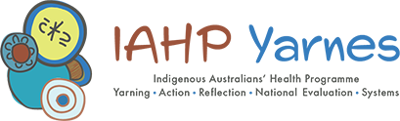

Key policy frameworks influencing the delivery of primary health care to Aboriginal and Torres Strait Islander people include the National Aboriginal and Torres Strait Islander Health Plan 2021-2031, the National Aboriginal and Torres Strait Islander Health Workforce Strategic Framework and Implementation Plan 2021-2031, Australia’s Primary Health Care 10 Year Plan 2022-2032, the Cultural Respect Framework 2016-2032 and the Health Sector Strengthening Plan. The recent recommendations of the Strengthening Medicare Taskforce will also shape the operation of the PHC system, including the delivery of PHC to Aboriginal and Torres Strait Islander people.
Babuny (also written as Bahbooney) is the name for Brachychiton rupestris, in the language of the Gunggari people, noting that each of the hundreds of Aboriginal and Torres Strait Islander languages would have their own name.
The Productivity Commission maintains a dashboard of the most up-to-date data and information on the targets and indicators in the National Agreement. The latest update was on 8 March 2023. The dashboard is available at: https://www.pc.gov.au/closing-the-gap-data/dashboard
A larger list of relevant policies, including state and territory policies, is in the National Aboriginal and Torres Strait Islander Health Plan. Found here: https://www.health.gov.au/sites/default/files/documents/2021/02/national-aboriginal-and-torres-strait-islander-health-plan-2013-2023.pdf
Article 12 of CEDAW provides for access to health care services for women, including family planning and reproductive healthcare.
Article 24 of the CRC recognises the right of the child to enjoy the highest stainable standard of health and facilities for the treatment of illness and rehabilitation of health. This includes commitments to diminish infant and child mortality and to ensure the provision of necessary medical assistance, including through the development of primary health care.
Article 25 of the CRPD provides that people with disabilities have the right to the enjoyment of the highest attainable standard of health without discrimination on the basis of disability. This includes commitment to take action to provide people with disabilities with the same range, quality, and standard of free or affordable health care and programmes provided to other persons.
The proposed sites were geographic areas large enough to explore comprehensive PHC systems in operation. The evaluation sties were selected according to the following parameters (criteria) (Bainbridge et al. 2020): - Sites will have a minimum Aboriginal and Torres Strait Islander population of around 1,500 to reduce the potential for random variation in data analysed for the evaluation and have a maximum Aboriginal and Torres Strait Islander population of around 8,000. - Sites will fall within the boundary of a single PHN and local health district (or equivalent state government-administered health district). Moreover, for a site to be a part of the evaluation, the ACCHS, any other PHC service that delivers services to a predominantly Aboriginal or Torres Strait Islander population (e.g. a state or territory government clinic), and the PHN in that location need to agree to partner with the evaluation (Bainbridge et al. 2020).
KEQ5 was added after Phase One and is not addressed in this report.
A semi-structured interview is a method that involves asking participants a set of open-ended questions and following these up with probe questions that explore the response further and make connections with the key evaluation questions. Semi-structured interviews focus on broader topics of interest and key evaluation questions, while allowing the space and flexibility to explore relevant ideas and concepts that may come up during the interview. Qualitative researchers use semi-structured interviews to collect new data, expand the notion of concepts and definitions, as well as to explore participants’ thoughts, beliefs and values about a particular topic.
Decolonising methodologies are not about rejecting all theory, research, or Western knowledge. Rather, they are about centring Indigenous concerns and world views and then coming to know and understand theory and research from our own perspectives and for our own purposes (Smith, 2021, p. 39). This decolonising (emancipatory) movement advocates building a body of knowledge that has relevance, practical application and vision for Indigenous people.
These professionals were selected by the evaluation team based on their knowledge and experience in Aboriginal and Torres Strait Islander health and primary health care systems.
This work included: (1) the development of an Accountability Framework as part of the National Aboriginal and Torres Strait Islander Health Plan 2021-2031; (2) work under Action 11 of the Closing the Gap Health Sector Strengthening Plan to rectifying the ‘overburden of activity reporting to governments to allow the Aboriginal and Torres Strait Islander community-controlled health sector to focus on outcomes while maintaining accountability’; and (3) the development of the NACCHO Core Services and Outcomes Framework which outlines the foundations for community-controlled comprehensive PHC.
Including Aboriginal Community Controlled Health Services (ACCHSs), state and territory government primary care services, non-government organisations and mainstream services (for example, private general practice).
Source: Health Portfolio Budget Statements 2021-22 (p63).
Data from Health Portfolio Budget Statements 2015-16 to 2023-24.
‘Indigenous Australians’ is used here for consistency with the AIHW’s health expenditure data.
This diagram of funding flows was developed when the IAHP was configured into slightly different funding streams than those presented elsewhere in this section.
Data provided by the Department of Health and Aged Care, March 2022.
Data provided by the Department of Health and Aged Care, December 2022.
Client data is from the OSR data collection and refers to how many individuals receive health care from an organisation during the period. This refers to Indigenous and non-Indigenous clients. There have been changes to the organisations reporting to the OSR collection over reporting periods. Currently, data is reported from over 200 organisations that receive funding under the IAHP to deliver comprehensive and culturally appropriate PHC services.
This reflects several limitations with the data including undercounting of the Indigenous population in ABS population data, double-counting of individual clients across health services in the OSR data collection (i.e. individuals who attend more than one health service in a given period), counting of non-Indigenous clients in the OSR collection, and transient populations across state and territory borders.
Brisbane North PHN no longer receives IAHP funding. In July 2022, the ITC program moved to a direct commissioning arrangement between the Department of Health and Aged Care and IUIH.
Torres and Cape Hospital and Health Service receives IAHP PHC Program funding for services in the Torres Strait Islands but this service was not a partner in the evaluation.
This data includes the 23 ACCHSs in the 17 evaluation sites. It excludes grant funding to the NT Regional Health Services as this grant covers the entire NT. It also excludes IAHP funding provided to ACCHSs indirectly through other funded organisations, such as PHNs.
Babuny (also written as Bahbooney) is the name for Brachychiton rupestris, in the language of the Gunggari people, noting that each of the hundreds of Aboriginal and Torres Strait Islander languages would have their own name.
The labels used to reflect these concepts on Babuny are those used in the Accessibility Framework for Indigenous peoples accessing Indigenous primary health care services developed by the Wardliparingga Aboriginal Research Unit to reflect the coherence of the evaluation’s findings with that framework (Davy et al., 2016b).
A tree’s taproot is the dominant root from which all other roots sprout
Community member.
Community member.
Community member.
Community members.
Data from the AIHW shows that the main service gaps reported by Indigenous PHC organisations receiving PHC Program funding, included mental health/social and emotional health and wellbeing (68%), youth services (54%) and alcohol, tobacco and other drug services (45%). https://www.indigenoushpf.gov.au/measures/3-14-access-services-compared-with-need
Clinical services have always been part of the intent of the IAHP. When the IAHP was established, the consolidation of funding streams was intended to reduce administrative complexity and enable an improved focus on basic health needs (including clinical PHC) at a local level (Australian National Audit Office, 2018).
AIHW data shows that nearly 7% of Indigenous Australians live in areas of low relative supply of GPs.
Coombes et al.(2022) refer to these as ‘soft entry’ pathways.
Source: National Health Workforce Dataset. Notes: (1) Restricted to staff in clinical job roles; (2) Includes staff in a range of settings, combined (including Aboriginal and Torres Strait Islander health organisations, hospitals, and private practice); (3) Based on count of people; not FTEs.
Source: National Health Workforce Dataset. Note: Site is based on geographical regions at SA3 level; not on services.
Source: National Health Workforce Dataset.
The distinction associated with having these two roles and its departure from from the ‘principal-agent’ concept of the relationship between funders and providers is discussed by Dwyer et al. (2014).
The Health Performance Framework (Australian Institute of Health and Welfare, 2020a) reported data from the Australian Aboriginal and Torres Strait Islander Health Survey, which assessed the reason(s) why participants did not attend a doctor in the last 12 months when they needed to (according to self-identifying a need to). Table D3.14.14 available from https://www.indigenoushpf.gov.au/measures/3-14-access-services-compared-with-need/data#DataSource
Client data from OSR (provided by AIHW); population estimate as at 30 June 2021 from ABS (https://www.abs.gov.au/statistics/people/aboriginal-and-torres-strait-islander-peoples/estimates-aboriginal-and-torres-strait-islander-australians/jun-2021)
These four funding streams were: primary health care; child and maternal health programs; Stronger Futures in the Northern Territory (Health); and programs covered by the Aboriginal and Torres Strait Islander Chronic Disease Fund.
This data includes the 23 ACCHSs in the 17 evaluation sites. It excludes grant funding to the NT Regional Health Services as this grant covers the entire NT. It also excludes IAHP funding provided to ACCHSs indirectly through other funded organisations, such as PHNs.
GrantConnect.
Five organisations were awarded more than 50 grants, with a maximum of 248. These are not reflected in the average of 16 reported here.
GrantConnect is the Australian Government’s grants information system: https://www.grants.gov.au/
GrantConnect is the Australian Government’s grants information system: https://www.grants.gov.au/
The COAG Section 19(2) Exemptions Initiative overrides Section 19(2) of the Health Insurance Act 1973 (the Act) that prohibits the payment of Medicare benefits where other government funding is provided for that service.
The PHC Program funding model includes adjustments for location and health care needs. Major cities do not attract a location multiplier. The health care needs adjustment is made up of an estimate of the impacts of the social determinants of health, and an estimate of the burden of disease in the population.
OSR data from organisations receiving IAHP funding. Provided by AIHW
OSR data from organisations receiving IAHP funding.
AIHW OSR collection. www.aihw.gov.au [accessed 10 March 2023].
Health workforce data were sourced from the National Health Workforce Dataset and was provided by the Department of Health and Aged Care. The workforce setting for ‘Aboriginal health organisation’ includes two categories in the dataset: ‘Aboriginal health service’ and ‘Other Aboriginal health service’.
Source: National Health Workforce Dataset.
Source: National Health Workforce Dataset.
The Implementation Plan Advisory Group works in partnership with the Australian Government to monitor and review the Implementation Plan for the National Aboriginal and Torres Strait Islander Health Plan 2013–2023. The National Health Leadership Forum is a partnership of national Aboriginal and Torres Strait Islander health and wellbeing organisations. It provides advice and direction to the Australian Government on policy and program objectives that contribute to improved and equitable health and life outcomes, and cultural wellbeing. Health Partnership Forums exist in each state and territory and provide a formal way for members to work together, plan and share information. Members include peak organisations for ACCHSs, state and territory government health departments, and the Australian Government Department of Health and Aged Care.
A strategic collaboration between the Aboriginal community-controlled health sector, the mainstream health sector, and the Victorian Department of Health.
See Final Report Supporting Material: Appendix G for a discussion on funding processes and responsibilities.
Currently, 22 of the 24 nKPIs are reported through the Health Data Portal.
Based on only three ACCHSs, this data should not be treated as representative of all ACCHSs. We aimed to collect reporting data from six ACCHSs but it was not readily available. The three ACCHSs that provided data were from regional (2) and remote (1) areas, had an average of 3,500 regular clients and annual revenue of $12 million.
These examples of how ACCHSs are using nKPI and OSR data are to support understanding about how the data is used. The evaluation did not attempt to measure the extent the data were being used in these ways. The data comes from interviews that focused on how services were using data and how useful this was.
Mortality data are only reported by five jurisdictions. For some indicators, Victoria had not reported at the time of compiling data.
A concept known as statistical power – the probability that a statistical test detects an effect, assuming it exists.
A general guideline of effect sizes: small = .10, medium = .30, large = .50 is given for Cohen’s (1998) ω - a measure of effect size for categorical associations in (Cohen, 1988).
The diagnosis established after study to be chiefly responsible for occasioning a patient's service event or episode. (https://meteor.aihw.gov.au/content/433351)
A condition or complaint either co-existing with the principal diagnosis or arising during a service event or episode. (https://meteor.aihw.gov.au/content/641014)
An MBS 715 health assessment can be conducted by any mainstream general practice or Aboriginal and Torres Strait Islander health service and is recommended as an annual check for all Aboriginal and Torres Strait Islander people. Completion of 715 health assessments is an nKPI. The working assumption was that widespread use of the 715 health assessment leads to appropriate follow-up health care (tests and other services) and the conduct of this follow-up care results in better health outcomes.
The ACCHS in one site, the Torres Strait Islands, did not receive IAHP PHC Program funding so did not report nKPI data.
An alcohol screen that can help identify people who are hazardous drinkers or have active alcohol use disorders.
Measure of blood glucose (sugar) levels.
Indicates how well kidneys are filtering.
Detects elevated protein.
These associations may be positive, where high scores correspond to high scores; or negative, where high scores on one measure correspond to low scores on another. Clustering methods are typically based on the strength of the association and ignore the direction.
Ensemble regression combines several models to improve predictive accuracy. However in this context it was used to elicit the plausible range of effects of the explanatory variables on health outcomes.
Emergency department presentations data were available for Time 2 only.
The specialist Indigenous and Rural Health Division has since transitioned to the Indigenous Health Division which then changed its name to the First Nations Health Division.
Community member
https://www.health.nsw.gov.au/lumos
State or territory government participant.
https://www.aihw.gov.au/reports/indigenous-australians/indigenous-primary-health-care-results-osr-nkpi/contents/nkpi-summary-over-time [Accessed: 5 June 2022].
The Productivity Commission maintains a dashboard of the most up-to-date data and information on the targets and indicators in the National Agreement. The latest update was on 8 March 2023. The dashboard is available at: https://www.pc.gov.au/closing-the-gap-data/dashboard
https://www.aihw.gov.au/reports/indigenous-australians/indigenous-health-checks-follow-ups/contents/about [Accessed 5 June 2023].
https://phidu.torrens.edu.au/notes-on-the-data/aboriginal-notes/aboriginal-avoidable-deaths [Accessed 5 June 2023].
The policy framework includes the National Agreement on Closing the Gap, the Strengthening Medicare Taskforce, Australia’s PHC 10 Year Plan, the Aboriginal and Torres Strait Islander Health Plan (see Section 1.5).
Client data from OSR (provided by AIHW); population estimate as at 30 June 2021 from ABS (https://www.abs.gov.au/statistics/people/aboriginal-and-torres-strait-islander-peoples/estimates-aboriginal-and-torres-strait-islander-australians/jun-2021).
Phase 2 of the Core Services and Outcomes Framework is intended to identify the expected benefits or outcomes of the model of Aboriginal and Torres Strait Islander community-controlled comprehensive PHC.
Subsequently superseded by the new National Aboriginal and Torres Strait Islander Health Plan 2021-2031.
The Hon Linda Burney MP, Minister for Indigenous Australians, Media Release, 8 March 2023.

