Health provider compliance strategy

2025-30



# Introduction

The Australian Government is committed to delivering a world class health care system. Health programs central to this include the:

Medicare Benefits Schedule (MBS) – Australia’s universal health benefits system, providing free or subsidised healthcare services to Australians and eligible overseas visitors.

**Pharmaceutical Benefits Scheme (PBS)** – provides subsidised medicines for Australians.

**Child Dental Benefits Schedule (CDBS)** – a means tested program that provides benefits for a wide range of basic dental services for eligible Australian children.

In 2023-24, these programs accounted for more than $48 billion in taxpayer expenditure.

The Department of Health, Disability and Ageing (department) is responsible for ensuring compliant health provider claiming under each of these programs. We support integrity through the prevention, early identification, and treatment of incorrect claiming, inappropriate practice and fraud.

# Objectives

This strategy outlines how the department uses a risk-based and proportionate approach to health provider compliance. We aim to:

* Prevent incorrect claiming, making it harder to get it wrong
* Enable correct claiming, supporting providers to get it right
* Effectively address non-compliance when it occurs, contributing to a sustainable and affordable health system.

# Principles and culture

The department encourages a strong integrity culture. We embed integrity into everything we do – from the conduct of individual staff to systems, processes and practices. This enables better decision-making, enhances public trust in Australian Government health program payments, and supports the sustainability of the Medicare system. We deliver our Compliance Program with:

**Proportionality** – we use a risk-based approach, with action taken based on the seriousness and scale of the identified behaviour.

**Fairness and transparency** – our compliance decisions are evidence-based and adhere to defined governance processes and legislative requirements. We afford health providers the opportunity to give information about their claiming before we make a compliance decision.

**Confidentiality** – we carry out compliance activities with sensitivity and according to privacy laws.

**Collaboration** – we talk to stakeholders to help our understanding of compliance risks and support health providers to meet their compliance obligations.

# Finding non-compliance

The department monitors claiming data, collects intelligence and carries out targeted data analysis to find non-compliance.

We consider:

* information and data alongside policy and clinical advice
* the context of the broader environment
* stakeholder advice to better understand compliance concerns.

We also continue to improve our advanced analytical modelling to detect fraudulent claiming. The department manages non-compliance across 5 broad themes:

## Incorrect claiming

Health providers claiming MBS, PBS, CDBS and/or PIP benefits where legislative and/or policy or program requirements have not been met.

## Incorrect prescribing

Health providers prescribing PBS medicines outside legislative and/or policy or program requirements.

## Business arrangements that seek to inappropriately maximise payment of benefits

Agreements and/or cooperation between individuals and/or entities to inappropriately maximise payment of benefits.

## Possible inappropriate practice

Inappropriate practice may reflect behaviour by health providers or corporate entities. Defined in section 82 of the Health Insurance Act 1973, it includes:

**Unacceptable conduct** – performing or initiating MBS, PBS or CDBS services which a general body of peers would reasonably conclude was inappropriate.

**Prescribed pattern of services** – performing or initiating services during a specified period constituting a prescribed pattern of services, including performing or initiating:

• 80 or more relevant services on each of 20 or more days in a 12-month period (the ‘80/20 rule)’.

• 30 or more relevant phone services on each of 20 or more days in a 12-month period (the ‘30/20 rule’).

**Causing or permitting inappropriate practice –** knowingly, recklessly, or negligently causing or permitting a health provider employed or otherwise engaged by the person to engage in conduct that constitutes inappropriate practice.

## Fraud

Health providers, their staff and/or unrelated persons dishonestly obtaining, or attempting to obtain, a gain or benefit, or causing a loss or risk of loss, by deception or other means.

# Reporting non-compliance

The department takes allegations of non-compliance seriously. We review all tip-offs according to our compliance assessment procedures. You can submit information:

* at [Reporting incorrect billing, claiming, or suspected fraud | Australian Government](https://www.health.gov.au/topics/medicare/compliance/reporting-incorrect-billing-claiming-or-suspected-fraud) [Department of Health, Disability and Ageing](https://www.health.gov.au/topics/medicare/compliance/reporting-incorrect-billing-claiming-or-suspected-fraud)
* by calling the department’s tip-off line on **1800 314 808**, between 8:30am and 5:00pm Monday to Friday.

Because of privacy and secrecy legislation, we cannot provide updates on our actions regarding received information.

Where concerns are outside the department’s remit, such as patient safety or professional conduct, we may refer them to other regulatory bodies as appropriate.

# Compliance approach

Based on our assessment of a compliance concern, we may pursue a range of responses. These may include education, review, audit and investigation into breaches of Australian laws. In deciding to act, we:

* use available information when making decisions including considering the context of the identified claiming,
* prioritise resources and effort based on the seriousness and scale of the identified concern,
* encourage improved awareness of claiming requirements, promoting voluntary compliance and focusing enforcement activity where the risks and impact of harm are the greatest,
* use evaluation and behavioural insights to design approaches to manage non- compliance.

We also consider broader opportunities including introducing increased system and/or legislative controls to better protect the integrity of Medicare.

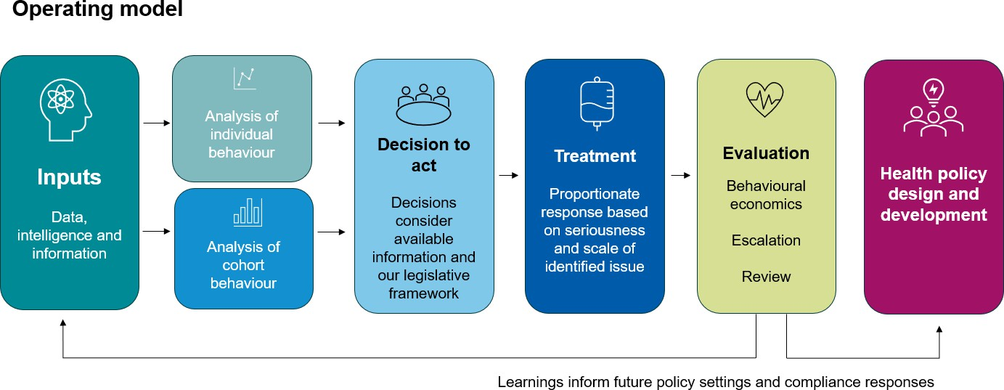We evaluate our compliance activities, applying learnings to future activities. We also:

* monitor providers following intervention, and
* escalate enforcement actions where non-compliance continues or behavioural indicators suggest further compliance action is warranted.

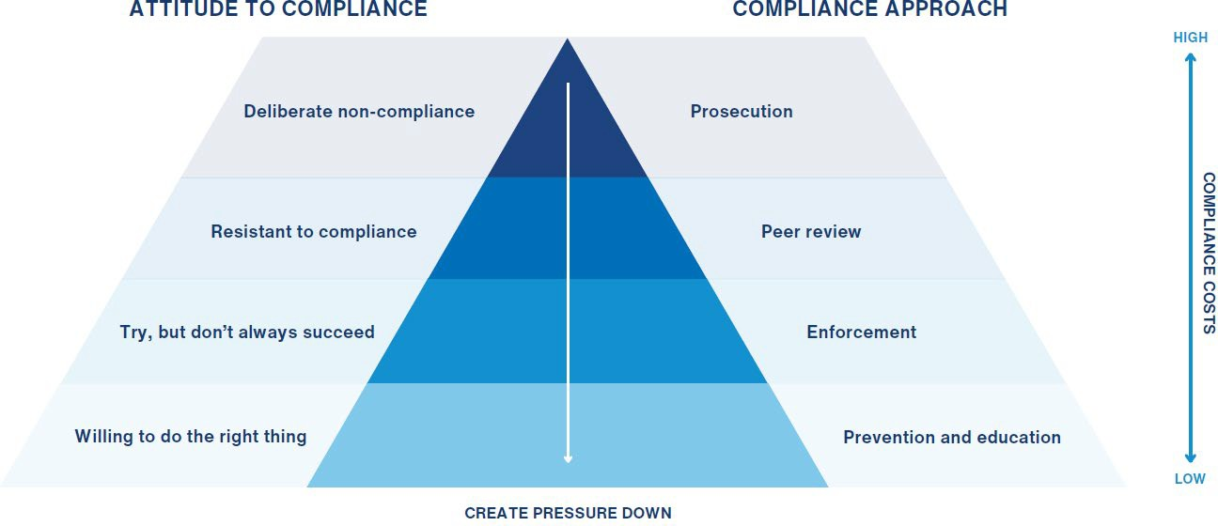

# Compliance priorities

We regularly review our compliance priorities. We choose issues based on their characteristics and considering the seriousness and scale of the harm posed to the Medicare system. Compliance priorities may relate to new and emerging risks, and those the department considers to be enduring. Focus areas are available on the department’s website.

Our published compliance priorities reflect our commitment to act. The department also monitors and plans for environmental changes, meaning that compliance priorities may evolve in response to emerging risks.