Guide to changes to financial reporting from 1 November 2025
Version 1.0

Overview
From 1 November 2025, Approved aged care providers will transition to being Registered Providers under the Aged Care Act 2024 (new Act). Providers delivering the Home Care Packages Program and Short-Term Restorative Care (STRC) Programme will also transition to the new Support at Home program.
From a financial reporting perspective, the 1 November 2025 commencement date is:
- one month into the Quarterly Financial Report (QFR) Quarter 2 2025-26 reporting period; and
- four months into the Aged Care Financial Report (ACFR) 2025-26 reporting period.
Even though the Aged Care Act 1997 and the new Act are both relevant legislation within the QFR Quarter 2 and ACFR 2025-26 reporting periods, providers will be required to complete only one QFR and one ACFR for the relevant reporting period. Providers will be required to complete the reporting under their new Registered Provider structure.
For a small number of providers, the transition from Approved Provider to Registered Provider will involve a change in organisational structure. In these circumstances, we encourage providers to consider how this will impact your financial reporting. The Department of Health, Disability and Ageing (the department) is available to assist providers if required.
There are changes to financial reporting for providers who deliver residential aged care, the Home Care Packages Program, STRC and the new Support at Home program. Financial reporting requirements for providers of the Multi-Purpose Services Program (MPSP), and the National Aboriginal and Torres Strait Islander Flexible Aged Care (NATSIFAC) Program will not change.
Providers are encouraged to review the resources available including the QFR Quarter 2 and ACFR 2025-26 non-uploadable templates, definitions, guidance and frequently asked questions available on the department’s website at Aged care provider reporting | Australian Government Department of Health, Disability and Ageing. The department will continue to update and communicate information about financial reporting throughout the 2025-26 financial year. Further information about assistance available for financial reporting is provided at the end of this guide.
Providers requiring additional assistance to better understand their business and financial operations, including their financial reporting obligations, can access support through department funded advisory and capability building programs. These programs can provide valuable support to providers who identify business or financial issues through the reporting process. Further information is available at Financial viability and capability support for aged care providers | Australian Government Department of Health, Disability and Ageing
This document provides guidance on:
- Quarterly Financial Report Quarter 2, 2025-26
- Aged Care Financial Report 2025-26
- Support at Home financial reporting 2025-26
- Financial reporting help

Quarterly Financial Report (QFR) Quarter 2, 2025-26

Who needs to complete a QFR
- If you are a Registered Provider delivering residential aged care and/or the Home Care Packages Program/Support at Home program, you are required to complete a QFR from Quarter 2, 2025-26 onwards.
- If you are a Registered Provider delivering MPSP and/or NATSIFAC, you are also required to complete a QFR from Quarter 2, 2025-26 onwards but will complete the food and nutrition reporting only.
- Each Registered Provider is required to complete one QFR each quarter.

QFR reporting requirements
- For the “YTD Financial Statements”, providers will report one form as a Registered Provider that covers the entire Quarter 2.
- Providers of the Home Care Packages Program which transition to the Support at Home program will be required to complete one form, that covers both one month of the Home Care Packages Program and two months of the Support at Home program. The form will be labelled as “Support at Home Labour Costs”.
The table below outlines reporting requirements in the QFR:
Form Name | Data Collection Level | Residential Aged Care | Home Care Packages/Support at Home | MPSP | NATSIFAC
Viability and Prudential Compliance Questions* | Registered Provider | YES | YES | NO | NO
YTD Financial Statements* | Registered Provider | YES | YES | NO | NO
Residential Labour Costs and Hours | Service level | YES | NO | NO | NO
Support at Home Labour Costs | Program level | NO | COSTS ONLY | NO | NO
Food and Nutrition Costs | Service level | YES | NO | YES | YES
* Government providers of residential aged care and Support at Home are not required to complete the Viability and Prudential Compliance Questions or the YTD Financial Statements.

Changes to the QFR
- The QFR has been updated to align with the commencement of the new Act and Support at Home program.
- For all providers, these changes include:
  - Updated terminology and legislative references throughout the forms and Declaration File. For example, references to “Approved Provider” have been changed to “Registered Provider” and references to “Home Care” have been changed to “Support at Home”
  - With the introduction of the new Financial and Prudential Standards:
    - the existing residential and home care liquidity questions have been removed from the “Questions – Residential Care” and the “Questions – Support at Home” forms
    - the liquidity and capital adequacy ratio calculations have been removed from the “Year to Date financial statement”
- For providers of residential aged care, these changes include:
  - the removal of Amortisation and Impairment of Bed Licenses from the “Year to Date financial statement” and the renaming of “Available bed days” to “Operational bed days” throughout the QFR. These changes are resulting from the change to allocating residential aged care places directly to older people from 1 November 2025
- For providers of Home Care Packages Program/Support at Home program, these changes include:
  - The removal of the home care business structure question from the “Questions – Support at Home” form
  - The removal of Aged Care Planning Regions (ACPRs) from the “Support at Home Labour Costs” form, as ACPRs are no longer applicable under the new Act. Instead, providers will report financial information at the total Support at Home program level
  - The removal of labour hours worked and non-worked hours reporting from the “Support at Home Labour Costs” form. Providers will only be required to report on labour costs
  - The removal of gardening and maintenance from the Personal Care Workers definition in the “Support at Home Labour Costs” form. Costs related to these workers should be included in the “Other employee staff (employed in a direct care role)”
  - Changes to all labour costs definitions to align reporting to the Support at Home service list

Use of Government Provider Management System (GPMS) to submit QFR
- Providers will continue using GPMS – Approved Provider Portal for submission of QFR Quarter 1 2025-26 and resubmissions of QFR Quarter 1 2025-26 and prior.
- Providers will use the new GPMS – Registered Provider Portal for submission of QFR Quarter 2 2025-26, under their new Registered Provider.
- For further assistance with changes to GPMS from 1 November 2025, please visit Government Provider Management System (GPMS) | Australian Government Department of Health, Disability and Ageing

Aged Care Financial Report 2025-26

Who needs to complete an ACFR
- If you are a Registered Provider delivering residential aged care and/or the Support at Home program, you are required to submit an ACFR for 2025-26.
- If you are a Registered Provider delivering MPSP, you will continue to complete the Annual Prudential Compliance Statement only in the ACFR 2025-26.
- Providers who delivered the Home Care Packages Program and/or STRC up until 31 October 2025, are still required to report information in the ACFR 2025-26.
- Each Registered Provider is required to complete one ACFR.

Reporting requirements
- For most forms within the ACFR, providers will report one form as a Registered Provider for the entire financial year.
The table below outlines the reporting requirements in the ACFR 2025-26:
Form Name | Data Collection Level | Residential Aged Care | Home Care Packages / Support at Home | MPS | STRC
Consolidated Segment Report* | Parent Entity or Registered Provider | YES | YES | NO | NO
Registered Provider Reporting (Income and expenditure, balance sheet, cash flow)* | Registered Provider | YES | YES | NO | NO
Movement Schedules* | Registered Provider | YES | NO | NO | NO
Residential Care Reporting (Income and expenditure, balance sheet, Care Minute Performance Statement) | Service level | YES | NO | NO | NO
Home Care Packages / STRC / Support at Home | Program level | NO | YES refer to additional table | NO | YES refer to additional table
Annual Prudential Compliance Statement | Registered Provider | YES | NO | YES | NO
Financial Support Statement* | Registered Provider | YES | NO | NO | NO
Survey of Aged Care Homes | Service level | YES | NO | NO | NO
Residential Building Activity | Service level | YES | NO | NO | NO
General Purpose Financial Statements* | Registered Provider | YES | NO | NO | NO
* Government providers of residential aged care and the Support at Home program are not required to complete the Consolidated Segment Report, Registered Provider Reporting, Movement Schedules, Financial Support Statement or to publish their General Purpose Financial Statements.
- Providers who delivered services under the Home Care Packages Program and/or STRC up until 31 October 2025, must report income and expenses in the “Home Care Income and Expenditure Statement” and/or the “STRC Income and Expenditure Statement”.
- Providers who deliver the Support at Home program from 1 November 2025 must report income and expenses in a new “Support at Home Income and Expenditure Statement”.
- Providers will need to attribute income and expenses received or incurred to the relevant program.
The table below outlines the reporting requirements in the ACFR 2025-26 for providers of the Home Care Packages Program, STRC and Support at Home program:
Form Name | Data Collection Level | Pre-1 November 2025 |  | Post-1 November 2025
 |  | Home Care | STRC | Support at Home
Home Care Income and Expenditure Statement | Program level | YES | NO | NO
STRC Income and Expenditure Statement | Program level | NO | YES | NO
Support at Home Income and Expenditure Statement | Program level | NO | NO | YES

Changes to the ACFR
- The ACFR has been updated to align with the commencement of the new Act and Support at Home program.
- For all providers these changes include:
  - Updated terminology and legislative references throughout the forms and Declaration File. For example, references to “Approved Provider” have been changed to “Registered Provider” and references to “Home Care” have been changed to “Support at Home”
- For providers of residential aged care, these changes include:
  - The removal of data items and references to bed licences and the renaming of “Available bed days” to “Operational bed days” throughout the ACFR. These changes are resulting from the move to allocating residential aged care places directly to older people from 1 November 2025
  - New, removed or amended data items in the “Residential Aged Care Home Income” and “Residential Aged Care Home Expenditure” forms
    - New “Higher Everyday Living Fee” and “Contribution to Hotelling Supplement” (Hotel Services Income)
    - New “RAD Retention Reduction” (Accommodation Income)
    - Addition of a question on how many residents were paying Higher Everyday Living Fees/Additional Service Fees/Extra Service Fees as at the end of the financial year
    - Renaming of “Other Hotel Expenses” data items:
      - “Extra and additional service fee charges (non-agency)” to “Higher Everyday Living Fees/Additional Service Fees/Extra Service Fees – staffing costs (non-agency)
      - “Extra and additional service fee charges (agency)” to “Higher Everyday Living Fees/Additional Service Fees/Extra Service Fees - consumables and contracting”
    - Two data items have also been added to “other direct care expenses” for “staffing retention – travel costs” for both agency and non-agency, to capture travel related expenses for direct care staff that are paid for by the provider, such as transport to and from the provider’s accommodation and a residential aged care home
    - Staff training costs are to be included as labour costs, which you will see in the updated definitions in a number of areas, including the Consolidated Segment Report and Residential Expenses form
  - A new Care Minutes Performance Statement (further guidance to be provided in due course)
  - Amended Annual Prudential Compliance Statement and Permitted Uses Reconciliation (changes to be advised in due course following finalisation of the Financial and Prudential Standards)
  - Additional and amended data items in the “Survey of Aged Care Homes” form
- For providers of the Home Care Packages Program these changes include the removal of Aged Care Planning Regions from the “Home Care Income and Expenditure Statement”. Instead, providers will report financial information at the total Home Care Packages Program level.
- For providers of STRC there are no changes.
- For providers of the Support at Home program there is a new “Support at Home Income and Expenditure Statement” that aligns income and expense reporting to the Support at Home Service List.

Use of Forms Administration portal to submit ACFR
- Providers will continue using the Forms Administration portal to submit the ACFR 2025-26.

Support at Home financial reporting

Income reporting in the ACFR
- Income reporting in the ACFR aligns with the Support at Home Service participant contribution categories:
  - Clinical Support Services
  - Independence Support Services
  - Everyday Living Services
  - Restorative Care Pathway
  - End of Life Pathway
  - Assistive Technology and Home Modifications Scheme.
- There is a separate line item for income from Participant Top-ups and Private Clients.
- Grants such as the Support at Home Thin Markets grant (rural, remote and specialised) are to be reported as Other Income.
- Income reporting is at the total program level, reporting by Aged Care Planning Regions is not required.

Expense reporting in the ACFR
- Expense reporting in the ACFR aligns with the Support at Home Service List.
- There is a new expense item for “Employee superannuation and on-costs” under Administration and Support.
- There is a new expense item under “Other expenses” for “Participant top-ups and Private Clients”.
- Care management labour costs and hours are to be split by those undertaken by clinical staff and those undertaken by non-clinical staff.
- More granular reporting of allied health expense items is required for six categories:
  - Physiotherapist
  - Occupational therapist
  - Speech pathologist
  - Podiatrist
  - Dietetic care
  - Other allied health

Hours reporting in the ACFR
- Labour hours reporting is only for internal direct care – employee care staff.

Difference in financial reporting for Support at Home in QFR and ACFR
- There are differences in the way that providers of Support at Home will report their financial information in the QFR and ACFR in 2025-26.
- The QFR for 2025-26 will continue to reflect labour cost reporting by worker type, which has been used for Home Care Packages reporting. Reporting by Aged Care Planning Regions and labour hours has been removed.
- The new “Support at Home Income and Expenditure Statement” in the ACFR has been designed to align income and expense reporting with the Support at Home Service List categories.
- An example of the structure of the QFR Quarter 2 Support at Home Labour Costs form and ACFR Support at Home Income and Expenditure Statement can be found below.
- You are encouraged to review the QFR and ACFR non-uploadable templates in more detail, which are available on the department’s webpage.
- In future financial years, financial reporting for providers of Support at Home will be aligned between the two reports.

Table showing difference in expense reporting in QFR and ACFR
QFR | ACFR
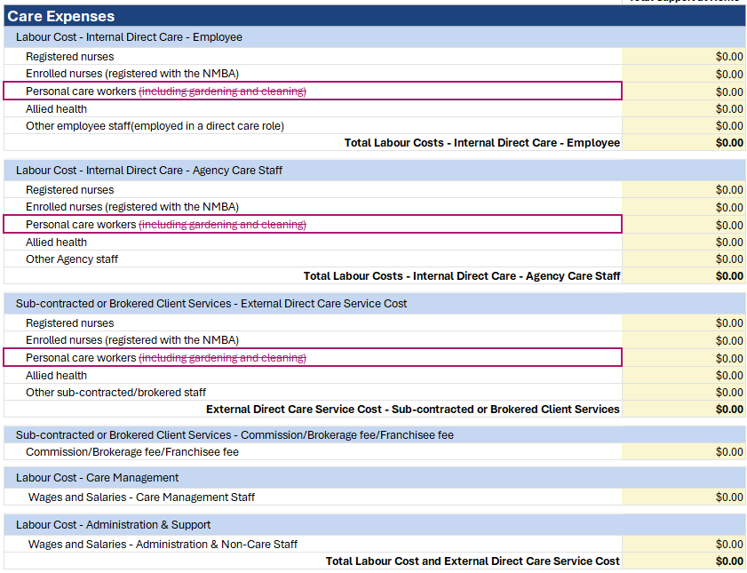 | 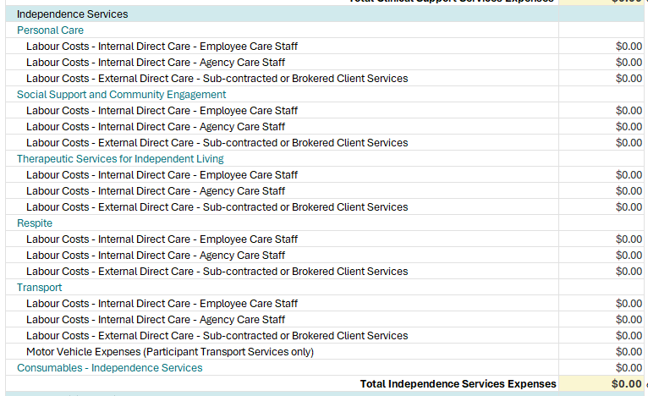  This example is only of independence services.
Example: Support at Home labour cost and hours reporting QFR vs ACFR
 | How to report in QFR from Qtr 2 | How to report in new Support at Home Income and Expenditure Statement in ACFR 2025-26
Labour cost for a Personal Care Worker employee | Labour Cost – Internal Direct Care – Employee  - Personal Care Workers  for assistance with selfcare and activities of daily living, assistance with the self-administration of medication, continence management (non-clinical)  - Other employee staff (employed in a direct care role)  for social support and community engagement, respite, transport, assistive technology and home modifications, domestic assistance, meals, nutrition  Labour cost definition includes salaries and superannuation for:  - direct care  - staff travel to and from recipient residences  - staff time completing administrative tasks / paperwork before and/or after a care recipient visit  This expense item should also include the payment of:  - Bonuses, incentive pay and commissions  - Allowances and reimbursements  - Annual leave, long service leave and medical leave  - Leave provisions  - Termination payments, retirement payments and leave encashment  - Value of Fringe Benefits/salary sacrifice  - Uniforms and/or laundry reimbursements  - Staff training.  Do not include staff amenities, staff recruitment, agency staff, workers compensation premiums or payroll tax. | Labour cost reporting is determined by the service provided e.g. personal care, social support and community engagement, domestic assistance etc  Labour cost definition includes salaries paid to employees providing services that are in-scope on the Support at Home service list for the relevant item.  This expense item should also include salaries for:  - staff travel to and from participant's residences;  - staff time completing administrative tasks/paperwork before and/or after a participant visit.  Do not include superannuation or other employee on-costs, which are to be reported separately under Administration & Support Expenses (two separate items for 1. administration and non-care staff and 2. care staff. Please note that these items will also:  - include the eight dot points in the left-hand side column commencing with bonuses, incentive pay and commissions, and  - maintain the exclusions
Labour hours for a Personal Care Worker employee | Labour hours no longer need to be reported in the QFR | Labour hours reporting is for employee care staff only and is determined by the service being provided e.g. personal care, social support and community engagement, domestic assistance etc

Financial Reporting Help Desks for Aged Care Providers
For information on aged care providers’ reporting obligations:
Aged Care Financial Report
Resources regarding the ACFR are available on the department’s website to support providers with their submissions.
Quarterly Financial Report
Resources regarding the QFR are available on the department’s website to support providers with their submissions
Financial reporting help desks:
- If you have technical questions about GPMS or the QFR application, contact the My Aged Care Service Provider Assessor Helpline on 1800 836 799. They can provide support with:
  - Assigning user access
  - Logging into GPMS
  - Accessing the QFR application on GPMS
- If you have questions about completing the QFR & ACFR, contact the Forms Administration Help Desk on (02) 4403 0640 or at health@formsadministration.com.au. They can provide support with:
  - Submission related questions
  - Re-opening the portal for resubmissions
  - General reporting queries
- If you have questions about your specific financial reporting data, contact the Financial Reporting Operations Team Help Desk at ACFRQFRQueries@Health.gov.au. They can provide support with:
  - Submission related questions
  - Support at Home financial reporting questions
  - Changes to reporting from 1 November 2025 questions
- If you have questions about residential direct care reporting and data quality checks, contact the Residential Care Help Desk at QFRACFRHelp@health.gov.au. They can provide support with:
  - Residential Labour Costs & Hours reporting questions
  - Care Minutes reporting questions
  - Residential data quality check questions

