Government Provider Management System

Quick Reference Guide: How to edit a contact in the GPMS Registered Provider portal
Organisation Administrators can edit contact accounts. Currently, the editing of contacts accounts is limited to user roles and access to the GPMS provider portal.

Editing or removing contact roles
To edit or remove a contact’s role/s, complete the following actions:
- In the Manage users screen, enter the individuals name or email in the search bar, then select Search.
- Locate the contact to be edited and select the drop-down arrow in the relevant row and select the Manage user roles link.
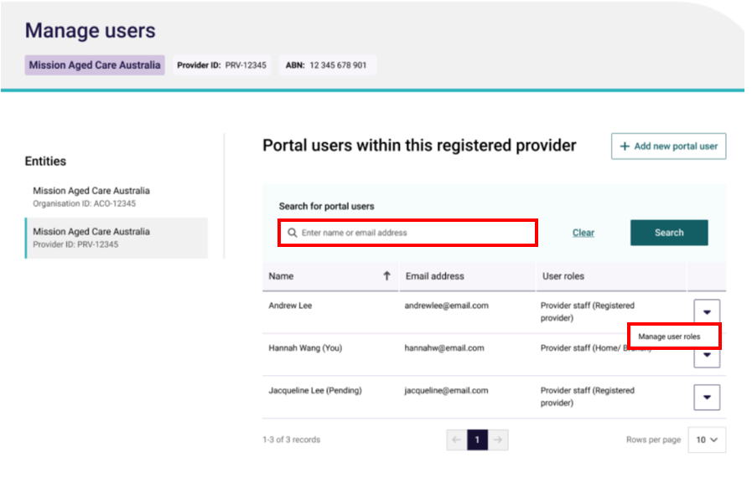

- The editable options will differ depending on if the contact was created at the organisation or provider level.
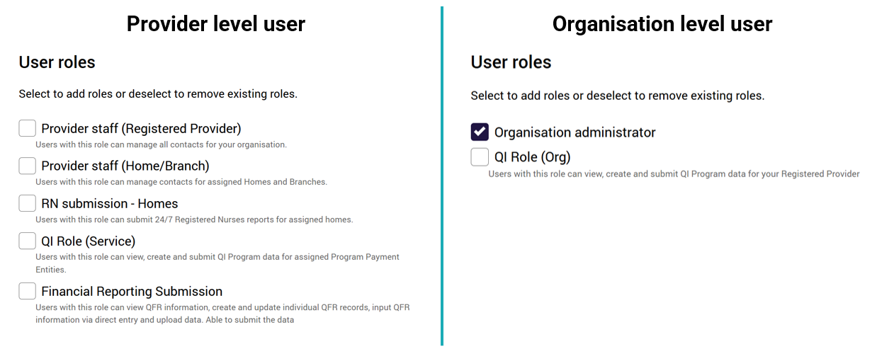

To edit the contact’s roles:
- For organisation level contacts select and/or deselect the Organisation administrator check box.
- For provider level contacts select and/or deselect the check box/es for the role/s and homes and/or branches.

- Select the Save button.
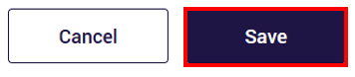
- The modal to confirm the updates to the contact’s role will be displayed. Select Update to confirm the changes.
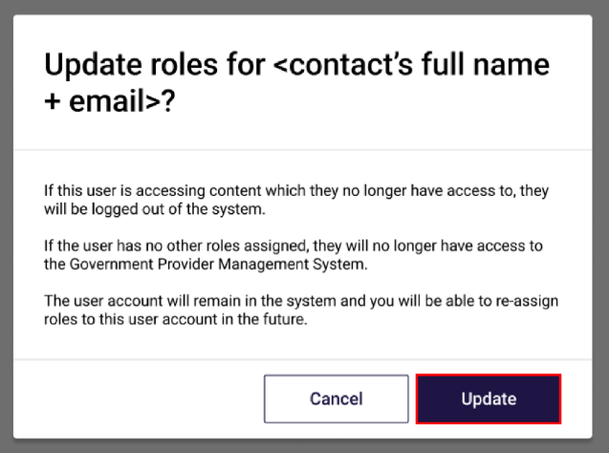

The GPMS portal will display a green banner informing that portal access for the contact has been successfully updated. The contact will receive an email notification advising their access roles have been changed.



If users require further assistance with GPMS, please contact the My Aged Care service provider and assessor helpline on 1800 836 799, Monday to Friday (8am to 8pm) and Saturday (10am to 2pm) local time across Australia.
For translating and interpreting services, call 131 450 and ask for My Aged Care on 1800 836 799.
To use the National Relay Service, visit About the National Relay Service (NRS) | Access Hub or call 1800 555 660.
To access sign language interpreting and captioning services through Deaf Connect, call 1300 773 803 or email interpreting@deafconnect.org.au.

