Government Provider Management System

Quick Reference Guide: How to add a user with the Registered Provider portal
Organisation Administrators can add new users to either GPMS provider portal. These new users can be added either at the organisation level or at the provider level. The level the new user is added to will determine what kind of access roles can be attributed to them.

Adding a user at the organisation level
To add a new user at the organisation level, complete the following actions:
- In the Manage users screen, ensure the Organisation account is highlighted, and select the
+ Add new portal user button.
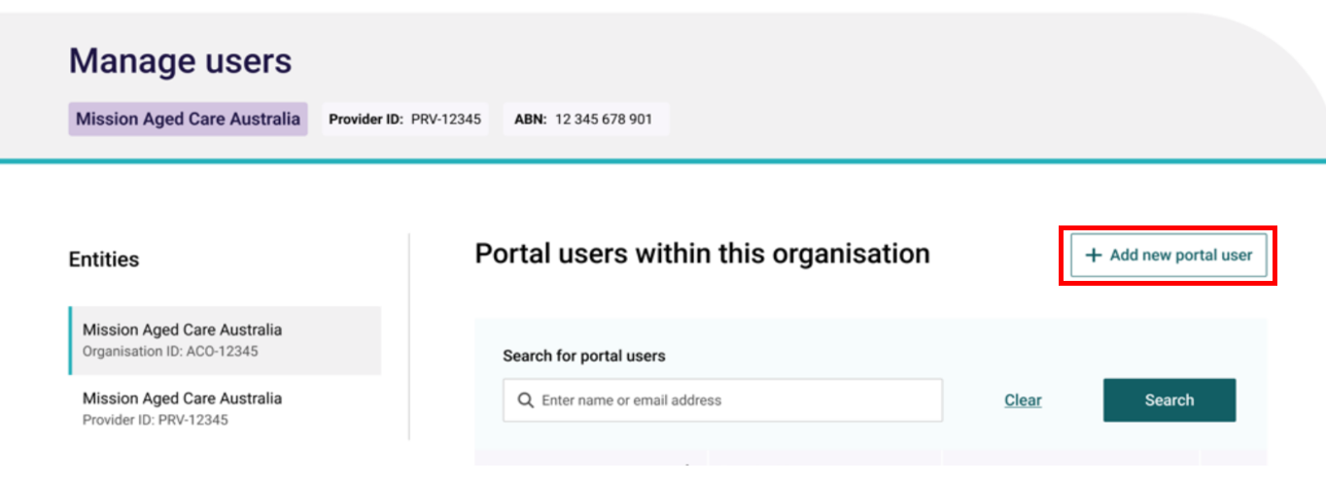

- To confirm whether the new user already has an existing contact record, in the Search for individuals field, enter the user’s name and click the Search button.
- If the does exist within the organisation and does not have a portal account, go to step 3.
- If the contact already has a portal account, follow the steps within the ‘Editing or removing user access roles’ Quick Reference Guide.
- If the search did not find an existing contact, go to step 4.
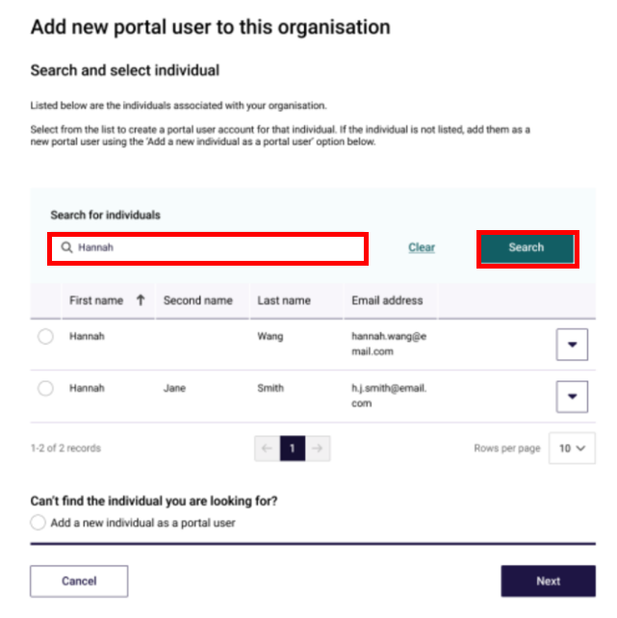

- Select the contact radio button and select the Next button. Go to step 5.
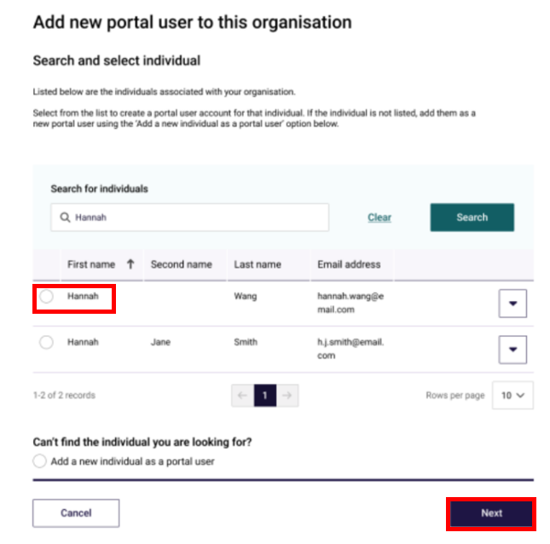

- If no contacts are found, select the Add a new individual as a portal user radio button, then select the Next button.
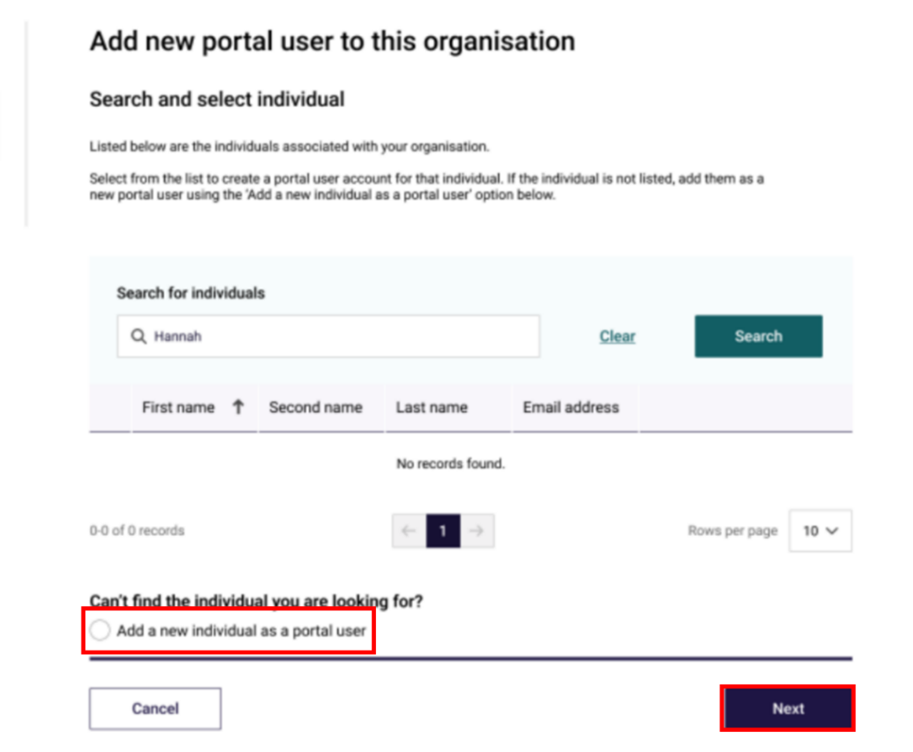

- In the User details section, enter the user’s details within the fields. In the User roles section (if not already populated), select the Organisation Administrator option, In the Declaration section, select I agree, then select the Add user button.
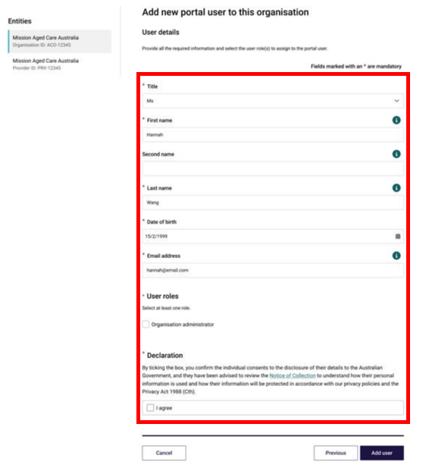

The GPMS portal will display a green banner informing that an invitation email has been sent to the new contact or portal access for the contact has been successfully updated.
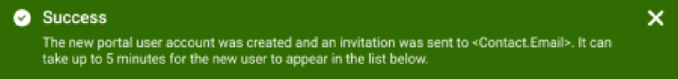

Adding a user at the provider level
To add a new user at the provider level, complete the following actions:
- In the Manage users screen, ensure the provider account is highlighted, and select the + Add New User button.

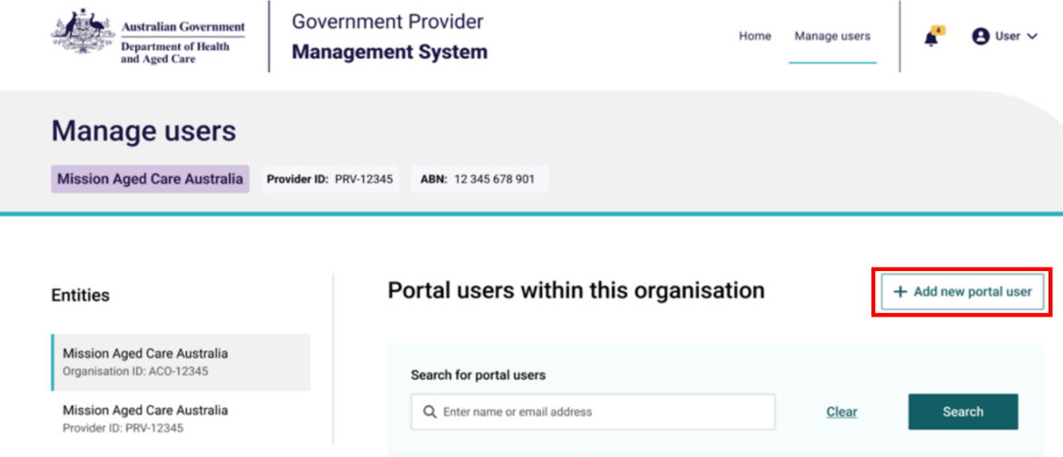
Mission Aged Care Australia
Organisation ID: ACO-12345
Mission Aged Care Australia
Provider ID: PRV-12345

- To confirm whether the new user already has an existing contact record, in the Search for individuals field, enter the user’s name and select the Search button.
- If the contact does exist within the organisation and does not have a portal account, go to step 3.
- If the contact already has a portal account, follow the steps within the ‘Editing or removing user access roles’ Quick Reference Guide.
- If the search did not find an existing contact, go to step 4.
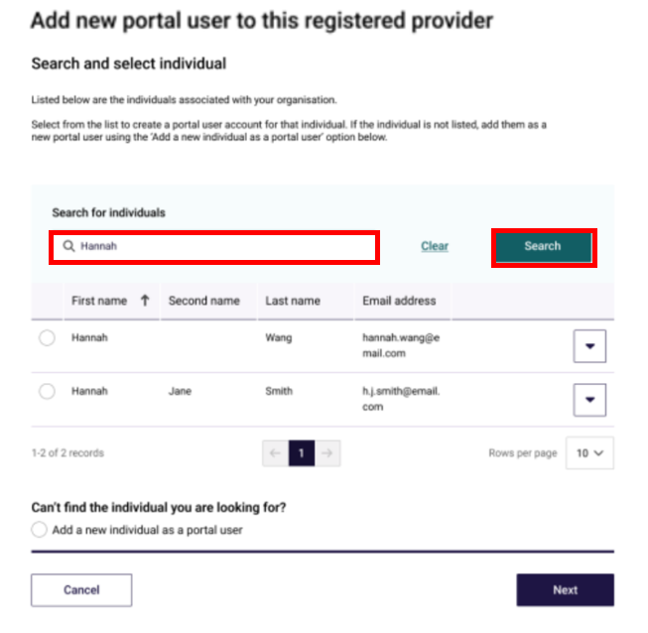

- Select the contact record’s radio button and select the Next button. Go to step 5.
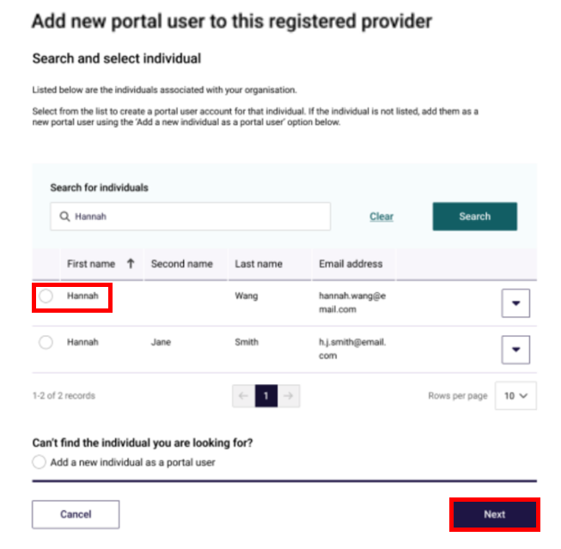

- If no contacts are found, select the Add a new individual as a portal user radio button and select the Next button.
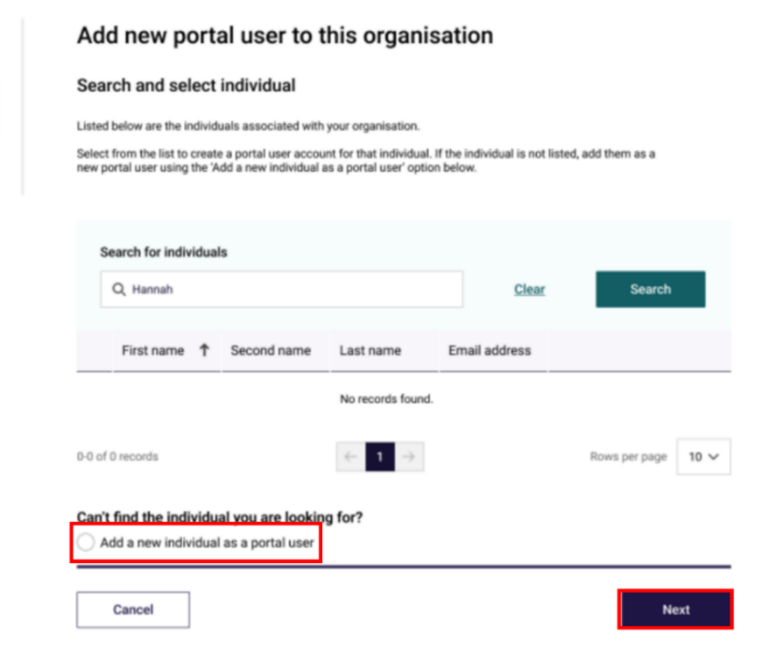

- In the User details section, enter the user’s details within the fields (if not already populated). Under User roles, select the check boxes of the access roles the user wishes to add.
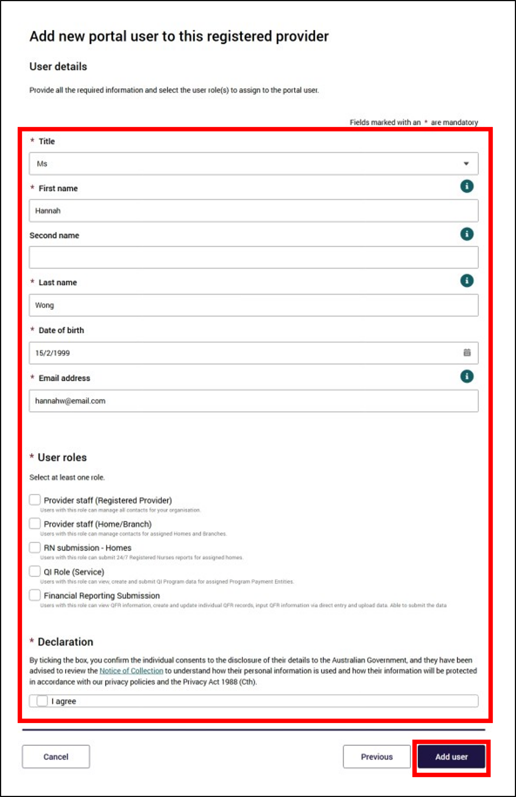

- Some access roles will require additional information to be entered. For example, a user with the access role of Provider staff (Home/Branch) will also list residential homes and/or branches operated by the selected provider. Select one or more of homes and/or branches.
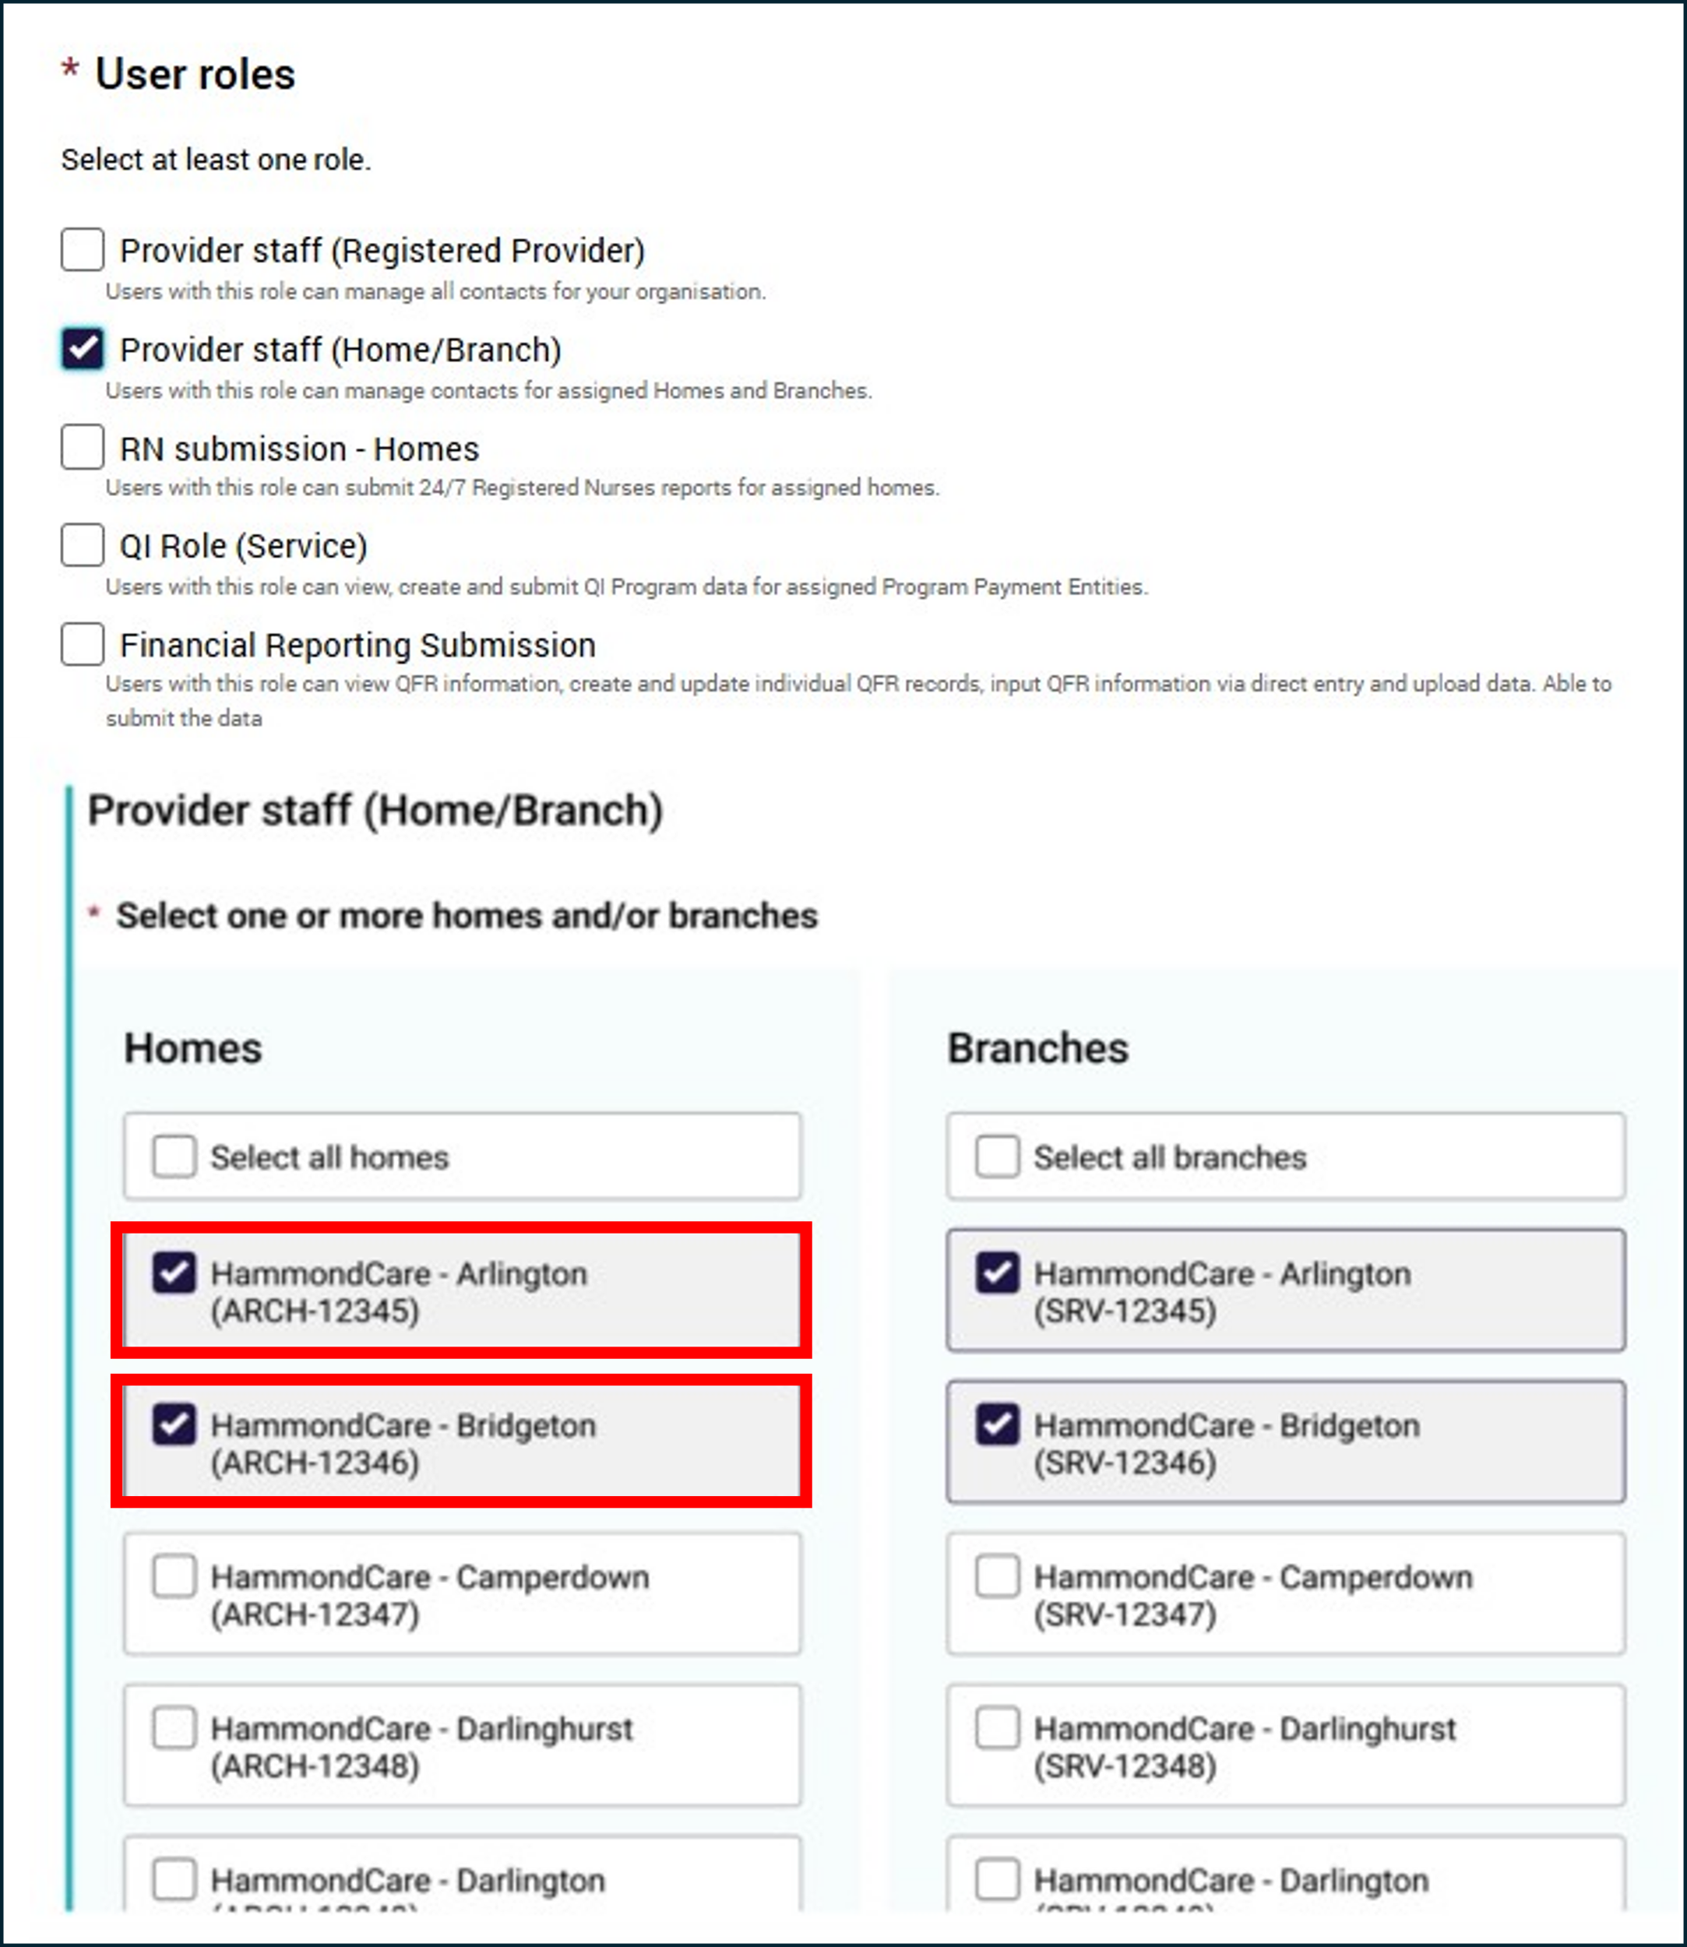

- In the Declaration section, select I agree, then select the Add user button.
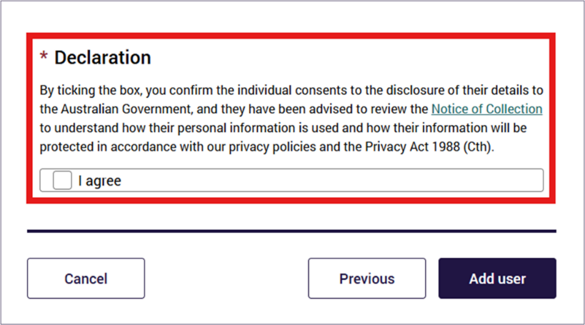
The GPMS portal will display a green banner informing that an invitation email has been sent to the new user, or to inform that portal access for the user has been successfully updated.
If users require further assistance with GPMS, please contact the My Aged Care service provider and assessor helpline on 1800 836 799, Monday to Friday (8am to 8pm) and Saturday (10am to 2pm) local time across Australia.
For translating and interpreting services, call 131 450 and ask for My Aged Care on 1800 836 799.
To use the National Relay Service, visit About the National Relay Service (NRS) | Access Hub or call 1800 555 660.
To access sign language interpreting and captioning services through Deaf Connect, call 1300 773 803 or email interpreting@deafconnect.org.au.

