Government Provider Management System – Registered Provider Portal
User Guide
September 2025
Version 5.5
This Government Provider Management System (GPMS) User Guide provides users with an overview of how to login to the GPMS Registered Provider portal and outlines how Organisation Administrators can add, edit and remove user roles.

Contents
1. Introduction 3
1.1 Purpose 3
1.2 Before proceeding 3
1.3 Login to the GPMS portal 4
2. GPMS Portal Access 4
2.1 Troubleshooting myID or VANguard issues 4
2.2 Terms of use 4
3. Organisation Administrators 7
3.1 The Manage Users screen 8
3.2 Adding a new user 9
3.2.1 Adding a user at the Organisation level 9
3.2.2 Adding a user at the Provider level 13
3.3 Search for existing contacts 18
3.4 Editing or removing contact access roles 18

Introduction
The Government Provider Management System (GPMS) is a flexible IT (Information Technology) system which is a critical part of the Aged Care Digital Transformation Initiative underway to support aged care reform through better technology.
GPMS provides greater connectivity and data sharing between aged care providers and government.

Purpose
This User Guide has been designed to support providers in understanding how to access and login to the GPMS Registered Provider portal for the first time.
It also provides an overview of the Organisation Administrator role and associated functionality, including the ability to:
- add users to the GPMS portal; and
- edit or remove user roles which allows users to access applications within the GPMS portal.

Before proceeding
Please be advised of the following:
The Department of Health, Disability and Ageing will retain records of users’ access to GPMS and when prompted, the user must accept the GPMS Terms of Use to be able to access the system.
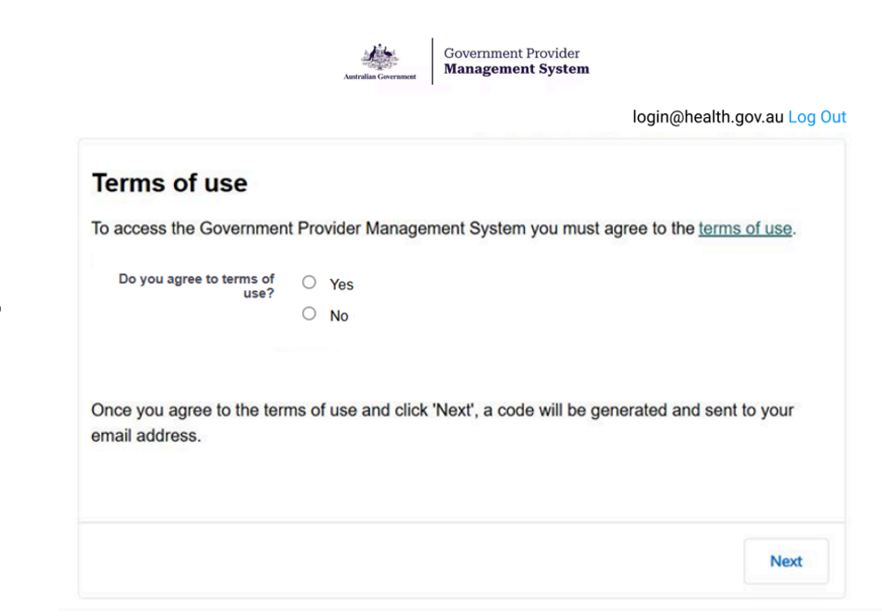

1.3 Login to the GPMS portal
To login to the GPMS portal for managing your organisation details, 24/7 registered nurse reporting, Quarterly Financial Reporting and Quality Indicator Program reporting please visit Log In into GPMS webpage.
If you require assistance to login to the GPMS portal, please refer to the GPMS Logging in to Aged Care Systems.

GPMS Portal Access
To access the GPMS portal, each staff member must have a My Aged Care portal user account linked to a supported third-party authentication service.
For more information regarding setting up users and logging into the system please refer to Logging in to Aged Care Systems.

Troubleshooting myID or VANguard issues
If users encounter any issues with logging in with myID or VANguard refer to Logging in to Aged Care Systems.
If the issue persists, users should contact their organisation’s technical support for assistance or call the My Aged Care service provider and assessor helpline on 1800 836 799. This helpline provides technical support and general information to registered providers, assessors, and hospital staff using our reporting systems and portals. Call from 8am to 8pm Monday to Friday or 10am to 2pm Saturday (local time).

Terms of use
When logging on for the first time the user will need to agree to the Government Provider Management System - Terms of Use (Terms of Use) and enter a Verification Code.
To agree, complete the following steps:
- Click the terms of use link to navigate to the Terms of Use.
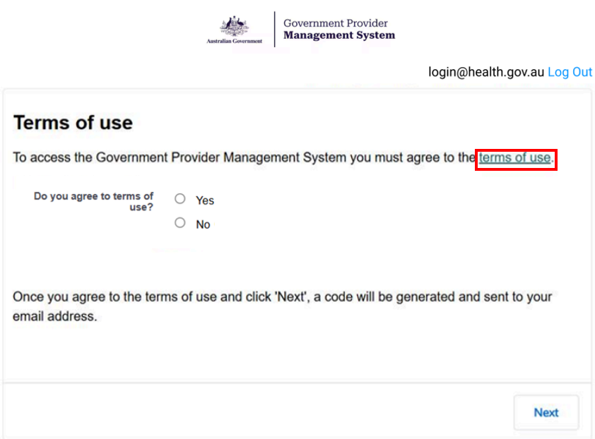
- If the terms of use are agreed to, select the Yes radio button and then select Next.
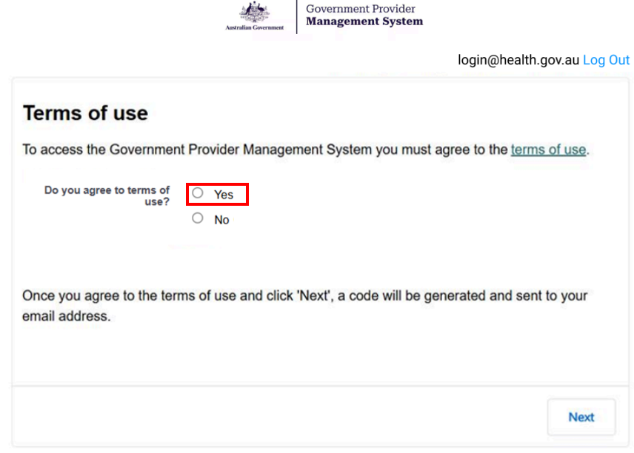
Please note:
If the user does not agree to the terms of use, selecting No will prevent them from being able to have access to the portal.
By agreeing to the Terms of Use, the user also agrees to the handling of their Personal Information in accordance with the GPMS Privacy Notice and the website privacy policy.
- If the user accepts the GPMS Terms of Use by selecting Yes, the Enter Verification Code screen will display.

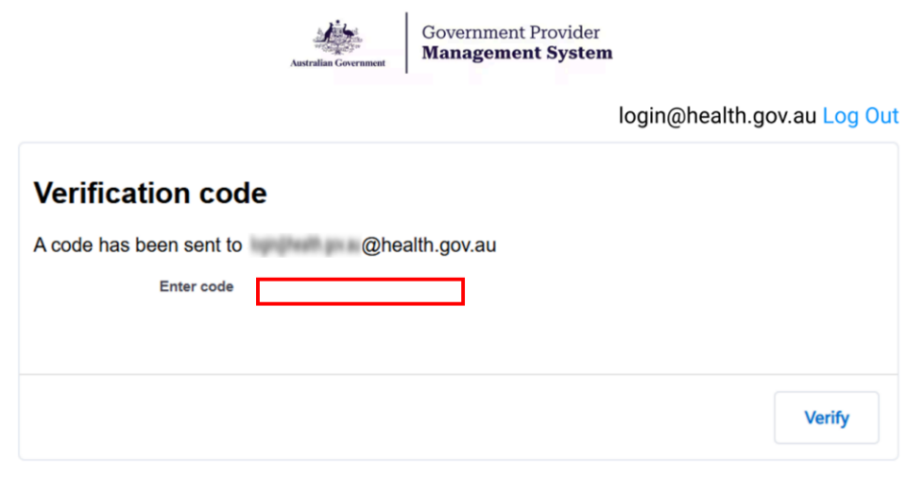
An eight-digit verification code will be sent to the user’s company email address.
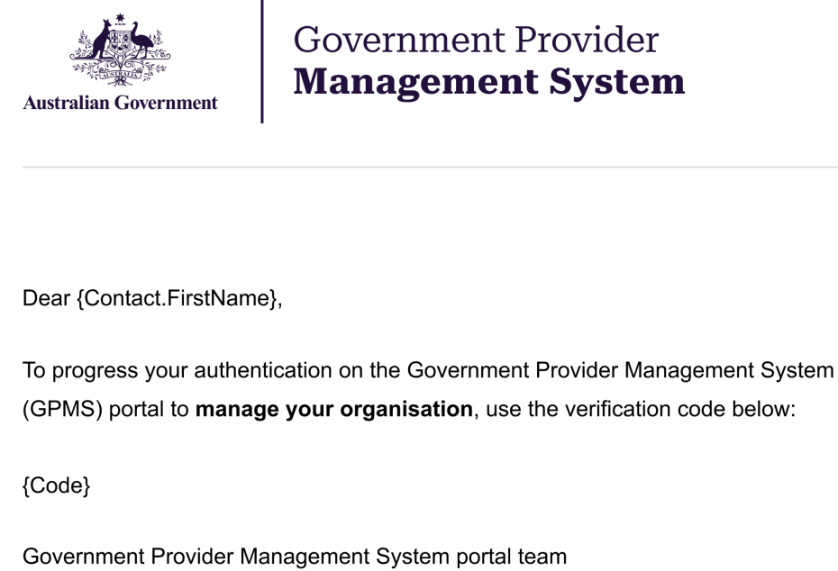
- In the Enter Verification Code field, the user should enter the eight-digit code received in the notification email and select Next.
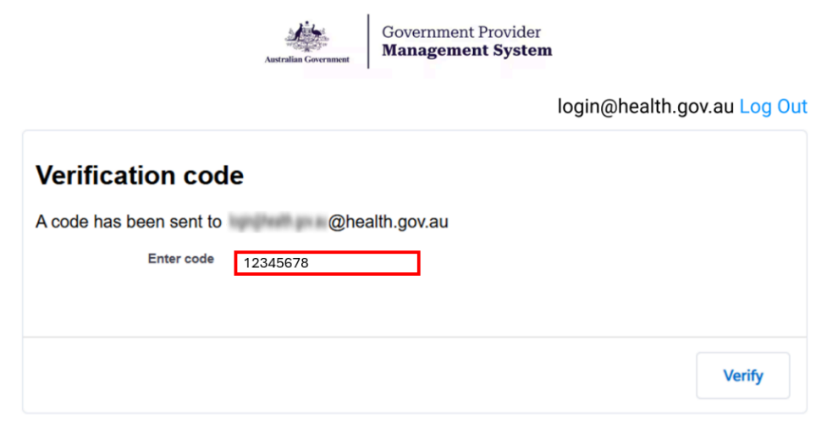
The GPMS portal landing page will display.

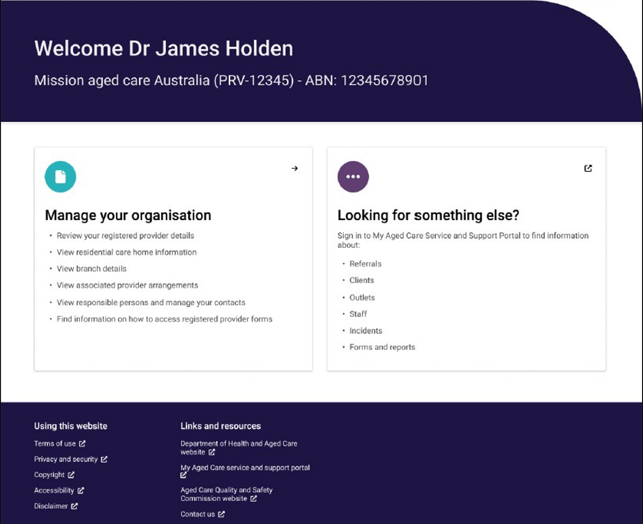

If users require further assistance to login to GPMS please contact the My Aged Care service provider and assessor helpline on 1800 836 799, Monday to Friday (8am to 8pm) and Saturday (10am to 2pm) local time across Australia.
For translating and interpreting services, call 131 450 and ask for My Aged Care on 1800 836 799.
To use the National Relay Service, visit About the National Relay Service (NRS) | Access Hub or call 1800 555 660.
To access sign language interpreting and captioning services through Deaf Connect, call 1300 773 803 or email interpreting@deafconnect.org.au.

Organisation Administrators
The Organisation Administrator is nominated by the organisation as someone who can perform the following administrative functions:
- Add additional users.
- Edit user access roles.
- Remove access roles for users who no longer require GPMS portal access.
The Organisation Administrator role in the My Aged Care system or GPMS Approved Provider portal is not interchangeable with the Organisation Administrator role in the GPMS Registered Provider portal.
If the Organisation Administrator role is not set up for GPMS for the user’s organisation, the organisation will need to nominate an Organisation Administrator for GPMS.
The following information relates to tasks that the Organisation Administrator can undertake in the GPMS portal.
Please note:
The Organisation Administrator will only be able to add, edit and remove GPMS users within the Registered Provider portal.

The Manage Users screen
The Manage Users screen is where Organisation Administrators will perform administrative functions, such as adding users and editing user access roles.
Only users assigned “Organisation Administrator” access to the GPMS portal will be able to carry out these functions.
To access the Manage Users functionality, select Manage Users in the top menu on the GPMS portal landing page.

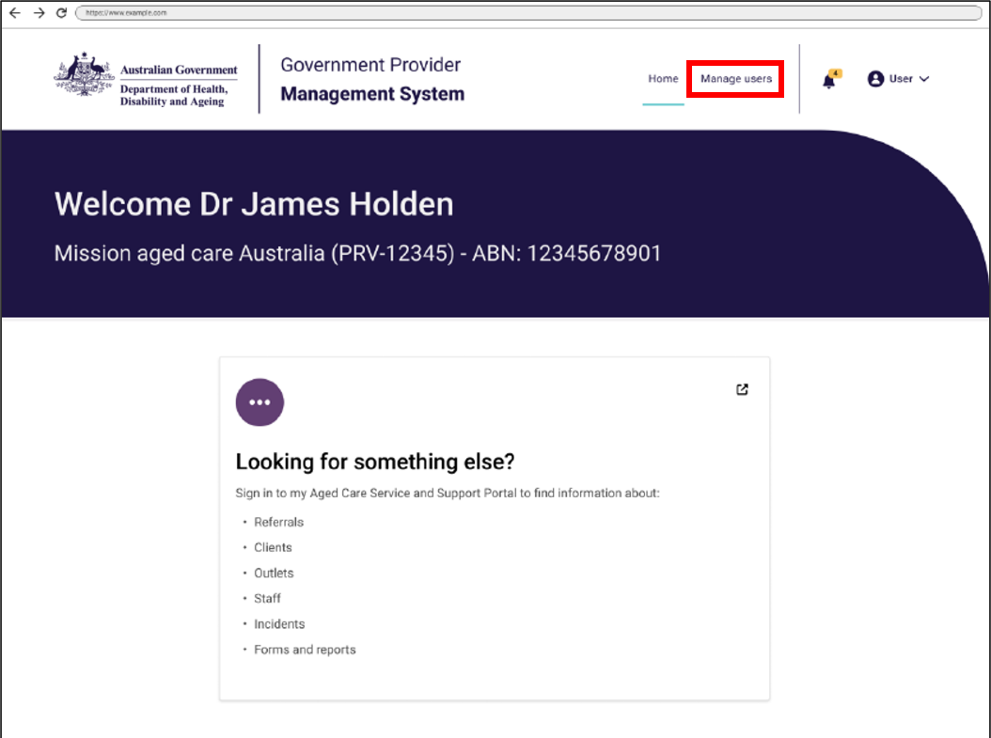
The Manage users screen will display.
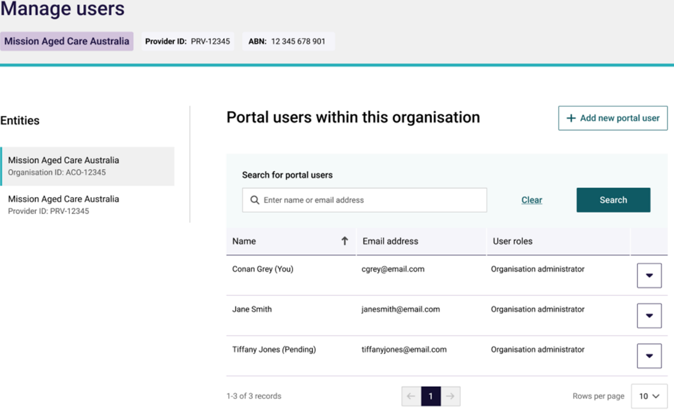

Adding a new user
Organisation Administrators can add new users to the GPMS portal. These users can be added either at the organisation level or at the provider level.
The level the new users are added to will determine what kind of access roles can be attributed to them.
Please note:
Before users login to GPMS for the first time, they must ensure they have completed the necessary steps to verify their identity in the myID or Vanguard FAS systems in accordance with their organisation’s IT policies.
For further information please refer to: Logging in to Aged Care Systems
If adding a user as an Organisation Administrator in GPMS, it is important the user is also set up as an Organisation Administrator in My Aged Care Service and Support Portal.
This will need to be done manually by the Organisation Administrator in the My Aged Care Service and Support portal.

Adding a user at the Organisation level
Users added at the organisation level can be given the Organisation Administrator role access as well as other access roles.
To add a new user at the organisation level, complete the following steps:
- In the Manage users screen, select the + Add new portal user button.
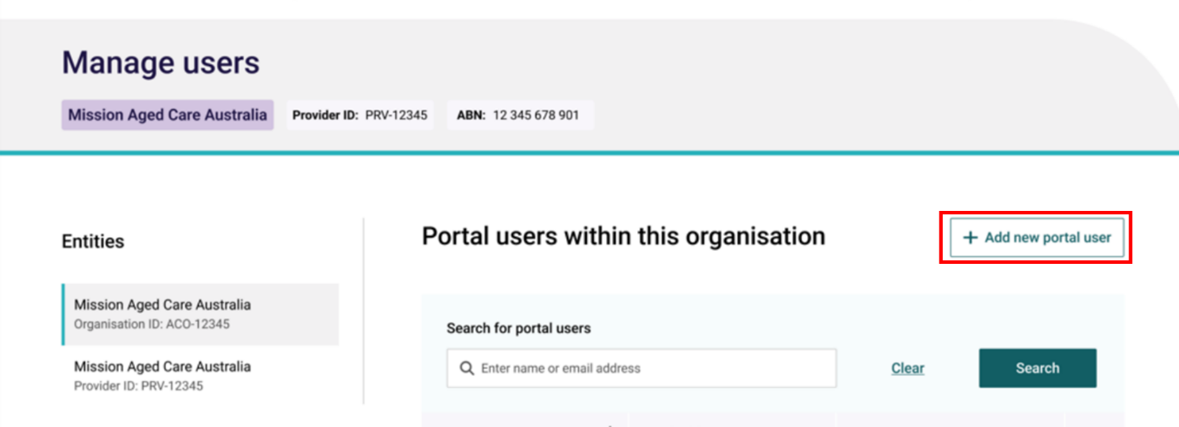
The Add new portal user to this organisation screen will then display.
- To confirm whether the new user already has an existing contact record, in the 'for individuals’ field, enter the user’s name and select the Search button.
- If the does exist within the organisation and does not have a portal account, go to step 3. If the contact already has a portal account, follow the steps within the ‘Editing or removing user access roles’ section.
- If the search did not find an existing contact, go to step 4.
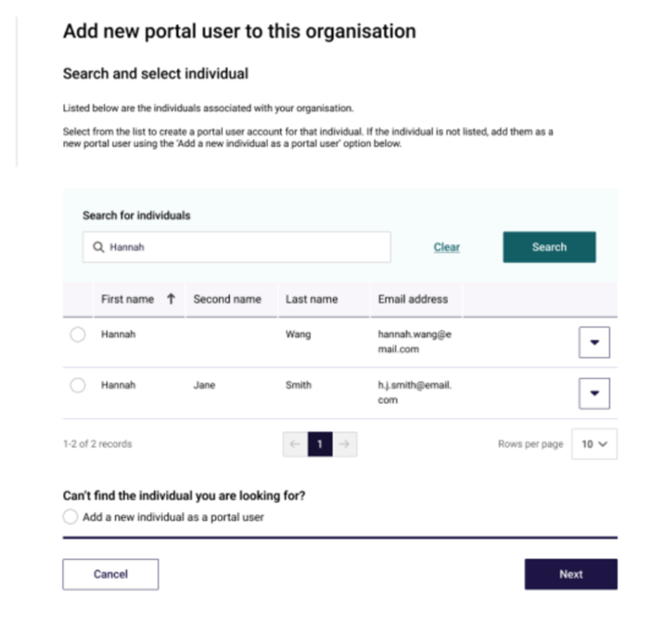
- Select the contact radio button and select the Next button, then go to step 5.
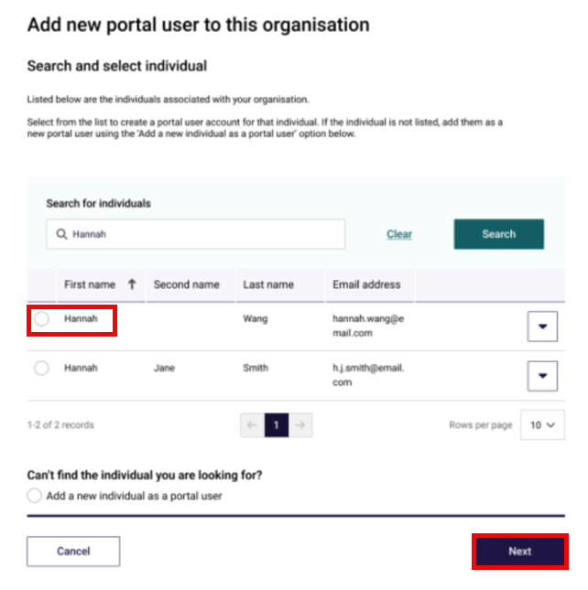
The User details screen will then display.
- If no contacts are found, select Add a new individual as a portal user radio button and select the Next button.
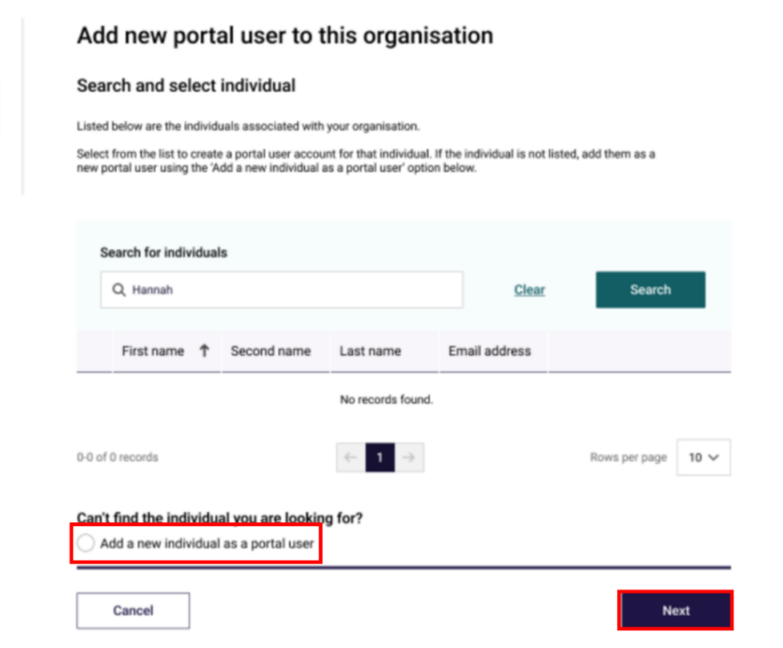
The User details screen will then display.
- In the User details section, enter the user’s details within the fields. In the User roles section (if not already populated), select the Organisation Administrator option, In the Declaration section, select I agree, then select the Add user button.
Please note:
It is important the new user’s company email address is entered correctly.
If the email address is entered incorrectly, it will prevent the user from being able to access the portal.
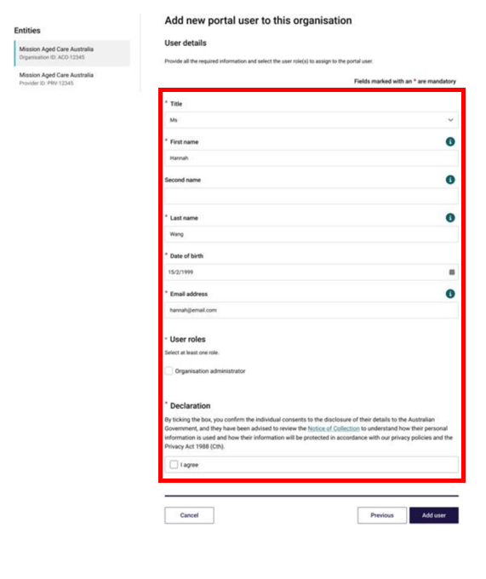
The GPMS portal will display a green banner informing that an invitation email has been sent to the new user or portal access for the user has been successfully updated.
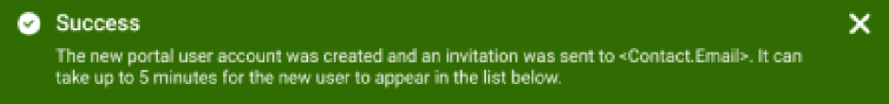

Newly added contact will have a status of (Pending). This status will remain until the newly added contact receives their notification email and selects the link to login to the GPMS portal for the first time.
Once their first login has been completed the (Pending) status will disappear.
Please note:
Organisation Administrators can add, manage and remove user access.
This level of access can only be added at the Organisation level.
Even as an Organisation Administrator, the user will need to be allocated other access roles if they require access to other GPMS applications.
The Organisation Administrator role does not automatically provide access to other GPMS applications on its own.

Adding a user at the Provider level
The Organisation Administrator may give a user access against a specific provider. This limits their access to those Providers only.
Please note:
Organisation Administrators must be allocated at the Organisation level. Provider level users cannot be Organisation Administrators.
To add a new user at the Provider level, complete the following steps:
- In the Manage Users screen, the user should select the Provider to which they want to add a new user, then select the + Add New User button.
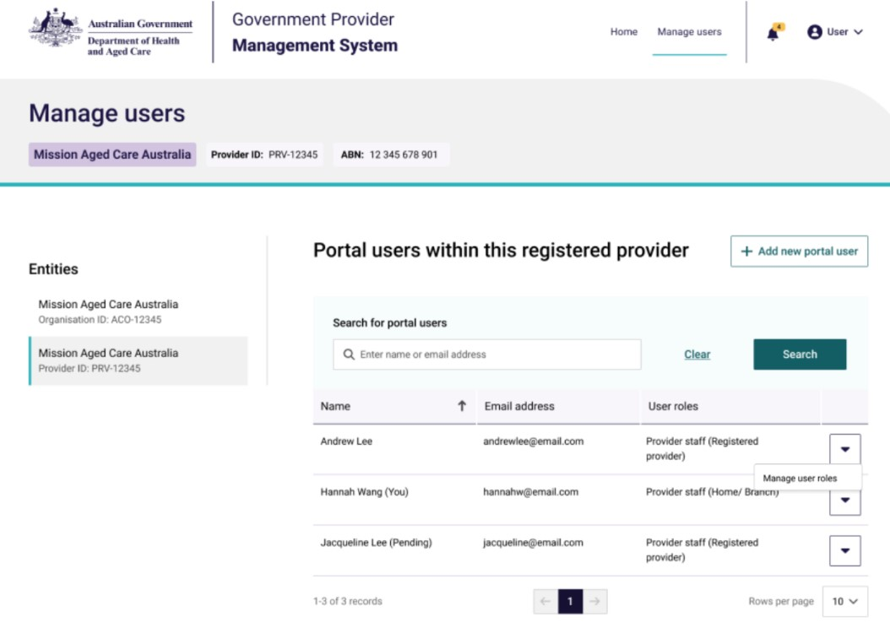

The Add new portal user to this registered provider screen will then display.
- To confirm whether the new user already has an existing contact record, in the ‘search for individuals’ field, enter the user’s name and select the Search button.
- If the does exist within the organisation and does not have a portal account, go to step 3. If the contact already has a portal account, follow the steps within the ‘Editing or removing user access roles’ section.
- If the search did not find an existing contact, go to step 4.
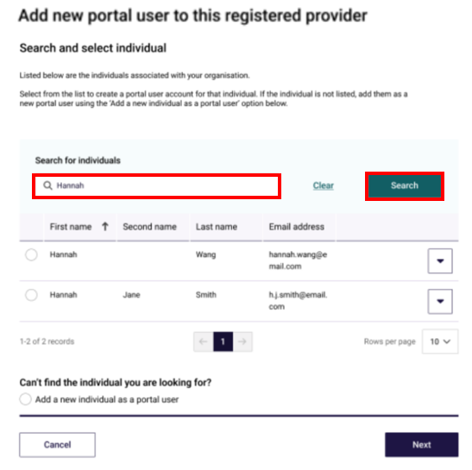
- Select the contact radio button and select the Next button. go to step 5.
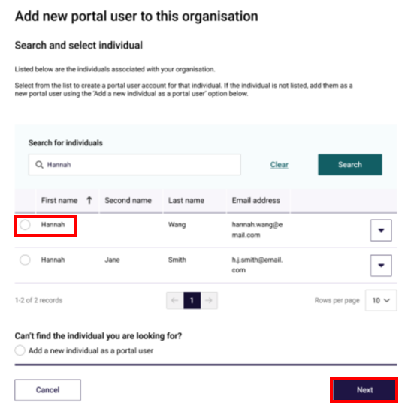
- If no contacts are found, select Add a new individual as a portal user radio button and select the Next button.
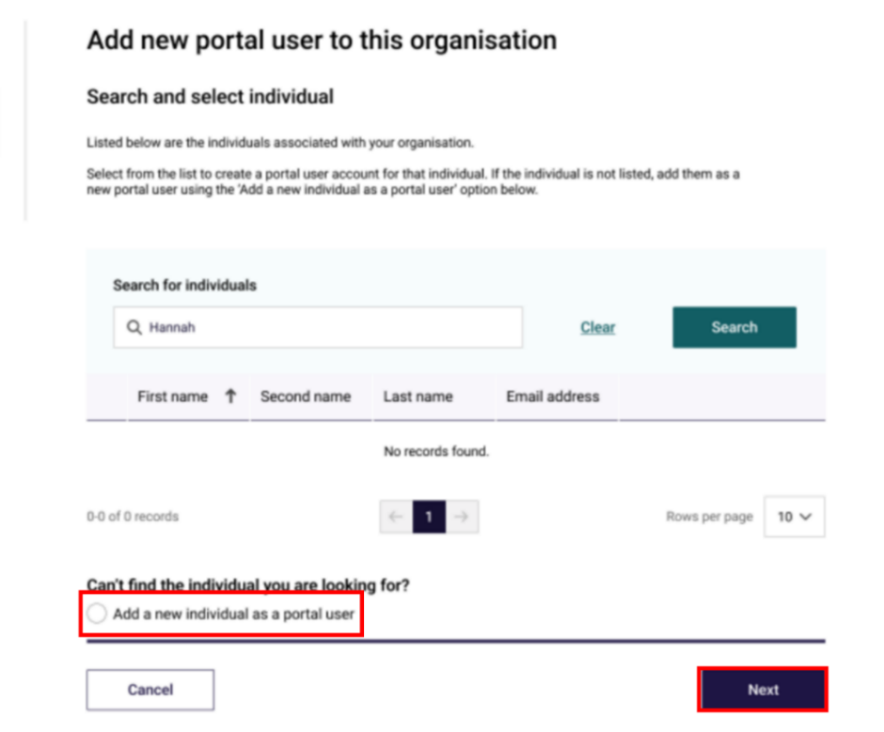
The User details screen will then display.
- In the User details section, enter the user’s details within the fields (if not already populated). Under User roles, select the check boxes of the access roles the user wishes to add.
The table below lists the available user roles and desriptions:
Role | Description
Registered Nurse Submission (Service) | Can submit 24/7 RN reporting on behalf of their organisation.
Financial Reporting Submission | Can submit QFRs on behalf of their organisation.
QI Bench Marker | Can upload bulk QI data.
QI Role (Org) | Can submit QI reports on behalf of their organisation.
QI Role (Service) | Can submit QI reports on behalf of their organisation.
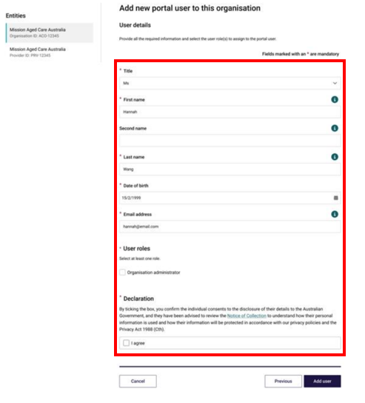
Please note:
It is important the new user’s company email address is entered correctly.
If the email address is entered incorrectly, it will prevent the user from being able to access the portal.
- Some access roles will require additional information. For example, a user with the access role of Provider staff (Home/Branch) will also list residential homes and/or branches operated by the selected provider. Select the check boxes of the services to which they want the user to have access to.
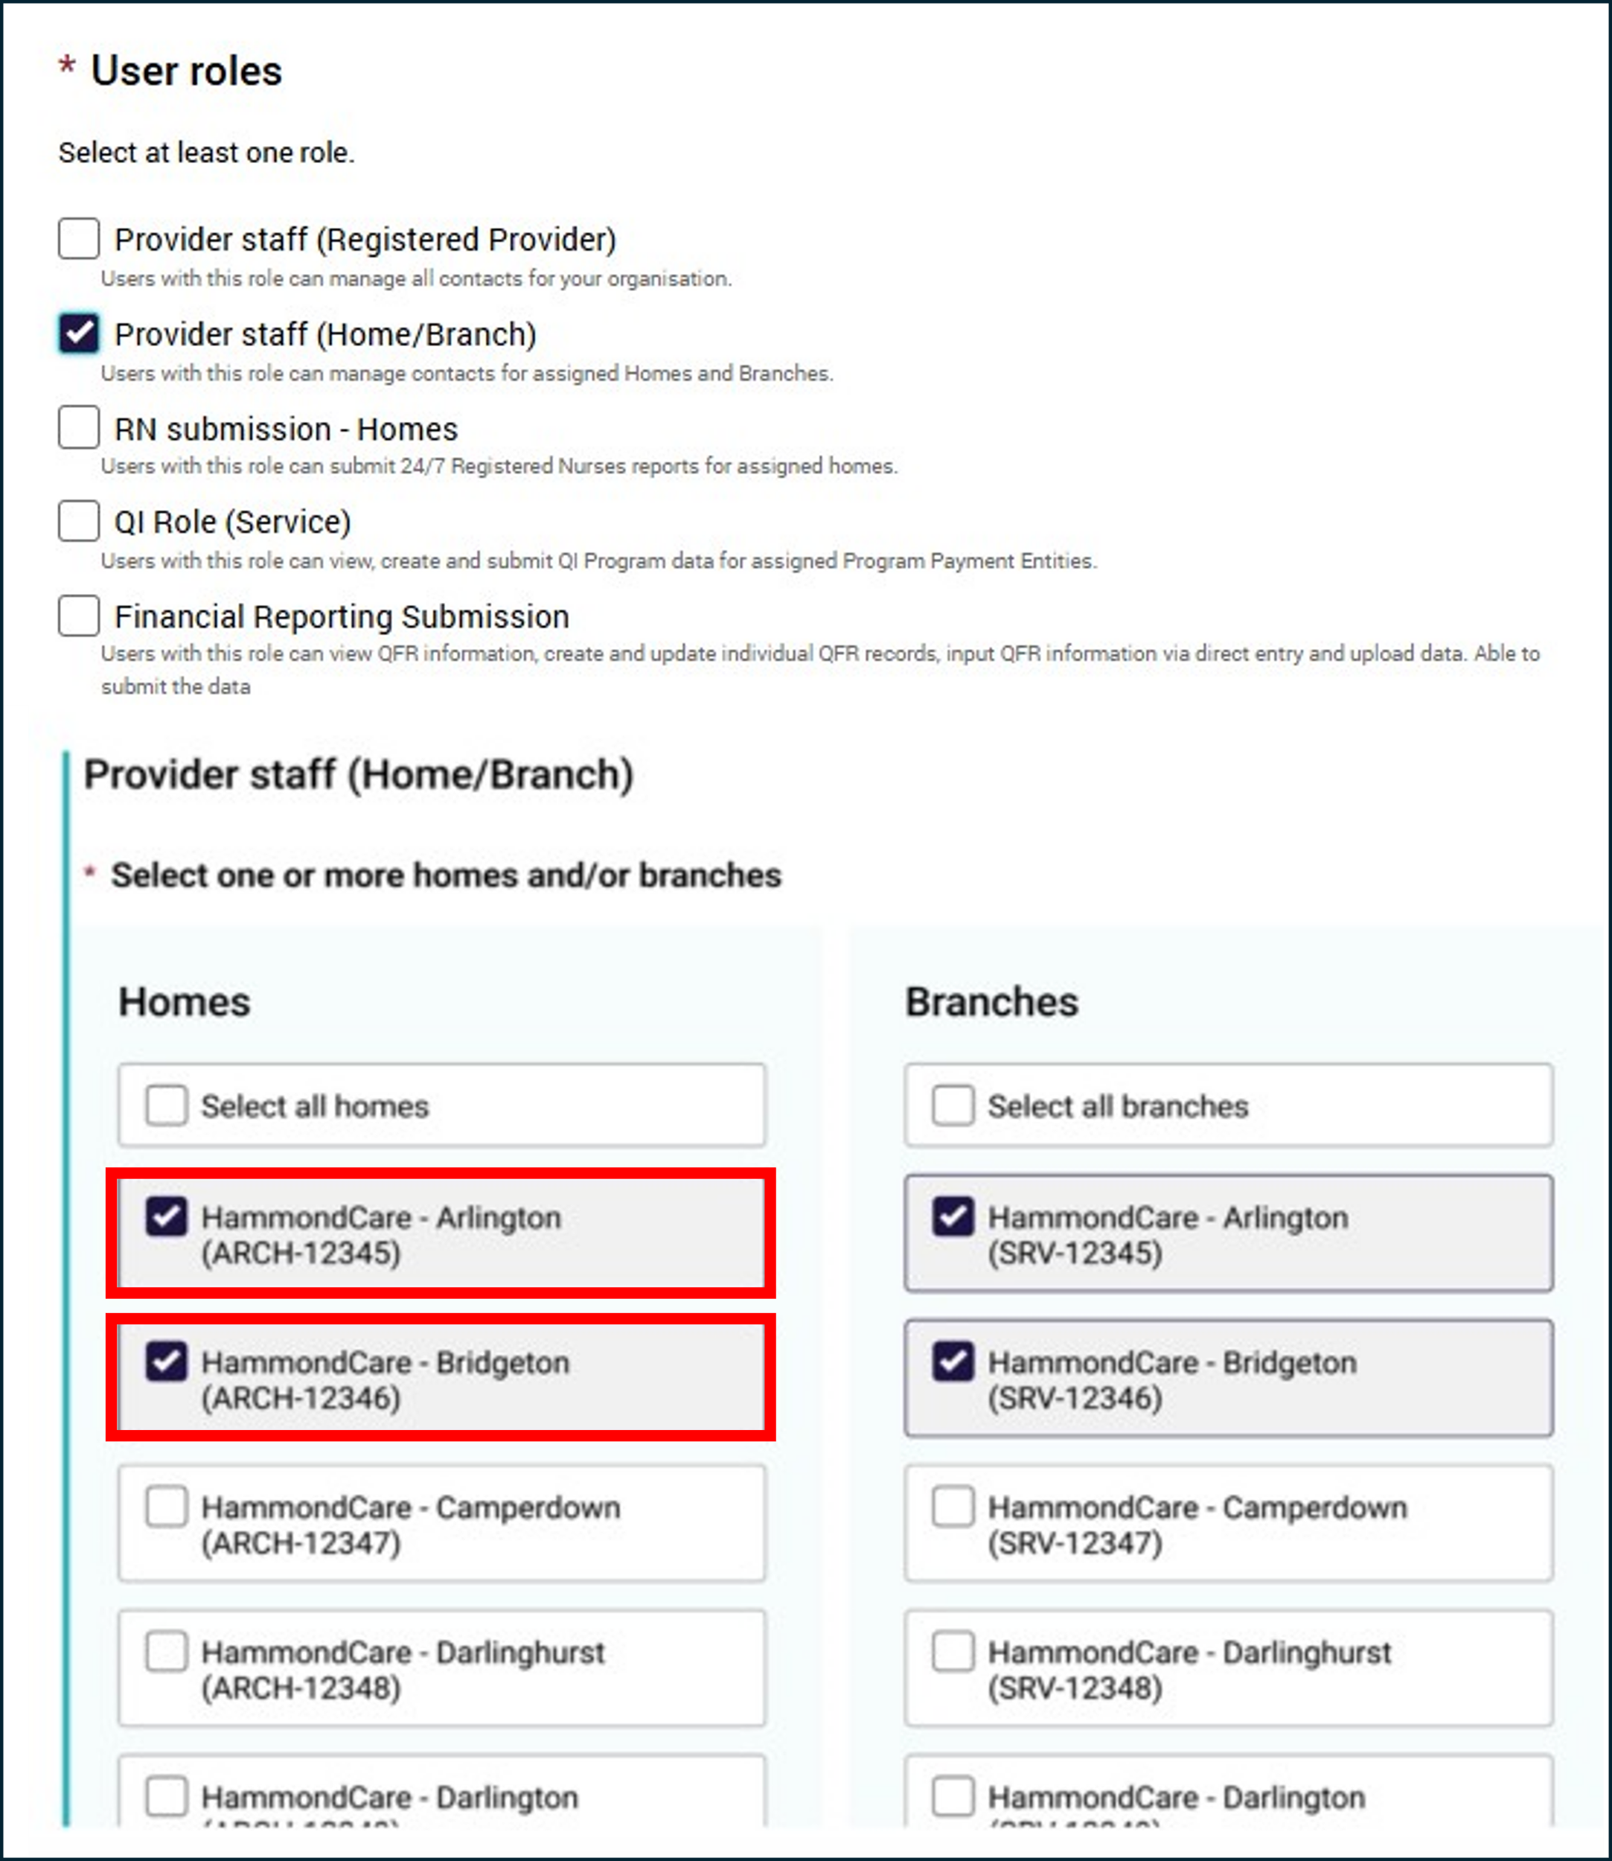
- In the Declaration section, select I agree, then select the Add user button.
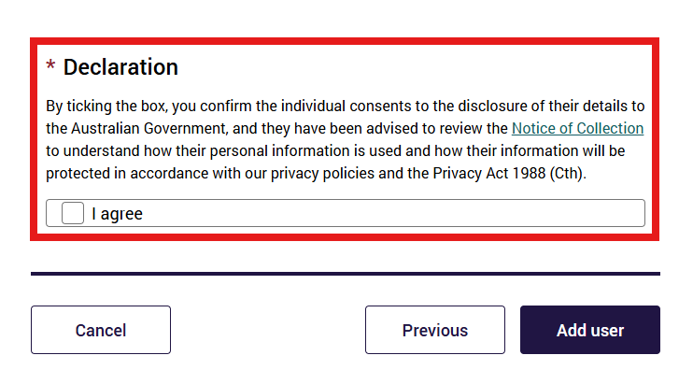
The GPMS portal will display a green banner informing that an invitation email has been sent to the new contact or portal access for the contact has been successfully updated.

Search for existing contacts
Organisation Administrators are able to search for existing GPMS contacts.
- In the Manage Users screen, enter the contacts email in the ‘search for individuals’ field, and select Search button.
If the contact already exists, their profile will display within the table.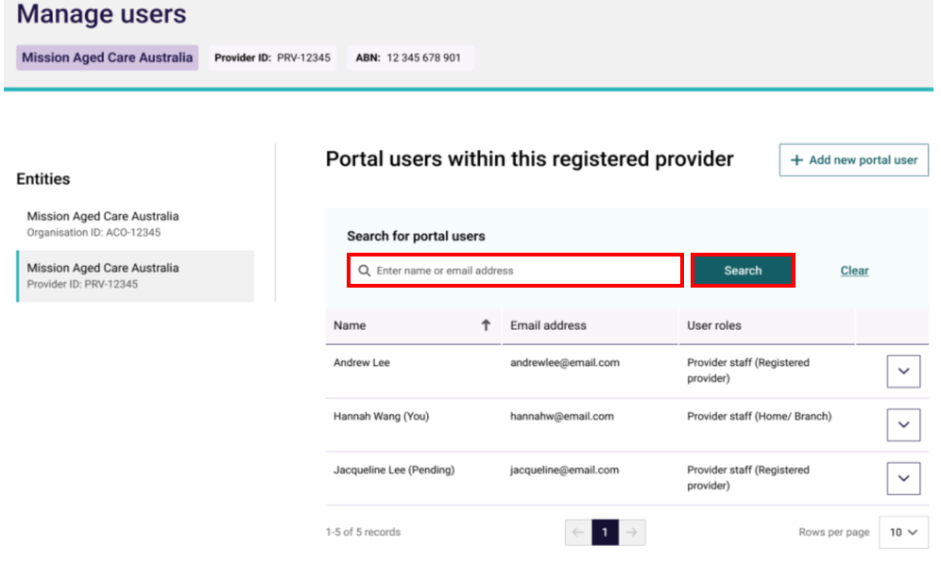

Editing or removing contact access roles
Organisation Administrators are able to edit or remove contacts’ access roles at any time.
To edit or remove access roles, complete the following steps:
- Search or select the contact for whom access is to be edited, then select Manage user roles.
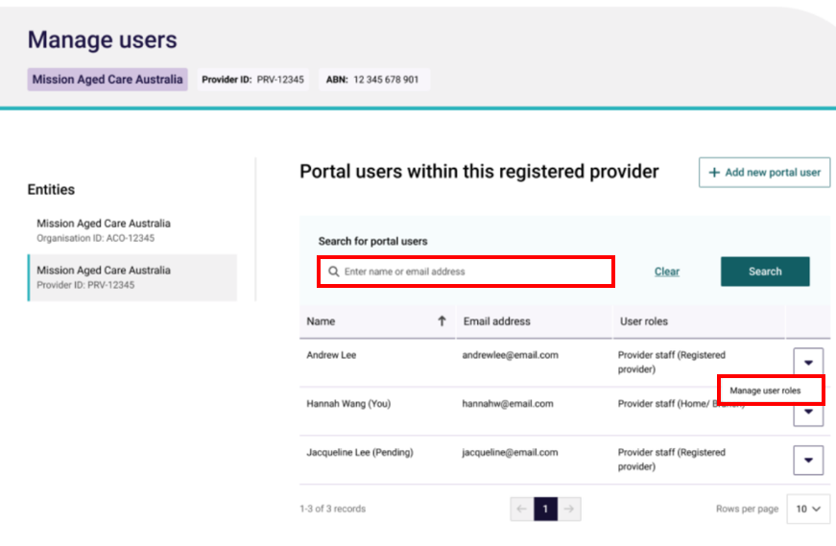
The Managing: [user name] screen will display.
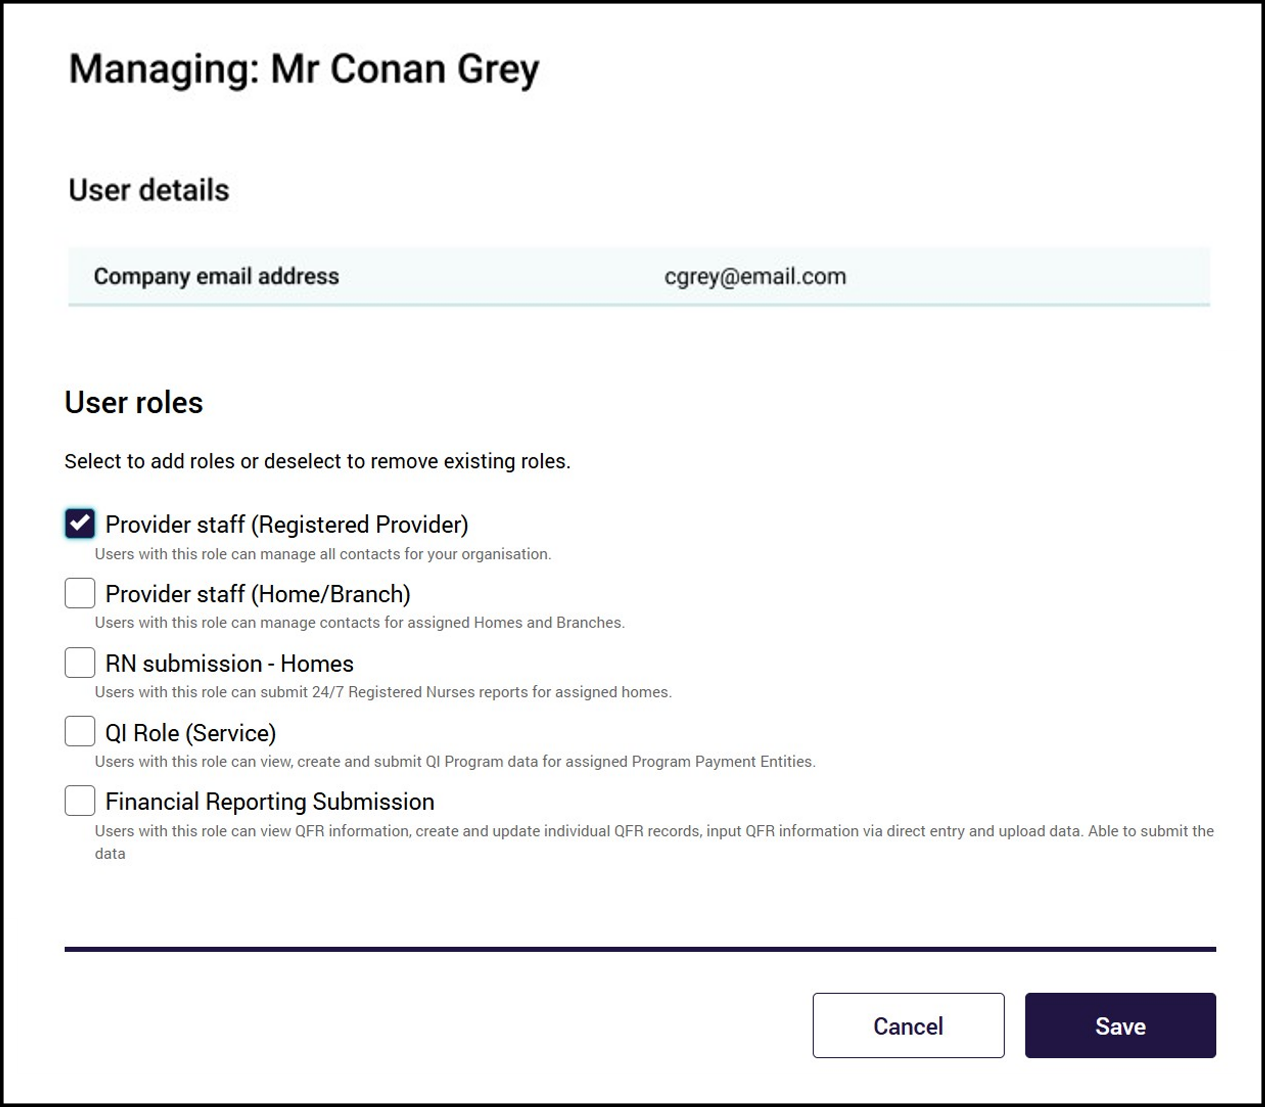
- Select or deselect the check box/es role/s and homes and/or branches for the user wishes to add and/or remove.
- Select the Save button.
- The modal to confirm the contact’s role update will display. Select Update to confirm the contact’s role update.
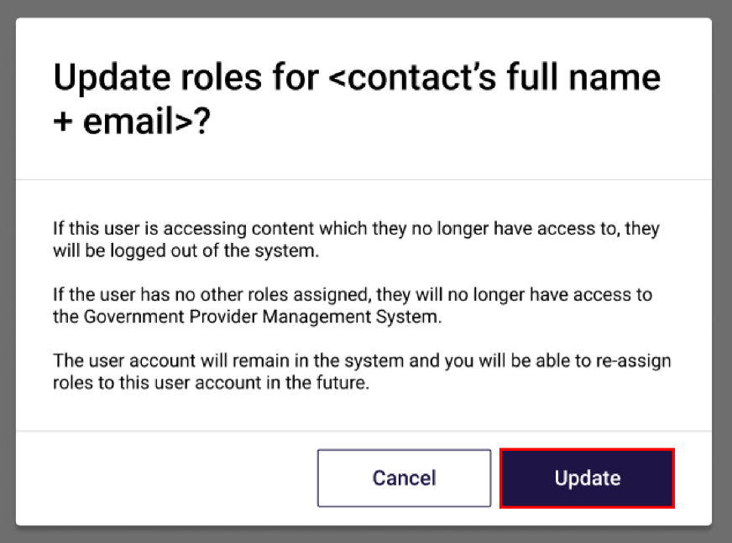
The GPMS portal will display a green banner informing that portal access for the user has been successfully updated.
An email notification will be sent to the contact with the edited roles advising a change has been made.
