# Government Provider Management System

# Quick Reference Guide: Logging into GPMS Approved Provider and Registered Provider Portal

From the implementation of the new Act, a new version of the GPMS portal is available for providers to manage their organisation’s details, submit registered nurse (RN) reports, submit Quarterly Financial Reports (QFR) and submit Quality Indicators data in the new GPMS Registered Provider portal. Registered providers can continue to use the GPMS Approved Provider to access all other reporting applications.

**Accessing the GPMS Approved Provider portal or Registered Provider portal**

|  |  |
| --- | --- |
| Access the **Approved Provider portal** to view information about your Approved Provider entity, as it existed under the *Aged Care Act 1997* up to 31 October 2025.  Here you can:   * View information about your organisation and personnel, as well as submit Approved Provider reporting:   + Star Ratings   + 24/7 Registered Nurse (RN) reports   + Care Minutes Targets   + Quality Indicator (QI) Program data   + Provider Operations   + Quarterly Financial Report (QFR) information * Preview information before it is published for the next period:   + Finance & Operations: Publication Preview   + Star Ratings | Access the **Registered Provider portal** to view information about your Registered Provider entity, as it exists under the *Aged Care Act 2024*, from 3 November 2025.  Here you can:   * View and maintain the information about your organisation including:   + View provider details   + View Residential Care Homes   + View Branches   + View Associated Provider Arrangements   + View Contacts (including Responsible Persons and Point of Contacts)   + Manage Provider Aboriginal Community Controlled Health Organisation details   + Manage provider business contact details   + Create, update and cease Point of Contacts * Submit Registered Provider reporting:   + 24/7 Registered Nurse (RN) report   + Quarterly Financial Report (QFR)   + Quality Indicator (QI) Program data   As GPMS is enhanced, additional applications will be introduced through future updates. |

To access the GPMS portals, complete the following steps:

1. Select the [GPMS log in](https://www.health.gov.au/resources/apps-and-tools/government-provider-management-system) page link. The GPMS web page will display.
2. Click on either button labelled “Log in to GPMS - Approved Provider” or “Log in to GPMS – Registered Provider” to take the user to the respective portal login page.

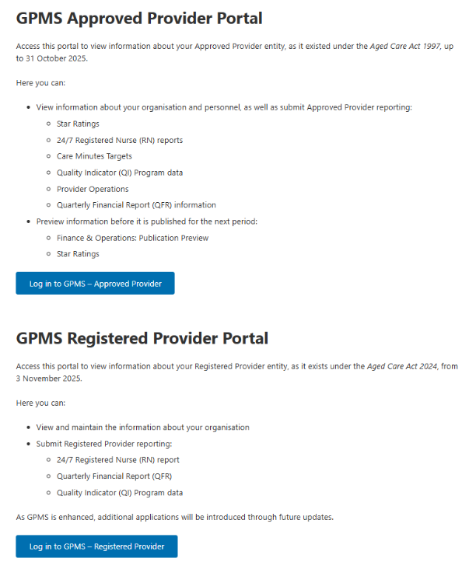

The Log In Using VANguard Federated Authentication Service or myID Digital Identity screen will display.

* To log in using VANguard Federated Authentication Service, go to Step 3.
* To log in using myID Digital Identity, go to Step 5.

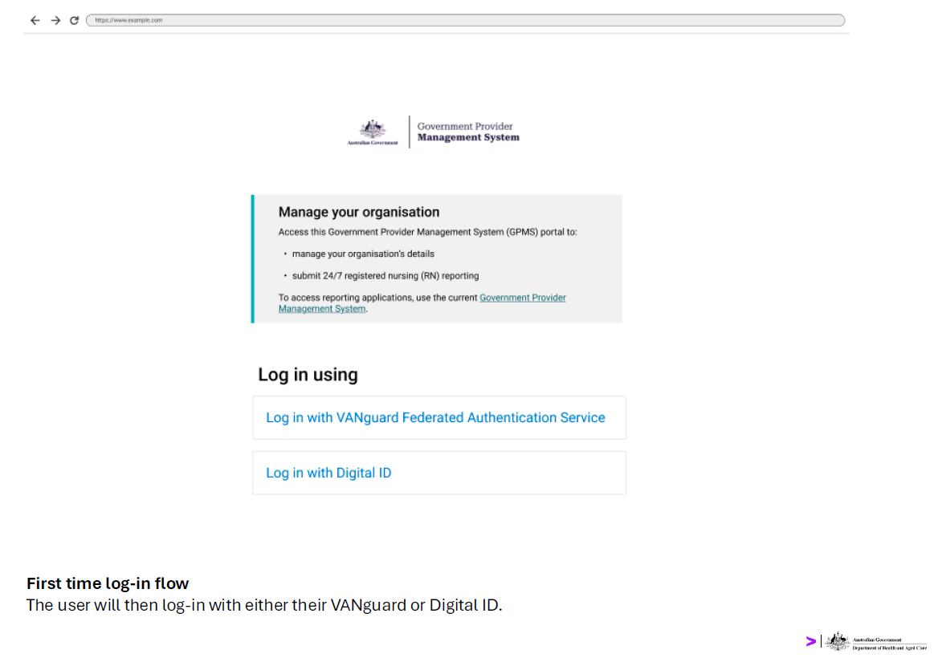

1. To log in using VANguard Federated Authentication Service, select **Log in with VANguard Federated Authentication Service.**

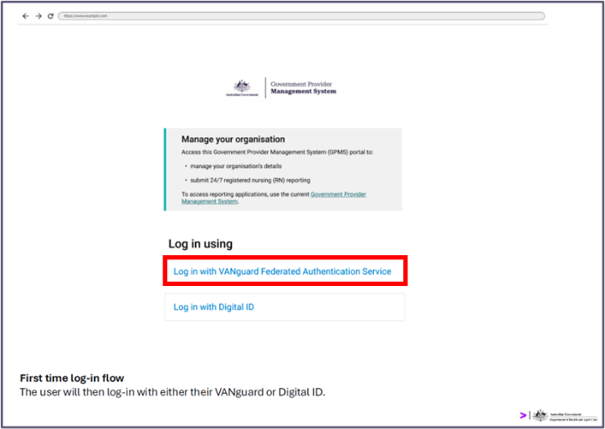

1. A page will be displayed requiring the user to choose to authenticate using either a local system, or by using the VANguard Federated Authentication Service. Select **VFAS Authentication** from the dropdown menu, then select the **Next** button.

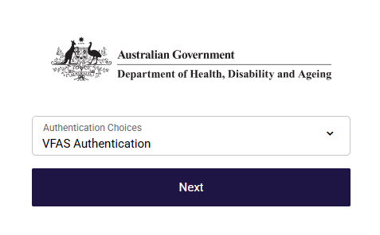

The Authentication Service page will display.

1. In the search field, enter the name of the organisation and then select the correct value from the suggestions in the drop-down. Once the organisation is selected, select the **Continue** button.

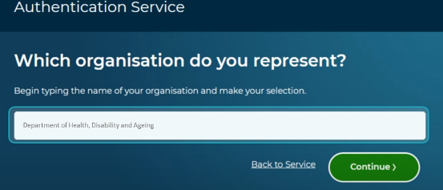

The GPMS landing page for the provider will then display.

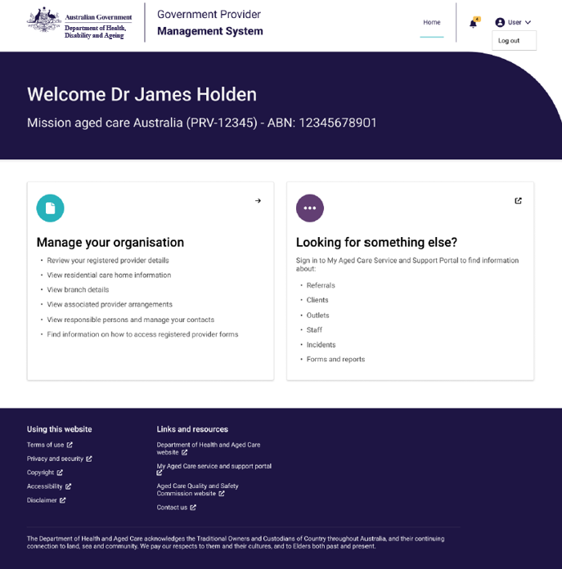

Please note:

**If this is the first time the user is logging into GPMS, the user must follow the screen instructions to agree to the GPMS Terms of Use and enter a verification code sent to their email.**

1. To log in using myID Digital Identity, select **Log in with Digital ID.**

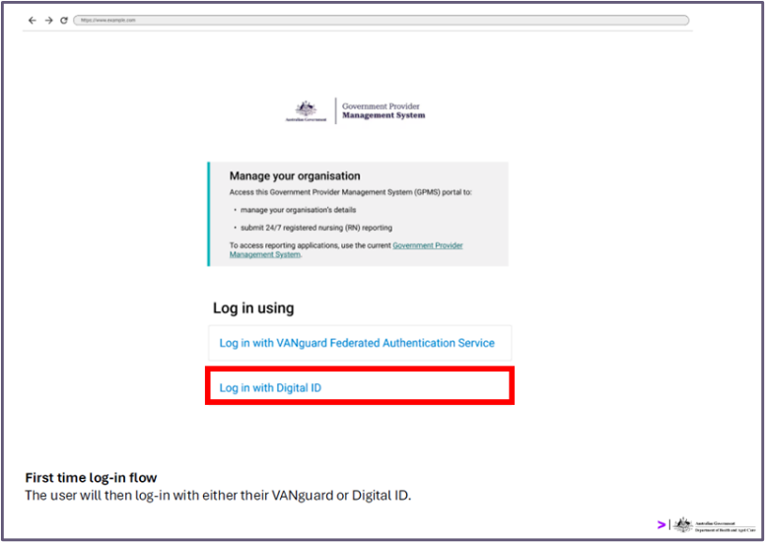

A page to select authentication method will display.

1. Ensure **Digital ID Authentication** is selected, then select the **Next** button.

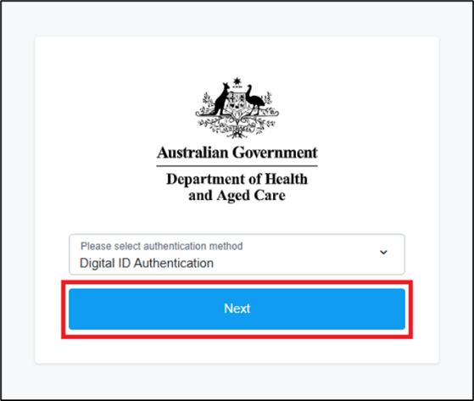

The Select your identity provider page will display.

1. Select the Select **myID** button.

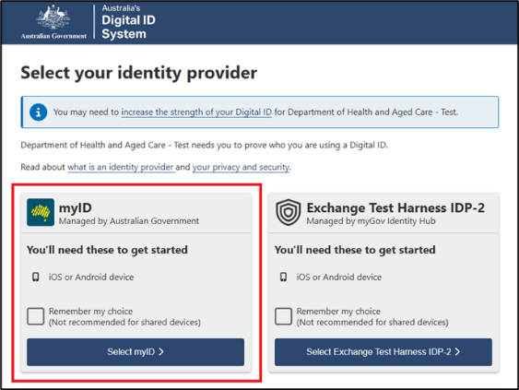

The myID page will display.

1. In the myID email field, the user enters their **email address** utilised for myID, then click **Get code** button.

The ‘myID’ page will display an authorisation code. Log in to the myID app on a device and enter the code displayed on the screen.

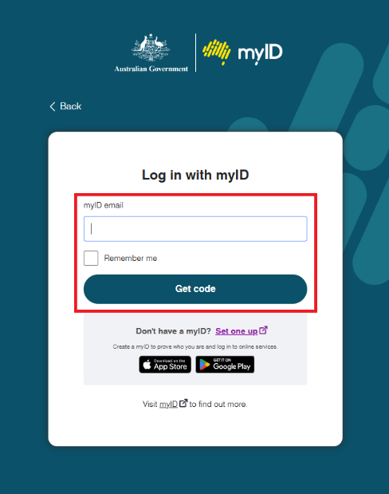

If the user works for more than one organisation, the Relationship Authorisation Manager screen will display

1. Select the **radio** button of the organisation that the user would like to access, then select the **Continue** button.

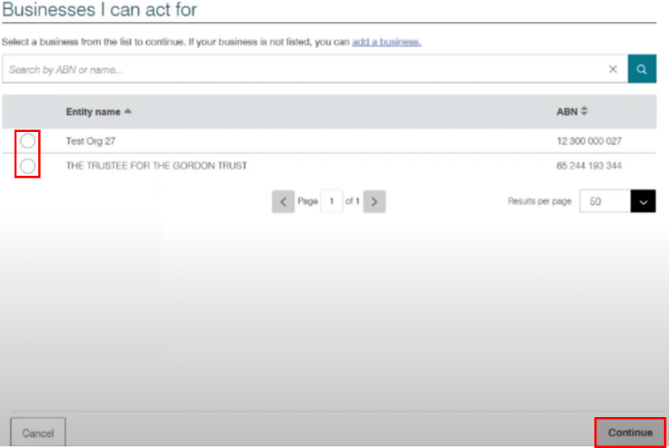

The GPMS landing page for the provider will then display.



Please note:

**If this is the first time the user is logging into GPMS, the user must follow the screen instructions to agree to the GPMS Terms of Use and enter a verification code sent to their email.**

If users require further assistance to login to GPMS please contact the My Aged Care service provider and assessor helpline on **1800 836 799**, Monday to Friday (8am to 8pm) and Saturday (10am to 2pm) local time across Australia.

For translating and interpreting services, call **131 450** and ask for My Aged Care on **1800 836 799**.

To use the National Relay Service, visit [About the National Relay Service (NRS) | Access Hub](https://www.accesshub.gov.au/about-the-nrs) or call **1800 555 660**.

To access sign language interpreting and captioning services through Deaf Connect, call [1300 773 803](tel:1300%20773%20803) or email [interpreting@deafconnect.org.au](mailto:interpreting@deafconnect.org.au).