Fact sheet for Assessors and Triage Delegates on Support Plan Reviews that initiate a new assessment

22 September 2025

# Purpose

This fact sheet explains why this change is being introduced and provides guidance on the process for Triage Delegates after a Support Plan Review (SPR).

This fact sheet details how Triage Delegates and assessors can limit duplicative phone calls with clients and leverage information previously captured within conversation summaries.

## Why the change?

Recent data has indicated that on average 17,000 Support Plan Reviews per month lead to a ‘new assessment’. This initiates the assessment workflow, requiring the Triage Delegate to contact the client.

Clients can often receive multiple calls in a short timeframe, from assessors contacting them for the Support Plan Review, to a Triage Delegate covering similar information. This creates a duplication of effort for the assessment organisation and requires the client to repeat their information.

Limiting the need to make triage phone calls for clients who have had a Support Plan Review, where a new assessment has been recommended, will help improve the triage experience for both the client and the assessment organisation.

There will still be instances where a follow-up triage call is required, as explained further below. Please note that:

* If there is uncertainty about the client’s needs or if the referral is being sent to a different assessment organisation (for example, the person has moved to another location), a triage call must still be completed
* This process is designed to support continuity of care and reduce duplication when the same team is managing the client’s case.

## What is the change?

To ensure that assessors conducting Support Plan Reviews (SPR) and Triage Delegates work together to minimise duplication, it is proposed that:

|  |  |
| --- | --- |
| Change | Following a Support Plan Review, desktop triage can be completed the Triage Delegates may no longer need to contact clients to complete Triage. |
| Scenario | When the outcome of a Support Plan Review is a new assessment is required |
| Criteria | * The Support Plan Review was completed by the assessor within the past two weeks and the conversation summary contains sufficient detail to answer the Triage questions and assign appropriate priority. * The assessor has obtained the client’s consent to complete the triage function during the Support Plan Review. * The Triage Delegate can confirm from the SPR that a significant change has occurred with enough detail to progress the referral to assessment. |
| Outcome | Minimise duplicate phone calls to clients made by Triage delegates after a Support Plan Review call. |

In the event all criteria are met, the Triage Delegate can:

| New Assessment referral meets the criteria under ‘Guiding criteria to undertake desktop triage’ (below) | |
| --- | --- |
| Step 1 | Determine if all criteria are met. |
| Step 2 | Complete Triage without contacting client. |
| Step 3 | If required, contact assessor that completed the Support Plan Review for further information. |
| Step 4 | When appropriate and in line with priority status, book client in for new assessment and assign to relevant assessor |

In the event all criteria are not met the Triage delegate can:

| New Assessment referral does not meet the criteria under ‘Guiding criteria to undertake desktop triage’ (below) | |
| --- | --- |
| Step 1 | Determine which criteria is not met. |
| Step 2 | Contact the assessor that completed the SPR for further information to attempt to meet the criteria. |
| Step 3 | If all criteria are not met, contact client to complete Triage questions, following regular process. |
| Step 4 | When appropriate and in line with priority status, book client in for assessment and assign to relevant assessor |

The following is a diagram that represents the criteria and decision points for the assessor conducting the SPR and the Triage Delegate triaging the new assessment outcome from the SPR.

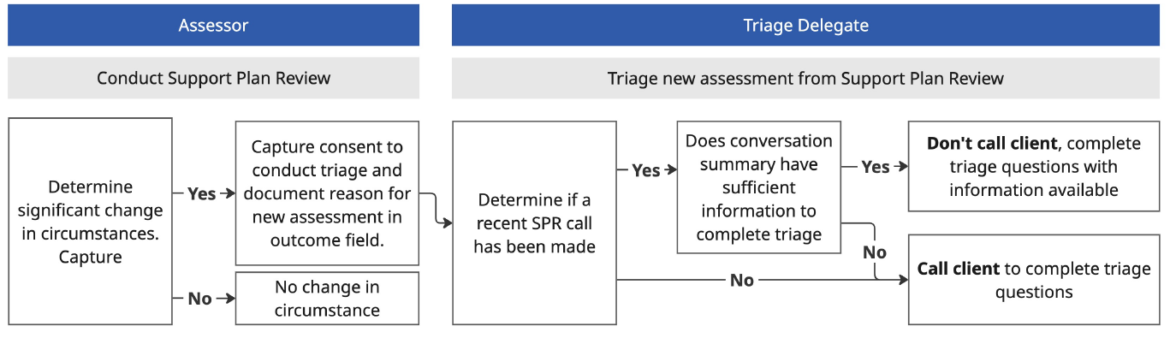

Figure 1 Flow diagram of Support Plan Review resulting in a new assessment that is triaged

## What remains the same?

This change will only impact SPRs that have determined a new assessment for the client is required, i.e. where a significant change of circumstances has been determined by the Assessor.

There is no change to existing clients where the SPR has determined a new assessment is not required; in that instance, the assessor should continue to allocate any additional services as required.

## What resources will support this change?

Section 5.2.5 of the My Aged Care Assessment Manual provides for the following:

In submitting a request for a new assessment following a SPR, the assessor is required to indicate whether they have spoken with the client and provide a summary of that conversation.

Where a conversation with the client has already occurred, the Triage Delegate should consider the conversation summary provided by the assessor as necessary. If satisfied, the Triage Delegate should complete the triage questions of the IAT, without needing to speak with the client, given this occurred at the SPR stage. An assessment can then be scheduled for the client at a time that aligns with their priority setting.

Note: That consent to complete IAT Triage questions should be sought by the assessor when the assessor is speaking with the client (or their supporter) at the SPR stage.

If a conversation with the client has not occurred at the SPR stage, the Triage Delegate should speak with the client to confirm a significant change has occurred, drawing on the IAT triage questions to inform response. If the Triage Delegate is satisfied a significant change has occurred, they should complete the triage questions and recommend a new assessment.

## Guiding criteria to undertake desktop triage

To help ensure a Triage Delegate can undertake a desktop triage for a new assessment following a SPR, the assessor will be required to input sufficient information within the SPR detailing the significant change in circumstances that warrants a new assessment. This information will support the Triage Delegate when conducting triage, limiting time to complete triage and the number of phone calls made to client.

Assessors should ensure they note the following information before submitting the SPR for a new assessment:

* Check for **urgency** – has sufficient information been collated by the assessor who conducted the SPR relating to the person’s urgent need for a new assessment
* Is there **sufficient support in place** while the person awaits a new assessment – are there sufficient linking supports or have CHSP services been recommended.
* Does the record **sufficiently describe the reasons** (or event) that has warranted the need for a new assessment, including any change to the person’s function (e.g. mobility status, recent falls, etc.)? and
* Has the assessor **sought consent** from the older person for them to proceed to triage and have it completed based on the SPR notes?
* If the client is a ‘home support’ assessment being recommended for a ‘comprehensive’ assessment, is there sufficient information supporting the conversion?

If there is insufficient text available within the SPR request box, the assessor should save a record of their conversation with the client in the client’s portal. Assessors may also wish to use some or all of the triage questions using the IAT Offline Form and save this version as a record of the SPR in the client portal if that assists.

## Steps in Assessor Portal completing a SPR

1. Start Support Plan Review assigned to you, expand the client card, either card or list view. The Client Summary page displays. Select **START SUPPORT PLAN REVIEW.**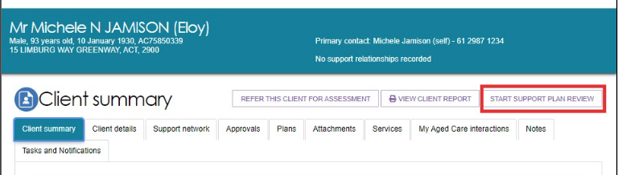
2. Pop-up will display to capture consent to share information with MyHealthRecord. Select ‘Yes’ or ‘No’.
3. Select reason for Support plan review before Starting the review.
4. Once the Support Plan Review is started, the assessor can make changes to information in the sections of the client’s support plan.
5. Final step to enter the outcome of the SPR, entering the outcome details. This information will be used to support the Triage Delegate to conduct triage without contacting the client.

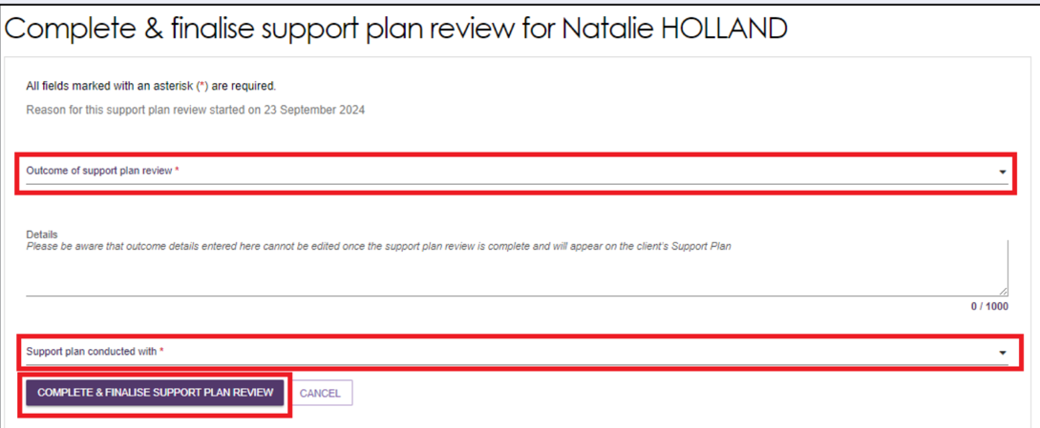

1. Select complete.

For more information visit:

* [Assessor Portal User Guide 7 – Completing a Support Plan and Support Plan Review](https://www.health.gov.au/sites/default/files/2025-02/my-aged-care-assessor-portal-user-guide-7-completing-a-support-plan-and-support-plan-review_1.pdf)

## Steps in Assessor Portal completing triage for a client who has had a Support Plan Review

Team Leader, can follow the steps to accept referral:

1. As a Team leader, start by viewing your Incoming referrals.
2. Once reviews the referral and decides to accept the referral. Click **ACCEPT**.
3. A dialogue box will appear asking for Change assessment priority and Triage category which is a free text field.

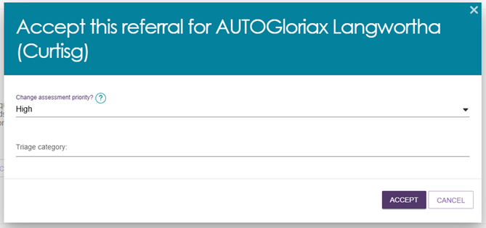

Mark the Referral as ‘Support Plan Review’ in Triage Category field.

1. Then assign to relevant Triage Delegate. Completing Accepting referral for your assessment organisation.

For more information visit:

* [Assessor Portal User Guide 3 - Topic: Accepting incoming assessment referrals](https://www.health.gov.au/sites/default/files/2025-03/my-aged-care-assessor-portal-user-guide-3-managing-referrals-for-assessment-and-support-plan-reviews.pdf#%5B%7B%22num%22%3A29%2C%22gen%22%3A0%7D%2C%7B%22name%22%3A%22XYZ%22%7D%2C68%2C631%2C0%5D)

Once a Team leader has reviewed the incoming referral, accepted and assigned the referral, the Triage Delegate can follow these steps:

1. View incoming referrals go to My Dashboard or select Assessment Referrals from the homepage or toolbar. Use the **Triage PENDING** tab to view assigned referrals.
2. Expand the client card using the **VIEW FULL CLIENT RECORD** button. Within the expanded client record There will be a label that reads:

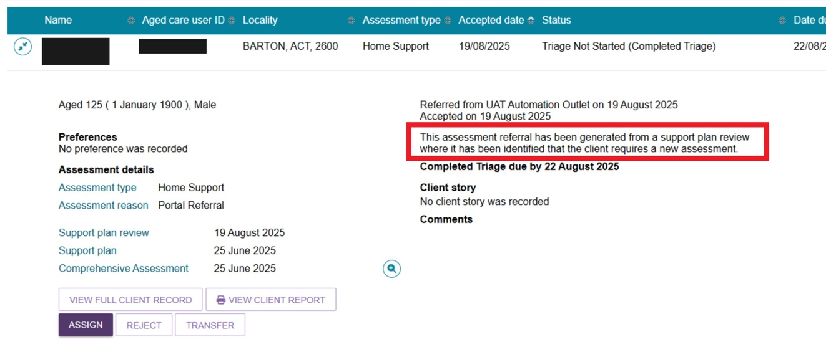

This assessment referral has been generated from a support plan review where it has been identified that the client requires a new assessment.

1. Navigate to the tab **PLANS,** andcheck **Plan History** on recent reviews made.

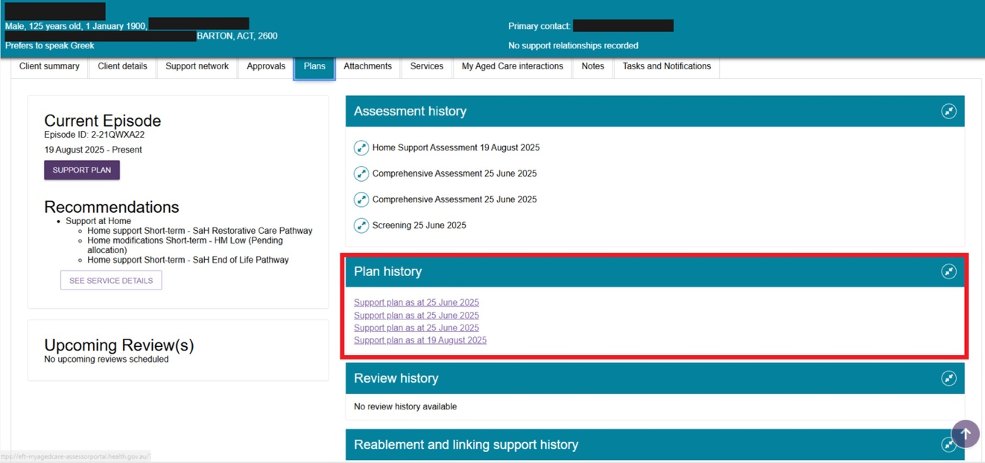

1. Select the recent **Support plan** and open to view the comments.

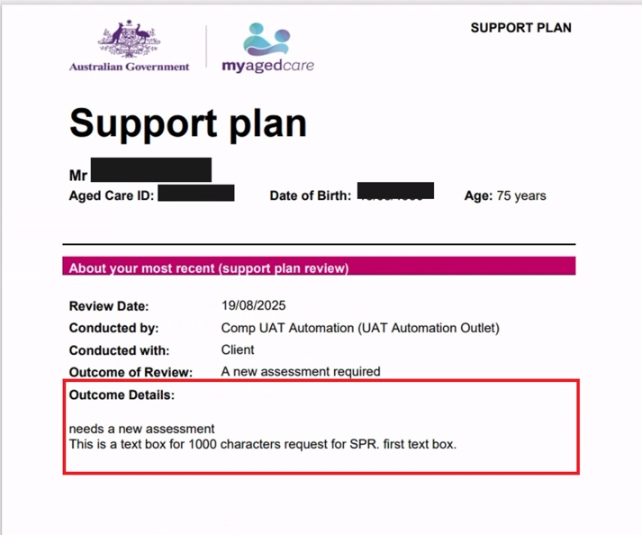

**Note:** Keep this Support Plan on another tab to reference when completing the Triage Questions.

1. Under **Outcome Details** of the exported Support Plan will detail the Support Plan Review comments. The information entered by the Assessor will support in determining if enough information was captured during the SPR call to conduct triage, mitigating calling the client again. If there is insufficient information the Triage delegate can contact the Assessor that performed the SPR for more information.
2. Navigate back to Client record and select **START TRIAGE.**
3. Following the Triage questions to complete.

For more information visit:

* [Assessor Portal User Guide 3 – Topic: Completing Triage](https://www.health.gov.au/resources/publications/my-aged-care-assessor-portal-user-guide-3-managing-referrals-for-assessment-and-support-plan-reviews?language=en)

# For further information

Call the My Aged Care assessor and provider helpline on 1800 836 799 for support and technical assistance. The helpline is available 8am to 8pm Monday to Friday and 10am to 2pm Saturdays, local time across Australia.

* [Video – How to manage a Support Plan Review (SPR) request](https://www.youtube.com/watch?v=3A8ZiAu-4T8)
* [Starting a Support Plan Review](https://www.health.gov.au/sites/default/files/2025-02/my-aged-care-assessor-portal-user-guide-7-completing-a-support-plan-and-support-plan-review_1.pdf#page=35)
* [Issuing an assessment referral as a result of a Support Plan Review](https://www.health.gov.au/sites/default/files/2025-02/my-aged-care-assessor-portal-user-guide-7-completing-a-support-plan-and-support-plan-review_1.pdf#%5B%7B%22num%22%3A286%2C%22gen%22%3A0%7D%2C%7B%22name%22%3A%22XYZ%22%7D%2C69%2C785%2C0%5D)